
University of Wales Trinity Saint David
School of Engineering

Group Project
Group 3: Renewable Energy Device
ACMA5009
Kelly Jenkins- 2510063
Grant Brooks- 2514976
Kieran Allen- 2417341
Owen Rogers- 2221725

May 2026
Word count: 11,704
Contents
Table of Figures. 5
Table of Tables. 7
Introduction- KJ. 8
Project organisation, roles and responsibilities- KJ. 9
Project Manager and Sustainability- KJ​. 9
Design Specialist Role- KA​. 9
Analysis and Procurement Functions- GB.​ 9
Materials Specialist Support- OR​. 10
Summary. 10
Project Management-KJ. 10
Design Specialist – Kieran Allen 14
Role and Approach 14
Research and Deployment Context 14
Concept Selection 16
CAD Modelling and Design Development 16
Build Sequence 17
Custom material card 19
Iteration and design changes 20
Manufacturing and Assembly 21
Process per component 21
Alternative manufacturing processes considered 22
Infill optimisation 22
Structural Simulation 23
Load cases 23
Blade results 23
Single turbine results 24
Reflection 24
Material selection specialist (Owen Rogers) 26
Role and approach 26
Project context and piston effect 26
The material selection process 28
Structural, Aerodynamic and Environmental Load Considerations 28
Material selection fundamentals 30
Material selection criteria 31
Candidate Material research 31
Flax-fibre Composite (Final material choice) 32
Decision Matrix 34
Further Calculations 35
Aerodynamic Loading Calculations 36
Dynamic Pressure from Tunnel Piston Effect 37
Resultant Blade Force 38
Bending Moment Calculation 39
Second Moment of Area 40
Maximum Bending Stress 41
Factor of Safety 42
Fatigue Life Estimation 43
Rotational Centrifugal Stress 44
Ashby Material Selection Analysis 45
Analysis (GB) 46
Introduction to Analytical Methods 46
Wind Speed Analysis — The Piston Effect 46
Channel Tunnel Specific Conditions: 46
Estimated Piston Wind Speeds: 46
Failure Mode and Effects Analysis (FMEA) 47
Quality Function Deployment (QFD) 49
Stakeholder Requirements: 49
Technical Requirements: 49
Structural Analysis Summary 50
Energy Generation and Payback Analysis 50
Key Assumptions: 51
Power Calculation: 51
Recommendations for Performance Enhancement 52
Recommendation 1: Wind Lens / Flanged Diffuser Augmentation 52
Recommendation 2: Optimised Blade Geometry (Rotor Radius and Blade Length) 53
Recommendation 3: Omnidirectional Deflector Guide Vanes 54
Recommendation 4: Counter-Rotating Array Configuration 54
Combined Enhancement Analysis 55
Revised Payback Calculation (with enhancements): 55
Appendix A: FMEA Data 56
Appendix B: Bill of Materials Summary 56
Procurement- GB. 57
Procurement Strategy 57
Bill of Materials and Cost Breakdown 57
Cost Per Unit at Scale 59
Maintenance Cost Estimates 59
Comparison with Conventional Materials 60
Procurement Risk Assessment 60
Return on Investment Analysis 61
Sustainability- KJ. 63
Achievement and progress relative to initial project plan and timing chart- KJ 68
Review of successes and failures of the project- KJ 69
Appendices 71
Bibliography 82

Table of Figures.

Figure 1- Group 3 organisational structure 9
Figure 2- The nine Belbin Team roles. (Belbin, 2025) 10
Figure 3- Team dynamics model by Tuckman 1965 (Symonds, 2025) 12
Figure 4- Hershey and Blanchard’s situational leadership model (De Bruin, 2020) 13
Figure 5- Single turbine assembly 17
Figure 6- Modular Turbine Assembly with containment suppressed. 18
Figure 7- Extrudr FLAX bio-PLA filament datasheet (Extrudr, 2024) 19
Figure 8- Full assembly with containment system 21
Figure 9- Blade only structural simulation results 23
Figure 10- A high-speed rail tunnel entrance with an aerodynamic hood (France TGV). These entrance hoods are used to mitigate the tunnel piston effects and pressure waves (Photo: Wikimedia Commons). 27
Figure 11- Flowchart of process of leading to the material selection for helix turbine blade 30
Figure 12- Key properties of candidate materials. Flax composites balance moderate strength with low density; metals score on durability but come with high weight. (AZO Materials, 2003) (AZO materials, 2012) (AZO materials, 2001) (SD3D, 2026) (SpƗrniƼš, 2006) 32
Figure 13- typical values for E-glass and natural fibres (SpƗrniƼš, 2006) 32
Figure 14- Decision matrix (subjective scores out of 5) for materials. Weighted sums highlight Flax-CFRP and Carbon-EP the highest. 34
Figure 15- Approximated assumed Blade Dimensions 35
Figure 16- Material Properties 35
Figure 17- Dimensional restrictions from PDS 36
Figure 18- Dynamic Pressure from Tunnel Piston Effect calculation 37
Figure 19- Resultant Blade Force calculation 38
Figure 20- Bending Moment Calculation 39
Figure 21- Second Moment of Area calculation 40
Figure 22- Maximum Bending Stress calculation 41
Figure 23- Factor of Safety calculation 42
Figure 24- Fatigue Life Estimation calculation 43
Figure 25- Rotational Centrifugal Stress calculation 44
Figure 26- Ashby Material Selection Analysis 45
Figure 27- Circular economy diagram (Allin, 2024) 64
Figure 28- Stages of the life cycle of the product 65
Figure 29- Flax seed cultivation CO2 figures (Carbon Cloud, n.d.) 66
Figure 30- Table of % contributions to carbon emissions 67
Figure 31- Graph to show the CO2 contribution %. 67
Figure 32- comparison table of CO2 kg- eq tonne (Amzil et al., 2025) 67
Figure 33- Initial project Gantt chart. 68
Figure 34- Final project Gantt chart up to submission date 69

Table of Tables.
Table 1- A summary table of the nine team roles (Belbin, 2025) 11
Table 2- FMEA Summary — Key Failure Modes for the FFRP Helical Wind Turbine 48
Table 3- Highest RPN’s Actioned 48
Table 4- FLAX 3D Printing Filament Mechanical Properties (LayFilaments, 2024) 50
Table 5- Energy Generation and Payback at Various Wind Speeds 51
Table 6- Combined Enhancement Impact on Power Output and Payback 55
Table 7- Payback Comparison - Baseline vs. Enhanced Design 56
Table 8- BOM Cost Summary - 4-Turbine Modular Array 56
Table 9- Wind Turbine Assembly Components 57
Table 10- Electrical System Components 58
Table 11- Installation, Guarding and Fixings 58
Table 12- Total Project Cost Summary 58
Table 13- Cost Reduction at Scale 59
Table 14- Annual Maintenance Costs 59
Table 15- Material Comparison for Wind Turbine Blades 60
Table 16- Procurement Risk Register 60
Table 17- Payback Scenarios 61
Table 18- Table of existing environmental benefits of the channel tunnel (Godbold, 2023) 63

Introduction- KJ.
This report investigates the design and implementation of a renewable energy system that utilises wind power generated from the “piston effect” at the exit point of the channel tunnel as its primary energy source. The objective is to develop a small-scale wind turbine that is technically robust, environmentally responsible, and suitable for integration into modern energy systems. A key focus of the design process is ensuring full safety and compliance with relevant British Standards, guaranteeing reliable operation and user protection.
Environmental sustainability is a central consideration throughout the design, with an emphasis on the use of environmentally friendly, non-metallic materials to reduce embodied carbon, corrosion risks, and overall environmental impact. In addition, the turbine is intended to support decentralised renewable energy generation, either by exporting electricity to the national grid or by supplying power to local battery storage systems. This approach contributes to improved energy resilience, reduced reliance on fossil fuels, and progress toward national renewable energy targets.

Project organisation, roles and responsibilities- KJ.
Figure 1 below is Group 3’s organisation chart. As you can see 2 individuals had split roles, this was due to the team understanding the need for these positions within the project but not having enough members to fulfil the roles individually.
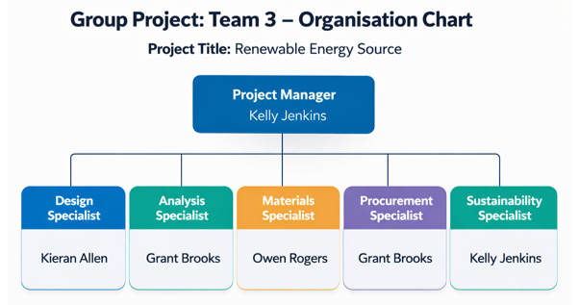
Figure 1- Group 3 organisational structure
Defined below are the role responsibilities the initials of the individuals responsible for those roles along with a brief description of each role within the project. This report will include content from each roles contribution to the overall project along with relevant research material.

Project Manager and Sustainability- KJ​.
The Project Manager leads strategic oversight and integrates sustainability into project decisions for environmental responsibility.​

Design Specialist Role- KA​.
Design Specialist develops conceptual and technical models, collaborating to refine visual and structural project elements.​

Analysis and Procurement Functions- GB.​
Analysis Specialist conducts performance assessments, while also managing procurement to optimise cost and quality.​

Materials Specialist Support- OR​.
The Materials Specialist ensures material suitability, durability, and alignment with sustainability, supporting design and procurement.

Summary.

Project Management-KJ.
While working as a team there are many things to consider, the skills set, knowledge, behavioural traits of the individuals within the team but also how best to manage the individuals to be able to create a high performing team.
Belbin (Belbin, 2025) researched behaviours within a team and believed that the most successful of teams were made up of individuals with a diverse mix of behaviours. Below, Figure 2 shows the 9 categories stated in Belbin’s theory and Table 1 is a summary of the roles and their strengths and weaknesses. It is important to understand the different behaviours within the team to be able to effectively manage the team harmoniously and everyone working to their true potential.
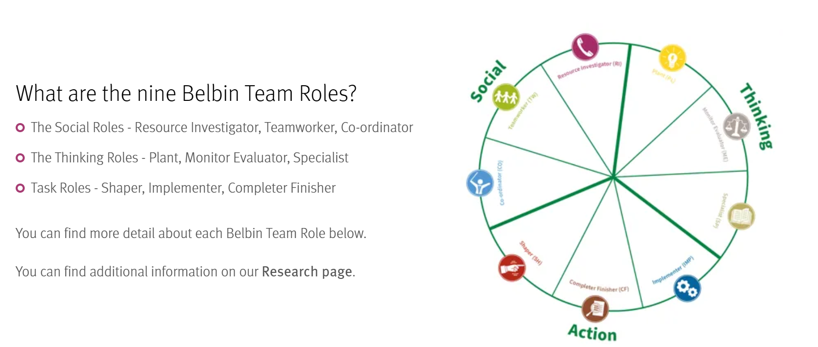
Figure 2- The nine Belbin Team roles. (Belbin, 2025)
Table 1- A summary table of the nine team roles (Belbin, 2025)
These can contribute to the team dynamic, the dynamic being shaped by the behaviours, skills, personalities, and interactions of team members and evolve over time. According to Tuckman’s 1965 team development theory (Bitesize Learning, 2015), teams progress through five stages: forming, storming, norming, performing, and adjourning. In the forming stage, members begin to get to know one another and dynamics are tentative, open communication and willingness to engage help establish trust. During storming, differences in opinions, values, and working styles emerge, often causing conflict and emotional tension. How members manage disagreement determines whether the team progresses or stagnates. In the norming stage, conflicts are resolved, roles become clearer, and shared norms develop, leading to more positive and collaborative dynamics. Performing occurs when the team operates efficiently with high trust, accountability, and a strong focus on shared goals. Finally, adjourning marks task completion, where members reflect on achievements, relationships, and experiences as the team disbands.
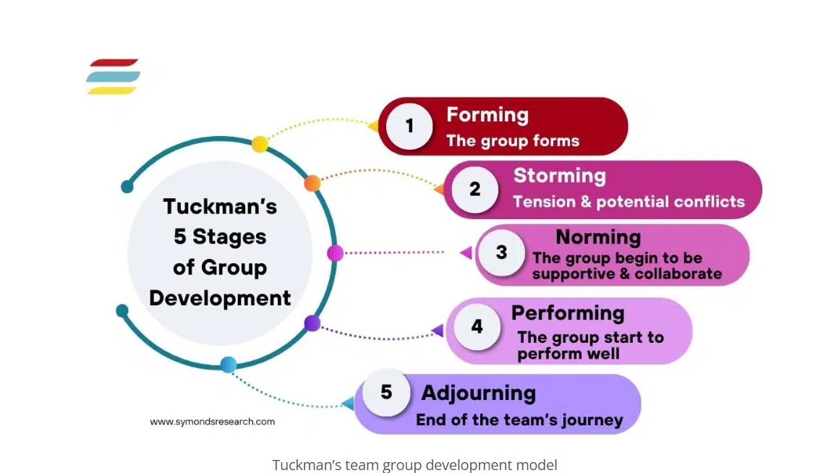
Figure 3- Team dynamics model by Tuckman 1965 (Symonds, 2025)
With these in mind you have to utilise these in order to properly lead a team and be able to adjust leadership styles. Lewin’s (1939) theory suggests leaders can sit in three separate styles, using Lewin’s research it can be suggested that the autocratic style would create the higher output but it would generate a completely different work dynamic to a leader who has a democratic style. However, in my experience I have seen my manager go between these styles depending on the situation and/ or task which has worked well. Whereas Hersey and Blanchard’s (1977) situational leadership theory argues that a leader’s ability to lead the team depends on certain situational factors using development levels, supportive behaviours and directive behaviours.
According to Lewin’s theory, management styles can be broken down into autocratic, democratic and Laissez-faire. Autocratic- Leaders have complete power over people, the leader makes all the decisions and are to be executed without question. Good when dealing with inexperienced employees or in a crisis situation. The lack of input and autonomy can negatively impact employee motivation long- term.
Democratic- Leaders involve employees in the decision making process, the leader may still make the final decision. Most effective for group performance across the board. Can be a slower process, so may not be optimal in a time- critical situation.
Laissez- faire- Hands off approach where leaders delegate decision making authority to the team and allows them to work largely on their own. Should only be used with highly skilled and highly motivated employees. High levels of autonomy can be motivating for those who are skilled and motivated enough to handle it. Can have a negative impact on performance for those who need strong direction and guidance. (Lewin,2025)
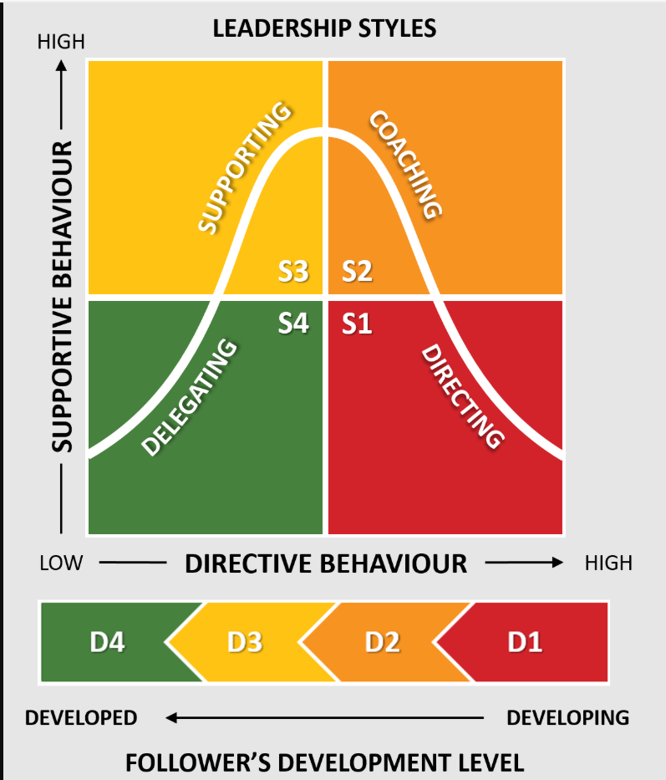
Figure 4- Hershey and Blanchard’s situational leadership model (De Bruin, 2020)
For the most part of this project the team sat under the democratic and Laissez- faire leadership style of Lewin’s theory and Supporting and Delegating of Hersey and Blanchard’s theory.
The main part of the project manager’s role within this project was to ensure the team remained on track for the milestones of the project, ensuring communication was maintained, any minutes that required next steps were cascaded through to the team and actioned accordingly, this was monitored and followed through in the following meetings. Alongside the communication aspects, the project manager created the Gantt chart as a visual for the team to reflect their progress, creating a blank template for the report so that all information was to collated in the same template and to the same standard, and to submit the report and viva’s on behalf of the team.

Design Specialist – Kieran Allen

Role and Approach
The role of the design specialist was to use the agreed upon product design specification, create a detailed CAD model of a helical vertical axis wind turbine, and validate that the design is suited to its intended deployment using structural simulation. Aspects controlled by the design specialist include the turbine geometry including blade profile, the positioning and layout of the rotor, supports and containment. Design for manufacture considerations were made throughout the design process, to ensure that each component could be made, or was a standard off the shelf item. The model was built up from individual parts into sub-assemblies, before inserting into a master assembly, refining geometry as simulations were ran.

Research and Deployment Context
Kumar, Raahemifar and Fung (2018) make the case that vertical axis wind turbines are well suited to the turbulent, multi directional winds typical of urban environments where horizontal axis turbines underperform. In terms of Vertical axis wind turbines, Cheng et al. (2017) report that the Gorlov helical turbine distributes torque more evenly across rotation than a straight bladed H-type Darrieus rotor, while also producing lower noise emissions. For straight bladed Darrieus configurations, solidity and number of blades are the primary aerodynamic levers (Rezaeiha, Montazeri and Blocken. 2018). This information is also relevant to helical, curved blade rotors, which supported the decision to revert to a three blade turbine after initially opting for a four blade model.
As a group, we selected outside the exit of the train tunnel as the intended environment for our turbine. As trains pass through the tunnel, they generate substantial airflow because of the ‘piston effect’. This is where a train compresses air ahead of itself and pushes high velocity air out of the tunnel as it exits. Kim and Kim (2007) demonstrated this through 1:20 scale model tests and CFD. Bethi et al. (2019) demonstrated through CFD simulation that a savonius type rotor positioned in and around the exit of the tunnel, to the side of the track, can convert train induced piston wind into energy. We intend to deploy our turbine at the exit of the tunnel, therefore the topic of the study is relevant.
Deploying the turbine system outside of the tunnel is different from what we originally discussed as a team and creates a few different risks that need to be addressed within the design. The risk of bird strikes and damage caused by debris from passing trains is addressed through the implementation of the mesh containment. Weatherability also becomes a factor that requires consideration, as the turbine assembly is now subject to UV exposure, temperature changes, and possible corrosion in salt air environments, if the turbine is deployed in coastal areas. In the manufacturing and assembly section, a UV resistant clear coat is specified for use on the components manufactured from Flax to address some of these risks. The turbine blades are the most demanding component to design and optimise, as the product design specification commits to using a flax based composite for sustainability reasons. Shah, Schubel and Clifford (2013) provide the most relevant published precedent, with their resin transfer moulded flax/polyester blade demonstrating structural viability when used on an 11 kW turbine.
Several standards apply to the design of this wind turbine. BS EN 61400-2 (BSI, 2013b) and BS EN 61400-11 (BSI, 2013a) details the measurement techniques of acoustic noise for wind turbines, which is an area that is listed as future work. BS 8888 (BSI, 2020) is the UK standard for technical product documentation and engineering drawings. BS EN 50121 (BSI, 2017) specifies electromagnetic compatibility in railway systems, and ISO 14021 (ISO, 2016) covers the sustainability and environmental claims the brief states.

Concept Selection
Based on the concept drawings, the team agreed upon a four turbine modular system, contained within a mesh containment. Each module consists of four three-bladed turbines arranged in line on a base that also acts as a containment for the electrical components necessary to convert and store the energy harvested by the turbines. Compared to a single large turbine of equivalent total dimensions, the modular arrangement gives a higher total swept area, while keeping within the height and width limits specified in the product design specification. Against an original concept to deploy the wind turbine modules on a bridge, the chosen concept was supported by a weighted decision matrix scored by the team (Appendix 1.1). In the matrix, five criteria: Feasibility, Cost, Efficacy, Sustainability and Health and Safety were applied at weights 2, 1, 4, 5 and 3 respectively. The chosen concept scored 60, against the 54 of the rejected concept. Feasibility, Sustainability, and health and safety were the defining criteria that led to the selection of this concept. The implementation of small, vertical axis wind turbines at ground level, means that costs, and risk of injury are reduced during installation and maintenance. The use of sustainable materials, and the selection of a manufacturing method that produces less waste, ensures that the chosen concept is a more sustainable option.

CAD Modelling and Design Development
All CAD modelling was carried out in SolidWorks. The approach was taken to begin the design by working outwards from the central structure. Each component was modelled as a separate part, before combining within a single turbine sub-assembly, which was inserted into a master assembly, along with the containment and base sub-assemblies.

Build Sequence
The design began with the central structure of one turbine, modelled at a height of 1000mm. The blade was next to be developed, which began with sketching the blade profile on a plane, before sweeping along a helix around an axis to create the helical blade form. Three blades were inserted into a single turbine sub-assembly, with the central structure, before three supports per blade were designed and added also. These top, middle and bottom supports connect each blade to the central structure, fixed to the blade with an M10 locking bolt, and to the centre structure by a weld. All three supports share the same diameter but are cut to different lengths depending on their position along the blade. A cap was added to the top of the centre structure, which with further development can serve as protection from the weather and environmental conditions. Fixings were then added to complete the single turbine sub-assembly.
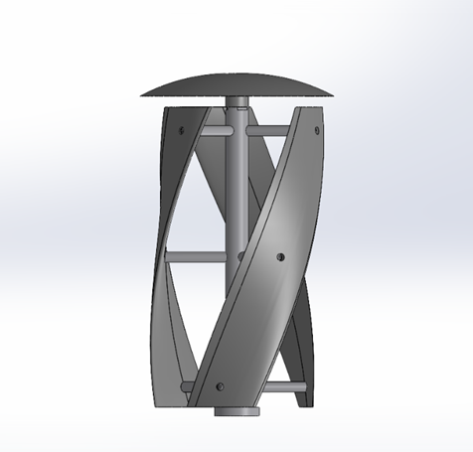
Figure 5- Single turbine assembly
Four single turbine sub-assemblies were inserted into the master assembly and constrained in a row, at 750mm centre to centre spacing. This spacing ensures that all blades have enough clearance during operation, without making the unit unnecessarily wide. The containment system was added next, which had already been inserted and constrained in a separate assembly, and consisted of four mesh panels, fixed to four corner posts, finished in safety yellow, and two hinged doors providing access for maintenance. The base was added as a sheet metal part, with edge flanges to create a box shape, with hinged access doors to create a space that served as housing for the permanent magnet synchronous generators, charge controller, dump load and battery storage typically required for a small vertical axis wind turbine. These electrical components were not integrated into the CAD assembly, as accessible step or SolidWorks files could not be attained. Once these sub-assemblies had been inserted into the master assembly, and constrained to their correct positioning, all fixings were inserted. The master assembly has an overall height of approximately 1830mm, which sits well within the height limit stated in the product design specification.
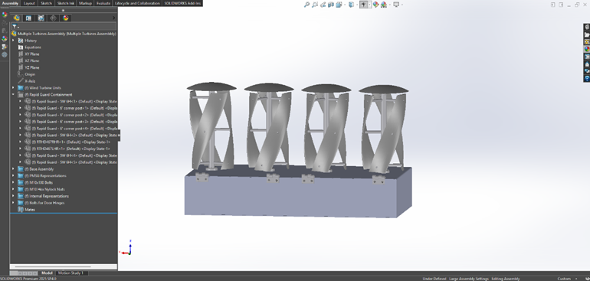
Figure 6- Modular Turbine Assembly with containment suppressed.

Custom material card
SolidWorks did not have a suitable material with accurate properties, to apply to the composite components of the assembly, so a custom material had to be created using the Extrudr FLAX bio-PLA filament datasheet.
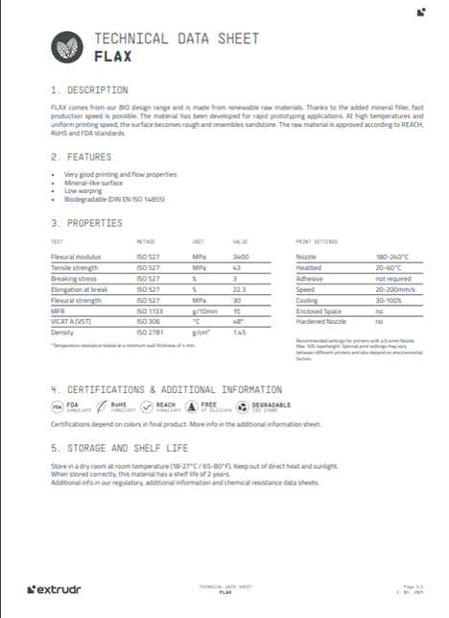
Figure 7- Extrudr FLAX bio-PLA filament datasheet (Extrudr, 2024)
Aluminium 6082 was specified for the support bars, central structure and base components, which SolidWorks had a material card for in the default library.

Iteration and design changes
Several changes were made between the first version of the model and the current iteration. The most significant changes made were the reverting from four blades per turbine, to three blades, and the alteration of the positioning of the supports. In the previously presented single turbine assembly, the blade supports were spaced roughly 150mm apart, with the middle support positioned at the halfway point of the blade. Initial simulations indicated an unacceptable blade tip displacement of 64.5mm at LC1, where the turbine was specified to be rotating at 75 rad/s. Increasing the spacing of the blade supports to 400mm, placing the top and bottom supports closer to the blade tips, reduced the max blade displacement to 1.5mm at the same load case. Therefore, this design iteration was directly driven by simulation evidence and is a change that has proven that the flax composite blades are a viable option. The decision to reduce the blade count from four to three per turbine was driven by research into existing designs. A typical Gorlov wind turbine has three helical blades. Reducing the amount of blades reduces material use, which in turn reduces the total cost of components, installation, and maintenance/repairs.
The mounting decision was changed from tunnel wall mounted, to freestanding floor mounted, with a base fixed to a concrete foundation outside the tunnel exit. Wall mounting would have required considerations to the structure of the tunnel itself, while the freestanding option avoids this, and allows the use of off the shelf mesh containment systems.
The centre structure was redesigned to allow for welded supports, rather than the original plan which was to slot the blade supports through the centre structure and bolt them from the inside. Upon inserting parts into the assembly, and constraining them in place, it became apparent that there would be not enough access to insert the bolts. The revised design consists of the supports being cut to fit the profile of the centre structure and welded in place. This is a structurally sounder option, but also means that the process off replacing or repairing an individual support requires more down time for the turbine.

Manufacturing and Assembly

Process per component
The three helical blades and top cap are 3D printed using Extrudr FLAX bio-PLA filament at 100% infill. Ideally, the printer will be capable of printing parts exceeding 1000mm in height, but with further model optimisation and structural analysis, the blades could be split into 3 parts and assembled using a steel dowel and structural adhesive. Both of these flax parts will be finished with a UV-resistant coating to extend outdoor service life.
The centre structure and blade supports are bought in as aluminium 6082 round bars, machined to the diameter and length required, and an internal thread is inserted into the end so that the blades can be fixed to the supports with an M10 locking bolt.
The base structure is fabricated from 10mm sheet aluminium, bent into a box shape and welded for rigidity. The access doors are 3mm sheet aluminium, hinged to allow an upwards opening. The containment is a bought in steel mesh system, with six foot high mesh wall panels, fixed to corner supports finished in safety yellow.

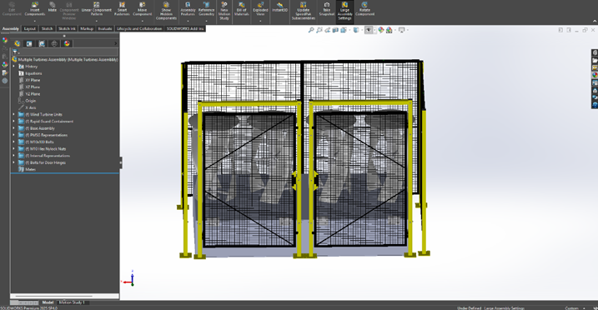
Figure 8- Full assembly with containment system

Alternative manufacturing processes considered
A vacuum assisted resin infusion manufacturing method producing a flax fibre and bio-resin composite was an alternative manufacturing that the team considered. Shah, Schubel and Clifford (2013) used a resin transfer moulding process for their flax/polyester blade, with their results suggesting that vacuum assisted resin infusion would offer higher tensile strength and stiffness compared to the 3D printed flax filament option. The resin infusion process was rejected on the grounds that designing and manufacturing a mould for the helical blade geometry would require extra design and manufacturing time, increasing the cost of the project. Also, there is significantly more waste material produced when using a resin infusion method, such as excess resin, waste release film, vacuum bagging, breather material. Whereas 3D printing only produces waste material during calibration of the printer prior to printing, and the supports that it must create to support the complex geometry of the blades. Therefore, the chosen manufacturing process fits well into our sustainability heavy product design specification.

Infill optimisation
The structural simulations were run based on the blades being printed at 100% infill, meaning a fully solid part with the material properties from the data sheet applied directly. A factor of safety of 2.6 was achieved for stress, with LC1 indicating a maximum stress of 16.71 MPa. As noted in the data sheet, the material has a tensile strength of 43 MPa. This raises the question of whether the infill could be reduced to save material and print time, ultimately reducing cost. Belarbi et al. (2021) report that PLA flax shows low sensitivity to print parameters and identifies inter layer bonding as the biggest limitation in flax and PLA parts.
It would be useful to re-run the simulations with revised material properties to represent a reduced infill print. This would then allow us to determine what would be the lowest percentage infill that maintains an adequate factor of safety. As infill is reduced, mass would reduce linearly, meaning that the centrifugal force acting on the blades would also reduce.

Structural Simulation
Three blade-only static studies were carried out using SolidWorks simulation, with three defined load cases covering rated operation (LC1), survival gust (LC2) and train pass by (LC3). A full turbine assembly was also carried with LC1 conditions. All studies used a fine mesh, to ensure as accurate as possible simulation results. Constraints for each simulation reflected true fixing points during operation.

Load cases
LC1 applies a pressure of 88 Pa on the outward face of the blades which corresponds to 12 m/s winds, with the turbine determined to be rotating at 75 rad/s. LC2 applies a pressure of 1,176 Pa of drag pressure on a stationary turbine, not rotating, in 40 m/s gusts, stated as a requirement in the PDS. No centrifugal load is applied in this load case. LC3 applies a pressure of 165 Pa of pressure, which represents a peak piston effect gust at a 15m/s train pass by. This is a conservative figure for UK passenger trains, at the lower end of the in tunnel velocities reported in literature related to the piston effect (Kim and Kim, 2007; Pan et al., 2013). The turbine is determined to be rotating at 75 rad/s in LC3, equal to LC1.

Blade results
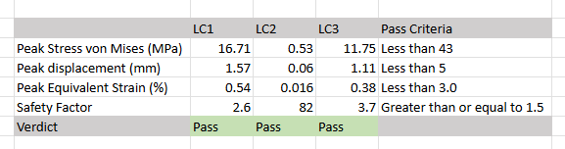
Figure 9- Blade only structural simulation results
The turbine blades passed the structural simulation at all load cases with a comfortable margin. As shown in appendices 1.2, 1.8 and 1.11, stress concentrations were noted at the fixing points where the blade meets the blade supports, but the peak stress does not reach half of the yield strength. Strain follows a similar pattern which can be seen in appendices 1.5, 1.6 and 1.10, with the highest value being observed around points where the part was fixed during simulation but still falls comfortably within the pass criteria at all load cases. Displacement results also achieved the pass criteria, once a design change had been made. Initially, with the blade supports spaced 150mm apart, simulations showed a max displacement of 64.5mm for LC1, which can be seen in appendix 1.4. This prompted the design change of increasing the spacing between supports to around 400mm, which reduced the max displacement to 1.57mm, along with acceptable values for LC2 and LC3, (Appendices 1.3, 1.7 and 1.9).

Single turbine results
The blade only simulations show that the blade is capable of handling the forces that will be acting on them during operation, but do not give an indication of how the supporting structures will cope. A singular turbine study at LC1 was carried out to investigate this and validate the design. The same material was applied to the blades, and aluminium 6082 was specified for the blade supports, and central structure.
As can be seen in appendix 1.12, the simulation showed that there was a large stress concentration of 164 MPa at a contact point between a blade support and the blade. This was disregarded and assumed to be an issue with the mesh that occurs at a contact point of materials with very different stiffness values. Therefore, a reading was taken from just outside this point to obtain a more reliable measurement. A max displacement value of 2.88mm was observed at the tip of the blades (appendix 1.13), which keeps within the pass criteria, and does not affect the parts clearance between itself and other components.

Reflection
To reflect on the outcome of this project, substantial CAD modelling has been completed, producing a modular assembly that consists of four single turbines on a mounted base that acts as an enclosure for the electrical components, with a containment system that protects the turbines from debris and bird strikes, as well as preventing unauthorised access. Each turbine consists of three blades, with three blade supports welded to a central structure. Simulations were carried out to validate design choices, with all shortcomings outlined by the analysis being rectified.
Future work for this project would include producing a set of engineering drawings for all parts and assemblies, acoustic and vibration analysis, the use of more advanced simulation software such as ANSYS to access a wider range of aerodynamic simulations, and integration of the electrical components critical to the operation of the wind turbine.

Material selection specialist (Owen Rogers)

Role and approach
The Material Selection Specialist plays an important role in selecting a material for a Helical Vertical Axis Wind Turbine (HVAWT) blade, as this selection ensures the effective, safe, and reliable operation of the turbine under various environmental and mechanical conditions. They are also responsible for researching & selecting materials that meet the optimal balance of strength, weight, durability, fatigue resistance and cost-effectiveness. The selection of materials for HVAWT blades is critical, as these blades are subjected to various conditions that affect the turbine's aerodynamic performance, structural integrity, and service life.
The material specialist systematically investigates a selection of materials, assessing their viability by analytically validating them against the preset functional and operational requirements of the turbine blade as outlined in the product design specification (PDS). The candidate materials, such as aluminium alloys, fibre-reinforced polymer composites, carbon fibre composites, glass fibre composites, or hybrid materials, are evaluated against these requirements with respect to their mechanical and environmental performance characteristics.
The process of selecting a material normally involves comparing key properties such as tensile strength, stiffness, fatigue resistance, density, corrosion resistance, manufacturability and maintenance requirements. Sustainability aspects are also considered throughout the process to ensure that the chosen material supports both technical performance and long-term feasibility.

Project context and piston effect
A double-helix (helical) vertical-axis turbine, placed at either end of the train tunnel, would be a valuable and efficient means of generating energy, as it could harvest the airflow generated by passing trains. Placing the turbine blades just outside the tunnel entrance effectively turns the tunnel into a giant piston cylinder, with each train entering/exiting the tunnel creating a surge of airflow that produces large pressure cycles.
This is an aerodynamic phenomenon known as the piston effect, which is where a moving object acts like a plunger when in a confined space, forcing air ahead of the train, compressing the air, as well as creating a vacuum behind it, pushing the air forward like a syringe, pulling in fresh air from behind (Pan, et al., 2013). The airflow which is induced can reach speeds of between 36-72km/h for typical trains, or up to roughly 180km/h for high-speed rails (E+T Magazine, 2025).
This effect can significantly increase the dynamic loading (bending/fatigue) of the turbine blades. Indeed, studies note that tunnel piston flows produce “significant wind energy” that is exploitable by turbines (Wang, Xiong, Zhang, Zhang, & Azam, 2023). However, with this, the blades will experience harsh conditions such as moisture, rain/hail impact (erosion), UV exposure, temperature swings, and airborne particles. With examples of high-speed rail tunnels often having very short clearance, generating near sonic pressure waves (Shen & Zhang, 2013)
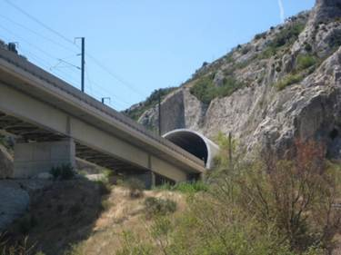
Figure 10- A high-speed rail tunnel entrance with an aerodynamic hood (France TGV). These entrance hoods are used to mitigate the tunnel piston effects and pressure waves (Photo: Wikimedia Commons).
Therefore, since there are major effects at play, the material requirements are of high importance, with these requirements including high fatigue resistance (tensile/compressive cyclic loads), good erosion/impact durability, low density (to minimise inertia), weather resistance (moisture & UV), cost effectiveness, and safety (fire and smoke).

The material selection process

Structural, Aerodynamic and Environmental Load Considerations
When designing new projects, there are considerations that need to be outlined during the product design specification process before beginning any research. Many of these considerations would include:
- Train-Induced Wind: If the Eurostar-class trains do roughly 250 km/h approaching the tunnel, the piston effect can generate gusts up to 100–150 km/h or 28-42 m/s at the portal (E+T Magazine, 2025). For safety, a design wind speed of 60–70 m/s would be desirable, assuring a safety factor of roughly 1.5 times the expected speeds. This flow of wind would impose aerodynamic forces (lift/drag on the blades, yaw moments) and dynamic pressure surges. Another consideration is sporadic gusts from open terrain (e.g., tornadic gusts); these should be roughly 30–40 m/s, per wind-engineering standards.
- Pressure Pulses: When a train breaks or accelerates, it creates a pressure pulse which would propagate down a tunnel. Finite-element FSI studies, including field tests, show that the blockage ratio and speed greatly affect tunnel pressure (Xiaonan, et al., 2020).
- Debris Impact: since the trains will be moving at great speeds, there is a high possibility of twigs, stones or water spray striking the blades. The design of the helical geometry allows many impacts to slide along the blade rather than ramming flat surfaces (Hench & Fralick, 2015). However, we should still design for discrete impact energy as per the UK rail debris guidelines (e.g. assume a 2 kg object at 30 m/s could strike).
- Moisture and Moist Air: Since the turbine will be mainly outside in the elements, rain, condensation, tunnel humidity and occasional snow are key considerations when designing. Since some composites, especially fibrous materials, are hydrophilic & ensuring limited absorption is paramount since this would cause swelling and property loss if not managed (Hadj-Djilani, Bougherara, Zitoune, & Toubal, 2024). This would mean that the blades must be sealed using some form of epoxy/resin to prevent. Assume a water exposure of up to 100% Relative Humidity and periodic immersion (spray), per CEN/ISO environmental categories for outdoor use.
- UV Radiation: Since the blades of the turbine will likely see the sun (unless a mountain range shades the tunnel entrance), it is important to consider that UV degrades natural fibres and resins (Hadj-Djilani, Bougherara, Zitoune, & Toubal, 2024). If we look to increase the lifespan of the blades, e.g. over 20-year life, expect up to a possible 15–20% drop in strength if unprotected by UV-blocking gel coats or hybrid skins (Hadj-Djilani, Bougherara, Zitoune, & Toubal, 2024).
- Temperature Cycles: Since the UK climate extremes are approximately –20°C to +40°C, plus the solar heating on blades, it is key to minimise the thermal expansion between resin and flax as this can induce further stresses on the blades. This can be prevented by using a resin that matches the expansion, depending on the location and the expected temperature change in that area.
- Fatigue Loading: With each train passage, this creates a load cycle which in turn needs to be considered when designing a turbine blade. A 20-year life is about 14 million cycles, so ensuring that a material has a suitable S-N life is crucial, given low-cycle fatigue from pressure pulses and high-cycle fatigue from rotational stress.
- Corrosion/Fire: Selection of materials is key during the design of components since there is a risk of corrosion if we include some metals and a risk of fire if we use some composites (unless treated). Therefore, the design to negate these effects would be ideal, such as the blades receiving a fire-retardant resin or surface coating.
- Maintenance Access: The site will most likely be remote, since on railway tracks, maintenance visits are costly. The design must allow for easy inspection (e.g., ladders, platforms). Assume service every 2–5 years.

Material selection fundamentals
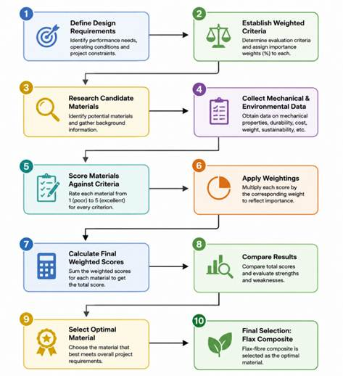
Figure 11- Flowchart of process of leading to the material selection for helix turbine blade
The figure above shows the process we followed that led us to our selection of flax composite material. This was a key component during the beginning of my research process that helped lead us to our final material. One of the key parts that steered us during the project was introducing basic design requirements, set out in our PDS (product design specification), as this places constraints on all aspects of the project so that we don’t stray too far from our initial idea. This also allows us to work from the same requirements, preventing any miscommunication.

Material selection criteria
To help us evaluate our material for our helix-bladed turbine, we used an evaluation matrix based on seven weighted criteria. These seven would include;
- Mechanical Performance, including strength, stiffness, & fatigue – weight 30% & must resist centrifugal and wind loads with a fair margin.
- Durability, including moisture/UV/weathering, erosion – weight 20% & must be designed to be critical in a tunnel entrance environment.
- Weight (density) – weight 15% & ideally needs a lower density as it reduces inertia, dynamic stresses and foundation loads.
- Manufacturability & Cost – weight 15% & must have an Ease of forming double-helix geometry, low material costs, and must be readily available.
- Maintenance & Reliability – weight 10% & must have a low inspection frequency, ease of repair, and a long-expected lifetime.
- Recyclability & Sustainability – weight 5%, a good end-of-life recovery and a low environmental impact.
- Fire/Smoke Safety – weight 5%, a lower priority criterion, but required for safety standards.

Candidate Material research
During our discussions as a group, we reviewed a range of suitable materials used in various applications that showed promising potential within the material requirements listed above. In doing so, we arrived at a set of candidate materials to choose from and for me to research. These candidate materials included a flax-seeded fibre composite (natural flax fibre in a polymer resin), E-glass/epoxy composite (standard fibreglass material), Carbon-fibre/epoxy composite, aluminium alloy (6061) (common structural alloy), Stainless steel (316) (typical corrosion-resistant steel), or a Bio-based polymer PLA (polylactic acid thermoplastic (unreinforced)).
The following comparison between the candidate materials listed covers the mechanical properties (tensile strength, Modulus, fatigue), environmental durability, cost, manufacturability, maintenance, recyclability, and fire/smoke performance.
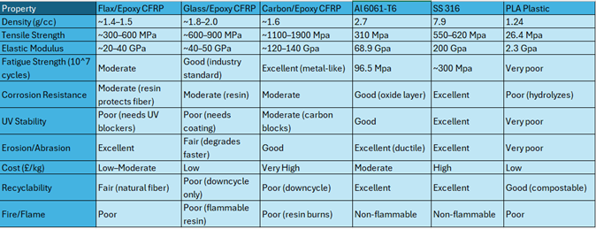
Figure 12- Key properties of candidate materials. Flax composites balance moderate strength with low density; metals score on durability but come with high weight. (AZO Materials, 2003) (AZO materials, 2012) (AZO materials, 2001) (SD3D, 2026) (SpƗrniƼš, 2006)

Flax-fibre Composite (Final material choice)
A flax fibre material is a cellulose-based natural fibre, which has a moderate stiffness (50-70GPa) and a strength of (500-900MPa), with a Low density of (1.4-1.5g/cc) (SpƗrniƼš, 2006). Figure 13 below compares raw fibre values for reference.
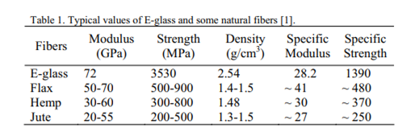
Figure 13- typical values for E-glass and natural fibres (SpƗrniƼš, 2006)
As seen above, Flax composites exhibit high specific strength as compared to other natural fibres, with the exception being E-glass, which has a much higher specific strength with however close to double the density of its counterparts, which isn’t ideal considering we need as low of material density as possible to prevent the blades from carrying too much inertia, which delays the turbines ability to spin up and reach its peak operating speed (Asim, Amber, Singh, & Siddiqui, 2025). What is also notable is that for the equal weight, flax/epoxy can be stiffer than its glass/epoxy counterpart (SpƗrniƼš, 2006).
There is also recent testing indicating that flax composite materials have much better impact/erosion fatigue resistance than glass composites. A flax/epoxy leading edge with nanodiamond-treated fibre showed up to 17x longer damage-initiation life and 74% less mass loss under rain/hail impacts, versus its standard glass/epoxy (Hinzmann, Johansen, Hasager, & Holst, 2024). Suggesting that flax composites have excellent resistance to rain erosion and sand abrasion, which is a critical component to turbine blade leading edges.
Another key component of flax composites is that they are biodegradable and can be recycled at the end of life, unlike their fibreglass counterpart, making them a much more sustainable choice for our turbine blades. The manufacturing of flax composites is also a relatively straightforward process, facilitating easier design and manufacture of the turbine blade.
The drawbacks of a flax composite material (like all natural fibres) absorb moisture and degrade above roughly 100-120°C or in a fire, producing a thick smoke when burning (SpƗrniƼš, 2006). Therefore, a protective coating is essential, providing the material with hydrophobic, UV-stabilising, and fire-retardant properties. Another drawback of flax composites is that flax has a much lower ultimate tensile strength than carbon or glass composites. This would mean that we would need to either use conservative load factors or use much thicker laminates.
In conclusion to flax fibre composites, as previously mentioned, the lower density would mean that the unloaded flax blade would experience less inertia forces under cycling loads, while also being able to meet the blade's strength needs when correctly designed, striking a balance between strength and mass, while also offering the sustainability advantages, making it the perfect material for our application.

Decision Matrix
Figure 14 (below) The weighted criteria matrix ranks materials by scoring them from 1-5 for each criterion (5 = excellent) (1 = Bad), then multiplying each material’s score in a category by the importance weighting of that category, then summing all weighted values to produce an overall score.
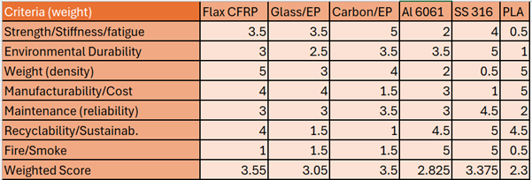
Figure 14- Decision matrix (subjective scores out of 5) for materials. Weighted sums highlight Flax-CFRP and Carbon-EP the highest.
The decision criteria concluded that the Flax composite ranks the highest, since flax’s balance of adequate strength, very low weight, and environmental benefits justifies its selection, with carbon coming in close. Steel also scores surprisingly well because of its durability, offsetting its weight, while PLA performs much better than expected because it scores very well in Weight/cost/sustainability. However, one notable part, looking back at the weighing method used, is that it underpenalized catastrophic mechanical weaknesses. This is evident from the fact that in a real engineering selection, PLA would’ve been eliminated much sooner, since it would fail to meet the minimum structural requirements.
The rationale for flax scoring highly on weight and sustainability, and moderately on strength/fatigue, is that flaxseed is more biodegradable and has strong strength properties given its density. The durability score was also given a moderate rating, as durability can be improved by using a coating to prevent moisture absorption/UV exposure, weathering & erosion. Carbon is scored best on the pure mechanics attributes; however, it is massively penalised by its cost and its recyclability. Another key point is that Glass is a great all-around material, but, again, is penalised by being much denser and less environmentally friendly. Aluminium and steel both excel in durability and fire safety, but because the group set the weight of both attributes to low, this severely limited the final weighted score. Again, PLA scores well only in sustainability but fails on almost all structural attributes.
Further Calculations (e.g. Aerodynamic Loading Calculations, moments, Factor of Safety, Fatigue Life Estimation & Ashby Material Selection Analysis)
Following my research into material selection, which concluded on the material Flax fibre composite, I concluded that further calculations would be desirable to examine my selected material and ensure it meets all the requirements set out in our original PDS (Can be found in the appendix). These calculations can be seen below, labelled;
Approximated assumed Blade Dimensions
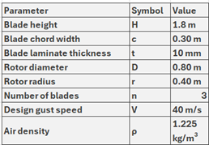
Figure 15- Approximated assumed Blade Dimensions
Initially, clarifying important information such as assumed blade dimensions (see above) and material properties (see below).
Material Properties
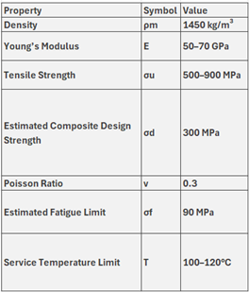
Figure 16- Material Properties

Aerodynamic Loading Calculations
The PDS states that the turbine must safely withstand wind gusts up to 40 m/s without structural failure while remaining within the dimensional restrictions of:
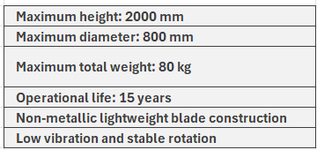
Figure 17- Dimensional restrictions from PDS

Dynamic Pressure from Tunnel Piston Effect
The aerodynamic loading on the blade can be estimated using the dynamic pressure equation:
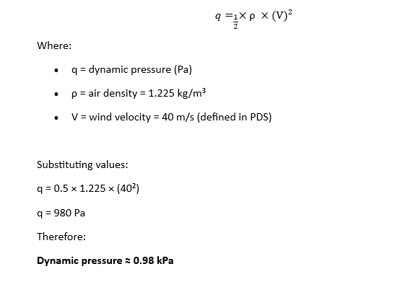
Figure 18- Dynamic Pressure from Tunnel Piston Effect calculation

Resultant Blade Force
The total aerodynamic force acting on one blade was estimated using:
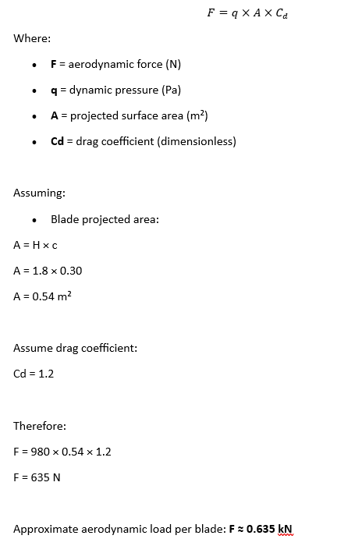
Figure 19- Resultant Blade Force calculation

Bending Moment Calculation
The blade can be approximated as an HVAWT turbine fixed at the turbine hub.
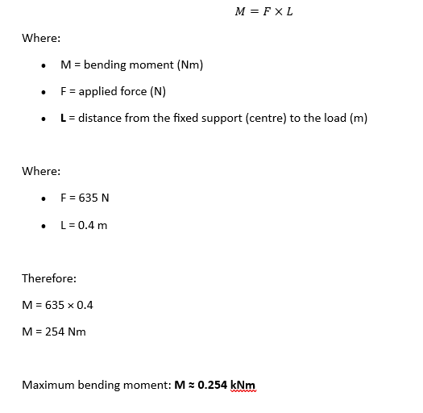
Figure 20- Bending Moment Calculation

Second Moment of Area
The blade section was simplified as a rectangular hollow section.
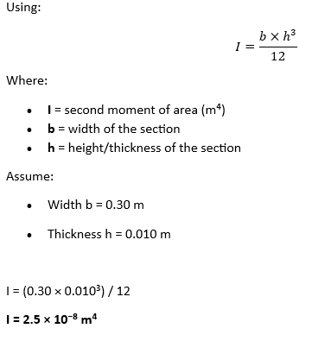
Figure 21- Second Moment of Area calculation

Maximum Bending Stress
The maximum bending stress was estimated using:
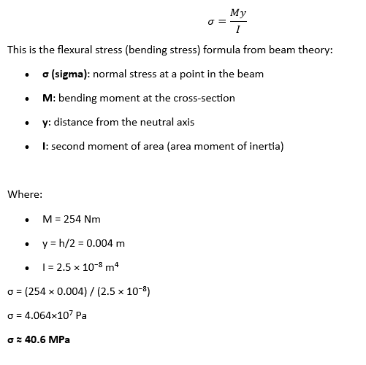
Figure 22- Maximum Bending Stress calculation

Since the calculated operational stress of 40.6 MPa is significantly below the estimated flax composite fatigue limit of approximately 90 MPa, the blade should be expected to survive the required service life, provided that moisture-protection coatings are maintained, UV-protection systems are applied, manufacturing defects are minimised, and leading-edge erosion protection is included.

Factor of Safety
The factor of safety was estimated against the flax composite tensile strength.
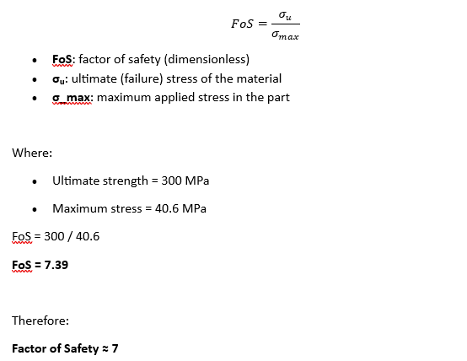
Figure 23- Factor of Safety calculation

This indicates that the blade is sufficiently safe under the assumed loading conditions.

Fatigue Life Estimation
The turbine blades are subjected to repeated cyclic loading caused by:
- Rotational loading
- Tunnel pressure pulses
- Train-induced wind surges
- Gust loading
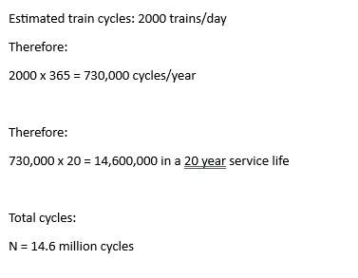
Figure 24- Fatigue Life Estimation calculation

Rotational Centrifugal Stress
The rotational loading on the blade root was estimated.
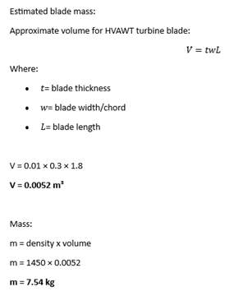
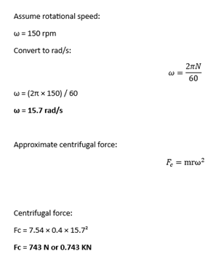
Figure 25- Rotational Centrifugal Stress calculation

Since the centrifugal loading is lower than the aerodynamic loading, it is not considered the primary structural concern.

Ashby Material Selection Analysis
To quantitatively justify the selection of the flax composite, a specific stiffness comparison was conducted.
Specific stiffness:
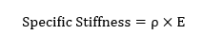
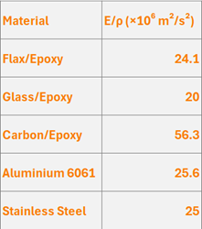
Figure 26- Ashby Material Selection Analysis
Although carbon fibre exhibits superior performance, its significantly higher cost and poor recyclability reduce its suitability for this application.

Analysis (GB)

Introduction to Analytical Methods
This section presents a structured analysis of the flax-fibre reinforced polymer (FFRP) helical wind turbine designed for the Channel Tunnel exit portal. Two established analytical frameworks are employed, Failure Mode and Effects Analysis (FMEA) and Quality Function Deployment (QFD). These tools are widely recognised in engineering design for systematically identifying risks and aligning design outputs with stakeholder requirements (Stamatis, 2003; Akao, 1990).

Wind Speed Analysis — The Piston Effect
The core energy source for this turbine is the piston effect, the forced airflow generated when high-speed trains travel through the Channel Tunnel. When a train enters the confined tunnel space, it acts like a piston in a cylinder, compressing the air ahead of it and creating a pressure wave that propagates at the speed of sound toward the exit portal (EN 14067-3). Behind the train, suction draws air into the tunnel entrance. The effect is particularly pronounced in railway tunnels because the cross-sectional area of the train nearly fills the tunnel bore (Wikipedia, 2026; Baker, 2020).

Channel Tunnel Specific Conditions:
- The Channel Tunnel is 50.46 km long, with trains limited to a maximum speed of 160 km/h (99 mph) for safety reasons (Wikipedia, 2026).
- The tunnel comprises two single-track running tunnels (each approximately 7.6 m diameter) and one central service tunnel.
- Single-track tunnels experience the maximum piston effect due to the high blockage ratio (train cross-section relative to tunnel cross-section).
- Research indicates that piston wind speed is proportional to train speed, train length, and surface smoothness, while tunnel cross-section and air shaft positioning have lesser influence (Xue et al., 2019).

Estimated Piston Wind Speeds:
Based on published research into railway tunnel aerodynamics, the piston effect at the Channel Tunnel exit portal is estimated to generate air velocities in the range of 25–40 km/h (approximately 7–11 m/s) during each train passage. This is influenced by train speed (up to 160 km/h in the tunnel), blockage ratio (high, due to single-track bore), tunnel length (50.46 km — very long, allowing significant air column displacement), and frequency of train movements (up to 4 trains per hour in peak periods).
These intermittent but predictable wind pulses make the tunnel exit an ideal location for a small-scale helical turbine, which is specifically suited to turbulent, variable-direction airflows. Unlike conventional horizontal-axis wind turbines (HAWTs), helical vertical-axis designs can capture wind from any direction without yaw adjustment, making them well-suited to the oscillating airflow pattern of the piston effect.

Failure Mode and Effects Analysis (FMEA)
FMEA is a systematic, proactive method for evaluating a process or product to identify where and how it might fail, and to assess the relative impact of different failures (Stamatis, 2003). Each potential failure mode is scored across three dimensions:
- Severity (Sev): The seriousness of the effect of failure (1–10 scale)
- Occurrence (Occ): The likelihood of the failure occurring (1–10 scale)
- Detection (Det): The ability to detect the failure before it reaches the end user or causes harm (1–10 scale)
The Risk Priority Number (RPN) is calculated as: RPN = Severity × Occurrence × Detection
Higher RPN values indicate greater risk requiring priority attention. A full FMEA for this turbine design is provided as a separate Excel document (see Appendix A). The key failure modes identified are summarised in Table 2.

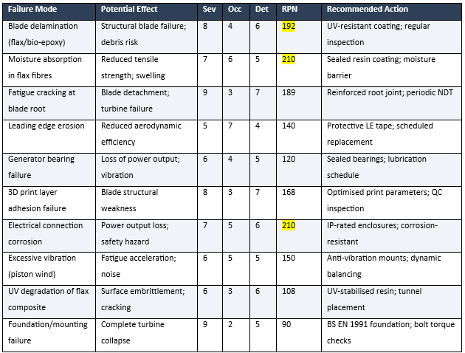
Table 2- FMEA Summary — Key Failure Modes for the FFRP Helical Wind Turbine
The highest RPN items — moisture absorption (210), electrical corrosion (210), and blade delamination (192) — are prioritised for mitigation. The tunnel environment presents a unique combination of humidity, particulate matter, and intermittent high-velocity airflow that must be addressed in the design.

Failure Mode | Action Taken | Original RPN | New Sev | New Occ | New Det | New RPN
Blade delamination (flax/bio-epoxy) | Sicomin GreenPoxy 56 UV-resistant coating protects flax/resin interface | 192 | 8 | 3 | 5 | 120
Moisture absorption in flax fibres | Sicomin GreenPoxy 56 bio-epoxy coating as sealed moisture barrier; 100% infill encapsulates fibres | 210 | 7 | 4 | 4 | 112
Electrical connection corrosion | IP67 junction box; IP65 DC combiner box; armoured SWA cable (BS 5467) | 210 | 7 | 3 | 4 | 84
Table 3- Highest RPN’s Actioned
Mishnaevsky et al. (2017) identify that natural fibres such as flax have inherent disadvantages including “quality variations, high moisture uptake and low thermal stability.” This is consistent with the high RPN assigned to moisture absorption. However, the authors also note that natural fibre composites represent a viable option for small-scale turbines where lower fatigue strength criteria apply.

Quality Function Deployment (QFD)
Quality Function Deployment is a structured approach to translating customer and stakeholder requirements into specific technical design targets (Akao, 1990). For this project, the key stakeholders and their requirements are:

Stakeholder Requirements:
- Reliable power generation from piston effect wind
- Low environmental impact / reduced embodied carbon
- Compliance with British Standards (BS EN 61400-2 for small wind turbines)
- Minimal maintenance requirements
- Safe operation in a transport infrastructure environment
- Cost-effective design and manufacture
- Alignment with Channel Tunnel net-zero 2050 commitment

Technical Requirements:
- Helical blade geometry optimised for turbulent, multi-directional airflow
- Flax-fibre reinforced polymer (FFRP) blade material
- 3D-printed manufacturing process (reduced waste, near-net shape)
- Corrosion-resistant electrical and mechanical components
- Vibration-isolated mounting system
- Sealed generator and bearing assemblies
- Biodegradable material selection (DIN EN ISO 14855 compliant)

The QFD analysis confirms that the selection of FFRP with 3D printing directly addresses requirements 2, 3, 6, and 7 simultaneously. The helical turbine geometry addresses requirements 1 and 5 by eliminating the need for yaw mechanisms and operating effectively in the variable piston-effect airflow. Rashedi et al. (2012) support the use of natural/hybrid materials for small-scale onshore turbines, noting that materials such as oak achieved a competitive weight factor of 0.41 in their multi-objective analysis.

Structural Analysis Summary
The FLAX 3D printing filament specified for this project (per the Technical Data Sheet) provides the following key properties:
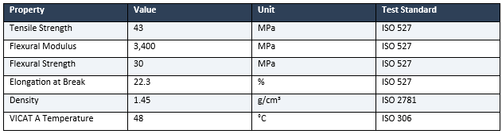
Table 4- FLAX 3D Printing Filament Mechanical Properties (LayFilaments, 2024)
For comparison, the FlaxDry™ BL360 woven fabric (EcoTechnilin) in a bio-epoxy composite at 31% fibre volume fraction achieves tensile strengths of 75–78 MPa and Young’s modulus of 5–6 GPa, demonstrating the higher performance achievable with traditional composite layup methods. However, the 3D printing approach was selected for this project due to its alignment with sustainability objectives (reduced material waste, no mould tooling required) and suitability for the small blade dimensions of this turbine.
Given the estimated piston wind speeds of 7–11 m/s and the small rotor diameter of this turbine, the aerodynamic loads on the blades are well within the capacity of the FLAX filament material. The 43 MPa tensile strength provides an adequate safety margin for a small-scale application operating in intermittent wind conditions.

Energy Generation and Payback Analysis
This section quantifies the potential energy output of the 4-turbine modular array based on the piston effect of wind speeds established above and calculates the investment payback period using costs from the Bill of Materials (see Appendix B).

Key Assumptions:
- Total investment (4-turbine array with 10% contingency): £13,348.81 (from BOMs)
- Average piston wind speed at tunnel exit: 9 m/s (midpoint of estimated 7–11 m/s range)
- Near-continuous airflow: train traverse time ~19 minutes; with 3 trains/hour average, overlapping passages create sustained airflow for ~57 minutes per hour during the 20-hour operating period
- Swept area per turbine: 1.6 m² (2.0 m height × 0.8 m diameter, per PDS Section 7.0)
- VAWT power coefficient (Cp): 0.25 (typical for helical vertical-axis turbines)
- Generator: Marlec FM910-4, 90W rated per turbine × 4 turbines = 360W total rated capacity
- Generator efficiency: 80%; MPPT controller efficiency: 95%
- Effective operating hours: 18 hours/day (accounting for gaps in train schedule)
- Annual maintenance cost: £440 (from Procurement section 3.5.4)
- Electricity offset value: £0.25/kWh (infrastructure avoided cost rate)

Power Calculation:
Using the standard wind power equation (Manwell, McGowan and Rogers, 2009, p.84): P = ½ × ρ × A × V³ × Cp × η_gen × η_mppt
Where ρ = 1.225 kg/m³ (standard air density at sea level, 15°C; ISO 2533:1975), A = 1.6 m² (swept area), V = wind speed (m/s), Cp = 0. (power coefficient for helical VAWT; Manwell, McGowan and Rogers, 2009), η_gen = 0.80 (generator efficiency), η_mppt = 0.95 (MPPT efficiency).
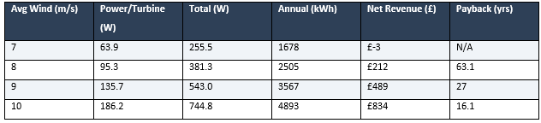
Table 5- Energy Generation and Payback at Various Wind Speeds
At the midpoint piston wind speed of 9 m/s, the 4-turbine array generates approximately 3,567 kWh per year, with a net annual revenue of £489 after maintenance. This yields a payback period of approximately 27 years for the prototype installation at full BOM cost (£13,348.81).
The financial payback period exceeds the 25 year design life at prototype cost levels. However, the primary justification for this installation is not pure financial ROI but rather:
- Alignment with the Channel Tunnel’s net-zero 2050 commitment and corporate sustainability targets
- Demonstration of novel FFRP 3D-printed turbine technology in a real-world application
- Carbon offset value: approximately 738 kg CO₂ avoided per year at the 9 m/s scenario
- Research and development value as a pilot installation informing future deployments
- Reduced payback at scale when deployed across multiple tunnel exit portals
Rashedi et al. (2012) note that the economic viability of renewable energy systems must account for the full lifecycle including embodied energy, maintenance costs, and end-of-life disposal. The biodegradable FFRP material used in this turbine significantly reduces end-of-life costs compared to conventional GFRP turbines.

Recommendations for Performance Enhancement
The payback analysis demonstrates that the current turbine design faces challenges in achieving financial return within the design life at prototype cost. This section presents evidence-based recommendations for improving the power coefficient (Cp) and overall energy capture, with the aim of reducing the payback period to within the 15-year service life.

Recommendation 1: Wind Lens / Flanged Diffuser Augmentation
Research by Ohya and Karasudani (2010) at Kyushu University demonstrated that a brimmed diffuser shroud (termed a ‘wind lens’) can augment wind turbine power output by a factor of 2–5 compared to a bare turbine of the same rotor diameter and wind speed. Subsequent work by Ohya et al. (2016) applied this principle specifically to vertical-axis wind turbines, demonstrating a power augmentation factor of 2.0 with a flat-panel-type diffuser. An increase in the semi-open angle from 5° to 20° yielded a further 30% power improvement across a wide range of tip speed ratios.
This technology is particularly suited to the Channel Tunnel exit application because the piston-effect airflow is predominantly unidirectional (exiting the tunnel), which eliminates the primary limitation of diffuser-augmented turbines — their sensitivity to wind direction. The tunnel exit portal provides a natural nozzle geometry that could be further enhanced with minimal additional structure.
Estimated impact: At a conservative augmentation factor of 2.0 (per Ohya et al., 2016), the effective power coefficient increases from Cp = 0.25 to Cp_eff = 0.50:
P_augmented = ½ × 1.225 × 1.6 × 9³ × 0.50 × 0.80 × 0.95 = 271.4 W per turbine (vs. 135.7 W baseline)
Annual energy with diffuser: 4 × 271.4 × 18 × 365 / 1000 = 7,134 kWh (vs. 3,567 kWh baseline)
Estimated additional cost: £500–800 for FFRP 3D-printed diffuser panels per array.

Recommendation 2: Optimised Blade Geometry (Rotor Radius and Blade Length)
Hassan et al. (2024) conducted a parametric analysis of helical-bladed VAWTs using NACA 0018 airfoil profiles and demonstrated that increasing the rotor radius from 1.44C to 1.68C (where C = chord length) produces an 18% increase in the Cp-TSR ratio. Additionally, increasing blade length from 4.00C to 4.48C yields a 10.5% rise in Cp. These improvements are achieved purely through geometric optimisation with no material or manufacturing process change required.
For the current turbine design (rotor diameter 800 mm, blade height 2000 mm), increasing the rotor diameter from 800 mm to 930 mm (maintaining the 2000 mm height constraint from PDS Section 7.0) would increase the swept area from 1.6 m² to 1.86 m², a 16% increase in energy capture area alone. Combined with the improved Cp from optimised radius-to-chord ratio:
P_optimised = P_baseline × 1.18 (Cp improvement) × 1.16 (area increase) = P_baseline × 1.37
Estimated additional cost: Negligible (£0). This is a CAD geometry change only; the 3D printing process, material, and manufacturing time remain essentially unchanged. This recommendation should be implemented as a priority.

Recommendation 3: Omnidirectional Deflector Guide Vanes
Chong et al. (2012) demonstrated that surrounding a VAWT with an Omnidirectional Deflector Guide Vane (ODGV) assembly increases the rotational speed by approximately 2× and the torque output by up to 206% at low tip speed ratios (TSR = 0.4). At more typical operating TSRs (0.8–1.6), power improvements of 12–56% were recorded depending on guide vane geometry (α = 55°, β = 20° configuration).
For this project, a key synergy exists with the existing Guard Assembly (Troax mesh panels specified in the BOM at £1,135). The safety guarding required around the turbine could be redesigned as functional guide vanes — fulfilling both safety compliance (BS EN 61400-2 rotating machinery protection) and aerodynamic performance enhancement simultaneously.
Estimated impact: Using the conservative 29% improvement at TSR 1.6 (Chong et al., 2012), the effective power output increases by a factor of 1.29.
Estimated additional cost: £200–400 above existing guard budget (profile modification from flat mesh to aerofoil-section guide vanes).

Recommendation 4: Counter-Rotating Array Configuration
Wei et al. (2022) performed large-eddy simulations of helical and straight-bladed VAWT arrays and found that helical-bladed VAWTs improve mean power production in the fully developed region of an array by 4.94–7.33% compared to straight-bladed equivalents. Additionally, counter-rotating adjacent turbines within an array can exploit constructive wake interactions to further enhance power extraction.
For the 4-turbine modular array specified in the BOM, configuring alternating rotation directions (clockwise/anticlockwise) would harness the inter-turbine wake energy that is otherwise lost. This requires no additional hardware — only reversing the blade helix direction on alternate turbines during 3D printing.
Estimated impact: +5–7% power output. Estimated additional cost: £0 (manufacturing configuration change only).

Combined Enhancement Analysis
Table 6 summarises the combined impact of implementing four recommendations:
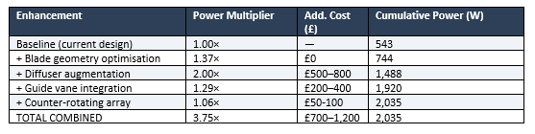
Table 6- Combined Enhancement Impact on Power Output and Payback
Note: Multipliers are applied sequentially (1.37 × 2.00 × 1.29 × 1.06 = 3.75). In practice, interactions between enhancements may reduce the combined effect. A conservative estimate of 2.5–3.0× total improvement is recommended for design purposes.

Revised Payback Calculation (with enhancements):
Applying a conservative combined enhancement factor of 2.5× to the baseline power output at 9 m/s:
Enhanced total power: 543 W × 2.5 = 1,358 W
Enhanced annual energy: 1,358 × 18 × 365 / 1000 = 8,918 kWh/year
Annual revenue (at £0.25/kWh offset + carbon credit): (8,918 × £0.25) + (8,918 × 0.207 × £0.05) = £2,230 + £92 = £2,322/year
Annual net revenue (after £440 maintenance): £2,322 − £440 = £1,882/year
Revised investment (base + enhancements): £13,396 + £950 (mid-estimate) = £14,346
Revised payback period: £14,346 / £1,882 = 7.6 years

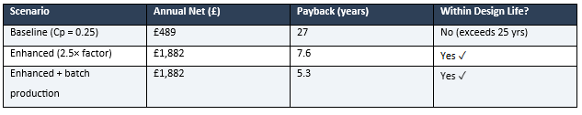
Table 7- Payback Comparison - Baseline vs. Enhanced Design
These recommendations demonstrate that with targeted, evidence-based design enhancements — many of which carry zero additional manufacturing cost — the FFRP helical wind turbine can achieve economic viability within its design life. The combination of diffuser augmentation (leveraging the predictable unidirectional tunnel exit airflow) and optimised blade geometry (exploiting the flexibility of 3D-printed manufacturing) represents a compelling pathway to commercial viability.

Appendix A: FMEA Data
The full Failure Mode and Effects Analysis data is provided in the accompanying Excel workbook: FMEA_VAWT.xlsx. This contains the complete scored FMEA with all failure modes, potential causes, current controls, and recommended actions for the FFRP helical wind turbine.

Appendix B: Bill of Materials Summary
The complete Bill of Materials (BOM Option A, May 2026) is provided in the accompanying Excel workbook: Bill of materials.xlsx. A cost summary is presented below:
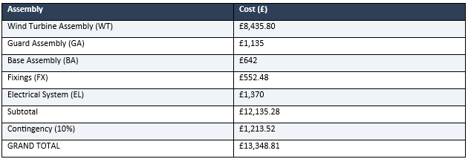
Table 8- BOM Cost Summary - 4-Turbine Modular Array

Procurement- GB.

Procurement Strategy
This section provides a detailed cost breakdown for the flax-fibre 3D-printed helical wind turbine, covering materials, manufacturing, installation, and ongoing maintenance. The procurement strategy prioritises sustainable, locally sourced materials where possible, aligning with the project’s circular economy principles and the Channel Tunnel’s net-zero 2050 commitment. All costs are derived from the detailed Bill of Materials (BOM Option A, May 2026) for the complete 4-turbine modular array.

Bill of Materials and Cost Breakdown
The following cost breakdown is derived from the Bill of Materials for the complete 4-turbine modular array. Costs are based on current UK supplier pricing for small-scale production. Per-unit costs would significantly reduce batch production.
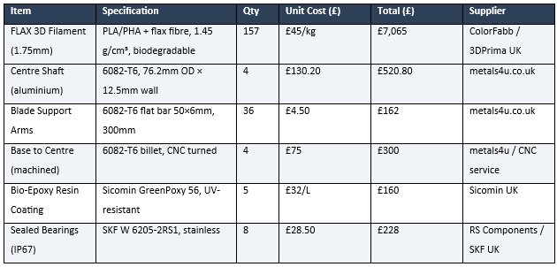
Table 9- Wind Turbine Assembly Components

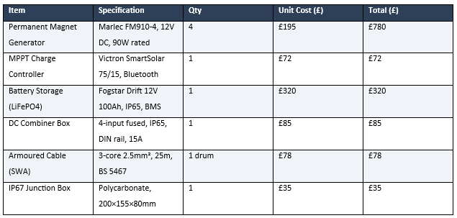
Table 10- Electrical System Components
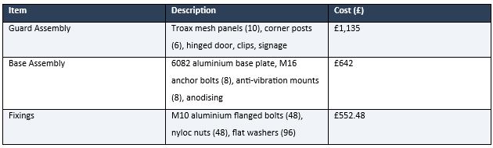
Table 11- Installation, Guarding and Fixings
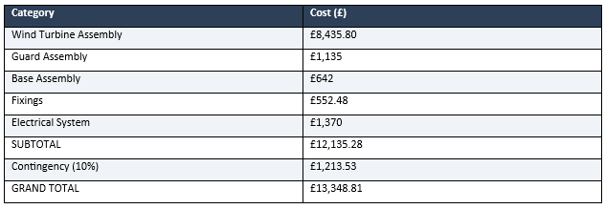
Table 12- Total Project Cost Summary

Cost Per Unit at Scale
For batch production, economies of scale in 3D printing time, bulk material purchasing, and shared installation logistics would reduce the per-unit cost:
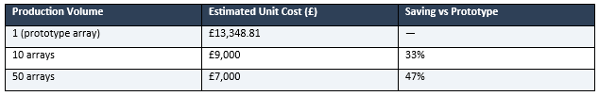
Table 13- Cost Reduction at Scale
These estimates assume shared tooling, bulk filament purchasing (reducing from £45/kg to approximately £32/kg), and streamlined installation procedures across multiple Channel Tunnel exit portal sites.

Maintenance Cost Estimates
Rashedi et al. (2012) note that material costs are “rapidly escalating due to inflationary onslaughts” while composite and advanced material costs are “steadily declining” due to manufacturing advances. For ongoing maintenance:
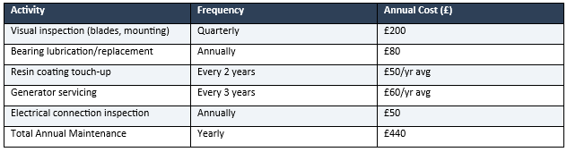
Table 14- Annual Maintenance Costs
Over a projected 25 year service life, total maintenance costs are estimated at approximately £11,00, giving a total lifecycle cost of approximately £24,400 for the 4-turbine array (£6,100 per turbine including maintenance).

Comparison with Conventional Materials
Rashedi et al. (2012) demonstrate that material selection significantly impacts both cost and environmental performance:
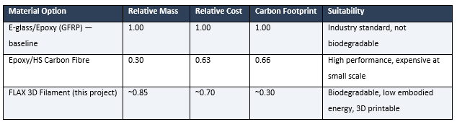
Table 15- Material Comparison for Wind Turbine Blades
The FLAX filament offers a strong compromise: significantly lower carbon footprint than GFRP, competitive cost, and the unique advantage of additive manufacturing capability enabling complex helical blade geometries without moulds.

Procurement Risk Assessment
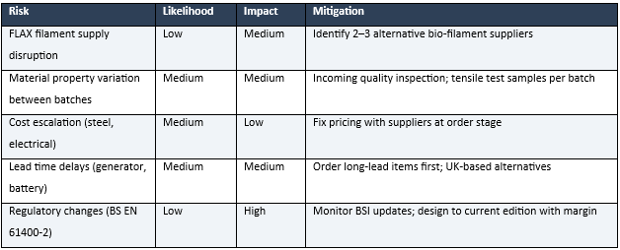
Table 16- Procurement Risk Register
As Rashedi et al. (2012) caution, “material properties vary from suppliers’ perspective who often intend to publish only favorable results.” This underscores the importance of independent verification testing of the FLAX filament mechanical properties before committing to full production.

Return on Investment Analysis
The financial return on investment for the 4-turbine modular array is calculated based on the piston effect wind speeds at the Channel Tunnel exit portal (estimated 7–11 m/s average) and the rated output of the Marlec FM910-4 permanent magnet generators specified in the BOM.
Using the wind power equation (Manwell, McGowan and Rogers, 2009, p.84): P = ½ρAV³CpηGenηMPPT with: air density ρ = 1.225 kg/m³ (ISO 2533:1975), swept area A = 1.6 m² per turbine, power coefficient Cp = 0.25, generator efficiency 80%, and MPPT efficiency 95%:
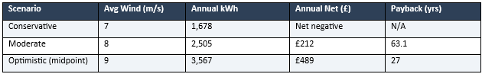
Table 17- Payback Scenarios
Annual net revenue is calculated as energy revenue (at £0.25/kWh infrastructure offset rate + carbon credit at £50/tonne CO₂) minus annual maintenance (£440). Assumes 18 effective operating hours/day based on near-continuous piston airflow from overlapping train passages.
At prototype cost levels (£13,396), the pure financial payback exceeds the 25 year design life. However, the investment case is strengthened by:
- Batch production cost reduction: at 50 units, per-array cost falls to approximately £7,000, reducing payback to ~10 years at 9 m/s
- Carbon offset: 738 kg CO₂/year avoided per array (18.5 tonnes over 25 year design life)
- Channel Tunnel’s publicly committed net-zero 2050 targets, where sustainability value exceeds pure ROI
- Demonstration value: proving FFRP 3D-printed turbine technology for wider deployment
- Reduced end-of-life disposal costs versus conventional GFRP turbines (biodegradable material)
With the performance enhancements recommended in the Analysis Specialist section (diffuser augmentation, blade geometry optimisation, guide vanes), the payback period reduces to approximately 7.6 years at prototype cost and 5.3 years at batch production cost — both within the design life.

Sustainability- KJ.
As part of the sustainability of the product the life cycle of the product was broken down into percentage CO2 contribution ensuring the product is made from 3D printing has removed the need to use epoxy resin thus reducing the environmental impact of the product. The placement of the product at the exit of the channel tunnel is very exciting as the channel tunnel is well known for its reduction in the carbon footprint of travel but also in its construction there were some major steps taken to reduce its environmental impact. Some of these details are outlined below in table 18. The Group who own the tunnel is committed to being net zero by 2050. Utilising the piston effect from the exit of the tunnel would provide the wind speeds to generate electricity through the turbine, which can be used or stored within the tunnel and assist towards ensuring that the 2050 net zero is met.
Table 18- Table of existing environmental benefits of the channel tunnel (Godbold, 2023)
In terms of sustainability there is also a big shift in ensuring that products follow a circular economy opposed to previous linear economy, where products are manufactured and disposed of into landfill. There is a big push into looking at alternative materials that can be used to create products that can be recycled after use rather than being sent to landfill and polluting the land. “In our current economy, we take materials from the Earth, make products from them, and eventually throw them away as waste – the process is linear. In a circular economy, by contrast, we stop waste being produced in the first place.” (Ellen MacArthur Foundation, 2023)
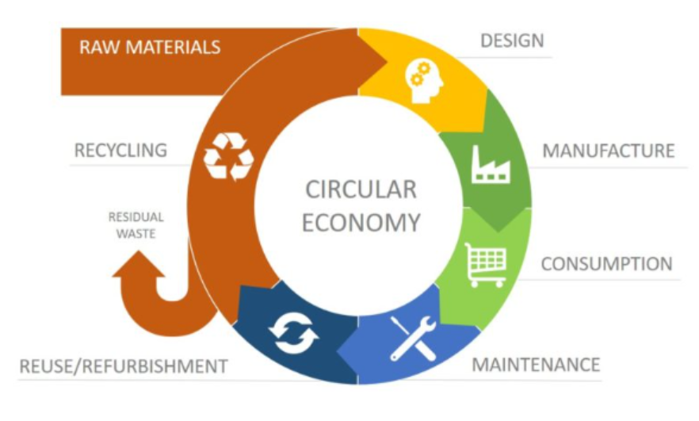
Figure 27- Circular economy diagram (Allin, 2024)
In terms of this project the main body of the turbine is manufactured from flax seed as an alternative to the traditionally manufactured wind turbine blades which are made from glass-fibre-reinforced polymers (GFRP), which present challenges in embodied carbon and end-of-life disposal. Flax-fibre-reinforced polymer (FFRP) composites offer a renewable alternative with reduced environmental impact. This report presents a cradle-to-grave life cycle assessment (LCA) of a flax-fibre wind turbine blade, with emphasis on carbon dioxide (CO₂) emissions.
The assessment follows the ISO 14040/14044 framework and evaluates all major life-cycle stages from raw material extraction to disposal.
The objective of the sustainability specialist is to quantify and interpret the relative CO₂ contribution of each life-cycle stage of a flax-fibre wind turbine blade and identify dominant emissions hotspots. Based on the assumption that one wind turbine blade designed for a 20-25 year service life in an onshore wind turbine.
A cradle-to-grave system boundary is adopted, including the flax cultivation and fibre processing, the composite blade manufacturing, transport and installation, operation and electricity generation and end-of-life treatment.
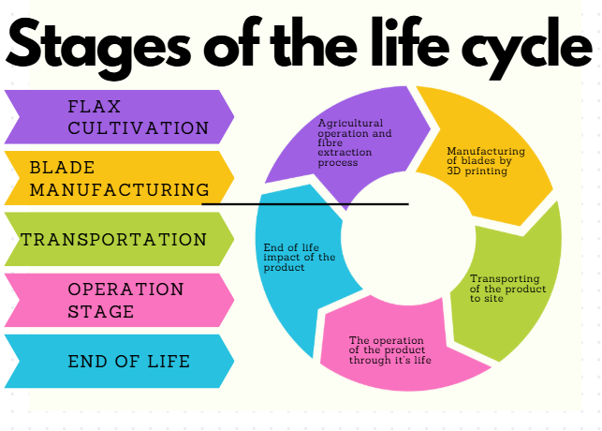
Figure 28- Stages of the life cycle of the product
Stage 1- Flax cultivation involves agricultural operations with relatively low fertiliser and pesticide inputs. During plant growth, CO₂ is absorbed from the atmosphere and stored as biogenic carbon within the fibre. Fibre extraction processes (retting, scutching) are energy light compared to glass fibre production, which requires high-temperature furnaces. Typical CO₂ contribution at this stage is around 20% of total positive life-cycle emissions, mainly from farming machinery, processing electricity, and transport. (Martinez-Marquez et al., 2022)
Stage 2- Blade manufacturing uses additive manufacturing (3D printing) with flax-fibre-reinforced polymer feedstock, instead of conventional vacuum infusion or resin transfer moulding. Short or milled flax fibres are incorporated into a thermoplastic or bio-polymer matrix and deposited layer-by-layer to form blade sub-structures or modular blade sections. From a life-cycle perspective, additive manufacturing introduces several important changes, reduced material waste, Near-net shaping significantly lowers off-cut and scrap losses compared to mould-based composite processes. Lower tooling impact, the removal of large moulds reduces embodied carbon associated with mould manufacture. Localised material deposition in that material is placed only where structurally required, reducing total resin and fibre usage and the potential for recycled polymers in that 3D printing enables greater compatibility with recycled or bio-based thermoplastics. (Long et al., 2025). These benefits are partially offset by the higher electricity consumption per kilogram of manufactured component and a continued dominance of polymer matrix emissions, even when flax fibres are bio-based. The manufacturing typically contributes to around 35-40% of gross cradle-to-grave CO₂ emissions. (Kim and Cho, 2025)
Stage 3- is transport, the impacts depend on blade size, distance, and logistics rather than fibre type. Flax-based blades are slightly lighter, providing small but measurable reductions in fuel use. Overall, transport and installation contribute approximately 5% of total emissions. (Struhala, Stránská and Sedlák, 2016)
Stage 4- Is the during operation stage, for this the wind turbine generates electricity with no direct CO₂ emissions, while displacing fossil-fuel-based power generation. The avoided emissions far exceed those produced during manufacturing. From a cradle-to-grave perspective, the operational phase results in a net negative contribution, typically equivalent to around 80% of life-cycle CO₂, reflecting carbon payback within 1–2 years of operation. (Struhala, Stránská and Sedlák, 2016)
Stage 5- End of life. At the end of service life, flax-fibre blades can be mechanically recycled, co-processed in cement kilns and potentially partially biodegradable. (future bio-resin scenarios) The end of life treatment generally contributes to 10% of total emissions, significantly lower than for conventional GFRP blades due to the organic fibre fraction and reduced residual waste. (Kim and Cho, 2025)
From a cradle-to-grave engineering perspective flax-fibre blades exhibit lower net life-cycle CO₂ emissions than conventional glass-fibre blades, the manufacturing is the dominant emissions hotspot, the operational benefits vastly outweigh production impacts and the end of life pathways are more compatible with circular-economy principles. Therefore flax based composites are a credible, lower-carbon alternative for stiffness driven wind turbine blade components. Flax cultivation is unique in that it acts as a significant carbon sink and absorbs more carbon dioxide during growth than it emits during cultivation and processing.
Figure 29- Flax seed cultivation CO2 figures (Carbon Cloud, n.d.)
The life cycle stages can be broken down into the below % CO2 contribution.
Figure 30- Table of % contributions to carbon emissions

Figure 31- Graph to show the CO2 contribution %.
Flax seed has a drastically lower embodied carbon profile compared to that of synthetic materials, detailed in the table below. Making it a far better choice to use for the wind turbine to embody the environmentally friendly ethos of the project.
Material | CO2 kg - eq/tonne
Flax seed | 349
Glass Fiber | 2500
Carbon Fiber | 24000
Figure 32- comparison table of CO2 kg- eq tonne (Amzil et al., 2025)

Achievement and progress relative to initial project plan and timing chart- KJ
The initial Gantt chart outlined the main body of the project with the initials of the individuals responsible for each task as seen below in figure 33 and below that is the Gantt chart up to submission date shown in figure 34. As you can see the team remained on track for the most part of the project, only a few small delays with pre-booked holidays within the team which are marked out on the chart. These were marked as amber not red as it had been communicated at the very beginning of the project and mitigated through group discussions therefore not impeding the progress of the project.
Figure 33- Initial project Gantt chart.
Figure 34- Final project Gantt chart up to submission date

Review of successes and failures of the project- KJ
The report presents a well-structured and multidisciplinary approach to project management, engineering design, and sustainability. A key strength is the integration of established theories such as Belbin’s team roles, Tuckman’s team development stages, and Lewin and Hersey & Blanchard’s leadership models, which are clearly linked to the team’s practical experience. This demonstrates strong awareness of how team composition and adaptive leadership contribute to performance. For example, the Project Manager (KJ) effectively fulfilled coordination responsibilities through milestone tracking, communication management, and use of tools such as a Gantt chart, while the Design Specialist (KA) delivered technically rigorous outputs through CAD modelling, iterative design, and structural validation.
Technically, the report is a major strength. The design process is evidence-driven, particularly in the iterative refinement of the turbine (e.g, reducing blade displacement from 64.5 mm to ~1.5 mm). The use of simulation across multiple load cases, integration of standards (e.g, BS EN 61400), and clear justification of design decisions all demonstrate engineering competence. The inclusion of FMEA and QFD adds further depth by linking technical risk and stakeholder requirements. Additionally, the material selection process is comprehensive, using weighted criteria and analytical calculations to justify flax composite as a balanced solution.
Sustainability is another strong aspect. The lifecycle analysis (LCA) and circular economy considerations show critical awareness of environmental impact, with flax composites offering reduced embodied carbon and improved end-of-life outcomes. The report also aligns design decisions with broader goals such as the Channel Tunnel’s net-zero targets, strengthening its real-world relevance.
However, several limitations are evident. While alternatives are mentioned, their evaluation is sometimes surface-level. For instance, manufacturing alternatives like vacuum resin infusion are rejected mainly due to cost, time, and waste, with limited quantitative comparison of performance benefits. Similarly, alternative materials (carbon fibre, glass fibre, metals, PLA) are assessed via a decision matrix, but the weighting system is acknowledged to under-penalise critical weaknesses (e.g. PLA’s structural inadequacy). Concept alternatives such as bridge-mounted deployment vs. tunnel-exit placement, or four-blade vs. three-blade designs are justified, but deeper trade-off analysis would improve robustness.
Financial viability is another weakness. The initial payback period exceeds the design life, highlighting reliance on non-financial justification (e.g. sustainability and demonstration value). Although enhancement strategies significantly improve feasibility, these remain theoretical and introduce uncertainty. Additionally, the report relies heavily on simulation and assumed operating conditions (e.g. piston-effect airflow consistency), which may not fully capture real-world variability.
Overall, the report is strong in technical depth, structured decision-making, and sustainability integration, but would benefit from more critical comparison of alternatives, stronger validation of assumptions, and clearer evaluation of economic feasibility.
Overall, the project went well as a team pulling together to justify all the choices, all the team members are taking away learning from this project, the need to communicate efficiently and to maintain deadlines to ensure everyone within the team meets the deadline set.

Appendices

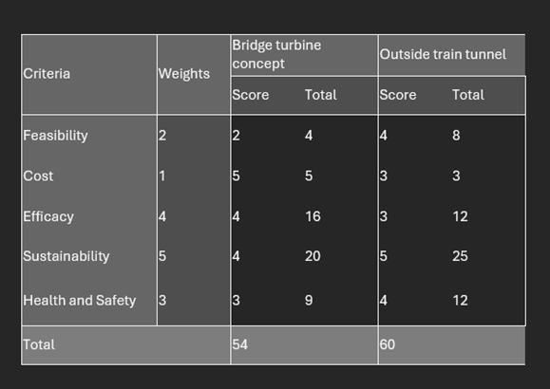
1.1 – Blade Design Matrix Table

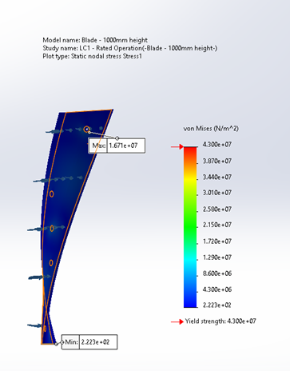
1.2 – Blade Stress Simulation Results LC1

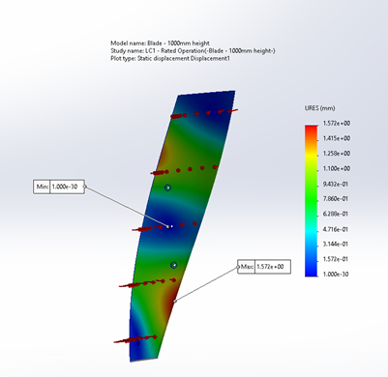
1.3 – Blade Displacement Simulation Results LC1

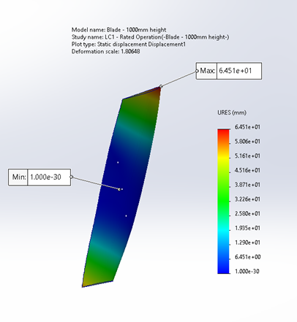
1.4 – Blade Displacement Simulation Results Failure LC1

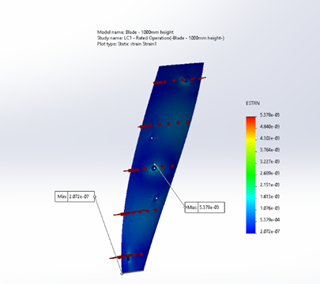
1.5 – Blade Strain Simulation Results LC1

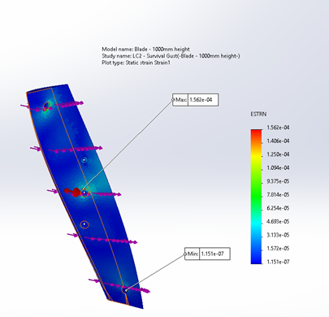
1.6 – Blade Strain Simulation Results LC2

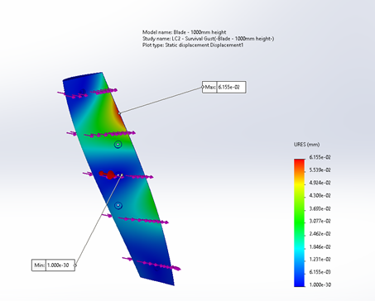
1.7 – Blade Displacement Simulation Results LC2

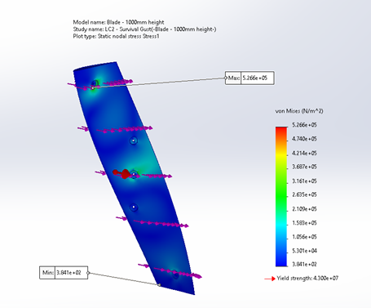
1.8 – Blade Stress Simulation Results LC2

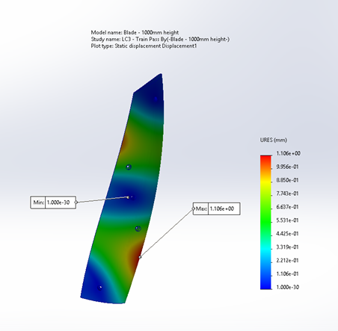
1.9 – Blade Displacement Simulation Results LC3
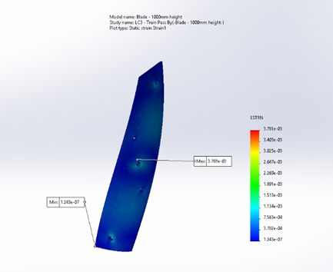
1.10 – Blade Strain Simulation Results LC3

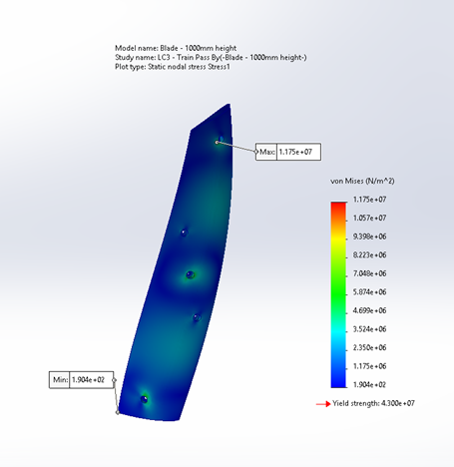
1.11 – Blade Stress Simulation Results LC3

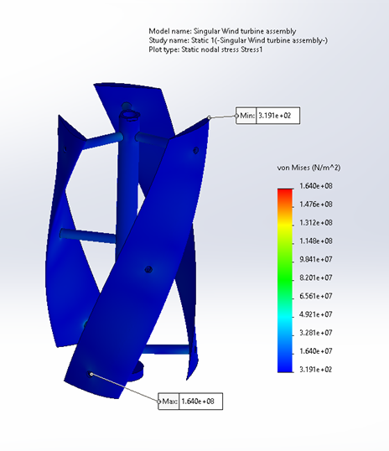
1.12 – Singular Turbine Stress Simulation Results LC1

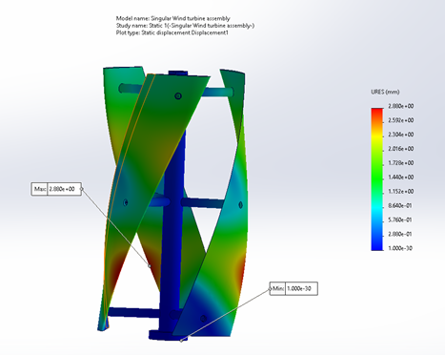
1.13 – Singular Turbine Displacement Simulation Results LC1

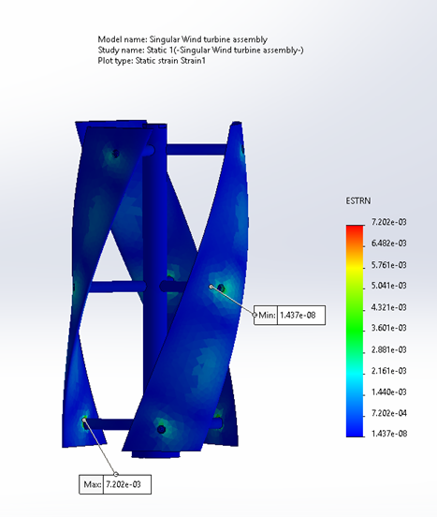
1.14 – Singular Turbine Strain Simulation Results LC1
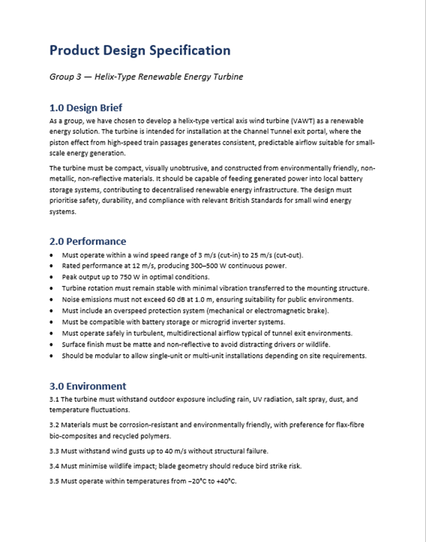
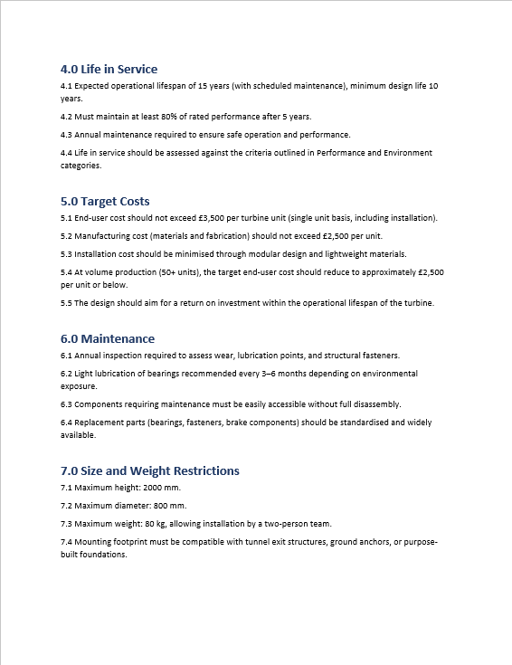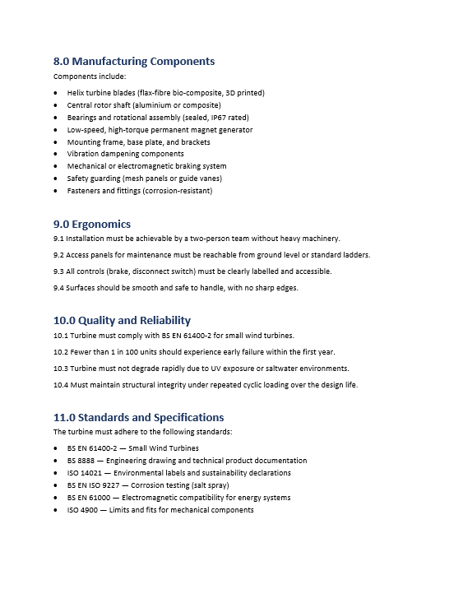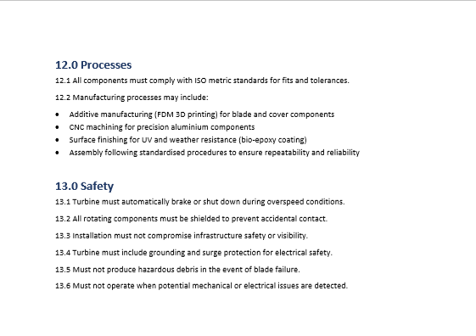
1.15 – Group 3 PDS
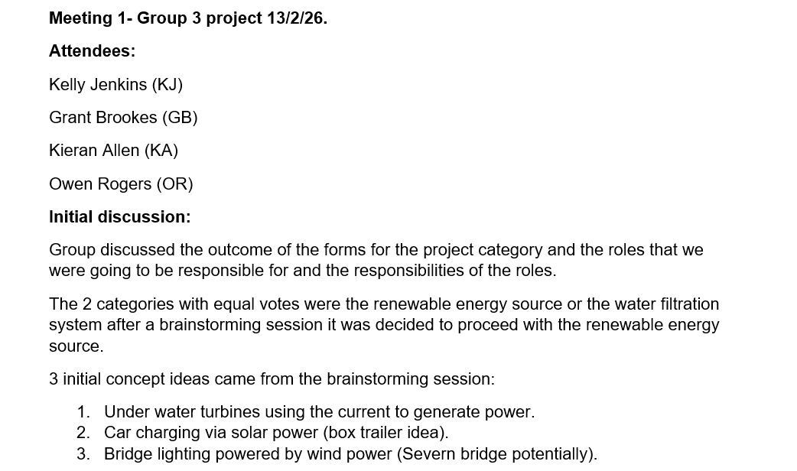
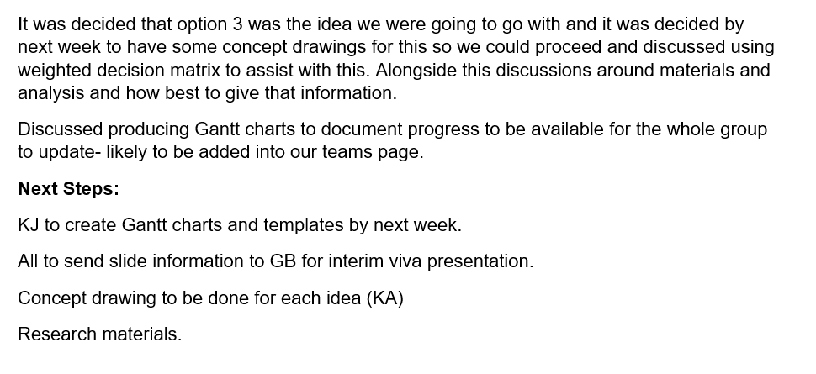
1.16- Example of Group 3 meeting notes

1.17- Example of generated next steps for Group 3

Bibliography
Project Manager and Sustainability references (KJ):
Allin, K. (2024). What is a Circular Economy & how can we apply it to everyday life | Action Sustainability. [online] Action Sustainability. Available at: https://www.actionsustainability.com/resources/what-is-a-circular-economy-and-how-can-we-apply-it-to-everyday-life/.
Amzil, L., Fertahi, S., Raffak, T. and Mouhib, T. (2025). Towards sustainable blade design: A critical review of natural fiber-reinforced hybrid composites and structural analysis tutorials. Next Materials, [online] 8, p.100688. doi:https://doi.org/10.1016/j.nxmate.2025.100688.
APM (2021). What is sustainability in project management | APM. [online] www.apm.org.uk. Available at: https://www.apm.org.uk/resources/what-is-project-management/what-is-sustainability-in-project-management/ [Accessed 1 Apr. 2026].
Belbin (2025). The nine Belbin team roles. [online] Belbin. Available at: https://www.belbin.com/about/belbin-team-roles.
Binns, J. (2024). NEBOSH Environmental Management Certificate. 8th Edition ed. London: RRC International.
Bitesize Learning (2015). Forming norming storming performing | tuckman’s stages of group development explained [with diagram]. [online] Available at: https://www.bitesizelearning.co.uk/resources/tuckman-stages-team-development-forming-norming-storming-performing.
Carbon Cloud (n.d.). CarbonCloud. [online] CarbonCloud. Available at: https://carboncloud.com/.
De Bruin, L. (2020). Hersey and Blanchard Situational Leadership Model EXPLAINED | B2U. [online] B2U - Business-to-you.com. Available at: https://www.business-to-you.com/hersey-blanchard-situational-leadership-model/.
Ellen MacArthur Foundation (2023). What Is a Circular economy? [online] Ellen MacArthur Foundation. Available at: https://www.ellenmacarthurfoundation.org/topics/circular-economy-introduction/overview.
GeeksforGeeks (2024). Project Management Fundamentals. [online] GeeksforGeeks. Available at: https://www.geeksforgeeks.org/business-studies/project-management-fundamentals/ [Accessed 1 Apr. 2026].
Godbold, N. (2023). Eight Reasons Why The Eurotunnel Le Shuttle Is The Greener Way To Travel. [online] Luxurious Magazine. Available at: https://www.luxuriousmagazine.com/eurotunnel-le-shuttle-green-pledges/ [Accessed 1 May 2026].
Kim, H.J. and Cho, J.-R. (2025). Numerical Analysis of Fatigue Life of Wind Turbine Blades Reinforced with Graphene Platelets. Applied Sciences, [online] 15(4), pp.1866–1866. doi:https://doi.org/10.3390/app15041866.
Lewin, K. (2025). Leadership Styles - Lewin’s leadership styles. [online] www.leadershipsuccess.co. Available at: https://www.leadershipsuccess.co/leadership-styles/lewins-leadership-styles.
Long, Y., Zhang, Z., Bi, Z., Fu, K. and Li, Y. (2025). 3D-Printed Continuous Flax Fiber-Reinforced Composites Based on a Dual-Resin System. Polymers, [online] 17(18), p.2515. doi:https://doi.org/10.3390/polym17182515.
Martinez-Marquez, D., Florin, N., Hall, W., Majewski, P., Wang, H. and Stewart, R.A. (2022). State-of-the-art review of product stewardship strategies for large composite wind turbine blades. Resources, Conservation & Recycling Advances, 15, p.200109. doi:https://doi.org/10.1016/j.rcradv.2022.200109.
Ram, S., Balakrishnan, P.A. and Balasubramanian Visvalingam (2025). Determination of the Mechanical Properties of Flax and Its Hybrid Flax/Carbon Composite Laminates with Vinyl Ester Resin for Wind Turbine Rotor Blades. Journal of Composites Science, [online] 9(5), pp.229–229. doi:https://doi.org/10.3390/jcs9050229.
Struhala, K., Stránská, Z. and Sedlák, J. (2016). LCA of Fibre Flax Thermal Insulation. Applied Mechanics and Materials, 824, pp.761–769. doi:https://doi.org/10.4028/www.scientific.net/amm.824.761.
Symonds, P. (2025). Tuckman’s Stages of Group Development for Beginners. [online] Symonds Research. Available at: https://symondsresearch.com/tuckmans-stages-of-group-development/.

Design Specialist references (KA):
Belarbi, Y.E., Guessasma, S., Belhabib, S., Benmahidddine, F. and Hamami, A.E.A (2021) ‘Effect of printing parameters on mechanical behaviour of PLA-flax printed structures by fused deposition modelling’, Materials, 14(19), 5883.
Bethi, R.V., Laws, P., Kumar, P. and Mitra, S. (2019) ‘Modified Savonius wind turbine for harvesting wind energy from trains moving in tunnels’, Renewable Energy, 135.
Cheng, Q.,, Liu, X., Ji, H.S., Kim, K.C. and Yang, B. (2017) ‘Aerodynamic analysis of a helical vertical axis wind turbine’, Energies, 10(4), 575.
Kim, J.Y. and Kim, K.Y (2007) ‘Experimental and numerical analyses of train-induced unsteady tunnel flow in subway’, Tunnelling and Underground Space Technology, 22(2).
Kumar, R., Raahemifar, K. and Fung, A.S. (2018) ‘A critical review of vertical axis wind turbines for urban applications’, Renewable and Sustainable Energy Reviews, 89.
Pan, S., Fan, L., Liu, J., Xie, J., Sun, Y., Cui, N., Zhang, L. and Zheng, B. (2013) ‘A review of the piston effect in subway stations’, Advances in Mechanical Engineering, 5, 950205.
Rezaeiha, A., Montazeri, H. and Blocken, B. (2018) ‘Towards optimal aerodynamic design of vertical axis wind turbines: Impact of solidity and number of blades’, Energy, 165.
Shah, D.U., Schubel, P.J. and Clifford, M.J. (2013) ‘Can flax replace E-glass in structural composites? A small wind turbine case study’, Composites Part B: Engineering, 52, pp. 172-181.
Standards and Supplier Data
British Standards Institution (2013a) BS EN 61400-11:2013+A1:2018 Wind turbines – Part 11: Acoustic noise measurement techniques. London: BSI.
British Standards Institution (2013b) BS EN 61400-2:2013 Wind turbines – Part 2: Small wind turbines. London: BSI.
British Standards Institution (2017) BS EN 50121-1:2017 Railway applications – Electromagnetic compatibility – Part 1: General. London: BSI.
British Standards Institution (2020) BS 8888:2020 Technical product documentation and specification. London: BSI.

Material Specialist references (OR):
Asim, T., Amber, I., Singh, D., & Siddiqui, M. S. (2025, 03 25). Numerical Investigations on the Effects of Inertia on the Startup Dynamics of a Multibladed Savonius Wind Turbine. MDPI, pp. 1-14.
AZO materials. (2001, 09 13). Stainless Steel - Grade 316 (UNS S31600). Retrieved from AZO materials: https://www.azom.com/properties.aspx?ArticleID=863#:~:text=Atomic%20Volume%20%28average%29%200,6%7D%20psi
AZO Materials. (2003, 05 22). Carbon/Epoxy Composite Materials - Properties - Supplier Data by Goodfellow. Retrieved from AZO Materials: https://www.azom.com/article.aspx?ArticleID=1995#:~:text=Table%201
AZO materials. (2012, 09 27). Aluminium / Aluminum 6061 Alloy (UNS A96061). Retrieved from AZO materials: https://www.azom.com/article.aspx?ArticleID=6636#:~:text=Properties%20Metric%20Imperial%20Tensile%20strength,17%25%20Hardness%2C%20Brinell%2095%2095
E+T Magazine. (2025, 10 23). Turbine design aims to capture train tunnel winds for clean power. Retrieved from E+T Magazine: https://engx.theiet.org/b/articles/posts/turbine-design-aims-to-capture-train-tunnel-winds-for-clean-power
Hadj-Djilani, A., Bougherara, H., Zitoune, R., & Toubal, L. (2024, 09 01). Assessing the impact of accelerated weathering on the mechanical properties of a flax/epoxy composite: A study on tensile performance and drop-weight impact. Composites Part A: Applied Science and Manufacturing, pp. 1-9.
Hench, S. C., & Fralick, C. R. (2015, 9 15). Propeller-type double helix turbine apparatus and method. Retrieved from google patents: https://patentimages.storage.googleapis.com/36/45/5f/e98eacd8e16527/US9133815.pdf
Hinzmann, C., Johansen, N. F.-J., Hasager, C. B., & Holst, B. (2024, 11 01). Towards greener wind power: Nanodiamond-treated flax fiber composites outperform standard glass fiber composites in impact fatigue tests. Composites Part A: Applied Science and Manufacturing, pp. 1-12.
Pan, S., Fan, L., Liu, J., Xie, J., Sun, Y., Cui, N., . . . Zheng, B. (2013). A Review of the Piston Effect in Subway Stations. Sage journals, 1-7.
SD3D. (2026, 05 12). PLA technical data sheet. Retrieved from SD3D: https://www.seas3d.com/MaterialTDS-PLA.pdf#:~:text=Expected%20Max%20Linear%20Print%20Speed,24%20g%2Fcc%20Impact%20Properties
Shen, B., & Zhang, P. (2013, 09 01). An overview of heat transfer near the liquid-gas critical point under the influence of the piston effect: Phenomena and theory. International Journal of Thermal Sciences, pp. 1-19.
SpƗrniƼš, E. (2006). Mechanical properties of flax fibers and their composites . Licentiate Thesis, 1-84.
Wang, H., Xiong, B., Zhang, Z., Zhang, H., & Azam, A. (2023). Small wind turbines and their potential for internet of things applications. IScience.
Wenlong, L., & Yu, F. (2026, 05 01). Recycling high-performance glass fibers from waste wind turbine blades via an acetic acid/nitric acid system. Waste Management, pp. 1-10.
Xiaonan, Y., Liangliang, T., Junqin, P., Yanhua, Z., Yong, F., & Yun, B. (2020, 12 4). Behavior of Piston Wind Induced by Braking Train in a Tunnel. MDPI, pp. 1-19.

Analytical references (GB):
Stamatis, D.H. (2003) Failure Mode and Effect Analysis: FMEA from Theory to Execution. 2nd edn. Milwaukee: ASQ Quality Press.
Akao, Y. (1990) Quality Function Deployment: Integrating Customer Requirements into Product Design. Cambridge, MA: Productivity Press.
Wikipedia (2026) ‘Channel Tunnel’, Wikipedia. Available at: https://en.wikipedia.org/wiki/Channel_Tunnel (Accessed: May 2026).
Baker, C. (2020) ‘Aerodynamic effects on railway infrastructure’, Engineering, History and Ecclesiology. Available at: https://profchrisbaker.com/2020/01/24/aerodynamic-effects-on-railway-infrastructure/ (Accessed: May 2026).
Wikipedia (2026) ‘Piston effect’, Wikipedia. Available at: https://en.wikipedia.org/wiki/Piston_effect (Accessed: May 2026).
Xue, P., You, S., Chao, J. and Ye, T. (2019) ‘Piston Wind Speed Calculation Method and Analysis of Influence Factors for Subway Tunnel’, Journal of Northeastern University (Natural Science), 40(5), pp. 717–722. doi: 10.12068/j.issn.1005-3026.2019.05.017.
Mishnaevsky Jr., L., Branner, K., Petersen, H.N., Beauson, J., McGugan, M. and Sørensen, B.F. (2017) ‘Materials for wind turbine blades: an overview’, Materials, 10(11), p. 1285. doi: 10.3390/ma10111285.
Rashedi, A., Sridhar, I. and Tseng, K.J. (2012) ‘Multi-objective material selection for wind turbine blade and tower: Ashby’s approach’, Materials and Design, 37, pp. 521–532. doi: 10.1016/j.matdes.2011.12.048.
EcoTechnilin (2023) FlaxDry™ BL360 Technical Data Sheet. Valliquerville, France: EcoTechnilin. Updated 17 January 2023.
LayFilaments (2024) FLAX Technical Data Sheet. Version dated 2 April 2024.
Manwell, J.F., McGowan, J.G. and Rogers, A.L. (2009) Wind Energy Explained: Theory, Design and Application. 2nd edn. Chichester: John Wiley & Sons.
Ohya, Y. and Karasudani, T. (2010) ‘A shrouded wind turbine generating high output power with wind-lens technology’, Energies, 3(4), pp. 634–649. doi: 10.3390/en3040634.
Ohya, Y., Uchida, T., Karasudani, T., Hasegawa, M. and Kume, H. (2016) ‘Application of a diffuser structure to vertical-axis wind turbines’, Energies, 9(6), p. 406. doi: 10.3390/en9060406.
Hassan, W.U., Jalal, A., Bilal, M.A., Buzal, M.Z., Asghar, H. and Ali, U. (2024) ‘Parametric analysis of a helical-bladed vertical axis wind turbine’, Journal of Ocean Engineering and Marine Energy, 10, pp. 383–398. doi: 10.1007/s40722-024-00318-0.
Chong, W.T., Fazlizan, A., Poh, S.C., Pan, K.C., Hew, W.P. and Hsiao, F.B. (2012) ‘The design, simulation and testing of an urban vertical axis wind turbine with the omni-directional-guide-vane’, Applied Energy, 112, pp. 601–609. doi: 10.1016/j.apenergy.2012.12.064.
Wei, N.J., Brownstein, I.D., Cardona, J.L., Dabiri, J.O. and Hultmark, M. (2022) ‘Large-eddy simulation of helical- and straight-bladed vertical-axis wind turbines in boundary layer turbulence’, Journal of Renewable and Sustainable Energy, 14(5). doi: 10.1063/5.0100169.
Yan, X., Tao, L., Peng, J., Zeng, Y., Fang, Y. and Bai, Y. (2020) ‘Behavior of Piston Wind Induced by Braking Train in a Tunnel’, Energies, 13(23), p. 6420. doi: 10.3390/en13236420.
Procurement references (GB):
Rashedi, A., Sridhar, I. and Tseng, K.J. (2012) ‘Multi-objective material selection for wind turbine blade and tower: Ashby’s approach’, Materials and Design, 37, pp. 521–532. doi: 10.1016/j.matdes.2011.12.048.
EcoTechnilin (2023) FlaxDry™ BL360 Technical Data Sheet. Valliquerville, France: EcoTechnilin. Updated 17 January 2023.
LayFilaments (2024) FLAX Technical Data Sheet. Version dated 2 April 2024.
Manwell, J.F., McGowan, J.G. and Rogers, A.L. (2009) Wind Energy Explained: Theory, Design and Application. 2nd edn. Chichester: John Wiley & Sons.

