Richard Askham
ACBA 5010
Management of Sustainable Construction
13/02/2020

Contents
An Introduction to Hydropower. 3
Types of Hydroelectricity Generation. 3
The Construction of a Hydroelectricity Plant. 4
Dam construction details 4
Environmental Impact of Hydroelectricity. 6
Hydroelectricity Generation as part of a Sustainable Future. 8
Conclusion. 9

Figure 1; Taken from the International Hydropower Association 2019 report. 10
Figure 2; Taken from the International Hydropower Association 2019 report. 10

An Introduction to Hydropower.
Hydropower is a term used to describe the capture or generation of energy from falling water, (Twidell J, 2015) the energy created is usually electricity but it has been used extensively in the past to power mechanical equipment and processes.

Types of Hydroelectricity Generation.
(International Hydropower Association, 2019) explains the four main methods of electricity generation by hydropower these are;
- Storage Hydropower: this is probably the most readily identifiable system to many people as this system uses water which is stored behind a manmade barrier such as a dam. Electricity is generated by the release of water through turbines which power a generator. This system offers both baseload and peak load supply generation if needed. Famous examples of these are The Hoover Dam in the USA and the more modern example at Three Gorges in China.
- Run of river Hydropower: this system relies on the diversion of water from a river and typically doesn’t have any water storage ability, because of its steady supply this system can be relied to generate a baseload of electricity.
- Pumped storage Hydropower: this system is used to provide peak load supply and it generates power by the water been released from an upper reservoir to a lower one at peak supply times and the water is then pumped from the lower reservoir to the upper one when demand for electricity is lower such as night time when the cost of electricity needed is cheaper due to lack of demand.
- Offshore Hydropower: this group of technologies is less well established than the others but is growing in popularity.

The Construction of a Hydroelectricity Plant.
The harnessing of electricity through a large hydropower plant necessitates the construction of truly gigantic structures with the current largest dam, the Three Gorges Dam in China needing 102.83 million cubic metres of rock and earth excavating with 31.98 million cubic metres refilling, the poring and placement of 27.94 million cubic metres of concrete and the installation of 256,000-ton metal frame (Power Technology, 2013).

Dam construction details
With most dams being in remote areas an extensive amount of construction work is needed in advance, such as building roads and railways, to provide access to the construction site, along with production and welfare facilities.
To construct a dam across a water source typically the river must first be diverted, like the River Colorado was prior to the construction of the Hoover Dam, this was achieved by the construction of four 17 metre diameter tunnels around the construction site (Bureau of Reclamation, 2015). Once river diversions are in place then cofferdams must be built to protect the construction site and workforce and the foundation area allowed to dry out and the bedrock investigated for faults and fissures which could cause leaks.
(CIRIA, 1996, p. 80) explains that in the UK most dams’ foundations are dug through the softer weathered rock into sound rock to a depth of roughly 1 metre, this acts as a key for the foundation. This depth can vary across the foundation due to the varying nature of rock which could have soft pockets in it or faults in the rock necessitating deeper excavations in places. To help reduce water seepage and uplift of the dam structure from water seeping through the ground a grout curtain is employed, these seal fissures in the ground and help to strengthen the mass of the rock below the foundation
An enormous amount of material is used and moved in the pre-construction phases of dam building. Taking the Hoover Dam as an example again the scale of work in dam construction is evident, enabling work for the construction of the first cofferdam, built to hold the water back and divert it into the tunnels previously mentioned, required 250,000 cubic yards (191138.714 cubic metres) of river silt to be removed before the cofferdam could be built. This first cofferdam was 98 feet high and was constructed of 516,000 cubic yards of earth, 157,000 cubic yards of rock which was protected by a 3-foot layer of rock covered by 6 inches of concrete. The second cofferdam which was smaller at 66 feet high still needed 230,000 cubic yards of earth and 63,000 cubic yards of rock (Bureau of Reclamation, 2015).

Environmental Impact of Hydroelectricity.
Whilst the actual generation of electricity at a Hydropower plant is considered clean there are concerns over certain aspects of the technology such as;
- Land use and displacement of people,
- The disruption of both land and water eco systems,
- The release of greenhouse gases from decaying plant matter,
(Moran. E. F, 2018) states the blocking or restriction of river flows to construct large dams has been shown to have negative consequences for the eco system of the river downstream from the dam, this can be shown through the;
- Fragmentation of habitat from the construction processes,
- Loss of aquatic and terrestrial biodiversity,
- The function of the river as a source of nutrients to eco-systems downstream is greatly diminished.
(J, 2006) shows that decaying plant matter in man-made reservoirs are emitting large amounts of methane (CH4), which is a more potent greenhouse gas than carbon dioxide (CO2). These gases are formed by organic matter, made up of plant matter left in place when the ground is flooded and debris brought downstream by rivers, decaying underwater and are released through the gas rising from the matter to the surface and from the discharge of water from the turbines. At the time the article was published in 2006 it was estimated that worldwide dams might release between 95 and 122 million tons of methane per year.
(A, 2018) explains how the problem of gasses from decaying plant matter underwater are more problematic in warmer latitudes because the warmer climactic conditions provide good conditions for the organic matter to decay quicker than colder latitudes.
An additional consideration to the above problems is thermal pollution created from the warmer water from the reservoir mixing with the river downstream. (F, 2017) talks about how a team of scientists monitored the Qingjiang River downstream from the Geheyan and Gaobazhou Dams and found that the reservoir water which is 5°C. warmer in the summer months shows up as thermal pollution in the river below the dams. The impacts of thermal pollution in environmental management should be given equal consideration to more immediately visible forms of pollution, as the harmful effects on eco systems can be just as damaging.

Hydroelectricity Generation as part of a Sustainable Future.
Hydroelectricity is a vital component of global renewable energy generation, and for some countries such as Uruguay and Norway it provides over 90% of the total electricity generated there. In 2018 hydroelectricity provided 15.9% of global electricity generated, and as a percentage of electricity generated it provided more than the rest of the various renewable energies combined (International Hydropower Association, 2019) see figure 1 .
(IRENA, 2018) shows that in 2016 hydropower generation capacity worldwide was 1,248,087 Megawatts (1248 Gigawatts) and produced 4,163,310 Gigawatts (4163 Terawatts) hours of electricity. The International Hydropower 2019 report (figure 2) shows the 2018 capacity was 1292 Gigawatts and produced 4200 Terawatt hours. These figures should be expected to continue to rise with various schemes being constructed or planned. The planned hydropower plant expansion at Inga Falls in the Democratic Republic of Congo is expected to have a combined generation capacity of 40,000 Megawatts of electricity which is almost twice the capacity of the worlds current largest hydropower plant the Three Gorges Dam and potentially provide electricity of a third of the African continent (International Rivers, 2010).

Conclusion.
When thinking about “clean energy” it is easy to jump to conclusion that hydroelectricity is an ideal clean source, which at the point of production it is, however investigation of the literature on the subject of hydroelectricity, in particular the engineering of massive hydroelectric structures shows it is far from that. It is easy to think of water as clean, however we must move beyond information available from sources such as the International Hydropower Association and into the construction and ecological impact. Hydroelectricity presents just as many potential and real problems to sustainable construction, environmental management and energy use even if it doesn’t meet our initial expectations of a polluting chimney belching out Carbon Dioxide. Understanding of the carbon footprint of the whole life cycle of hydroelectric dams is essential to inform future decisions in regard to the future of sustainable energy production should consider the whole impact of projects, including volumes of material involved in construction, earth and peoples moved, along with some of the more surprising side effects from rotting plant matter.

Figure 1; Taken from the International Hydropower Association 2019 report.
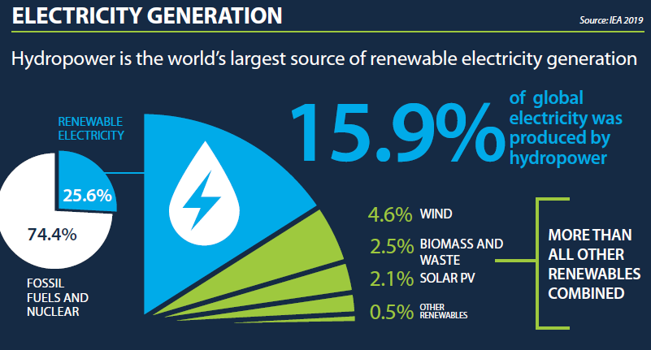
Figure 2; Taken from the International Hydropower Association 2019 report.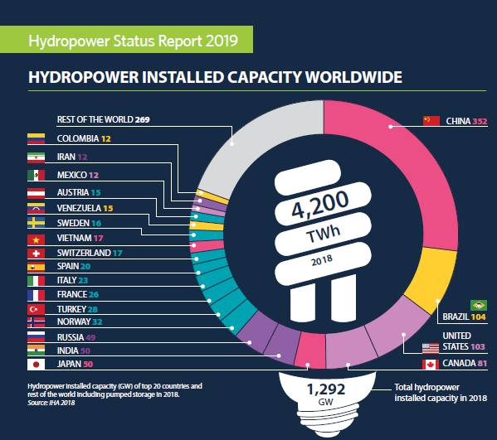

Bibliography
A, P. M. (2018). Methane Emissions from Ecuadorian Hydropower Dams . IOP Conf. Series: Earth and Environmental Science 151 (2018) 012002 , 1-6.
Boyle, G. (2012). Renewable Energy, Power for a Sustainable Future (3rd ed.). Oxford: Oxford University Press.
Bureau of Reclamation. (2015, 03 12). Hoover Dam. Retrieved 02 06, 2020, from Bureau of Reclamation: https://www.usbr.gov/lc/hooverdam/history/essays/coffer.html
CIRIA. (1996). Engineering guide to the safety of concrete and masonry structures in the UK. London: CIRIA.
F, L. (2017). Monitoring Thermal Pollution in Rivers Downstream of Dams. Remote Sensing, 1-16.
International Hydropower Association. (2019, 01 18). Types of Hydropower. Retrieved 02 2020, 02, from International Hydropower Association: https://www.hydropower.org/types-of-hydropower
International Rivers. (2010, 07 28). Grand Inga Dam, DR Congo. Retrieved 02 08, 2020, from International Rivers: https://www.internationalrivers.org/campaigns/grand-inga-dam-dr-congo
IRENA. (2018). Renewable Energy Statistics 2018. Abu Dhabi: The International Renewable Energy Agency.
J, G. (2006). Methane quashes green credentials of hydropower. Nature Publishing Group, 524-525.
Moran. E. F, L. M. (2018). Sustainable hydropower in the 21st century. East Lancing: Michigan State University.
Power Technology. (2013, 10 14). Three Gorges Dam Hydro Electric Power Plant, China. Retrieved 02 06, 2020, from Power-Technology: https://www.power-technology.com/projects/gorges/
The Renewable Energy Hub UK. (2014, 10 21). History of Hydroelctricity. Retrieved 02 01, 2020, from The Renewable Energy Hub UK: https://www.renewableenergyhub.co.uk/main/hydroelectricity-information/history-of-hydroelectricity/
Twidell J, W. T. (2015). Renewable Enegy Resources. Oxon: Routledge.

