

Surveying
Basic Site Levelling at the SA1 Swansea Waterfront Development (Land/site surveying)
Daniel Lawrence
1706618

Table of Contents
Task One 3
Introduction 3
Basic Equipment of the Surveying. 3
Site Set Up Procedures. 4
Pre-site Checks 4
Onsite Checks 4
SA1 Swansea Waterfront Development Recordings – Rise and Fall Method 6
SA1 Swansea Waterfront Development Recordings – The Collimation Method 7
Factors that could Affect Accuracy. 8
Equipment error 8
Staff defects 8
Tripod errors 8
Calibration of Staff or Levelling Instrument 9
Reading and Booking Errors 9
Weather 9
Task Two 11
SA1 Swansea Waterfront Development – Fly Levelling – The Collimation Method 11
Fly Level Sketch 13
Conclusion 14
References 15

Surveying of the SA1 Swansea Waterfront Development

Task One

Introduction
The assessment of the proposed SA1 Swansea Waterfront Development for a Gymnastics Centre and new Library building would need to undergo a basic levelling survey to assess the sites practicalities of the proposed facilities. This incorporates an assessment of the differential elevation of the proposed site through basic levelling techniques with the collation of this information to understand if this is a realistic option.

Basic Equipment of the Surveying.
The equipment required and implemented in the field work for the levelling undertaken at the SA1 Swansea Waterfront development included: -
- Level/Straight Edge – The level is used to establish a level horizontal straight edge. This is used with a measuring tape and establishes the gradient of a specific site.
- Tripod – The tripod is used to accommodate and provide a level and stable fixed point for the telescopic instrument such as a Dumpy Level or a Theodolite.
- Levelling Staff (5 metre) - This implement enables exact measurements to be recorded from the tripod. This is used in conjunction with a with the tripod/Dumpy Level to determine the difference in height between levelling points. The staff needs to be visibly measurement increments to enable accurate recordings of vertical heights.
- Staff bubble – A staff bubble is utilized to enable accurate measurements to be taken when using the Levelling staff. The staff bubble prevents human error taking place due to the staff leaning from the plumb position, potentially creating an incorrect reading. The staff bubble prevents this as the operator has a visible reference for the staff to be in a plumb position.
- Field book - This enabled the recording of information such as, detailed recordings, weather effects, potential variables in the data and other participants within the exercise.
- Measuring Tape (50 metre) -This implement enables the exact measurements to be recorded between levelling positions. This is used in conjunction with the Plumb bob to get an accurate measurement from the levelling instrument to the levelling staff.
- Plumb Bob - This implement enables the establishment of the exact position of the tripod. This is achieved by releasing the plumb bob from beneath the centre of the tripod onto the ground to mark the position achieving a vertical reference line.
- Safety vest and steel toe cap boots– This conforms to the Health and Safety at Work Act 1974 and the utilization of the Personal Protective Equipment Regulations 1992. This legislation and regulations enforce workers to wear protective equipment such as, high vis clothing to ensure visibility to others and steel toe cap boots to ensure your feet are protected when on site. The utilisation of a hard hat can also be used when on site or in an area of high levels.
- Hammer – A hammer can be used to clear debris at the instruments position or to clear an area for the levelling staff to get a true lay of the land.
- Marking Paint – Marking paint is utilized to mark specific recording points to keep a reference of previous/future positions.
- Dumpy Level – A Dumpy level is a rotating telescopic instrument which is used in conjunction with the tripod as previously mentioned. This equipment enables the readings to be taken from the instruments position to the levelling staff to assess differential levels between positions.

Site Set Up Procedures.

Pre-site Checks
- Ensure all the equipment required for the task is accounted for, calibrated and in perfect working order.
- Ensure all Personal Protective Equipment necessary for access to site in accordance with the Personal Protective Equipment Regulations 1992 and Health and Safety at Work Act 1974 and site policies is available and worn before entering site.
- Tool box talk - ensuring the leader of the group or person of responsibility has briefed the operator about the tools, how to use it safely and rules of the site.

Onsite Checks
- Communicate with your team or operatives on job roles and delegate tasks as required.
- Assess the site for; hazards, objects that could obscure view, weather conditions, time of day, record who was present, get an understanding of the task at hand and the approximate positions of instruments. All must be recorded and communicated in the survey report.
- Find the approximate position of the first levelling station in conjunction with the known TBM and understand the sequencing of levelling positions of the survey.
- Set up of equipment in the first levelling station and ensure the tripod is level, legs extended correctly, and the metal feet are secure in position.
- Once the Tripod is in position, mount the Dumpy Level to the levelling instrument and ensure its accurately levelled with the use of the instruments levelling bubbles.
- Communicating with the staff operator of the positions of the BS, IS and FS as required and ensuring they’re marked in case of mistake and potential repeats of survey. Be sure to highlight to the operator that the staff must be level and vertical for the survey to be accurate.
- Once the Staff operator is in position, focus the lens of the levelling instrument so the measuring increments of the levelling staff are clear and visibly recordable.
- Tap the Levelling instrument to ensure the compensator is working correctly. This can be seen by the tapping or placing pressure on the front or back of the levelling instrument. The levelling instrument should return to its previous levelled position after the action has occurred.
- Communication between the tripod and the levelling staff operators should take place to initiate the survey to ensure all parties are ready.

SA1 Swansea Waterfront Development Recordings – Rise and Fall Method

A basic levelling survey was completed for the SA1 Swansea Waterfront Development with an additional operative. The recordings of the survey have been collated into the Rise and Fall method of recording measurements. This can be seen below.
Project Title | Basic Site Levelling at the SA1 Swansea Waterfront Development (Land/site Surveying)
Site Location | SA1 Swansea Waterfront development
Date | 05/11/2018
Weather Conditions | Windy, low temperature, occasional shower of rain/overcast.
Ground Conditions | Compacted gravel with minimal loose debris.
Surveyor | Daniel Lawrence
Surveyor | Philip Abdullah

BOOKING |  |  |  |  | REDUCTION
Station | Points | BS | IS | FS | Rise | Fall | RL
L1 | A | 1562 |  |  |  |  | 350m
L1 | B |  | 1676 |  |  | -114 | 349.886
L1 | C |  | 1780 |  |  | -104 | 349.782
L1 | D |  |  | 1665 | 115 |  | 349.897
L2 | D | 1618 |  |  |  |  | (349.897)
L2 | E |  | 1750 |  |  | -132 | 349.765
L2 | F |  | 1700 |  | 50 |  | 349.915
L2 | G |  |  | 1620 | 80 |  | 349.895
 | Total BS = | 3180 |  | Initial RL | 350m
 | Total FS = | 3285 |  | New RL | 349.895
 | BS – FS = | -0.105 |  | RL – New RL = | 0.105

As seen from the table, the initial Bench Mark within the table of the Rise and Fall Method was recorded at 350m progressed with some fluctuations in the ground height to a reduced level of 349.895m. From the recordings collected at the SA1 Swansea Waterfront development survey and the calculations used to distinguish any errors or anomalies I feel that the new Reduced Level is correct in the Rise and Fall Method.

SA1 Swansea Waterfront Development Recordings – The Collimation Method

A basic levelling survey was completed for the SA1 Swansea Waterfront development with an additional operative. The recordings of the survey have been collated into the Collimation method of recording measurements. This can be seen below.
Site | Basic Site Levelling at the SA1 Swansea Waterfront Development (Land/site surveying).
Weather Conditions | Windy, low temperature, occasional shower of rain/overcast.
Ground Conditions | Compacted gravel with minimal loose debris.
Date | 05/11/2018
Surveyor | Daniel Lawrence
Surveyor | Philip Abdullah
BACKSIGHT | INTERMEDIATE | FORESIGHT | HEIGHT of COLL. | REDUCED LEVEL | REMARKS
1562 |  |  | 351.562 | 350m | TBM = 350M
 | 1676 |  |  | 349.886 | B
 | 1780 |  |  | 349.782 | C
1618 |  | 1665 | 351.515 | 349.897 | BS = D  Change Point  FS = D
 | 1750 |  | 349.765 |  | E
 | 1700 |  | 349.815 |  | F
 |  | 1620 | 349.895 |  | G
 | Total BS = | 3180 |  | Initial RL = | 350m
 | Total FS = | 3285 |  | New RL = | 349.895
 | BS – FS = | -0.105 |  | RL – New RL = | -0.105

As seen in the above table, the readings for the Collimation method are the same as the previous Rise and Fall Method table.

Factors that could Affect Accuracy.

There are various factors that could have affected the accuracy of the levelling exercise at the SA1 Swansea Waterfront development which included: -

Equipment error
Equipment errors can arise causing various issues with the accuracy of levelling such as dysfunctional compensators and focusing issues. The compensator enables the instrument to have a clear line of sight compensating for the operators adjustments. However, ‘Reliable readings are not possible if the compensator is sticking or jammed’ (Jerrymahun.com, 2017). The compensator works with a system of fixed prisms and mirrors in which a moving prism compensates for the operator’s adjustments, enabling the continued line of sight through the levelling instrument. Regular maintenance of the levelling instrument is required to ensure the accuracy of readings is achieved.
Additionally, the Parallax error can also cause issues with the accuracy of levelling. As, ‘Parallax error occurs when the measurement of an object's length is more or less than the true length because of your eye being positioned at an angle to the measurement markings.’ (Wallulis. K, 2018). This can affect the precise nature of the levelling process as inaccurate readings could result in wrong recordings being made. It is good practise to ensure that parallax has been identified and removed from the instrument to ensure accurate levels are achieved.

Staff defects
Staff defects can arise though general wear and tear of the equipment and incompetency in use. As, ‘If the rod bubble is off, then the rod will not be vertical and reading errors will be introduced.’ (Jerrymahun.com, 2017). This could be due to ‘wear and tear’ of the staff and staff bubble which could cause; dysfunctional rod bubble, nonlinear or bent affecting the accuracy of the staff, loss of measurement markings/symbols reducing measurement reading ability, the inability to extend the staff to its full length or the wrong section being extended. All of which could affect the accuracy of the measurements recorded in the survey.
Additionally, the operators competency in use can affect the accuracy in the levelling survey. As, ‘When using a Grade Rod, be sure that it is fully extended for the most accurate results.’ (Johnsonlevel.com, 2019). A non-vertical rod can raise or lower the measurements recorded from the site levels which could lead to inaccuracies in recordings. It is important to ensure the operator of the staff is sufficiently briefed and trained to use the staff and if an error in use is highlighted it should then be communicated to the staffing operator. For Instance, during the survey of the SA1 site the Dumpy level operator communicated with the staff operator to ensure the staff was level at all times. This was because it was cold and windy, and the staff operator was moving around which could have led to inaccuracies in the survey.

Tripod errors
Systemic errors such as Tripod errors can occur for various reasons such as defective equipment and instability occurring upon its erection. ‘The systematic errors may arise due to… faulty setting or improper levelling of any instrument and personal vision of an individual.’ (Civil Engineers Forum, 2016). This could be caused through incorrectly mounting the levelling instrument to the tripod, shoes missing from the tripod creating instability and insecure leg extensions of the tripod. These issues could all contribute to tripod errors resulting in inaccurate levelling and readings being obtained. For Instance, a potential error was avoided in erection of the tripod due to the presence of loose debris within the SA1 site which could have affected the stability/levels of the instrument.

Calibration of Staff or Levelling Instrument
The calibration of surveying equipment is essential to obtain accurate readings when in the field. As, ‘The surveyor is responsible for ensuring all equipment is calibrated/verified and checked prior to use and maintained as such throughout the period of survey works, as well as ensuring it is fit for the survey purpose required.’ (RICS, 2014). This is due to the accuracy of the measuring equipment degrading over time and through wear and tear. Regular calibration from a qualified calibrator for the surveying equipment is essential for obtaining accurate readings when in the field. An example of this would be the inspection of the equipment used on the SA1 site to ensure it was calibrated recently and had the certification label on the instrument.

Reading and Booking Errors
Reading and booking errors can affect the accuracy of levelling survey potentially due to staff competency in the field. As, ‘The surveyor is responsible for ensuring that his/her staff are qualified, competent, appropriately insured and trained to do the tasks for which they are engaged.’ (RICS, 2014). Errors such as miscommunication between the tripod operator and the booking and recording individual, incorrect calculations could take place due to human error resulting in inaccuracies occurring in the data. To mitigate the chances of this taking place during the SA1 site survey, verbal communication between the operatives was at a high level and proof reading of data was implemented to clarify the recordings were correct.
Furthermore, reading and booking errors could result due to obscuring objects within the survey area. As the operative may come across, ‘features obscured by vehicles, trailers, temporary covers, stacked materials’ (RICS, 2014). This can affect the accuracy of the site survey due to the reduced visibility of instruments and accessibility to areas for the survey. For Instance, the SA1 site incorporates a car park resulting in obscured features such as, cars being present in the survey area. This resulted in the levelling operatives having to communicate between each other and approximate the levelling positions and points to ensure the most accurate recordings were being achieved. A means to mitigate this would be to assess the site prior to the survey and instruct the client to ensure the survey area was clear of obscuring objects the SA1 site survey entailed.

Weather
Potential inaccuracies occur during differential climatic temperatures due to the stave’s material which can contract and expand. As, ‘Bright sunlight striking certain parts of the instrument may cause differential expansion of the metal components of the instrument, resulting in small errors.’ (s.n., 2005). This is because of the co-efficient of linear expansion of the material causing contraction or expansion depending on the temperature, which would either increase or decrease the distance between the measurement increments, potentially resulting in inaccurate measurements.
Furthermore, as previously mentioned the weather of the SA1 site was windy which could have resulted in movement taking place during the operating of equipment and potentially inaccuracies in the survey. A means to mitigate this would be through communication with the staff operator and the utilisation of a rod bubble on the levelling staff to ensure accuracy.
Furthermore, inconsistencies can appear due to weather conditions such as: -
- Fog creating poor visibility.
- Heavy rainfall making the top soil pliable, confusing the top level for measurements.
- Frozen conditions, compaction of snow and ice could give an inaccurate ground level.
- Heatwaves causing distortion from reflection affecting the line of sight.

Task Two

SA1 Swansea Waterfront Development – Fly Levelling – The Collimation Method

The Fly levelling exercise was completed and the information calculated with the utilisation of the Collimation method. This can be seen in the table below.
Site | Basic Site Levelling at the SA1 Swansea Waterfront Development.  Fly Levelling Exercise.
Date | 05/11/2018
Weather Conditions | Windy, low temperature, occasional shower of rain/overcast.
Ground Cover | Compacted gravel with minimal loose debris and included concreted sections with minimal vegetation.
Surveyor | Daniel Lawrence.
Surveyor | Philip Abdullah.
BACKSIGHT | INTERMEDIATE | FORESIGHT | HEIGHT of COLL. | REDUCED LEVEL | REMARKS
1608mm |  |  | 351.608m | 350m | Levelling Position 1.  Staff Position (A).  Initial TBM = 350M.
 |  | 1693mm |  | 349.915m | Levelling Position 1.  Staff Position (B).
1462mm |  |  | 351.377m |  | Levelling Position 2.  Staff Position (B)
 |  | 1878mm |  | 349.499m | Levelling Position 2.  Position (C).
 | Total BS = | 3070mm |  | Initial RL = | 350m
 | Total FS = | 3571mm |  | New RL = | 349.499m
 | BS – FS = | Reduced Level  = -0.501m |  | RL – New RL = | Reduced level  = -0.501m

The table highlights the overall reduced level from the initial 350m Temporary Bench Mark to a decline of -0.501m between the points (A) and (c). Refer to ‘Fly Level Sketch’ in the table of contents to see an illustration of the fly level survey undertaken on the SA1 site.

Fly Level Sketch
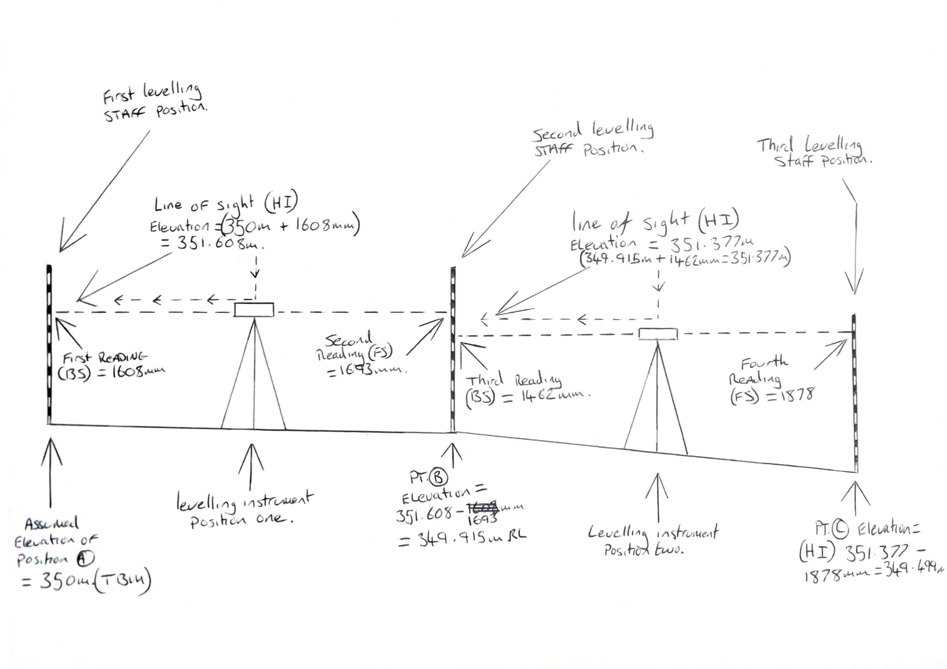
E
茎
、

As seen in the previous sketch, a rough sketch has been provided to illustrate the reduced level at various points of the exercise.

Conclusion

In Conclusion, the surveying exercise/experience was completed for the SA1 Swansea Waterfront Development and incorporated an informed use of the equipment, an understanding of the procedures involved in its undertaking and highlights the potential issues which could reduce accuracy of the survey.
The data collated with the use of the Collimation method and the Rise and Fall method express the differential reduced level of the proposed development site in numerical form.

References

Civil Engineers Forum, 2016. Why Errors in Surveying Take Place | Types of Error That Occurs During Survey. [ONLINE] Available at: <http://civilengineersforum.com/errors-in-surveying/> [Accessed 10 January 2019].
JerryMahun.com, 2017. Chapter D. Differential Leveling Errors. [ONLINE] Available at: <http://www.jerrymahun.com/index.php/home/open-access/elevations/12-elevations-chap-d> [Accessed 2 January 2019].
JerryMahun.com, 2017. Chapter D. Differential Leveling Errors. [ONLINE] Available at: <http://www.jerrymahun.com/index.php/home/open-access/elevations/12-elevations-chap-d> [Accessed 2 January 2019].
JohnsonLevel.com, 2019. Grade Rods: All About Grade Rods. [ONLINE] Available at: <http://www.johnsonlevel.com/News/GradeRodsAllAboutGradeRod> [Accessed 10 January 2019].
K, Wallulis, 2018. How to Prevent Parallax Error. [ONLINE] Available at: <https://sciencing.com/prevent-parallax-error-10000073.html> [Accessed 3 January 2019].
RICS, 2014. Measured surveys of land, buildings and utilities. [PDF] London, Royal Institute of chartered Surveyors. Available at: <https://www.rics.org/globalassets/rics-website/media/upholding-professional-standards/sector-standards/land/measured-surveys-of-land-buildings-and-utilities-3rd-edition-rics.pdf> [Accessed 5 January 2019]
RICS, 2014. Measured surveys of land, buildings and utilities. [PDF] London, Royal Institute of chartered Surveyors. Available at: <https://www.rics.org/globalassets/rics-website/media/upholding-professional-standards/sector-standards/land/measured-surveys-of-land-buildings-and-utilities-3rd-edition-rics.pdf> [Accessed 5 January 2019]
RICS, 2014. Measured surveys of land, buildings and utilities. [PDF] London, Royal Institute of chartered Surveyors. Available at: <https://www.rics.org/globalassets/rics-website/media/upholding-professional-standards/sector-standards/land/measured-surveys-of-land-buildings-and-utilities-3rd-edition-rics.pdf> [Accessed 6 January 2019]
s.n., 2005. Surveying Equipment, Measurements and Errors. [PDF] s.l. Available at: <http://www.wsdot.wa.gov/publications/fulltext/design/Webinar/5_2011/sm_chapter03.pdf> [Accessed at 7 January 2019]

