

ASSESSMENT 2
BMIH5007 FINANCIAL MANAGEMENT FOR THE HOTEL INDUSTRY
REPORT CASE STUDY: THE CITY HOTEL
STUDENT NAME:SEBASTIAO CLEMENTE FERNANDES
STUDENT ID :2243325

AI Acknowledgement
I confirm that I have not used any AI tools in the research and creation of this assignment and have not presented any AI-generated materials as my own work. I confirm that I have copies of my drafts, notes, and other resources I used, which I may be asked to provide in evidence.

Executive summary
Financial management is important for a business in planning and controlling business activities by managing financial performance. In this report, the City Hotel is focused on an urban area. “Revenue, expenses, profitability, liquidity and solvency position” of the company is analysed in this report for 2021-2023. Gross profit ratio and operating profit margin ratio are calculated to measure profitability ratios, and current ratio and quick ratio are calculated to analyse for evaluating liquidity position. Debt-equity ratio and equity multiplier are calculated to measure solvency capacity. High business and lower revenue earning capacity are the reason behind the lower profitability position of the hotel. A turnaround strategy is prepared to suggest a way of improving financial help and business reputation in the hotel industry.

Table of Contents
Introduction 4
Trends and outlines in the hotel's financial act over the past three Years 5
Revenue 6
Expenses 7
Profitability 10
Liquidity 11
Solvency 12
Reasons behind the decline in profitability 13
Internal reasons 13
Real-world events and current economy 14
Turnaround strategy to regenerate the hotels’ financial health and restore status 15
Turnaround strategy to regenerate the hotels’ financial health 15
Strategy to restore its reputation 15
Conclusion 16
References 17

Introduction
Financial management is a process of planning, organising, and controlling a business's financial transactions. It is important to utilise and allocate resources for a business to achieve goals and objectives in a competitive market. The City Hotel is a restaurant and bar that offers event facilities in urban areas. The report's main drive is to analyse the financial act and health of the City Hotel and recommend a turnaround strategy for improving its performance. The hotel's revenue and expense trends for the last 3 years are analysed, and “profitability, liquidity and solvency” ratios are also evaluated. The reasons behind the decline in the profitability of the hotel and the strategy for improving financial health and business reputation are some of the scopes of the report.

Trends and outlines in the hotel's financial act over the past three Years
Trends and patterns of revenue and expenses
Item (in GBP) | 2021 | 2022 | 2023 | Trend percentage "(Current year amount- base year amount)/Base year amount"
 |  |  |  | 2021-2022 | 2022-2023
"Revenue" | 52,48,290 | 53,07,480 | 23,25,440 | 1% | -56%
"Cost of goods sold" | -4,11,600 | -4,01,510 | -1,76,250 | -2% | -56%
"Employee costs" | -17,24,760 | -17,70,700 | -12,33,160 | 3% | -30%
"External expenses" | -18,94,720 | -16,75,410 | -10,71,030 | -12% | -36%
"Taxes and duties" | -1,44,070 | -1,33,020 | -88,950 | -8% | -33%
"Depreciation & amortisation" | -4,09,190 | -6,34,030 | -6,61,590 | 55% | 4%
"Charges to provisions" | 5960 | 17,950 | -55,550 | 201% | -409%
"Other current operating income and expenses" | -40,520 | -25,030 | -41,100 | -38% | 64%
"Other operating income and expenses" | 34,780 | -11,000 | -2,16,650 | -132% | 1870%
"Operating Income" | 6,64,160 | 6,74,730 | -12,18,850 | 2% | -281%
Table 1: Revenue and Expenses Trend Evaluation
(Source: MS-Excel)
Trend analysis is important for a business to understand patterns of historical data that help in the decision-making process. However, trend analysis is important for the quality control process of a business, which helps in comparing product performance with its standard quality and cost (Drury, 2021). Trend analysis of the City Hotel is performed that reflects revenue earning potential and income generation capacity has declined however, some expenses trend percentage has increased.

Revenue
Revenue of the City Hotel was £52,48,290 in 2021, increased to £53,07,480 in 2022, and declined to £23,25,440 in 2023. Hence, revenue of the hotel has increased by 1% in 2021-2022 however, it has declined by 56% in 2022-2023. Decreasing revenue generation capacity of the hotel is observed in 2022-2023 negatively influences its profitability position. On the other hand, a decrease in revenue may not significantly affect the profitability position of a company if the cost of business has also decreased (BBC, 2024). However, the expenses of the hotel have increased in some, creating challenges in managing profitability. As a result, decreasing revenue reflects lower customer satisfaction and significantly affects the income sources of the hotel.

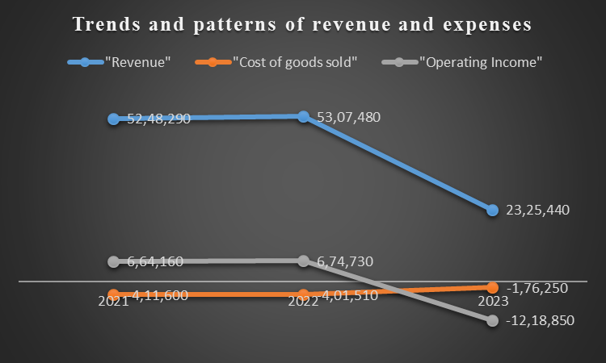
Figure 1: Trend and patterns of revenue and expenses
(Source: MS-Excel)

Expenses
“Cost of goods sold (COGS), employees cost, external expenses, taxes and duties, depreciation and amortisation and other operating expenses” are some of the expenditures incurred by the City Hotel. For instance, the COGS of the hotel was £4,11,600 in 2021, decreasing to £4,01,510 in 2022 and £1,76,250 in 2023. COGS of the City Hotel has decreased by 2% in 2021-2022 and declined by 56% in 2022-2023. In addition, the price of properties sold reflects the percentage of a business cost required for generating revenue (Seal et al., 2018). This reflects that COGS has decreased for the hotel, and a lower cost is required to earn revenue. Employee cost is another business expense that increased by 3% in 2021-2022 and declined by 30% in 2022-2023. As a result, decreasing employee costs reflect the hotel's high staff turnover rate, which may be due to increasing employee termination or resignation, which lowers employee costs. In contrast, increasing employee turnover rate can enhance business expenses for the recruitment process and a shortage of skilled labour (Forbes, 2024a). Hence, employee costs have decreased from 2021 to 2023, reflecting lower availability of skilled workforce and employee satisfaction.
External expenses are another business cost that has decreased by 12% in 2021-2022 and 36% in 2022-2023. The City Hotel has controlled its external expenses effectively which reflects its ability to implement cost control initiatives. Taxes and duties have decreased by 8% in 2021-2022 and again declined by 33% in 2022-2023. Decreasing tax and duty reflects the hotel has lower profit generated results in lower tax paid. Additionally, other operating income and expenses have decreased by 132% in 2021-2022 and increased by 1870% in 2022-2023. Hence, overall operating expenses have increased in 2021-2023 reflecting the hotel has high internal business expenses that result in lower operating income. High operating expenses can result in lower profitability of a business, which can create challenges in managing competitive advantage (Nwosu, 2024). As a result, operating income declined by 281% in 2022-2023, which reflects high business expenses and negativity that affect the profitability of the hotel.
Profitability, liquidity, and solvency ratios evaluation |  |  |  | Trend percentage
PROFITABILITY RATIOS: | 2021 (in GBP) | 2022 (in GBP) | 2023 (in GBP) | 2021-2022 | 2022-2023
Gross Profit (Revenue- cost of goods sold) | 48,36,690 | 49,05,970 | 21,49,190
Operating Income | 6,64,160 | 6,74,730 | -12,18,850
Sales | 52,48,290 | 53,07,480 | 23,25,440
Gross Margin | 92% | 92% | 92% | 0% | 0%
"Gross Profit/Sales"
Operating Margin | 13% | 13% | -52% | 0% | -512%
"Operating Income/Sales"
LIQUIDITY RATIOS: | 2021 | 2022 | 2023
Current Assets | 18,91,970 | 19,65,340 | 12,85,880
Current Liabilities | 19,57,360 | 21,07,750 | 20,14,600
Inventories | 35,230 | 36,350 | 29,470
Current Ratio | 0.97 | 0.93 | 0.64 | -4% | -32%
"Current Assets/Current Liabilities"
Quick Ratio (or Acid Test Ratio) | 0.95 | 0.92 | 0.62 | -4% | -32%
"(Current Assets-Inventories)/Current Liabilities"
SOLVENCY RATIOS: | 2021 | 2022 | 2023
Total Debt | 1,06,84,940 | 1,33,38,050 | 1,42,43,390
Total Equity | 22,56,180 | 25,83,030 | 14,10,580
Total Assets | 1,29,41,110 | 1,59,21,080 | 1,56,53,970
Debt/Equity Ratio | 4.74 | 5.16 | 10.10 | 9% | 96%
"Total Debt/Total Equity"
Equity Multiplier | 5.74 | 6.16 | 11.10 | 7% | 80%
"Total Assets/Total Equity"
Table 2: Financial ratios analysis
(Source: MS-Excel)

Profitability
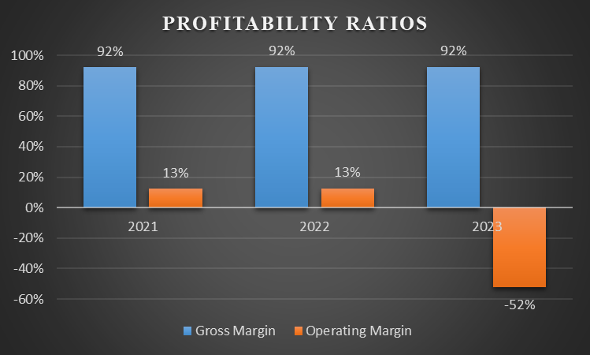
Figure 2: Profitability ratios evaluation
(Source: MS-Excel)
Profitability ratios analyse the profit-earning volume of a business from its revenue earned in a year. The gross profit ratio evaluates the profitability position of a business by calculating gross profit retained after deducting the cost of goods sold from revenue (Mishra, 2023). The City Hotel has a gross profit ratio of 92% in 2021, 2022 and 2023 that has 0% of changes. The gross profit ratio does not significantly change, which reflects that the hotel has the capability of managing gross profit after deducting the cost of goods sold from revenue. On the other hand, operating profit margin analysis is the ability to earn an operating profit after paying variable costs of production such as wages and raw materials (Zeeshan et al. 2021). The operating profit margin of the hotel was 13% in 2021 and 2022, which declined to -52% with -512% trend percentage changes. The decreasing operating profit margin reflects the poor profitability position of the hotel, resulting in operating loss in 2023. High business expenditure and decreasing revenue earning capacity negatively affect operating profit margin management and profitability position in 2021-2023.

Liquidity
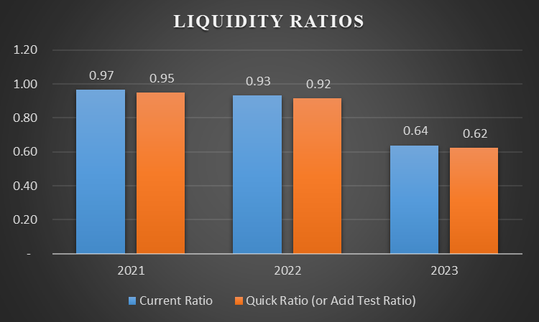
Figure 3: Liquidity ratios analysis
(Source: MS-Excel)
Liquidity ratios analyse the capability of a business to manage immediate obligations in a year. Current ratio analysis of the liquidity position of a business by measuring the relationship between current assets and current liabilities (Atrill and McLaney, 2021). The City Hotel has a current ratio of 0.97 in 2021, which decreases to 0.93 in 2022 with -4% changes and again declines to 0.64 in 2023 with -0.32% changes. Decreasing the current ratio of the hotel reflects a poor ability to pay short-term obligations faster by using its short-term assets. Moreover, the quick ratio or acid test ratio is another liquidity ratio that analyses its ability to pay short-term obligations by using assets that can be easily converted into cash (CFI, 2024). The quick ratio of the hotel was 0.95 in 2021, which declined to 0.92 in 2022 with -4% changes and again reduced to 0.62 in 2023 with a -32% trend percentage. A higher value of current liabilities against the availability of current assets results in a poor liquidity position. However, a higher value of quick ratio is expected from a business that reflects the City Hotel's poor liquidity position, which negatively affects its effectiveness in the faster payment of short-term obligations in 2021-2023.

Solvency
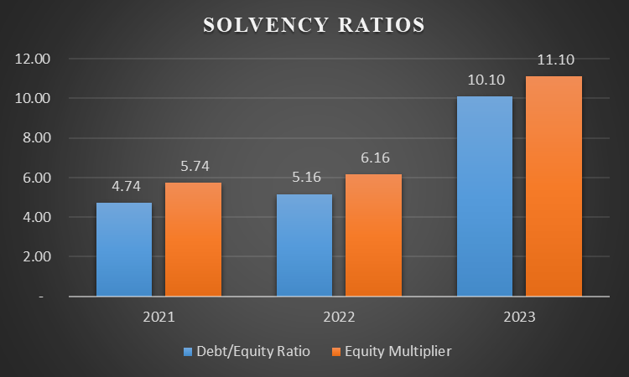
Figure 4: Solvency ratios evaluation
(Source: MS-Excel)
Solvency ratio analysis of the effectiveness of a business for managing long-term debt that significantly influences its financial health. Debt-equity (D/E) ratio analysis weightage of total debt and financial liabilities compared to shareholders’ equity of a business (CFI, 2024). The D/E ratio of the hotel was 4.74 in 2021, which increased to 5.16 in 2022 and 10.10 in 2023. Hence, 9% of changes are observed in 2021-2022 and increase by 96% in 2022-2023. On the other hand, the equity multiplier ratio analyses the proportion of assets financed by equity sources of a company (Li, 2022). However, a lower value of equity multiplier is expected from a company that reflects lower dependency on capital, which helps manage financial risks. Moreover, the equity multiplier of the hotel was 5.74 in 2021, which increased to 6.16 by a change of 7% in 2022 and 11.10 by a change of 80% in 2023. A higher proportion of total debt capital in comparison with its available total assets and equity results in high financial risk and poor solvency capacity. Increasing the equity multiplier reflects the high financial risk of the business due to its dependency on debt capital more than equity capital. High financial risk and inadequate solvency position have been observed for the company in the last 3 years.

Reasons behind the decline in profitability

Internal reasons
The City Hotel has a declining profitability position from 2021 to 2023, which creates challenges in managing customer satisfaction, occupancy rate, and revenue. The hotel had revenue earned in 2021 was £52,48,290 reduced to £23,25,440 in 2023. Hence, decreasing revenue earning capacity results in a lower profitability position for the hotel. In addition, other operating income and expenses have increased by 1870% in 2022-2023, which also results in a lower profitability position. As a result, decreasing revenue earning capacity and increasing business expenses negatively affected the profitability position of The City Hotel in the last 3 years.

Real-world events and current economy
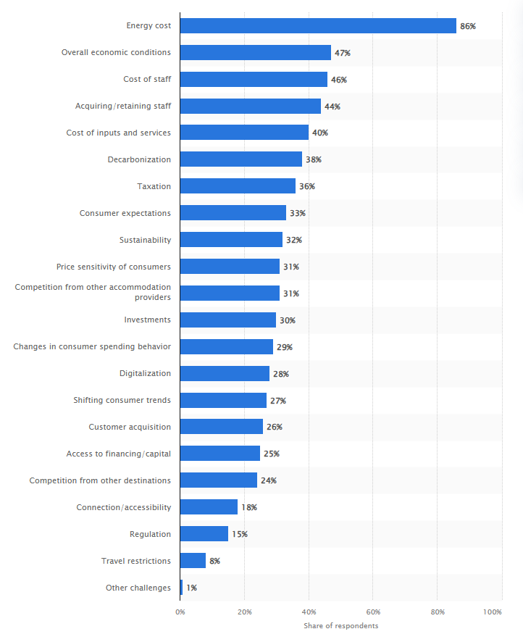
Figure 5: Challenges faced by European accommodation businesses as of May 2023
(Source: Statista, 2024)
Energy costs, economic conditions, staff costs, and taxation are some of the main challenges faced by accommodation businesses in Europe. It is expected that 86% of accommodation businesses will face challenges in managing energy costs and economic conditions, which will create challenges for 47% of businesses as of May 2023 (Statista, 2024). Hence, high energy costs and economic conditions create significant challenges for the hotel in managing its profitability due to high business operating costs. In March 2021, the inflation rate of the UK was 0.7% for the Consumer Price Index (CPI), which increased to 3.2% in March 2024 (Statista, 2024). Hence, the increasing inflation rate resulted in high business expenditure and accommodation costs of the hotel that negatively influenced its revenue earning capacity and its profitability position in the past 3 years.

Turnaround strategy to regenerate the hotels’ financial health and restore status

Turnaround strategy to regenerate the hotels’ financial health
It is suggested to the City Hotel to focus on cost control to manage financial performance and profitability. Cost control is important for increasing profitability of a business and ensuring financial stability (Victorino and Ramesh, 2022). Cost control can help in managing variable costs of businesses that are important for earning operating profit.

Strategy to restore its reputation
Application of a digital marketing strategy is also suggested to the hotel that can positively influence its brand reputation in the hotel industry. Social media marketing is a part of a digital marketing strategy that is effective in improving website traffic and enhancing brand awareness (Forbes, 2024b). Social media marketing strategy applications in social media platforms such as Facebook, YouTube and Instagram can help the hotel in improving brand reputation.

Conclusion
It can be concluded that the revenue earning capacity of the City Hotel has deteriorated in 2021-2023. Depreciation amortisation and other company operating expenses have increased in the last 3 years. Poor profitability position is observed for the hotel due to decreasing operating profit margin ratio, and liquidity position is also not maintained properly. The decreasing value of the current ratio and preparation reflects a poor liquidity position, and the solvency position is negatively influenced due to high debt capital. The high inflation rate and lower revenue earning capacity significantly affect the hotel's poor profitability position. Implementing a cost control initiative and social media marketing strategy to improve financial performance and brand reputation is suggested.

References
Atrill, P. and McLaney, E., (2021). Management Accounting for Decision Makers, 6th Edition, FT Prentice Hall: UK.
BBC, (2024). Business revenue, costs and profits - Edexcel. Available at: https://www.bbc.co.uk/bitesize/guides/zb2shbk/revision/4 [Accessed on: 01.11.2024].
CFI, (2024). Debt Equity Ratio. Available at: https://corporatefinanceinstitute.com/resources/commercial-lending/debt-to-equity-ratio-formula/ [Accessed on: 01.11.2024].
CFI, (2024). Quick Ratio. Available at: https://corporatefinanceinstitute.com/resources/accounting/quick-ratio-definition/ [Accessed on: 01.11.2024].
Drury, C., (2021). Management and Cost Accounting, 11th Edition, London, Prentice Hall.
Forbes, (2024a). Employee Turnover Rate: Definition & Calculation. Available at: https://www.forbes.com/advisor/business/employee-turnover-rate/#:~:text=A%20high%20turnover%20rate%20shows,company%20for%20a%20long%20time. [Accessed on: 01.11.2024].
Forbes, (2024b). Social Media Marketing In 2024: The Ultimate Guide. Available at: https://www.forbes.com/advisor/business/social-media-marketing/ [Accessed on: 01.11.2024].
Li, W., (2022). Financial analysis of acoustech Bhd in Malaysia. In Modern Economics & Management Forum (Vol. 3, No. 2, pp. 118-122).
Mishra, M.A., (2023). A Study on Financial Analysis-A Case Approach. International Journal of Multidisciplinary Research Transactions, 8(5), pp.2663-2381.
Nwosu, N.T., (2024). Reducing operational costs in healthcare through advanced BI tools and data integration. World Journal of Advanced Research and Reviews, 22(3), pp.1144-1156.
Seal, W., Rohde, C., Garrison, R. and Noreen, E., (2018). Management Accounting, 6e. McGraw-Hill Education (UK).
Statista, (2024). Inflation rate for the Consumer Price Index (CPI) in the United Kingdom from January 1989 to September 2024. Available at: https://www.statista.com/statistics/306648/inflation-rate-consumer-price-index-cpi-united-kingdom-uk/#:~:text=Inflation%20rate%20in%20the%20UK%201989%2D2024&text=The%20UK%20inflation%20rate%20was,11.1%20percent%20in%20October%202022. [Accessed on: 01.11.2024].
Statista, (2024). Main challenges expected by accommodation businesses over the next six months in Europe as of May 2023. Available at: https://www.statista.com/statistics/1358403/challenges-expected-accommodation-europe/ [Accessed on: 01.11.2024].
Victorino, M.L. and Ramesh, D., (2022). Advantages of the Cost Accounting View for Entrepreneurs in Improving Productivity and Financial Stability. Technoarete Journal on Accounting and Finance, 2(5), pp.2-5.
Zeeshan, K., Kondapally, S.R., Reddy, P.V. and Pranaya, P., (2021). A Study on Financial Performance Analysis of National Aluminum Company (Nalco). NVEO-NATURAL VOLATILES & ESSENTIAL OILS Journal| NVEO, pp.9294-9325.

