Analysis of Results
Introduction
This chapter presents a thorough analysis of the data collected through a survey that was conducted as part of this dissertation. The purpose of the survey was to obtain participant insights on the topic of, the growth of county lines and gang dynamics. The objective of utilising a quantitative method is to provide quantifiable results, that will enhance the research issues presented in previous chapters. In addition to presenting the findings this analysis, it will be discussed about their significance to the study question, as well as providing important new information that could guide future research.

Content and Analysis of Quantitative Data
Twenty-five questionnaires were sent out to individuals ranging from police officers, police staff and members of the public, of which twenty of the participants completed the survey. The survey was compiled and distributed via an online service, Survey Monkey, which is accessible on the following link; https://www.surveymonkey.com/r/2N6ZRXG. The survey is accumulated of ten multiple choice questions regarding; the awareness of what county lines is, ownership of who is to tackle the issue, the vulnerability of the youths involved as well as overall satisfaction with the training provided for the topic. The purpose of the survey is to fill in gaps regarding the current research of the subject, according to Holtom et al (2022) considering the simple accessibility brought about by the advancement of current technology, survey technique is becoming increasingly popular in academia and is a successful research tool.
The survey consists of ten questions, the first of which requests that the participants identify themselves as either; police officer, police staff and member of the public, there is no further personal details obtained and the survey remains anonymous. Balamurugan (2024) discusses that the power of anonymity is essential in order to foster honest feedback, therefore it was important that the survey upheld this theory. Upon analysing the data collected from the first question, it was established that 65% of the respondents were police officers, 15% were police staff and 20% of participants were members of the public. It is clear from these findings that there has been a more dominant response from members of the police service, rather than members of the public. Furthermore, due to the survey being anonymous as well as identical questions asked to each respondent, it is not possible to determine whether the perspectives of the police service members who took part in the survey, differ from those of the public. The graph below displays the findings of the first question:
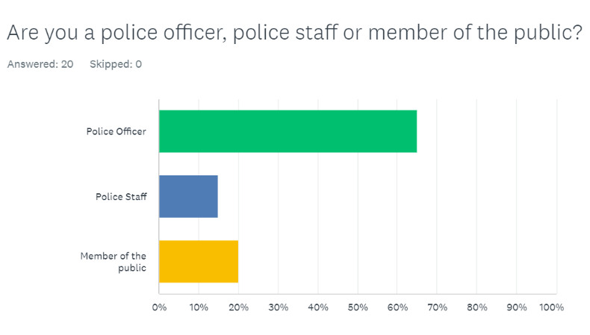

The analysis from the survey found an interesting representation of how participants would view the youth of their community as vulnerable, 35% deemed that they would deem young people as vulnerable, however 35% had an opposite opinion and probably would not class the youth as such. Adding to this, 30% of the respondents selected that they probably would class the young members of their community as vulnerable. Overall, most of the participants would class persons under the age of eighteen as vulnerable, according to Ford (2021) vulnerable young people are at risk of being drawn to crime or gang dynamics. The graph below displays the findings of the question:
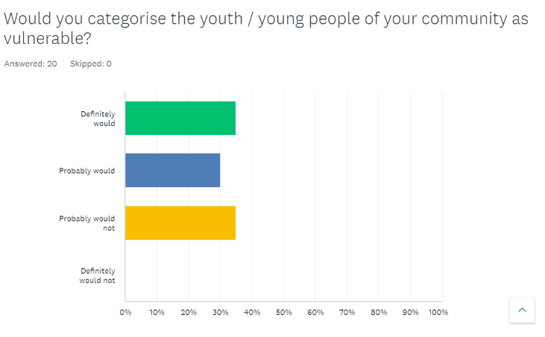

The data collected from the survey found that an overall percentage of 25% of participants had not heard of the term “county lines” before, with only 35% being somewhat familiar with the expression, additionally a substantial 85% of respondents believe ownership of tackling youth related crime and gang violence was held with the police service, with the other 15% either stating that ownership lies with the parents or could not say. Further analysis of the survey found that an overwhelming 95% of participants believe that county lines and youth related crime is an escalating issue for law enforcement, this is displayed in the graph below:
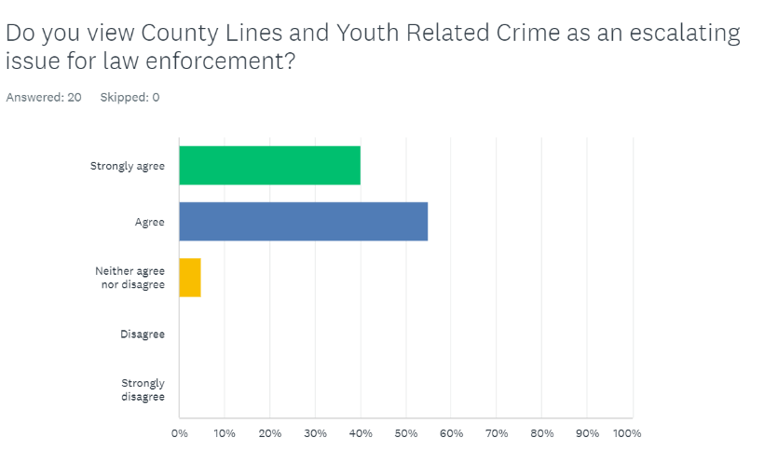

Data from the survey found that if applicable to participants, there is a dissatisfaction with the level of training as well as awareness to powers and policies available to officers and staff, with 35% stating that they are not content. In addition to this 45% believe that they could not identify the early stages of youth involvement with gang related crime. Analysis of the data has created a clear understanding of how little knowledge there is on the matter of youth related crime, both within and outside the police services, as well as concern for the level of attention it is receiving as displayed in the graph below:
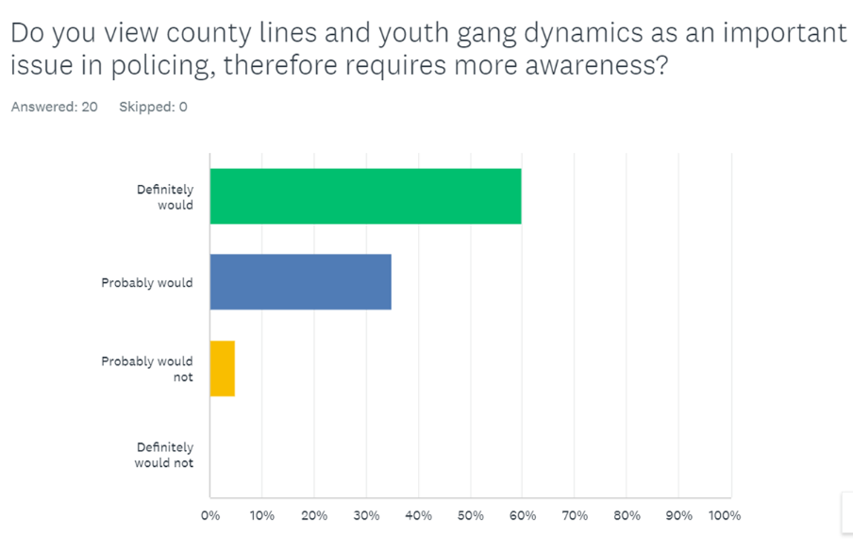

To conclude, from analysing the data collected from the surveys, it has can be suggested that young people are especially vulnerable to crime dynamics, a dynamic which is clear to be a continuous growing problem for law enforcement authorities. It could be suggested that effective intervention efforts may also be hampered by the present discontent with the level of training and knowledge that surrounds juvenile crime. The outcome results from the survey showed a prominent police officer and staff response, which could therefore establish further and more accurate insight into how law enforcement perceive county lines. Overall, county lines and youth related crime dynamics is a complex and escalating issue for law enforcement agencies, linked to complex interplay of; social, economic and psychological factors.

Bibliography
Holtom, B., Baruch, Y., Aguinis, H., and Ballinger, G,. (2022) - Survey response rates: Trends and a validity assessment framework. Available at: https://journals.sagepub.com/doi/10.1177/00187267211070769 Accessed (18th July 2024)

Balamurugan, V. (2024) - The Power of Anonymity: Why Anonymous Surveys Foster Honest Feedback. Available at: https://blocksurvey.io/features/why-should-surveys-be-anonymous Accessed (18th July 2024)

Ford, V. (2021) - Targeted support for vulnerable young people in serious violence hotspots Available at: https://www.gov.uk/government/news/targeted-support-for-vulnerable-young-people-in-serious-violence-hotspots Accessed: (18th July 2024)

