ACBA 5001: Management and quality management in construction
  - By Ben Kneeshaw – SN:1902457

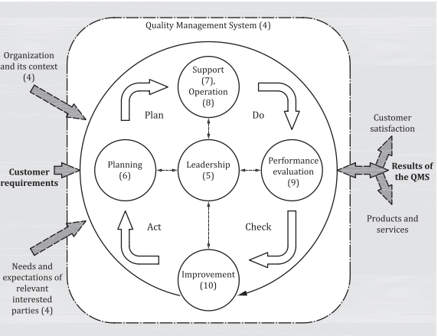

Table of contents

1. Introduction……………………………………………………………………Page 3
2. Management procedures……………………………………………………Pages 3-5
2.1 Overview…………………………………………………………………….Page 3
2.2 Procurement………………………………………………………………..Pages 3-4
2.3 Communication…………………………………………………………….Pages 4-5
3. Q uality assurance procedures……………………………………………..Pages 5-9
3.1 On-site and internal precautions…………………………………………Pages 5-7
3.2 Site and material testing…………………………………………………..Pages 7-8
3.3 Handover procedure………………………………………………………Pages 8-9
4. Closing statement…………………………………………………………...Page 9
5. List of figures………………………………………………………………...Page 10
6. List of references……………………………………………………………Pages 10-11

Introduction

The aim of this report is to outline the intended management procedures for the proposed project. It also details the quality assurance techniques that will be used to ensure the project is completed to the required level of quality.

Management procedures

Overview

The client has specified that a high level of quality is required for this project. There are a number of ways this can be assured from a management perspective, these are detailed below. Due to the emphasis on quality control the time/cost of the project is likely to be higher than otherwise, as per the ‘iron triangle’, shown in figure 1.
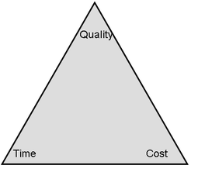
Figure 1:
The ‘iron triangle’ (Madsen, 2013)

Procurement

The procurement method for this project will be traditional. This approach tends to lead to a higher overall quality for the build (designingbuildings, 2020), making it ideal for this project. This is because the client will maintain control over the design and quality of the build, being in communication with both the design/consultant team and construction team. The only communication between the design/consultant and construction teams will be the drawings/models supplied when signed off by the client, along with any follow-ups deemed necessary by the project manager. The close control on the part of the client should ensure their quality requirements are met. A diagram detailing the contractual relations present in the traditional procurement route is available in figure 2.
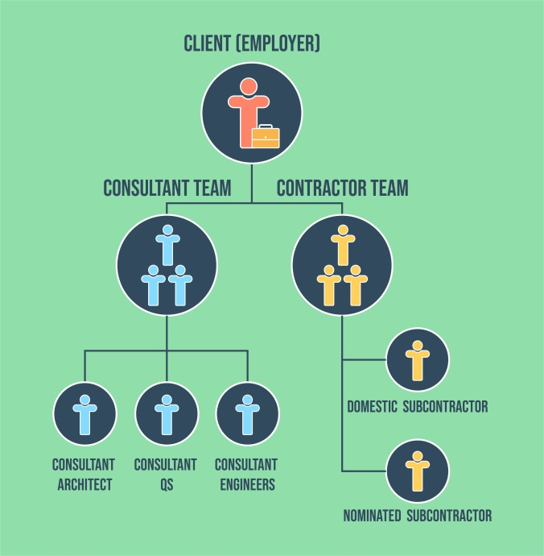
Figure 2:
Contractual relations in traditional procurement (futurelearn, 2020)
A further way of increasing the quality at this stage would be the use of an architect proficient in the use of BIM. BIM level 2/3 would be ideal for this project as it would ensure accurate models can be shared between the relevant teams (united-bim, 2019). As such, over the whole course of the project (design, build, operate) efficiency and quality can be kept to a maximum, with the risk of defects due to poor communication kept to an absolute minimum. This will also ensure full models and documents can be given to the client at handover for efficient operation of the building.

Communication

As with any project, good communication is the key to successful implementation of the projects goals. As such, a communication plan has been put in place to ensure this is done effectively under the traditional procurement route, shown in figure 3. The client will communicate directly with the design team who will relay their aims to the project manager and construction manager in the form of concise models/drawings. These will then be passed down to the relevant teams in order to ensure they are clear of their goals. There will be an oral feedback loop to the management team and project manager in order to inform the design team of any unforeseen circumstances that require remedy. Meetings will be held between the subcontractors and management team on a regular basis in order to ensure all parts of the project are moving as planned, this will also help to identify areas for improvement on a continual basis. When passing down information, written communication such as drawings will be used as much as possible, so as to reduce the possibility of aims becoming obscured by being passed in an oral fashion. Any oral communication will be direct to the person whom it concerns where possible.

Project manager
Architect/design team
Client
Figure 3:
Flowchart showing communication links for the project
Labourers
Subcontractors
Foreman
Site manager
Main contractor
Construction manager

Quality assurance procedures

On-site and internal precautions

A number of precautions will be taken both on-site and internally, within the company, in order to ensure the quality requirements are met.
The company takes a process based approach to project delivery, defined by a quality management system as required by ISO9001:2015 (bsi, 2015). A detailed process map for the project is included in figure 4, with the management and support processes acting in tandem with the key processes. In line with this a number of documents will be available on site, devised internally prior to commencement of works. The first of these is a risk/control register. This will detail any risks identified early in the process, outlining the controls that should be in place to mitigate said risk. This should ensure all predetermined risks have no adverse effect on the project as a whole. Risk assessments will also be available to the applicable staff, identifying the level of risk and precautions needed for all aspects of applicable work. This will ensure all possible dangers have been thought through, with precautions put in place to ensure both worker safety and timely execution of the project. Finally, a quality manual will also be available on-site. The aim of this is to provide anyone reading with a clear understanding of the company’s quality management system and expectations. It identifies all, risks external and internal, defining how to deal with them in clear terminology (iso-9001-checklist, 2020).

QMS management
Resource management
Internal communication
Quality planning
MANAGEMENT PROCESSES
Internal audits

KEY PROCESSES
Client satisfaction
Handover
Construction phase
Site layout
Acceptance of cost
Costing of project
Client expectations

SUPPORT PROCESSES
Maintenance
Client satisfaction monitoring
Process measurement and monitoring
Continuous improvement
Supplier selection and verification

Figure 4: Process map for traditional procurement

Work will be continuously monitored during the build stage. This will ensure quality is maintained throughout the build and any lapses in quality are quickly identified and dealt with. This will primarily be done via a cyclical PDCA (plan-do-check-act) quality management system, as shown in figure 5. Bsi (2015) cites this can be broken down into the following steps:
- Plan – Establishing ‘the objectives of the system and its processes’, delegating the resources necessary for the requirements of the customer and policies of the organisation, and identifying and addressing any risks or opportunities.
- Do – Implementation of the plan.
- Check – Monitoring and measuring the process and results against ‘policies, objective, requirements and planned activities’, and then reporting said results.
- Act – Actions taken to improve performance, if necessary.

This system will be monitored closely at all stages by the leadership and management teams. A ‘clerk of works’ will be present on-site for the duration. It will be his/her duty to perform the ‘check’ part of the PDCA quality management system. This will be done via a quality checklist, forming a vital part of the feedback loop for the project. Any lapses in quality will be dealt with in the appropriate manner.
Figure 5:
PDCA quality management system (bsi, 2015)

Site and material testing

In order to ensure the project is completed to the required quality, a number of tests will be conducted on both the site and the materials used.
The first of these is the ‘California bearing ratio’ test. This is a test which will assess the strength of the subgrade for the site (ems-geotech, 2021). This is important as knowledge of the geology underneath the site will help ensure the foundations act in the proper way, transferring the load of the building into the bedrock in an even manner. This will eliminate the risk of subsidence, or other foundation-based issues. Ems-geotech (2021) cites that it works by testing the soil underneath the site at pressure, usually at 20-30mm intervals, from which a CBR ratio number can be ascertained. The higher that number is, the stronger the soil is. In good circumstances the testing period for this should be no longer than a day.
Tests will also be conducted on the concrete used at regular intervals. This will ensure the concrete used is capable of performing under the pressures it will be subject to upon completion of the project. The first of these is the slump test. This is a way to ensure the correct amount of water is present within the mix (concrete.org, 2021). This will be carried out in accordance with BS EN 12350‑2:2019. Bsi (2019) states this should be carried out using the following procedure. Firstly, a cone will be placed upon a hard surface and filled with 3 layers of the concrete, being compacted at each layer. Any excess concrete will then be removed from the cone and base plate before raising it off the concrete in a vertical motion. The whole operation should take no longer than 150 seconds. The cone of concrete within will then slump, the amount of slump observed will show whether or not the correct amount of water has been added to the mix. This is important as the concrete will not perform its duties properly if there is too much or too little water present.
Another test to be performed on the concrete will be the cube test. This will be used to ensure the concrete exhibits the compressive strength required for the project. It will be carried out in accordance with BS EN 12390. Bsi (2019) cite this should be carried out in the following manner. Cubic specimens will be moulded of the concrete; these will be allowed to set/cure before testing begins. These will then be placed in a compression machine; this will apply a continuous load and measure any deformation of the specimen until it fails. This will be repeated multiple times, the data resulting from this will be used to calculate a characteristic strength for the set. This will include a safety factor from the eurocodes. This will ensure the concrete used for the project is capable of withstanding its load in a safe manner, without risk of failure.

Handover procedure

In order to ensure the client receives the desired quality on the build a comprehensive handover procedure will be followed.
Firstly, final inspections will be carried out on the site once the main contractor has finished the works defined in the contract. The design team will also be involved in this to ensure the design is to the required standard (sitemate, 2020).
Once all involved are happy with the build, a number of documents will be prepared to hand over to the client. These will include: as-built drawings, operations manuals, health and safety files, up-to-date testing and commissioning data and any other necessary documentation (sitemate, 2020). Training will also be provided, if necessary, for efficient operation of the building. After this the client will receive any keys/fobs necessary for access to the finished building, thus completing the handover.
In order to ensure the high quality requirements of the client, a 24 month defects period will then come into effect as insurance. During which time the client can report any defect present and the contractor will make arrangements to come and fix the issue (sitemate, 2020).
A flowchart is included in figure 6 detailing the handover process in full.

Client satisfaction
End of defect period
Defect period (24 months)
Document/access handover
Final inspections
If defect, contractor comes to remedy

Figure 6:
Flowchart of after-sales procedure

Closing statement

It is believed the precautions and measures detailed in this report will be sufficient to ensure the quality expectations of the client are met. A communication plan has been developed to ensure efficient communication during works. Quality management systems have been put in place to ensure quality is maintained during works, and checked frequently. Testing measures have been put in place, in line with official guidelines. Finally, a handover procedure dedicated towards ensuring the client’s quality expectations are met has been detailed, including sufficient insurance measures.

List of figures

- Figure 1: Madsen, S (2013) Is the iron triangle outdated?. [Online] Available at: https://www.susannemadsen.co.uk/blog/the-iron-triangle-and-the-tripleconstraintsare-outdated (Accessed: 12.01.21)
- Figure 2: futurelearn (2020) Traditional procurement. [Online] Available at: https://www.futurelearn.com/info/courses/contract-management-and-procurement/0/steps/75144 (Accessed: 12.01.21)
- Figure 3: Own work
- Figure 4: Own work
- Figure 5: bsi (2015) BS EN ISO 9001:2015. Quality management systems Requirements. [Online] Available at: https://www-ihsti-com.ezproxy.uwtsd.ac.uk/tempimg/30E0A03-CIS888614800312642.pdf (Accessed: 19.01.21)
- Figure 6: Own work

List of references

- bsi (2015) BS EN ISO 9001:2015. Quality management systems Requirements. [Online] Available at: https://www-ihsti-com.ezproxy.uwtsd.ac.uk/tempimg/30E0A03-CIS888614800312642.pdf (Accessed: 19.01.21)
- bsi (2019) BS EN 12350‑2:2019. Testing fresh concrete – Part 2: Slump test. [Online] Available at: https://www-ihsti-com.ezproxy.uwtsd.ac.uk/tempimg/4AFBF20-CIS888614800327128.pdf (Accessed: 20.01.21)
- bsi (2019) BS EN 12390‑3:2019. Testing hardened concrete - Part 3: Compressive strength of test specimens. [Online] Available at: https://www-ihsti-com.ezproxy.uwtsd.ac.uk/tempimg/22A83EB-CIS888614800326874.pdf (Acessed: 20.01.21)
- concrete.org (2021) Slump test. [Online] Available at: http://www.concrete.org.uk/fingertips-document.asp?id=559#:~:text=The%20slump%20test%20is%20a,%2D2%2C%20Testing%20fresh%20concrete. (Accessed: 20.01.21)
- designingbuildings (2020) Traditional procurement method. [Online] Available at: https://www.designingbuildings.co.uk/wiki/Traditional_procurement_method (Accessed: 13.01.21)
- ems-geotech (2021) [Online] Available at: https://www.ems-geotech.co.uk/cbr-testing/ (Accessed: 20.01.21)
- futurelearn (2020) Traditional procurement. [Online] Available at: https://www.futurelearn.com/info/courses/contract-management-and-procurement/0/steps/75144 (Accessed: 12.01.21)
- iso-9001-checklist (2020) ISO 9001 Quality Manual & Template ~ Everything You Need to Know [Online] Available at: https://www.iso-9001-checklist.co.uk/quality-manual-template-gbp.htm (Accessed: 19.01.21)
- Madsen, S (2013) Is the iron triangle outdated?. [Online] Available at: https://www.susannemadsen.co.uk/blog/the-iron-triangle-and-the-tripleconstraintsare-outdated (Accessed: 12.01.21)
- Sitemate (2020) Construction project handover procedure [Online] Available at: https://sitemate.com/uk/resources/articles/construction/construction-project-handover-procedure/ (Accessed: 20.01.21)
- United-bim (2019) BIM Maturity Levels Explained- Level 0, Level 1, Level 2, Level 3 [Online] Available at: https://www.united-bim.com/bim-maturity-levels-explained-level-0-1-2-3/ (Accessed: 14.01.21)

