

INTENDED CAREER-BEAUTY SALON OWNER

MARIA ALEXANDRA MIHAI 2030294

- Academic and Employability Skills ( BMSW4001_LON )

- Lecturer: Joanna Walsh




INTRODUCTION
  - INTENDED CAREER
  - REQUESTINGS
  - PERSONAL DEVELOPMENT PLAN
  - SWOT ANALISYS
  - CONCLUSION
  - REFERENCES


INTENDED CAREER
- OPEN A BEAUTY SALON WICH WILL INCLUDE:
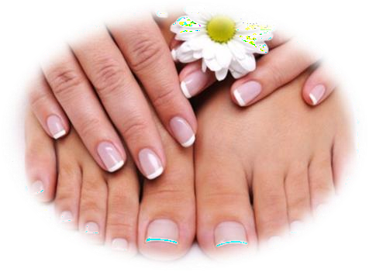
  - MAKEUP
  - HAIRDRESSING / HAIRSTYLE
  - MANICURE / PEDICURE
  - FACIAL AND SKIN CARE TREATMENTS
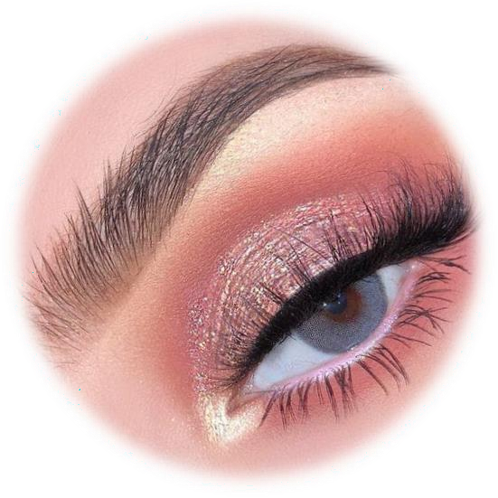
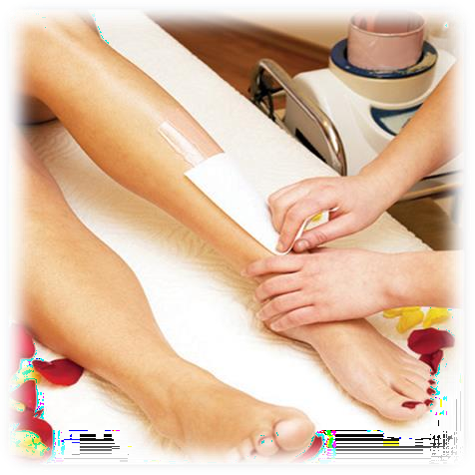
  - HAIR REMOVAL SERVICES
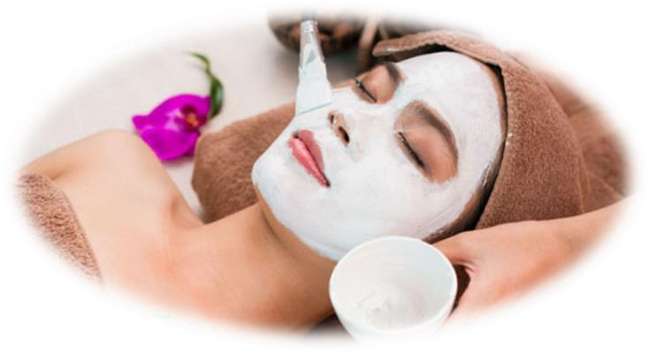

REQUESTINGS

- COURSES TO ACQUIRE THE NECESSARY KNOWLEDGE AND CERTIFICATES
- FIND THE IDEAL PLACE
- ATTRACT PEOPLE INSIDE
- PLEASE THE COSTUMERS
- KEEP THE SALON A FUN ,RELAXING PLACE

PERSONAL DEVELOPMENT PLAN




Learn,work, enjoy


 Purpose

Open my own beauty salon

Specialized courses
Identify development need
Develop an action plan

Execute the plan

Cash Place Equipment System
Record outcomes
Growing bussiness, Run my own bussiness

SWOT ANALYSIS

- Mitivated
- Lots of experience
S
- Impatience
- Anxiety
W
- Active life style
- Parnerships
O
- New competitors in the area
- Price wars with the competitors
T

CONCLUSION

  - 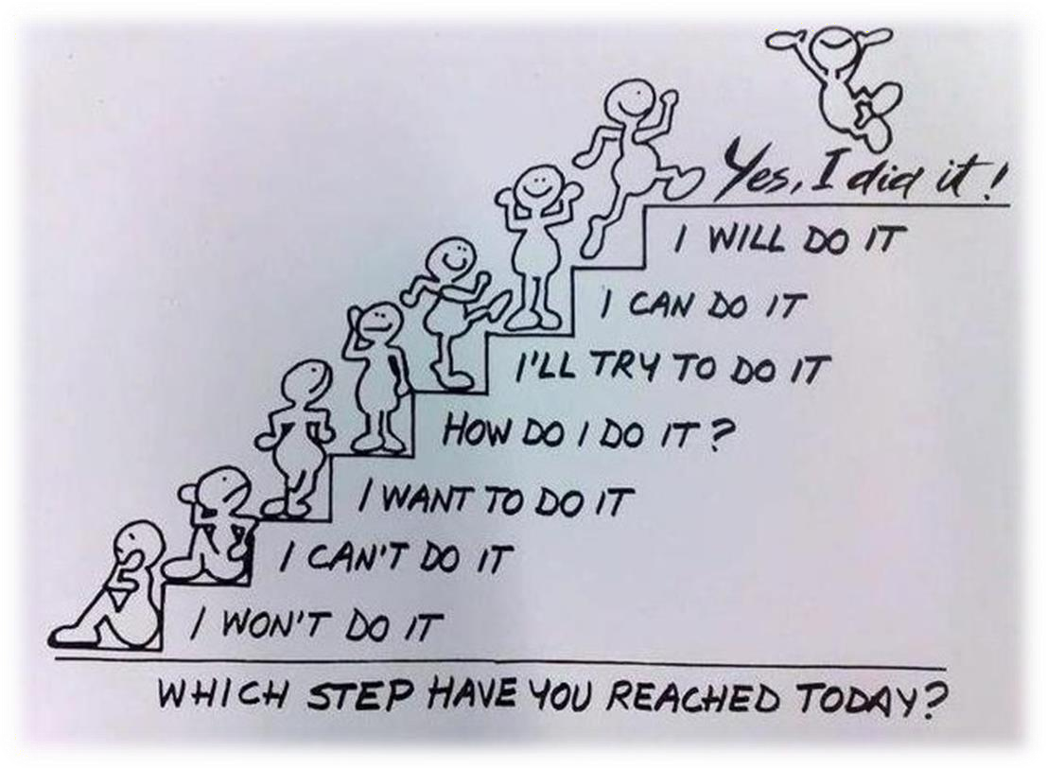INTEND TO FOLLOW SOME PROFESSIONAL COURSES
  - WORK HARD AND SAVE MONEY
  - OPEN THE BEAUTY SALON
  - RUN THE BUSSINESS
  - BE SUCCESSFUL

REFERENCES:
    - TIME TO RELAX, DATE N/D ,TIME TO RELAX WOODEN SIGN ,DEPOSIT PHOTOS, CAN BE FOUND AT: HTTPS://ST2.DEPOSITPHOTOS.COM/3837271/7343/I/950/DEPOSITPHOTOS_73439335-STOCK-PHOTO-TIME-TO-RELAX-WOODEN- SIGN.JPG
    - AMAZON ,DATE N/D ,,BEAUTY SALON MAKEUP WOMEN SILHOUETTE,AMAZON ,CAN BE FOUND AT: HTTPS://WWW.AMAZON.COM/BOODECAL- SILHOUETTE-REMOVABLE-STICKERS-BEDROOM/DP/B01D1BTETW?REF_=D6K_APPLINK_BB_MARKETPLACE#
    - DREAMMASTERPHOTOGRAPHER,,DATE N/D ,,BUSSINESS MAN STEPPING UP TO HIS SUCCESSFUL GOAL ON TOP OF THE STAIIRS,DREAMSTIME,CAN BE FOUND: ATHTTPS://THUMBS.DREAMSTIME.COM/Z/D-BUSINESS-MAN-STEPPING-UP-TO-HIS-SUCCESSFUL-GOAL-TOP-STAIRS-OVER-WHITE- BACKGROUND-44000894.JPG
    - THE MAGAZINE, DATE 2020 ,,CHRISTMAS MAKEUP LOOKS, ,BLOC LTD, CAN BE FOUND AT:
HTTPS://WWW.BLOWLTD.COM/MAGAZINE
    - PINTEREST, DATE 2020 , WELLINGTON HAIR STATELE, ,ALIZURA, CAN BE FOUND AT:
HTTPS://PIN.IT/20FDQQV
    - UK NAILS BAR, DATE N/D ,PEDICURE & MANICURE , ,UK NAILS BAR , CAN BE FOUND AT:
HTTPS://WWW.UKNAILSBAR.CO.UK/PRICES-PEDICURE-MANICURE/
    - SERENITATE SALON SPA &TÂNJIND, DATA N/D , HAIR REMOVAL, SERENITATE SALON SPA &TÂNJIND, CAN BE FOUND AT:
HTTPS://SERENITYCC.COM/
    - DAILY VANITY ,DATE N/D. , ,FACIAL TREATMENTS ,DAILY VANITY , CAN BE FOUND AT :
HTTPS://WWW.BELLAMARIEFRANCE.COM.SG/THEME/IMAGES/ARTICLES/57/DO-YOU-STILL-NEED-FACIAL-TREATMENT-3.JPG
    - ANONIME, DATE 2010 , GOAL STAIRS ,JOYREACTOR ,,VAN BE FOUND AT: FTTTP://JOYREACTOR.COM/POST/283083

