University of Wales Trinity Saint David

Name: Vasyl Kovenia
Student number: 2422023
Course: Certificate of Higher Education in Business Skills for the Workplace.
LCLM4005 Employability and Career Development (LCLM4005_LON)
Lecturer: Jayalakshmi Gopalkrishnan: j.gopalkrishnan@uwtsd.ac.uk

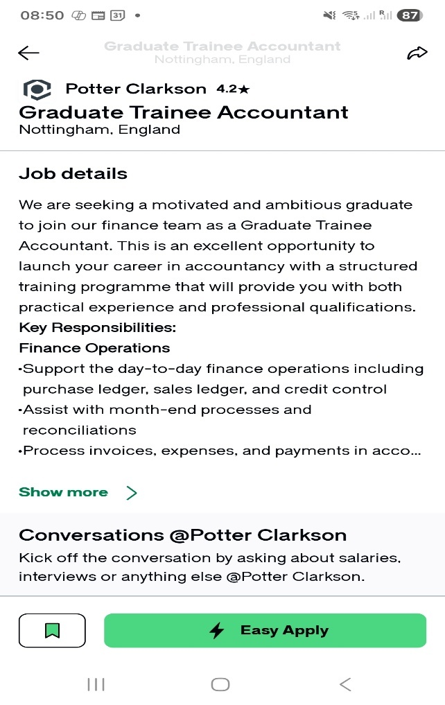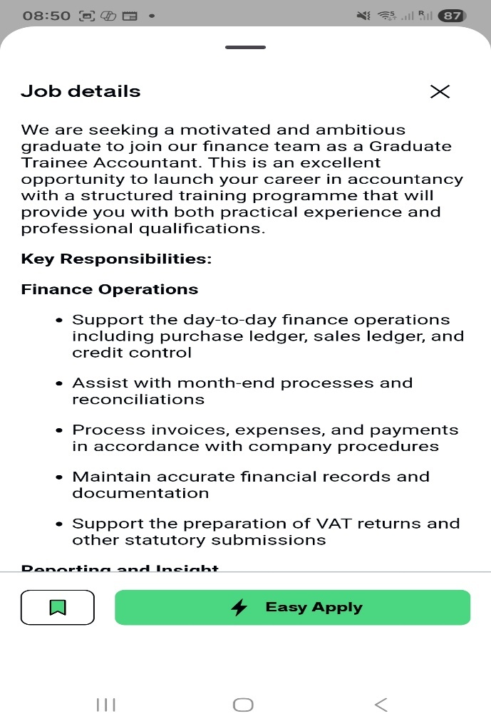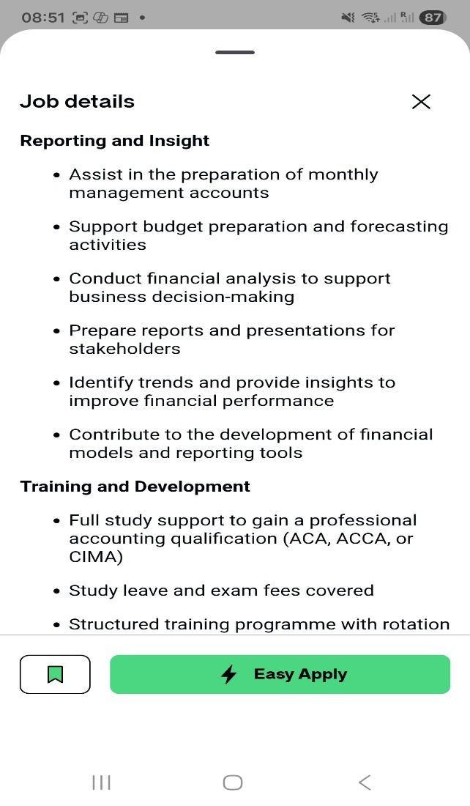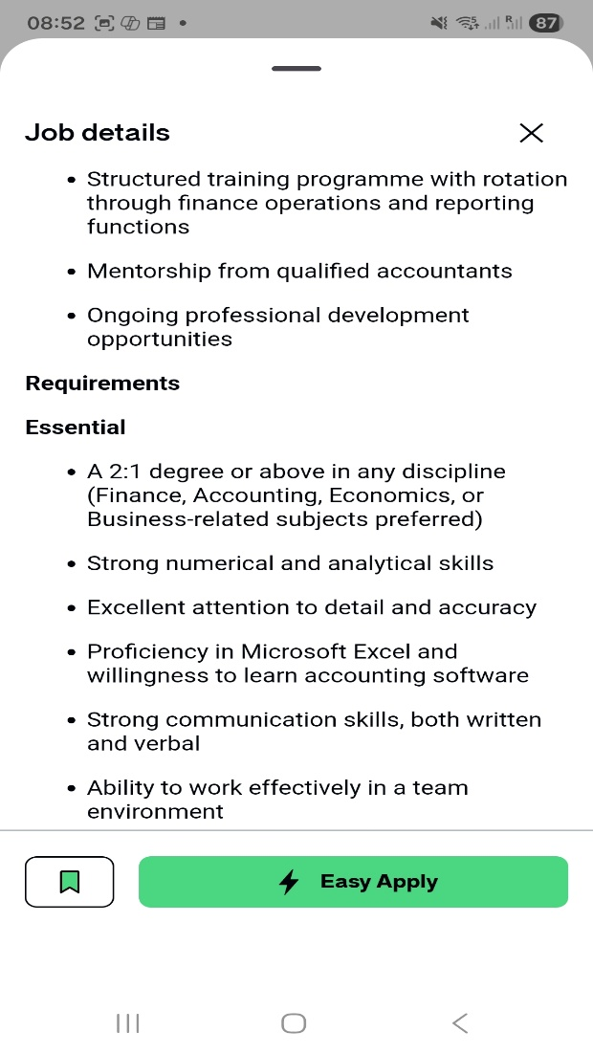
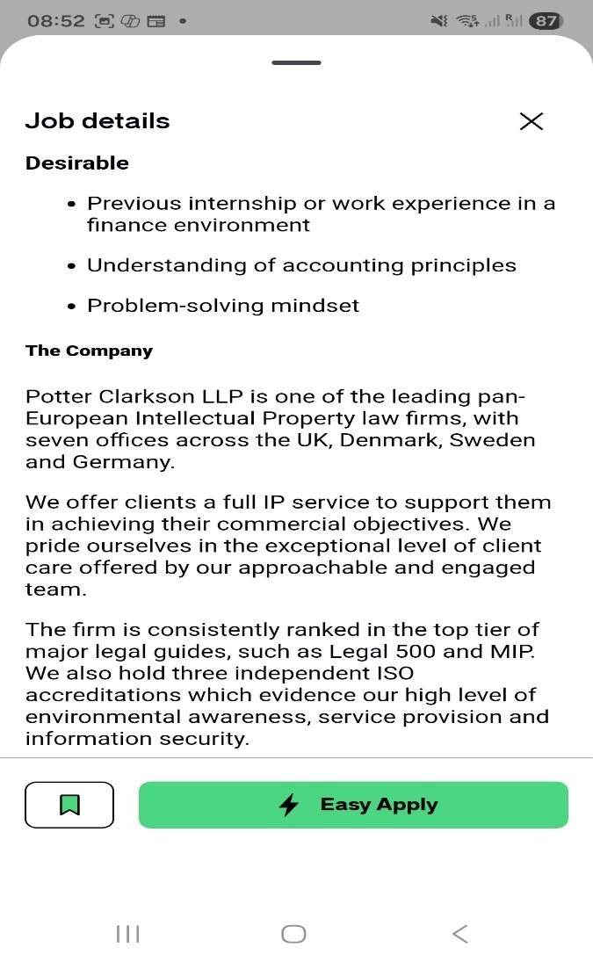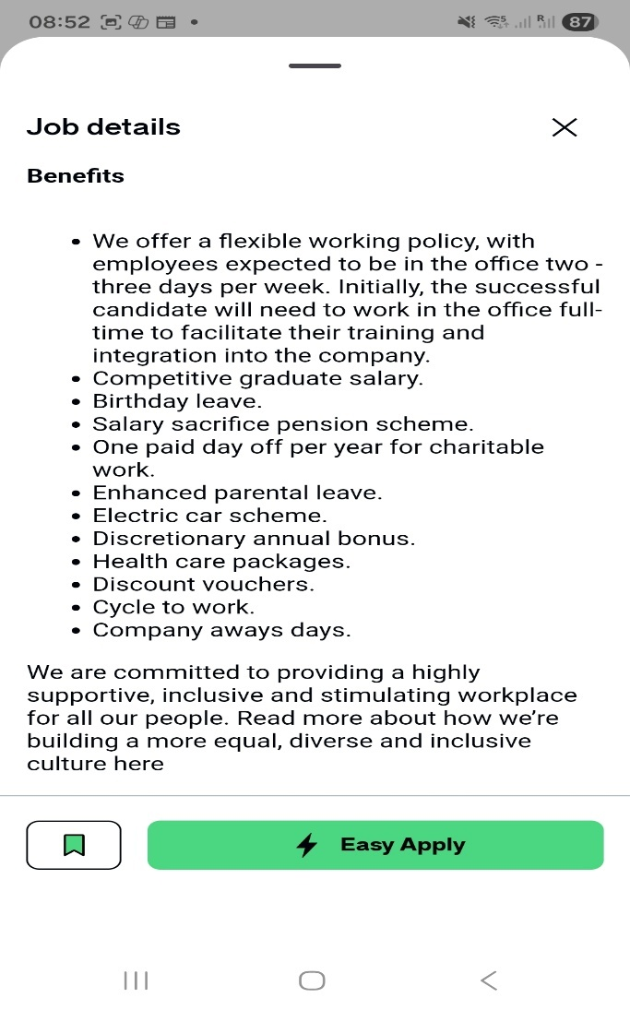

COVER LETTER

Vasyl Kovenia
Address: Derby, Allestree, DE22 2HP
Email: koveniavv@gmail.com
​November 10, 2025
​Hiring Manager
Potter Clarkson
Address: Chapel Quarter, Mount Street, Nottingham, NG1 6HQ |
​
Subject: Application for Graduate Trainee Accountant
​
Dear Manager!

​I am writing to apply for the Graduate Trainee Accountant position at Potter Clarkson. I am very interested in launching my career with your firm. I believe my background in Internal Audit and my ongoing financial training make me a dedicated and capable candidate.
​My Experience and Skills
​For almost three years, I worked as an Internal Auditor with LLC "NEWTON-PROMSERVICE." This job taught me how important it is to be accurate, follow rules, and check that money and processes are handled correctly.
​I checked financial documents and company processes to make sure they followed all the rules.
​I found errors and weak spots in systems and reported them clearly to management.
​I understand the importance of keeping detailed, accurate records and making sure controls are working.
​To move fully into accounting, I have been actively studying:
​I am an AAT Registered Student and serious about getting my professional qualifications.
​I passed the initial exams for a Level 2 Bookkeeping Course. This gave me hands-on skills in processing invoices, managing ledgers, and helping with basic month-end tasks.
​I am also completing a CertHE in Business Skills, which confirms my focus on business management and finance.
​
​I am confident I can quickly handle the tasks of a Trainee Accountant, like assisting with reconciliations and managing invoices. My past work shows I am disciplined and focused on accuracy—qualities that are essential for your finance team.
​I look forward to discussing how my experience and my dedication to professional development will be a great fit for your training programme.
​Thank you for your time and consideration.
​Yours sincerely,
​Vasyl Kovenia

CURRICULUM VITAE

VASYL KOVENIA
​Derby Allestree DE22 2HP | 077 24 255 382 | koveniavv@gmail.com
​

Professional Profile
​Highly motivated and disciplined individual committed to launching a career in accountancy. Possesses a strong professional background in Internal Audit, risk assessment, and detailed compliance, paired with formal training in bookkeeping and business skills. Proactive and dedicated to achieving professional qualifications (AAT Registered), making me ready to take on the core responsibilities of a Graduate Trainee Accountant immediately.
​

Professional Experience
​Internal Auditor | LLC "NEWTON-PROMSERVICE" | Ukraine
​October 2019 – July 2022
- ​Financial Control: Conducted systematic internal audits of financial transactions and operational processes to ensure strict adherence to company standards and regulatory compliance.
- ​Risk Analysis: Specialized in testing and evaluating internal controls to safeguard company assets and ensure the integrity and accuracy of accounting records.
- ​Process Improvement: Analysed financial documentation and operational data to identify discrepancies, control weaknesses, and areas of non-compliance.
- ​Formal Reporting: Prepared and presented clear audit reports detailing findings, assessed risks, and proposed specific corrective actions for management review.
- ​Documentation: Demonstrated a high level of discipline in maintaining meticulous supporting documentation for all audit cycles and compliance reviews.
​

Education and Professional Development
​CertHE Business Skills for the Workplace
​University of Wales Trinity Saint David | February 2025 – Expected Completion: January 2026
- ​Focus areas include Workplace Finance, Business Fundamentals, and Process Management.
​
Professional Accountancy Training
- ​AAT (Association of Accounting Technicians) Registered Student: Actively pursuing formal professional accounting qualifications.
- ​Bookkeeping Course (Level 2): Completed comprehensive coursework and successfully passed initial internal examinations (Derby Adult Learning Service, 2023). Acquired practical skills in supporting month-end processes, general ledger work, and processing invoices.
​Functional Skills & Languages
- ​NCFE Level 1 Functional Skills Qualification in Mathematics: Proves strong competency in foundational numerical concepts essential for accuracy in finance.
- ​English: Fluent | Ukrainian: Native
​
Other Relevant Experience
​Volunteer - Food and Education Enterprise "FEE Cafe"
​April 2022 – August 2022
- ​Assisted with the systematic tracking and distribution of stock inventory and resources.
- ​Maintained rigorous adherence to internal organizational standards and stock management processes.

