Utilising the Entrecomp Framework critically evaluate your own creativity and enterprise and consider how you might be able to develop the creative and enterprising skills of primary learners through your own pedagogy.

Creativity and enterprise skills are important features of life that should be developed throughout school in order for students to become successful within their future careers (Donaldson, 2015: Galloway et al, 2005). Sander (2017) supports this view, as she believes that future employers will ask their workers to have transferable enterprising and creativity skills more often than other skills. This therefore implies that in order to ensure students are successful within their futures, teachers need to develop their enterprise and creativity skills wherever possible. Currently, the Draft New National Curriculum for Wales emphasises that students need to have experiences and opportunities to develop their enterprise knowledge and their creativity skills (Welsh Government, 2019a). In order to proceed within this discussion, it is essential that clear definitions for enterprise and creativity have been identified. Enterprise can be defined as an ‘application of creative ideas and innovations to practical situations’ (The Quality Assurance Agency for Higher Education, 2012, p.8; Rae, 2007). However, Turner (2002) defines enterprise as incorporating entrepreneurship and employability. Arguably, Turner’s (2002) definition is not sufficient for the purposes of this discussion as it focuses on the use of enterprising skills within entrepreneurship not within education. Thus, the definition that will be used throughout this essay for enterprise skills will be the ability to create and implement new innovative ideas used within personal and working life as proposed by Gillie (2012). Creativity, however, can be difficult to define, as there are many differing views and interpretations of it, for example, Ken Robinson (Magee, 2016) defines creativity as “the process of having original ideas that have value” and doing something with these ideas. In contrast to this, Bruner (1962) believes that to be creative, effective surprise is needed, arguably all of these definitions contain similar attributes. For the purposes of this essay, the definition that will be used when creativity is being referred to will be Education Scotland’s (2013) definition, who identify creativity as a process where the ideas that are created have a value for the learner.

The National Advisory Committee on Creative and Cultural Education (NACCCE, 1999) identified a distinction between “teaching creatively” and “teaching for creativity”. Jeffrey and Craft (2004) recognise, “teaching for creativity” as the methods and approaches for developing learner’s creativity, and “teaching creatively” as using imaginative approaches which make learning interesting. The first section of this discussion will focus on my “teaching creatively” skills, and will result in recommendations and strategies I can use to ensure future lessons are carried out through a more creative approach. Whereas, the second section of this discussion will focus on how I am going to promote learner’s creativity, by “teaching for creativity”. Within this section I will provide methods and approaches I will use to encourage learners to develop their own creative and enterprising skills.

Section 1:
Jeffrey and Craft (2001) argue that to teach creatively is to teach effectively, thus supporting the view that teachers need to have some degree of creativity in order to carry out effective lessons. In addition to this, Desailly (2015) believes that in order to enable students to develop their creativity, teachers must first understand their own creativity levels and be able to model this to children. With regards to enterprise skills, Tiernan (2016) emphasises that the role of the teacher is essential and thus their skills should reflect this when they are teaching. Skogen and Sjovoll (2010) suggest that in order for enterprising education to become more effective, teachers should reflect on their own understanding and abilities and use this to strengthen their knowledge for enterprising education. However, it can be argued that these skills may be limited for particular teachers due to their lack of confidence in how they may deliver their lessons, ultimately, if they are unable to deliver the lessons creatively then they may not be effective creative and enterprising educators (Craft, 1997). Therefore, in order to develop my own creativity and enterprising skills I will assess myself using the Entrecomp Framework (Bacigalupo et al., 2016) and from this create personal targets for future practice.

The Entrecomp Framework, ultimately, was designed to bridge the gap between employment and education, which therefore emphasises the importance of educators to acknowledge its existence within schools (Bacigalupo et al, 2016). By providing a clear levelled framework it enables viewers to place themselves within a level, and from this understand how to progress to a higher level within the competence. However, the vast majority of the levels within the framework are aimed towards the progression of entrepreneurship, this is not relevant for the purposes of this discussion as the main focus is upon the development of enterprising and creativity skills. Although, a majority of the framework refers to entrepreneurship, this can be adapted for the development of enterprising and creativity skills for educators, thus making it beneficial for a wide range of people due to its adaptability and flexibility (Bacigalupo et al, 2016). However, it can be argued that this flexibility can have some drawbacks, with reference to the interpretations of each level. This can cause concern as the levels may be interpreted in different ways, thus creating an inaccurate form of assessment as it would need to be assessed for a “best-fit” level. Donaldson (2015) emphasises how this can only provide limited information of someone’s achievement because one aspect may bring the person down a level. In addition to this, I have also come to recognise that the Entrecomp Framework levels have a large difference between, which therefore makes self-assessment slightly challenging as some elements of my own practice fit in with the higher level, this can also cause inconsistencies amongst the levels. With reference to evidencing my capabilities, I have only levelled myself against assessable physical outcomes and achievements, this therefore limits the accuracy of my levels, as some skills may not have physical evidence in place currently. Another limitation to the framework is the wording of some of the level descriptors, these would need to be adapted if a child were to use the framework to assess their own creativity and enterprise skills. Thus, the Entrecomp Framework may not be very effective for the assessment of creativity and enterprise skills of children.

For this self-assessment, I will use the Entrecomp Framework as a starting point for developing both my creativity and my motivation and perseverance competencies as identified within the Entrecomp Framework. I have chosen these competences because research suggests that motivation forms part of the core attributes of a creative person, thus emphasising the need to develop my own motivation (Dacey, Lennon and Lubart, 2000). Hayes (2009) and Hennessey (2010) believe that in order to encourage creativity within the classroom teachers need to motivate their learners as opposed to threaten them. In order to motivate learners to become more creative and enterprising, I must first develop my own motivation. However, Barbot (2016) argues, it is not motivation alone that drives creativity within people, but he argues that it is a combination of things that enable this.

There are five different threads within the Entrecomp Framework that combine together to create the creativity competence, each of these contain different levels of ability which I will use to assess myself. I believe that some of these threads contain similar aspects which may require similar strategies to improve on, therefore some of these threads will be discussed together. The first thread discusses the ability to be ‘curious and open’. Evidence from my Professional Teaching Experience (PTE) suggests that I fit best within Level 2 of this thread, as I have been able to ‘explore new ways to make use of existing resources’ within lessons. This is evidenced within Appendix 1, where I set a task for the learners to create animal paintings without using a paintbrush, I then provided them with a variety of different ‘painting tools’ that are not associated with painting, such as potatoes and carrots. It can be argued that this type of creativity comes from encouraging ‘functional fixedness’ as proposed by Duncker (in Glaveanu, 2015). Duncker (in Glaveanu, 2015) believes that in order to be successful in creativity, a person needs to overcome this. However, I want to increase my ‘curiosity and openness’ further within my teaching and be confident to experiment with my skills in situations that are new to me. This essentially would require me to take more risks within my teaching, although I have proposed risks within my lessons these have not always been carried out. For example, I created a forest school activity for my learners (see Appendix 2), however, due to poor weather I was unable to carry out this lesson, thus preventing me from experiencing teaching within a different learning environment. Biesta (2013) argues that there should always be a degree of risk taking within education and teachers should embrace this within their lessons. In addition to this, Davies et al (2013) and Wood and Ashfield (2008) believe that when a teacher is encouraged to take risks within their lessons, it can enhance not only their own creativity but the student’s creativity too. Heunks (1998) believes that innovation, alongside curiosity, is an important element needed to take-risks. Arguably, a lack of confidence with experimenting with new situations could negatively impact my ability to develop ideas. Currently, I would place myself as a level two for my ‘developing ideas’ thread, evidence from PTE shows that I am able to develop ideas that can create value for others (see Appendix 3). However, in order to progress within this thread, I would need to develop my own innovation and risk-taking skills further. In addition to this, my innovation skills are evidenced to be very weak as I am very cautious and afraid to take risks and experiment with new ideas that I have not used before. Henceforth, I am placing myself as a Level 1 for the innovation thread within the Entrecomp Framework, as I am able to find examples of innovative solutions. This can be shown within some of the lessons that I have done whilst on PTE, for example within Appendix 4, I used an idea that I had found on the internet within my lesson for bee-bots. However, I feel as though the Entrecomp Framework is not effective for assessing one’s innovation skills within education and teaching, as it heavily revolves around entrepreneurship, business and product skills. Thus, in order to gain a deeper understanding of my current innovation level, I used an online test which provided a very detailed and informative set of results on my current innovation level and gave possible progression steps needed to develop (Trendhunter, 2020). The results from the test show that I am very hesitant to try new things and reluctant to move away from my comfort zone, this often restrains me from becoming experiential as a teacher (see Appendix 5). The test revealed that I need to take more chances within my approaches in order to develop, therefore, I will begin to use Eberle’s (1972) SCAMPER model (see Appendix 6) to develop my own risk-taking, innovation and developing ideas threads within my next PTE. This model will enable me to create innovative and creative lesson ideas for my learners (Eberle, 1972), I will use this to develop my divergent thinking during my next PTE. Hussain and Carignan (2016) found that the use of SCAMPER develops students’ creativity a great amount, however, this information may be non-reliable for the purposes of this argument as it discusses the use of the model on learners, as opposed to adults or teachers. Although this is true, this is beneficial to an extent as it can show the impact that the SCAMPER model may have on developing one’s creativity skills. Although this model may be effective for some lessons and activities, this may not always be achievable, this therefore limits the overall effectiveness of it within the classroom. Henceforth, I am aiming to use some of its elements at least once a week within my lessons on my final PTE. In addition to supporting the development of my creativity skills, the SCAMPER model can also be used to enhance my motivation and perseverance skills. Currently, evidence would suggest that I am at an overall Level 2 in Motivation and Perseverance in the Entrecomp Framework, as I am able to learn from previous mistakes and I am beginning to use this to inform future practice. However, in order to progress within this competence even more, I will begin to use the SCAMPER model, alongside good reflective strategies in order to encourage and motivate myself to try new approaches to teaching and provide learners with opportunities to have their lessons delivered through a more creative approach.

The next thread to be assessed from the framework is “defining problems”, I have interpreted this as my ability to recognise and adapt to problems that may arise within the classroom. Currently, I would place myself as a Level 2 as I have been able to explore problems to generate multiple solutions, this can be evidenced from my PTE where I was able to adapt my teaching strategies to suit the needs of different learners with different abilities (see Appendix 7). However, in order to be a successful and creative teacher, I need to develop this by reshaping open ended problems to suit my skills. Arguably, I could achieve this by becoming more flexible and adaptable within my lessons, with regards to structure and how well the lesson is actually going. Craft (1997) argues that a willingness to adapt plans and practice is essential for fostering creativity and becoming a creative practitioner. From one of my PTE observations, it was noted how I was unsuccessful in adapting my lesson to make the learning more accessible for the learners (see Appendix 8), which therefore limits my own creativity as an educator. Arguably, this would not only limit my ability to “define problems”, but it would also limit my ability to achieve a higher level within other threads in the Entrecomp Framework. Currently, within “design value” I am working at a level one as I am able to use objects that produce value within the classroom. For example, I was able to use Numicon to help learners understand the concept of ‘adding on’ within numeracy (see Appendix 9). However, in order to progress I need to develop my skills within adaptation to improve existing products so they meet the learners needs more. Quigley (2016) suggests using an observation from another teacher to provide suggestions on ways to improve and adaptations for next time. Spendlove (2009) also supports the use of this, but he encourages the use of students giving the teacher feedback throughout the lesson. Spendlove (2009) argues that when this is done, it enables the teacher to gain a better understanding of how the students feel about different aspects of the lesson. In addition to this, he also believes that it is essential that feedback is not only given at the end of the lesson, but it should be given throughout. Although this method would enable feedback for adaptability to occur within the lesson, good levels of feedback would only come from students who have trust in their teacher and are able to provide constructive feedback. This would, arguably, be difficult to receive from younger students, therefore, in order for feedback to become successful within a foundation phase setting, adjustments would need to be made to the methods of this approach.

To conclude my personal reflection, it is crucial that teachers need to develop their own creativity and enterprise skills if they want to create learners who are competent in these skills (Skogen and Sjovoll, 2010). Arguably, if a teacher lacks confidence and ability to develop their own creativity and enterprising skills then it would be questionable to assume that they are able to develop learners enterprising and creative skills (Davies, 2000). From my own self-assessment, I have recognised the need to develop my own confidence to enable me to take more risks within the classroom so that I can enable my learners to develop and progress within an engaging and creative learning environment. To achieve this, I will begin to use Eberle’s (1989) SCAMPER model at least once a week to ensure some lessons are more creative and interesting. In addition to this, I will begin to ask for more feedback from my learners and teaching staff with regards to the methods and approaches of my lessons, and use this information to inform future practice which will enable me to make changes and adaptations as necessary to ensure my students are receiving the best possible education which enables them to grow as independent learners who are ready to face the world of work (Miller, 2015).

Section 2:
Donaldson (2015) advocates that creativity and enterprise skills should be placed as core themes within the National Curriculum alongside literacy and numeracy, as he believes that they are central features to modern life, and therefore need to be used more within schools. Arguably, these skills are vital in order to be successful in future and current job prospects within the 21st Century, therefore it is essential that schools are providing learners with these opportunities to develop these skills (Welsh Government, 2019a; World Economic Forum, 2016; Henriksen, Mishra and Fisser, 2016). Shaheen (2010) and Wyse and Ferrari (2015) believe that, once learners are equipped with these skills, they will be successful and thus contribute to the economy, and create a prosperous country. In relation to the educational benefits, teaching for creativity and enterprising skills can promote good behaviour and develop self-esteem within the pupils, as it enables learning to occur through an engaging and enjoyable approach (Qualifications and Curriculum Authority, 2005). However, even with all of these benefits, Dobbins (2009) found that the pressures of national testing and inspections mean that creative and enterprising skills are not being developed as much as they should be within education. Nevertheless, it is crucial that creativity and enterprising skills are developed across the curriculum for learners as it can enable learners to develop resilience (Albert, 1996) and enables children to develop their adaptability to new situations (Collard and Looney, 2014). Therefore, to ensure learners are being provided with an education that enables them to become successful in the working world, it is essential that educators give learners opportunities to develop these skills. Henceforth, this section of the discussion will focus on how I will encourage the development of learners' creative and enterprising skills within the classroom.

To exemplify this, I have decided to focus on the development of the student’s ability to ‘be curious’, as mentioned within the Entrecomp Framework (Bacigalupo et al.,2016). Kagan (1972) defines the act of curiosity as being the need to solve uncertainty, therefore, I have decided to illustrate the development process of curiosity through the Humanities Area of Learning and Experience, as stated within the Draft New National Curriculum for Wales (Welsh Government, 2019b). Whilst on PTE, I observed that teachers were often preventing curiosity within the classrooms, as they were focused on the development of other skills and thus pushed curiosity aside. This became evident as I progressed from Reception to a Year 5 class, the teachers began to dissolve any forms of curiosity students expressed in the upper years of Primary School. Pluck and Johnson (2011) argue that curiosity needs to be enabled within the classroom experiences of a child, they believe it is part of human nature as it develops intrinsic motivation which can be used to enhance learning. Therefore, in order to provide my future class with engaging activities that trigger their intrinsic motivation, I will exemplify the development of curiosity through an Enquiry-Based Approach within the Humanities (Welsh Government, 2019b). Grigg and Hughes (2013) argue that an Enquiry-Based Approach enables learners to develop independence and it provides learners with an eagerness to know more about the Humanities as a whole, thus suggesting this is the best possible approach for developing curiosity and creative thinking within the Humanities.

To begin with, enquiry-based learning is often based around a problem or a question that a learner may have (Grigg and Hughes, 2013). Arguably, when this is based around a real-life problem or scenario, both motivation and curiosity are enhanced (Malmia et al., 2019). As this discussion is focusing on developing learners' curiosity within the Humanities, a prompt for the enquiry could be a class visit to a local castle. This provides strong historical, geographical and religious links for the learners to question and explore. Although the learners will be focusing on developing their creativity skills within the Humanities, the approach can be adapted and transferred for different situations, including current real-world problems (Jonassen and Hung, 2008). An Enquiry-Based Learning approach is often not done by teachers this may be because one of the main aspects requires teachers to “let go” of the control and become facilitators of knowledge (Binson, 2009). This can be quite challenging for teachers who lack confidence in their students and in their own teaching as the learning outcomes can often be quite unpredictable and risky (Blundell, 2019). However, in an attempt to reduce the possibility of the pupils going off track, I will use scaffolded questioning and learning strategies to ensure the learners are on track. Vygotsky (1978) supports scaffolded learning as it enables learners to think for themselves and learn more independently, as opposed to relying on the teacher for information. However, in order to be successful, I will need to be careful in my approach because when scaffolding is not done well, the learning can become indispensable (Smidt, 2010). Once this has been done effectively, the learners will be able to think more independently about problems and any interests they may have about the set task (Elton, 2006). In addition to this, the student-led approach can also encourage motivation and curiosity as the students are able to take the learning where they choose, thus resulting in a sense of ownership (Osborne and Dillon, 2008). It does this, by challenging pupils’ current conceptions which can therefore lead to increased curiosity (Timperley et al., 2007; Ofsted, 2015). Although learning through an Enquiry-Based Approach has many different benefits, there are some limitations to it as well. One of which, is the skills required prior to the activities taking place, Byrne, Rietdijk and Cheek (2016) have recognised that in order for this approach to be most effective learners need to have good speaking, listening, turn-taking, decision making and trusting skills in both their peers and themselves. Arguably, when there is a lack of these skills, the learning situation can become challenging and frustrating for both the teacher and the pupils. Therefore, in order to avoid this, I will gradually build learners skills through small group activities prior to the implementation of the approach, as this will enable them to become familiar with a hands-on approach to learning. Once all of these considerations have been addressed, the students will be able to develop their higher-level thinking skills and therefore, deep learning will happen naturally within a controlled and engaging environment that promotes curiosity within all learners (Indraganti, 2018; Crawford, 2000). As well as promoting curiosity within learners, different environments can also offer opportunity for some pupils to take-risks within their own learning through experimentation (Dewett, 2007).

As mentioned previously, an Enquiry-Based Approach often begins with a problem or a scenario, I have chosen to visit a castle with my learners as an example of developing learners’ curiosity within the Humanities. Amabile (1990) argues that learners' creativity can become excessively enhanced when educators use an environment that encourages exploration and independent work. Dowdell, Gray and Malone (2011) also support the use of a different learning environment to encourage and promote creativity as they offer learners with new surroundings to explore. Scott (2000) argues that enabling learners to explore new learning environments is not usually done by teachers, as they have the perception that creative children are disruptive students. Thus, they will avoid the risk of taking their learners to different learning environments that promote creativity skills, as they fear the learning will become unsuccessful. However, it is important that educators ignore this “fear” and provide their children with opportunities to explore different environments that encourage and foster creativity and enterprise skills.

However, it is important to recognise that not all schools will have access to these facilities or resources, therefore this would limit the effectiveness of the approach within these schools (Dillon et al. 2006). Although, this source comes from a secondary school, the reasoning can be quite valid as not all schools are placed near castles thus an alternative solution would need to be created. Instead of a visit, I could bring elements of a castle into the classroom this could be done using digital technologies such as Virtual Reality (VR) goggles, although this may not be as efficient as a visit, it can still provide learners with an understanding of what a castle may hold. However, Strong-Wilson and Ellis (2007) believe that this can also be successful for developing learners' curiosity as the teacher can provide more guidance in their learning. Arguably, this could ultimately limit the effectiveness of the approach as the learners may not be curious about the items within the classroom. Therefore, I will need to ensure I provide the learners with interesting and worthwhile artefacts and observations on VR goggles. By showing the learners a physical item, it can encourage curiosity surrounding the object, it makes the learning more inviting. However, Raath and Golightly (2017) suggest, wherever possible, using an outdoor or a different learning environment as it can promote curiosity further as it is not a familiar environment. Arguably, the success of the approach is ultimately due to the personal interests of each individual, if it is based around a topic that the learners do not enjoy or have any interest towards then the learning can become ineffective (Engel, 2011). This limitation could be avoided if I was to enable the learners to choose their own topic of interest, as this would ensure that they all feel interested in the learning. Lindholm (2018, p.992) argues that enabling children to have personalised control over their learning, allows them to develop ‘maximism’, which he describes as the ‘lightheartedness that characterises’ various things such as fairy tales and children’s books which is something he views as important in creativity.

Although the Enquiry-Based Approach can be used to develop learners creative thinking and curiosity, Mindham (2005) states that it is important to recognise that no singular approach will provide the best opportunity to develop learners' creativity. Therefore, I am going to exemplify how I could develop learners’ creativity by embedding Habits of Mind within their Humanities lessons (Costa and Kallick, 2000a). Costa and Kallick (2000b) believe that there are sixteen Habits of Mind, they argue that these are visible in all aspects of life as they are the skills and attributes needed to become successful learners and active participants of the world. However, Lucas, Claxton and Spencer (2013) believe that there are five essential Habits of Mind with regards to creativity, these are the following; inquisitive, persistent, imaginative, collaborative and disciplined. Interestingly, the development of these habits can enable the learners to understand how to creatively solve problems that they may encounter. I am going to exemplify how I would develop these Habits of Mind within the Humanities using Roger Van Oech’s (1992) “Whack Pack’s” as prompts. To begin with, Oech’s “Whack Packs” can be used to encourage creative thinking within learners, they consist of four differing colours which each represent the different roles needed within the creative process, these include an explorer, an artist, a judge and a warrior. These cards can be used to encourage learners to think more creatively and question themselves as it encourages divergent thinking (Guastello et al. 1998). Firstly, I would show the learners a small segment of an image, such as a plastic bottle in the sea. They will not be made aware of what the full image could be. From this, I would ask them to use their “whack pack” cards within small groups to try and solve what the full image is, within the groups the learners would assign themselves different roles. Each person would need to focus on their card’s role. This activity could be used as an introduction for a lesson that is based around the environmental impacts that recycling may have on the world. The use of the cards, enable the learners to use some of their creative Habits of Mind to solve a mini-problem. This activity will engage the learner’s curiosity, and it encourages learners to use their inquisitive, imaginative and collaborative Habits of Mind in order to figure out the problem. Although these cards promote creative thinking, sometimes they contradict themselves thus limiting the effectiveness within different scenarios. In addition to this, the activity I have presented would only be effective for older pupils and thus would need to be adapted in order to suit the needs of the younger years.

To conclude, it is essential that learners are encompassed within an environment that supports and facilitates the development of their creativity and enterprising skills (Unsworth, 2001). This environment should be outside of the usual learning area, in order to promote more effective creative thinking skills as the learners will develop a sense of curiosity (Runco, 2014). Throughout this discussion I have made several recommendations to use when completing my final PTE, however, I think a lot of the research I have undertaken has motivated me to use creative methods not just when teaching my students but also in my approaches to new situations. Arguably the future of education is going to be completely different to what it is now, and if the curriculum is ever changing then the teachers and educators need to be adaptable, flexible, creative and enterprising in order to provide the best possible education for learners (Sahlberg, 2009). Through using an Enquiry-Based Learning approach it can enable not only the learners to develop their creativity and enterprise skills, but it can also enable me to develop my own creative thinking and it can also encourage me to use more creative and engaging approaches and methods of teaching any subject. However, I need to be careful with my input when the enquiries take place, in order to ensure learners are learning independently.

Reference List:
Albert, R. (1996) ‘Some reasons why childhood creativity often fails to make it past puberty into the real world’, in Runco, M. (Ed) Creativity from Childhood through Adulthood: the developmental issues. pp. 43–56, San Francisco: Jossey-Bass.

Amabile, T. (1990) ‘Within you, without you: the social psychology of creativity, and beyond’, in Runco, M. and Albert, R. (Eds) Theories of Creativity. New Jersey: Hampton Press.
Bacigalupo, M. et al (2016) EntreComp: The Entrepreneurship Competence Framework. Available at: https://publications.jrc.ec.europa.eu/repository/bitstream/JRC101581/lfna27939enn.pdf (Accessed: 17th January 2020).

Barbot, B. (2016) Perspectives on creativity development. New Directions for Child and Adolescent Development. San Francisco: Wiley Periodicals.

Biesta, G. (2013) The Beautiful Risk of Education. London: Routledge.

Binson, B. (2009) ‘Curiosity-based learning (CBL) program’, US-China Education Review, 6(12), pp. 13-22. Available at: https://files.eric.ed.gov/fulltext/ED511167.pdf (accessed: 17th January 2020).

Blundell, L. (2019) Enquiry-Based Learning. Available at: https://www.liverpool.ac.uk/media/livacuk/centre-for-innovation-in-education/staff-guides/enquiry-based-learning/enquiry-based-learning.pdf (Accessed: 17th January 2020).

Bruner, J. S. (1962) ‘The conditions of creativity’, In Gruber, H.,Terrell, G. and Wertheimer, M. (Eds.), Contemporary approaches to creative thinking, pp. 1–30, New York: Atherton.

Byrne, J., Rietdijk, W. and Cheek, S. (2016) Enquiry-Based Science in the Infant Classroom: ‘letting go’. Available at: https://eprints.soton.ac.uk/390546/2/Early%2520Years%2520Article%2520for%2520eprints.pdf (Accessed: 17th January 2020).

Collard, P. and Looney, J. (2014) ‘Nurturing Creativity in Education’, European Journal of Education, 49(3), pp. 348-364. DOI: 10.1111/ejed.12090 (Accessed: 17th January 2020).

Costa, A. and Kallick, B (2000b) ‘Creating “thoughtful Classroom Environments’, in Costa, A. and Kallick, B. (ed) Activating and Engaging Habits of Mind. California: Association for Supervision and Curriculum Development 2000.

Costa, A. and Kallick, B. (2000a) Discovering and exploring habits of mind. Michigan: Association for Supervision and Curriculum Development, 2000.

Craft, A. (1997) ‘Identity and creativity: educating teachers for postmodernism?’, Teacher Development, 1(1), pp. 83-96. DOI: 10.1080/13664539700200001 (Accessed: 16th January 2020).

Crawford, B. (2000) ‘Embracing the Essence of Inquiry: New Roles for Science Teachers’, Journal of Research in Science Teaching, 37(9), pp. 916-937. Available at: http://www.gso.uri.edu/merl/ARIR2_pdfs/Crawford_2000.pdf (Accessed: 17th January 2020).

Dacey, J., Lennon, K. and Lubart, T. (2000) ‘Understanding Creativity: Mission Impossible?’, Psyccritiques, 45(5), pp.495-497. Available at: https://insights.ovid.com/psyccritiques/psycc/2000/10/000/understanding-creativity/12/01258377 (Accessed: 11th January 2020).

Davies, D. et al. (2013) ‘Creative Learning environments in education - a systematic literature review’, Thinking Skills and Creativity, 8, pp. 80-91. Available at: https://reader.elsevier.com/reader/sd/pii/S187118711200051X?token=F63353B1DF6F6D762AD47CC16E96D2B056582B9C1AA153B71AB98A4D12FA397CFE9300A58E0C3B1F912CCDA1DF94EF96 (Accessed: 7th January 2020).

Davies, T. (2000) ‘Confidence! Its role in the creative teaching and learning of design and technology’, Journal of Technology Education, 12(1), pp.18-31. Available at: https://vtechworks.lib.vt.edu/bitstream/handle/10919/8244/davies.pdf?sequence=1 (Accessed: 17th January 2020).

Desailly, J. (2015) Creativity in the Primary Classroom. 2nd Ed. London: SAGE Publications.

Dewett, T. (2007) ‘Linking intrinsic motivation, risk taking, and employee creativity in an R&D environment’, R&D Management, 37(3), pp. 197-208. Available at: https://onlinelibrary.wiley.com/doi/pdf/10.1111/j.1467-9310.2007.00469.x (Accessed: 17th January 2020).

Dillon, J. et al. (2006) ‘The value of outdoor learning: evidence from research in the UK and elsewhere’, School Science Review, 87(320, pp. 107-111. Available at: http://www.outlab.ie/forums/documents/the_value_of_school_science_review_march_2006_87320_141.pdf (Accessed: 17th January 2020).

Dobbins, K. (2009) ‘Teacher creativity within the current education system: a case study of the perceptions of primary teachers’, Education 3-13, 37(2), pp. 95-104. DOI: 10.1080/03004270802012632 (Accessed: 17th January 2020).

Donaldson, G. (2015) Successful Futures. Available at: https://gov.wales/sites/default/files/publications/2018-03/successful-futures.pdf (Accessed: 3rd January 2020).

Dowdell, K., Gray, T. and Malone, K. (2011) ‘Nature and its influence on Children’s Outdoor Play’, Australian Journal of Outdoor Education, 15(2), pp. 24-35. Available at: https://link.springer.com/content/pdf/10.1007/BF03400925.pdf (Accessed: 17th January 2020).

Eberle, R. (1972) ‘Developing Imagination Through Scamper’, The Journal of Creative Behavior, 6(3), pp. 199-203. Available at: http://lib1.qsm.ac.il/EBERLE-1972-The_Journal-of-Creative-Behavior.pdf (Accessed: 10th January 2020).

Education Scotland (2013) Creativity Across Learning 3-18. Available at: https://education.gov.scot/improvement/Documents/cre39-impact-report.pdf (Accessed: 17th January 2020).

Elton, L. (2006) ‘Assessing Creativity in an unhelpful climate’, Art, Design & Communication in Higher Education, 5(2), pp. 119-130. DOI: 10.1386/adch.5.2.119/6 (Accessed: 17th January 2020).

Engel, S. (2011) ‘Children’s Need to know: Curiosity in Schools’, Harvard Educational Review, 81(4), pp. 625-645. Available at: https://s3.amazonaws.com/academia.edu.documents/7701411/fulltext.pdf?response-content-disposition=inline%3B%20filename%3DChildren_s_Need_to_Know_Curiosity_in_Sch.pdf&X-Amz-Algorithm=AWS4-HMAC-SHA256&X-Amz-Credential=AKIAIWOWYYGZ2Y53UL3A%2F20200119%2Fus-east-1%2Fs3%2Faws4_request&X-Amz-Date=20200119T224128Z&X-Amz-Expires=3600&X-Amz-SignedHeaders=host&X-Amz-Signature=bc5b621c9783add18099e9c7e783402b11741e3e3514a6e9aa945b711016a769 (Accessed: 17th January 2020).

Galloway, L. et al. (2005) ‘Enterprise skills for the economy’, Education and Training, 47(1), pp. 7-17. DOI: 10.1108/00400910510580593 (Accessed: 3rd January 2020).

Gillie, C. (2012) Enterprise education in schools. Social Policy Section, London: House of Commons.

Glaveanu, V. (2019) ‘Functional Fixedness, Creativity and Problem-Solving’, in Glaveanu, V. (ed) The Creativity Reader. New York: Oxford University Press.

Grigg, R. and Hughes, S. (2013) Teaching Primary Humanities. London: Pearson Education Limited.

Guastello, S. et al (1998) ‘Are some cognitive styles more creatively productive than others?’, The Journal of Creative Behaviour, 32(2), pp.77-91. Available at: https://onlinelibrary.wiley.com/doi/pdf/10.1002/j.2162-6057.1998.tb00807.x (Accessed: 18th January 2020).

Hayes, D. (2009) Learning and Teaching in Primary Schools. Exeter: Learning Matters.

Hennessey, B. (2010) ‘The Creativity-Motivation Connection’, in Kaufman, J. and Sternberg, R. (ed.) The Cambridge Handbook of Creativity. Cambridge: Cambridge University Press.

Henriksen, D., Mishra, P., and Fisser, P. (2016) ‘Infusing Creativity and Technology in 21st Century Education: A Systemic View for Change’, Educational Technology & Society, 19 (3), pp. 27–37. Available at: https://punyamishra.com/wp-content/uploads/2016/08/henriksen-Mishra-Fisser-Creativity-ETS2016.pdf (Accessed: 17th January 2020).

Heunks, F. (1998) ‘Innovation, Creativity and Success’, Small Business Economics, 10, pp.263-272. Available at: https://link-springer-com.ezproxy.uwtsd.ac.uk/content/pdf/10.1023/A:1007968217565.pdf (Accessed: 17th January 2020).

Hussain, M. and Carignan, A. (2016) ‘Fourth Graders Make Inventions using SCAMPER and Animal Adaptation Ideas’, Journal of STEM Arts, Craft and Constructions, 1(2), pp. 48-66. Available at: https://scholarworks.uni.edu/cgi/viewcontent.cgi?article=1012&context=journal-stem-arts (Accessed: 11th January 2020).

Indraganti, M. (2018) ‘Enquiry-based learning workshop for deep learning in Middle Eastern classrooms – an action research approach’, Educational Action Research, 26(4), pp. 603-625, DOI: 10.1080/09650792.2017.1379423 (Accessed: 17th January 2020).

Jeffrey, B. and Craft, A. (2001) ‘The universalization of creativity in education’, in Craft, A., Jeffrey, B. and Leibling, M. (ed) Creativity in Education. London: Continuum.

Jeffrey, B. and Craft, A. (2004) ‘Teaching creatively and teaching for creativity: distinctions and relationships’, Educational Studies, 30(1), pp. 77-87. DOI:10.1080/0305569032000159750 (Accessed: 18th January 2020).

Jonassen, D. and Hung, W. (2008) ‘All problems are not equal: Implications for Problem-Based learning’, Interdisciplinary Journal of Problem-Based Learning, 2(2), pp. 6-28. Available at: https://doi.org/10.7771/1541-5015.1080 (Accessed: 18th January 2020).

Kagan, J. (1972) ‘Motives and development’, Journal of personality and social psychology, 22(1), p.51-66. Available at: https://web-b-ebscohost-com.ezproxy.uwtsd.ac.uk/ehost/pdfviewer/pdfviewer?vid=1&sid=5483fd03-7fd5-45ca-9d28-337d76dc6825%40sessionmgr101 (Accessed: 16th January 2020).

Lindholm, M. (2018) ‘Promoting Curiosity?’, Science and Education, 27, pp.987-1002. Available at: https://link.springer.com/content/pdf/10.1007%2Fs11191-018-0015-7.pdf (Accessed: 16th January 2020).

Lucas, B., Claxton, G. and Spencer, E. (2013) ‘Progression in student creativity in school: first steps towards new forms of formative assessments’, OECD Education Working Paper No. 86, Paris: OECD.

Magee, K. (2016) Ken Robinson: ‘You don’t want a caste system for creativity. Available at: https://www.campaignlive.co.uk/article/ken-robinson-you-dont-want-caste-system-creativity/1403876 (Accessed: 17th January 2020).

Malmia, W. et al. (2019) ‘Problem-based Learning as an effort to improve student outcomes’, International Journal of Scientific & Technology Research, 8(9), pp.1140-1143. Available at: https://s3.amazonaws.com/academia.edu.documents/60752576/Problem-based-Learning-As-An-Effort-To-Improve-Student-Learning-Outcomes20190930-117399-1pl5fdu.pdf?response-content-disposition=inline%3B%20filename%3DProblem-Based_Learning_As_An_Effort_To_I.pdf&X-Amz-Algorithm=AWS4-HMAC-SHA256&X-Amz-Credential=AKIAIWOWYYGZ2Y53UL3A%2F20200119%2Fus-east-1%2Fs3%2Faws4_request&X-Amz-Date=20200119T212244Z&X-Amz-Expires=3600&X-Amz-SignedHeaders=host&X-Amz-Signature=c01971ab7600d40ebab86b3600264a532c83ff3013ce0b8e1ba4eff4319cb9c4 (Accessed: 17th January 2020).

Miller, D. (2015) ‘Cultivating Creativity’, The English Journal, 104(6), pp. 25-30. Available at: https://www.jstor.org/stable/pdf/24484423.pdf (Accessed: 17th January 2020).

Mindham, C. (2005) ‘Creativity and the young child’, Early Years, 25(1), pp.81-84. DOI: 10.1080/09575140500043245 (Accessed: 17th January 2020).

National Advisory Committee on Creative and Cultural Education (NACCCE). (1999) All our futures: creativity, culture and education. London: DfEE.

Oech, R. (1992) Creative Whack Pack. Stamford: US Games Systems Inc.

Office for Standards in Education (Ofsted) (2015) Handbook for Inspecting Schools in England. Manchester: HMSO

Osborne, J. and Dillon, J. (2008) Science Education in Europe: Critical Reflections. London: Nuffield Foundation.

Pluck, G. and Johnson, H. (2011) ‘Stimulating curiosity to enhance learning’, GESJ: Education Sciences and Psychology, 2(19), pp. 24-31. Available at: http://eprints.whiterose.ac.uk/74470/ (Accessed: 17th January 2020).

Qualifications and Curriculum Authority (2005) Creativity: Find it! Promote it! London: QCA/DfEE.

Quigley, A. (2016) The Confident Teacher. Oxon: Routledge.

Raath, S. and Golightly, A. (2017) ‘Geography Education Students' Experiences with a Problem-Based Learning Fieldwork Activity’, Journal of Geography, 116(5), pp. 217-225, DOI: 10.1080/00221341.2016.1264059 (Accessed: 17th January 2020).

Rae, D. (2007) ‘Connecting enterprise and graduate employability: Challenges to the higher education culture and curriculum?’, Education and Training, 49(8/9), pp. 605-619. DOI: 10.1108/00400910710834049 (Accessed: 3rd January 2020).

Runco, M. (2014) Creativity. 2nd Ed. London: Academic Press.

Sahlberg, P. (2009) ‘The role of education in promoting creativity: potential barriers and enabling factors’, in Villalba, E. (ed) Measuring Creativity. Ispra: European Union.

Sander, L. (2017) In the workplace of the future, these are the skills employers want. Available at: https://www.weforum.org/agenda/2017/03/in-the-workplace-of-the-future-these-are-the-skills-employers-want (Accessed: 3rd January 2020).

Scott, G. (2000) ‘Understanding and achieving successful change in adult education’, in Foley, G. (ed) Praise for the first edition of Understanding Adult Education and Training. London: Allen and Unwin.

Shaheen, R. (2010) ‘Creativity and Education’, Creative Education, 1(3), pp. 166-169. DOI:10.4236/ce.2010.13026 (Accessed: 17th January 2020).

Skogen, K. and Sjovoll, J. (2010) Creativity and Innovation: Preconditions for Entrepreneurial Education. Trondheim: Tapir Academic Press.

Smidt, S. (2010) Key issues in early years education. 2nd Ed. Oxon: Routledge.

Spendlove, D. (2009) Putting Assessment for Learning into Practice. London: Continuum International Publishing Group.

Strong-Wilson, T. and Ellis, J. (2007) ‘Children and Place: Reggio Emilia’s Environment As Third Teacher’, Theory into Practice, 46(1), pp.40-47. Available at: https://www.jstor.org/stable/40071632 (Accessed: 17th January 2020).

The Quality Assurance Agency for Higher Education (2012) Enterprise and entrepreneurship education: Guidance for UK higher education providers. Available at: https://moodle.uwtsd.ac.uk/pluginfile.php/184473/mod_resource/content/1/enterprise-entrepreneurship-guidance.pdf (Accessed: 3rd January 2020).

Tiernan, P. (2016) ‘Enterprise education in initial teacher education in Ireland’, Education and Training, 58(7/8), pp. 849-860. Available at: http://doras.dcu.ie/23287/1/Enterprise%20Education%20in%20Initial%20Teacher%20Education%20-%20no%20author%20v3.pdf (Accessed: 10th January 2020).

Timperley, H. et al. (2007) Teacher Professional Learning and Development: best evidence synthesis iteration. Wellington: New Zealand Ministry of Education.
Trendhunter (2020) Innovation Assessment. Available at: https://www.trendhunter.com/innovation-assessment?ref=4051d2fc1f17cea4832e25678a15be88 (Accessed: 17th January 2020).

Turner, D. (2002) Employability skills development in the United Kingdom. Available at: https://www.ncver.edu.au/__data/assets/file/0022/9751/employability-skills-development-777.pdf (Accessed: 3rd January 2020).

Unsworth, K. (2001) ‘Unpacking Creativity’, The Academy of Management Review, 26(2), pp.289-297. Available at: https://www.jstor.org/stable/pdf/259123.pdf (Accessed: 17th January 2020).

Vygotsky, L. (1978) Mind in Society. Cambridge: Harvard University Press.

Welsh Government (2019a) A Guide to Curriculum for Wales 2022. Available at: https://hwb.gov.wales/storage/f8f9760c-64a1-48ea-80fd-db130ad9050b/a-guide-to-curriculum-for-wales-2022.pdf (Accessed: 3rd January 2020).

Welsh Government (2019b) Humanities. Available at: https://hwb.gov.wales/storage/cc0ec1e5-dbd1-4137-8811-5c88742dc3f3/draft-statutory-guidance-humanities.pdf (Accessed: 17th January 2020).

Wood, R. and Ashfield, J. (2008) ‘The use of the interactive whiteboard for creative teaching and learning in literacy and mathematics: A case study’, British Journal of Educational Technology, 39(1), pp. 84-96. DOI: 10.1111/j.1467-8535.2007.00703.x (Accessed: 7th January 2020).

World Economic Forum (2016) New Vision for education: Fostering Social and Emotional Learning through Technology. Available at: http://www3.weforum.org/docs/WEF_New_Vision_for_Education.pdf (Accessed: 17th January 2020).

Wyse, D. and Ferrari, A. (2015) ‘Creativity and education: comparing the national curricula of the states of the European Union and the United Kingdom’, British Educational Research Journal, 41(1), pp.30-47. DOI: 10.1002/berj.3135 (accessed: 17th January 2020).

Appendices

Appendix 1:
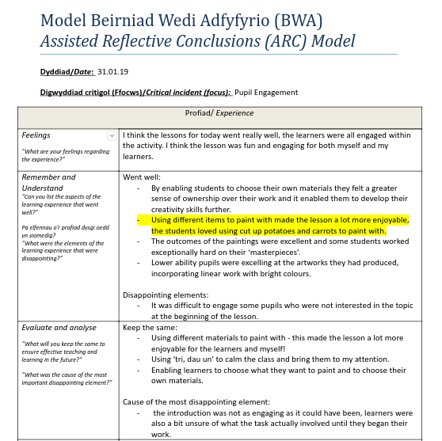

Appendix 2:
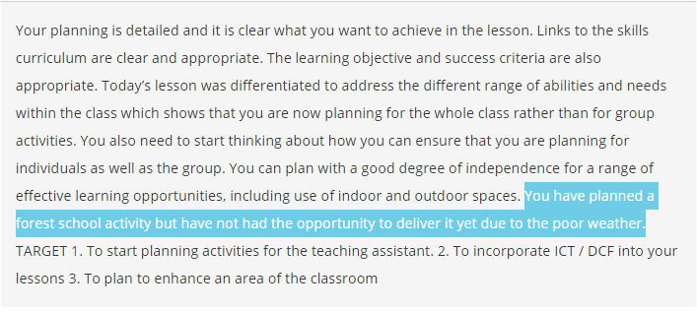

Appendix 3:
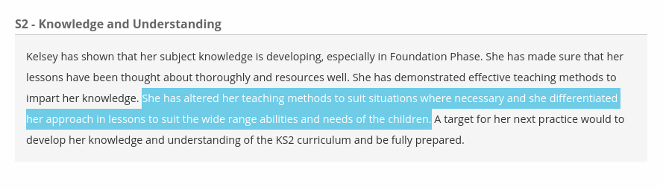
Appendix 4:
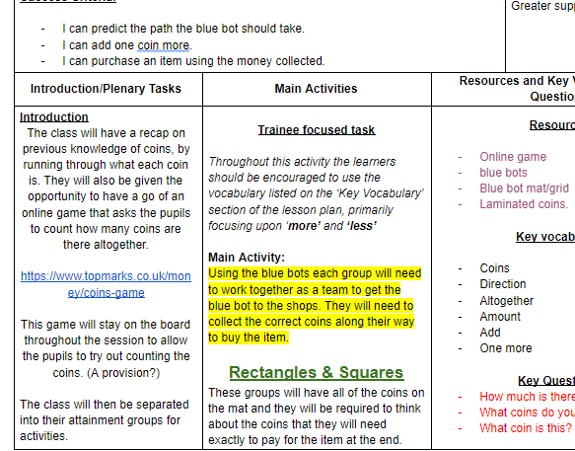

Appendix 5:
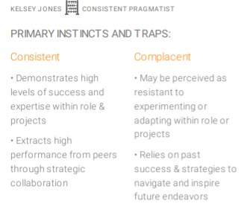
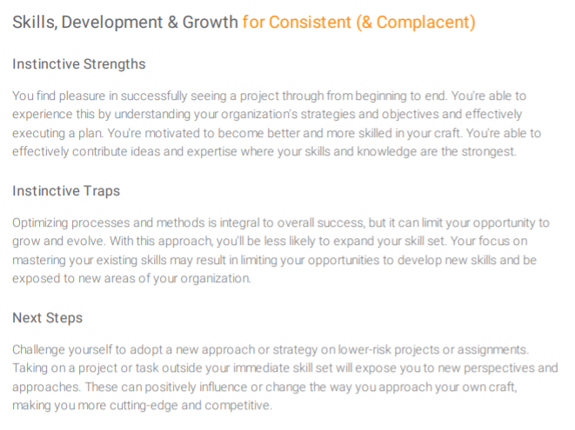
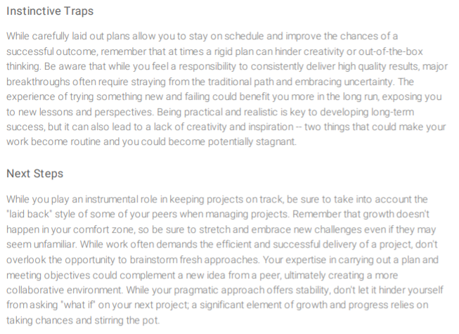
(Trendhunter, 2020)

Appendix 6:

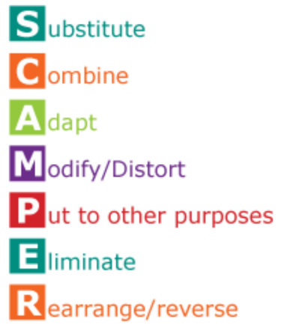
(Eberle, 1972)

Appendix 7:

Appendix 8:
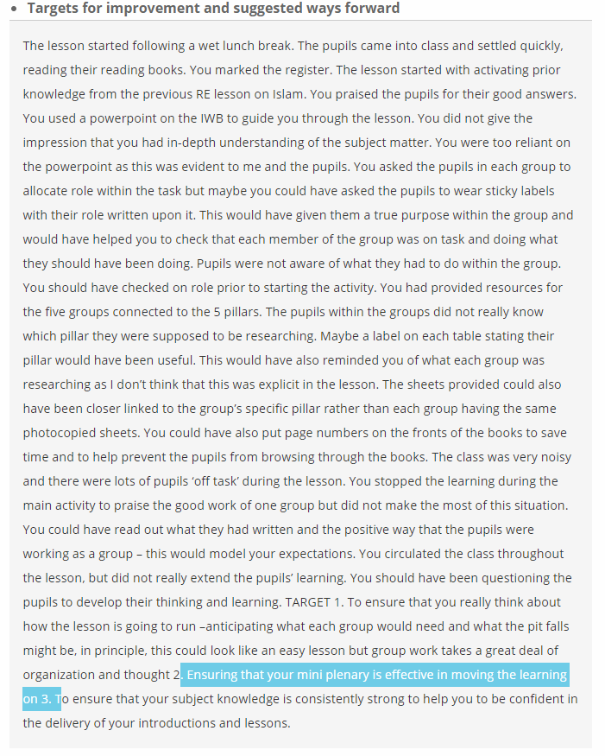

Appendix 9:


