Problem Solving and Decision Making

Executive Summary
The stated problem of the GSK Company that is lack of motivation and job satisfaction among the production department’s staffs is putting a range of negative impact on the overall performance of the company and the job commitment of the staffs. In order to solve the problem that is depicted in this study, a range of data and information regarding the problem has been discovered. From the analysis of the problem and scenarios of the GSK Company, it was evident that the GSK Company has a substantial gap in the HRM practices. That’s why the level of motivation and job satisfaction of the staffs are decreasing day by. However, the company could solve the problem by taking a range of alternative solutions in its performance and HRM practices. However, in order to solve the problem that is outlined in the study should be solved using a range of decision-making tools and techniques. This study analyses the work based problem and their solution as well as a plan implementation strategy.

Contents
Executive Summary 2
Introduction 4
Overview of the company and problem statement 5
Scope and impact of the problem 5
Analysing a range of information regarding the problem 7
Alternative solutions to the identified problem 9
Applying decision making tools to evaluate the solutions 10
Brainstorming and decision making 10
Ishikawa diagram 12
SWOT analysis 14
PESTLE analysis 16
Solution implementation plan 17
Plan communication tactics 18
Appropriate monitoring and review techniques for implementing the plan 19
Conclusion 21
Reference 22

Introduction
A range of problems arises on the day to day work activities of a company which should be solved using appropriate problem-solving tools and techniques. The tools and techniques should be implemented properly for finding an appropriate solution. This study has been designed and structured in order to identify a work based problem and identify the solution and solution to implement the solution properly.

Overview of the company and problem statement
Problem-solving and decision making is a crucial skill in the organisation which supports the organisation in order to solve work-based problems and create harmony in the workplace. For this reason, the managers responsible for formulating strategies and plan in order to solve the problems that derive in normal work procedures. However, this study has been formulated and structured in order to analyse and solve a work-based problem of the GSK Company which was founded in 2000. The company produces pharmaceutical products such as generic drugs, vaccines, medical equipment and all other pharmaceutical products. However, the company serves worldwide and has operations in more than 120 countries across the world. Therefore, the company is in the second position in the UK in terms of revenue generation in the UK(Data.gsk.com, 2019). Recently, the company has discovered that the production efficiency of the production operation department has declined. The investigation discovered that the previously the production staff could deliver around 10 units of products in an hour which has reached to 7 units per hour. However, further investigation discovered that the employees are lack of motivation and not satisfied with the job. That is why due to less commitment to the job, the employee turnover rate is also high for the company(Data.gsk.com, 2019). That is why lack of motivation and lack of job satisfaction has become a potential problem for the company in order to improve the production efficiency of the production department.

Scope and impact of the problem
The stated problem of the GSK Company that is lack of motivation and job satisfaction among the production department’s staffs is putting a range of negative impact on the overall performance of the company and the job commitment of the staffs. However, the scope and impact of the problems are described in the following section-
Lower production: due to lower job satisfaction and lower job motivation among the staffs, the production of the company is largely impacted and reduced (Schmidle, 2011). That is why; the GSK company is concerned with the issue because the production has reduced to 7 units per hour from 10 units per hour. As a result, the supply chain of the company is hampered and managing the large market all over the world becoming difficult for the company.

Figure: Scope and impact of the problem
Source: (Author)
Rising operating cost: Lower production causes higher operating cost and it is as usual for any company. Moreover, the larger unused capacity of the company incurring a huge cost for the GSK company because it raises the production cost as well as an operating cost. That is why; the profitability of the company is also being lowered due to a higher cost structure.
Lower job commitment: The job commitment of the employees derives from a higher level of motivation and job satisfaction. As the motivation level and job satisfaction level are higher for the GSK company, the staffs are less committed to their job so that they can bring out highest performance for the betterment of the company (Philips, 2018). The impact of lower job commitment is very adverse for the GSK company because they don’t drive any pressure or internal commitment to achieving the goals and objectives of the company. As a result, the company fail s to reach its goals and established that are planned and budgeted within the period.
High Employee turnover: Another impact of the lower motivation and lower job satisfaction of the staffs is high turnover or churning of the staff from the GSK company. As a result, the GSK company is losing its potential employees and staffs due to lower motivational tools and the consequent lower job satisfaction. On the other hand, higher employee turnover also causing the GSK company in order to incur high cost in newer employee recruitment and selection, training and development, placement etc. As a result, a cost burden is imposed on the company which ultimately lowering the profitability of the GSK company.
Lower profitability: Lower profitability is the combined impact of the lower level of motivation and lower job satisfaction. The GSK Company has to face lower profitability from operations due to lower production of the goods(Denby, 2010). On the other hand, the cost structure of GSK has increased due to huge unused production capacities. Moreover, the employee turnover due to less motivation and less job satisfaction also imposing a cost on the company. All of the cost is reducing the profitability of GSK Company.
Strategic impact: The GSK Company historically has adopted a cost leadership strategy so that it can serve the products at cheaper prices compared to its competitors. As a result, the GSK Company has been able in order to capture a large market share within a very short time. Moreover, it was one of the competitive advantages for the company. However, due to the high-cost structure and lower level of production, the company is failing to maintain the strategy. That is because; the company has lost its economies of scale capabilities in the production process which supports lower production. So, the company will have to revise its strategy and lose a significant market share due to the loss of potential market and customers.

Analysing a range of information regarding the problem
In order to solve the problem that is depicted in this study, a range of data and information regarding the problem has been discovered. However, the analysis of the information is described to show the reasons for the problems.
Uncompetitive compensation: It is recognised that the GSK Company don’t provide competitive compensation to its staffs. According to the pay report of the company, the salary of the staffs is average and lower to the dire competitors such as Pfizer, AG Bayer, Johnson and Johnson etc. As a result, the staffs are not getting the extrinsic motivation that can enhance their job satisfaction and motivates to work for the betterment of the company(Abbot, 2014). On the other hand, the GSK Company don’t have an Employee Ownership Plan (EOP) which most of the competitors now have that enhance the level of motivation for enhancing their performance. That is why the employees in the production department are lacking motivation and job satisfaction.
Negative work environment: According to research, it was evident that the work culture and work environment of the GSK Company is negative in nature. That is because workplace bullying and harassment also exist in the organisation. For this reason, the motivation level of the employee is lower and hence the lower job satisfaction. Moreover, the GSK employees at the lower level have to face punishment for obtaining the goals and objectives that also decreasing the job satisfaction of the staffs.
Lack of training and development: In recent times, the GSK Company is facing lower productivity and lower profitability as a result. However, it is derived from the lack of the level of motivation and job satisfaction of the production department staffs and employees(Jones, 2016). Therefore, one of the reasons for the lower level of motivation and lower job satisfaction is the lack of training and development of the staffs. It is historically proved that the training and motivation programs increase the job satisfaction and motivation of the staffs. As a result, the staffs can bring out their all-out efforts in order to obtain the organisational goals and objectives.
Lower career growth: The GSK Company is providing with the staffs of the company with a lower level of career growth and sustainable promotional practices. As a result, the staffs are fear of their career in the organisation. On the other hand, the job security of the staffs is not strengthened enough and for this reason, the staffs are consistently scared regarding the security of the job of the staffs. However, all of the factors are motivational drivers for the lower level staffs which are absent in the organisation. So, the staffs of the production department are not being motivated in order to work for the betterment of the company with their all-out efforts.
No performance recognition initiatives: The Competitors of the GSK Company are adopting a range of techniques for performance appraisals of the staffs and rewarding the most interactive and efficient staffs within the organisation(Perkins et al., 2017). However, Key Performance Indicators (KPI), Balanced Score Cards (BSC) etc can be used for selecting the most potential staffs. Therefore, there are no such practices within the GSK Company. On the other hand, Pfizer uses competency-based payment practices and Employee ownership plan in the organization that motivates the staffs to a great extent. So, the GSK Company has lacked in its human resource management practices and strategies that support to improve the motivation level of the staffs and enhance their job satisfaction.

Alternative solutions to the identified problem
From the analysis of the problem and scenarios of the GSK Company, it was evident that the GSK Company has a substantial gap in the HRM practices. That’s why the level of motivation and job satisfaction of the staffs are decreasing day by. However, the company could solve the problem by taking a range of alternative solutions in its performance and HRM practices. They are shown in the following section.
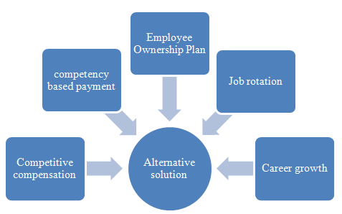
Figure: Alternative solution to a given problem
Source: (Tornquist, 2010)
Providing competitive compensation: It is evident from the research that the GSK company is not providing the staffs with competitive compensation to the lower level employees such as production staffs. The company large focus on the minimum wage regulation of the government in paying these staffs (Tornquist, 2010). As a result, the staffs working in the production department are demotivated as the staffs of other department are getting better compensation compared to them. This unfair policy not only demotivating the staffs but also reducing the job satisfaction of the staffs. As a result, the company should pay competitive and fair play to the staffs working in the production department.
Providing competency-based payment: Competency-based payment is another tool that supports the GSK Company in order to enhance the motivational level and the job satisfaction of the staffs. However, in this payment model, the employees are paid according to his or her performance and competencies(Marwala, 2016). In this payment model, the highest performance is rewarded, on the contrary, the poor performance is punished. As a result, the employees are endeavours in order to enhance their performance within the scope.
Providing employee ownership plan: Another effective tool and solution for solving the problem of GSK Company’s lower productivity is to provide the employee with the ownership plan. However, in this solution, the employees will be provided with the ownership programs. As a result, the employees will be satisfied and endeavours to enhance the performance of the company.
Job rotation and improved work culture: Job satisfaction and motivation are largely dependent on providing the training and development to the staffs and implementing the job rotation strategies(Putman and Paulus, 2010). That is because the employees become bored and monotony due to doing a task over and again. That is why job rotation opportunities should be provided to the employees.
Job security and sustainable career growth: Another possible solution for solving the problem is providing the staffs with job security and sustainable career growth. As a result, the employees will not be remaining in fear of job lay off. On the other hand, the employees should be provided with opportunities for promotions and career growth. Moreover, they will be provided with sustainable pension and gratuity programs. However, all these solutions discussed in the study will be supportive enough in order to solve the problems of lower motivation and lower job satisfaction as well as lower productivity of the employees.

Applying decision-making tools to evaluate the solutions
However, in order to solve the problem that is outlined in the study should be solved using a range of decision-making tools and techniques. However, the possible and implementable tools and techniques are depicted in the following section.

Brainstorming and decision making
Brainstorming and decision making are one of the vital tools for solving the problems that are existed in the GSK Company(Puman and Paulus, 2010). However, it is a systematic approach through the problem is analysed and a sustainable and everybody accepted decision is accepted for solving the problem. However, the brainstorming is a circular approach which is adopted step by step in order to reach in a decision. The steps are described here-
Arranging session: The first step of the brainstorming approach is to arrange a session comprising the departmental managers who are aware of the problem and have deep knowledge regarding it. However, the sessions generally held in a round table so that everyone can see the face of everyone.

Figure: Brainstorming and decision-making stages
Source: (Putman and Paulus, 2010)
Briefing of the problem: At the beginning of the session, the chairperson of the session provides a brief introduction of the problem and the impact of the problem that is imposing upon the company(Noordman, 2012). For this reason, the participants of the session get insight regarding the problem and can generate ideas conveniently.
Generating ideas: In the next step, generating ideas or solutions is a vital option for the members of the session. As part of the idea generation process, the members of the session generate a long range of ideas for solving the problems. The chairperson of the session records the ideas and leaves them for and against argument on the solution.
The argument on the ideas: After generating a long range of ideas, the members of the session provide for and against argument on the ideas. However, the session participants discuss the advantages and disadvantages of the ideas and solutions for finding the best alternative solution among the generated ideas.
Selecting an appropriate solution: However, the next and final step of brainstorming and idea generation session is to generate the best alternative solution from a range of solutions that are generated. The solution is accepted by all session members and obtained the highest weight among others.

Ishikawa diagram
Ishikawa model diagram is described as the fishbone diagram or the root cause analysis diagram is a unique model that supports in order to breakdown the problem and identify the root causes of a problem. It is recognised that the GSK Company don’t provide competitive compensation to its staffs. According to the pay report of the company, the salary of the staffs is average and lower to the dire competitors such as Pfizer, AG Bayer, Johnson and Johnson etc. As a result, the staffs are not getting the extrinsic motivation that can enhance their job satisfaction and motivates to work for the betterment of the company (Istikomah, 2017). On the other hand, the GSK Company don’t have an Employee Ownership Plan (EOP) which most of the competitors now have that enhance the level of motivation for enhancing their performance. That is why the employees in the production department are lacking motivation and job satisfaction. According to research, it was evident that the work culture and work environment of the GSK Company is negative in nature. That is because workplace bullying and harassment also exist in the organisation. For this reason, the motivation level of the employee is lower and hence the lower job satisfaction. Moreover, the GSK employees at the lower level have to face punishment for obtaining the goals and objectives that also decreasing the job satisfaction of the staffs.

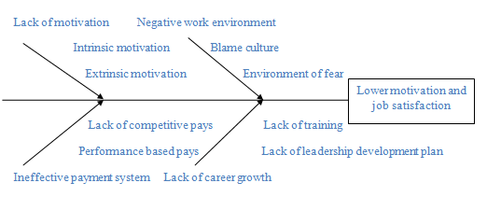
Figure: Ishikawa model or fishbone diagram
Source: (Istikomah, 2017)
Lack of training and development: In recent times, the GSK Company is facing lower productivity and lower profitability as a result. However, it is derived from the lack of the level of motivation and job satisfaction of the production department staffs and employees. Therefore, one of the reasons for the lower level of motivation and lower job satisfaction is the lack of training and development of the staffs. It is historically proved that the training and motivation programs increase the job satisfaction and motivation of the staffs. As a result, the staffs can bring out their all-out efforts in order to obtain the organisational goals and objectives. The GSK Company is providing with the staffs of the company with a lower level of career growth and a sustainable promotional practice (Istikomah, 2017). As a result, the staffs are fear of their career in the organisation. On the other hand, the job security of the staffs is not strengthened enough and for this reason, the staffs are consistently scared regarding the security of the job of the staffs. However, all of the factors are motivational drivers for the lower level staffs which are absent in the organisation. So, the staffs of the production department are not being motivated in order to work for the betterment of the company with their all-out efforts. The Competitors of the GSK Company are adopting a range of techniques for performance appraisals of the staffs and rewarding the most interactive and efficient staffs within the organisation. However, Key Performance Indicators (KPI), Balanced Score Cards (BSC) etc can be used for selecting the most potential staffs(O’Neil et al., 2012). Therefore, there are no such practices within the GSK Company. On the other hand, Pfizer uses competency-based payment practices and Employee ownership plan in the organization that motivates the staffs to a great extent. So, the GSK Company has lacked in its human resource management practices and strategies that support to improve the motivation level of the staffs and enhance their job satisfaction.

SWOT analysis
SWOT analysis provides opportunities in order to analyse the internal capabilities of the GSK Company in order to solve the identified problem that is discussed in the previous section. However, in order to increase the productivity of the employee through enhancing motivation and job satisfaction, the internal capabilities are imperative for the company. However, the threats and weakness of the company is analysed in the following section-
Strengths: The GSK Company has operations in 120 countries and production plants in more than 20 countries. As a result, the company has financial capabilities to solve the problem by implementing motivational techniques(Seth, 2015). On the other hand, the company has strong R&D supports which are expanding the product portfolio of the company. Moreover, the company has a strong distribution network worldwide. As a result, the company is capable of implementing the strategies.
Weaknesses: However, the GSK Company has a wide range of weaknesses on the way of implementing the strategies and ideas for enhancing the motivation and job satisfaction of the employees working in the production department. That is because the Return on Investment is lower for the company and the cost structure is not favourable for being high. On the other hand, the company is facing from lower marketing expertise due to the appointment of a newer marketing manager.
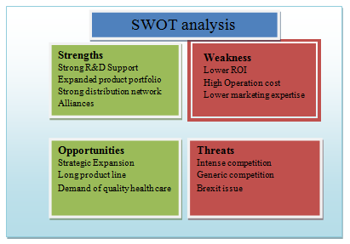
Figure: SWOT analysis of GSK
Source: Author
Opportunities: The GSK Company has opportunities to expand the market through strategic expansion and thus enlarging market share. It will enable the company to obtain higher profitability and thus solving the problem. On the other hand, long product portfolio of the company also supports to obtain a larger market share. Similarly, the demand for quality health care services also provides opportunities to ensure quality goods in the market and ensure profitability. However, higher profitability also ensures to implement motivational tools and techniques that ensure higher job satisfaction and increase productivity.
Threats: The Brexit issue is posing a threat for the company on the way of strategic expansion in the EU market arena(Seth, 2015). On the other hand, the immensely competitive market place of the pharmaceutical industry is also a potential threat for the GSK Company. Moreover, there exists a generic competition in the pharmaceutical sector. That is also a potential threat to the company. As a result, the company will be able in order to implement the motivational tactics that enhance the job satisfaction of the employees.

PESTLE analysis
PESTLE analysis provides the opportunities in order to analyse the broad macro environment of the GSK Company which can impact on the plan implementation regarding employee motivation and job satisfaction.
Political factors: The Brexit issue which has a potential impact on the performance and expansion of the GSK Company. On the other hand, internal and international politics and government policies also play a potential role in the plan implementation of the company.
Economic factors: The economic condition also impacts on the plan implementation of the GSK. For example, a favourable economic condition such as a moderate level of inflation, low-interest rate, the low unemployment rate also impacts on the company performance(Bros et al., 2010). However, they favourably drive the profitability of the GSK Company and supports motivation and job satisfaction.
Social factors: The awareness of the social people, lifestyle of the social people, education level and population growth also supports the implementation of the plan in the GSK Company. However, favourable social environment and positive relationship of the GSK Company with social stakeholders also support the implementation of the plan and strategies for enhancing motivation and job satisfaction.
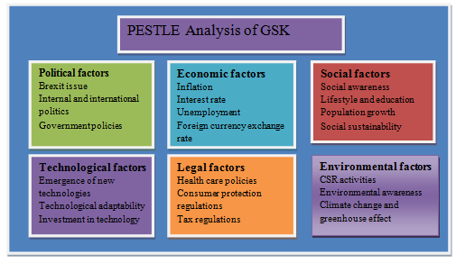
Figure: PESTLE analysis of GSK
Source: Author
Technological factors: GSK Company is aware of the technological factors such as the emergence of newer technologies, adaptability with newer technologies etc. for this reason, the company has invested a substantial amount of fund in the technology as well as R&D.
Legal factors: The health care policies of the government, laws regarding the protection of consumer protection, and taxation policies of the government influences the operations of the GSK Company. Moreover, the GSK Company has to comply with a range of legal environment that supports the implementation of motivational tools and techniques to the staffs.
Environmental factors: The CSR activities of the company, environmental awareness, weather condition and climate change impact on the performance of the government. For this reason, the implementation of the plan regarding employee motivation and job satisfaction becomes easier for the company.

Solution implementation plan
In order to implement the plan, the first stage is to select the best alternative solution. However, the best solution is selected by critical analysis of the alternative solutions. Secondly, the analysis of the financial implications of the selected solution should be analysed before the implementation of the plan.
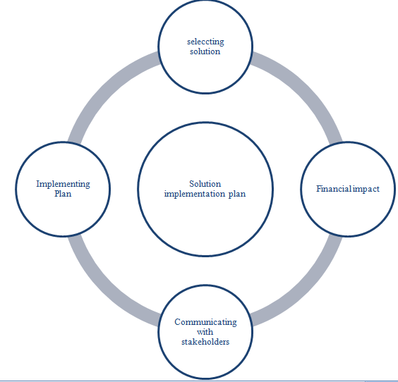

Figure: Solution implementation plan
Source: (Delorme, 2014)
In the third stage, the plan should be communicated with the stakeholders such as investors, creditors, suppliers, customers etc(Delorme, 2014). And finally, the plan is implemented within the organisation engaging all layer of the organisation.

Plan communication tactics
The solution plan should be communicated with the stakeholders following a range of stages such as the first stage is to establish the objective of the communication. On the second stage, the key messages are required to identify what should be communicated with the stakeholders.
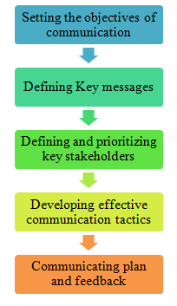
Figure: Stakeholder communication plan
Source: (Rao, 2010)
On the other hand, key stakeholders should be identified and prioritised before communicating the key messages. Moreover, developing an effective communication channel in the third stage is required for effective stakeholder communication. Thus, the communication off the plan with the stakeholders is completed.

Appropriate monitoring and review techniques for implementing the plan
However, the implementation of the plan for solving the problem is not enough; rather it should be monitored properly to see if it is going in the right direction. However, if it is not in the right direction, the GSK Company can take corrective actions.

Figure: Monitoring and review technique
Source: (Jones, 2016)
The first stage of the appropriate monitoring and review technique is to set an objective for the monitoring and review. The second stage is to establish a standard of performance with which the actual performance is measured(Delorme, 2014). However, data should be collected for analysing and comparing if the plan is going in the right direction in the fourth stage. In the final stage, the monitor takes corrective actions if the plan goes to the wrong direction or deviated from the standard.

Conclusion
In conclusion, it can be stated that the GSK Company is facing a range of problems which I reducing the productivity of the company. However, alternative solutions are proposed for the resolution of the problem. A range of tools and techniques have been implemented to find out a solution. On the other hand, the plan should be implemented following a range of plan implementation strategy. Moreover, the plan should be communicated with stakeholders properly. In addition, the implemented plan should be monitored and reviewed for proper implementation.

Reference
Abbot, H. (2014). Strategic management in problem-solving. [Place of publication not identified]: Palgrave Macmillan.
Bross, R., de Araújo, M. and Salgado, H. (2010). A Review of Analytical Techniques for the Determination of Glimepiride: Present and Perspectives. Therapeutic Drug Monitoring, 32(5), pp.550-559
Delorme, Q. (2014). Defining Goals and Objectives for a Woodlot. The Forestry Chronicle, 90(05), pp.560-561.
Denby, S. (2010). The importance of training needs analysis. Industrial and Commercial Training, 42(3), pp.147-150.
gsk. com(2019). gsk-pharmaceutical products manufacturer and supplier. [online] Available at: https://www.gsk.com/us/english/ [Accessed 19 February. 2019].
Istikomah, I. (2017). The Influences Of Problem-Based Learning Model with Fishbone Diagram to Students' Critical Thinking Ability. Indonesian Journal of Informatics Education, 1(2).
Jones, P. (2016). Communicating strategy. London: Routledge.
Marwala, T. (2016). Artificial intelligence techniques for rational decision making. [Place of publication not identified]: Springer International Pu.
Noordman (2012). Do Trained Practice Nurses Apply Motivational Interviewing Techniques in Primary Care Consultations?. Journal of
O'Neil, J., Drillings, M. and O'Neil, H. (2012). Motivation. Hoboken: Taylor and Francis.
Perkins, G., Lean, J. and Newbery, R. (2017). The Role of Organizational Vision in Guiding Idea Generation within SME Contexts. Creativity and Innovation Management, 26(1), pp.75-90.
Philips. (2018). Philips. [online] Available at: https://www.philips.com/ [Accessed 18 Nov. 2018].
PUTMAN, V. and PAULUS, P. (2010). Brainstorming, Brainstorming Rules and Decision Making. The Journal of Creative Behavior, 43(1), pp.29-40.
Schmidle, T. (2011). Performance Management. Public Performance & Management Review, 35(2), pp.370-389.
Seth, C. (2015). Swot analysis. Namur: 50minutes.
Tornquist, D. (2010). Effects of Amtrak's poor on-time performance. [Washington, D.C.]: U.S. Dept. of Transportation, Office of the Secretary of Transportation, Office of Inspector General.
Rao, T. (2010). Performance management and appraisal systems. New Delhi: Response Books, a division of Sage Publication.

