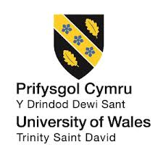

Effective teamwork and communication

MR. Toyin Adisa
23.08.2020

Introducing effective team working

- Student Name/ID
- Ramona Jantea – 1916897 (Introduction, Benefits of team working)
- Diana Dodoi – 1915911 (Stages of Team Development)
- Tiberiu Grigoras – 1916657 (Team Roles and Significance of Team Roles)
- Dariusz Rzepecki – 1916895 (Conflict Management)
- Maria Manole– 1917700 (Successful Team Development)

Introduction
Slide -1
- The significance of team working has become an important aspect that every organization needs to adapt as the nature of work becomes complex.
- Being a part of any company organization, the primary work that needs to be accomplished, is introducing a team while working in organizations associated with this firm
- Teamwork means multiple numbers of employees, who are working under one group to fulfill common objectives.
- Team working is highly effective in the perspective of a big organization.
- The different aspects and theories related to the aspects are discussed for having a clear understanding of the concept.

Teamwork is one of the most essential aspects that gained importance in today's organizational operations. Being a part of any company, the primary work that needs to be accomplished, is introducing a team while working in the companies associated with the firm. Teamwork can be defined as working under a group by a specific number of members for fulfilling common objectives. For a big organization, this aspect is very essential as multiple numbers of projects are carried out there. For the efficient accomplishment of the projects, different teams work within an organization. Thus, to get a clear understanding of what teamwork is and the different aspects of the team working are needed to be discussed. The theories and model of the different aspects of team working are also considered in this discussion.

Slide 2 – Benefits of teamwork
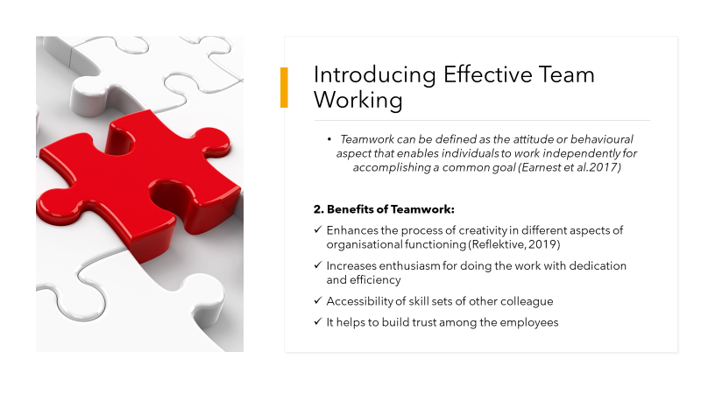

Teamwork can be defined as the attitude of an individual while working within an organization, which helps him or her to accomplish common objectives. There are different advantages of this teamwork, which are discussed below:
The first advantage of team working is it enhances creativity. In a group, multiple individuals work for common goals. This different person belongs to different backgrounds, having different skills, and working experiences. When they work in a team they can get access to share and receive each other's skills, experiences, and values. This sharing helps the members to apply those in work. A combination of skills, values, and experience leads the team to provide innovation or creation in aspects of working and in making a decision. Thus team working enhances and incorporates creativity in the process of operating within an organization.
Teamwork raises the level of enthusiasm in the workplace. When a group of people works together they tend to share each other's excitement, which helps them to accomplish the work with fun. Any member of a group that has enthusiastic colleagues never feels less motivated. Enthusiasm accelerates the feeling of dedication for work, which is very important to achieve organizational goals. Thus team working helps an individual to be enthusiastic and positive.
Different members working together in a team have different skills. Some of the members may be an efficient planner. Some can be a good presenter. Some can be a good problem solver or a decision-maker. During team working the members get accessibility of each other's skills. Sharing skills can increase the scope of knowledge which combines to provide a positive outcome of any task they perform. Thus team working helps the individual to share and receives knowledge relating to skill nurturing.
When a group of members works for a single team they grew trust for each other. Working together for a common goal enables the members to spend a good time with one another. The members' something shares informal relations among them which strengthens their bonds and psychological connection. They emotionally share and help each other in accomplishing the task. Trust is the most effective driving force that can help the member to work unified and with perfection.
Slide 3 – Benefits of teamworking
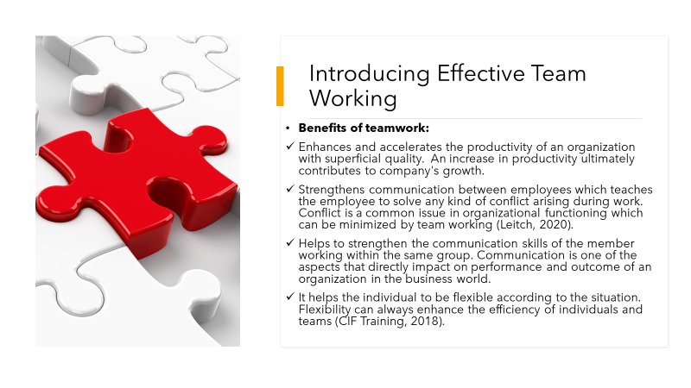

Team working accelerates the rate of productivity in an organization. In a teamwork every member is assigned a specific portion of the whole task to accomplish. This distribution is made by the team leader at the beginning of the task. The distribution is made based on employee's strong areas of specialization so that they can perform the portion they know. If an individual efficiently performs his or her portion of the task then the whole task is accomplished very smoothly and quickly. This also enhances the quality of work which ultimately contributes to company's growth.
Conflicts are part of organizational functioning. When a different members with different thoughts, opinions, and ideas assembled for common goal, conflicts are common to arise. When the members of the team work together and share each other thought their psychological bond is enhanced. In case of any conflicts arises the members try to solve it in the best possible way without hampering the work. Team working thus provides a conflict solving power within its members which contributes to achieving quality performance.
Communication skill is one of the major skills needed for the professional world. Teamwork enhances this skill very much. Different members working in a team for accomplishing common objectives needed to build up strong communication among them. Communication means sharing thoughts, opinion, and personal values with each other which enable to know what one member expects from the other. Proper communication skill builds a strong relationship among the members of a team. Communication is the only way where a leader can gain his or her team members trusty.
Team working requires a collaborative effort to provide an effective outcome. When much individual work together under a team, they get to know each other well. This bond enables them to complement each other weaknesses and with each other's strength so that the task is completed with efficiency. Flexibility in an individual also helps to nurture working skills as the strengths and weaknesses can be recognized. Thus then the team with flexible members can overcome any challenges they may be exposed to.

Slide – 4: Stages of team development
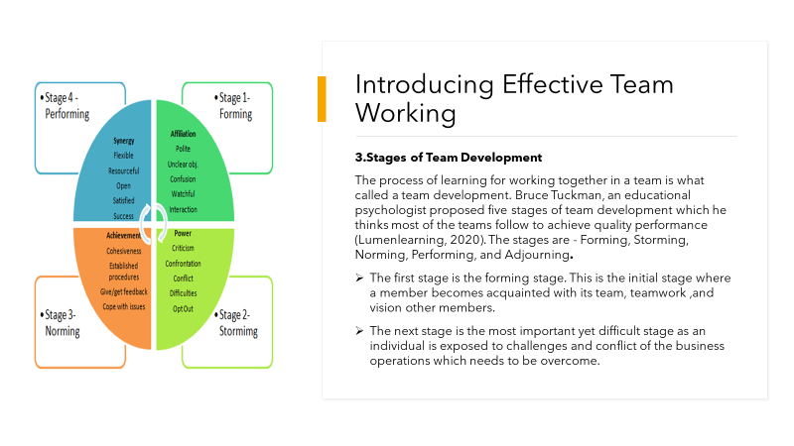
S.N.
Teamwork involves a lot of aspects that need to know and recognized. A team is formed within an organization with the purpose of effective performance, so the team members need to be aware of each and every aspect of team functioning. The process of learning these aspects to work together is what called a team development. Bruce Tuckman who was an educational psychologist proposed five stages of team development which is based on what the majority of organizational teams follow to achieve qualitative performance. According to Tuckman, the stages are – Forming, Storming, Norming, Performing, and Adjourning. These stages can provide competency and efficiency to a team.
Forming stage - this is the initial stage of team building. This can be called the first day when all the members including their leader meet for the very first time. In this stage, individuals are not aware of certain aspects relating to the team. They had lots of questions which is clarified in this stage. The team leader takes charge of conducting this stage. He or she steps forward to ask the team member to introduce them with others. He or she explains the goals which will be accomplished by the members. information related to the timeline of the project and the framework of its execution is provided in this stage. Moreover, the leader distributes specific job roles to individual members depending on their specialization in this very stage. An individual thus gets to know what will be his or her role in the team and what work needs to be accomplished. They get to meet new colleagues in this stage which enlarges the area of being recognized in the workplace. Thus this is just the onset stage of team formation (Toggl, 2020).
Storming stage - This is the most crucial yet challenging phase of an individual being a part of a team function. In this stage, an individual get the exposure of challenges and conflicts that are common to group functioning. This is the time when the individual first faces criticism or hindrance in his work. This is the stage when an individual needs to recognize his or her inner skills, competencies, and deficiency. The individual who shows flexibility in recognizing his lacking areas and corrects them can overcome this stage efficiently.
Slide – 5 Stages of team development
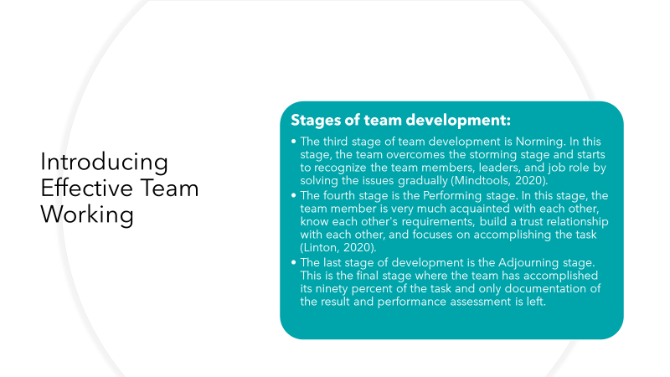
Norming stage is the third stage of team development in this stage the team overcomes the hurdles it faces in the storming stage. In this stage, the team members started to recognize other members and their leaders or leader. They may yet be facing some issues but the member's starts to form bonds with the other member and try to solve the issues together. The members in this phase know their strengths and weaknesses. The only focus of the members of a team in these phases in to accomplish the task efficiently within a given period of time. Moreover, relationship among the members strengthens in this phase as they recognize themselves a contributor to team performance and outcome. The fourth stage is the performing stage of the team. In this stage, the team members become efficient in their job execution. Their relationships strengthen where they cooperate and complement each other in accomplishing the task. The whole team in this phase just aims to execute the work with efficiency so that their team achieves the desired outcome. In these stage, members do not recognize themselves individually but they are motivated to perform for their team. This stage denotes how efficiently the work is going to be performed. Moreover, the team members become like a family where informal relations are formed which lasts even after the team splits up at the end of the project. The last stage of the team development is known as the Adjourning stage. In this stage near about ninety percent of the task is accomplished by the team. Only the documentation of the outcome and performance report is left. In this stage, the group almost splits up. Some of the group members are assigned to join other groups. There is an emotional circumstance relating to the parting of group members. The leader often arranges a success party or a get together to relive the memories they all spend together while working informally. This stage also leaves some friendlier bonds among members which sometimes lasted forever.

Slide: 6: Teamwork and Communication
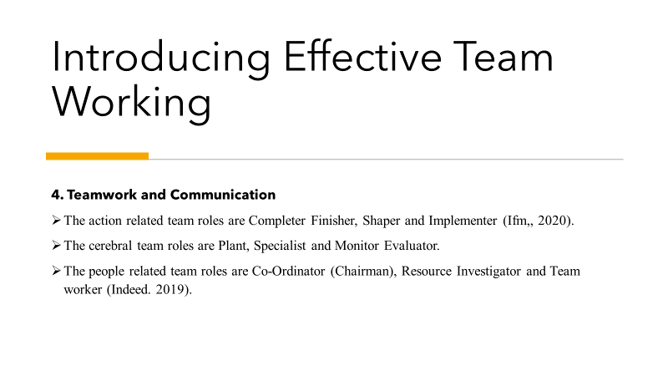
The action-oriented roles are based on dynamic individuals to inspire and motivate the team members. Sharper tends for getting quick results that helps the organization to move forward. They act definitively in tough situations as an ideal material of management. The strengths of this role are challenging, dynamic; though it offends the feelings of people sometimes. Every organization needs an individual finisher to make sure the high-quality production. A finisher searches out the odds and errors for the growth of organization. Implementers are the spine of the organization as they ensure about the task will be done efficiently. Specialists are the asset of an organization; they have the knowledge in every subject. They will contribute to the task at the time of their proficiency. The senior management creates proposals on the basis of the knowledge of specialists. They have no issue to guide the fellow members of their team. Plants are considered as a free-thinker, they have generated original thoughts and suggested the way of innovation. Plants are that team members who work for success and growth of organization. The creative thinking of them lends to groundbreaking concepts. Monitor evaluators take decisions on the basis of rational thinking and facts for opposing the instinct and emotions. It works best at the time of challenges and access to the problem solving method. It considers all the possibilities and then comes to any conclusion. The role of Coordinators is mainly to help the team members and appreciate their work objectives. Coordinators should have good communication and interpersonal skills. They basically handle the management position but their roles are quite different from the Shapers. Co-Ordinator are good in identifying the team talent and then utilize it in a proper way. They should ensure broad perspectives and use the team strength properly. Co-Ordinator generally prefers democratic approach with open communication. Team workers are mainly calm and extroverts with a friendly approach. They work efficiently for the growth of the organization and are highly versatile, adaptable in nature. They are popular among their colleagues and make a harmony with them. Resource Investigators are very enthusiastic and positive people, they explore the possible opportunities, investigate new evolution and build the network. They are good at making new business chains that help to bring new paths for growth. They are experts in picking up new thoughts from others.
Slide 7 Significance of Team Role in Workplace
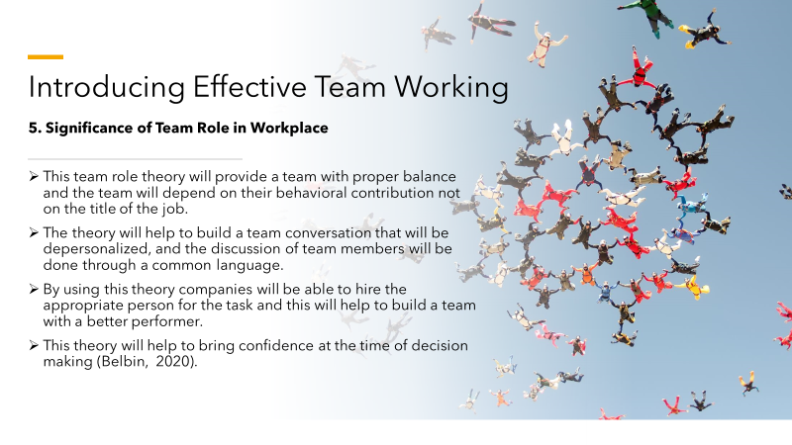
Being a Team leader in a company, it can easily be stated that the theory of the Belbin Team Role has huge importance in different sectors of a company such as in team building, the training of management, development in leadership, etc. As a leader, it can be said that this theory always offers fast delivery, flexibility and learning opportunity in a team and not only that it selects the people those who are high-performing and train the existing member carefully and build a good team of the project. If it is possible to apply in the team management of any company, then the quality of the team will be increased to perform good project work. It is much significant in the training of the management of a company; it can understand and utilize the talents and motivates the staff to build great management. It is well understood that the theory insists to bring transformation and help the effective managers to be the outstanding managers of peoples. This theory has provided the language of the interaction of each other to the managers of the company. The improvement will be great if the trainer of any company applies this theory. As a leader, it is observed that the theory is providing the way to the leaders to connect effectively with their staff and to lead the team. This theory is helping to assess the strength of the leaders and also showing them how to improve the quality of leadership to their workplace and by this, they are ensuring their positive impact in their organization. As a leader, it is examined that the theory of Belbin are significantly helping the company to make their decision regarding the promotion and recruitment of a particular individual. It is useful to find the gaps to be filled in a balanced team and helping them every employee to find the next step by providing useful information. The theory is also significant for the engagement of the employees, it is helping each individual to find their actual strength and it is doing the recognitions and using their strengths as an advantage and not only that when any senior is assigning a project, this theory is helpful for the team members to understand their strength in the project work. Companies can increase their engagement if the Belbin Team role theory is implemented by its management (Cleverism, 2020). It can be stated that these are the significance of The Belbin Team Role theory in the workplace of a company. If the management of any company is ready to implement the Belbin Team Role Theory then it will be quite significant for them.

Slide: 8: Conflict Management
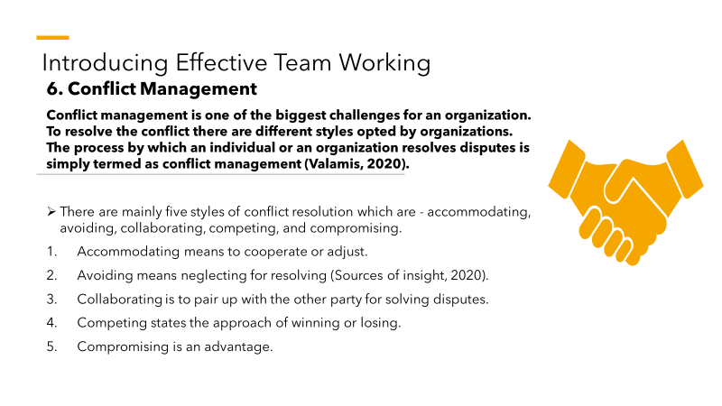
Conflicts are a part of organizational functioning which requires being resolved in the correct time to prevent unlikely circumstances that can harm an organization. Organizations implement different styles for conflict resolution. This process of managing and handling conflict is what simply termed conflict management. There are mainly five styles of conflict resolution which are Accommodating, Avoiding, Collaborating, Competing, and Compromising. These five styles are used based on the nature of disputes.
Accommodating - this style means that one party let the other party win with their conditions. When one organization feels that a small issue with less importance needs to be solved quickly it accepts the other company's proposal without much argument. This style can be effective in solving small issues quickly and without many complexities. Adapting this style can enhance a manager's reputation as an easy-going individual. But this style sometimes can consider the accommodating party as weak.
Avoiding - this style is objectified to solve the dispute just by ignoring it or eliminating the conflicting sides or some other manner. In a team, if such conflicts arise leaders sometimes suspend both of the parties or can try to push the deadline so that the conflict can be resolved if they get proper time. This style often proves effective as time helps the conflicting parties to calm down. But if it is used in the wrong case then the outcome can be worse.
Collaborating - this is the best possible style in the perspective of organizational disputes. Two partner organizations always solve issues by sitting with each other, listen, and consider one another's a requirement and try to adapt a way where both the parties can be satisfied. This style is effective as it leaves no gaps and misunderstandings between the conflicting parties. But this process is time-consuming which can hamper organizational functioning.
Competing - This style can be called as 'Win or lose' approach. In many cases, both the conflicting parties stay firm and adamant with their condition and are not ready to consider the conditions of another side to implement. This style can solve many issues very quickly but reduce the morale aspect and organizational productivity.
Compromising – this simply means adjusting. There are instances when both parties want to mediate and solve the issue by listening to the other party's requirements and then come to a decision. This process is more like a bargaining process where both sides comprise some of their requirements to come to a solution. This style is effective as it provides chances to both parties to hear and understand each other's thoughts but still, it does not completely satisfy both parties.

Slide: 9: Conflict Management
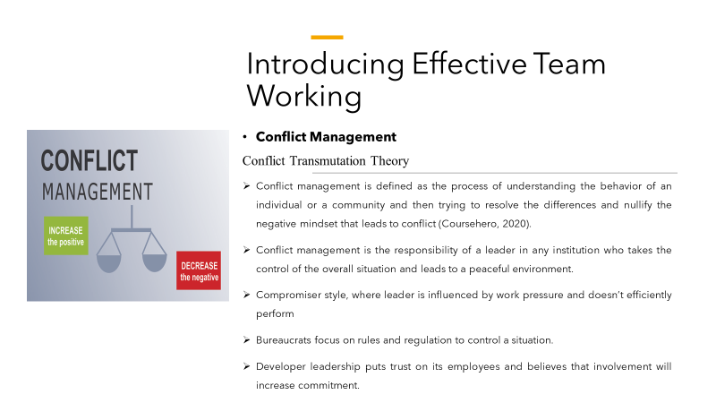
​All the above strategies are related to Conflict Transmutation theory which believes that transforming conflict will change the equations between the individuals. It does not try to find the underlying cause of the conflict. Conflict resolution is highly related to genetic structure and alchemy. Genetic formation influences the emotional behavior of a human in any adverse situation leading to conflict. Protecting oneself from disturbances is inherent inhuman and some feelings are inculcated from society. These factors trigger conflict behaviour in any community. Alchemy is an ancient form of study in chemistry. It believes in transformation from sinner to saint (Trinstitute, 2020). In modern context, the approach should be to identify the reason for conflict and try to eradicate the factors resulting in conflict. Conflict management can be a challenging process in a large business but it encourages innovation and better performance. A large number of ideas emerge from the different individuals which can be constructive but can create chaos if not handled properly. Different problem solving approaches can be undertaken by the leaders like filling up questionnaires, surveys among the employees regarding their views. The methods that are prevalent include a problem solving approach where the cause of conflict is addressed and solved accordingly. It ensures more efficiency and productivity as it has respect for the views of others. This is the best approach as companies with high performance follow this method. The second method is dominating where the leader forces its own beliefs and tries to suppress the disagreements. It leads to high productivity as this method believes in transformation of thoughts. The third strategy is based on obligations where the leader has low self esteem for self and high respect for others. In such a scenario he remains obliged to others which take away his controlling power to resolve the difference of opinions. It is not recommendable for large organizations where there are ample of unique ideas. The policy of avoidance refers to ignore the whole scenario for a while. It is where one resigns from the organization which is extreme avoidance. Diffused and withdrawal methods are also prevalent.

Slide: 10: Successful team development
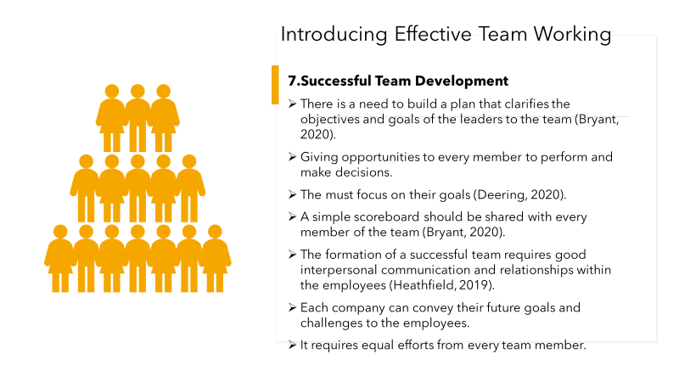
Successful team is a team that maintains effective communication within them (Deering, 2020). Companies can hire best quality and skilled employees that can help them to allocate responsibilities freely and trust them to make better decisions related to work. They can choose the candidates based on not only their academic education but their ambitions, decision making skills and their intentions. It will help in getting the right employees for the company. It will also help them in building a more efficient team that can work with each other in synchrony. A team needs to maintain effective communication within the company (Deering, 2020). It will help them to not only solve the issues and challenges efficiently but also prevent any type of conflict within the premises. It also helps in building better connection between the employees and the employer (Bryant, 2020). This is how companies provide them with opportunities to grow and earn better positions or designations within the company. Every individual strives for growth. Hence, the opportunity to learn and master new talents and skills always keep the employees committed to their work. It helps in increasing Any Company can also share a scoreboard that is simple and every member can contribute to it equally. It helps them in understanding the goals and the ambitions of the company and makes the employees feel that the company depends on them (Bryant, 2020). This increases their responsibilities towards their jobs and the company as well. It also aids the employees to connect to the work and the company in a deeper sense and they work as if the company is their own. The employees and the employers need to put equal efforts for the working of the team and the success. Conveying the future goals to the employees also helps in building deeper connections with the employees.
Slide: 11: Successful team development
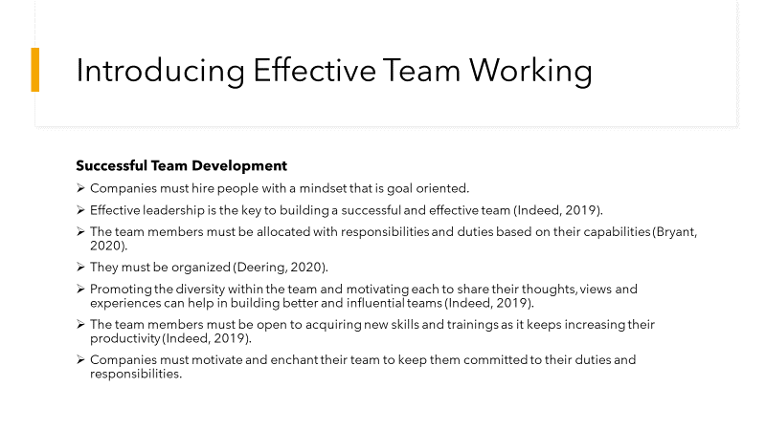
Companies requires a team that is goal oriented and determined towards the goals set by themselves and the company. It will help in making progress towards the goals efficiently as when the whole team works in a single direction it becomes easy to reach the goals. Leadership is of key significance. Leaders can help in motivating the team and bringing out the most of the team members (Indeed, 2019). Effective leadership can help companies to enhance the productivity of the company. The members of the team must be allocated with work that is suitable to them. They should be given the work that they can do the best based on their capabilities and skills (Bryant, 2020). It helps in keeping them committed to the work and perform their best. Motivation is of immense importance. A motivated team can perform and function much better compared to an average team. It must also allow the team members and the employees to learn new skills within the company. It can help the employees to get the job satisfaction that they require to work effectively. It also depends on the employees if they are open to learning new skills, hence, the company should be concerned about hiring those candidates that show the required traits that help the company in building a better team. The employees must be open to changes and development and must contribute efficiently in the processes (Heathfield, 2019). They should have the zeal to learn new skills and perform better. They should be motivated so that they can connect to the company on a deeper note and perform with the best of their ability (Heathfield, 2019). The company should also keep track of the productivity of the employees and allocate jobs according to their capacities.
Slide: 12: Conclusion
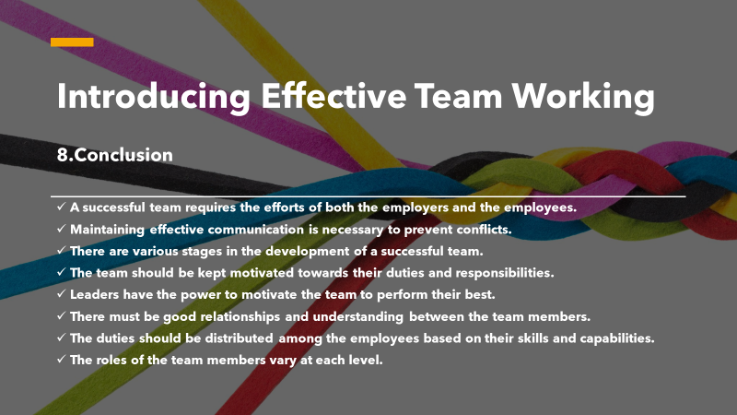
It is concluded that a successful team is the success of the company. Companies can incorporate the various steps and strategies to build a successful team that can help it in achieving more success in the global market. Effective communication and leadership are the most important aspects of a team which helps in motivating as well as preventing conflicts within an organization. It is also helpful in maintain ethics and positivity and good bonding within the company. Companies must ensure that a successful team is built as it can help them in growing and performing better in the future.

References
Belbin.com. 2020. Why Use Belbin Team Roles?. [online] Available at: <https://www.belbin.com/about/why-use belbin/#:~:text=Belbin%20Team%20Roles%20are%20used,work%20together%20with%20greater%20understanding.> [Accessed 15 August 2020].
Bryant, A., 2020. How To Build A Successful Team. [online] Nytimes.com. Available at: <https://www.nytimes.com/guides/business/manage-a-successful-team> [Accessed 15 August 2020].
CIF Training. 2018. The Benefits Of Teamwork In The Workplace | CIF Training. [online] Available at: <https://ciftraining.ie/2018/03/the-benefits-of-teamwork-in-the-workplace/> [Accessed 14 August 2020].
Cleverism. 2020. Belbin's Team Roles: How Understanding Team Roles Can Improve Team Performance. [online] Available at: <https://www.cleverism.com/belbins-team-roles-how-understanding-team-roles-can-improve-team-performance/> [Accessed 15 August 2020].
Coursehero. 2020. Conflict Transmutation Those Theorists Who Practice Conflict Transmutation | Course Hero. [online] Available at: <https://www.coursehero.com/file/p5hqn31/Conflict-Transmutation-Those-theorists-who-practice-conflict-transmutation/> [Accessed 15 August 2020].
Deering, S., 2020. Top 7 Qualities Of A Successful Team. [online] Undercover Recruiter. Available at: <https://theundercoverrecruiter.com/qualities-successful-work-team/> [Accessed 15 August 2020].
Earnest, M.A., Williams, J., and Aagaard, E.M., 2017. Toward an optimal pedagogy for teamwork. Academic Medicine, 92(10), pp.1378-1381.
Heathfield, S., 2019. Essential Tips And Ideas For Building A Successful Work Team. [online] The Balance Careers. Available at: <https://www.thebalancecareers.com/how-to-build-a-successful-work-team-1918515> [Accessed 15 August 2020].
Ifm. 2020. Belbin's Team Roles. [online] Available at: <https://www.ifm.eng.cam.ac.uk/research/dmg/tools-and-techniques/belbins-team-roles/> [Accessed 15 August 2020].
Indeed. 2019. [online] Indeed.com. Available at: <https://www.indeed.com/career-advice/career-development/steps-to-building-a-successful-team> [Accessed 15 August 2020].
Leitch, C., 2020. 10 Powerful Benefits Of Teamwork In The Workplace. [online] Careeraddict.com. Available at: <https://www.careeraddict.com/5-benefits-of-teamwork-in-the-workplace> [Accessed 14 August 2020].
Linton, P., 2020. The 5 Stages Of Team Development For Growing Companies. [online] Boltonremote.com. Available at: <https://www.boltonremote.com/blog/the-5-stages-of-team-development-for-growing-companies> [Accessed 14 August 2020].
Lumenlearning. 2020. The Five Stages Of Team Development | Principles Of Management. [online] Available at: <https://courses.lumenlearning.com/suny-principlesmanagement/chapter/reading-the-five-stages-of-team-development/> [Accessed 14 August 2020].
Mindtools. 2020. Forming, Storming, Norming, And Performing: Understanding The Stages Of Team Formation. [online] Available at: <https://www.mindtools.com/pages/article/newLDR_86.htm> [Accessed 14 August 2020].
Reflektive. 2019. 8 Benefits Of Teamwork In The Workplace - Reflektive. [online] Available at: <https://www.reflektive.com/blog/8-benefits-of-teamwork-in-the-workplace/.> [Accessed 14 August 2020].
Sourcesofinsight.2020. 5 Conflict Management Styles At A Glance. [online] Available at: <http://sourcesofinsight.com/conflict-management-styles-at-a-glance/> [Accessed 15 August 2020].
Toggl. 2020. 5 Stages Of Team Development. [online] Available at: <https://toggl.com/stages-of-team-development/> [Accessed 14 August 2020].
Trinstitute. 2020. OJPCR 3.3: Conflict Resolution, Genetics, And Alchemy. [online] Available at: <http://www.trinstitute.org/ojpcr/3_3salla.htm> [Accessed 15 August 2020].
Valamis. 2020. 5 Conflict Management Styles Every Manager Must Know [2020]. [online] Available at: <https://www.valamis.com/hub/conflict-management-styles> [Accessed 15 August 2020].

