

Module Title: Professional Career Development within H&SC
Module Number: LCHS 4009 (LON)
Assignment No: ASSIGNMENT 2
Student Name: Krasimira B Yordanova-Krumova
Student ID: 2510713
Lecturer’s Name: Dilhara Mampitiya

Table of Contents

1. Receptionist at University College London Hospitals NHS Foundation Trust (UCLH) 3
2. Curriculum Vitae (CV)……………………………………………………………...4
3. Personal statemen………………………………………………………………….6
4. SWOT Analysis and Personal Development Plan (PDP) (Receptionist at UCLH)…………………………………………………………………………………..….7
4.1. SWOT Analysis (Receptionist at UCLH)……………………………………......7
4.2. Personal Development Plan (PDP - Receptionist at UCLH)…………………9
5. Critical Reflection on Component 1 Presentation (Gibbs Model)………….10
6. Reference list…………………………………………………………….................14

- Receptionist at University College London Hospitals NHS Foundation Trust (UCLH)

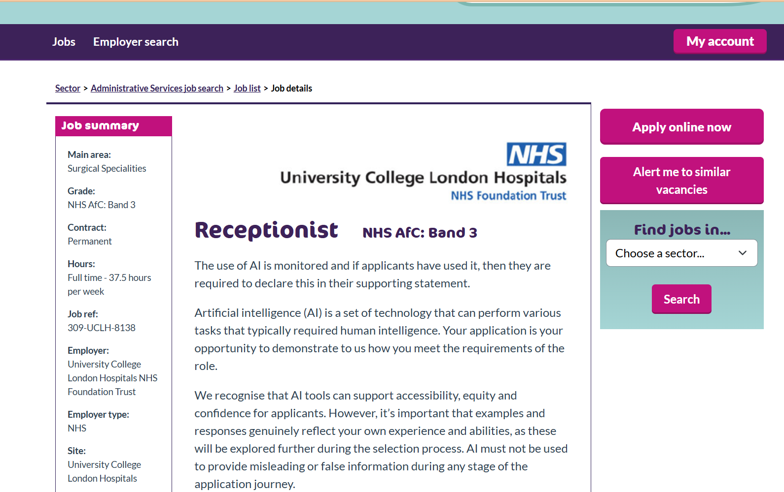

Job vacancy: Administrative Assistant, University College London Hospitals NHS Foundation Trust, London | trac.jobs

- Curriculum Vitae (CV) (TASK 1)
Krasimira Yordanova- Krumova
London, United Kingdom Email: krasimirakrumova@gmail.com
Phone: 075 00000000
Languages: Bulgarian (Native), English (Working Proficiency), Spanish (Working Proficiency), Russian (Elementary)

Professional Profile
I am a motivated administrative professional with substantial experience in customer service, office coordination and data management in both Bulgaria and the United Kingdom. I have developed strong skills in managing enquiries, supporting clients, maintaining accurate documentation and upholding confidentiality. My calm and approachable manner enables me to work effectively in fast paced environments. I demonstrate clear alignment with NHS values of kindness, respect, teamwork and continuous improvement and I am committed to ensuring that patients, visitors and colleagues receive a positive and professional experience in the role of Receptionist at University College London Hospitals NHS Foundation Trust (UCLH).

Key Skills
- Excellent communication and customer service
- Professional telephone and email handling
- Strong organisational and time management skills
- Accuracy in data entry and record keeping
- Ability to work calmly under pressure
- Confidentiality and respect for sensitive information
- Problem solving and proactive support
- Teamwork and partnership working
- MS Office (Word, Excel, Outlook)
- Experience with digital systems and databases
Education Qualifications
Certificate of Higher Education Skills for the Workplace (Health and Social Care), Level 4 University of Wales Trinity Saint David - In progress, expected completion September 2026
Professional Qualification in Business Administration Awarding Institution: St. Cyril and St. Methodius University of Veliko Tarnovo Completion: 2007
Duolingo English Test Certificate
Work Experience

Administrator - London Construction Services Ltd, London 2022 - Present
- Managing daily administrative tasks and supporting smooth office operations.
- Handling enquiries from clients and partners in a professional and courteous manner.
- Maintaining accurate records and preparing reports for management.
- Supporting workflow coordination and ensuring timely communication.
- Demonstrating reliability, adaptability and strong organisational skills.

Office Manager - Sofia Business Solutions Ltd, Sofia 2009 - 2016
- Managing client and vendor relationships with a focus on customer satisfaction.
- Coordinating sales activities and supporting business processes.
- Ensuring a welcoming and organised environment for visitors and staff.

Senior Credit & Card Operations Expert - Balkan Financial Services, Sofia 2004 - 2009
- Reviewing and processing customer documentation with high accuracy.
- Handling enquiries, complaints and claims in a professional manner.
- Ensuring compliance with regulations and confidentiality standards.
- Supporting colleagues through training and guidance.
- Demonstrating strong attention to detail and problem solving skills.

Voluntary Experience
Available upon request

Interests and Hobbies
- Reading professional literature related to health, wellbeing and communication
- Sports and regular physical activity
- Nature walks and outdoor recreationLearning languages and developing digital skills

3. Personal Statement (TASK 2 )
I am an organised and motivated administrative professional with a strong background in customer service, office coordination and data management. My career aim is to secure a role as a Receptionist within University College London Hospitals NHS Foundation Trust (UCLH), where I can contribute to the delivery of excellent patient care and support the smooth running of front line services. This role aligns with my personal values of kindness, respect and teamwork and provides the opportunity to apply my skills in a healthcare environment that makes a real difference to people’s lives.
My professional experience spans both Bulgaria and the United Kingdom, giving me a broad perspective and adaptability in different organisational settings. In my current role as Administrator at London Construction Services Ltd, I manage daily office tasks, handle enquiries and maintain accurate records. This has strengthened my ability to work under pressure, prioritise tasks and communicate effectively with diverse clients and colleagues. Previously, as Office Manager at Sofia Business Solutions Ltd, I oversaw office operations, coordinated schedules and supported business processes. This role required strong organisational skills, attention to detail and the ability to create a welcoming environment for staff and visitors. Earlier in my career, I worked as a Senior Credit and Card Operations Expert at Balkan Financial Services, where I reviewed documentation, handled customer enquiries and ensured compliance with regulations. This experience developed my accuracy, confidentiality and problem solving skills, all of which are highly relevant to the Receptionist role.
My education has provided me with a solid foundation for professional practice. I hold a Professional Qualification in Business Administration and I am currently completing a Certificate of Higher Education Skills for the Workplace (Health and Social Care) at Level 4. This programme has enhanced my understanding of communication in health and social care, teamwork and reflective practice. Academic guidance highlights that a high quality personal statement should clearly connect education, skills and career aims (Landry et al., 2022). I have also achieved certification in English language proficiency through the Duolingo English Test. These qualifications demonstrate my commitment to continuous learning and my ability to apply academic knowledge in practical settings.
I consider my personal strengths to be reliability, adaptability and empathy. I am calm and approachable, able to support people in stressful situations and provide reassurance when needed. I value confidentiality and respect, which are essential in healthcare environments. My professional skills include excellent communication, accurate data entry, strong organisational ability and proficiency in Microsoft Office and digital systems. I am confident in handling telephone and email enquiries, managing appointments and maintaining records. These skills would be of value to an employer such as UCLH, where efficiency, accuracy and patient centred service are critical.
Looking ahead, my career aim is to develop within the NHS, starting as a Receptionist and progressing to more senior administrative roles. I am committed to professional growth through training, reflective practice and continuous improvement. I believe that my combination of experience, education, strengths and skills makes me a strong candidate for the Receptionist role. I am enthusiastic about the opportunity to contribute to UCLH and to support patients, visitors and colleagues in a professional and compassionate manner.
4. SWOT Analysis and PDP (Receptionist at UCLH) (TASK 3)
4.1. SWOT Analysis (Receptionist at UCLH)

Strengths | Weaknesses
- Strong organisational skills and ability to prioritise tasks | - Limited direct NHS front-line experience
- Excellent communication and customer service background | - Need to further develop advanced medical terminology
- Accuracy in data entry and record management | - Confidence in handling highly stressful patient situations still developing
- Multilingual skills (Bulgarian and English) | - Limited exposure to specialised NHS IT systems

Opportunities | Threats
- Training and development programmes within UCLH | - High competition for NHS administrative roles
- Career progression to senior administrative positions | - Rapid changes in healthcare policies and procedures
- Continuous learning through reflective practice and PDP | - Risk of burnout in busy hospital environment
- Building strong professional networks in healthcare | - Potential technological changes requiring constant adaptation

My principal strengths lie in organisation, accuracy and effective communication. These qualities are directly relevant to the Receptionist role at UCLH, where efficiency and clarity are essential in supporting patients and colleagues. My background in customer service and administration has equipped me with the ability to prioritise tasks and maintain professionalism in busy environments.
At the same time, I recognise certain weaknesses. I have limited direct experience within NHS front-line services and must continue to build confidence when dealing with highly stressful patient situations. These areas represent opportunities for growth through structured training, mentoring and reflective practice. Academic literature highlights that Personal Development Planning is a valuable tool for encouraging reflection and supporting career progression (Huntington and Moss, 2004), which reinforces my approach to addressing these weaknesses.
The opportunities available within UCLH are considerable. Access to induction programmes, career development pathways and continuous learning initiatives will enable me to strengthen my skills and progress towards more senior administrative roles. Furthermore, participatory innovation strategies in health services are recognised as a means of enhancing administrative practice and patient experience (Lee et al., 2026).
The NHS Handbook of Quality and Service Improvement Tools offers practical methods for embedding continuous improvement in health care practice (Institute for Innovation and Improvement, 2010).
Nevertheless, there are potential threats. Competition for NHS posts is strong, and the hospital environment can be demanding, with risks of stress and burnout. Remaining adaptable, resilient and committed to wellbeing strategies will be essential in overcoming these challenges. In addition, failure to adopt innovation or to engage staff in participatory development may limit organisational progress and create barriers to improvement (Lee et al., 2026).
4.2. Personal Development Plan (PDP) (Receptionist at UCLH)
Personal Development Planning (PDP) provides a structured framework for identifying goals, planning actions and monitoring progress. It is widely recognised as a valuable tool for reflection and career development, enabling individuals to take responsibility for their own learning and professional growth (Huntington and Moss, 2004). Within the context of my role as Receptionist at University College London Hospitals NHS Foundation Trust (UCLH), PDP allows me to connect my current skills with future aspirations and to address areas requiring improvement.
Clear guidance on producing high quality personal statements highlights the importance of structure and mentorship in professional development (Landry et al., 2022).
Goal 1 – NHS systems knowledge: My action will be to attend induction training and complete e-learning modules, using NHS training resources and mentor support. The timescale is three months, and success will be measured by accurate handling of patient records and confident use of IT systems.
Goal 2 – Communication skills: I will participate in workshops and role play exercises, supported by tutors and peer feedback. The timescale is six months, and success will be demonstrated through positive feedback from patients and colleagues.
Goal 3 – Resilience and stress management: My actions include mindfulness practice and engagement with NHS wellbeing programmes, using wellbeing services as resources. This is an ongoing goal, with success measured by maintaining composure and professionalism in busy hospital situations.
Goal 4 – Career progression: I will shadow senior staff and seek mentorship, drawing on guidance from experienced colleagues. The timescale is one year, and success will be evident through increased responsibility and readiness for promotion.
Goal 5 – Reflective practice: I will apply Gibbs’ Reflective Cycle to both academic and workplace experiences, supported by tutor feedback. This is an ongoing process, with success measured by improved reflective writing and critical evaluation of practice.
Overall, my PDP represents a balanced plan that addresses immediate needs while supporting long term career progression. By combining structured training, reflective practice and resilience strategies, I will continue to develop as an effective and professional member of the NHS team. The academic literature confirms that PDP is not only a record of objectives but also a process that fosters critical reflection and adaptability in professional practice (Huntington and Moss, 2004), which directly supports my approach to personal and career development.
UCLH demonstrates how NHS Trusts communicate their values and services publicly, reinforcing the importance of accessible communication (University College London Hospitals NHS Foundation Trust, 2026).
5.Critical Reflection on Component 1 Presentation(Gibbs Model)
(TASK 4)
Description
For Component 1 of LCHS4009, I delivered a presentation focusing on communication as a core skill in health and social care practice. The task required me to prepare clear slides, reference academic sources in Harvard style, and present confidently to peers and my lecturer. The presentation lasted five minutes and was followed by verbal feedback.
Feelings
Before presenting, I felt nervous about whether I would communicate effectively and whether my delivery would reflect the importance of communication in professional care contexts. I worried that I might speak too quickly or rely too heavily on my slides. During the presentation, my anxiety lessened as I progressed, and I began to feel more confident. I noticed that maintaining eye contact and varying my tone helped me connect with the audience. After completing the task, I felt relieved and proud of my preparation, but also aware of areas where my communication could be improved.
Evaluation
Several aspects of my communication were successful. I spoke clearly and projected my voice well, which ensured that the audience could hear and understand me. My lecturer commented that my slides were well structured and appropriately referenced, which supported the clarity of my message. I also maintained eye contact and used gestures to emphasise key points, which enhanced engagement.
However, there were weaknesses. At times, I spoke too quickly, which may have reduced audience comprehension. I occasionally read directly from the slides rather than elaborating verbally, which limited the depth of my communication. My lecturer advised me to slow down and expand on key points to ensure that my spoken delivery adds value beyond the written content.
Analysis
Reflecting critically, I recognise that my strengths in organisation and accuracy supported effective communication. These qualities ensured that the presentation was coherent and academically credible. However, the weaknesses highlight the importance of developing confidence in extemporaneous speaking and pacing. Reading from slides suggests a reliance on written text rather than confident verbal delivery, while rapid speech indicates nervousness.
As highlighted by the University of Edinburgh (2024), Gibbs’ Reflective Cycle provides a structured framework for analysing experiences and identifying areas for improvement in professional practice.
Academic literature supports the value of structured reflection in professional growth. Huntington and Moss (2004) emphasise that Personal Development Planning encourages reflection and supports career progression, which reinforces my focus on communication as a skill requiring structured improvement. Furthermore, Lee et al. (2026) highlight the importance of participatory strategies in professional development, suggesting that engaging actively with feedback and innovation is essential for improvement. In addition, recent research demonstrates that applying Gibbs’ Reflective Model can enhance empathy and communication skills in health care education, supporting both professional development and patient interaction (Ahmadpour et al., 2025). These perspectives confirm that reflecting on communication and planning targeted actions is a valid approach to professional growth in health and social care.
Conclusion
Overall, the presentation demonstrated that I am capable of producing academically credible work and delivering it in a professional manner. My preparation and research were strong, and my communication was clear in many respects. However, I must continue to refine my delivery by slowing down, elaborating verbally and reducing reliance on slides. Communication is both a strength and an area for improvement, and addressing these issues will enhance my effectiveness in future presentations and in health and social care practice.
Action Plan
- To improve my communication in future presentations, I will:
- Practise delivering slides aloud to refine pacing and reduce reliance on written text.
- Record myself rehearsing to identify areas where I speak too quickly or fail to elaborate.
- Engage in peer practice sessions to build confidence in extemporaneous speaking.
- Apply Gibbs’ Reflective Cycle after each presentation to evaluate communication systematically.
- Incorporate lecturer feedback into my preparation, ensuring that I consciously slow down and expand on key points.
- Seek opportunities to present in smaller settings to gradually build confidence before larger audiences.
The NHS Change Model provides a structured framework for planning and sustaining improvement in professional practice (NHS England, 2018).
By implementing this plan, I aim to strengthen my communication skills and enhance my ability to deliver clear, engaging and professional presentations. This will support my academic progression and align with NHS values of continuous improvement and effective communication.

Reference List:

Ahmadpour, N., et al. (2025) “Effect of narrative writing based on Gibbs’ reflective model on the empathy and communication skills of nursing students”, BMC Medical Education, 25(1), pp. 1-9. doi:10.1186/s12909-024-06593-7
NHS England (2018) The Change Model Guide. London: NHS England.
Huntington, A. and Moss, B. (2004) “Personal development planning: Into a brave new world?”, Social Work Education, 23(1), pp. 51–62. doi:10.1080/0261547032000175700
Institute for Innovation and Improvement (2010) The handbook of quality and service improvement tools. London: NHS Institute for Innovation and Improvement, 20 March
Landry, A., et al. (2022) “Creating a high‐quality personal statement for residency application: A guide for medical students and mentors”, AEM Education and Training, 6(5), pp. 1-7. doi:10.1002/aet2.10797
Lee, M. et al. (2026) “Participatory development of innovation and implementation strategy
– an action-oriented approach”, BMC Health Services Research, 26(1), 25 March. doi:10.1186/s12913-026-14420-6
The University of Edinburgh (2024) Gibbs’ Reflective Cycle. The University of Edinburgh. Available at: https://reflection.ed.ac.uk/reflectors-toolkit/reflecting-on-experience/gibbs-reflective-cycle (Accessed: 14 July 2026)
University College London Hospitals NHS Foundation Trust (2026) Home. Available at: https://www.uclh.nhs.uk/Pages/Home.aspx (Accessed: 13 July 2026

