Glossary

Actant A vital element of Actor Network Theory (ANT) (see below). Distinction was originally made between actors as humans and actants as nonhumans within ANT, with Gell (1998, pp. 16-17) stating that agency is synonymous with intentionality, creating an ontological difference between actors and actants - that actors’ agency is intentional whilst actants’ agency is not (ibid; Bennett, 2010, pp. 29-30; Attala and Steel, 2019a, p. 3). Within the field of New Materialities, this notion has been questioned, rejecting anthropocentrism and stating that by “simply being, things can impact on other things, including humans” (Attala and Steel, 2019, p. 3; Boivin, 2008, p. 27). The term actant has therefore grown to mean any entity that has agency and has the power to affect change on other entities; humans can also be described as actants.

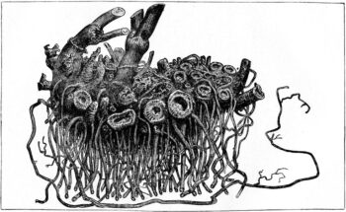
Actor Network Theory Developed primarily by sociologists in the 1980s, Actor Network Theory (ANT) is an influential theory within social sciences (Crawford, 2020). This theory brings forward an idea of distributed agency, whereby “agency is not a priori located - either in persons or things - but draws upon constellations that have a traceable effect (van Oyen, 2015, p. 65). This essentially recognises the agency that nonhumans have (see actants) and how they relate to human actors, and focuses on their relational interactions.
Figure 1: Actor Network Theory (Sophla Kosmaoglou, no date).

Agencement Discussed in relation to the etymology of the word assemblage (see below). Assemblage is the common French word for agencement (Nail, 2017, p. 22), although it is argued that there is a terminological issue with this translation; that agencement refers to the action of “matching or fitting together a set of components (agencer), as well as to the result of such an action: an ensemble of parts that mesh together well (ibid; DeLanda, 2016, p. 1).” Delanda (2016, p.1) argues that “the English word [...] captures only the second of these meanings”. This terminological issue also exists due to the archaeological usage of the word, meaning “a group of artefacts recurring together at a particular time and place, and representing the sum of human activities (Renfrew and Bahn, 2016, p. 596)”, creating an issue for archaeologists working within the New Materialisms.

Agency Originally reserved to human beings as being “events caused by acts of mind or will or intention (Gell, 1998, p. 16)”, that being the ability of humans to affect the material world around them. This has since been questioned however, notably Hoskins (2006, p. 74) described agency as being “the socio-culturally mediated capacity to act, [which] is deliberately not restricted to persons, and may include spirits, machines, signs and collective entities”. The New Materialities develops this further, questioning the status of the human within the material world; this approach looks at the material world more holistically and theories that matter and substance impact upon and influence each other, including but not limited to humans (Attala and Steel, 2019a, p. 3; Bennett, 2010, pp. 4-6) (see Agential Realism).

Agential Realism A theory utilised within the New Materialities by quantum physicist and feminist theorist Karen Barad. This approach develops ideas of agency (see above), rejecting representationalism (see below) for a completely indeterministic notion of agency that relies on existences of entities relying on relationships between matter (Marshall and Alberti, 2013, pp. 25-28), stating that “[m]atter is not a fixed essence; rather, matter is substance in its intra-active becoming - not a thing but a doing, a congealing of agency (Barad, 2003, p. 828 cited in Atalla and Steel, 2019, p. 2), and that “things do not have inherently determinate boundaries or properties” (Barad, 2007, p.38). Furthermore, things “never pre-exist their relating and the specific form and qualities of the things produced will depend on the material conditions that produce them” (Marshall and Alberti, 2013, p.26), that things are “complex entanglements whose properties or attributes are produces or effects of phenomena (see below) rather than pre-existing those phenomena. This theory highlights the constant flowing of matter, and highlights how the world is made up of this flow (see vibrant matter and agency).

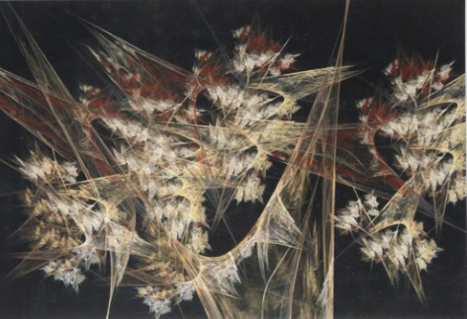
Assemblage An important concept within New Materialisms, an assemblage can be defined as an “ad hoc grouping of vibrant material of diverse elements, of vibrant materials of all sorts” (Bennett, 2010, p. 23). This emphasises Bennett’s vibrant matter theory (see below; Bennett, 2010), that entities are flowing in and out of relationships with each other and an assemblage is one such relationship that is in a “constant state of becoming” (Attala and Steel, 2019b, p. 216). Bennett (2010, pp. 24-28) discusses a power outage in North America, applying this theory. She discusses how a number of things mixed volatilely at the assemblage, that being not only just the actants and actors who run the electrical grid, but the electricity itself, something which isn’t a tangible entity, is also part of it, as well as all the households that were affected by it and the people within the households. She discusses distributive agency, and how agency is something that is “distributed along a continuum” (Bennett, 2010, p. 28) due to the friction of many different things that caused the power outage. She develops this further, stating that “there is not so much a doer (an agent) behind the deed (the blackout) as a doing and effecting by a human-nonhuman assemblage” (ibid.).
Figure 2: Assemblage theory (Amazon, no date).

Cartesian Cut Coming from concepts by Descartes, the Cartesian cut is an idea that emphasises a distinction between the material world from the nonmaterial world. This idea is the foundation of enlightenment ontologies that have dominated bases of knowledge within the “global north” (Atalla, 2019, pp. 39-40).

Conatus The “active impulsion or trending tendency to persist” (Bennett, 2010, p.2). Spinoza ascribes power to bodies, and that each thing strives to persevere in its own being. Whilst Spinoza specifically gives power to humans over nonhumans, he also argues that every nonhuman body also strives to persevere (ibid.). This theory is utilised by Bennett in her vibrant matters (see below) theory, and expands upon the idea that nonhumans “strive for perseverance”.

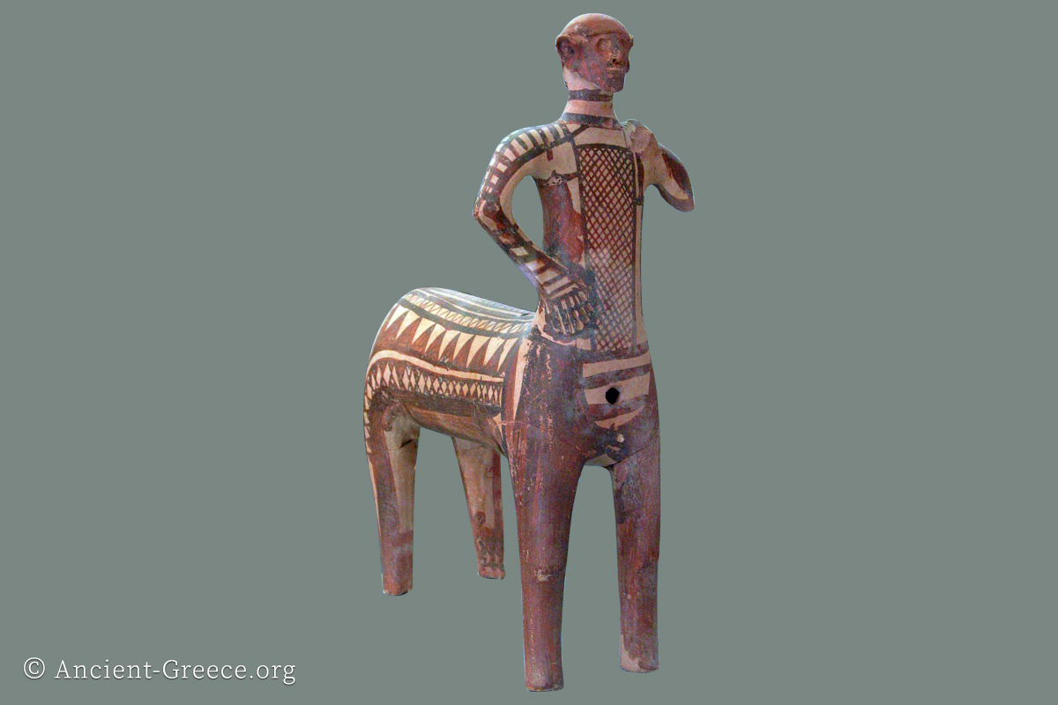
Fragmentation Archaeological theory that aims to explain broken things within the archaeological record. Chapman (2000, p.6) discusses this in terms of Balkan archaeology, whereby he proposes a practice whereby a specific artefact is broken into two by two individuals, creating two different individual parts that both become inalienable to the individuals (see inalienability). He goes on to discuss the importance of interactions between “parts, wholes and sets that provide so much of the dynamics in Balkan MNCA communities” (Chapman, 2000, p.7). Chapman (2000, pp. 7-8) argues that the human interaction with clay is one of importance, that the number of fragmented clay artefacts is great within this region, proposing that perhaps clay was fired within the purpose of fragmentation. He discusses how fragmentation is also found in human bones and metals (ibid.). This theory is useful in understanding relational ontologies between humans and nonhumans, and the importance of nonhuman interactions, as well as opposing Cartesian ideas (see Cartesian cut).
Figure 3: Centaur of Lefkandi, whereby the head and body were found in different graves and put back together after excavation. An example of fragmentation (see above). (Ancient-Greece.org, no date)

Inalienability The capacity of something to be inalienable, that is, for something to be unable to never truly be detached from their owner or owners. Weiner (1992, p. 6) discusses items as commodities and as gifts, but states that “there are other possessions that are imbued with the intrinsic and ineffable identities of their owners which are not easy to give away”. She uses the example of the Parthenon’s Elgin marbles in the British Museum as an example of something that “assume[s] a subjective value that place[s] them above exchange value”, meaning that the marbles are of such value to Greece that they are inalienable to Greece (ibid.). She develops this idea further, stating that “inalienable possessions are symbolic repositories of genealogies and historical events”, and states that their uniqueness and value makes something like the Elgin marbles always Greek and always belonging to Greece (Weiner, 1992, p.33).
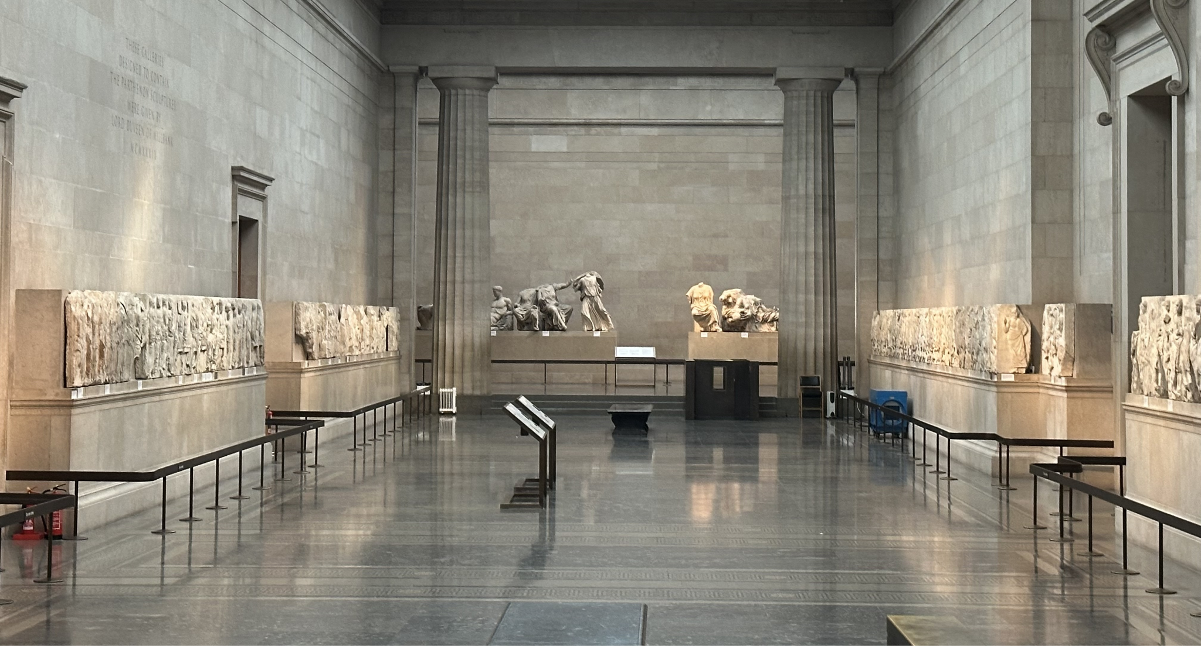
Figure 4: The Elgin marbles, at the British Museum (see inalienability) (Jay.M, 2024).
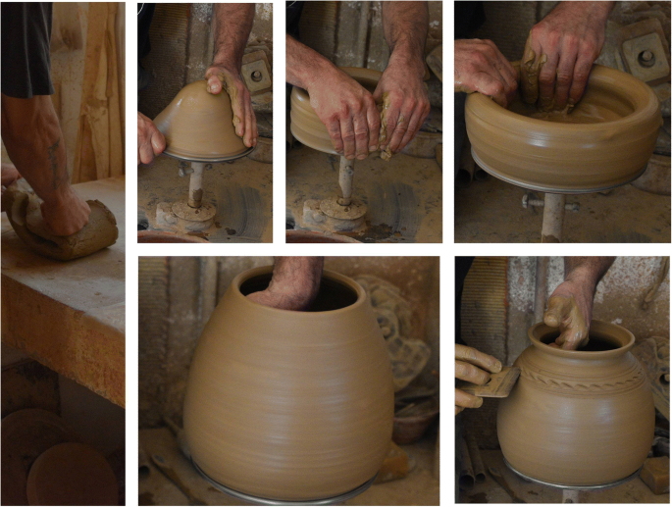
Material Engagement Theory An ontological theory that discusses human cognition and its relationship with material. Disputing representationalism (see below), Malafouris (2004, p. 58) proposes that “material culture is consubstantial with the mind”; that is, disregarding Cartesian principles (see Cartesian cut), the relationship between the material world and human cognitions is not one of abstract representationalism but one of “ontological inseparability” (ibid.), that the material world is not one of just external stimuli but is part of cognition itself and moulds peoples’ agency (see above). Steel (2018, pp. 201 - 203) utilises this theory when discussing Cypriot pottery, discussing the concept of affordances, that being the specific material qualities of things: material, form, size, colour, etc. and that “specific attributes are intrinsic to certain objects” (ibid.). Steel (ibid.) uses an example of figurines and statues, that figurines are portable therefore facilitates a “tactile handling / carrying relationship [...] whereas the latter is more appropriately displayed and viewed”. (ibid.).
Figure 5: Thinking with and through clay. Material engagement in action (Malafouris, 2019).

Materiality Physicality of the material world, the quality or character of things. The New Materialisms focuses on materiality relationally; the way in which matter (what things are made of) influences not only human behaviour, but also how matter (see below) influences matter (see Agential Realism) (Atalla and Steel, 2019c, p.xvii; Miller, 1998, p.6; Boivin, 2008, p.26).

Matter Whilst often synonymous with materiality (see above), matter can be described as the physical substance in the universe (Cambridge Dictionary, no date). The New Materialisms aims to unite mind and matter, physics and metaphysics, and how the two sides of this dichotomy have a continuous history of bringing each other into being (Boivin, 2008, p. 23; Barad, Butler and Adorno, 2024, p. 3).

New Materialisms A broad interdisciplinary field within contemporary academia. This challenges Cartesian ideas (see Cartesian cut) and rejects and challenges human exceptionalism and aims to recognise the significance of the nonhuman in creating worlds (Attala and Steel, 2019a, p.1). Coole and Frost (2010, pp. 6-7) discuss three themes that set a framework for New Materialisms: firstly, an ontological reorientation to one of relations: an orientation that conceives of matter itself exhibiting agency (see above): and one of political economy, the material details of everyday life, and broader geopolitics and socioeconomic structures.

Object Something that is perceived, materialised, and objectified by a perceiving subject (Brown, 2001, p. 5; Govier and Steel, 2021). This differs from a thing (see below), that is not perceived and singled out but instead is not contextualised. Knappett (2010, pp. 81-82) discusses that the difference between thing and object causes a linguistic issue, and that perhaps the difference between the two is overstated and the terms are interchangeable. This separation of things and objects causes ontological issues within a New Materialist perspective as it perpetuates a sense of anthropocentrism and representationalism (see below) that the field of study rejects.

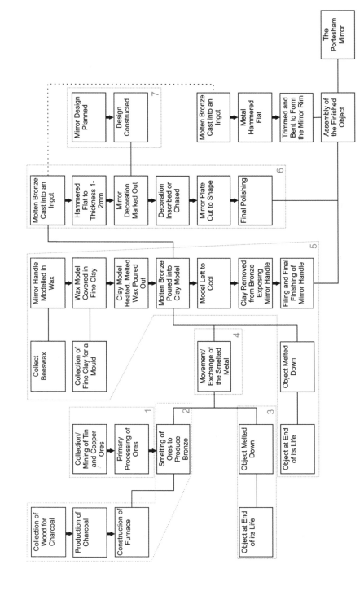
Object Biography Developed from an idea of biography within anthropology in terms of studying kinship and relationships, the term was applied to objects by Kopytoff (1986, pp. 66-68), whereby he proposes that objects go through different “ages”, from conception to destruction, and that they have different cultural markers and undergo different relationships, like humans, during these ages of their life. Joy (2009, pp. 546-552) utilises this in discussing an English Iron Age mirror, discussing the gathering and manipulation of raw materials to create a mirror that is potentially meaningful and symbolic, not just practical, to how it ended up as a grave good and then subsequently continuing its life within the archaeological record. She also reiterates that biographies are not simply historical reconstructions but are relational and a biography is constructed of the “sum of relationships that constitute it” (Joy, 2009, p. 552).
Figure 6: Stages in the construction of mirror (Joy, 2009, p. 547).

Object Itinerary A different approach to thinking about lives of objects (see above) to Kopytoff’s biography (see object biography). Whilst biographies take quite linear approach to life in the sense of birth to life to death, an itinerary approach rejects linearity by rejecting the tendency to anthropomorphize that the theory takes and instead focuses on the relationships between different contexts and lives that the object has lived and metaphorically focuses on the “pathways, distinctions and transitions” that they go through instead of a “pilgrimage” (Hahn and Weiss, 2013, pp. 1-2; Joyce, 2015, p. 21).

Ontology A branch of metaphysics that explores the nature of being and existence and how one understands being and existence; it is the study of “what there is” (Attala and Steel, 2019b, p.219; Stanford Encyclopedia of Philosophy, 2023). The New Materialisms (see above) reject human exceptionalist ontologies (see Cartesian cut) and instead proposes a relational ontology and the relations between entities with humans and nonhuman participants (Govier, 2019, pp. 24-25).
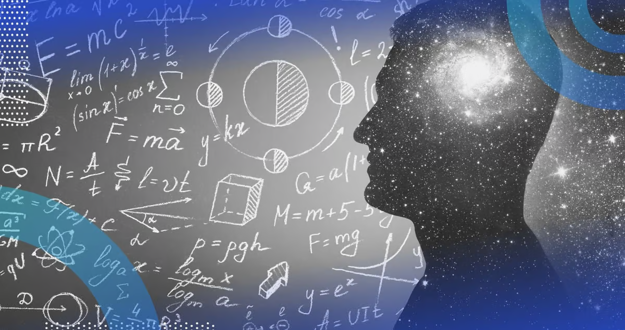
Personhood The meaning of being a person, according to their ontologies and culture (Attala and Steel, 2019b, p.220). The New Materialisms reject bounded personhoods; “rather than considering the skulls, the bodies of the living and other materials as separate entities”, they think about the relationships between matter as it entangles and how they cooperate to create personhood (Steel, 2019, p.110). Steel (2019, pp. 109-110) thinks about this in terms of Early Minoan and Cypriot burial practices, and how people choose to bury their dead and the social practices between the living and dead form identity and personhood for them.
Figure 7: Ontology (Urwin, 2024).

Phenomena A key concept within agential realism (see above). Phenomena is the basis of material reality, rejecting the bounded separateness of entities and that “[m]atter is not a fixed essence; rather, matter is substance in its intra-active becoming - not a thing but a doing, a congealing of agency (Barad, 2003, p. 828 cited in Atalla and Steel, 2019, p. 2). Phenomena are the forever folding, forming, reenfolding and reforming of matter within new relationships that form things-in-phenomena, not separately bounded things, that form the material world (Barad, 2007, p.177, 205).

Thing When thinking about objects (see above), which can be described as being singled out and contextualised (Brown, 2001, p. 5; Govier and Steel, 2021), a thing can be thought of as something that is neither of those descriptions. Knappett (2010, pp. 81-82) describes people as being “habitually surrounded in our everyday lives by things”, and Brown (2001, p.3) writes that things lurk in the shadows, regardless of interaction and perception. This has largely been rejected within the New Materialisms, arguing for an approach towards matter and entities that rejects human exceptionalism.

Vibrant Matter A theory within New Materialisms (see above) that proposes a rejection towards bounded separate entities and instead discusses matter as being vibrant, that flows in and out of relationships disclosing things as being “dead stuff” one moment whilst having a “live presence” the next (Bennett, 2010, pp. 4-8). She also discusses the vitality of matter; instead of focusing on particular social lives and contexts that matter enters in and out of, but an “effluescence that persists before and after any arrangement in space” (Bennett, 2010, pp. 56-57). An important concept within New Materialisms. (see Agential Realism and assemblage).

Bibliography

Amazon (no date) Assemblage Theory (Speculative Realism): Manuela Delanda. Available at: https://www.amazon.co.uk/Assemblage-Theory-Speculative-Realism-Delanda/dp/1474413633 (Accessed on 13th of November 2024).

Ancient-Greece.org (no date) Lefkandi Centaur. Available at: https://ancient-greece.org/lefkandi-centaur/ (Accessed on 15th of November 2024).

Attala, L. (2019) ‘I am Apple’, in Attala, L. and Steel, L. (eds.) Body Matters: exploring the materiality of the human body. Cardiff: University of Wales Press.

Attala, L. and Steel, L. (2019a) ‘Introduction’, in Attala, L. and Steel, L. (eds.) Body Matters: exploring the materiality of the human body. Cardiff: University of Wales Press.

Attala, L. and Steel, L. (2019b) ‘Glossary’, in Attala, L. and Steel, L. (eds.) Body Matters: exploring the materiality of the human body. Cardiff: University of Wales Press.

Attala, L. and Steel, L. (2019c) ‘Preface’, in Attala, L. and Steel, L. (eds.) Body Matters: exploring the materiality of the human body. Cardiff: University of Wales Press.

Barad, K. (2007) Meeting the Universe Halfway. Durham, North Carolina: Duke University Press.

Barad, Butler and Adorno (2024) ‘What is the Matter with Matter?’, Matter: Journal of New Materialist Research, 9, pp. 1-16. Available at: https://doi.org/10.1344/jnmr.v9.46426/

Bennett, J. (2010) Vibrant Matter: a political ecology of things. Durham, North Carolina: Duke University Press.

Boivin, N. (2008) Material Cultures, Material Minds. New York: Cambridge University Press.

Brown, B. (2001) ‘Thing Theory’, Critical Inquiry, 28(1), pp. 1-22. Available at: https://projects.iq.harvard.edu/files/riverbed_seashore/files/brown.pdf (Accessed on 15th of November 2024).

Cambridge Dictionary (no date) matter. Available at: https://dictionary.cambridge.org/dictionary/english/matter (Accessed on 14th of November 2024).

Chapman, J. (2000) Fragmentation in Archaeology. London: Routledge.

Coole, D. and Frost, S. (2010) ‘Introducing the New Materialisms’ in Coole, D. and Frost, S. (eds.) New Materialisms: Ontology, Agency and Politics. Durham, North Carolina: Duke University Press.

Crawford, T. H. (2020) Actor-Network Theory. Available at: https://oxfordre.com/literature/display/10.1093/acrefore/9780190201098.001.0001/acrefore-9780190201098-e-965#:~:text=Summary,a%20useful%20form%20of%20inquiry. (Accessed on 9th of November 2024).

DeLanda, M. (2016) Assemblage Theory. Edinburgh: Edinburgh University Press.

Gell, A. (1998) Art and Agency: An Anthropological Theory. New York: Oxford University Press.

Govier, E. (2019) ‘Bodies that co-create: the Residues and Intimacies of Vital Materials’, in Attala, L. and Steel, L. (eds.) Body Matters: exploring the materiality of the human body. Cardiff: University of Wales Press.

Govier, E. and Steel, L. (2021) ‘Beyond the ‘thingification’ of worlds: Archaeology and the New Materialisms’, Journal of Material Culture, 26(3), pp. 1-20.

Hahn, H. P. and Weiss, H. (2013) ‘Introduction: Biographies, travels and itineraries of things’ in Hahn, H. P. and Weiss, H. (eds.) Mobility, Meaning and Transformations of Things: shifting contexts of material culture through time and space. Oxford: Oxbow Books.

Hoskins, J. (2006) ‘Agency, biography and objects.” in Tilley, C. et al. (eds.) Handbook of Material Culture. London: SAGE Publications.

Jay.M (2024) File:Elgin-marbles-jan-2024.jpg. Available at: https://en.wikipedia.org/wiki/File:Elgin-marbles-jan-2024.jpg (Accessed on 15th of November 2024).

Joy, J. (2009) ‘Reinvigorating Object Biography: Reproducing the Drama of Object Lives’, World Archaeology, 41(4), pp. 540-556.

Knappett, C. (2010) ‘Communities of Things and Objects: a Spatial Perspective’, in Malafouris, L. and Renfrew, C. (eds.) The cognitive life of things. Cambridge: McDonald Institute for Archaeological Research.

Kopytoff, I. (1986) ‘The cultural biography of things: commoditization as process’ in Appadurai, A. (ed.) The social life of things: Commodities in cultural perspective. Cambridge: Cambridge University Press.

Malafouris, L. (2004) ‘The cognitive basis of material engagement: where brain, body and culture conflate.’ in DeMarrais, E., Gosden, C., and Refrew, C. (eds.) Rethinking Materiality: Engagement of Mind with Material World. Cambridge: McDonald Institute for Archaeological Research.

Malafouris, L. (2019) ‘Mind and material engagement’, Phenom Cogn Sci, 18, pp. 1-17. Available at: https://link.springer.com/article/10.1007/s11097-018-9606-7 (Accessed on 15th of November 2024).

Marshall, Y. and Alberti, B, (2013) ‘A Matter of Difference: Karen Barad, Ontology and Archaeological Bodies’, Cambridge Archaeological Journal, 24(1), pp. 19-36.

Miller, D. (1998) ‘Why some things matter.’ in Miller, D. (ed.) Material cultures: Why some things matter. London: UCL Press.

Nail, T. (2017) ‘What is an Assemblage?’, SubStance, 46(142), pp. 21-37.

van Oyen, A. (2015) ‘Actor-Network Theory’s Take on Archaeological Types:
Becoming, Material Agency and Historical Explanation’, Cambridge Archaeological Journal, 25(1), pp. 63-78.

Renfrew, C. and Bahn, P. (2016) Archaeology: Theories, Methods and Practices. 7th edn. London: Thames and Hudson

Sophla Kosmaoglou (no date) [Symposium] Book Club #5 Latour: On Actor Network Theory. Available at: https://videomole.tv/latour-on-actor-network-theory/ (Accessed on 9th of November 2024).

Stanford Encyclopedia of Philosophy (2023) Logic and Ontology. Available at: https://plato.stanford.edu/entries/logic-ontology/#Onto (Accessed on 15th of November 2024).

Steel, L. (2019) ‘Embodied Encounters with the Ancestors’, in Attala, L. and Steel, L. (eds.) Body Matters: exploring the materiality of the human body. Cardiff: University of Wales Press.

Urwin, M. (2024) How Ontology and Data Go Hand-in-Hand. Available at: https://builtin.com/data-science/ontology (Accessed on 15th of November).

Weiner, A. B. (1992) Inalienable Possessions: The Paradox of Keeping-While-Giving. Oxford: University of California Press.

