Reflective Report on Kolb’s Reflective Cycle and Johari Window
professional carrer development 09/06/2023
Elena Ravelo Barreto (2240356)
2023
Contents

Terms of Reference 2
Executive Summary 2
Introduction 2
Main Findings 2
Conclusion 5
Reference List 7

Terms of Reference

This report has been requested by James Squire-Wood, for my Professional Career Development module, to be submitted by the 09/06/2023.

Executive Summary

The purpose of this report is to provide you with an overview of Kolb's Reflective Cycle by David A. Kolb, as well as Johari's Window, a visual tool created by Joseph Luft and Harry Ingham. First, I will provide some background information on the creators of both theories. Then, I will briefly explain each theory and offer practical examples for both. To provide a comprehensive understanding, I will use myself as the subject from both a professional and personal perspective.

Introduction

This report delves into the theories and practical applications of D.A. Kolb and J. Luft and H. Ingham, with a focus on two specific approaches: The Kolb’s Reflective Cycle by David A. Kolb and The Johari Window by Joseph Luft and Harry Ingham. These methods serve as effective tools for achieving self-awareness within the marketing and business realms, ultimately leading to a more efficient and productive work style.

Kolb's theory is centred around the idea that we learn through experience, as he states, "Learning is the process whereby knowledge is created through the transformation of experience" (David A. Kolb, 2014). On the other hand, the Johari Window method promotes interpersonal awareness by encouraging individuals to consider not only their own perspective, but also the perception of others around them.

Main Findings

KOLB
D.A. Kolb, an American psychologist and educational theorist, obtained his undergraduate degree from Knox College and subsequently earned a Ph.D. in Social Psychology from Harvard University. He is renowned for his research on experimental learning. One of his most notable works is Kolb's Reflective Cycle, published in 1984, (Kendra Cherry,2020).
Please refer to the diagram below for further explanation of this theory.
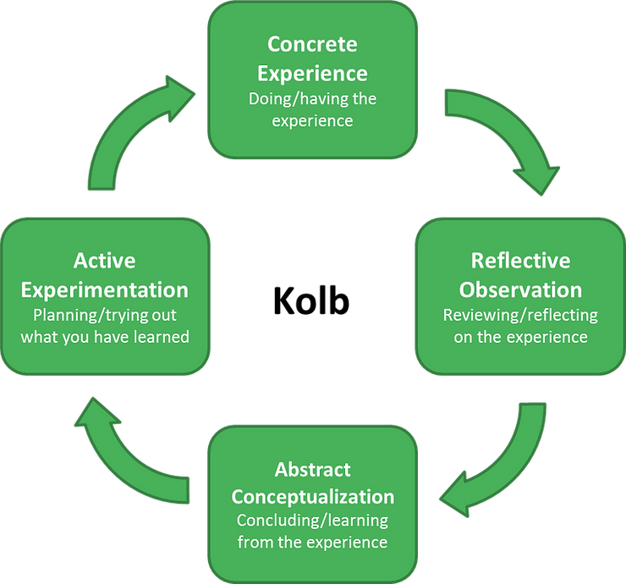
(Mrsstrickney, 2021)
Kolb's theory utilizes self-awareness to recognize and address problems by learning through personal experiences and overcoming obstacles. The theory aims to achieve two objectives- to learn from a particular situation and to discover more about oneself. (Kolb D.A, 1984)

Here's a practical example based on my own work-related experience.

The Concreate Experience: The reason for my concern stems from an issue I faced at work. A report by BBC was aired and had the potential to harm my industry, the Nail Business. The report discussed the development of nail allergies without providing any specific details, which led to the entire sector being tarnished instead of highlighting the specific problem. This resulted in the spread of fear and misinformation.
Reflective Observation: In response to a challenging situation, I took steps to address and reassure my clients. I proactively raised the issue in discussions with them, allowing me to tackle any concerns directly. While a report highlighted the need to work with full systems, I already had one in place. However, with the introduction of a new brand, I needed to either discontinue using it or obtain the necessary tools to work with the full system.
Abstract Conceptualization: As a professional and accredited service provider, I understand the importance of reassuring our clients on social media. It's essential for them to know that we are fully insured and always comply with the highest health and safety requirements. I encourage clients to ask for our certifications and other necessary paperwork, as it's their right to have access to them. We only use brands and products from reputable sources in the EU, UK, and US.
After careful consideration, I decided to work with a well-known brand in the industry, which is synonymous with quality and professionalism. However, I had to research the additional expenses of acquiring the necessary tools to work with their full system, as this was an important aspect to consider.
Active Experimentation: I successfully posted the social media content that I had been working on and ordered the necessary items. I am pleased to report that this approach was fruitful, as I not only managed to retain all my clients but also gained a considerable number of new ones. My clients are now better informed and satisfied with the knowledge of how to identify a genuine, professional technician.

JOHARI WINDOW
Joseph Luft and Harry Ingham developed this self-awareness technique in 1955. (Marilia Fiuza, 2018). The name "Johari" is a combination of the authors' names. (Mind Tools Content Team It is a tool that has been created to aid in comprehending our relationships with both ourselves and others. (Upskill Coach,.). The objective is to expand the Open area while reducing the Hidden and Unknown areas (Admin, 2017).

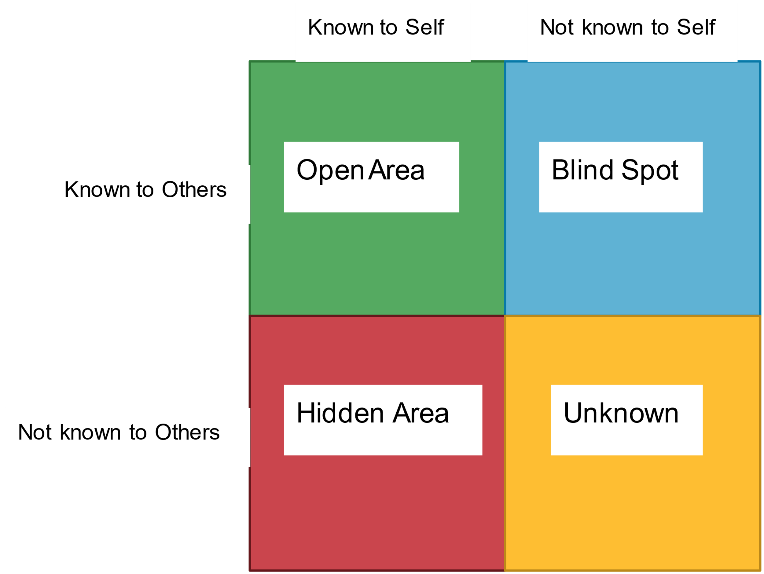
(Lalindri Amunugama, .)

On the following example, I have used this method to define myself with five adjectives. I participated with five adjectives of my own, for self-insight; and for a more comprehensive perspective, I asked four other people to provide too, five adjectives each, that they felt it described me. To ensure a realistic outcome, I specified that the adjectives could be positive, negative, or a combination of both, as I felt that including flaws was crucial for accuracy.

Know to Self Not Know to Self

Know to Others

Not Know to Others

During this exercise, I was surprised to discover that some things I knew were noticed by others, while other traits about myself were brought to my attention by multiple people. What really struck me was how critical and negative I can be towards myself. I knew I could be hard on myself, but I never fully realized the extent of it until now.
During this practical exercise, my biggest challenge was filling up the quadrant labelled "Not Known by Me / Not Known by Others". While it may seem like I'm not putting in enough effort, the truth is that I already know a lot about myself that others don't, and vice versa. I'm a very analytical person who frequently reflects on my actions, thoughts, and life experiences. I tend to keep my innermost thoughts and feelings hidden from others, but I'm always honest with myself.
The only new discovery I made about myself during this exercise is that I am an introvert. This realization came during a lecture at my university, thanks to J. Squire-Wood. I never realized before that my depression has led me to become an introvert in many aspects of my life. This information was previously unknown to me, and it's unlikely that others knew about it either. I tend to put on an extroverted facade to distract from my pain and struggles, so I'm sure many people assume I'm outgoing and sociable.

Conclusion

This work has been amazing, not only I had the opportunity to use the Kolb’s Reflective Cycle with a work environment practical issue but also had the chance to know me and my circle better by using the Johari Window. Throughout the work for this report, I have only grown curious about the authors of this theories and their work. And I wonder, if I feel like this at the beginning of my university year, how many other amazing things I will learn and wonder.

Reference List

Admin. (2017). The Johari Window: An Avenue to Interpersonal Skills. [Online]. The Oasys Group. Last Updated: 08/11/2017. Available at: https://www.theoasysgroup.com/the-johari-window-an-avenue-to-interpersonal-skills/#:~:text=The%20goa [Accessed 1 June 2023].
David A. Kolb (2014). “Experiential Learning: Experience as the Source of Learning and Development”, p.51, FT Press
Kendra Cherry. (2020). Biography of Psychologist David Kolb. [Online]. Very Well Mind. Last Updated: 12/03/2020. Available at: https://www.verywellmind.com/david-kolb-biography-2795505 [Accessed 30 May 2023]. (1)
Kolb, D. A. (1984). Experiential learning: Experience as the source of learning and development (Vol. 1). Englewood Cliffs, NJ: Prentice-Hall.
Lalindri Amunugama. (.). Johari Window 1. [Online]. Creately. Last Updated: .. Available at: https://creately.com/diagram/example/5es6S0Kn0OA/johari-window-01 [Accessed 30 May 2023]. (3/Diagram)
Marilia Fiuza. (2018). Behind the Johari Window. [Online]. Institute of Coaching. Last Updated: 28/08/2018. Available at: https://instituteofcoaching.org/blogs/behind-johari-window [Accessed 1 June 2023].
Mind Tools Content Team. (.). The Johari Window. [Online]. Mind Tools. Last Updated: .. Available at: https://www.mindtools.com/au7v71d/the-johari-window [Accessed 1 June 2023].
Mrsstrickney. (2021). Reflective Practice. [Online]. Teach with Mrs T. Last Updated: 16/05/2022. Available at: https://www.teachwithmrst.com/post/reflective-practice [Accessed 30 May 2023]. (2/Diagram)
Upskill Coach. (.). What is the Johari Window Model — Become A Great Communicator. [Online]. Upskill Coach. Last Updated: .. Available at: https://upskillcoach.com/blog/what-is-the-johari-window/ [Accessed 1 June 2023].

