

MODULE CODE/ INTRODUCING THE MODERN WORKPLACE (LCBB4003)

TOPIC: TESCO

LECTURER: HUSAM HELMI

STUDENT: HRISTIYAN PARVANOV

ID: 1817604

Table of contents

1. Introduction ....................................................................................... 3.
2. Exploration of TESCO …................................................................... 3.
3. Organisational Structuture ................................................................ 4.
4. Culture – Hofstede’s Framework........................................................ 5.
5. People and Motivation ………………………………………………….. 6.
Theory X and Theory Y ……………………………………………………. 7.
6. Motivational Theories …………………………………………………… 7.
Maslow’s Hierarchy of Needs …………………………………………….. 7.
Herzberg’s Motivation – Hygiene Theory ………………………………... 8.
7. Performance Management ……………………………………………... 8.
8. Recommendations ………………………………………………………. 9.
9. Conclusion ……………………………………………………………….. 9.
10. References ……………………………………………………………... 10.

Table of figures

Figure 1. Tesco Corporate Governance Structure chart
Figure 2. Tesco organizational structure at store level

Introduction

This essay will introduce one of the major and largest trading shops in England.
(1) Tesco's history and the key to its success;
(2) the organizational structure of Tesco; people and motivation to work in accordance with Maslow and Herzberg theories.

Exploration of TESCO

Tesco is one of the largest stores in England and is the retailer and headquarters in England: Welwyn Garden City, Hertfordshire, England, United Kingdom. (Tesco PLC,2018). It is the third largest trader in the whole world. Tesco has stores in seven countries in Europe and Asia. There are 6800 stores open in England (Tesco PLC,2016). It has 450,000 employees (Tesco PLC,2018). Tesco's subsidiaries are TESCO stores LTD, TESCO Bank, TESCO Mobile and others. Back in 1919, Tesco launched as a market stall (BBC NEWS, 2014) The founder was Jack Cohen named Register 1924. The first Tesco store opened its doors in 1931. In Burnt Oak. This small English grocery expanded and entered the global markets in the 1990s. Since the 1960s, Tesco has increased its market share by including the sale of books, clothing, furniture, toys and financial services. Tesco bravely enters the world of low-cost products that stand up to strong competition from Asda and Lidl. These are TESCO value products (BBC news, 2014), but it also retains products aimed at a higher socially - valued consumer group - leaving them with the variety of "TESCO FINES". Today, Tesco is successfully developing its online business. It attracts many users with a so-called club card that gives discounts and points for free shopping. To date, Tesco has implemented its new weapon against the German LIDL and AUDI. Jack's stores are now open to introduce new patriotic merchandise. Jack's stores offer low-cost products made in England. With the new chain, the company hopes to maintain the balance by opposing the discounters. Tesco has been in constant battle with competition in recent years. AUDI holds 7.6% of food sales, increasing its share by 0.6%, LIDL increasing its share by 5.5%. Tesco is down 0.5% to 27.4%, according to Kantar Worldpanel.

Organisational Structuture

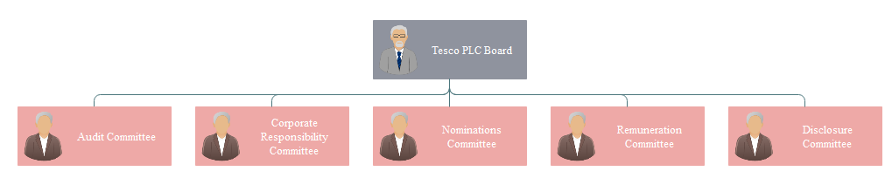

Figure 1. Tesco Corporate Governance Structure chart
Figure 1 shows the organizational structure of Tesco. It has five committees that report to the Tesco PLC board. 11 members of the Executive Committee, headed by Dave Lewis, Group Chief Executive. The chart of the organizational structure of Tesco is very hierarchical.

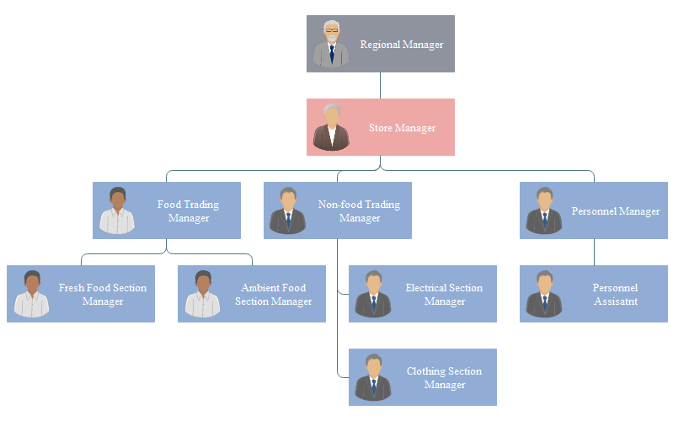
Figure 2. Tesco organizational structure at store level
Figure 2 shows the organizational structure of the Tesco company at the store level. It has 4 layers of control that disrupt communication, so it is recommended to shorten the layers to create more flexibility.
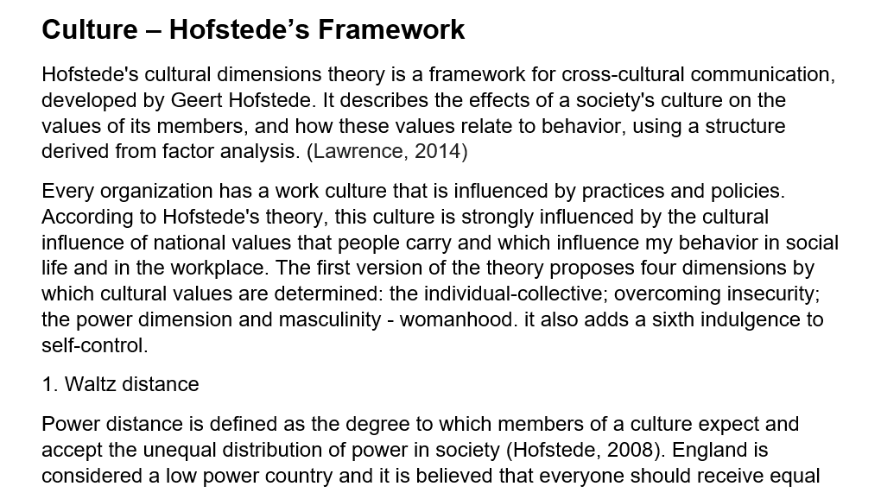
privileges in organizations. The involvement of TESCO employees in the decision-making process determines the factor that individuality and personal opinion are highly valued. It works through peaceful cooperative strategies during joint negotiations and activities, easily compromises and collaborates with other cultures.
2 Individual versus group orientation.
This dimension represents the connection between the individual and the group in the organization of TESCO in honor of the individual who cares for himself / herself.
3. Avoiding uncertainty
Hofstede defines uncertainty avoidance as a dimension that describes the tolerance of society to counteract uncertainty and ambiguity. It involves how people respond to an unexpected situation.
4. Masculinity versus femininity. This dimension shows what values ​​are common in different societies - male or female. The masculine cultures, which is also English, are usually more ambitious, self-confident, and competitive with them, people work to live; the dominant values ​​in life are material successes and progress.
5. Long-term versus short-term orientation. Long-term oriented cultures look to the future, while short-term to the past and present. Despite numerous criticisms, the Hofstede model has been used as one of many guidelines for embracing people from different cultures and improving business relationships in the business environment.

5.People and Motivation
To strengthen its growth, Tesco needs a flexible, motivated and well-trained staff that knows and feels the needs of its customers. Tesco employees take on different roles at different levels - from customer assistants to managers; from warehouse staff to office and logistics workers. I will look at how Tesco motivates its employees through trainings, skills development, job satisfaction, and a well-deserved reward and recognition. The motivated working staff will work for quality, for higher results and for a shorter time - thus reducing labor costs. For Tesco, there are two main groups that define business - customers and staff. Not only the work of the staff but also the life outside it is appreciated. For this, Tesco rewards with flexibility the discounts for fitness, good salaries, options to buy shares of the company. Tesco builds respect and trust. At Tesco, the "motivated" person works in partnership with others to achieve individual and team goals. In 1911, engineer Frederick Taylor identified one of the earliest theories of motivation - that is, people work only for money. The Tesco financial bundle has something in common with Taylor's theory. But there are other non-financial motivating factors. Training, for example, enhances the knowledge and skills of employees (job satisfaction). Some of the strengths of Tesco's staff are: termination of careers with the right of return and the retirement benefits offered; all Tesco employees also have their own development plan. The employee-manager relationship is 360%, which ensures that the employee is committed to growing the company and working for improvements.
Theory X and Theory Y
Theory X and Theory Y are theories of motivation, created by Douglas Macgregor in the 1960s. They are applied in human resource management by presenting two different attitudes to motivate the workforce (Wikipedia) Theory X workers are:
- Avoiding and disliking their job
- Lacking initiative and identity, individuals who are preferred to be led; people who do not accept security. It is a fact that in order to achieve organizational goals through the management of Theory X staff, business is forced to operate under the control and punishment management method. The workers in Theory Y are defined by McGregor as:
- Work process participants who perceive it as rest and play:
- Ordinary people who show personality are motivated. With this Theory Y, rewards are one of the strongest motivators for people. Managers create such a cultural and work environment that staff can express their creativity. This is the principle of integration. Work through self-direction and self-control (Mc.Gregor, 1960)

6.Motivation Theories
Motivation can be coordinated by self-interest or by external factors such as praise and reward. There are many theories to motivate workers. Money is considered to be a major motivator. responsibility, enjoyment, progress, challenge.

Maslow’s Hierarchy of Needs
Abraham Maslow is one of the theorists of motivation. He identifies five basic needs for motivating people. He is known for his pyramid, called the 'need hierarchy'. The first is the basic needs of motivation - food and shelter. for example, better working conditions, which Tesco offers its employees. Our third need is social needs - for example, one feels part of something, inclusion. The fourth level is self-esteem, which is achieved through training and skills development. tip n and the pyramid is creativity and interest. Maslow thinks that by conquering levels, one goes to perfection. It strongly encourages the work of teams and groups. Strictly ensures the security of employment contracts. Tesco values ​​promote self-esteem and respect for the other.

Herzberg’s Motivation – Hygiene Theory
Herzberg's motivational theory. In 1959, Frederick Herzberg created the two-factor theory of motivation - factors that are motivators and satisfiers. (So-called hygiene)., good enough to feel good in their workplace. Satisfactory factors are recognition and achievement. Hygiene factors are pay, relationships with colleagues, growth, training, promotion, working conditions. It is very important for Tesco to motivate its employees, taking into account hygiene factors. It is difficult to motivate by creating direct communication - staff can participate in decision making for the enterprise. Tesco's staff is also involved in the choice of food for its restaurants - so the employees make choices and show creativity.

7.Performans management
Tesco's performance management system is a way of ensuring that company goals are met by staff. It is a holistic process that involves an organization's strategy for achieving goals and the desire and competence of individuals and individuals to work toward its achievement. (Rigby, 2015). First, to determine the right strategy, and then to synchronize it in the management of human resources. Last but not least, the organization needs to seriously consider staff training as a tool to improve employee status - this is an effective way to work toward goals. There are 6 components to Tesco's performance management system:
1st performance determination; 2nd performance evaluation; 3rd employee-manager feedback; 4th payment and prizes - bonus and prizes; 5th improvement of employee efficiency - through training; 6th employee evaluation. Several key features of Tesco's performance management system are identified. These key functions are - at Tesco, each employee must set their annual goals that are relevant to the organization's business strategy. Involvement of staff in the process of growing the organization in order to increase ownership. Tesco management aligns with its goals and employees' own resources. This implies high commitment and support. Tesco invests heavily in training programs. This focus helps the company have standardized results management.

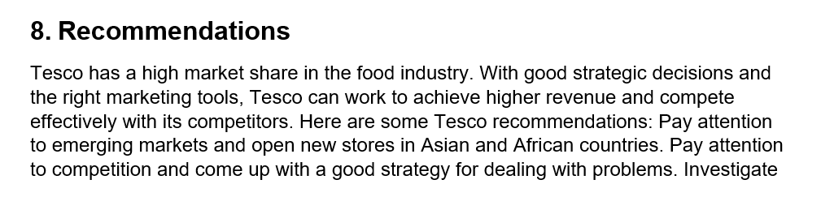
the market share very carefully even before entering a new market in order to avoid possible failures and losses. A huge resource should be channeled into online shopping, improved and made more attractive to its customers, providing them with additional bonuses and emotions. When launching a new advertisement, it would be appropriate to reach out and take the opinions of the clients, seeking their pre-approved ones in order to stop the possible discomfort of the public. There is a need for continuous improvement, renewal and increase of advertising activities in order to attract new customers from the competition. What Tesco needs to improve is that it has launched new Jax-branded stores that offer low-cost goods made entirely in England in order to further attract a new contingent of consumers - geared very patriotically. Tesco needs to focus on managing immigrants, because as employees of Tesco there are people of different backgrounds and backgrounds. Tesco must also rely on its cost leadership strategy.

9. Conclusion
This essay discusses the factors that are important to Tesco's ability to grow its business in the national and international markets and examines the current position of this company. The factors that are important for a successful business are Tesco's strategic goals. To this end, they are consistent with both management and its employees. Communication feedback teamwork and individual work staff assessment - all this underpins a well-developed and competitive business, as developed by one of the UK's leading retailers - Tesco. It is important for Tesco that it is following the globalization strategy, and that it is entering new markets, overcoming the serious barriers that the company faces when it comes to working with local companies and leveraging its resources.

10. References

- En.wikipedia.org. (2016). Tesco. [online] Available at: https://en.wikipedia.org/wiki/Tesco_PLC [Accessed 20 January 2016].
- En.wikipedia.org. (2014). Tesco. [online] Available at: https://en.wikipedia.org/wiki/Tesco_Hypermarket [Accessed 18 October, 2014].
- En.wikipedia.org. (2018). Tesco. [online] Available at: https://en.wikipedia.org/wiki/Tesco_PLC [Accessed 13 Apr. 2018].
- Economic.bg. (2018). Economic.bg – The Economic Portal - News, Economics, Business, Companies, Finance, Markets, Jobs, Interviews, Analysis. [online] Available at: https://www.economic.bg/ [Accessed 19 Sep. 2018].
- Meng, M. (2017). Tesco Company Organizational Structure Chart Example | Org Charting. [online] Orgcharting.com. Available at: http://www.orgcharting.com/tesco-company-organisational-structure-chart-example/ [Accessed 19 Aug. 2017].
- Is.muni.cz. (2015). [online] Available at: https://is.muni.cz/el/1451/podzim2013/np2330/tesco_15_full.pdf [Accessed 7 May 2015].
- Myassignmenthelp.com. (2015). Tesco Performance Management: Performance And Productivity - Free Solu. [online] Available at: https://myassignmenthelp.com/free-samples/tesco-performance-management-performance-and-productivity [Accessed 3 Mar. 2015].
- En.wikipedia.org. (2018). Hofstede's cultural dimensions theory. [online] Available at: https://en.wikipedia.org/wiki/Hofstede%27s_cultural_dimensions_theory#cite_note-1 [Accessed 7 Sep. 2018].
- Adeoye, Blessing; Tomei, Lawrence (2014). Effects of information capitalism and globalisation on teaching and learning. Pennsylvania: Information Science Reference. Retrieved 21 October 2015.
- Mc.Gregor (1960) Theory x and Theory Y. Organization theory
- tutor2u. (2019). Motivation - McGregor (Theory X & Theory Y) | Business | tutor2u. [online] Available at: https://www.tutor2u.net/business/reference/motivation-mcgregor-theory-x-theory-y [Accessed 9 Feb. 2016].

