

Methods and Search Strategy Academic Poster

Student name:Ionela Slavoiu
Student ID:2243457

Module name: Independent Project
Module code:BMHP6020

Exploring the Effectiveness of Tele-Paliative Care in Quality of Life for End-of Life Patients

01 Introduction and Research Aim  A methods chapter contains the way a study is planned, carried out and analysed to provide transparency, rigour and credibility. This scholarly approach poster abstracts the secondary research design taken by this dissertation, the search strategy, retrieval procedure, validation, analysis, and ethics. The poster presents a summary of the method used to systematically identify, review, and synthesise evidence to meet the purpose of the research: to investigate the role of tele-palliative care in improving the quality of life of patients. This is a methodological approach ensuring that findings are based on robust and up-to-date evidence applicable to practise in health and social care. | 02 Search Strategy  In secondary research, a search strategy is a well-organised and systematic approach to finding the appropriate literature with a minimum of bias and omission (Chigbu et al., 2023). In this paper, the tactic entailed the application of pre-determined key words, Boolean operators, and inclusion thresholds to access evidence of high quality. PubMed, CINAHL, and Google Scholar databases were searched with combinations of various terms like tele-palliative care, end-of-life care, quality of life, and digital health. Peer-reviewed journal articles released since 2015 were used as filters to ensure relevance and up-to-date results.
03 Searching for Information  The search for information was in a step-by-step mode. First, the main concepts were determined based on the research purpose. Second, appropriate synonyms and alternative terms have been created to expand the retrieval. Third, the results were further narrowed using database-specific filters, such as date, language, and type of study. The screening of abstracts was subsequently conducted to determine relevancy, and then a full-text review of qualifying articles was conducted. This systematic inclusion made sure that only the literature that dealt with tele-palliative care outcomes and quality of life was incorporated (Krieckemans et al., 2025). Secondary research allows summarising the existing body of evidence and is especially suitable when it comes to assessing novel healthcare models (Dusin et al., 2023). | 04 Picture / Graph / Visual Aid / Statistics  The study of Greer et al. (2024) offer conclusive data that tele- palliative care is equal to face-to- face visits. The figure indicates that patients in both groups had a significant improvement in quality of life, which establishes that virtual delivery effectively sustains clinical standards without necessitating higher accessibility in end-of-life patients.  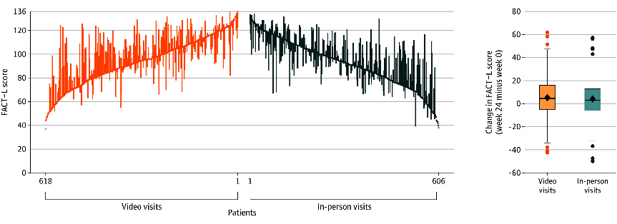  Figure 1: Changes in Patient-Reported Quality of Life From Baseline to Week 24 by Study Group (Greer et al., 2024)
05 Research Validation and Analysis
Validation of secondary research means that the sources must be credible, reliable and methodologically sound (Cheong et al., 2023). This was attained through prioritising peer-reviewed studies, criticism of research design, and synthesis of findings in more than one study. Whereas validation enhances reliability, there are constraints such as publication bias and a change in the quality of a study. The secondary research analysis is a keen examination of literature to determine the patterns and themes (Basheer et al., 2024). A thematic analysis method was adopted in order to derive consistent themes like symptom management, access to care, and emotional support that will inform Chapter 4 findings.
06 Inclusion Criteria  This literature review incorporated peer-reviewed journal publications as of 2015, in English, and literature on tele-palliative or digital end-of-life care and was 100 per cent accessible online. | 07 Exclusion Criteria  Sources that were excluded included publications dated prior to 2015, non-peer-reviewed articles, publications not dealing with end-of-life care, and those articles lacking full-text access.
08 Ethical Considerations
In secondary research, ethics includes good sharing of existing data, proper reference, and avoidance of misrepresentation (Kambhampati et al., 2023). Ethical factors were proper reference, observation of academic integrity policies and objective explanation of findings so that bias/distortion of evidence is avoided.

References
Basheer, N., Ahmed, V., Bahroun, Z., and Anane, C. (2024). Exploring sustainability assessment practices in higher education: a comprehensive review through content and bibliometric analyses. Sustainability, 16(13), 5799. https://doi.org/10.3390/su16135799
Cheong, H.I., Lyons, A., Houghton, R. and Majumdar, A., (2023). Secondary qualitative research methodology using online data within the context of social sciences. International Journal of Qualitative Methods, 22, p.16094069231180160. https://doi.org/10.1177/16094069231180160?urlappend=%3Futm_source%3Dresearchgate.net%26utm_medium%3Darticle
Chigbu, U.E., Atiku, S.O. and Du Plessis, C.C., (2023). The science of literature reviews: Searching, identifying, selecting, and synthesising. Publications, 11(1), p.2. https://doi.org/10.3390/publications11010002
Dusin, J., Melanson, A. and Mische-Lawson, L., (2023). Evidence-based practice models and frameworks in the healthcare setting: a scoping review. BMJ open, 13(5), p.e071188. https://doi.org/10.1136/bmjopen-2022-071188
Greer, J.A., Temel, J.S., El-Jawahri, A., Rinaldi, S., Kamdar, M., Park, E.R., Horick, N.K., Pintro, K., Rabideau, D.J., Schwamm, L. and Feliciano, J., (2024). Telehealth vs in-person early palliative care for patients with advanced lung cancer: a multisite randomised clinical trial. JAMA, 332(14), pp.1153-1164. https://jamanetwork.com/journals/jama/fullarticle/2823624
Kambhampati, S.B., Menon, J. and Maini, L., (2023). Ethics in research and publications. Indian Journal of Orthopaedics, 57(11), pp.1722-1734. https://doi.org/10.1007/s43465-023-00971-x
Krieckemans, L., Cavolo, A., Casaer, M., and Gastmans, C. (2025). Telehealth in palliative care settings: A systematic review of argument-based ethics literature. Palliative medicine, 02692163251360115. https://doi.org/10.1177/02692163251360115

