REPORT TEMPLATE
Module: Introduction to Web and Database Concepts (ACCA4023)
Assignment: HTML & CSS Web Development
Student Name: Daud Mohammed Jama
Student ID: 2442748
Course: _CERTHE computing skills for workplace_________________________
Submission Date: _23/04/26_________________________

Table of Contents

Table of Contents 1
1. Introduction (Abstract) 2
2. Requirements 2
3. Implementation 2
4. Evaluation 2
5. Conclusion 2
6. References (IEEE Format) 3
7. Appendices 3

1. Introduction (Abstract)
I created the Manchester Heritage website to help tell the story of the city’s history in a way that’s easy for anyone to dive into. For this assignment I focused on building a clean, modern site using HTML and CSS, with a major emphasis on making sure the design feels natural and responsive to all people.
I wanted to make sure the site was running good, so I ran everything through W3C code validation to keep it clean and professional. Since this is an educational tool meant for everyone all the way from local students to tourists exploring the city I made sure to also do a deep dive into WCAG accessibility guidelines. This helped me ensure that the final result isn't just a project, but a functional and inclusive resource that actually works for its users.

2. Requirements
The main goal for the site was to break down Manchester’s massive history into three clear pages. its Roman roots at Mamucium, the explosion of the Industrial Revolution and the lasting legacy of Victorian architecture. I wanted the website to also act as a efficient hub where someone could actually plan a visit or dive deep into a research project without getting lost or confused due to unnecessary information .
Due to the fact i was designing for both tourists looking for a quick cultural fix and students who need structured facts, I had to find a balance. I made sure to pair high quality imagery with a very straightforward and efficient navigation system. This ensures the site stays easy to get around and works perfectly across different devices, making the history feel accessible rather than overwhelming.

3. Implementation



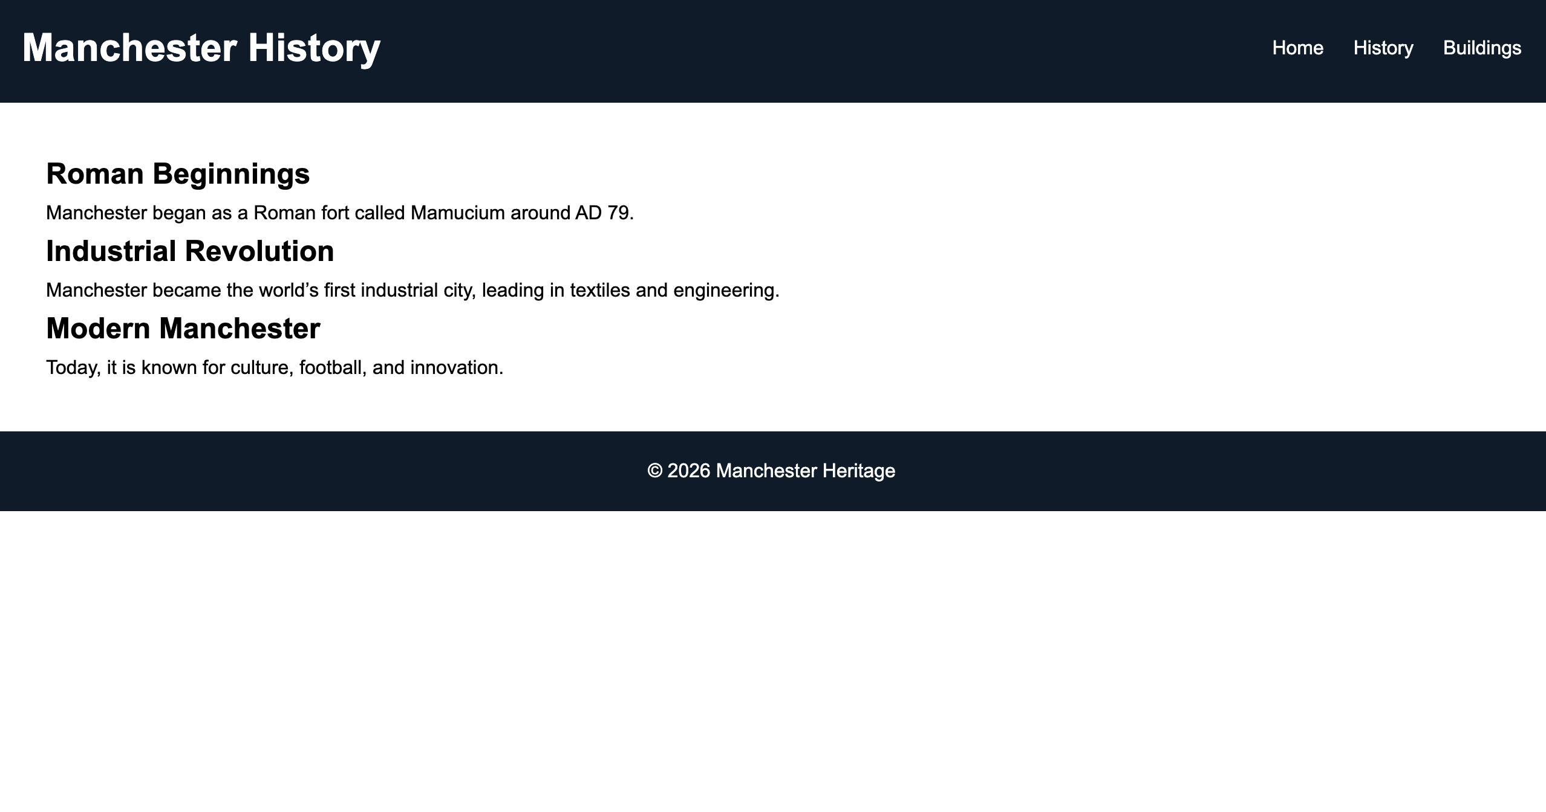

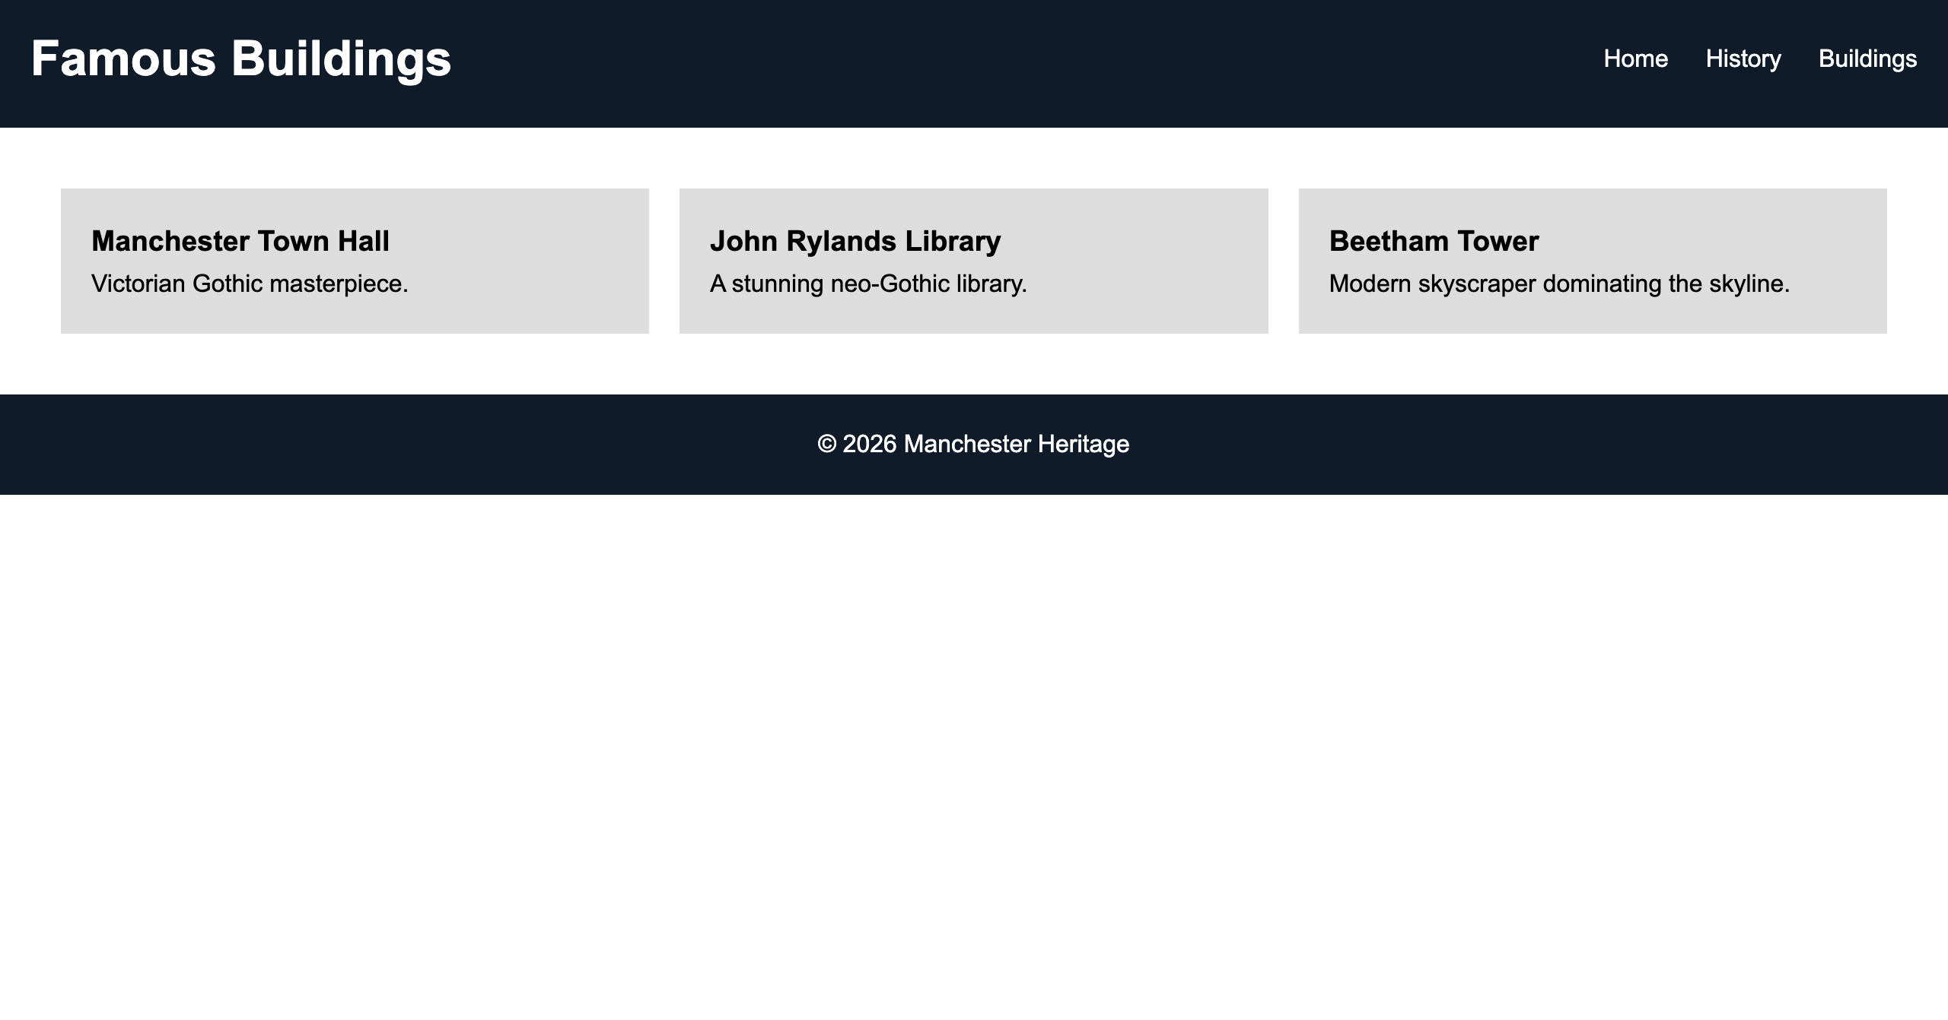
I focused on a responsive design for the website by using CSS flexbox and grid to make sure the interface runs smoothly and also scales naturally to fit whatever screen size the user is on. I also kept the design focused on high contrast and clear font because if the content isn't easy to read the history gets lost and becomes confusing.
The development process was a bit of a learning curve. When I ran my code through the W3C markup and Jigsaw services, I caught some errors but my main struggle was keeping the internal links from breaking as I restructured the folders. I had to go back and manually fix several broken paths for the images and stylesheets to make sure everything connected properly across the different pages. Sorting these issues out didn't just clean up the code it made the site load faster and ensured it’s actually accessible for every user, regardless of their device.

4. Evaluation
a) Research:
Usability: For me, usability was all about making sure the site was satisfying and efficient to use. As noted in [1]usability is a huge factor in building user trust. I made sure I focused on making the navigation as intuitive as possible to decrease complexity basically making sure people don’t have to think too hard about how to move around. This is especially essential for an educational site like this, where I want the focus to stay on learning the history, not on figuring out how to use the website.
Accessibility: Accessibility was about more than just checking boxes it was also about making sure there were no digital barriers for anyone regardless of their needs. Following the logic in [2]], I realized that while automated tools are great for catching technical bugs you also really need to do manual checks to make sure the site is truly understandable. I made sure to follow WCAG 2.1 standards so that the history of Manchester is inclusive for everyone
SEO: To help people actually find the site,I made sure to focus on search visibility. Research indicates that modern search algorithms now focuses on things such as mobile responsiveness and HTML structures. For example using H1 and H2 tags instead of just cramming in keywords [3]. By building the site this way, I’ve made it much easier for search engines to recognize it as a relevant high quality resource.

b) Website Evaluation:
I wanted the site to be as practical as possible, so I organized the history into clear modules and included a navigation bar. This means no matter how far down a page you scroll, you always have your bearings and can jump to another section easily. For search engine optimization I didn't just stop at keywords.I made sure to use unique titles and headers for every page to make sure search engines can index the content properly.
Accessibility was also a huge priority for me, and I made sure I stuck to the four core WCAG 2.1 principles to make sure the site works for everyone. I made the content perceivable by using high color contrast so everything is easy to see and ensured it is operable by making sure you can navigate the entire site by using just a keyboard. I also focused on making it understandable by keeping the layouts consistent across all pages so users don't have any confusion as they browse. Finally, I made sure the site is robust by using validated standard compliant code, which keeps it stable and functional across all modern web browsers. This approach wasn't just about passing a checklist it was also about making sure the Manchester Heritage site is a reliable, inclusive tool for anyone interested in the city's past.

c) Website Comparison:
Looking at sites like BBC News and Gov.uk really highlighted the different ways to approach web design. While the BBC is good for visual engagement and helping you discover new stories I personally found Gov.uk to be the better model for what I wanted to achieve. Its minimalistic design system completely avoids distractions, making it the higher standard for accessibility and pure speed.
That efficiency had a big influence on how I built the Manchester Heritage project. I chose to prioritize clean design and relevant information over unnecessary decorative elements. By cutting out the irrelevant clutter, I was able to focus on functional efficiency ensuring that the history of Manchester is the main focus and that the site remains inclusive and easy to navigate for everyone.

5. Conclusion
The Manchester Heritage website ended up being a really good mix of historical storytelling and solid technical standards. By sticking to W3C and WCAG 2.1 guidelines, I managed to build a platform that’s not just stable and inclusive but is also future proof. This project really showed me how focusing on a strong sstructure and high usability can make a huge difference for an educational audience.
In the future I think there’s a lot of room to make the site even more engaging. In future versions, I’d love to add interactive features such as a JavaScript driven timeline . These would give users a more hands-on way to explore Manchester’s history and would definitely add another layer of utility to the site as a digital resource.

6. References (IEEE Format)

Works Cited

[1] | L. V. C. a. M. G. D. Belanche, "Website usability, consumer satisfaction and the intention to use a website: The moderating effect of perceived risk," Journal of Retailing and Consumer Services, vol. 19, no. 1, pp. 124-132, 2012.
[2] | J. B. a. V. C. M. Vigo, "Benchmarking automated web accessibility evaluation tools," in Proceedings of the 10th International Cross-Disciplinary Conference on Web Accessibility, 2013.
[3] | M. V. a. T. K. N. Ziakis, "Important factors for improving Google search rankings," Journal of Digital & Social Media Marketing, vol. 7, no. 2, pp. 155-165, 2019.

7. Appendices
Include full HTML and CSS code listings.
Index.HTML:
<!DOCTYPE html>
<html lang="en">
<head>
<meta charset="UTF-8">
<meta name="viewport" content="width=device-width, initial-scale=1.0">
<title>Manchester Heritage</title>
<link rel="stylesheet" href="style.css">
</head>
<body>

<header>
<h1>Manchester Heritage</h1>
<nav>
<a href="index.html">Home</a>
<a href="history.html">History</a>
<a href="buildings.html">Buildings</a>
</nav>
</header>

<section class="hero">
<h2>Discover Manchester</h2>
<p>A city shaped by history and innovation</p>
<button onclick="scrollToSection()">Explore</button>
</section>

<section id="about">
<h2>Welcome to Manchester</h2>
<p>
From Roman origins to the Industrial Revolution, Manchester is one of the most historically rich cities in the UK.
</p>
</section>

<section class="cards">
<div class="card">
<h3>Rich History</h3>
<p>Explore Manchester’s journey through centuries.</p>
</div>

<div class="card">
<h3>Famous Buildings</h3>
<p>Architecture that defines the skyline.</p>
</div>

<div class="card">
<h3>Modern Culture</h3>
<p>A vibrant and evolving city.</p>
</div>
</section>

<footer>
History.HTML:
<!DOCTYPE html>
<html lang="en">
<head>
<meta charset="UTF-8">
<meta name="viewport" content="width=device-width, initial-scale=1.0">
<title>History of Manchester</title>
<link rel="stylesheet" href="style.css">
</head>
<body>

<header>
<h1>Manchester History</h1>
<nav>
<a href="index.html">Home</a>
<a href="history.html">History</a>
<a href="buildings.html">Buildings</a>
</nav>
</header>

<section class="content">
<h2>Roman Beginnings</h2>
<p>
Manchester began as a Roman fort called Mamucium around AD 79.
</p>

<h2>Industrial Revolution</h2>
<p>
Manchester became the world’s first industrial city, leading in textiles and engineering.
</p>

<h2>Modern Manchester</h2>
<p>
Today, it is known for culture, football, and innovation.
</p>
</section>

<footer>
<p>© 2026 Manchester Heritage</p>
</footer>

</body>
</html>

Buildings.HTML:
<!DOCTYPE html>
<html lang="en">
<head>
<meta charset="UTF-8">
<meta name="viewport" content="width=device-width, initial-scale=1.0">
<title>Manchester Buildings</title>
<link rel="stylesheet" href="style.css">
</head>
<body>

<header>
<h1>Famous Buildings</h1>
<nav>
<a href="index.html">Home</a>
<a href="history.html">History</a>
<a href="buildings.html">Buildings</a>
</nav>
</header>

<section class="grid">
<div class="building">
<h3>Manchester Town Hall</h3>
<p>Victorian Gothic masterpiece.</p>
</div>

<div class="building">
<h3>John Rylands Library</h3>
<p>A stunning neo-Gothic library.</p>
</div>

<div class="building">
<h3>Beetham Tower</h3>
<p>Modern skyscraper dominating the skyline.</p>
</div>
</section>

<footer>
<p>© 2026 Manchester Heritage</p>
</footer>

</body>
</html>

Style.CSS:
* {
margin: 0;
padding: 0;
box-sizing: border-box;
font-family: Arial, sans-serif;
}

body {
line-height: 1.6;
}

/* HEADER */
header {
background: #0d1b2a;
color: white;
padding: 20px;
display: flex;
justify-content: space-between;
align-items: center;
}

nav a {
color: white;
margin-left: 20px;
text-decoration: none;
}

nav a:hover {
color: gold;
}

/* HERO */
.hero {
height: 80vh;
background: url('https://images.unsplash.com/photo-1549924231-f129b911e442') no-repeat center/cover;
color: white;
display: flex;
flex-direction: column;
justify-content: center;
align-items: center;
text-align: center;

}

.hero button {
margin-top: 15px;
padding: 10px 20px;
border: none;
background: gold;
cursor: pointer;
}

/* CARDS */
.cards {
display: flex;
gap: 20px;
padding: 40px;
justify-content: center;
}

.card {
background: #eee;
padding: 20px;
width: 250px;
text-align: center;
transition: transform 0.3s;
}

.card:hover {
transform: scale(1.05);
}

/* GRID */
.grid {
display: grid;
grid-template-columns: repeat(auto-fit, minmax(250px, 1fr));
padding: 40px;
gap: 20px;
}

.building {
background: #ddd;
padding: 20px;
}

/* CONTENT */
.content {
padding: 40px;
}

/* FOOTER */
footer {
background: #0d1b2a;
color: white;
text-align: center;
padding: 20px;
}

/* RESPONSIVE */
@media (max-width: 768px) {
.cards {
flex-direction: column;
align-items: center;
}
}

