

A Strategic Analysis of Amazon's Operations in the UK E-commerce Industry: Applying Porter’s Diamond Model and PELC Framework

Programme: Master of Business Administration
Module Name: International Business Concepts
Module Code: LCMB7034

Lecturer Name: Jean Wang

Student Name: Durjoy Kumar Kundu
Student ID: 2503600

Submission Date: 27th April 2026

AI use Acknowledgement

I acknowledge the use of multiple AI tools on 26th March 2026 to 26th April 2026 to support my research work, proofreading, paraphrasing, writing of this assignment. The following AI tools were used, along with specific prompt examples relevant to this report:
1. Quillbot https://quillbot.com/ used to rephrase selected source excerpts for improved academic clarity and flow, correct grammatical errors, and ensure consistent formal tone across the final draft. For example, Prompt: ‘Input a dense passage from Porter (1990) on national competitive advantage and used the ‘Academic’ mode to rephrase it for clearer articulation while retaining all technical meaning.
2. ChatGPT OpenAI https://chatgpt.com/ used to assist in structuring comparative tables (e.g., domestic vs multinational firm comparison, Porter’s Diamond visualization), refining subsection logic, and serving as a non‑judgmental sounding board for structuring the Gibbs Reflective Cycle (Section 2). For example, Prompt: “Help me design a clear comparative table of key domestic and multinational e‑commerce firms in the UK (Amazon, eBay, ASOS, Ocado, Temu, Shein). Include columns for strategy, market position, and financial indicators.’’
3. Semantic Scholar https://www.semanticscholar.org/ used to locate peer‑reviewed studies, literature support for theoretical frameworks (Porter’s Diamond, PELC, Gibbs’ Reflective Cycle), and evidence‑based conclusions regarding e‑commerce competitiveness and MNC adaptation. For example, Prompt: “What does the literature say about the impact of the Digital Markets, Competition and Consumers Act 2024 on platform-based e-commerce firms in the UK?”
I confirm that I have not presented any AI generated text as my own work. I confirm I have copies of my drafts, notes, and other resources I used before, and after the use of AI tools which I may be asked to provide in evidence.
Contents
Introduction 4
2. Industry and Country Overview 4
2.1 Introduction to the E-commerce Industry in the United Kingdom 4
2.2 Economic Importance of the E-commerce Industry 5
2.3 Key Domestic and Multinational Firms in the UK E-commerce Industry 5
2.4 Comparative Analysis of Market Position 6
3. Application of Michael Porter’s Diamond Model 7
3.1 Factor Conditions 8
3.2 Demand Conditions 9
3.3 Related and Supporting Industries 9
3.4 Firm Strategy, Structure, and Rivalry 10
4. Foreign MNC Analysis: Amazon in the UK E-commerce Industry 10
4.1 Overview of Amazon’s Operations in the UK 10
4.2 External Factors Analysis for Amazon in the UK 11
4.3 Impact of External Factors on Amazon’s Success in the UK 15
5. Conclusion 16
Section 2: Reflective Account 17
6. Reflective Account using Gibbs’ Reflective Cycle 17
6.1 Description (What Happened?) 17
6.2 Feelings (What Were You Thinking and Feeling?) 18
6.3 Evaluation (What Was Good and Bad About the Experience?) 18
6.5 Conclusion (What Else Could You Have Done?) 20
6.6 Action Plan (If It Occurs Again, What Would You Do?) 20
Conclusion 20
References 22

Introduction
A strategic analysis of the e-commerce industry in the United Kingdom is presented in this report, with particular attention being given to Amazon as a leading foreign multinational corporation operating within this sector. The UK e-commerce market is widely recognised as one of the most advanced and competitive globally, where sustained growth has been supported by strong digital infrastructure, reliable logistics networks, and continuously evolving consumer purchasing behaviours (Seidu et al., 2021). A significant transformation of the competitive environment has been driven by Amazon through the adoption of innovative technologies and the implementation of a customer-focused business model to maintain market leadership (Hassel and Sieker, 2022). Furthermore, Porter’s Diamond Model is applied to evaluate national competitive advantages. In addition, a PESTLE analysis is utilised to assess external environmental factors influencing operational performance and strategic direction (Quinones et al., 2023). Finally, Gibbs’ Reflective Cycle is employed to evaluate the learning process and support continuous academic and professional development (Markkanen et al., 2020).

2. Industry and Country Overview

2.1 Introduction to the E-commerce Industry in the United Kingdom
The e-commerce industry in the United Kingdom is recognised as one of the most advanced and competitive globally (Seidu et al., 2021). It is valued at over £150 billion annually, and exponential growth has been experienced, particularly as it was accelerated by the COVID-19 pandemic (Dolega et al., 2021). All online retail activities are encompassed within e-commerce, including digital marketplaces, direct-to-consumer brands, and omnichannel retail integrations. The UK market is characterised by a high level of consumer trust in online payments, widespread smartphone usage, and a strong culture of convenience (Ologunebi et al., 2024). Amazon, as a dominant force, has not only been benefited from these trends but has also been actively shaped them through continuous innovation in logistics, user experience, and data-driven personalisation (Hassel and Sieker, 2022).

2.2 Economic Importance of the E-commerce Industry
The e-commerce industry is regarded as a critical pillar of the UK economy (Seidu et al., 2021). In 2023, online sales were accounted for approximately 26% of all retail transactions in the UK, representing one of the highest ratios in Europe (Dolega et al., 2021). Over £45 billion is directly contributed to GDP by the sector, and hundreds of thousands of jobs are supported in areas such as warehousing, last-mile delivery, digital marketing, and IT development (Khan, 2023). Small and medium-sized enterprises (SMEs) have also been enabled to reach national and international audiences through platforms such as Amazon, eBay, and Shopify. Furthermore, growth is stimulated in adjacent sectors, including fintech (e.g., PayPal, Stripe), logistics (e.g., Royal Mail, DPD), and cloud computing (e.g., Amazon Web Services) (Quinones et al., 2023). The resilience and adaptability of e-commerce have been regarded as a cornerstone of the UK’s digital economy.

2.3 Key Domestic and Multinational Firms in the UK E-commerce Industry
A comparative overview of key firms operating within the UK e-commerce and retail market is presented in the table, where both multinational and domestic players are evaluated based on strategy, market position, and financial performance. It is observed that Amazon maintains a dominant position, supported by its ecosystem integration and logistics capabilities, which have enabled strong revenue growth and market share expansion (Hassel and Sieker, 2022). Competitive pressure is exerted by firms such as eBay and Temu, where shifts in consumer behaviour and pricing strategies have intensified rivalry.
Furthermore, rapid growth in niche segments is demonstrated by Shein and TikTok Shop, where data-driven and social commerce models have been increasingly adopted (Ologunebi et al., 2024). Domestic firms such as ASOS, Ocado, and THG are positioned within specialised segments, where mixed financial performance and strategic adjustments are evident (Quinones et al., 2023). Overall, the market is characterised by intense competition, technological innovation, and evolving consumer demand, which continue to shape strategic positioning across firms (Végh et al., 2025).

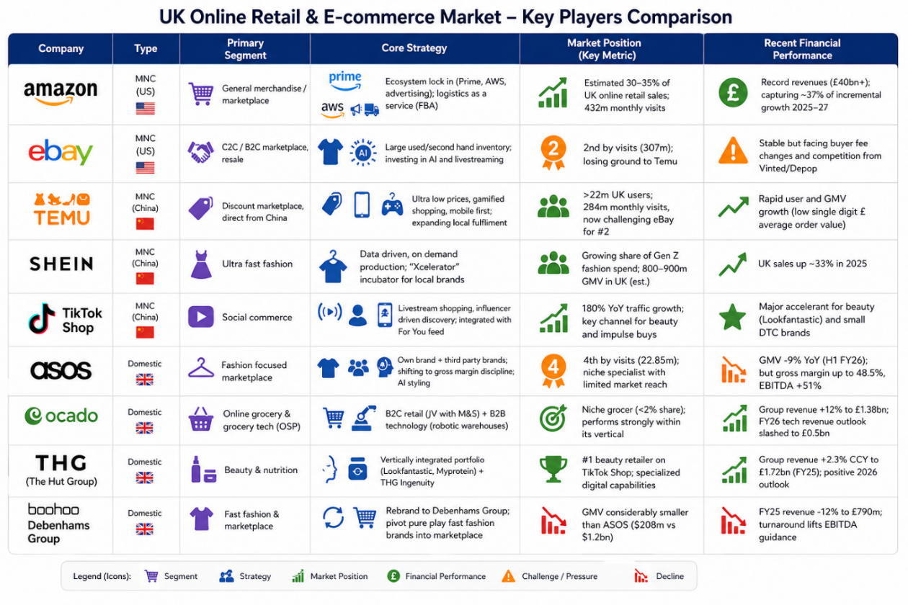

Fig: 01 E-commerce Industry Comparison between Domestic & Multinational

2.4 Comparative Analysis of Market Position
The United Kingdom is recognised as Europe’s largest and most advanced e-commerce market, characterised by exceptionally high online penetration rates. The market value for 2025 has been estimated between $253 billion and $351 billion, with steady annual growth of 7–9% and a projected CAGR of 7.9% through 2035 (IMARC, 2025; Expert Market Research, 2025). By 2025, 30.7% of total retail spending is expected to be conducted online, supported by 97.8% internet penetration and over 62 million e-commerce users (Statista, 2025). Average consumer spending of £3,715 annually has been recorded, with 69% of transactions completed via mobile devices (Statista, 2025). The competitive landscape has become increasingly saturated, shifting from Amazon–eBay dominance to a multi-platform environment. Emerging platforms such as Temu, Shein, TikTok Shop, and Vinted have intensified competition, placing pressure on retailers like ASOS and Boohoo. Additionally, Tesco and Sainsbury’s have strengthened positions in online grocery (Kantar, 2025).

3. Application of Michael Porter’s Diamond Model
Michael Porter’s Diamond Model of National Advantage has been employed in this report as a strategic framework by which it can be explained why sustained competitive advantage is achieved by certain nations within specific industries. Four interconnected determinants are identified by the model: factor conditions, demand conditions, related and supporting industries, and firm strategy, structure, and rivalry. Within the context of the UK e‑commerce industry, a systematic assessment of the national environment is enabled by this framework, through which the conditions that allow firms such as Amazon to thrive are examined (Quinones et al., 2023). By the application of the Diamond Model, an analysis is conducted of how the UK’s skilled workforce, sophisticated consumer base, advanced logistics infrastructure, and intense competitive rivalry are collectively contributed to the creation of a fertile ecosystem for e‑commerce innovation and growth. A foundation for the understanding of Amazon’s strategic positioning is provided by this analysis, as are the external factors that influence its operational success in the United Kingdom. Consequently, valuable insights into the national determinants of competitive advantage are offered, and a structured basis for the subsequent evaluation of the company’s external environment is established (Quinones et al., 2023)

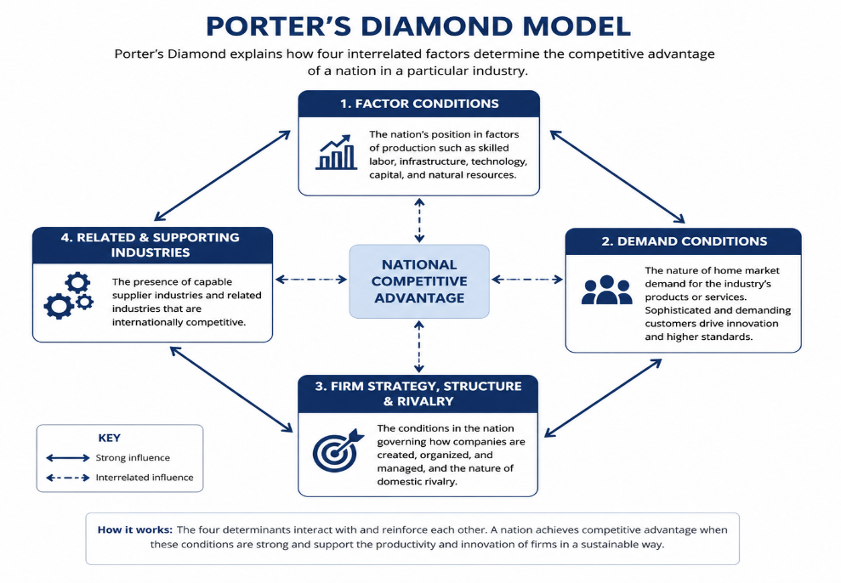

Fig: 02 Porter’s Diamond Model Analysis on E-commerce industry in the UK

3.1 Factor Conditions
Strong factor conditions are recognised as a foundation for e-commerce competitiveness in the United Kingdom. A highly skilled workforce is supported, with approximately 76% of adults holding A-level or higher qualifications, through which expertise in software development, data science, and logistics is supplied. Continued investment in digital roles and apprenticeships is undertaken by major firms such as Sainsbury’s and Amazon, while demand for cybersecurity talent is observed to grow annually. Advanced physical infrastructure is also established, with extensive transport networks and a freight logistics market projected to reach £167 billion by 2031, supported by warehousing expansion initiatives (Gonda et al., 2020). Furthermore, robust digital infrastructure is maintained, with high levels of connectivity enabling efficient mobile commerce. Overall, a combination of skilled labour, logistics capability, and technological infrastructure is facilitated, thereby strengthening the UK’s e-commerce environment (Quinones et al., 2023)

3.2 Demand Conditions
Demand conditions in the United Kingdom are characterised by sophisticated and digitally engaged consumers, through which continuous innovation in e-commerce is driven. The market has been valued at approximately $252.89 billion in 2025 and is regarded as one of the largest and most mature globally, with a projected CAGR of 7.9% through 2035 (IMARC, 2025; Expert Market Research, 2025). High levels of online engagement are observed, as nearly 90% of consumers are reported to utilise supermarket websites for grocery shopping, with home delivery, lower prices, and wider product choice being prioritised (Dolega et al., 2021). Furthermore, online marketplaces are preferred by a significant proportion of consumers, while strong price sensitivity is demonstrated through the prioritisation of discounts. Frequent purchasing behaviour is also identified, particularly among sustainability-focused consumers. The increasing share of online retail in total spending further reinforces demand intensity. Consequently, service innovation and operational efficiency are continuously required from firms in order to respond to evolving consumer expectations (Ologunebi et al., 2024).

3.3 Related and Supporting Industries
The UK e-commerce industry is supported by highly developed related and supporting industries, through which operational efficiency and innovation are enhanced. A rapidly expanding logistics outsourcing market has been established, where scalable fulfilment and distribution capabilities are provided by specialised firms, supported by advanced infrastructure and warehousing systems (Gonda et al., 2020). In addition, a strong technology sector, particularly concentrated in major urban centres, facilitates the adoption of artificial intelligence, cloud computing, and data-driven retail solutions. The widespread utilisation of advanced technologies in retail operations has been observed, enabling personalisation, inventory optimisation, and improved customer experience (Quinones et al., 2023). Furthermore, advanced financial and payment systems are supported by a well-developed fintech environment, through which secure and seamless transactions are enabled. Digital transformation and cloud-based platforms are also leveraged to support omnichannel retailing. Collectively, these logistics, technological, and financial infrastructures are integrated, thereby strengthening the competitiveness and innovation capacity of the UK e-commerce sector (Quinones et al., 2023).

3.4 Firm Strategy, Structure, and Rivalry
The UK e-commerce market is characterised by intense rivalry among domestic firms and multinational corporations, through which continuous innovation is stimulated. Market leadership is maintained by Amazon, while competitive pressure is exerted by firms such as ASOS and Zalando, where pricing strategies are continuously adjusted to narrow competitive gaps (Végh et al., 2025). In the online grocery segment, strong competition is observed among Ocado Retail, Tesco, Sainsbury’s, and Asda, where operational efficiencies are enhanced through logistics optimisation and technological investment (Dolega et al., 2021). Distinct strategic approaches are adopted across firms, including the utilisation of advanced fulfilment systems, omnichannel integration, and automation technologies. The increasing importance of data-driven decision-making and artificial intelligence has also been recognised, particularly in enhancing customer experience and operational performance (Quinones et al., 2023). Furthermore, competitive dynamics have been intensified by the entry of new international platforms, which has accelerated digital transformation across the sector (Ologunebi et al., 2024).
Overall, a highly competitive and open market structure is maintained, whereby innovation, efficiency, and service quality are continuously improved, thereby strengthening the international competitiveness of the UK e-commerce industry (Seidu et al., 2021).

4. Foreign MNC Analysis: Amazon in the UK E-commerce Industry

4.1 Overview of Amazon’s Operations in the UK
A dominant position in the UK e-commerce market has been established by Amazon, with approximately 30% of online retail market share being held and regional revenue reaching $43.2 billion in 2025, alongside a gross merchandise value (GMV) of $53.7 billion (Végh et al., 2025). Its operations are structured around an extensive e-commerce platform and the Prime membership ecosystem, through which strong customer loyalty is cultivated (Hassel and Sieker, 2022). A vast logistics infrastructure has been developed, consisting of over 100 operational buildings and fulfilment centres across the United Kingdom, thereby enabling efficient distribution and rapid delivery services (Hassel and Sieker, 2022). Furthermore, long-term market commitment has been demonstrated through a £40 billion investment plan announced for the period 2025 to 2027, under which new fulfilment centres are to be constructed, delivery networks expanded, and significant employment opportunities generated across multiple regions (Saji, 2026).

4.2 External Factors Analysis for Amazon in the UK
Political, economic, legal, and cultural frameworks are applied in this report to evaluate Amazon’s UK e-commerce operations. Regulatory oversight is examined under political factors, price-sensitive consumption is considered under economic factors, and labour compliance is addressed within legal analysis. Consumer behaviour and strategic adaptation are interpreted through Hofstede’s cultural dimensions’ framework (Hofstede, 2011).
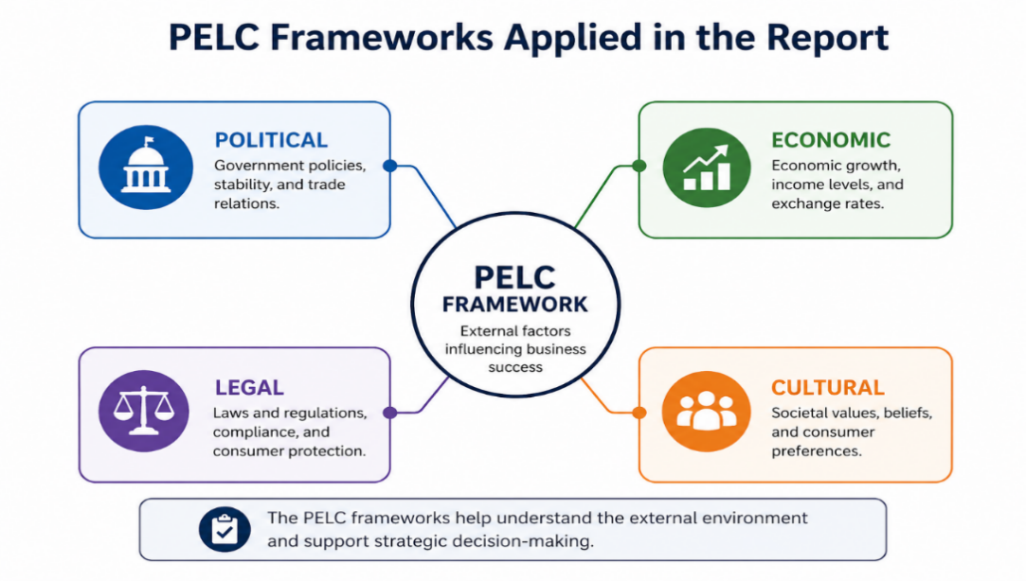

Fig:03 PELC Model for Amazon external factor Analysis

Political: Regulatory Environment in the UK
The UK political environment for Amazon is characterised by three interrelated factors. First, enhanced regulatory oversight has been established through the Digital Markets, Competition and Consumers Act 2024, by which direct investigative and fining powers have been granted to the Competition and Markets Authority (CMA). Market power in cloud services has been formally examined, and although concerns have been identified, voluntary commitments have been accepted in place of formal designation, thereby allowing operational flexibility while regulatory monitoring is maintained (Ologunebi et al., 2024; Saji, 2026). Second, increased consumer protection requirements have been implemented, with formal undertakings agreed to strengthen fake-review detection and enforcement mechanisms. These measures have required operational investment but have established a stable compliance framework without significantly restricting core activities (Quinones et al., 2023). Third, labour-related legal challenges have been raised, with disputes concerning union recognition and employment practices remaining unresolved, thereby creating ongoing legal exposure (Hassel and Sieker, 2022). Overall, regulatory supervision has been intensified; however, continued operation has been enabled through strategic compliance and adaptation, although potential risks remain present (Saji, 2026).
Economic: Economic Factors Affecting Amazon’s Retail Business
The UK economic environment for Amazon is characterised by resilient but increasingly price-sensitive consumer behaviour following a period of high inflation. Inflation was reported to have eased to approximately 3.6% in late 2025; however, household budgets have remained constrained, with around 78% of shoppers being identified as more price-conscious and 74% being observed to seek discounts (Office for National Statistics, 2025; Retail Economics, 2025). Amazon’s low-pricing strategy and supply-chain efficiencies have been recognised as key drivers of growth, with approximately 36.7% of incremental online retail expansion between 2025 and 2027 being captured by the company (Statista, 2026). However, economic pressures have been experienced, including rising labour and energy costs. In response, warehouse automation has been increasingly implemented, and investment in electric delivery vehicles has been expanded to improve efficiency (McKinsey, 2025). Despite slow online spending growth in early 2025, the continued shift towards e-commerce is being supported, enabling Amazon to maintain strong performance in the UK market (Deloitte, 2025)
Legal: Compliance, Labour Laws, and Intellectual Property
The UK legal environment is characterised by several regulatory challenges for Amazon, yet continued operations have been sustained through proactive compliance measures. Labour law risks have been identified as significant, particularly in May 2025 when an inducement claim was filed by the GMB union at the Employment Tribunal following the Coventry union-recognition vote, which was reported to have fallen short by 28 votes, with allegations that unionisation efforts had been discouraged unlawfully (GMB Union, 2025; BBC News, 2025). Additionally, concerns regarding excessive working hours during peak seasons have been raised, highlighting potential breaches of working time regulations (Health and Safety Executive, 2025). In response to these risks, minimum wages have been increased to £28,000 nationally (£30,000 in London), and investment in workplace safety has been strengthened (Amazon UK, 2025). Furthermore, anti-counterfeit initiatives such as Project Zero and Brand Registry have been implemented to address intellectual property risks, while compliance with the Digital Markets, Competition and Consumers Act (DMCCA) has been ensured through improved fake-review detection systems (UK Government, 2025). Despite ongoing legal scrutiny, operational continuity has been maintained, although higher compliance costs are being incurred.
Social: Consumer Trends and Cultural Factors Impacting Amazon
The UK social and cultural environment is considered strongly support Amazon’s business model, enabling successful operations, although certain challenges continue to be encountered. British consumers are widely recognised as highly digitally literate, with nearly 70% being reported to use artificial intelligence when shopping online, while average monthly e-commerce spending has been estimated at approximately £89, exceeding European averages (Statista, 2025; Eurostat, 2025). Convenience, rapid delivery, and price comparison have become embedded cultural expectations, which are closely aligned with Amazon’s Prime ecosystem and its generative AI shopping assistant, Rufus, which was introduced in August 2025 (Amazon, 2025). At the same time, rising sustainability awareness has been observed among UK consumers. Approximately 78% of consumers have been found to prefer Forest Stewardship Council (FSC)-certified products, and 65% are reported to favour environmentally responsible retailers (FSC UK, 2025; Deloitte, 2025). In response, automated packaging technology has been deployed to reduce waste, and investment in electric delivery vehicles has been expanded to support environmental goals (McKinsey, 2025). However, cultural tensions have been highlighted by activist protests against “hyper-consumerism” in November 2025, and the closure of 19 Amazon Fresh stores in September 2025 has been interpreted as evidence that digital capabilities do not always translate into physical retail success (BBC, 2025). Overall, UK social factors are being effectively navigated through adaptation to convenience-driven and technology-oriented consumer behaviour, although reputational risks related to sustainability and community impact are required to be carefully managed to maintain long-term public trust (Deloitte, 2025).
Hofstede’s cultural dimensions are widely applied to analyse consumer behaviour within the UK e-commerce market in which Amazon operates. Low power distance in the UK (35) is associated with expectations of equal service and transparent communication. Moderate individualism (60) is reflected in demand for convenience, while social and environmental responsibility is also considered in purchasing decisions. A relatively low uncertainty avoidance score (35) is interpreted as indicating openness to innovation, enabling new technologies such as AI assistants and advanced delivery systems to be adopted more readily. High indulgence (69) is linked to impulse purchasing and subscription-based services such as Amazon Prime. Overall, UK cultural traits are considered to support Amazon’s experimentation, customer-focused innovation, and service efficiency in the competitive e-commerce environment (Hofstede, 2011).
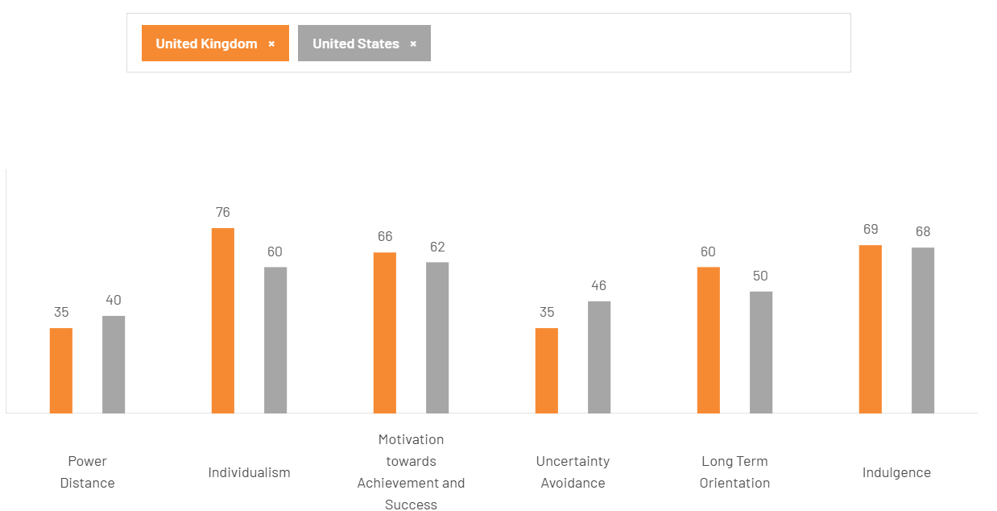

Fig: 04 Hosftede Cultural Dimension analysis between UK & USA for amazon

4.3 Impact of External Factors on Amazon’s Success in the UK
It is indicated by the report’s analysis that political, economic, legal, and cultural factors exert a mixed yet manageable influence on Amazon’s success in the United Kingdom. Politically, increased regulatory oversight by the Competition and Markets Authority under the Digital Markets, Competition and Consumers Act 2024 has been implemented; however, core operations have not been significantly constrained, as compliance mechanisms have been effectively adopted (Ologunebi et al., 2024; Saji, 2026). Economically, heightened price sensitivity and inflationary pressures have shifted consumer behaviour towards cost-efficient platforms, through which Amazon’s low-price model has been strengthened, enabling substantial market growth capture, despite rising labour and energy costs affecting profitability (Statista, 2026; Deloitte, 2025). Legally, challenges associated with labour disputes, including the Coventry union recognition case, and intellectual property enforcement requirements have increased compliance costs; nevertheless, these risks have been mitigated through proactive wage adjustments and the implementation of anti-counterfeit initiatives (GMB Union, 2025; Amazon UK, 2025). Culturally, strong alignment has been observed between Amazon’s services and the digitally literate, convenience-oriented preferences of UK consumers, while increasing sustainability expectations have driven investment in environmentally responsible logistics (Statista, 2025; Deloitte, 2025). Overall, external pressures are being strategically managed, although regulatory and reputational risks continue to persist.

5. Conclusion
Amazon’s strategic position within the United Kingdom’s e-commerce sector has been analysed, and a market characterised by advanced digital infrastructure, sophisticated consumer behaviour, and intense competitive rivalry has been identified (Seidu et al., 2021). A leading market position has been established through the utilisation of logistical efficiency, technological innovation, and a customer-centric business model (Hassel and Sieker, 2022). However, the operating environment has been shaped by complex external pressures, including regulatory developments, economic fluctuations, legal compliance obligations, and evolving cultural expectations related to sustainability and corporate responsibility (Deloitte, 2025). Although operational challenges and constraints have been introduced, strong adaptive capacity has been demonstrated through strategic investment, regulatory compliance, and responsiveness to changing consumer trends (Saji, 2026). It is indicated that sustained success will be dependent upon the ability to navigate a dynamic and highly scrutinised environment without compromising core value propositions. Overall, both opportunities and risks have been presented, requiring continuous strategic agility and proactive stakeholder engagement (Végh et al., 2025).

Section 2: Reflective Account

6. Reflective Account using Gibbs’ Reflective Cycle

This reflective account is structured through the application of Gibbs’ Reflective Cycle (1988), by which the process undertaken in researching, analysing, and preparing Section 1 of the report—focused on the strategic analysis of Amazon’s operations within the UK e-commerce industry—has been critically examined (Gibbs, 1988). The six stages of the model, namely description, feelings, evaluation, analysis, conclusion, and action plan, have been utilised as a systematic framework through which learning has been assessed, challenges have been identified, and areas for future improvement have been established.

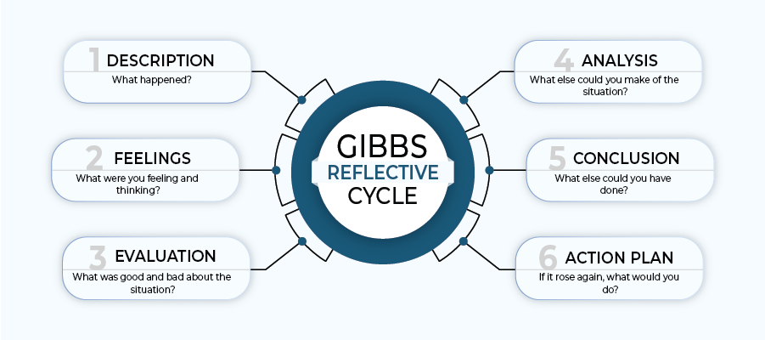
Fig: 05 Six-Step Gibbs Reflection Framework

6.1 Description (What Happened?)
The macro-environmental analysis of Amazon within the UK e-commerce sector was undertaken through the application of Porter’s Diamond Model and the PELC (Political, Economic, Legal, Cultural) frameworks as key analytical tools (Quinones et al., 2023). Secondary data were collected from academic journals, industry reports such as Statista and IMARC, official statistics from the Office for National Statistics, and reputable news sources (Statista, 2025; IMARC, 2025; ONS, 2025). The information was organised into thematic sections, including industry overview, Porter’s determinants, and external factor analysis. The evidence was then synthesised to assess the influence of political, economic, legal, and cultural factors on Amazon’s performance (Ologunebi et al., 2024). A critical approach was maintained through comparison of multiple sources and evaluation of conflicting evidence (Hassel and Sieker, 2022).

6.2 Feelings (What Were You Thinking and Feeling?)
Initially, feelings of being overwhelmed were experienced due to the extensive volume of data available on the UK e-commerce sector and Amazon’s complex operations. Conflicting market share estimates and rapidly evolving regulatory developments, including the Digital Markets, Competition and Consumers Act 2024, were encountered, which created frustration during the research process. However, confidence was gradually developed as the PELC framework was systematically applied to analyse external factors affecting Amazon’s performance. Clear patterns were successfully identified, particularly the relationship between low uncertainty avoidance in UK culture and the acceptance of innovative delivery services, which has been recognised as a key enabler of technological adoption within the e-commerce environment (Hofstede, 2011). Moments of anxiety were experienced regarding the maintenance of academic rigour, especially when recent developments between 2025 and 2026 were examined, where peer-reviewed literature was limited. Nevertheless, a strong sense of achievement was ultimately achieved following the completion of a structured and evidence-based analysis of Amazon’s operations in the UK retail market (Markkanen et al., 2020)

6.3 Evaluation (What Was Good and Bad About the Experience?)
The most effective aspect of the process was the utilisation of recognised strategic frameworks, including Porter’s Diamond Model and the PELC framework, through which complex information was systematically organised and analysed. A wide range of diverse and up-to-date sources, such as government publications, market research reports, and Hofstede’s cultural insights, was accessed, thereby strengthening the credibility and depth of the analysis (Hofstede, 2011; Quinones et al., 2023). In addition, collaboration with peers to discuss recent regulatory developments was undertaken, and valuable insights were gained through shared perspectives and critical discussion.
However, weaknesses in time management were identified, as excessive time was allocated to the initial stage of data collection, which resulted in limited time being available for the synthesis and refinement of arguments. Difficulties in balancing analytical depth with conciseness were also experienced, leading to certain sections being presented in an overly descriptive manner rather than through critical evaluation (Markkanen et al., 2020). Furthermore, reliance on non-academic sources, such as news articles, for very recent events was observed, which may have reduced theoretical depth, although the timeliness and relevance of the analysis were maintained (Quinones et al,2023).
6.4 Analysis (What Else Can You Make of the Situation?)
Valuable lessons were derived from this experience, through which the importance of structured frameworks was clearly recognised, although their effectiveness was understood to depend on disciplined and systematic application. An initial tendency to accumulate large volumes of data without a clear filtering strategy was identified, which resulted in inefficiencies during the research process. In contrast, improved focus was achieved when a question-driven approach was adopted, particularly when each PELC factor was examined in relation to its specific impact on Amazon’s operations (Quinones et al., 2023). The value of triangulating sources was also recognised, as regulatory interpretations were validated by cross-referencing official Competition and Markets Authority announcements with legal analyses and commentaries (UK, 2025). Furthermore, reflective writing was understood to enhance learning by revealing analytical gaps, such as the limited exploration of interactions between economic and cultural factors influencing organisational performance (Markkanen et al., 2020).

6.5 Conclusion (What Else Could You Have Done?)
In retrospect, improvements in the research approach could have been achieved through the development of a detailed research plan in which specific milestones for each analytical framework were clearly established. Sources could have been more effectively organised through the utilisation of reference management software such as Zotero, thereby reducing duplication and improving efficiency. Greater time could have been allocated to critical synthesis rather than descriptive summarising, while early feedback from tutors or peers could have been sought to strengthen framework application and enhance analytical depth (Markkanen et al., 2020).

6.6 Action Plan (If It Occurs Again, What Would You Do?)
For future assignments, a phased timeline will be established, through which specific periods will be allocated to research, outlining, drafting, and revision in order to improve efficiency. A structured note-taking template will be utilised, whereby evidence will be categorised under PESTLE or PELC headings to support systematic analysis. Descriptive writing will be limited through the application of a clear critical focus, while regular peer discussions will be conducted to identify analytical gaps. In addition, the application of frameworks in model journal articles will be reviewed to emulate higher-level critical analysis and professional academic standards (Quinones et al., 2023). Consequently, more efficient, critically robust, and professionally presented strategic analyses are expected to be produced in future academic work (Markkanen et al., 2020).

Conclusion
A comprehensive strategic analysis of Amazon’s operations within the UK e-commerce industry has been presented, supported by the application of Porter’s Diamond Model and PESTLE frameworks. It has been confirmed that Amazon’s dominant position is underpinned by strong factor and demand conditions, intense competitive rivalry, and well-developed supporting industries (Quinones et al., 2023 ). At the same time, external political, economic, legal, and socio-cultural factors are recognised as presenting both opportunities and challenges for the organisation (Ologunebi et al., 2024). Through proactive compliance, continuous innovation, and strategic investment, regulatory pressures and sustainability concerns have been effectively navigated (Saji, 2026). Furthermore, the reflective account has demonstrated that structured analytical frameworks and critical self-evaluation are utilised to enhance academic learning and professional competence, thereby informing future strategic research practices (Markkanen et al., 2020)

References
Adams, Carol. (2008). A commentary on: Corporate social responsibility reporting and reputation risk management. Accounting, Auditing & Accountability Journal. 21. 365-370. 10.1108/09513570810863950.
Amazon UK. (2025) Amazon announces pay increase for UK employees. London: Amazon Corporate Communications.
Anke Hassel and Felix Sieker, (2022). The platform effect: How Amazon changed work in logistics in Germany, the United States and the United Kingdom. Volume 28, Issue 3. https://doi.org/10.1177/09596801221082456.
Ansoff, H. I. (1957) Strategies for Diversification. Harvard Business Review.
Ansoff, H.I. (1965). Corporate Strategy.
BBC News, (2024). Amazon workers narrowly reject union in historic vote. Available at: https://www.bbc.co.uk/news/articles/c8vd72zrpr1o (Accessed 15.04.2026)
Brynjolfsson, E., & McAfee, A., (2017). The Business of Artificial Intelligence. Harvard Business Review.
Barney, J. (1991). Firm resources and sustained competitive advantage. Journal of Management, 17(1), 99–120.
Burnes, B. (2020) Kurt Lewin and the Harwood studies: The foundations of OD. Journal of Applied Behavioral Science, 56(3), pp. 255–273.
Christopher, M. (2016). Logistics & Supply Chain Management (5th ed.). Pearson.
Crane, A., Matten, D., Glozer, S. and Spence, L.J. (2019) Business ethics: Managing corporate citizenship and sustainability in the age of globalization. 5th edn. Oxford: Oxford University Press.
Department for Environment, Food and Rural Affairs –DEFRA, (2022). UK Environmental Policy Report.
Department of Health and Social Care (2020) Restricting promotions of products high in fat, sugar and salt by location and by price: government response to public consultation. London: DHSC.
Dhingra, S., Huang, H., Ottaviano, G., Pessoa, J.P., Sampson, T. and Van Reenen, J. (2021) ‘The costs of Brexit’, Economic Policy, 36(106), pp. 1–52.
Dolega, L., Reynolds, J., Singleton, A. and Pavlis, M., 2021. Beyond retail: New ways of classifying UK shopping and consumption spaces. Environment and Planning B: Urban Analytics and City Science, 48(1), pp.132-150.
Euromonitor, (2022). Health and Wellness Trends in the UK.
Euromonitor (2023) Health and Wellness Trends in Packaged Food.
Euromonitor International (2023) Private Label in the United Kingdom. London: Euromonitor.
Euromonitor International (2024) Coffee in the United Kingdom. Available at: https://www.euromonitor.com/coffee-in-the-united-kingdom/report (Accessed 15.04.2026)
Ellen MacArthur Foundation (2019) Completing the Picture: How the Circular Economy Tackles Climate Change.
Euromonitor International (2024) UK Food and Beverage Industry Analysis. Available at: https://www.euromonitor.com/ (Accessed: 22 April 2026).
Expert Market Research (2025) UK E-commerce Market Analysis.
Food and Drink Federation (2024) Industry Overview. Available at: https://www.fdf.org.uk/ (Accessed: 22 April 2026).
Gonda, G., Gorgenyi-Hegyes, E., Nathan, R.J. and Fekete-Farkas, M., 2020. Competitive factors of fashion retail sector with special focus on SMEs. Economies, 8(4), p.95.
GMB, (2024). Amazon faces legal challenge over workers' rights revelations. Available at: https://www.gmb.org.uk/news/amazon-faces-legal-challenge-over-workers-rights-revelations (Accessed at: 15.04.2026)
Gibbs, G. (1988) Learning by Doing: A Guide to Teaching and Learning Methods. Oxford: Oxford Polytechnic.
Grant, R. (2022). Contemporary Strategy Analysis. Wiley.
Hofstede, G. (2011). Dimensionalizing Cultures.
Health and Safety Executive (HSE). (2025) Working time and employee welfare guidance.
Hassel, A. and Sieker, F. (2022) European Journal of Industrial Relations.
IMF, (2023). World Economic Outlook. Available at: https://www.imf.org/en/publications/weo/weo-database/2023/october. (Accessed 09.04.2026)
IMARC (2025) UK E-commerce Market Report.
Johnson, G., Scholes, K., & Whittington, R., (2020). Exploring Corporate Strategy. Pearson.
Kantar (2025) UK Grocery Market Share Data
Khan, A.M., 2023. Employment Trends and Relative Influence of US Retail Subsector Employments on GDP. Archives of Business Research, 11(7).
Keller, K. L. (2013). Strategic Brand Management (4th ed.). Pearson.
Kaplan, R.S. and Norton, D.P. (1992) ‘The Balanced Scorecard: Measures that Drive Performance’, Harvard Business Review, 70(1), pp. 71–79.
Lewin, K. (1947) Frontiers in group dynamics. Human Relations, 1(1), pp. 5–41.
Lenoël, C., Macqueen, R. and Mortimer-Lee, P., (2021). UK Economic Outlook. National Institute Economic Review, 258, pp.6-32.
McKinsey & Company, (2022) The net-zero transition: What it would cost, what it could bring.
Mendes, T., González-Loureiro, M., Braga, V. and Silva, C., (2026). Move fast and break things: Mapping the intellectual structure of the speed of the internationalization process to develop a research agenda for further inquiry. International Entrepreneurship and Management Journal, 22(1), p.1.
Markkanen, P., Välimäki, M., Anttila, M. and Kuuskorpi, M., 2020. A reflective cycle: Understanding challenging situations in a school setting. Educational Research, 62(1), pp.46–62.
Nestlé, (2023) Nestlé Company History. Available at: https://www.nestle.com/about/history (Accessed 15.04.2026)
Office for National Statistics (ONS). (2025) Consumer price inflation, UK: 2025. London: ONS.
Ologunebi, J., Taiwo, E.O. and Alli, K., 2024. Digital consumer behavior in e-commerce: A study of Amazon and Temu's customer purchase decision-making processes in the UK and the USA. Available at SSRN 5071874.
Office for National Statistics (ONS). (2026) Retail sales and internet sales, January 2026. London: ONS.
Prahalad, C.K. and Hamel, G., (1990). The Core Competence of the Corporation.
Porter, M.E. and Kramer, M.R., (2011) Creating shared value. Harvard Business Review, 89(1–2), pp. 62–77
Porter, M. E., & Heppelmann, J. E. , (2015). How Smart, Connected Products Are Transforming Competition. Harvard Business Review.
Porter, M.E., (1985) Competitive Advantage: Creating and Sustaining Superior Performance.
Prahalad, C. K., & Hamel, G. (1990). The core competence of the corporation. Harvard Business Review, 68(3), 79–91.
Quinones, M., Gomez-Suarez, M., Cruz-Roche, I. and Diaz-Martin, A.M., 2023. Technology: a strategic imperative for successful retailers. International journal of retail & distribution management, 51(4), pp.546-566.
Retail Economics. (2025) UK consumer behaviour and discount trends report. London: Retail Economics
Saji, S.S., 2026. Quantitative Assessment of Amazon’s Strategic Adaptation and Consumer
Seidu, R.D., Young, B.E., Madanayake, U.H. and Clark, H., 2021. The UK retail industry and its effect on construction sectors. Journal of Emerging Trends in Economics and Management Sciences, 12(1), pp.27-33.
Statista. (2026) Share of online retail growth captured by leading e-commerce companies in the UK. Hamburg: Statista.
Shenkar, O., Luo, Y. and Chi, T., (2021). International business. Routledge.
Sloman, J., Garratt, D., & Guest, J. , (2021). Economics. Pearson.
Statista (2024) Nestlé UK – Market Data and Industry Position Available at: https://www.statista.com/statistics/311477/nestle-leading-products-in-the-uk/ (Accessed 15.04.2026)
Statista, (2024). Food Industry in the United Kingdom. Available at: https://www.statista.com/ (Accessed: 22 April 2026).
Teece, D. J. (2007) ‘Explicating Dynamic Capabilities: The Nature and Microfoundations of (Sustainable) Enterprise Performance’, Strategic Management Journal, 28(13), pp. 1319–1350.
UK Government, (2022). HFSS Regulations Guidance.
United Nations, (2021). Net Zero Coalition Report. available at: https://www.un.org/en/climatechange/net-zero-coalition (Accessed 10.04.2026)
United Nations, (2021). Sustainability Frameworks.
UK Government. (2025) Digital Markets, Competition and Consumers Act: Compliance requirements. London: Department for Business and Trade.
Végh, K. et al. (2025) Journal of Cultural Analysis and Social Change.
World Health Organization (2020). Guidelines on Sugar Intake. Available at: https://www.who.int/europe/news-room/fact-sheets/item/nutrition---maintaining-a-healthy-lifestyle (Accessed 10.04.2026)
YouGov (2024) Brand Awareness Rankings: UK Confectionery Market. Available at: https://yougov.co.uk/ (Accessed: 22 April 2026).

