Research Proposal Title | "Sustainability in the Luxury Car Industry: A Case Study of Aston Martin’s Green Transition"
Name Of the Student | Yeshwanth Reddy Adama
Date Of Submission | 29/04/2025
Course ID | BMMB7028
Course Name | Business Research
Professor Name | Helen Evans
University Name | University of Wales
Word count | 5001 Words

TABLE OF CONTENTS
Background 4
Research rationale 5
Research question 6
Research Aim 6
Research objectives 6
Contribution of the current research 7
Key literature review 7
Evolution of the sustainability efforts of the Astron Martin 7
Internal and external drivers pushing Aston Martin 9
Challenges and opportunities Aston Martin faces in implementing these sustainability measures 10
Theoretical framework 12
Conceptual framework 13
Literature gap 13
Chosen methodology 14
Philosophy 14
Approach 14
Strategy 14
Choice 15
Time horizon 15
Advantages and disadvantages of the method 15
Effective tool for the data collection 16
Data analysis 18
Timeline for the research process 18
Ethical consideration 19
Limitation of study 20
Conclusion 21
References 22

Background
In a world that is increasingly defined by the rising climate and environmental crises, the luxury can industry is also shifting towards a future where it meets responsibility. In the research by Guevara, (2021), it has been determined that traditionally luxury cars were focused on premium designs that cater to the base of elite consumers. However, with the changes in the automotive industry, sustainability and electrification have been rising in importance.
In the report conducted (Rodrigues, 2024), the global luxury electric market was valued at approximately $1.8 billion in 2022, and it is expected to be growing at CAGR of 17.7% from the year 2023 to 2030. The shift in the sustainable category is attributed to the demand for technologically advanced, emission-free, fuel-efficient vehicles.
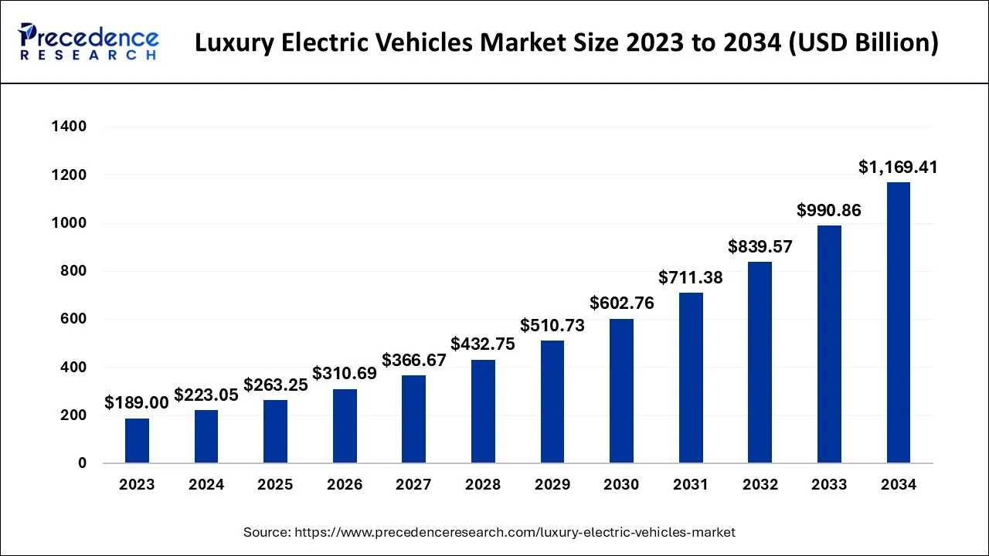
Figure 1: Luxury Electric Vehicles Market Size, Share, and Trends 2024 to 2034.
(Source: Precedence Research. 2025)
From the image above, it can be determined that the luxury electric vehicle market size is accounting for USD 223.05 billion in 2024, which is to grow by USD 263.35 billion in 2025. Electric vehicles are now considered the future of the automobile sector as a way to reduce emissions into the environment. Additionally, in the market today, electric vehicles have gained a lot more momentum, going from the category of niche to becoming necessary. Besides this, the sustainable initiatives being used in the category of the luxury car industry are the incorporation of eco-friendly material in production, the reduction of the level of emission, and the adoption of sustainable production practices (Barakati et al., 2024). Astron Martin is one such luxury British car company with a unique brand identity. The company is moving towards the production of vehicles including key sustainability and therefore has claimed to reduce the environmental impact and achieve net zero emissions by 2039 (Aston Martin, 2023). The company is aiming to fully electrify its core ranges, including GT and SUV sports cars, by 2030. The current research focuses on the navigation of the luxury car industry to sustainability while ensuring a strong brand and position in the market.

Research rationale
The rationale for conducting the current research is to understand how sustainability is integrated within the luxury cat sector. Luxury brands face unique challenges and opportunities in creating a balance between performance, tradition, and green innovation, which is to be covered in the current research (Jones, Cai and Kamasak, 2024). Luxury brands are shifting to a new era where sustainability has become a prime commitment, including sourcing sustainable materials, selecting the best production process, and developing electric cars. Ever since, the car industry has been the prominent contributor to air pollution, primarily through greenhouse gas emissions such as CO2 and other kinds of pollutants. In 2022, the global CO2 emission from the car and vans has reached to 2.53 billion demanding significant efforts to change the processes towards the sustainability (Stefanoni and Voltes-Dorta, 2021).
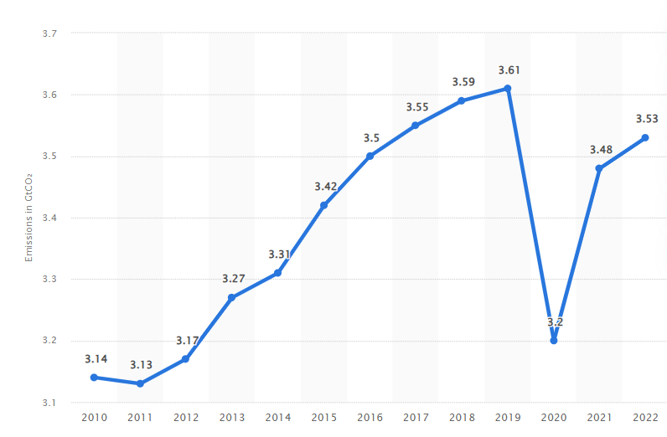
Figure 2: Carbon dioxide (CO₂) emissions from cars and vans worldwide from 2010 to 2022
(Source: Statista, 2022)
Although in the image, in the year 2020, there were very low carbon emissions, mainly due to the pandemic, since then, it has started increasing again and, therefore, needs to be controlled. The luxury car sector, therefore, needs to adopt more sustainable policies, which are to be covered in the current research. Many brands, such as Toyota and Tesla, are well-researched in the field because they are mainstream electric car manufacturers (Kelleci, 2022). However, the research has been limited to the legacy brand categories that are to be covered in the current research. The green transition of Aston Martin is an attribute of the broader trends perused in the industry, which will be identified in the present study.

Research question
- How Astron Martin integrates sustainability into the operation and strategy as part of the green transition in the luxury automative sector.

Research Aim
The aim of the current study is to examine the sustainability efforts in the luxury car sector: A case study on Astron Martin.

Research objectives
- To explore the evolution of the sustainability efforts of the Astron Martin.
- To analyze the internal and external drivers pushing Aston Martin toward green transition.
- To investigate the challenges and opportunities Aston Martin faces in implementing these sustainability measures.
- To construct strategic recommendations for enhancing Aston Martin’s sustainability practices

Contribution of the current research
The contribution of the current research can be observed in both academic literature and industry practices as it explores the area that has not been examined in-depth below. For instance, many studies focus on mass-market automotive brands; therefore, legacy brands' efforts are ignored. The current study, therefore, focuses on legacy brands that contribute to a better understanding of the concept of sustainability. In addition, the study findings will offer the luxury brand stakeholders the opportunity to adapt to the ways of helping the green transition with aggressive puts towards environmental strategies (Ranfagni and Ozuem, 2022). By adopting the secondary qualitative case approach, the research shows an in-depth analysis of the available data, generating a nuanced understanding of the strategy of the corporate environment.
Moreover, the research highlights the key challenges and opportunities faced in the high-emission industry; the policy framework, therefore, offers the flexibility to promote green innovation without damaging the industrial heritage.

Key literature review

Evolution of the sustainability efforts of the Astron Martin
The luxury car industry is prioritizing sustainability efforts by introducing different initiatives that include the development of electric cars, the use of eco-friendly materials, and the implementation of circular principles. In the research by Brun, (2021), the key sustainability efforts of the companies operating in the luxury market are highlighted. It includes the focus on the decarbonization. Decarbonization in the luxury car market includes the shift towards EVs and the implementation of sustainable practices within the supply chain procedure. This is done by the companies by taking into consideration the government support for the various types of tax breaks, incentives, and subsidies that are offered. One such initiative of Astron Martin is the racing green that was launched in 2022, playing a significant role in achieving sustainability ambition by the year 2030 and beyond (Osburg et al., 2021). In this strategy, the focus of the company is to achieve zero single-use plastic packaging waste from the manufacturer facility by 2025, and the focus is also on the reduction of water consumption by 15% (Astron Martin, 2025). Another way through which sustainability can be achieved is through a focus on incremental innovation. In the research conducted by Grigorescu and Ion, (2022), it has been cited that Aston Martin’s effort towards sustainability can be observed in its fuel efficiency improvement and the adoption of lightweight materials. With the increased pressure in the external environment, the brand, by doing innovation, can meet the benchmark of the industry (Agrawal et al., 2021). Lightweight materials such as carbon fiber and aluminum are to be utilized, aiming to reduce the consumption of fuel and greenhouse gas emissions. Through this, the company can achieve carbon neutrality by the year 2030.
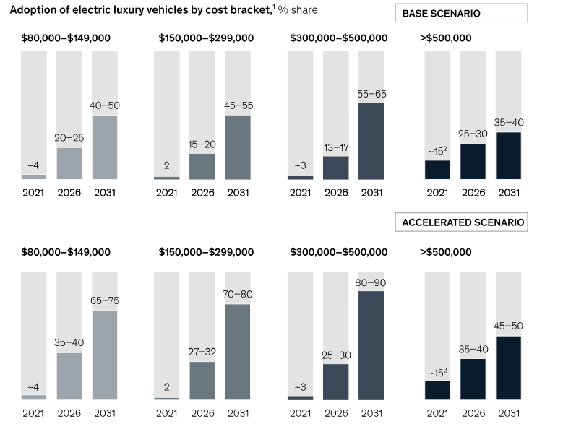
Figure 3: Adoption of EV cars
(Source: Mc Kinsey, 2022)
The image above determines the adoption of electric vehicles by 2031 within the luxury car market. In every segment determined above, the growth is witnessed at a very rapid speed. This also requires Astron Martin company also to achieve net zero emissions across the entire supply chain procedure. The business has also partnered with the BWT Alpine F1 team to develop technologies that could support the process of electrification and carbon reduction.

Internal and external drivers pushing Aston Martin
Sulistyo, (2024), viewed that both internal and external drivers are important for pushing the company toward the green transformation. Firstly, the internal driver is the corporate strategy and the vision of the leader. The leader's strong commitment to the ESG goals is the reason behind the adoption of sustainability in the company. EO Lawrence Stroll is focusing on building a future-proofing brand with the key initiative named Racing Green (Chandiran, 2021). This initiative highlights the company's internal commitment to achieving brand value. In the strategy, the focus is to achieve the world's leading sustainable ultra-luxury business that includes the roadmap towards electrification, reaching net zero emissions in all the facilities manufacturing vehicles by the year 2030, and achieving the net zero across the entire supply chain processes. The company's goals are in alignment with the UN SDG.
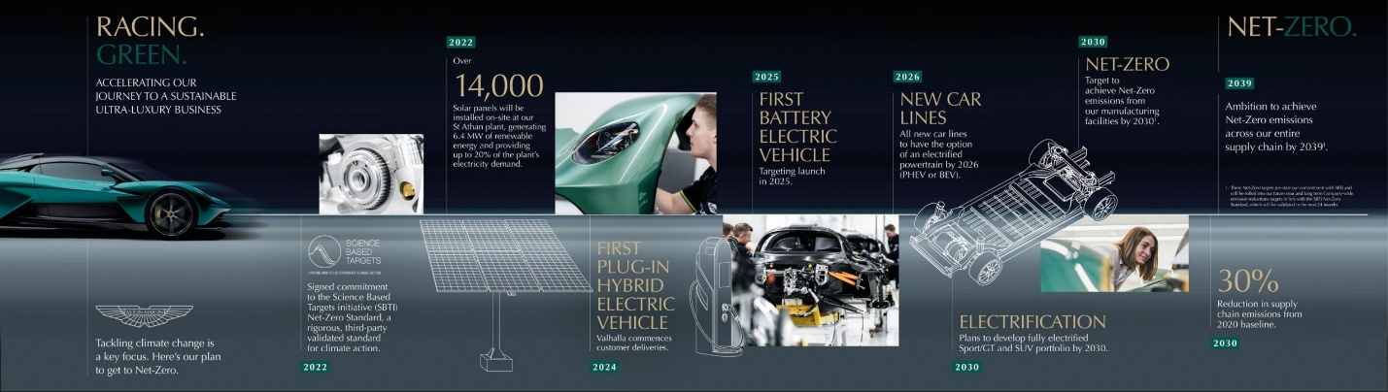
Figure 4: Aston Martin reveals bold new action plan
(Source: Car Dealer, 2025)
The image above highlights the green racing mission achieved by 2030. On the contrary, ORJI, (2024), states that other important drivers for the company are brand relevance and competitiveness. As the EV market is growing at a very rapid speed because of the younger and eco-conscious consumers, moving towards those areas can be beneficial for the business as well. Lastly, it can be determined that over the long term, this is important to achieve cost efficiency. Heavy investment in energy efficiency and waste reduction techniques helps to decrease the costs of the operations over time.
However, according to the view of Pedeliento, Leek and Christodoulides, (2024), external drivers are also an integral part that pushes the company to achieve green transmission. The first is regulatory pressures. In accordance with the EU regulations, the bands on the engines are the major motivator. Noncompliance to the same could lead to heavier penalties and reduced access to the market. Additionally, it can be denoted that the market itself is demanding sustainable efforts because of the market and consumer trends. Tesla and Polestar have already created heavy benchmarks in the space, and therefore, it is necessary to follow the same path to survive in a highly competitive industry.
The stakeholders are also demanding transparency in the planning and implementation of actions on climate change. To attract capital, this shows the credibility of the company towards sustainability.

Challenges and opportunities Aston Martin faces in implementing these sustainability measures
In the research Maradin, Malnar and Kaštelan, (2022), the different challenges faced when shifting to Astron Martin are identified. It included, first of all, the high cost of the transition. It is important when transforming that the proper electric platform is developed to restructure supply chain processes with the adoption of new technologies. Additionally, it can be determined that shifting from the higher performance of V12 and V8, which are very powerful engines, to the quieter electric drivetrain’s risks may not alienate the traditional consumers valuing the legacy of the brand. The challenge is integrating with the new technologies without the dilution of brand identity. On the contrary, it is to be argued by Kutaula et al., (2024), that despite these technologies, there are powerful opportunities that could turn sustainability into an advantage. For instance, through this transformation, the company has a chance to secure the position of the first mover advantage in the luxury industry. While there are many competitors producing the same product, the ultra-luxury EV segment has remained underdeveloped.
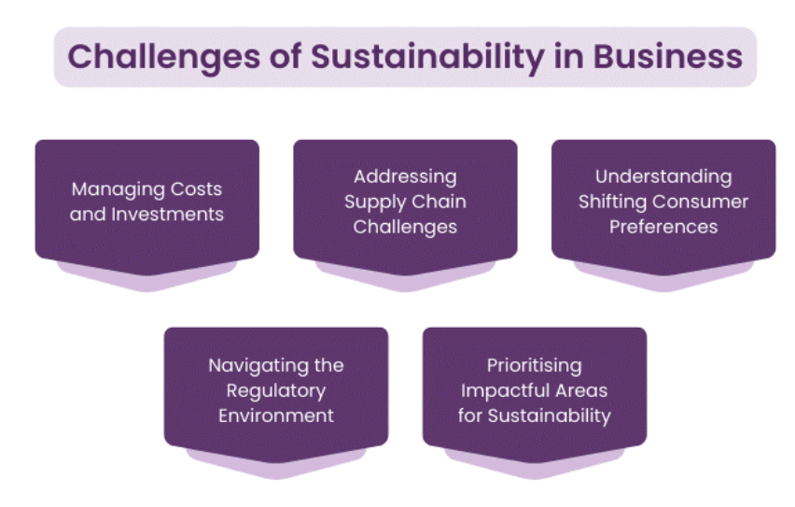
Figure 5: Sustainable challenges
(Source: The Knowledge academy, 2025)
Successfully introducing sustainability could appeal to the future consumer base. In addition, in the view of Kang, Lu and Whidborne, (2024), it can be determined that there exists an opportunity for a strategic partnership. The strategic partnership does have significant potential. The collaboration can be done with big brands such as Mercedes-AMG, providing access to cutting-edge EV architecture and innovative technologies. While it can be determined that the company's recent partnership has ensured the acceleration of innovation with BWT Alpine F1, this new alliance allows the scaling up of sustainable capabilities without bearing the burden of R&D.
Alkaraan et al., (2024), mentioned that the supply chain complexities also present significant risks. Adoption of ethical sourcing standards and integration of the circular economy principles across the supply chain does increase the logistical and managerial overhead. However, embracing sustainability can enhance the reputation of the brand in the long run. It can be determined that the consumers and the potential investors of the company could ensure more investment when valuing transparency and environmental sustainability. Overall, it is to be determined that sustainability presents genuine issues and offers the opportunity to reinvent itself as a modern luxury brand.

Theoretical framework
The theoretical framework anchors the sustainability study initiatives in the relevant academic perspectives (Vann Yaroson et al., 2024). For Aston Martin, two key theories are to be offered: explanatory power institutional theory and stakeholder theory. Institutional theory explains external institutions such as the regulations of the government, norms of the industry, and the shaping of organizational behavior.
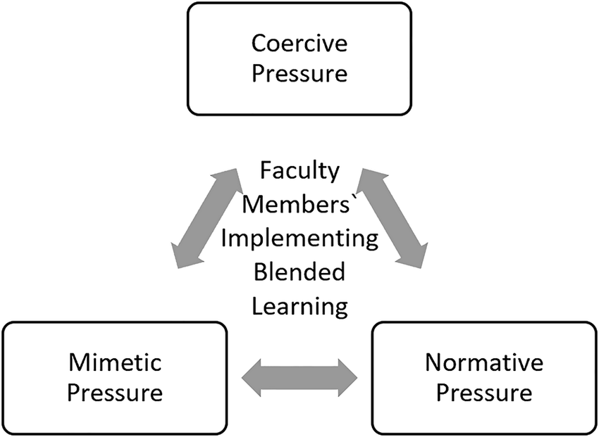
Figure 6: Institutional theory
(Source: Anthony, 2021)
Astron Martin, like others, is under institutional pressures, including UK and EU regulations on emissions, targets of the government, and stakeholder activism, which has been compelling the company to develop EVs and adopt cleaner technologies. Astron Martin is aligning with the regulatory requirements, such as EU emission standards and UK net zero goals. The regulatory bodies act as caregiving to the institutions, compelling the firms to adapt. The mimetic pressures, especially from competitors such as Porsche and Ferrari, are influencing the journey of Aston Martin. This is the reason that the company should adopt greener innovations to maintain a competitive edge and prestige. Narrative pressures are coming from industry expectations, and the standards of sustainability are prompting the firms to adopt certain environmental management practices (Barakati et al., 2024).
The stakeholder theory, on the contrary, emphasizes the needs of the stakeholders, not just the shareholders. Aston Martin’s cases include consumers, investors, regulators, and environmental groups. For instance, with the growing interest in ESG, the influence on corporate strategy is determined by the demand of consumers shifting towards sustainable luxury.

Conceptual framework
The key components of the study are determined in the image above. The Independent variables for the research are the internal drivers, which are strategic vision, innovation, and cost consideration. The external drivers are the regulations, stakeholder expectations, and the consumer's needs. Additionally, moderating factors are the organizational capabilities, resource limitations, and market positioning. The sustainability initiatives are the meditating variables, including green manufacturing, Electric vehicle development, Ethical sourcing, and Emission reduction targets.

Literature gap
While there has been extensive research focusing on the concept of sustainability in the automotive sector, the focus is limited in the context of luxury sports car manufacturers, especially those that are working on low production volumes. The niche positioning of Aston Martin has not been studied before with the green transformation efforts; therefore, it is to be covered in the current study.
Another gap is the key understanding of the legacy luxury brands balancing the heritage with sustainability (Vera-Martínez et al., 2024). While much of the studies address the operational challenges, there has been less focus on the identity transformation to be present here. Additionally, several studies have largely ignored the challenges and opportunities of smaller luxury firms that have become an essential part of dealing with environmental demands. Finally, in the research, limited research is integrated with the institutional theory and the stakeholder theory with a specific focus on the luxury automotive segment.

Chosen methodology
The research methodology to be selected will be the onion method that Saunder proposed. The reason for considering the onion methodology is that it ensures an in-depth understanding of both dependent and independent variables within the research process (Mishra, and Alok, 2022). Given that the focus of the study is to explore sustainability within the luxury automotive industry, the qualitative research design is used. The design and analysis of the qualitative research will be based on secondary data deemed appropriate for the research.

Philosophy
The current study adopts the interpretive research philosophy, which aligns with the collection of textual data. Ocaña-Fernández, and Fuster-Guillén, (2021), defined that the interpretivism research philosophy defines the in-depth understanding of the sustainability efforts interpreted and implemented in Aston Martin in a conceptual manner rather than focusing on the objective truth. Because of the exploratory nature of the study, the use of interpretivism acknowledges the knowledge to be constructed from the different fields, especially when assessing shifts in the strategy like sustainable innovation. The use of positivism is not selected as it seeks to find out the quantitative outcomes on the basis of the numerical evidence that, at times, can have errors leading to faulty results.

Approach
The research approach of the study is a guiding pathway to reach solid conclusions. There are two main approach types: inductive and deductive (Habu and Henderson, 2023). The inductive approach is to be employed within the research that is associated with the emergence of unique data patterns rather than relying on testing of the pre-conceived hypothesis. Taking this into consideration also aims to not generalize findings but rather is a way to understand the unique factors that influence the journey of the Astron Martin. The deductive approach, which focuses on testing the hypothesis by collecting numerical evidence, is rejected because it is a rigid approach that does not allow for taking wider information available. Besides, the pre-existing hypothesis can be wrong at times, leading to manipulated conclusions; therefore, for the current research, interpretivism is used.

Strategy
The strategy is a prominent part of the study in which the development and analysis of the data set are to be assessed and examined. According to the research by Firdaus, Zulfadilla, and Caniago, (2021), there exist many types of strategies for the researcher to examine the concept of the research survey, experiment, case study, and ethnography. The current research focuses on the case study approach, which facilitated an in-depth and contextually rich analysis of Aston Martin's green transition. This is ideal for the study as it is useful for producing evidence that is taken from real-life instances. It allows an understanding of the cause-and-effect relationship while capturing qualitative insights. Moreover, the case study methodology enables the researcher to explore sustainable practices, corporate decisions, public communication, and innovation concepts in a detailed and nuanced manner.

Choice
The choice is that layer of the onion methodology that helps define the data to be collected. Mono method qualitative choice is selected that focuses only on the secondary sources to assemble the required information. The reason for selecting the qualitative method is that it allows for the exploration of complicated phenomena that can only be understood by digging into subjective experiences (Islam et al., 2022). It is a flexible approach, which makes it suitable for the current research as it is exploratory in nature, and the existing research has limited knowledge prior to that. The researcher did not focus on the quantitative methods as they produced evidence that is lacking in depth and context. It, at times, fails to produce evidence that is socially acceptable, thus not revealing true opinions.

Time horizon
The time horizon is the layer in the selected methodology that determines the data to be assembled either at a single point or over a period of time (Cheong et al., 2023). In the research, the cross-sectional time horizon will be selected as it helps to assemble information at a specific point rather than repeatedly over time. However, the change cannot be tracked in the cross-sectional time horizon taking this into account provides up-to-date information, therefore generating a solid conclusion (Lim, 2024). The specific time period in which the data is to be collected is from 2020-2025, which aligns with the current sustainability strategies and the corporate announcement that has been made.

Advantages and disadvantages of the method
The use of secondary qualitative data brings both advantages and disadvantages to the research. In the research by Sreekumar and Sreekumar, (2023), it can be determined that through incorporating the secondary data into consideration, the focus is on delving into the conceptual insights that are in coherence with the actual practices. The sustainability claims can be understood better with the data selected from different sources, including official reports, journal articles, press releases, and industry reviews. This allows triangulation, which means multiple sources are used to ensure the validity and reliability of the findings. The nuanced understanding of the phenomena can be understood in a much better manner with the theoretical perspectives to interpret the generated findings (Susilawati et al., 2025). The methodology selected is also highly efficient in terms of both the costs and the time. Usage of the existing data reduces the need to do fieldwork that ensures the completion of the research in a limited period of time.
On the contrary, in the view of Marra and Nielsen, (2025), when taking secondary data into consideration, it has more weaknesses. The weaknesses of the research are the data reliability and the bias. Relying more on the secondary sources introduces biases in the research that cannot be verified (Ren, 2025). Also, when the sources of the research are taken directly from the corporations, it can contain bias that is difficult to verify, so it does not ensure academic scrutiny. Besides, the lack of primary data, which means the absence of direct observation and interviews, may limit the ability of the research to ensure thorough verification. The researcher makes use of the cross-sectional design and does not capture the trends over a period of time, therefore limiting the dynamic understanding of the topic (Mohajan and Mohajan, 2022). Additionally, when taking secondary data into consideration, the researcher becomes dependent on the quality, scope, and detail of the existing documents, which can lead to strong evidence.
Effective tool for the data collection
The current study uses secondary data sources to the tool collect information about the company and its strategy for sustainability.
Source Type | Examples | Purpose in Study
Company Reports | Aston Martin’s Annual Sustainability and ESG Reports | To understand official sustainability goals, ESG performance, and progress metrics.
Strategic Documents | “Racing Green” Sustainability Strategy | To analyse long-term sustainability vision, strategic priorities, and future targets.
Corporate Communications | Press releases, CEO speeches, stakeholder briefings | To interpret leadership perspectives and messaging on environmental responsibility.
Industry Analyses & Reports | McKinsey, Bloomberg, Deloitte automotive sustainability reports | To compare Aston Martin’s strategy with industry benchmarks and global trends.
Media Articles & Trade Publications | News features from BBC, Financial Times, Top Gear, Autocar, etc. | To gather external commentary, critiques, and market perception of sustainability efforts.
Academic Literature | Peer-reviewed journal articles on sustainable practices in the auto industry | To support theoretical framework and validate observed themes with academic discourse.
Table 1: Tools for the Data collection
(Source: created by author)
The method is highly relevant for the current study. The documentary data listed above defined the access to the strategic narratives, targets, and the actual outcomes published by the company, providing in-depth insight into the intention and implementation (Hall and Liebenberg, 2024). Secondly, it can be determined that by capturing the diversified green initiatives by taking into account the multiple sources, the reliability and relevance of the study can be ensured. All the data taken is published after 2019 and has high academic integrity (Dehalwar and Sharma, 2024). Peer-reviewed articles to be taken are considered only from journals that are highly reputed. For the extraction of the articles, the keywords to be taken are Sustainability, Luxury Car Industry, Aston Martin, Green Transition, Environmental, Social, and Governance (ESG), Automotive Industry, and Sustainable Innovation. These are extracted from reputed databases, including Google Scholar, JSTOR, Science Direct, and ProQuest, or even industry sites like McKinsey and Deloitte.
Criteria | Inclusion | Exclusion
Topic | Sustainability in luxury automotive (e.g., Aston Martin) | Unrelated to sustainability or automotive sector
Source Type | Reports, peer-reviewed articles, industry publications | Blogs, Wikipedia, non-academic sources
Date Range | 2020–2025 | Pre-2020
Language | English only | Non-English
Credibility | Authored by experts or reputable organizations | Unverified or anonymous sources
Table 2: Inclusion and Exclusion criteria
(Source: created by author)

Data analysis
The analysis of the information is part of summarizing the research information. It will include thematic data analysis, which is the widely accepted research for the identification, analysis, and reporting of themes focusing on the recurring data sets in the qualitative information. A phase framework is selected for the research guiding the process of the study:
Familiarization:
This will be the first step to collecting the data, in which the information collected from the sources is read and then re-read to gain comprehensive insights about the content (Rahimi, 2024).
Generating initial codes:
This is the second step in which the nodes are to be created across the datasets, which is related to the concepts of sustainability practices, goals, and issues.
Searching for themes:
The third step for the study is grouping the codes into broader categories that include, for instance, green innovation, brand positioning, and the challenges in EVs.
Reviewing themes:
This is the fourth step of the procedure, which is very important for ensuring that all themes are aligned with the objectives of the research and adequately presenting the collected data.
Defining and the naming of themes:
The stage focuses on the clear labeling of each theme, which reflects the relevance of Aston Martin’s sustainability journey
Report:
This is the last stage of producing the report, which integrates the research findings into the narratives that determine the existing theories presented in relation to the objective and the practice of luxury automotive sustainability.

Timeline for the research process
Task | Duration
Topic finalisation and proposal | Week 1
Literature review and framework | Weeks 2–3
Data collection (document retrieval) | Weeks 4–5
Thematic analysis of data | Weeks 6–7
Drafting methodology & findings | Weeks 8–9
Review, editing, and finalisation | Weeks 10–11
Final submission | Week 12
Table 3: Timeline for the research process
(Source: created by author)
The current research will be starting from the week 1 in which the focus is on the finalization of the research topic and the its approval. The next will be focused on the literature review and the development of the theoretical framework for the research. In the next few weeks data is to be collected primarily through the documents. Subsequently then collected data is to be organized using thematic analysis with the final editing and reviewing refining the overall methodology of the study. The last week will be dedicated for the final submission.

Ethical consideration
Ethical considerations are the core part of the research (Karunarathna et al., 2024). Mainly, the ethics to be upheld include data authenticity, credibility, and intellectual property. It is significant that the data taken in the research is publicly available, verified, and reputed so that the authenticity of the findings can be ensured. To avoid misinterpretation, the data taken is cross-checked from the sources of the media and other relevant academic articles so that the bias can be reduced and the claims can be validated. Besides, all the data sources and the ideas that are taken from the existing database are to be cited in the research in the proper manner using the academic referencing style (Mandzuk and Wener, 2025). As the study includes the interpretation of the secondary data biases can occur, and therefore, the triangulation ensures that multiple perspectives are included in the dataset. Even though no primary data is involved, the stakeholder fairly needs to be presented. Since all the information taken is publicly available, it does not consider confidentiality and anonymity issues, but still, no sensitive information can be taken without the proper authorization.
Ethical Aspect | Description
Data Authenticity | Use of publicly available, verified, and reputable sources
Credibility | Cross-checking data with media and academic articles to reduce bias
Intellectual Property | Proper citation of all sources using academic referencing style
Bias Mitigation | Use of triangulation to incorporate multiple perspectives
Stakeholder Representation | Ensuring fair representation of stakeholders even without primary data
Confidentiality & Anonymity | Not directly applicable, but sensitive data not used without authorization
Table 4: Ethical aspect of the research process
(Source: created by author)

Limitation of study
The study does have major limitations, which, first, is that the entire focus is on secondary qualitative information (Karunarathna et al., 2024). This limits the ability to understand the perspectives of the stakeholders and validate their claims through first-hand information. Secondly, in the research, it can be determined that the case study approach is selected with a focus on Astron Martin, which can limit the applicability of the findings in other contexts and to the larger automotive sector. The strategies adopted do not ensure that the competitors follow the same process of the transition due to the differences that exist in the scale, market positioning, ownership, and corporate culture (Bedenik, Cahir and Bennett, 2025). Additionally, the constraint of time can also be determined as a major weakness, which is associated with taking into account cross-sectional time horizons. Given the dynamic nature of the industry, which constantly adapts to changes, the regulatory frameworks, issues in technology adoption, and the preferences of the consumer, which have altered over time, can not be studied.
Limitation | Description
Use of Secondary Data | Limits understanding of stakeholder perspectives and lacks first-hand validation
Single Case Focus (Aston Martin) | Reduces generalisability to the broader automotive industry
Lack of Competitive Context | Strategies may not apply to competitors due to differences in scale, culture, and market position
Time Constraint | Cross-sectional approach restricts understanding of evolving industry dynamics and long-term changes
Table 5: Limitation of the research process
(Source: created by author)

Conclusion
The research will be conducting an in-depth analysis of Aston Martin’s environmental transformation within the luxurious car market. The research will be studding the institutional pressure roles using secondary data to analyze environmental responsibility strategic changes for the company. The analysis of Aston Martin sustainability initiatives through secondary qualitative data offers valuable insights about their low-emission car development use of sustainable materials and regulatory framework alignment with the stakeholder participation for broader industry application. However, in the study, the use of a case strategy limits wide applicability of the research findings can be applied across the entire luxury car sector. The study will demonstrate how institutional theory continues to gain significance as an influential factor for sustainable practices within high-end manufacturing companies. The industry demands that luxury car brands must adapt to innovations based on community demands, environmental hazards and competitive market forces to develop an ethical foundation for sustainable mobility.

References
Agrawal, G., Rathi, R., Garg, R., and Chhikara, R. (2021). Abundantly rare: Changing consumer trends in the luxury market. New Paradigms in Management, Bloomsbury Publishers. https://www.researchgate.net/profile/Rubal_Rathi2/publication/354923662_Abundantly_Rare_Changing_Consumer_Trends_in_the_Luxury_Market/links/615c80615a481543a8874fbd/Abundantly-Rare-Changing-Consumer-Trends-in-the-Luxury-Market.pdf
Alkaraan, F., Elmarzouky, M., Hussainey, K., Venkatesh, V. G., Shi, Y., and Gulko, N. (2024). Reinforcing green business strategies with Industry 4.0 and governance towards sustainability: Natural‐resource‐based view and dynamic capability. Business Strategy and the Environment, 33(4), 3588-3606. https://onlinelibrary.wiley.com/doi/pdf/10.1002%2Fbse.3665
Anthony Jnr, B. (2021). Institutional factors for faculty members' implementation of blended learning in higher education. Education+ Training, 63(5), 701-719. https://ntnuopen.ntnu.no/ntnu-xmlui/bitstream/handle/11250/2736047/Institutional%2BFactors%2Bfor%2BFaculty%2BMembers%2560%2BImplementation%2Bof%2BBlended%2BLearning%2Bin%2BHigher%2BEducation.pdf?sequence=2
Aston Martin, (2023). Aston Martin intensifies Racing. Green. sustainability strategy, achieving carbon neutral manufacturing. [Online]. Available through < https://media.astonmartin.com/aston-martin-intensifies-racing-green-sustainability-strategy-achieving-carbon-neutral-manufacturing-85459 >Accessed on: 12th April 2025
Astron Martin, (2025). Green Initiatives. [Online]. Available through < https://www.astonmartin.com/en-gb/our-world/racing-green#:~:text=Creating%20a%20better%20environment,our%20use%20of%20sustainable%20materials. >Accessed on: 12th April 2025
Barakati, P., Bertini, F., Corsi, E., Gabbrielli, M., and Montesi, D. (2024). Luxury Car Data Analysis: A Literature Review. Data, 9(4 https://run.unl.pt/bitstream/10362/122799/1/24678_carlos_alberto_guevara_galarza_2020-21_fall_41468_carlos_guevara_150146_891209915.pdf
Barakati, P., Bertini, F., Corsi, E., Gabbrielli, M., and Montesi, D. (2024). Luxury Car Data Analysis: A Literature Review. Data, 9(4), 48. https://www.mdpi.com/2306-5729/9/4/48
Bedenik, T., Cahir, C., and Bennett, K. E. (2025). I don’t mind my information going to the Moon, but I don’t want any letters from Mars: a qualitative exploration of the challenges with secondary use of health data in Ireland. Archives of Public Health, 83(1), 50. https://link.springer.com/content/pdf/10.1186/s13690-025-01524-4.pdf
Brun, A. (2021). DEFINING LUXURY CARS: A COMPREHENSIVE STUDY OF CRITICAL. https://d1wqtxts1xzle7.cloudfront.net/78099876/DEFINING_LUXURY_CARS_1_-libre.pdf?1641372565=&response-content-disposition=inline%3B+filename%3DDEFINING_LUXURY_CARS_A_COMPREHENSIVE_STU.pdf&Expires=1744457586&Signature=cv6eqSKdzMi~bt3tp9DgBbpq~9c3qq6RYKad4C5oNtHqDrH1Pfqifp-ZlVhPNmCnu7zUpouJNmY3PKhhyo0jvaagyTr8rHYYzMmroPPxL80zdYV352hRUfod4rP8OoVLOt0J26e202qjDcI2We3q6oo4MnOPtZyzo4lfXlvYDs5UySGCu0mlFO3EvcEYuWM5rugRqoo8yqT~PJsSD8i6iLZPxHgvr2mcziCnWCQOgb6h00~FwWurjFqWdYHour9IO1KUskty7kLfLQv3X-pbTphzAOKHAZ3HuL16YfPZ8GsjEZzMX8TcQ6o9WxSwykZ7UaeEpYEvaT2-qZRj77m2lw__&Key-Pair-Id=APKAJLOHF5GGSLRBV4ZA
Car Dealer, (2025). Aston Martin reveals bold new action plan to achieve net-zero status by 2030. [Online]. Available through < https://cardealermagazine.co.uk/publish/aston-martin-reveals-bold-new-action-plan-to-achieve-net-zero-status-by-2030/260851. >Accessed on: 12th April 2025
Chandiran, G. K. (2021). LUXURY BRANDING: WHAT IT TAKES TO BE RECOGNISED AS A LUXURY BRAND. https://www.researchgate.net/profile/Goutham-Kondapatti-Chandiran/publication/348183588_LUXURY_BRANDING_WHAT_IT_TAKES_TO_BE_RECOGNISED_AS_A_LUXURY_BRAND/links/6311bbab61e4553b955b5c1f/LUXURY-BRANDING-WHAT-IT-TAKES-TO-BE-RECOGNISED-AS-A-LUXURY-BRAND.pdf
Cheong, H. I., Lyons, A., Houghton, R., and Majumdar, A. (2023). Secondary qualitative research methodology using online data within the context of social sciences. International Journal of Qualitative Methods, 22, 16094069231180160. DOI: 10.1177/16094069231180160
Dehalwar, K. S. S. N., and Sharma, S. N. (2024). Exploring the distinctions between quantitative and qualitative research methods. Think India Journal, 27(1), 7-15. https://www.researchgate.net/profile/Kavita-Dehalwar/publication/377624694_Exploring_the_Distinctions_between_Quantitative_and_Qualitative_Research_Methods/links/65afbac57fe0d83cb561ee80/Exploring-the-Distinctions-between-Quantitative-and-Qualitative-Research-Methods.pdf
Firdaus, F., Zulfadilla, Z., and Caniago, F. (2021). Research methodology: Types in the new perspective. Manazhim, 3(1), 1-16. https://ejournal.stitpn.ac.id/index.php/manazhim/article/view/903
Grigorescu, A., and Ion, A. E. (2022). Qualitative analysis of sustainability and innovation within the luxury business sector. Journal of the knowledge economy, 13(4), 3150-3171. https://link.springer.com/article/10.1007/s13132-021-00835-5
Guevara, C. (2021). The Green Wave on the Luxury Automobile Industry (Master's thesis, Universidade NOVA de Lisboa (Portugal)). https://run.unl.pt/bitstream/10362/122799/1/24678_carlos_alberto_guevara_galarza_2020-21_fall_41468_carlos_guevara_150146_891209915.pdf
Habu, A. A., and Henderson, T. (2023). Data subject rights as a research methodology: A systematic literature review. Journal of Responsible Technology, 16, 100070. https://doi.org/10.1016/j.jrt.2023.100070
Hall, S., and Liebenberg, L. (2024). Qualitative description as an introductory method to qualitative research for master’s-level students and research trainees. International Journal of Qualitative Methods, 23, 16094069241242264. https://journals.sagepub.com/doi/pdf/10.1177/16094069241242264
Islam, M. R., Khan, N. A., and Baikady, R. (Eds.). (2022). Principles of social research methodology. Springer Nature. https://www.researchgate.net/profile/M-Islam-22/publication/364810712_Principles_of_Social_Research_Methodology/links/635aba2496e83c26eb5d3b8c/Principles-of-Social-Research-Methodology.pdf
Jones, A., Cai, Y. C., and Kamasak, R. (2024). Examining sustainable packaging designs in the automotive industry: A case study of a luxury car manufacturer. In Strategies for Environmentally Responsible Supply Chain and Production Management (pp. 206-227). IGI Global. https://www.researchgate.net/profile/Rifat-Kamasak/publication/378769735_Examining_Sustainable_Packaging_Designs_in_the_Automotive_Industry_A_Case_Study_of_a_Luxury_Car_Manufacturer_Examining_Sustainable_Packaging_Designs_in_the_Automotive_Industry/links/65e8d176adf2362b637d01ba/Examining-Sustainable-Packaging-Designs-in-the-Automotive-Industry-A-Case-Study-of-a-Luxury-Car-Manufacturer-Examining-Sustainable-Packaging-Designs-in-the-Automotive-Industry.pdf
Kang, N., Lu, L., and Whidborne, J. (2024). Minimum Energy Performance for Autonomous Control of Tiltrotor eVTOL Operations. https://www.researchgate.net/profile/James-Whidborne/publication/384197247_Minimum_Energy_Performance_for_Autonomous_Control_of_Tiltrotor_eVTOL_Operations/links/671f46bd2b65f6174dd04abe/Minimum-Energy-Performance-for-Autonomous-Control-of-Tiltrotor-eVTOL-Operations.pdf
Karunarathna, I., Gunasena, P., Hapuarachchi, T., and Gunathilake, S. (2024). Comprehensive data collection: Methods, challenges, and the importance of accuracy. Uva Clinical Research, 1-24. https://www.researchgate.net/publication/383155455_Comprehensive_Data_Collection_Methods_Challenges_and_the_Importance_of_Accuracy
Karunarathna, I., Gunasena, P., Hapuarachchi, T., and Gunathilake, S. (2024). The crucial role of data collection in research: Techniques, challenges, and best practices. Uva Clinical Research, 1-24. https://www.researchgate.net/publication/383155720_The_Crucial_Role_of_Data_Collection_in_Research_Techniques_Challenges_and_Best_Practices
Kelleci, A. (2022). Key determinants of luxury marketing accordant with sustainability-oriented value perspectives. Sustainability, 14(10), 5916. https://doi.org/10.3390/su14105916
Kutaula, S., Chowdhury, S., Gillani, A., Budhwar, P. S., and Dey, P. K. (2024). Linking HRM with sustainability performance through sustainability practices: Unlocking the black box. British Journal of Management. https://onlinelibrary.wiley.com/doi/pdf/10.1111/1467-8551.12861
Lim, W. M. (2024). What is qualitative research? An overview and guidelines. Australasian Marketing Journal, 14413582241264619. https://journals.sagepub.com/doi/pdf/10.1177/14413582241264619
Mandzuk, A., and Wener, P. (2025). Occupational Therapists’ Psychotherapy Competence: A Scoping Review of Secondary Data. Canadian Journal of Occupational Therapy, 00084174251319768. https://journals.sagepub.com/doi/pdf/10.1177/00084174251319768
Maradin, D., Malnar, A., and Kaštelan, A. (2022). Sustainable and clean energy: the case of tesla company. Journal of economics, finance and management studies, 5(12), 3531-3542. https://www.bib.irb.hr:8443/1235912/download/1235912.Sustainable_and_Clean_Energy_The_Case_of_Tesla_Company.pdf
Marra, M., and Nielsen, B. B. (2025). Research methodology: Best practices for rigorous, credible, and impactful research. Journal of International Business Studies, 1-3. https://www.researchgate.net/profile/Marianna-Marra/publication/388869219_Research_Methodology_Best_Practices_for_Rigorous_Credible_and_Impactful_Research/links/67ab09a5645ef274a479dc8a/Research-Methodology-Best-Practices-for-Rigorous-Credible-and-Impactful-Research.pdf
Mc Kinsey, (2022). Five trends shaping tomorrow’s luxury-car market. [Online]. Available through < https://www.mckinsey.com/industries/automotive-and-assembly/our-insights/five-trends-shaping-tomorrows-luxury-car-market >Accessed on: 12th April 2025
Mishra, S. B., and Alok, S. (2022). Handbook of research methodology. Educreation publishing. https://dspace.unitywomenscollege.ac.in/bitstream/123456789/1319/1/BookResearchMethodology.pdf
Mohajan, D., and Mohajan, H. (2022). Memo writing procedures in grounded theory research methodology. https://mpra.ub.uni-muenchen.de/115246/1/MPRA_paper_115246.pdf
Ocaña-Fernández, Y., and Fuster-Guillén, D. (2021). The bibliographical review as a research methodology. Revista Tempos e Espaços em Educação, 14(33), e15614-e15614. http://dx.doi.org/10.20952/revtee.v14i33.15614
ORJI, A. (2024). Assessing the Implementation of Sustainable Manufacturing Practices: A Comparative Analysis between the Automobile Sectors of Sweden and Select European Countries. https://e-journal.uajy.ac.id/33367/
Osburg, V. S., Davies, I., Yoganathan, V., and McLeay, F. (2021). Perspectives, opportunities and tensions in ethical and sustainable luxury: Introduction to the thematic symposium. Journal of Business Ethics, 169, 201-210. https://qmro.qmul.ac.uk/xmlui/bitstream/handle/123456789/82062/Yoganathan%20Perspectives%2C%20opportunities%20and%20tensions%20in%20ethical%20and%20sustainable%20luxury%3A%20introduction%20to%20the%20thematic%20symposium%202020%20Accepted.pdf?sequence=2&isAllowed=y
Pedeliento, G., Leek, S., and Christodoulides, G. (2024). Luxury branding in B2B. Journal of Strategic Marketing, 32(3), 289-303. https://research.birmingham.ac.uk/files/226400296/Abstract_for_2021_AUS_Chalhoub_Symposium_B2B_Lux_.pdf
Precedence Research. (2025). Luxury Electric Vehicles Market Size, Share, and Trends 2024 to 2034. [Online]. Available through < https://www.precedenceresearch.com/luxury-electric-vehicles-market >Accessed on: 12th April 2025
Rahimi, S. (2024). Saturation in qualitative research: An evolutionary concept analysis. International Journal of Nursing Studies Advances, 6, 100174. https://www.sciencedirect.com/science/article/pii/S2666142X24000018
Ranfagni, S., and Ozuem, W. (2022). Luxury and sustainability: Technological pathways and potential opportunities. Sustainability, 14(9), 5209. https://www.taylorfrancis.com/chapters/edit/10.4324/9781003015826-8/luxury-sustainability-eleonora-cattaneo
Ren, C. (2025). Qualitative research. In Encyclopedia of Tourism (pp. 841-844). Cham: Springer Nature Switzerland. https://vbn.aau.dk/en/publications/qualitative-research-2
Rodrigues, F., (2024). Beyond The Wheel: Sustainability is the Next Frontier for Luxury Automakers. [Online]. Available through < https://luxe.outlookindia.com/tech-auto/auto/beyond-the-wheel-sustainability-is-the-next-frontier-for-luxury-automakers >Accessed on: 12th April 2025
Sreekumar, D., and Sreekumar, D. (2023). What is research methodology? Definition, types, and examples. Paperpal Blog-Academic Writing Guides. https://paperpal.com/blog/academic-writing-guides/what-is-research-methodology
Statista, (2022). Carbon dioxide (CO₂) emissions from cars and vans worldwide from 2010 to 2022. [Online]. Available through < https://www.statista.com/statistics/1388092/carbon-dioxide-emissions-cars-vans-transport/#:~:text=In%202022%2C%20global%20carbon%20dioxide%20(CO%E2%82%82)%20emissions,2010%20to%202022%20(in%20billion%20metric%20tons) >Accessed on: 12th April 2025
Stefanoni, S., and Voltes-Dorta, A. (2021). Technical efficiency of car manufacturers under environmental and sustainability pressures: A data envelopment analysis approach. Journal of Cleaner Production, 311, 127589. https://www.pure.ed.ac.uk/ws/portalfiles/portal/210195828/Manuscript_revised_PURE.pdf
Sulistyo, M. A. A. (2024). ANALYSIS OF ASTON MARTIN’S MARKETING AUDIT IN THE UNITED KINGDOM (Doctoral dissertation, UNIVERSITAS ATMA JAYA YOGYAKARTA). https://e-journal.uajy.ac.id/33367/8/201225874_Chap%207.pdf
Susilawati, A., Al-Obaidi, A. S. M., Abduh, A., Irwansyah, F. S., and Nandiyanto, A. B. D. (2025). How to do research methodology: From literature review, bibliometric, step-by-step research stages, to practical examples in science and engineering education. Indonesian Journal of Science and Technology, 10(1), 1-40. https://ejournal.upi.edu/index.php/ijost/article/download/78637/29986
The Knowledge academy, (2025). 14 Challenges of Sustainability in Business. [Online]. Available through < https://www.theknowledgeacademy.com/blog/challenges-of-sustainability-in-business/ >Accessed on: 12th April 2025
The Knowledge academy, (2025). 14 Challenges of Sustainability in Business. [Online]. Available through < https://www.researchgate.net/figure/Components-of-institutional-theory_fig2_349350594 >Accessed on: 12th April 2025
Vann Yaroson, E., Chowdhury, S., Mangla, S. K., Dey, P., Chan, F. T., and Roux, M. (2024). A systematic literature review exploring and linking circular economy and sustainable development goals in the past three decades (1991–2022). International Journal of Production Research, 62(4), 1399-1433. https://pure.hud.ac.uk/ws/files/73704188/R2_final_work.pdf
Vera-Martínez, J., Fuentes, H., and Kolbe, D. (2024). Sustainable behaviors and personality moderating the status goal and purchase intention relationship of luxury brands. Journal of Business Economics and Management, 25(2), 377-395. https://aviation.vgtu.lt/index.php/JBEM/article/view/21062

