7/24/2026
University of Wales Trinity Saint David
London campus
E-Portfolio Link:
Module Name: Learning In the Digital Era
Module Code: ACCA 4025

Student Name: Victoria Owen
Student ID:2542322
Group: 3

Lecturer’s Name: Anees Baqir

LDE Assignment 1
E-Portfolio
Table of Contents
Introduction 2
Main Body 2
Task 1: Essential Academic and Employment Skills for the future career Path 2
Task 1 (a): Report on Essential Academic and Employment Skills 2
Task 1 (b): Evaluation of Task 1 (a) based on Similarity report 2
Task 2: Collaborative Mind Map and Individual Poster 2
Mind Map (Collaborative) 2
Poster (Individual) 2
Task 3: Virtual Collaboration and RefWorks 2
Report on Virtual Collaboration 2
Step-by-step process of using RefWorks with visuals 2
Task 4: E-Portfolio Creation and Evaluation 2
Task 4 (a): E-Portfolio Creation 2
Task 4 (b): Illustrative Review of E-Portfolio tool Selection 2
Conclusion 2
References 2
Task 1 References: 2
Task 3 References: 2

INTRODUCTION
Learning in the digital era has transformed education by making it more accessible, flexible, and engaging. As technology continues to evolve, digital learning will play an even greater role in helping people gain knowledge, develop new skills, and prepare for future careers. While it offers many advantages, learners should also develop good time management and critical thinking skills to make the most of digital education.

Main Body

Task 1: Essential Academic and Employment Skills for the future career Path

Task 1 (a): Report on Essential Academic and Employment Skills Here's a more natural, human-sounding version expanded to around 250 words:
Essential Academic and Employment Skills Essential Academic and Employment Skills
Essential academic and employment skills are fundamental to achieving success in higher education and the workplace. These skills encompass a combination of knowledge, practical abilities, and personal attributes that enable individuals to learn effectively, adapt to changing environments, and contribute positively to organisations. Developing these competencies enhances academic performance while improving employability and long-term career prospects [1].
Academic skills include critical thinking, academic writing, research, numeracy, problem-solving, communication, and digital literacy. These competencies enable students to analyse information critically, produce evidence-based work, communicate ideas clearly, and make informed decisions. Digital literacy has become particularly important as education increasingly relies on technology for learning, collaboration, and information management [2].
Employment skills, often referred to as employability or transferable skills, are highly valued across all sectors. Employers consistently seek individuals who can communicate effectively, work collaboratively, demonstrate professionalism, manage their time efficiently, and adapt to organisational change. Leadership, resilience, creativity, and ethical decision-making are also recognised as essential qualities that support workplace success and career progression [3]
The integration of academic and employment skills prepares individuals for lifelong learning and enables them to respond effectively to evolving labour market demands. As technology, globalisation, and workplace expectations continue to change, individuals who continuously develop these skills are better positioned to achieve personal fulfilment, secure sustainable employment, and contribute meaningfully to society. Consequently, investing in the development of both academic and employability skills is essential for academic achievement, professional success, and continuous personal development.

Task 1 (b): Evaluation of Task 1 (a) based on Similarity report
I have similarity report of 10%, I will improve my work by making sure all sources are referenced more accurately using the stated citation style. When next am using information from published work, I need to paraphrase it in my own words still maintaining the original meaning, then copying word from word. If I must use an exact phrase, I need to place it in a quotation mark and give the right citation. I will always need to rephrase my work carefully before submission to identify repetitive words and adjust my sentence. I will always use similarity report as a guide to make every necessary revision to improve my academic writing and referencing skills and quality.

Task 2a: Collaborative Mind Map and (2b) Individual Poster

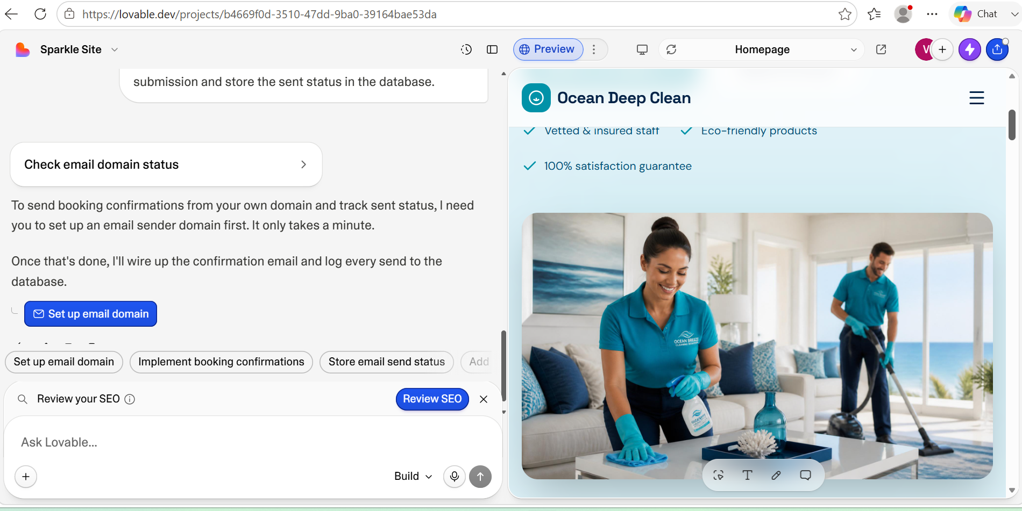

Mind Map (Collaborative)

Penelope Flores
Communication: Good communication helps team members understand their roles, share ideas and work together efficiently. Clarity ensures that instructions and expectations are easy to understand, reducing mistakes and confusion. Active listening allows people to understand different perspectives and respond appropriately. Constructive feedback helps individual improvement their performance and encourages continuous learning. Open communication channels create an environment where employees feel comfortable asking questions, sharing concerns, and suggesting new ideas.
Leadership: is equally important in creating and effective workplace. Good leaders provide guidance by setting clear goals and supporting their teams. They make informed decisions that help the organization achieve its objectives. Effective leaders also resolve conflicts fairly, maintaining positive relationships among team members. By empowering employees through trust, responsibility, and encourage, leaders build where individuals and organizations can succeed.
Victoria Owen
Planning and organization are essential for effective teamwork because they help teams work efficiently toward shared goals. Planning sets clear objectives, establishes priorities, and creates timelines, ensuring everyone understands what needs to be achieved. Organization assigns roles and responsibilities according to each member's skills, reducing confusion and preventing duplication of work. Together, they improve communication by providing clear reporting structures and regular updates, helping team members stay informed and collaborate effectively. They also support better time management and efficient use of resources, enabling tasks to be completed on schedule and within budget. By defining expectations and responsibilities, planning and organization reduce misunderstandings and conflicts while increasing accountability. They also help teams anticipate potential challenges and develop solutions in advance, improving problem-solving. As team members achieve milestones and see progress, motivation, trust, and morale increase. Overall, effective planning and organization create a productive, coordinated, and supportive working environment that leads to higher-quality outcomes and successful achievement of team objectives.
Samuel Ojok
Collaboration supports effective teamwork by keeping all members on shared goals allowing all members to work towards same objectives. Having clear roles shared among members reduce chances of confusion and give better accountability. Trust permits open communication, sharing ideas, build confidence, reinforce cooperation and solving problems amongst members. These elements give room for positive work environment where members contribute effectively, resolve issues and achieve better results. Strong collaboration therefore foster productivity, strengthen relationship and permit teams to contribute efficiently while meeting all objectives.
Team dynamic positively influences effective teamwork through diversity, cohesion, adaptability, and motivation. Diversity allows members to contribute different ideas, knowledge and skills which greatly improve creativity and decision-making. Cohesion builds relationship and promotes cooperation amongst members. Adaptability permits teams to respond efficiently to changing environment and challenges whilst motivation strengthens individual commitment and outcomes. Collectively these elements effectively build communication, collaboration, and problem solving while enabling teams to successfully achieve shared goals.

Poster (Individual)

Task 3: Virtual Collaboration and RefWorks
FORMING A TEAM
Trust is the foundation of effective team it build trust and boost team productivity.
Patrick Lencioni's The Five Dysfunctions of a Team explains why some teams struggle to perform well even when they have talented members. The book argues that success depends less on individual ability and more on how well people work together. Lencioni identifies five common problems that reduce teamwork and offers practical ways to overcome them.
The first dysfunction is the absence of trust. Trust is the foundation of every successful team because it allows members to be honest, admit mistakes, ask for support, and share ideas without fear of being judged. When trust is missing, communication becomes limited, and collaboration suffers.
The second dysfunction is the fear of conflict. Many people avoid disagreements because they worry about damaging relationships. However, respectful and open discussions often lead to better ideas and stronger decisions. Teams that avoid conflict may leave important issues unresolved, reducing their effectiveness.
The third dysfunction is the lack of commitment. Team members are more likely to support decisions when they have the opportunity to express their opinions during discussions. Clear communication and shared understanding help everyone work towards the same objectives, even if not everyone initially agrees with the final decision.[4]
The fourth dysfunction is the avoidance of accountability. Strong teams encourage members to take responsibility for their actions and performance. Holding one another accountable helps maintain high standards, improves productivity, and builds trust within the group.
Finally, inattention to results occurs when individuals focus more on personal success than on achieving team goals. High-performing teams place collective outcomes above individual recognition, creating a culture of cooperation and shared responsibility.
Overall, Lencioni highlights that trust is the starting point for overcoming the other four dysfunctions. By building trust, encouraging healthy conflict, promoting commitment, strengthening accountability, and focusing on shared goals, teams can improve communication, decision-making, and overall performance. These principles are valuable for businesses, educational institutions, and any group working towards a common objective.

Task 4 (a): E-Portfolio Creation

Task 4 (b): Illustrative Review of E-Portfolio tool Selection

Conclusion
In conclusion, I chose to use an e-portfolio for this assignment because it is an effective way to organize, present, and reflect on my learning. An e-portfolio allows me to collect my work in one place, demonstrate my progress over time, and showcase the knowledge and skills I have gained throughout the course. It also helps me develop important digital literacy and communication skills that are valuable in both academic and professional settings. By using an e-portfolio, I can present my work in a clear, creative, and accessible format while reflecting on my learning journey and identifying areas for future improvement.

References

Task 1 References:

Task 3 References:

References
[1] A. P. Silva, P. Lourtie and L. Aires, "Employability in online higher education: A case study," vol. 14, no. 1, pp.106–125, 2013,
[2] S. Greener, "The tensions of student engagement with technology," vol. 30, no. 3, pp.397–399, 2022,
[3] T. Richardson and E. Lumsden, "" It's ok not to know what I want to do": An exploration into the aspirations of early childhood studies students," vol. 14, no. 1, pp.1–14, 2023,
[4] A. Mirakyan, "ORGANIZATIONAL BEHAVIOR EDUCATION PRACTICE AND ISSUES", in EDULEARN25 Proceedings, pp. 8300–8306.

E-Porfilio Link: Home | My Site 5

