Construction Materials
Rhys Bolton (1902382) Word Count:2289 (including referencing)
Concrete Framed Building:
The Marina City, Chicago, U.S.A, was completed in 1968 after a construction phase of 8 years, with alterations completed on it in 1996. The function of the building is mixed use, including residential and commercial. The building stands at an enormous 558 feet (179.22m) with the highest occupied floor being at 534.5 feet (162.92m). Between floor 21 and 60 there are; there are numerous floors of 1 bed and 2 bed studios and apartments. With the 61st floor and above occupying an observation deck and a penthouse. The Marina City is made up of two towers, with each tower having 336 studio apartments, 67 one bed apartments and 45 two bed apartments. Overall, within the Marina City there are; 896 apartments and 354 hotel rooms. The Marina City houses approximately 18 businesses and 1,400 residents. (Dahlman, 2017)

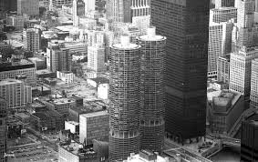
Figure 1: An image of the Marina City, Chicago, U.S.A. (Cinematreasure.org, n.d.)

Steel Framed Building:
The Shun Hing Square Tower, Shenzhen, China was completed in 1996 after three years of construction. This monumental skyscraper holds numerous records after the completion of its construction. These include; the 34th tallest in the world, the 23rd tallest in Asia, the 18th tallest in China and the 4th tallest in Shenzhen. In total it has 72 floors, with 3 of these being below ground. The architectural height of this structure is 1,260 feet (384m) but its height of top occupancy is 978 feet (298m). The speed that this construction was completed was extremely fast, with the main tower being built at a rate of 4 floors every 90 days and only taking 40 months for the completion from start to finish. The Shun Hing Square Tower has within it; a 35-floor annex containing 330 high end apartments, 144,200 square meters of Grade A office space, a 5-story shopping arcade and a parking garage. The Tower is made up of; the core being reinforced concrete, the columns within being concrete encased steel and the floor spanning also being steel. (Global Tall Building Database of the CTBUH, 2016)
The Shun Hing Square Tower’s structural system is a rather complicated one due to the sheer size of the building it has to withhold. It is fundamentally made up of a circumferential rigid steel frame, with a rectangular center core made of reinforced concrete which are both connected together at four different levels up the building by using rigid steel outriggers. Closely-spaced steel beams and one-way spanning plates compose the floor plates. (HO, 2017)
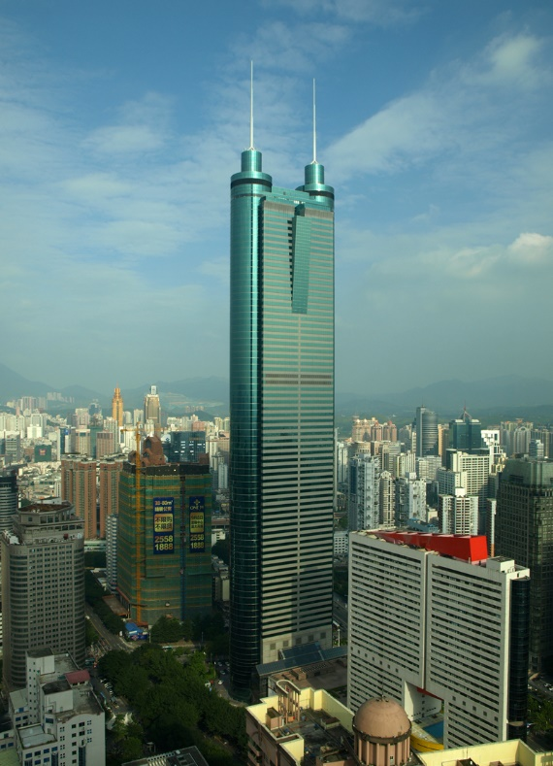

Figure 2: An image of Shun Hing Square Tower, Shenzhen, China. (Skyscrapercenter.org, n.d.)

Durability and climatic resistance, given the environmental conditions they are exposed to at the site.
In Shenzhen, China, during the wet season it is very hot, harsh, overbearing and overcast. Within a year in Shenzhen the average temperature is between 12.8 degrees Celsius and 31.7 degrees Celsius and the average level of precipitation being very abundant varying from 40mm in the least rainy periods all the way up to 200mm on average per month in the most-rainy periods. On average around 1,900mm of rainfall falls every year. (Cedar Lake Ventures, inc, 2019) (WORLD CLIMATE GUIDE, 2019)
Across the whole world in 2018, 1808.6 million tons of steel was produced, with China being at the top of the table of production producing 928.3 million tons of this grand total (821.8 million tons more than India in second place). (World Steel Association, 2019). The total amount of steel used within the construction of the Shun Hing Square Tower is between 24,500 and 25,000 tons. (Chinese National Engineering Research Centre for Steel Construction, n.d.) (K.F. Chung, M.C.H Yam and H.C Ho, The Hong Kong polytechnic University, 2015). This means that per year, China produces enough steel independently to provide enough steel for a construction of equivalent size of the construction of the Shun Hing Square Tower 37,172 times per year.
Research has proven that when temperatures reach around 37 degrees Celsius steel can start to expand by around 0.006-0.007%. This means that it can cause safety concerns to arise, as parts of the construction may begin to move ever so slightly and cause faults which could jeopardize the entire building. As temperatures in Shenzhen rarely, if ever exceed the 37 degrees mark, the construction of the Shun Hing Tower is a fairly safe one in terms of its steel not reacting due to the temperatures it experiences. Also, in terms of how the steel within the Shun Hing Square Tower reacts with rainfall, it is another fairly positive outcome for the construction of the tower as Stainless Steel does not rust as the reaction between the environment and its alloying elements. Stainless Steel is adequately able to protect itself from being invaded by producing a passive corrosion product coating. Because of its ability to protect itself from weathering and rusting and its level of durability in hot temperatures with the highest average temperatures in Shenzhen not having a reaction on the steel, steel is an extremely good choice of material to be used as the framing material for a construction of this magnitude in Shenzhen. (SCIENTIFIC AMERICAN, 2001) However, as a precaution due to the high temperatures that could be achieved in Shenzhen, the steel that was used in this construction would have been sprayed with fire protection so that it will not melt and the chances of the steel weakening in strength or expanding will have been lowered drastically.
In Chicago, U.S.A, there is a variance in their weather during the year, with their summers usually being relatively hot averaging at around 29.4 degrees Celsius with its hottest day of the year usually being around the point of 37.8 degrees Celsius. On the other end of the weather spectrum in Chicago, during the winter months the average temperature recorded is around -8.3 degrees Celsius, with barely any days during this month reaching higher temperatures than 0 degree Celsius. (Weather Atlas, 2019) Precipitation and rainfall in Chicago occurs throughout the entire calendar year, with the averages ranging from around 3.7 inches falling on average in May (the rainiest month) down to around 0.9 inches of rainfall falling on average during January (the driest month). (Cedar Lake Ventures, Inc, 2019)
In 2018, in the United States, there was an estimated 88.5 million tons of cement produced, which Is a reasonably sized proportion of the 4.1 billion tons of cement that was produced in the same year. The additional production of cement clinker reached a huge figure of 77.7 million tons. (Wang, 2019)
Concrete reacts differently in hot and cold weather conditions during both the construction phases and the day to day uphold of the construction. This is extremely important in places like Chicago as it experiences a huge variance in its weather conditions between its hot summers and freezing winters. This means that during the construction phase of the Marina City in Chicago, extreme care would have had to have been taken when the concrete was being placed as if new concrete has the ability to cool too quickly when below freezing point then the concrete will be damaged so badly that it would therefore be inadequate for use. Also, another point that needs to be considered when pouring concrete is that it does not matter whether the weather conditions drop below 0 degrees Celsius, the concretes strength will still develop a reasonable amount slower than it does during warmer months. When concrete is delivered, poured and freshly laid, it is majorly important that the concrete is kept above 5 degrees Celsius, one way this can be achieved is to use heated water within the mixture, using specially designed heaters to protect it or to just delaying the pouring of the concrete until the weather gets warmer. Pouring and the continuous protection of concrete in hot weather conditions can also be an issue, the reason for this is that the top layer of the concrete will dry a lot faster than the bottom. When concrete dries, it shrinks, meaning that the top of the concrete will be beginning to shrink, while at the same time the bottom will still be stationary. Because of this, the top and the bottom will begin to break apart from each other causing cracking and weakening the strength of it. For this to be avoided, keeping the concrete mix in cooler conditions before hand, using extremely cold water within the mix, or as in the same way as if it is too cold, it can be encouraged that the pouring of the mix can be postponed to a later date, when the conditions are cooler. (Sakrete, n.d.)

Impact of the frame material’s original production process on the environment.
The production of steel involves iron ore being heated up, with the impurities being removed at the stage where it is melted within furnaces and carbon is added. In this day and age, there are two main ways processes that are used in the production of steel. These are; using a blast furnace or an EAF (Electric Arc Furnace). A blast furnace uses mainly only raw materials such as; limestone, coke and iron ore) with a small proportion of scrap metal, whereas on the other hand, a EAF uses predominantly scrap metal. (Metal Supermarkets, 2015).
The steel that was used for the construction of the Shun Hing Square Tower was made by the China Construction Steel Structure Corporation (CSCEC) and one of the main aims of this company within the construction of its steel is sustainability. There are green concepts interspersed throughout the whole process, not only of the construction but also the design, which in tole is delving into new directions for green development within the construction industry. Another aim that CSCEC has is to target low amounts of carbon and conserve as much energy as possible, and developing green building technologies while also organizing benchmarks for products constructed from steel. This meaning that the company behind the construction of the steel used for the Tower, are extremely efficient with conservation and looking after the environment around them, using greener technology methods and materials. Even though the production of any type of steel isn’t going to positively impact the environment such as the negative impacts including air emissions, hazardous wastes and solid wastes, having a company like CSCEC being in charge of constructing the steel for a project is making the negative impact on the environment subsequently much lower, with their best efforts trying to nullify these negative impacts as best as they can within their power. (CHINA CONSTRUCTION STEEL STRUCTURE CORP LTD., 2015-2016) (Greenspec, 2019)
Concrete’s production involves the process of bringing together different ingredients such as water, cement, aggregates and any other additives to the mix. Concrete production is very time-sensitive and it is about getting the timings right such as the mixing, pouring and setting times. The production of Concrete also has a huge impact on the environment. With the construction of concrete not giving off harmful gasses, it gives off a rather high amount of potent green house gases such as carbon dioxide. When concrete has been constructed and poured into place, it also has a negative impact on surface runoff that can possibly have a negative impact on flooding, surface runoff and water pollution. It also has a huge impact on the use of the worlds water supplies, using up a massive 10th of the worlds industrial water supply. The dust from the production of concrete causes 10% of the coarse particles in the air. It also makes up 5%of the worlds of the CO2 emission levels world-wide, and takes up huge amounts of energy, that could easily be used elsewhere. (Ehrlich, 2010)
Frames ease of assembly and the potential ease of its adaption to different building shape and use, within the life cycle of the building
When the construction of the Marina City Towers in Chicago took place, they used the construction method of Ground assemble, hoisted up and then fixed into place. The Concrete can be poured into molds on site near the construction itself, or even poured and set off site and then transported to the site before being fitted into place. Concrete is a material that is set into a standard shape, with all of its walls and the entire construction as a whole being set and cannot be altered into any other shapes. Therefore, the adaptability levels of a concrete building such as The Marina Towers is very low if at all. Also, the flexibility and malleability of concrete is also very low and it is very hard to cast concrete into curves.
The construction of the Shun Hing Square Tower, Shenzhen, China involved the construction of a steel-skeleton building. The floors are therefore constructed on the layers of horizontal bracing. The floors are supported by steel beams in a horizontal format which are attached to the buildings core, which in this specific example is reinforced concrete. Panels of corrugated thin steel is then placed across the beams, being welded into place, being finished off with a very thin layer of concrete being around 2-4 inches thick to complete the flooring off. (How Products are Made, 2007) The difference with using steel as a main component in a construction rather than concrete is that its adaptability levels are so much higher, the steel frame of the Shun Hing Square Tower, can be adjusted and it is a lot easier to cast steel beams into curves. Steel can also be recycled, at the end of use of the Shun Hing Square Tower, it could possibly be pulled down and all of the steel used within the construction could easily be used within other structures.
(n.d.). Retrieved from Skyscrapercenter.org.
Cedar Lake Ventures, Inc. (2019). Average Weather in Chicago. Retrieved from https://weatherspark.com/y/14091/Average-Weather-in-Chicago-Illinois-United-States-Year-Round.
Cedar Lake Ventures, inc. (2019). Weather Spark. Retrieved from https://weatherspark.com/y/127893/Average-Weather-in-Shenzhen-China-Year-Round.
CHINA CONSTRUCTION STEEL STRUCTURE CORP LTD. (2015-2016). Sustainability. Retrieved from http://sstr.cscec.com/english31/Sustainability31/GreenBuilding31/.
Chinese National Engineering Research Centre for Steel Construction. (n.d.). Chinese Engineering. Retrieved from www.polyu.edu.hk/cnerc-steel/en/construction/chinese-engineering/diwang-international-building.
Cinematreasure.org. (n.d.).
Dahlman, S. (2017). Marina City. Retrieved from https://www.marinacity.org/about.htm?m.
Ehrlich, B. (2010, August 30). Reducing Environmental Impacts of Cement and Concrete. Retrieved from https://www.buildinggreen.com/feature/reducing-environmental-impacts-cement-and-concrete.
Global Tall Building Database of the CTBUH. (2016). The Skyscraper Centre. Retrieved from www.skyscrapercentre.com/building/shun-hing-square/258.
Greenspec. (2019). Steel production and environmental impact. Retrieved from http://www.greenspec.co.uk/building-design/steel-products-and-environmental-impact/.
HO, D. P. (2017, May 13-17). Economics Planning of Super Tall Buildings in Asia Pacific Cities. Retrieved from https://www.fig.net/resources/proceedings/fig-proceedings/fig2007/papers/ts_4g/ts04g_01_ho_1673.pdf.
How Products are Made. (2007). Skyscraper. Retrieved from http://www.madehow.com/Volume-6/Skyscraper.html.
K.F. Chung, M.C.H Yam and H.C Ho, The Hong Kong polytechnic University. (2015). Technical Guide: Effective Design And Construction To Structural Eurocodes: EN 1993-1-1 Design of Steel Structures. Hong Kong: Construction Industry Council, Hong Kong SAR.
Metal Supermarkets. (2015, June 5). How Steel Is Made. Retrieved from https://www.metalsupermarkets.co.uk/how-steel-is-made/.
Sakrete. (n.d.). Placing Concrete in Hot or Cold Weather. Retrieved from https://www.sakrete.com/blog/placing-concrete-in-hot-or-cold-weather.
SCIENTIFIC AMERICAN. (2001, March 12). THE SCIENCES. Retrieved from https://www.scientificamerican.com/article/why-doesnt-stainless-stee/.
Wang, T. (2019, August 9). Statista. Retrieved from https://www.statista.com/statistics/219343/cement-production-worldwide/.
Weather Atlas. (2019). Monthly weather forecast and climate Chicago, IL. Retrieved from https://www.weather-us.com/en/illinois-usa/chicago-climate.
WORLD CLIMATE GUIDE. (2019). CLIMATES TO TRAVEL. Retrieved from https://www.climatestotravel.com/climate/china/shenzhen.
World Steel Association. (2019, January 25). Global crude steel output increases by 4.6% in 2018. Retrieved from https://www.worldsteel.org/media-centrer/press-releases/2019/Global-crude-steel-output-increases-by-4.6--in-2018.html.

