

Strategic Management
Module Code: LCMB7003

Assessment Title:
Netflix UK Strategic Management Analysis

Student Name: Rutvik Patel
Student ID: 2505514

Lecturer Name: Mr. Ghulam Mujtaba

Table of Contents
Section 1 — Strategic Management Report 3
1. Organisational Context and Overview 3
1.1 Organisation and Market Context 3
1.2 Historical and Strategic Development 3
1.3 Mission, Vision and Business Model 3
1.4 Industry, Competitors and Market Position 4
2. External and Internal Analysis 4
2.1 External Environment: PESTEL Analysis 4
2.2 Industry Competition: Porter's Five Forces 7
2.3 Internal Environment: VRIO Analysis 9
2.4 SWOT Strategic Synthesis 11
3. Comprehensive and Holistic View 12
3.1 Corporate Social Responsibility Strategy 13
3.2 Balanced Scorecard 14
4. Strategic Choices and Implementation 16
4.1 Alternative Strategic Choices 16
4.2 Evaluation of Strategic Options 17
4.3 Recommended Strategy 18
4.4 Strategic Validation 18
4.5 Competitive Advantage and Performance 19
4.6 Implementation Challenges and Mitigation 19
Section 2 — Reflective Account 21
5. Reflective Account 21
5.1 Description 21
5.2 Feelings and Challenges 21
5.3 Evaluation 22
5.4 Critical Analysis 22
5.5 Conclusion 23
5.6 Action Plan 23
Reference List 24

Section 1 — Strategic Management Report

1. Organisational Context and Overview

1.1 Organisation and Market Context
Netflix, Inc. is an entertainment company providing films, series and other content via its online streaming service around the world. In this report the focus is on the UK video-streaming market and Netflix. The UK is an important market as streaming is already well in place and there's a huge competition for viewers. In the fourth quarter of 2025, 69.7% of UK households had access to a subscription-based video-on-demand service for at least one service. Netflix is thus not just about acquiring customers, but also about retaining them, engaging them, and achieving profitable growth in a mature market (Zheng & al. 2022).

1.2 Historical and Strategic Development
Netflix began as a DVD rental service and became a streaming-based entertainment company, with the addition of original content. This change decreased the reliance on external licences and assisted to further distinguish its service. It also has significant local production as part of its UK strategy. Netflix spent nearly US$6 billion on the British creative economy from 2020 to 2023, including in films like The Crown, Top Boy and Heartstopper. This investment is local but helps Netflix to become more relevant in the UK and to produce content for international audiences as well.

1.3 Mission, Vision and Business Model
Netflix's strategic intent is focused on delivering entertainment services conveniently and on-demand in a variety of content. The value proposition is a mix of original programmes and licensed programmes, customised suggestions and multi-device availability. Although the membership is paid, it is the primary revenue stream, its advertising-supported model will generate a second revenue stream and will be a more cost-effective option for customers who are price sensitive. The same time in the UK, 38% of Netflix households were on its advert-supported tier that equates to approximately 6.9 million households. This hybrid approach will help Netflix better cater to various customer segments. But Netflix will have to take a more careful look at what they advertise and how much they charge customers because too many ads or more expensive subscription fees may drive customers to other services (Muhammad Masao & Imam Salehudin 2023).

1.4 Industry, Competitors and Market Position
There is a competitive streaming market in the UK. Netflix is battling Amazon Prime Video and Disney+ head-on, and other digital entertainment providers are vying for viewers' time in the broadcast sector. Netflix's strong household reach was further evidenced by 18.0 million UK homes (60.9%) with access to Netflix in Q4 2025, which was higher than the 13.8 million (46.5%) who had access to Prime Video and the 7.6 million (25.8%) who had access to Disney+. But a high percentage of households with the product does not guarantee that the audience will be very demanding. Figure 1 offers a demand-driven view: According to Parrot Analytics, around 7% of UK series demand was for Netflix-originated series, compared to a higher proportion for BBC content. This indicates that Netflix is not just about subscribing to the service, it is also about the attention it garners. The key strategic question is now one of engagement, differentiation and moving the masses of customers into sustainable values (Cui 2024).
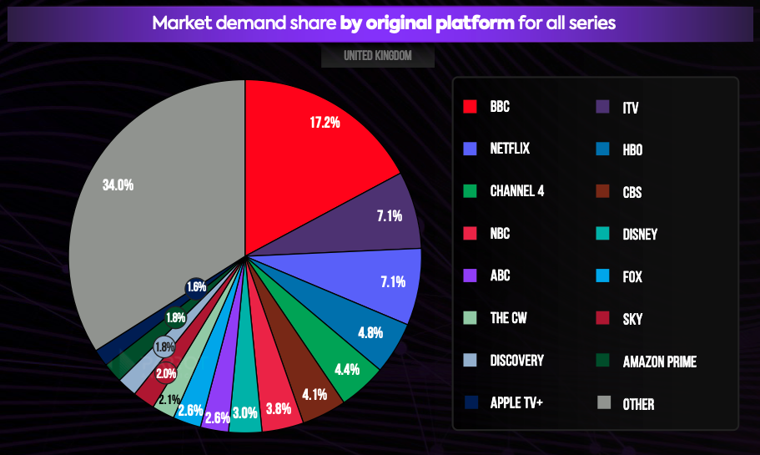
Figure 1: UK Streaming Series Demand Share

2. External and Internal Analysis

2.1 External Environment: PESTEL Analysis
2.1.1 Political Factors
UK media policy is becoming more important for Netflix. The Media Act 2024 is introducing tougher rules for these major streaming platforms, and in 2026 Ofcom stated it will be supervising Netflix for the first time. Planned requirements address issues of harmful content, fairness and accuracy, privacy and accessibility. This poses a risk as increased regulation can lead to higher compliance costs and reduce some operating options. But the higher standards could also boost confidence among users, which could be a boon to old-line services like Netflix (Wang 2022).
2.1.2 Economic Factors
When economic pressures arise, there's a difficult balance between affordability and revenue growth. Ofcom discovered Netflix has raised its UK Basic plan by £2/month and Premium plan by £1/month in the year to September 2025. Other big streaming companies also increased their ticket prices. Raising the price can help increase the amount of revenue collected per customer, but can also encourage price-sensitive households to cancel, downgrade or switch. Partly, Netflix mitigates this risk with its advertising-supported, cheaper service. This strategy is becoming more popular: The ad tier was used by 38% of homes in the UK with Netflix by Q4 2025. As a result, flexible pricing is a revenue opportunity and a defensive action to meet the challenge of affordability (Forero-Quintero & al. 2022).
2.1.3 Social Factors
Streaming services have a strong foothold in the UK viewing landscape, especially amongst younger audiences. In a previous report, Ofcom discovered that 9 out of 10 18- to 24-year-olds started on streaming, on-demand or social-video services when searching for something to watch. The importance of Netflix is even more recent, as 26% of UK viewers said they would prefer Netflix as their default choice when choosing what to watch in 2026 – just shy of BBC at 25%. But penetration has been largely stuck at around 70% of UK households when it comes to subscription streaming. However, retention and engagement are now becoming significant concerns, as are changes to viewing habits..
2.1.4 Technological Factors
Netflix is at the forefront of technology as streaming quality, personalisation and data analysis directly contribute to customer experience. By leveraging recommendation technology, the process of locating suitable programs can be streamlined, and AI can enhance content discovery and business efficiency. But technology isn't the sole sustainable edge, as other companies like Amazon and Disney can spend a ton of money on digital platforms, too. Thus, technology is a more valuable addition to Netflix's value proposition when used with viewing data, its content catalogue, and its scale. Data-driven personalisation also introduces privacy obligations as covered by the UK GDPR, regarding profiling and automated processing of personal information. As a result, there is a need to strike a balance between innovation and customer trust and regulatory compliance (Chan & al. 2024).
2.1.5 Environmental Factors
Netflix is under strain from TV and film production and distribution as well as all the other components of the infrastructure required to provide digital entertainment. Netflix understands that a large portion of its impact is from physical productions and has decided to cut emissions by about 50% by 2030. This puts pressure on the use of cleaner production processes and more efficient use of energy. Sustainability can also boost the reputation of the business with the environmentally conscious stakeholders, though. The question for Netflix is then whether it can grow and be sustainable or whether it can grow and be unsustainable.
2.1.6 Legal Factors
UK regulations on privacy, consumer protection, IP and now streaming-content standards are up to Netflix to handle. Data protection is very crucial as personalisation relies on user behaviour analysis. UK GDPR applies to profiling, says the ICO, and organisations must have a lawful basis, be transparent and provide the right safeguards. In the meantime, the implementation of the Media Act is putting big streaming services closer to the television-type of regulation, with new requirements regarding accessibility and audience-protection. Compliance adds to operational responsibility, and good privacy and content governance can help to build trust and mitigate reputational risk (Bernardo & al. 2024).
These pressures are summarised in Figure 2. Technology and declining viewing patterns offer significant opportunities, and regulations, price sensitivity and heavy digital competition present major threats overall. Importantly, the factors feed off each other: the power of personalisation, for instance, depends on technology, but also brings data-protection responsibilities. This interaction is more significant than dealing with the six PESTEL factors separately.
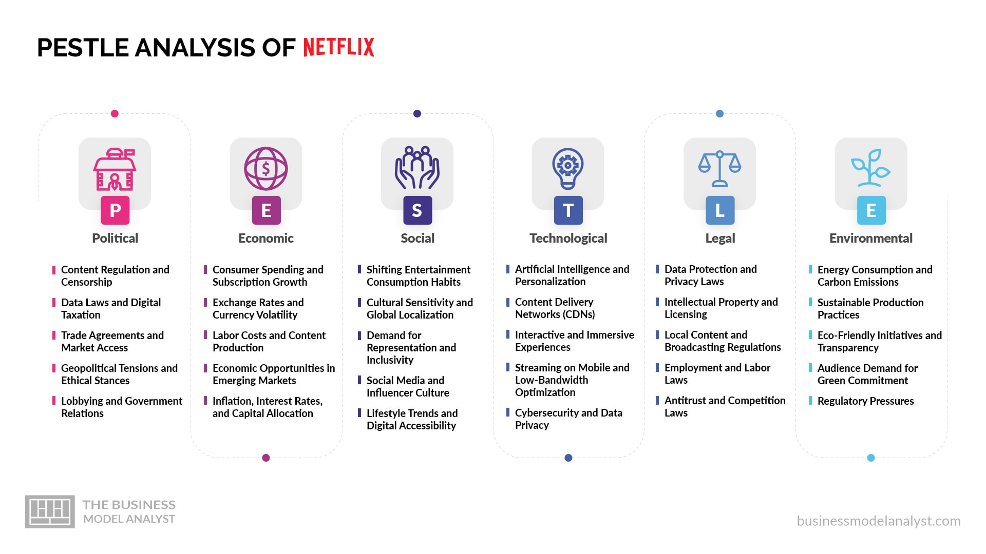
Figure 2: Netflix UK External Environment Analysis

2.2 Industry Competition: Porter's Five Forces
2.2.1 Competitive Rivalry — High
The level of competition in the UK streaming is high. The other major streaming services that compete with Netflix include Prime Video, Disney+, Apple TV+, Paramount+ and NOW, and the streaming services offered by broadcasters like BBC iPlayer and ITVX. Netflix served 18.0 million homes in the UK in Q4 2025, while Prime Video and Disney+ had 13.8 million and 7.6 million respectively. But rivals compete with Netflix via exclusive content, pricing and platform ecosystems, so Netflix remains the dominant player in the big skies of SVoD. Furthermore, on-demand viewing offered by UK broadcasters has increased by 9% YoY, highlighting the competitive nature of the SVoD market as a whole (Beckett 2024).
2.2.2 Buyer Power — High
With many options available, users can easily switch streaming platforms, giving them a high degree of buyer power. Unlike many industries, consumers can easily switch back and forth between Netflix and Prime with no onetime costs. Price hikes can thus lead to cancellation or downgrade. Netflix's new ad-supported subscription level partially alleviates this pressure by offering a more affordable offer to those who are price conscious. It also shows that that Netflix can no longer expect that customers will stick with it no matter what prices they have to pay as a result of the strength of its brand.
2.2.3 Supplier Power — Moderate to High
Supplier power is medium-high, as attractive programmes rely on writers/actors/producers/studios and IP owners. Exclusive content and very recognised creative talent may thus be costly. Netflix is minimizing this reliance on others by producing original content and cultivating close ties with production communities around the world. It has recently pledged to invest nearly US$6 billion in the British creative economy from 2020 to 2023. Its own dedicated production hub in Shepperton also boosts the UK production capability. However, supplier influence remains strong due to the competition for high quality talent and the success of IP (Ma & al. 2025).
2.2.4 Threat of Substitutes — High
There is a risk of substitutes since Netflix is not only competing with other subscription services, but also with leisure time. YouTube, broadcaster television, social video, gaming, cinema and free advertising-supported content are available to choose from. With fragmentation of viewing behaviour this threat is growing. Ofcom's latest research indicates that YouTube viewing on TV has doubled since 2022, and on-demand television viewing services owned by broadcasters are also on the rise. Netflix has to be constantly engaging, therefore, because if it's technically sound, viewers will not spend their valuable entertainment time using it.
2.2.5 Threat of New Entrants — Moderate
Moderate threat of complete new entrants. While it is technically possible to launch a streaming service via digital distribution, it will be difficult to compete with Netflix if you don't have the financial resources, technology, brand recognition, and customer base. It's not as if a new competitor has to compete with just any Netflix, though: Netflix has an audience of 18 million UK households. But, existing media and technology firms can get in more easily due to the fact that they have the content and some amount of capital or customer bases already in place. Thus, the obstacles are significant for large established firms, and even minimal for independent newcomers (Banka & al. 2024).
The industry is not an easy one for Netflix to be in, as is evident in Figure 3. There is a high level of rivalry and buyer power and close product substitutes. The United Kingdom market is therefore appealing due to its high number of streaming users, yet it presents difficulties due to the fact that the customers require constant investment to keep their interest. Some of the pressure is being alleviated by Netflix's market leadership, but these structural pressures are still there.
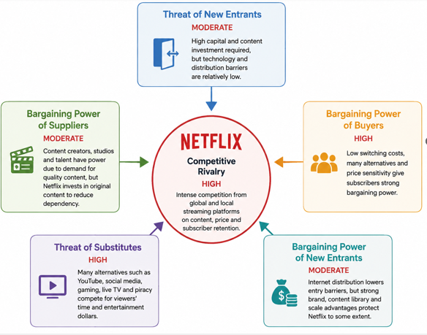
Figure 3: Netflix Five Forces Competitive Analysis

2.3 Internal Environment: VRIO Analysis
2.3.1 Key Resources and Capabilities
Netflix's most significant assets in the UK are its respected brand, vast subscriber numbers, recommendations and data tools, global library of content, original content production, financial size, and ties with the UK’s creative industry. Strategically relevant as well is its production infrastructure in the United Kingdom. Netflix set up a dedicated production facility at Shepperton Studios with 14 sound stages, workshops and office spaces. The resources complement each other: production leads to unique programmes, and the platform/recommendation make these programmes efficient (Asadullah & Faik 2026).
2.3.2 Value and Rarity
Netflix's scale is definitely useful because it disseminates content and technology investment over a very big audience. It also has strong base for monetisation as it is accessible by 18 million households in the UK. Not all resources are, however, rare. The other two, Prime Video and Disney+, also have strong brands, vast libraries and loads of money. When Netflix's strengths, in its global distribution, local production, customer relationships and personalised content discovery are viewed together, it's a far more powerful combination than any of these elements alone.
2.3.3 Imitability and Organisation
There are some parts of Netflix that can be replicated. Competitor can build streaming apps, add advertising tiers and build recommendation systems. Competitors' exclusive productions challenge Original programmes as well. Replicating the entire mix of brand recognition, scale, audience habits, production networks and global rollout is more complex and costly, however. Netflix also seems to be well-equipped to take advantage of these features, with its streaming service, content investment platform and UK production network. The British investment indicates that it is being used rather than just held (Nguyen & Almodóvar 2025).
2.3.4 Competitive Advantage Assessment
In this regard, VRIO indicates a combination of competitive and non-competitive characteristic. The basic streaming technology is competitive, as major players have similar platforms. The advantages of brand investment and content investment can be short-lived as there's always someone else able to counter them with their brand and expenditure. The combination of scale, audience relationship, discovery of data, distribution globally and locally produced content, is where Netflix has a better overall chance of continued advantage. However, this benefit can't be viewed as a permanent one. Disney has an enviable IP and Amazon can tie video to a larger Prime ecosystem. Netflix has to keep on renewing its capability bundle, not only based on the market leadership, but also to keep up with the competition (Joonas & al. 2023).
Figure 4 provides further evidence for this conclusion, as ordinary competitive resources are distinguished from resources that have greater capacity to give rise to sustained competitive advantage.
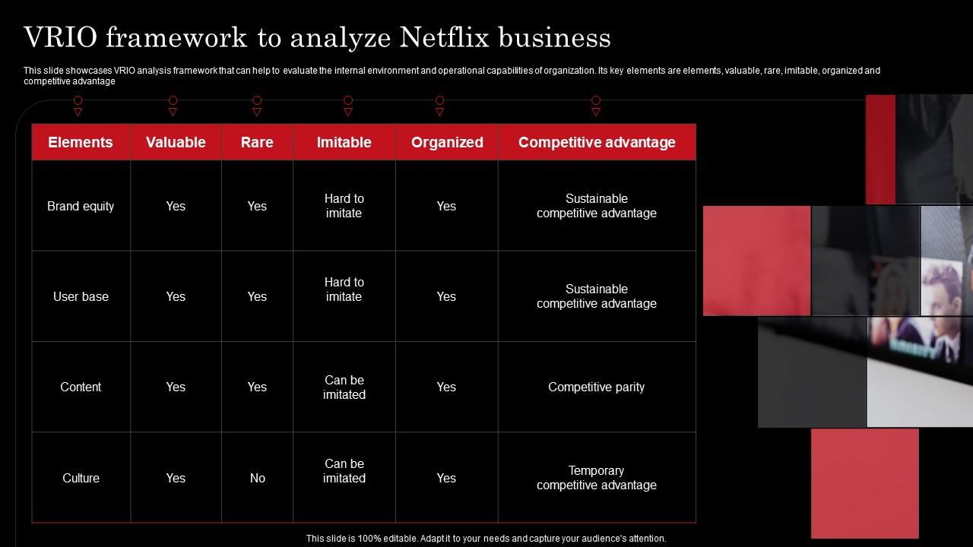
Figure 4: Netflix VRIO Competitive Advantage Analysis

2.4 SWOT Strategic Synthesis
2.4.1 Strengths
The UK reach of its main binge offering, Netflix, is a major strength, as is its brand, its big content library, its personalisation features and its capacity to distribute UK shows around the world. It has 18.0 million UK-household reach which enables the platform to support subscriptions and advertising revenue. Important production investment in the UK also helps to build and cultivate relationships with local creators and promote differentiated content.
2.4.2 Weaknesses
Netflix's biggest drawback is it has to keep investing to keep viewers engaged. Content can be costly and effective programmes are hard to foresee. Netflix also doesn't have the same commercial ecosystem that Amazon and some of the established ownership of a brand like Disney do. It is a strength and limitation at the same time, as the UK penetration is high; which means there are not many completely new households in which to easily add subscribers (Dunn & al. 2025).
2.4.3 Opportunities
The best prospects include the rise of advertising-supported streaming, the shift of traditional TV to streaming OTT, technological advances and the excellent, internationally successful UK product. The advertising opportunity is clear, with 6.9 million UK homes on Netflix's ad tier in Q4 2025 compared to 6.1 million in Q3. Local production can also realise two times value – first in Britain and subsequently via the international distribution arm of Netflix.
2.4.4 Threats
The key risks are high competitive pressures, subscribers fatigue, sensitivity to price, alternative entertainment platforms, increasing costs of content and more stringent regulations. Overall SVoD penetration has remained at around 70% of UK households, and on-demand, broadcaster owned services are on the rise, Ofcom reports. It means that Netflix shouldn't rely on continued growth to fuel performance (Bell & al. 2021).
2.4.5 Strategic Implications
These results are summarized in Figure 5. The key strategic opportunity lies in the ability to integrate the scale and personalisation of Netflix's UK production with increased advertising-supported viewing and locally relevant content. But, the biggest drawback is that high pricing and strident competition make customers less loyal in a fully established market. Netflix should therefore prioritise engagement, customised UK content, advertising revenues and retention (as opposed to just subscription rates). This synthesis serves as the starting point for Netflix's strategic evaluation later in the report.
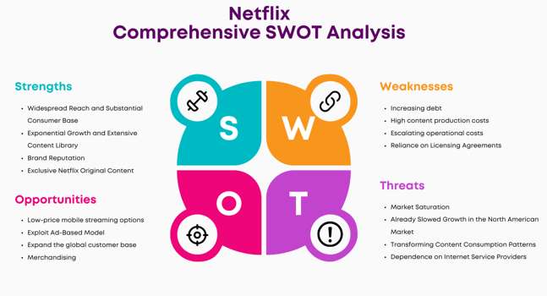
Figure 5: Netflix SWOT Strategic Position Analysis

3. Comprehensive and Holistic View

3.1 Corporate Social Responsibility Strategy
3.1.1 Current CSR Approach
Netflix's CSR approach includes environmental responsibility, social impact, responsible content production and workforce related topics. Netflix's environmental efforts are geared towards minimizing the carbon emissions of its operations and film and television productions. Its climate policy involves lowering emissions, employing alternative fuels and more environmentally friendly production processes. Additionally, Netflix's 2025 ESG reporting includes Scope 1, Scope 2 and Scope 3 GHG emissions, giving a more solid foundation for judging actual results, beyond just sustainability promises. Socially, Netflix helps in entertainment representation, workforce development and creative opportunities. These activities are relevant because Netflix is heavily dependent on creative talent, and audience trust and its reputation as a global entertainment company (Netflix 2025).
3.1.2 CSR and Business Objectives
The CSR strategy of Netflix is meaningful and has a relationship with the broader business goals. Sustainable production practices can help mitigate environmental risks and ensure Netflix can continue to deliver on high production volumes of original content. Social investment also can support the linkages with writers, actors, production workers and local creative industries. This is especially significant in the UK, where Netflix has been spending nearly US$6 billion in the UK's creative economy over the past four years (2020-23). This investment will help to enable Netflix to achieve its commercial goal of creating differentiated British content as well as create jobs and opportunities in the creative sector. In the context of greater strategic value to CSR, it is much more significant when the activities in the environment and society complement Netflix's production capacity, relations with stakeholders and brand, rather than being distinct from it (Brown 2023).
3.1.3 Critical CSR Evaluation
But just because there are environmental targets does not guarantee Netflix good sustainability performance. The importance of figure 6 is that it enables a comparison of commitments with measurable outcomes. Netflix's 2025 ESG data states that the company emits 38,379 metric tons CO₂e from Scope 1 emissions, 160 metric tons CO₂e from Scope 2 emissions and 1,053,697 metric tons CO₂e from Scope 3 emissions, totaling around 1.09 million metric tons CO₂e. Scope 3 is by far the biggest portion of the footprint. Most notably, the total emissions of the market rose from 843,107 metric tons CO₂e in 2023 to 1,092,236 in 2025. This means sustainability is still difficult as production and business activity goes on (Feraday 2022).
Therefore, Netflix's CSR strategy has mixed strategic intent. Measurement, independent assurance and emission-reduction targets enhance the accountability for the actions taken, and investment in local creative industries can serve social as well as commercial purposes. However, in order to consider environmental progress, one should look at the trends in emissions (Figure 6) instead of targets alone. The conundrum for stakeholders is whether there is a way for Netflix to grow its content output and revenue and at the same time minimize the environmental footprint produced throughout its value chain.
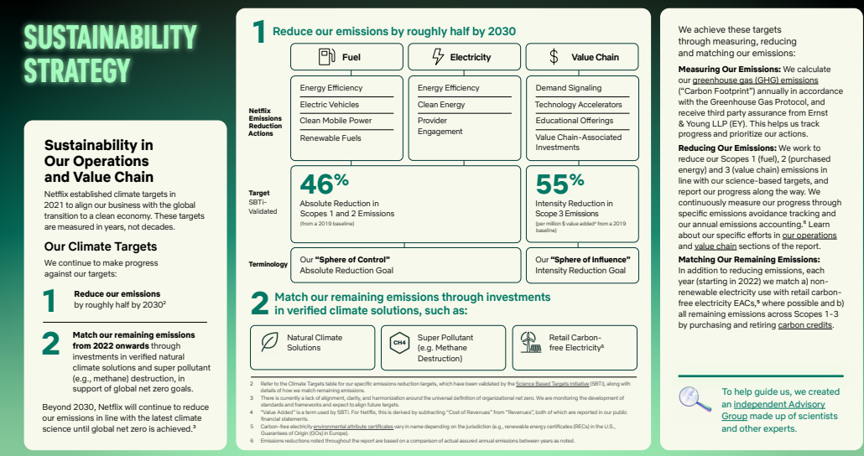
Figure 6: Netflix Carbon Footprint Emissions Analysis

3.2 Balanced Scorecard
A Balanced Scorecard is able to find a wider evaluation of Netflix as it is not only the financial performance that shows the sustainability of its competitive position in the UK. The four perspectives (financial, customer, internal processes, and learning and growth) are connected to four perspectives via objectives, measures and initiatives, as illustrated in Figure 7.
3.2.1 Financial Perspective
Netflix's goal is to grow sustainably in the UK and profitably. Revenue Growth, Operating Margin, Revenue per Membership, Advertising Revenue and ROI on Content Investment are important KPIs. The target for UK revenues is proposed to be 5-8% per annum, operating margin is to be held steady and advertising income is to be strengthened. These should cover more effective ad tier monetisation, more effective ads pricing, more effective content investment evaluation. These measures would generate financial value, not just subscriber numbers, as a result of growth (Mennekes & Schramm-Klein 2025).
3.2.2 Customer Perspective
The customer goal should be to create greater retention, engagement and value. The metrics to consider for KPIs are churn, retention, viewing engagement, satisfaction and ad-tier adoption. Netflix's strategy is to reduce customer attrition by 5% and boost viewing engagement by 5–10% over a period of two years. Personalised recommendations, unique UK content and limited frequency of advertising may help support these objectives. It's significant because Netflix has already achieved high penetration in the UK, so retention is becoming more important.
3.2.3 Internal Business Processes
Netflix needs to become more efficient in content creation, platform reliability and sustainable production. The KPIs should encompass content-development time, return per production, effectiveness of the recommendations, platform availability and emissions. Availability is suggested to be greater than 99.9% and a 5% year-on-year drop in avoidable production costs over a 2-year period, with meaningful steps made towards Netflix's existing emissions reduction targets. Activities should feature data-driven content decisions, reduced carbon footprint in the production process and ongoing refinement of the recommendation technology (Olekanma & al. 2026).
3.2.4 Learning and Growth
The goal should be to enhance employee skills and innovation capacity. Employee retention, training participation, engagement and innovation outcomes are among the KPIs. Netflix should strive for 90% or more annual participation in relevant professional development activities, and a year-on-year increase in employee engagement. Initiatives should focus on AI, data analytics, advertising technology and sustainable-production skills.
3.2.5 Strategic Linkages
These viewpoints are shown to be interrelated in Figure 7. Greater employee capabilities leads to better internal processes, which leads to better content quality and customer experience, which leads to better customer engagement, which leads to improved customer retention, improved advertising revenue and improved profitability. Thus, Netflix should constantly audit performance against these targets and establish an easily measurable chain of learning, processes, customers, and the revenue (Sariani 2025).
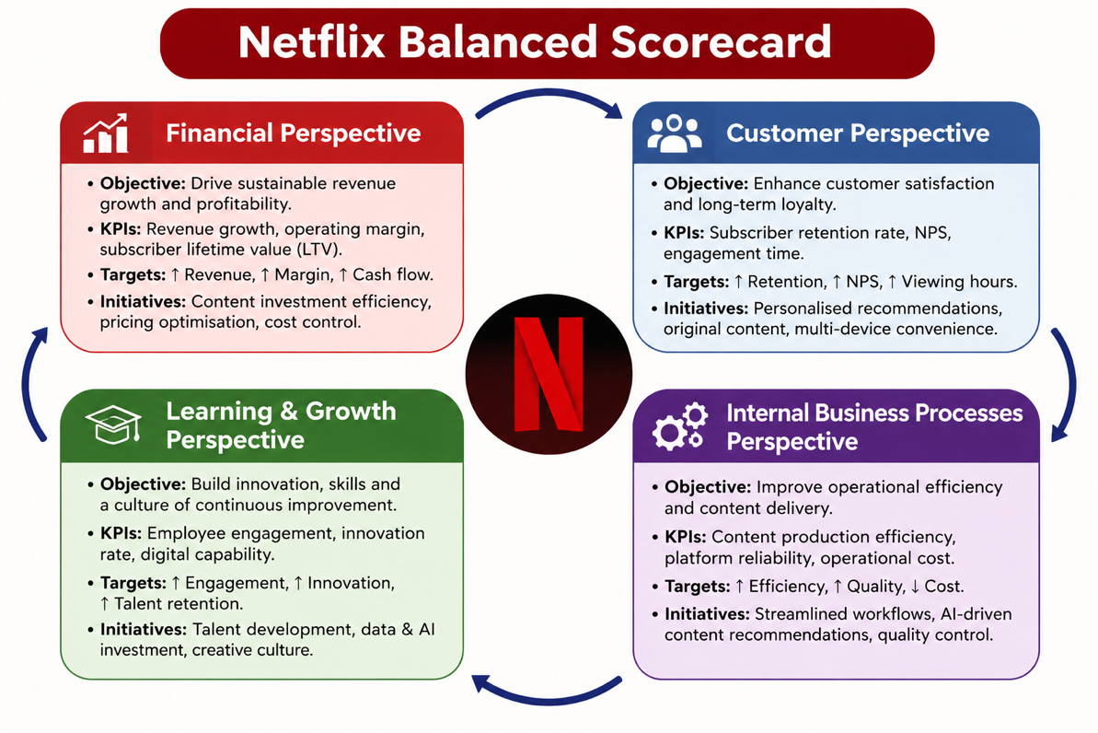
Figure 7: Netflix Balanced Scorecard Performance Framework

4. Strategic Choices and Implementation

4.1 Alternative Strategic Choices
There are three realistic strategies that Netflix can use to boost its strength in the UK. It might try to gain market share by expanding its advertising-supported plan. This is a less expensive alternative and it enables Netflix to generate both subscription and advertising revenue. The opportunity is already out there, as 40% of UK Netflix households were subscribed to the company's ads tier in Q1 2026 (7.2 million households) (Cross-Kovoor & Cross-Kovoor 2024).
Second, Netflix might trawl the meteoric product development by investing in unique British films, series and live entertainment. This development is a continuation of the current capability, as Netflix has invested in the UK since 2020, with more than $6 billion going to UK productions to date and over 100 active productions in the UK.
Third, Netflix could expand to other areas, like gaming and live entertainment. That's a possibility of lessening the reliance on traditional movies and TV shows, but it also puts Netflix at a higher risk as it would be playing outside its league. These options are represented in the Ansoff Matrix in Figure 8. Market penetration and product development are less risky strategy options than unrelated diversification, as they extend more directly into the existing UK audience and resources of Netflix (Ye 2024).
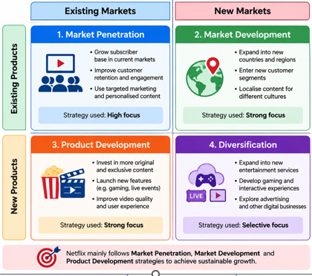
Figure 8: Netflix Ansoff Growth Strategy Matrix

4.2 Evaluation of Strategic Options
The previous analysis indicates that product development and increased advertising revenues would fit better than a major diversification. PESTEL identified digital entertainment as a strong demand while at the same time digital entertainment is becoming increasingly more affordable and more regulated. Five Forces states high rivalry, buyer power and substitutes, Netflix has to have content that is worth keeping to customers. VRIO revealed that technology is easily imitable for large competitors, but Netflix's global distribution, audience data, brand and UK production relationships are not easily imitable (Jerab & Mabrouk 2023).
A SWOT analysis came to the same conclusion. Netflix is well-positioned for UK market but the market is mature and expansion of subscribers is restricted. According to Ofcom, UK penetration of SVoD has stalled, meanwhile cost is one of the most important drivers of cancellation of Netflix. So, it's not as appealing as building the value and income of Netflix's current subscriber base.

4.3 Recommended Strategy
Netflix needs a differentiated product development strategy with a differentiated approach to monetisation via advertising in the UK. The heart of this concept should be sustained investment in unique British films and programmes with a greater degree of personalisation and an increased advertising tier.
This is a natural consequence of the foregoing analysis. Netflix already serves 18.1 million UK households (61%), so it is time to focus more on retaining, engaging and creating value for its customers rather than acquiring homes. British content offers differentiation, which price competition cannot; Netflix's worldwide distribution means that successful UK productions can generate value beyond just the UK. The advertising tier is able to address even more price sensitive consumers while providing advertising revenues. Instead, the strategy involves bringing together Netflix's strongest internal strengths with the most appealing external opportunities — and not venturing into an unrelated market with less competitive strengths (Williams 2023).

4.4 Strategic Validation
The recommended strategy can be tested using the SAFe framework that is used to evaluate suitability, acceptability and feasibility. The following is this evaluation, which is displayed in Figure 9. Suitability is high due to investment being made in differentiated UK content, with advertising monetisation being stronger, driven directly by the high levels of competition, customer switch, price sensitivity and maturity levels in the market described in the preceding analysis. The level of acceptability is moderate to high because it would allow customers to enjoy unique local content and a reduced ad price, and would help Netflix to enhance its advertising and subscription income. Increased production investment and over-advertising, however, could make profits or satisfaction less. It has high feasibility because Netflix has a high market share in the UK, production ties, data on audience, technological skills and funds. It has already invested in British production, thus creating a solid base for implementation. On the whole, Figure 9 shows that the strategy is viable, if Netflix can manage costs of content and regularly monitor customer engagement, retention, advertising effectiveness and return on content investment (Afilipoaie & al. 2021).
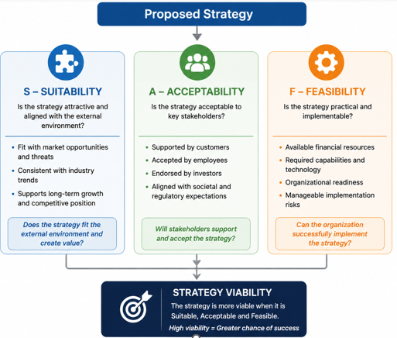
Figure 9: SAFe Strategic Evaluation Decision Framework

4.5 Competitive Advantage and Performance
The strategy might help reinforce Netflix' competitive position, with localisation, global distribution, personalisation and flexible pricing. If viewers have the option to choose between advertising-supported and premium plans, the latter would be preferable if they can enjoy unique programmes as well. The main performance measures should include customer retention, viewing engagement, ad-tier adoption, revenue per membership and return on content investment. Netflix will be particularly interested in growth in the ad tier as UK adoption has jumped from 38% in Q4 2025 to 40% in Q1 2026. Sustainable advantage would not accrue from any single element, rather through a general improvement of how these capabilities are integrated with one another and other capabilities to outperform competitors (Langford 2026).

4.6 Implementation Challenges and Mitigation
The strategy should be represented in Figure 10 from investment to implementation and measurement. Three issues are of special note. First, higher levels of spending on content would make the programmes less profitable if they are not successful. Netflix should then consider making progressive investments and tracking viewing, retention and return rates per major production. Secondly, there may be too much advertising, which may affect customer experience. Ad frequency shall be managed and tracked based on the satisfaction, engagement and churn. Third, there's also the possibility of competitors to react by increasing the UK information and pricing. Netflix should be able to tap into the UK production networks for more diverse programmes, and understand the country's customer base, to produce the same in a quicker time frame (Rao 2021).
The process of implementation should then be continuous, that is, content investment – audience response – performance measurement – strategic adjustment. This is not just a statement of intent – it's a measurable goal that Netflix can adjust to in response to changing UK viewing habits.
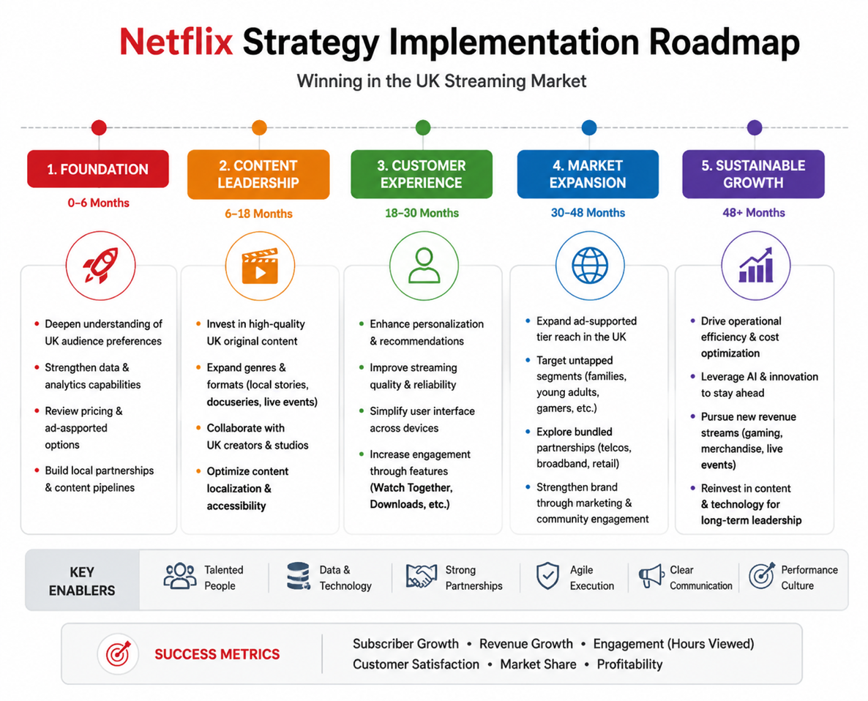
Figure 10: Netflix Strategy Implementation Roadmap Framework

Section 2 — Reflective Account

5. Reflective Account

5.1 Description
I employed Gibbs' Reflective Cycle to practice my reflection to analyze and design the strategic analysis of Netflix for the UK video streaming market. First, I had to define the market clearly as it is a global market, and the report had to be set in a specific strategic context. I then gathered data from the Netflix reports, Ofcom and academic sources. I applied PESTEL and the Porter's Five Forces to gain insight into the external pressures and VRIO to explore Netflix's internal resources. These findings are then synthesized by SWOT. CSR, Balanced Scorecard, Ansoff and Safe were all useful in helping to shift my focus from my understanding of what Netflix was doing, to what they could do in the future. These stages are shown in the reflective process in figure 11 (Nyarko 2026).
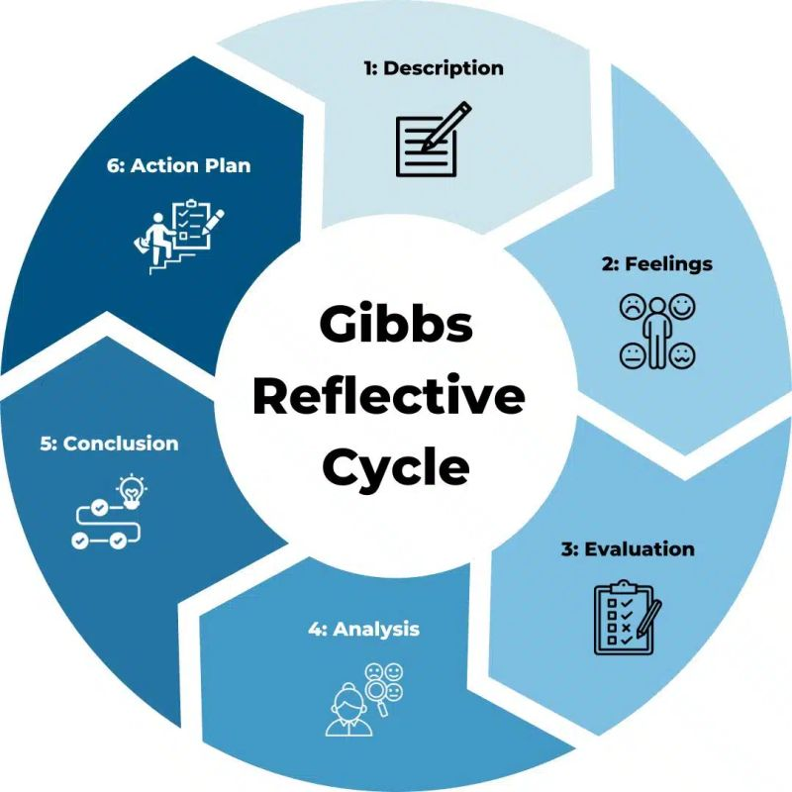
Figure 11: Gibbs Reflective Learning Cycle Framework

5.2 Feelings and Challenges
I thought it was going to be easy to find info about Netflix since it is a giant and well-known organization. The real challenge was not finding information, it was knowing which information was credible and pertinent to the UK. Some sources talked about Netflix worldwide, others about various concepts like access by households, demand by the audience, subscriptions or viewing time. I knew that I could not just consider these measures to be interchangeable. It was also difficult to be critical as Netflix's brand and market power seemed more formidable and enduring than it was.

5.3 Evaluation
There were some aspects of the process that were successful. There were some official sources that were especially helpful as they gave UK-specific insights into streaming behaviour, household access and competition, such as from Ofcom and Barb. Netflix's corporate and ESG data was helpful to understand the production investment, however, it was important to be aware of the need to critically evaluate the company information as organisations present their activities in their best possible light. The multiple frameworks also allowed me to look at Netflix a variety of ways. At first I dealt with the PESTEL, Five Forces, VRIO and SWOT separately, however. This led to repetition and the analysis was perceived as a series of models instead of a single strategic argument. Linking results to the frameworks enhanced my analysis (Abdalla & al. 2026).

5.4 Critical Analysis
The key learning was that strategic frameworks can only be of benefit if they are underpinned by judgement. PESTEL was useful for highlighting the regulatory, economic, social and technological shifts, but did not demonstrate whether Netflix possessed the means to effectively react to them. VRIO looked at internal resources to comb the same issue. Likewise, Five Forces indicated that there was much rivalry and buyer power and substitutes, while SWOT was used to tie these external threats with the Netflix strengths and weaknesses.
The analysis of Competitive Advantages underwent a shift in my thinking also. At first, I thought that the Netflix brand, technology and large customer base would be obvious sources of long-term advantages. Further comparison revealed that Amazon and Disney also have strong brands, technology, content and financial resources. In the end, I decided that the power of scale, data, personalisation, global distribution and local content powers was more significant for Netflix than the individual resource (Karim 2018).
Some contradictory evidence was also given to me that I could not overlook the importance of checking definitions and dates. For instance, market demand share is distinct from access to the market (household share) or access to the subscribers (subscriber share). I found out that it doesn't suffice to use a recent number without having it actually support the argument you're making. This helped me with my evidence selection and my strategic thinking.

5.5 Conclusion
In general, I learned that strategic analysis is not just about the use of management models. The primary skill is to link evidence, challenge their beliefs and draw an appropriate conclusion. I also gained the awareness that a well established company may have serious strategic challenges. These challenges – price sensitivity, maturity of the market, substitutes and regulation – do not disappear in the UK due to Netflix's strong position. But it shifted my focus from just talking about how successful Netflix is to asking myself the question about whether or not the benefits of Netflix are sustainable (Netflix 2023).

5.6 Action Plan
I will create a definition of the market and key measures, then gather evidence in future strategic work. Using the most recent, independent and specific information from a range of sources, and contrasting conflicting information, I will argue my own interpretations. I will also be linking the frameworks together, rather than finishing them individually. Lastly, I will make sure to have measurable criteria for recommending strategies to ensure implementation and performance can be assessed. These enhancements will enable me to provide more evidence based analysis and make better decisions in the future, both in my professional life and in my analysis (Agure & al. 2024).

Reference List
Abdalla, B.A., Abbas, Y.N., Fattah, F.H., Ghafour, A.K., Hamasaeed, A.Gh., Ezzat, S.L., Hasan, S.J., Sadullah, A.D., Hamasalih, H.M., Mohammed, K.K., Najar, K.A. & Kakamad, F.H. 2026. Qualitative research and data analysis across methodological traditions: A narrative review. Journal of Medicine, Surgery, and Public Health, 9, pp. 100240. URL: https://doi.org/10.1016/j.glmedi.2026.100240. Accessed: 8 August 2026.
Afilipoaie, A., Iordache, C. & Raats, T. 2021. The ‘Netflix Original’ and what it means for the production of European television content. Critical Studies in Television: The International Journal of Television Studies, 16, 3, pp. 304–325. URL: https://www.researchgate.net/publication/354545344_The_’Netflix_Original’_and_what_it_means_for_the_production_of_European_television_content. Accessed: 8 August 2026.
Agure, S., Miyeso, B. & Abdullahi, L. 2024. Interventions to enhance the use of evidence based decision making for quality care among nurses: A systematic review. PubMed, 8, 1, pp. 148–163. URL: https://doi.org/10.24248/eahrj.v8i1.760. Accessed: 8 August 2026.
Asadullah, A. & Faik, I. 2026. How digital platform-provided resources enable SMEs to develop organizational capabilities: An organizational learning perspective. International Journal of Information Management, 88, pp. 103041. URL: https://doi.org/10.1016/j.ijinfomgt.2026.103041.
Banka, M., Chmiel, N., Kostrzewski, M., Marczewska, M., Arkadiusz Michal Kowalski, Katarzyna Sedkiewicz & Mariusz Salwin 2024. Understanding corporate concerns. Barriers and challenges in corporate–start-up collaboration. Journal of Open Innovation Technology Market and Complexity, pp. 100388–100388. URL: https://doi.org/10.1016/j.joitmc.2024.100388. Accessed: 8 August 2026.
Beckett, M. 2024. UK online streaming statistics 2024. URL: https://www.uswitch.com/broadband/studies/online-streaming-statistics/. Accessed: 8 August 2026.
Bell, O.A., Ondracek, J., Saeed, M. & Bertsch, A. 2021. Netflix, Inc. in the time of Covid-19: A case of managing and strategizing. URL: https://www.researchgate.net/publication/354224256_Netflix_Inc_in_the_Time_of_Covid-19_A_Case_of_Managing_and_Strategizing. Accessed: 8 August 2026.
Bernardo, B.M.V., Mamede, H.S., Barroso, J.M.P. & dos Santos, V.M.P.D. 2024. Data governance & quality management—Innovation and breakthroughs across different fields. Journal of Innovation & Knowledge, 9, 4, pp. 100598. URL: https://doi.org/https://doi.org/10.1016/j.jik.2024.100598. Accessed: 8 August 2026.
Brown, L. 2023. Netflix’s stakeholders, ESG & CSR. URL: https://panmore.com/netflix-sustainability-esg-csr-stakeholders-analysis-case-study. Accessed: 8 August 2026.
Chan, K.J.D., Papyshev, G. & Yarime, M. 2024. Balancing the tradeoff between regulation and innovation for artificial intelligence: An analysis of top-down command and control and bottom-up self-regulatory approaches. Technology in Society, 79, pp. 102747. URL: https://doi.org/10.1016/j.techsoc.2024.102747. Accessed: 8 August 2026.
Cross-Kovoor, T. & Cross-Kovoor, T. 2024. Netflix’s ad tier reaches nearly ten percent of UK households, finds Barb. URL: https://videoweek.com/2024/08/15/netflixs-ad-tier-reaches-nearly-ten-percent-of-uk-households-finds-barb/. Accessed: 8 August 2026.
Cui, Y. 2024. Research on Netflix’s expansion and competitive strategies in the global markets. Highlights in Business, Economics and Management, 41, pp. 107–114. URL: https://doi.org/10.54097/4nyc7106.
Dunn, S., Nenycz-Thiel, M., Graham, C., Dawes, J., Danenberg, N., Tanusondjaja, A., Trinh, G. & McColl, B. 2025. How categories grow: The behavioural drivers of revenue growth. Journal of Business Research, 195, pp. 115385. URL: https://doi.org/10.1016/j.jbusres.2025.115385.
Feraday, S. 2022. Five sustainability challenges and how to overcome them. URL: https://www.apriori.com/blog/five-sustainability-challenges-and-how-to-overcome-them/. Accessed: 8 August 2026.
Forero-Quintero, J.-F., Villafáfila-Robles, R., Barja-Martinez, S., Munné-Collado, I., Olivella-Rosell, P. & Montesinos-Miracle, D. 2022. Profitability analysis on demand-side flexibility: A review. Renewable and Sustainable Energy Reviews, 169, pp. 112906. URL: https://doi.org/10.1016/j.rser.2022.112906.
Jerab, D.A. & Mabrouk, T. 2023. Strategic excellence: Achieving competitive advantage through differentiation strategy. Elsevier BV. URL: https://www.researchgate.net/publication/373999782_Strategic_Excellence_Achieving_Competitive_Advantage_through_Differentiation_Strategy. Accessed: 8 August 2026.
Joonas, K., Mahfouz, A.Y. & Hayes, R.A. 2023. Strategy for growth and market leadership: The Netflix case. AIMS International Journal of Management, 17, 2, pp. 87–102. URL: https://eds.p.ebscohost.com/eds/detail/detail?vid=1&sid=67270d8b-d71f-44b2-8674-2538ad48b450%40redis&bdata=JkF1dGhUeXBlPXNzbyZhdXRodHlwZT1zaGliJnNpdGU9ZWRzLWxpdmUmc2NvcGU9c2l0ZQ%3d%3d#AN=171358135&db=bsu. Accessed: 8 August 2026.
Karim, A. 2018. Netflix and the rise of global scale media (or how media learned to love its customers). URL: https://intrinsicinvesting.com/2018/07/20/netflix-and-rise-of-global-scale-media/. Accessed: 8 August 2026.
Langford, R. 2026. Netflix’s AD tier now makes uP 40% of its total UK audience. PerformanceMarketingWorld. URL: https://www.performancemarketingworld.com/article/1959046/netflixs-ad-tier-makes-40-its-total-uk-audience. Accessed: 8 August 2026.
Ma, F., Li, X. & Liu, P. 2025. Intellectual property strategy and corporate ESG performance: A quasi-natural experiment from national intellectual property demonstration cities. Alexandria Engineering Journal, 125, pp. 636–646. URL: https://doi.org/10.1016/j.aej.2025.04.070. Accessed: 8 August 2026.
Mennekes, T. & Schramm-Klein, H. 2025. Effects of crisis-induced inflation on purchasing and consumer behavior in Germany. Journal of Retailing and Consumer Services, 85, pp. 104295. URL: https://doi.org/10.1016/j.jretconser.2025.104295.
Muhammad Masao & Imam Salehudin 2023. Unveiling the dynamics of expectation, flow, enjoyment, and satisfaction: Drivers of continued subscription intentions among Netflix users. South East Asian Journal of Management, 17, 2, pp. 96–121. URL: https://doi.org/10.21002/seam.v17i2.1410.
Netflix 2025. Netflix culture — The best work of our lives. URL: https://jobs.netflix.com/culture. Accessed: 8 August 2026.
Netflix 2023. About Netflix - sustainability. URL: https://about.netflix.com/sustainability. Accessed: 8 August 2026.
Nguyen, Q.T.K. & Almodóvar, P. 2025. Foreign subsidiary performance in multinational enterprises: The role of business development capabilities and resource deployment. Journal of International Management, pp. 101251. URL: https://doi.org/10.1016/j.intman.2025.101251.
Nyarko, I.K. 2026. Strategic management in a global era: The playbook for competitive advantage in a volatile world. URL: https://doi.org/10.9734/bpi/mono/978-93-47485-94-7. Accessed: 8 August 2026.
Olekanma, O., Rodrigo, L.S., Adu, D.A. & Gahir, B. 2026. Carbon footprint reduction initiatives and green jobs creation: The mediating role of green innovation. Journal of Environmental Management, 400, pp. 128736. URL: https://doi.org/10.1016/j.jenvman.2026.128736.
Rao, P. 2021. Netflix: Leveraging big data for decision-making. URL: https://poonamrao.medium.com/netflix-leveraging-big-data-for-decision-making-e761281aa802. Accessed: 8 August 2026.
Sariani, S. 2025. The effect of balanced scorecard implementation on financial and non-financial performance. Dhana, 2, 4, pp. 30–37. URL: https://doi.org/10.62872/s8cy7a40.
Wang, Y. 2022. Netflix: How to keep a continued success. Atlantis Press. URL: https://doi.org/10.2991/aebmr.k.220603.197. Accessed: 8 August 2026.
Williams, A. 2023. Netflix SWOT Analysis & Recommendations. URL: https://panmore.com/netflix-swot-analysis-recommendations-case-study. Accessed: 8 August 2026.
Ye, W. 2024. The study of Netflix’s integrated marketing model based on SWOT theory. Advances in Economics Management and Political Sciences, 132, 1, pp. 119–124. URL: https://doi.org/10.54254/2754-1169/2024.18452. Accessed: 8 August 2026.
Zheng, R., Li, Z. & Na, S. 2022. How customer engagement in the live-streaming affects purchase intention and customer acquisition, e-tailer’s perspective. Journal of Retailing and Consumer Services, 68, pp. 103015. URL: https://doi.org/10.1016/j.jretconser.2022.103015.

