Date | Role | Event | Hours
20/10/24 | Way finding | Abba tribute | 4
12/11/24 | Scanning | Jane McDonald | 4
31/01/25 | VIP lounge | Neck Deep | 6
06/02/25 | VIP lounge |  | 8
07/02/25 | VIP lounge | Paul Smith: Pablo | 6
08/02/25 | Scanning | Paul Smith: Pablo | 4
10/02/25 | Set up | ITT Future You | 6
11/02/25 | Mocktail making | ITT Future You | 5
14/02/25 | VIP lounge | Paddy McGuinness | 6
15/02/25 | Side stage/set up | House Party | 8
24/02/25 | Deliver to seat | The Repair Shop Live | 4
25/02/25 | VIP lounge | Queen Extravaganza | 6
R01/03/25 | VIP lounge | Bowling for Soup | 6
03/03/25 | VIP lounge | James Martin | 6
05/03/25 | Set up | 4 The Region | 5
06/03/25 | Way finding and social media | 4 The Region | 7
07/03/25 | Deliver to seat | Dr Rangan Chatterjee | 5
09/03/25 | VIP lounge | Darkness | 6
14/03/25 | VIP lounge | Alison Moyet | 6
05/04/25 | VIP lounge | Ocean Colour Scene | 5
11/04/25 | VIP lounge | M1ke and the Machen1c5 | 5
19/04/25 | VIP lounge | Anastacia | 7
22/04/25 | Bar | Bingo Lingo | 6
TOTAL | - | - | 131
Charlotte Palmer 2404336
Event and festival Experience (BMTP4016)
Jacqui Jones

Part 2 Placement Experience Review:

Part B:

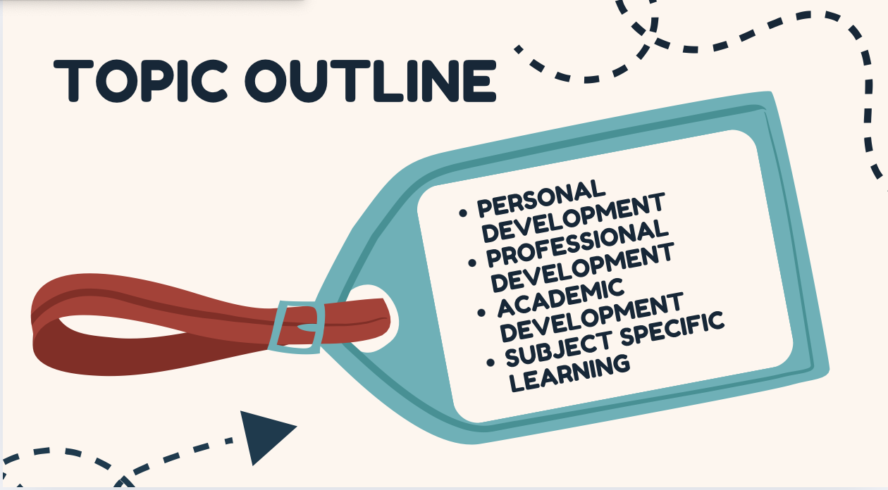

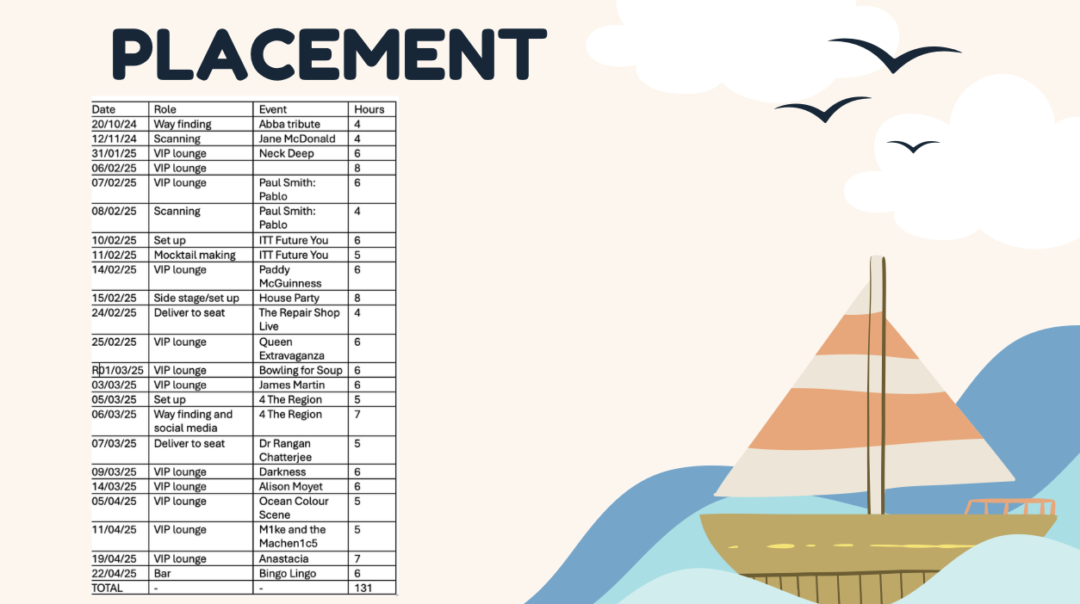
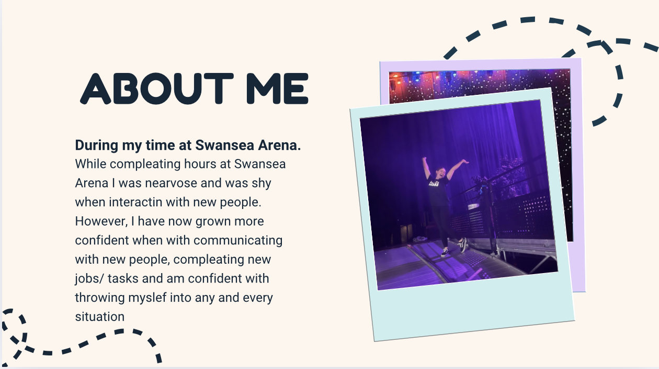

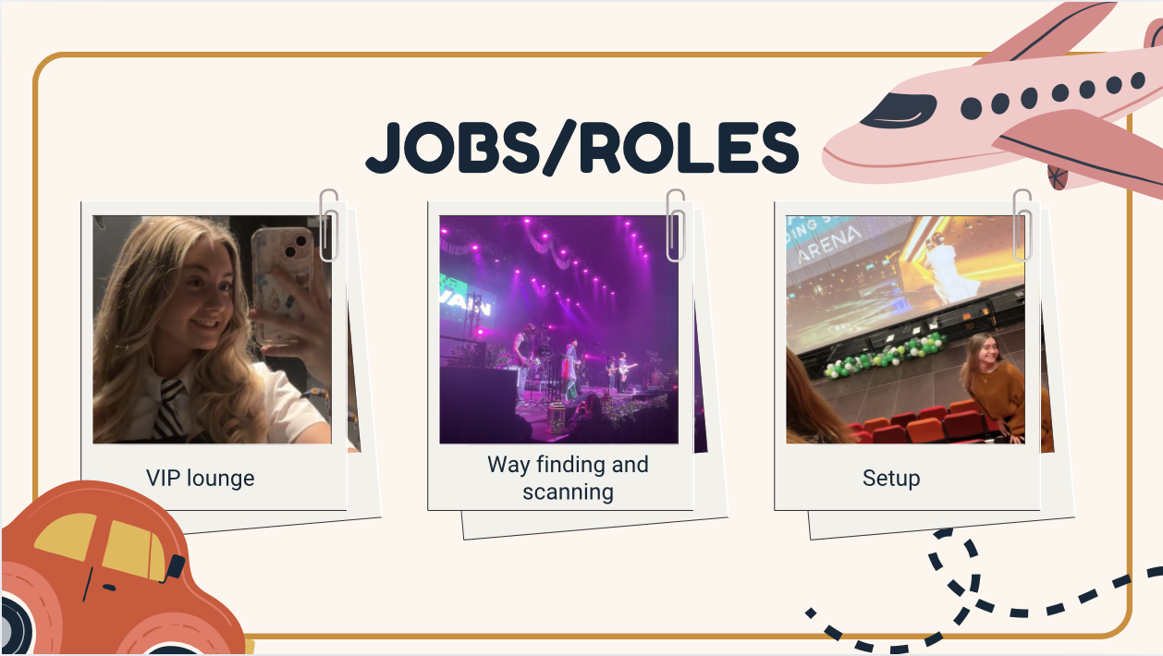
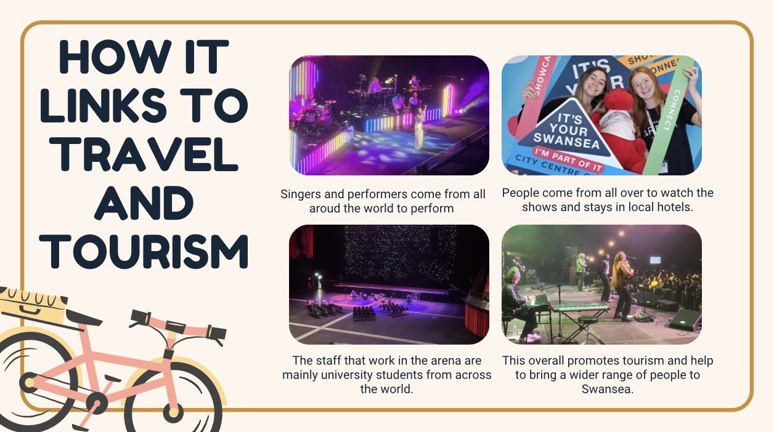
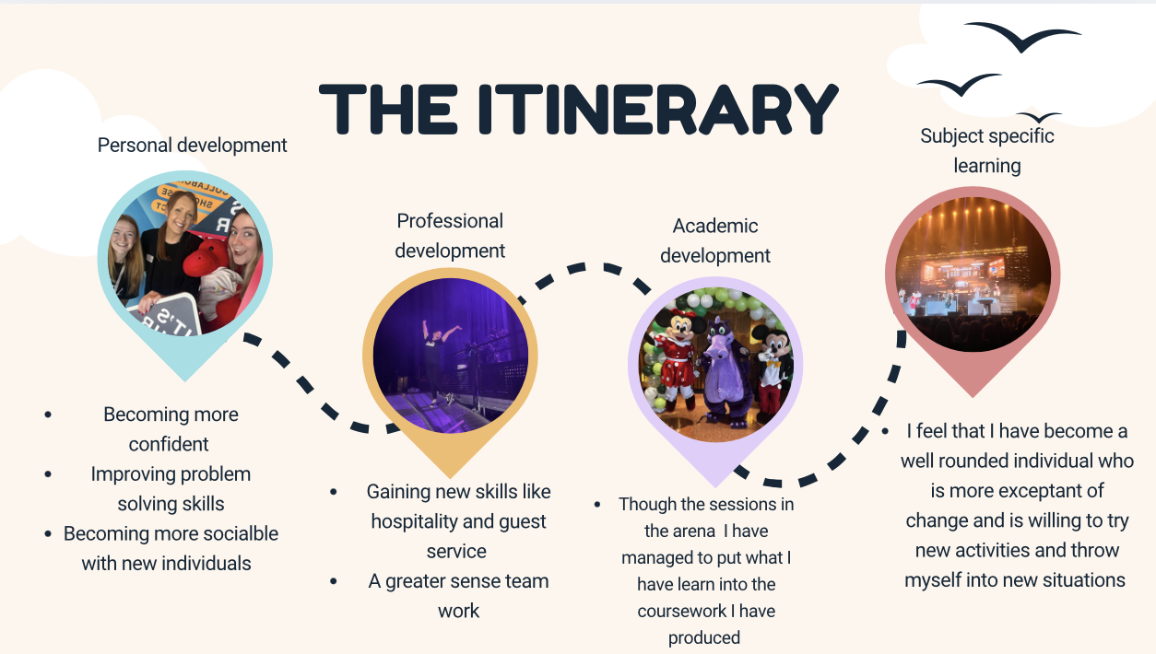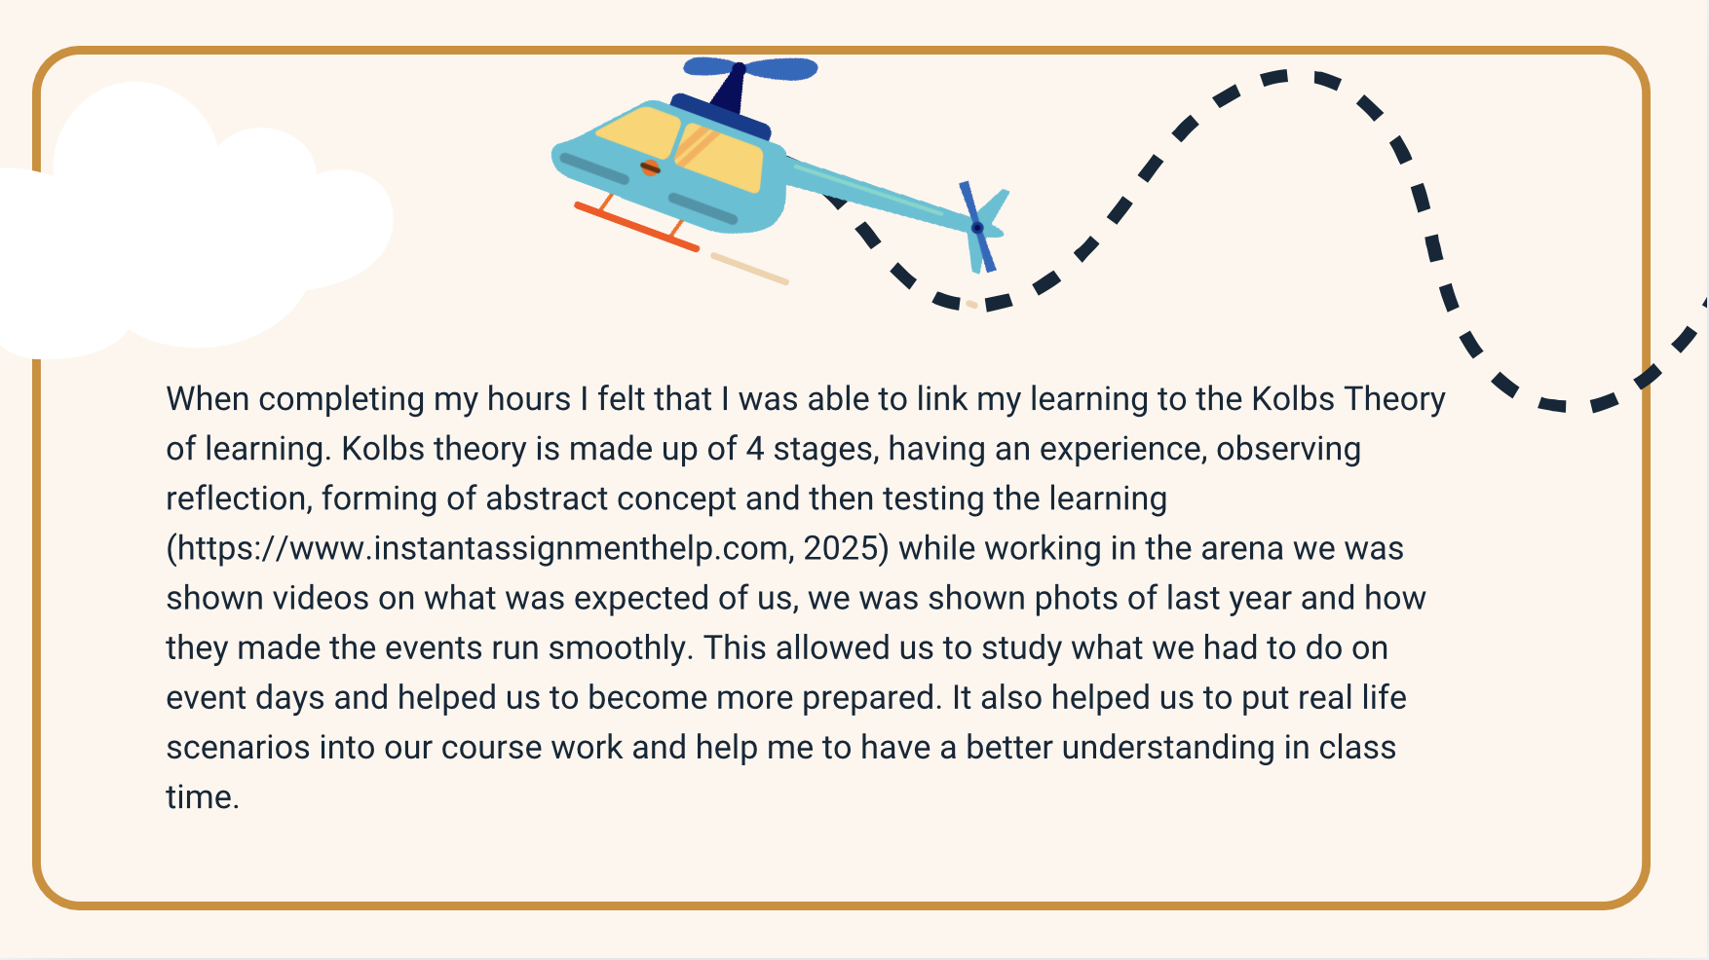

Part C – Placement Review (500 words)
I fulfilled my 100 hours of placement in Swansea building society arena where I took part in a various of different roles in different areas each having their own skill set that I had to adapt to. This consisted of working in the VIP lounge, way finding, working in the bar and working in deliver to seat. When on arrival I would get there 15 minutes earlier and would enter by stage door, I would sign in and go upstairs to hear briefing. In this we would hear more about each show, what time each interval is, if there is any planned fire evacuations, how many people are attending. The duty manager will tell us where each of us will be located where things have to be a de-canned. This way we will get to know more about how to keep our selves and others safe. After this we will then go to where we have to be located this will be different for each role. For scanning we had to go to box office to get the scanners and the standby the doors and wait for the duty manager to confirmed we are ready to open. I enjoyed learning all the different roles in the arena and seeing different people perform on stage. Through learning the different roles, it allowed me to gain lots of new skill such as team working, problem-solving and helped to gain my communication skills. When I first started my placement hours, I was shy and was scared to throw myself into new jobs. I was worried about meeting the new staff, and talking to customers however, after talking to the managers they gave me new ways of overcoming this. They also provided me with ways I could talk to customers to help me overcome this and after a few sessions I was confident with the staff, management, and customer. This meant that I was able to spend more time is places I felt that I needed to grow more such as bar and VIP. This was a challenge for me as I felt that I was in direct contact with customers and this meant that I had to speak with them and put what I learnt into practice. After completing my 100 hours I found a love for customer service and found I thrive in group settings. This allowed me to apply for a job working at the arena, I am now working in the VIP lounge and occasionally working in deliver to seat. This has allowed me to put what I have learnt into my university work, especially in group presentations and presenting work. I feel that since completing my 100 placement hours I grown as an individuals and is more outgoing and feel more confident apply for new jobs with similar characteristics.

https://www.instantassignmenthelp.com (2025). Kolb Reflective Cycle: an Insight into the Model of Reflection. [online] www.instantassignmenthelp.com. Available at: https://www.instantassignmenthelp.com/blog/kolb-reflective-cycle [Accessed 18 May 2025].

