

Student Name: Sara Panicocolo
Student ID: 2322396
Module name: Independent Project
Module code: BMHP6020
Supervisor’s name: Jolly Nwankwo

 |  | The Effectiveness of Early Intervention Programs for Children with Autism Spectrum Disorder  Aim: This study aims to evaluate the effectiveness of early intervention programs for children with autism spectrum disorder  Objective:  -To examine the impact of early intervention on communication development in children with ASD.  -To assess the effect of early intervention on social interaction and behavioral outcomes.  -To explore the implications of early intervention programs for health and social care practice.  ) Aim: The aim of this study |  | 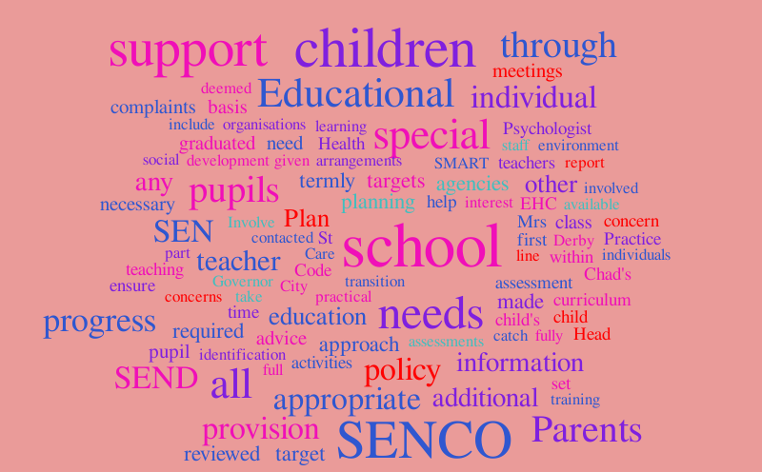
Proposed Methodology  This project will adopt a literature review methodology using secondary research. Relevant academic literature will be collected from peer-reviewed journals, government publications, and professional reports. The project will search electronic databases, including PubMed, CINAHL, Google Scholar, and ScienceDirect, to identify relevant studies.  The search strategy will focus on literature published between 2020 and 2026 to ensure the inclusion of current evidence. Key search terms will include “autism spectrum disorder”, “ASD”, “early intervention”, “communication development”, “social skills”, and “child development”. Inclusion criteria will include English-language studies of children diagnosed with ASD that evaluate the outcomes of early intervention programs. The selected studies will be critically analysed to identify common findings, strengths, limitations, and implications for practice. This approach will provide a comprehensive understanding of the effectiveness of early intervention programmes and their contribution to child development. |  |  |  | Data Analysis  Data were analysed using a thematic synthesis approach. Relevant information was extracted from each included study, including author details, study design, sample characteristics, type of intervention, and reported outcomes.  Findings were then grouped into key thematic categories aligned with the research objectives: communication outcomes, social interaction outcomes, and behavioral outcomes. This approach allowed for comparison across heterogeneous studies and supported the identification of patterns, consistencies, and gaps in the evidence base.  To ensure rigor, included studies were critically appraised using CASP (Critical Appraisal Skills Programme) tools for qualitative and observational studies, and AMSTAR 2 for systematic reviews. This helped assess methodological quality and reduce the influence of bias on the final synthesis.  Ethical Considerations  This study is based entirely on secondary data and therefore does not involve direct participation from human or animal subjects. As such, formal ethical approval was not required.  However, ethical research principles were still applied. All sources used were publicly available academic or policy documents, and all findings were appropriately cited to avoid plagiarism and ensure academic integrity. Care was also taken to present Autism Spectrum Disorder in a respectful and non-stigmatising manner, consistent with neurodiversity-affirming perspectives.  Confidentiality concerns were not applicable due to the use of published literature only.

Data Collection
Data were collected through a systematic search of relevant academic and professional literature. Secondary data sources were used, including peer-reviewed journal articles, systematic reviews, and official policy documents.
Electronic databases searched included PubMed, Scopus, PsycINFO, Google Scholar, NHS Evidence, and the Cochrane Library. The search strategy used a combination of keywords and Boolean operators such as “Autism Spectrum Disorder AND early intervention”, “ASD AND Speech and Language Therapy”, “ABA and autism children”, and “occupational therapy AND ASD”.
To ensure relevance to current practice, the search was limited to studies published between 2020 and 2026. Inclusion criteria focused on English-language studies involving children aged 0–10 years diagnosed with ASD and evaluating early intervention outcomes related to communication, social interaction, or behaviour. Studies focusing on adults, non-peer-reviewed sources, or publications prior to 2020 were excluded.

References
Gómez-Cotilla, R., López-de-Uralde-Selva, M.A. and Valero-Aguayo, L. (2024) Efficacy of Early Intervention Programmes: Systematic Review and Meta-analysis. Revista de Psicología, 30(1), pp.1–10.
National Institute for Health and Care Excellence (NICE) (2021) Autism Spectrum Disorder in Under 19s: Support and Management (CG170). London: NICE.

Pires, J.F., Grattão, C.C. and Gomes, R.M.R. (2024) ‘The challenges for early intervention and its effects on the prognosis of Autism Spectrum Disorder: a systematic review’, Dementia & Neuropsychologia, 18, e20230034.
World Health Organization (2025) Autism. Available at: https://www.who.int/news-room/fact-sheets/detail/autism-spectrum-disorders

