University of Wales Trinity Saint David



Student Name: Rumen Pavlov

Student Number:1902012

Module: International Marketing

Module Code: LCMB7006

Programme: MBA Marketing

Assignment: 1

Lecture: Tushara Balendran



Table of contents:

Introduction
Background
Porters 5 Forces model
SWOT Analysis
Relate Segmentation, Targeting and Positioning to the company.
Perception map
Marketing mix elements (7Ps)
Comparing two countries
Place Market entry
What facts influence the market entry methods
Directional development (definition)
Ansoff Matrix (2 countries) Hofstede
Recommendations
Tows matrix
Conclusion

Introduction

This report will cover the marketing of NYS Collections, the background, the macro environment,
porters 5 Forces model, SWOT Analysis, Relate Segmentation, Targeting and Positioning to the
company.
Perception map, Marketing mix elements (7Ps), Comparing two countries, Place Market entry.
What facts influence the market entry methods, directional development, Ansoff Matrix (2 countries)
Hofstede, Recommendations, Tows matrix and Conclusion.



Background

Sal Babbino and Marc Behar founded the American sunglasses and eyewear company NYS Collection in 1996.
The business began in the retail space of the World Trade Center in New York.
Today, NYS collection sunglasses are offered through franchised trucks, branded mall kiosks and a network of other retail partners.
The New York Times has given permission to sell eyewear under the NYS Collection brand.

Porters 5 Forces model

The Porter's Five factors model helps to identify the sector's strengths and weaknesses by identifying and analysing the five competitive factors that each industry is shaped by. Industry structure is frequently identified, and company strategy is usually decided using a five forces analysis.

Any sector of the economy can use Porter's model to analyse the level of industry competition and boost a firm's long-term profitability. Michael E. Porter, a professor at his Harvard Business School, is remembered by the name of the Five Forces Model. The five abilities of Porter are:

- Industrial competitiveness is one factor.
- The potential for new players to enter the market.
- Provider power
- Customer clout
- Threat of replacements.
Source: Porter's 5 Forces Explained and How to Use the Model (investopedia.com)



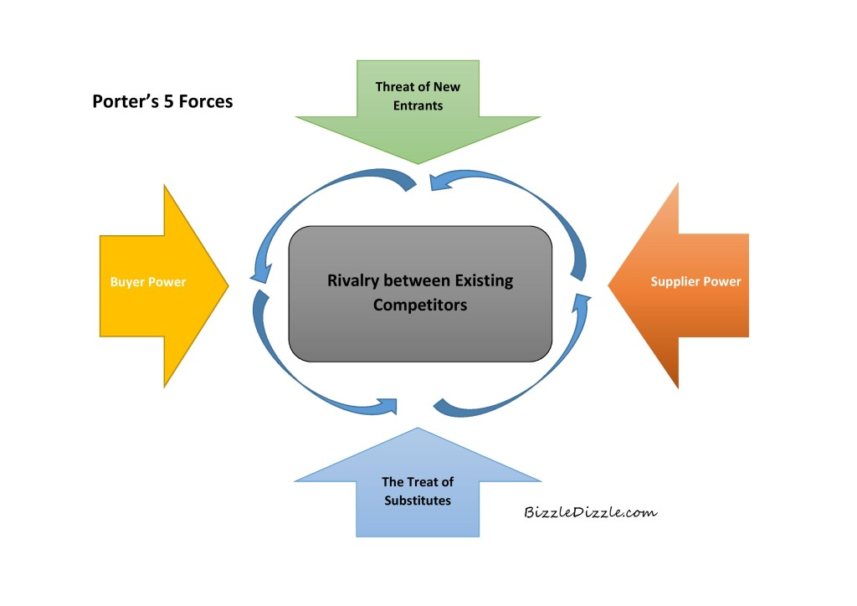
We are all different because everyone is different. The degree of control one individual has over others is one of the most obvious features of inequality. The degree to which a person can affect the ideas and behaviours of others is referred to as their level of power.

This component tackles the issue of social inequality and reflects cultural perspectives on our society's system of power dynamics. As measured by how much members who lack authority anticipate and accept the unequal distribution of power. It has to do with the reality that followers and leaders alike tolerate inequity in society.
The degree of interconnectedness a society maintains among its members is the key topic addressed in this dimension. It has to do with whether or not 'I' or 'us' define people's self-image. People are supposed to simply think about themselves and their immediate family in individualistic societies. People live in "groups" that look out for them in return for their undying allegiance in a collectivist society.


Individualistic Cultures (91) is reflected below.
"Liberty and justice for all" is America's guiding principle. The blatant focus on equal rights in every sphere of American culture and government serves as strong evidence of this. In American organisations, hierarchies are set up for convenience, managers rely on their own and their teams' knowledge, and supervisors are readily available. Employees and management anticipate regular communication and information exchange. Communication is also casual, direct, and partially participative. People are simply supposed to care for themselves and their immediate family and not (overly) rely on the help of the authorities in society, which is a loose society. Additionally, there is a lot of geographic liquidity in the US. The world's top carpenters are Americans. Deep friendships may be hard to form, though, especially for guys. Americans are used to conducting business with and dealing with strangers. Because of this, Americans are not hesitant to inquire about or seek for information from possible partners. Employees are expected to be independent and exhibit initiative in the corporate sector. Additionally, we discover that hiring, promotion, and other decisions in the world of exchange-based work are based on merit or proof of what the applicant has accomplished or can accomplish.
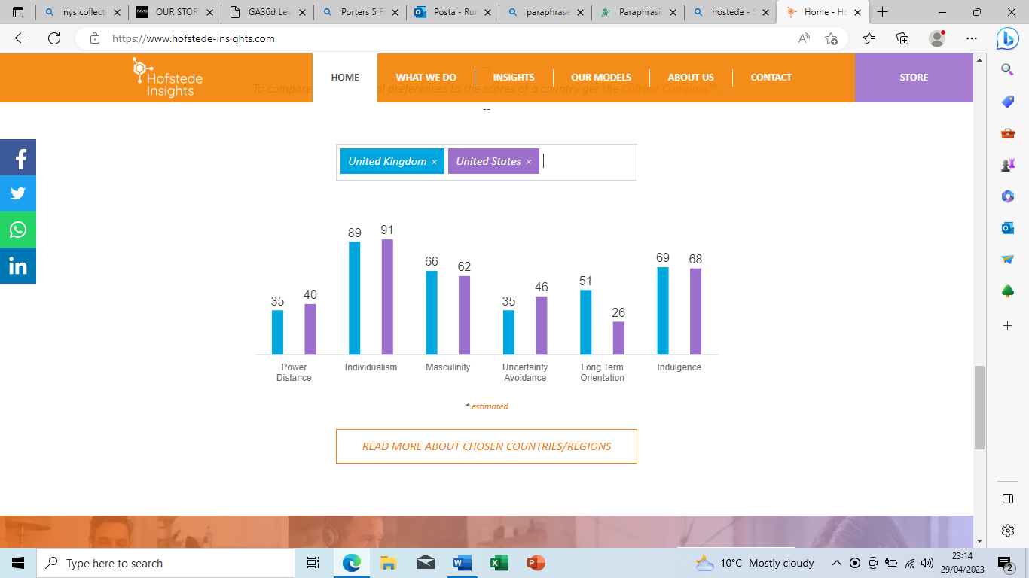



Source: (Country Comparison - Hofstede Insights (hofstede-insights.com))

The UK is 35 and ranks lower in the PDI. H. A society that believes that inequalities between people should be minimized. Interestingly, research shows that the PD index of the British upper class is lower than that of the working class. The PDI score initially appears to contradict the established historical British class system and reveals one of the tensions inherent in British culture. Between deep-rooted beliefs about where birth boundaries should not be placed. How far can you travel in life. A sense of fair play drives the belief that people should be treated equally in some way.
Exploring American culture through the lens of the 6-D Model© gives us a better understanding of the profound dynamics of American culture compared to other cultures in the world. When providing this information, keep in mind that culture represents central trends in society. Everyone is unique, but social controls ensure that most people don't deviate too far from the norm. In addition, there are regional cultural differences within each country, including within the United States. However, Americans do not have to go to a cultural fair before successfully moving to another state.



SWOT

A SWOT analysis provides information that helps match an organization's resources and capabilities to the competitive environment in which it operates. Strengths and weaknesses are usually organizational factors, whereas opportunities and threats are.
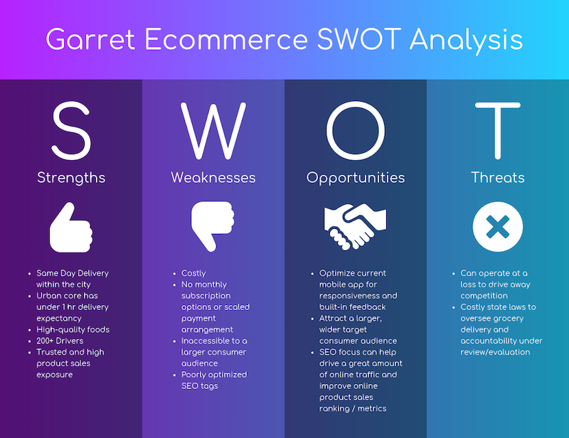
Sourc


Sourcee: ( SWOT Analysis: What Is it, How To Use it (with Examples) [2023] • Asana)
Countries | Strengths | Weaknesses
UK | In the UK, kiosks are only available in two locations: Westfield London and Westfield Stratford. | It's time for the company to become famous. The pros are the price, there is also a lifetime warranty on the product, and the prices are affordable for everyone, but the cons are that the company is not well known in the UK.
USA | Kiosks and shop in USA. | Competitors are larger in state size.  The company is already a US brand. In UK is for the moment only kiosks

Countries | Opportunity | Threats
UK | In the UK, franchise owners could open stores like they do in the USA | New competitors.
USA | Open more shops and kiosk | Competitors are larger in state size.



Segmentation, targeting, positioning (STP) marketing model.
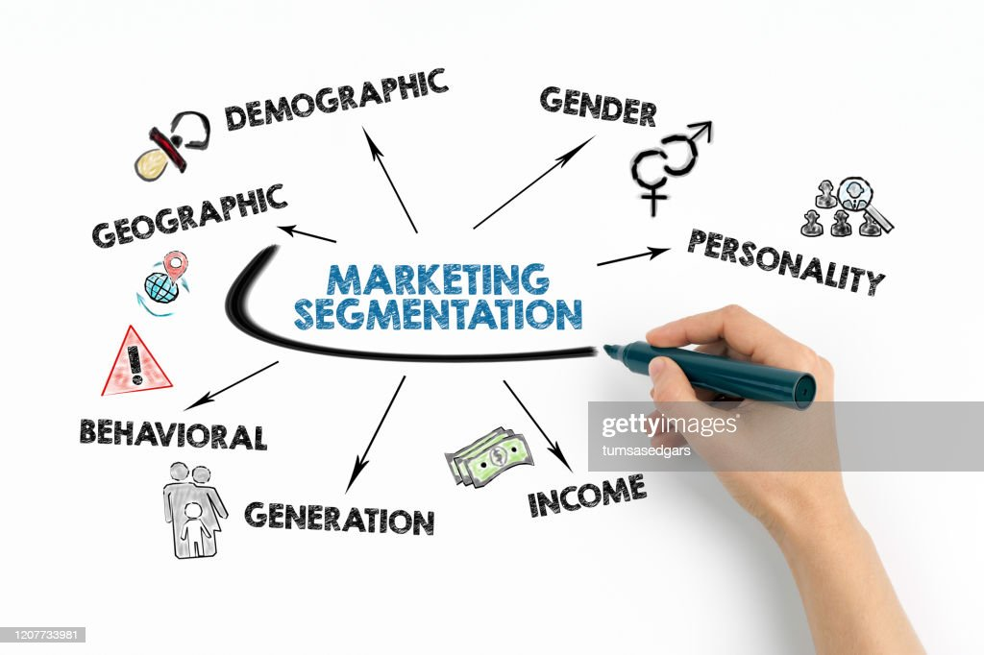

Source: market segmentation - Bing images
The STP marketing model helps you analyze your product offering and how to communicate its benefits and value to specific groups.
STP stands for:
Segment your market.
Talk to your best customers.
Place your offer.
This model is useful because it helps you identify your most valuable customer types and develop products and marketing messages tailored to them. This allows you to engage more effectively with each audience, personalize your message, and ultimately drive more sales.
There are many ways to segment your target market.
Demographics – based on personal characteristics such as age, marital status, gender, ethnicity, sexuality, education and occupation.
Geographic - By Country, Region, State, City, Neighbourhood.
Psychographic - by personality, risk aversion, values, or lifestyle.
Behaviour – how people use your product, how loyal they are, or what benefits they seek.
Source: The Segmentation, Targeting and Positioning (STP) Marketing Model - What Is the STP Process in Marketing? (mindtools.com)

Following the meaning of the STP for NYS Collection comparing them product like United Kingdom and United State of America.
In United State of America the revenue is 36.3M, in United Kingdom the revenue is 100K per one year, in America NYS is basing on the fat they have more than 100 workers and more than 10.000 shops and only 8 kiosk, in United Kingdom NYS Collection have only two kiosks in a very traffic place of people like Westfield London and Westfield Stratford, with only 8 people. In UK the company is basing themselves on the good selection of the people and training them on everything regarding the products and services. The USA is basing on the fat they have plenty of shops as o the size of the country. NYS Collection in America is already a brand in UK and Europe is developing and opening new kiosks. The competitors in UK were Caroline Luke but is no longer as they move them business out of UK. In United States and United Kingdom, the competitors are less as the company is basing on the NICHE market.
The inflation helped the business as with it the company has been able to increase the price of the product, in both countries are sold regular, polarized and elite sunglasses. The segmentation of this business in America is every area of the states to have a shop like the busiest towns, this helps the customers to not travel to much. In United Kingdom is only in two places in London as the owner of the franchise A.Oren strategically focusing on the most visited town London. The products doesn’t have any limitations of the age, sexual orientation, religion, and culture.
UK and USA Segmentation:
UK is basing on all age of customers, USA basing them on different products.
Targeting in UK and USA- UK is targeting people between 18-65, USA any because they have more products, in UK are limited.
Positioning-
UK is NICHE market in USA is a brand, UK doesn’t have competitors, USA compare with the big brands of sunglasses.
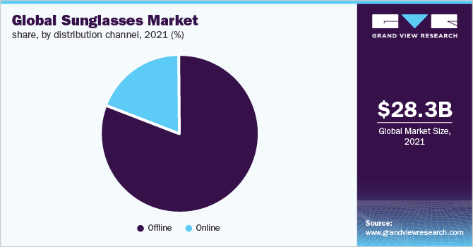
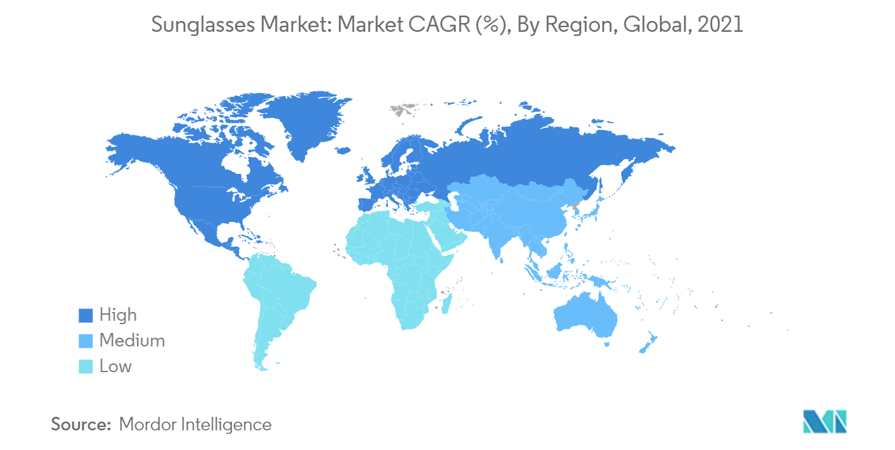

Source: (Sunglasses Market Size & Share Analysis - Industry Research Report - Growth Trends (mordorintelligence.com)

The marketing mix elements (7Ps)

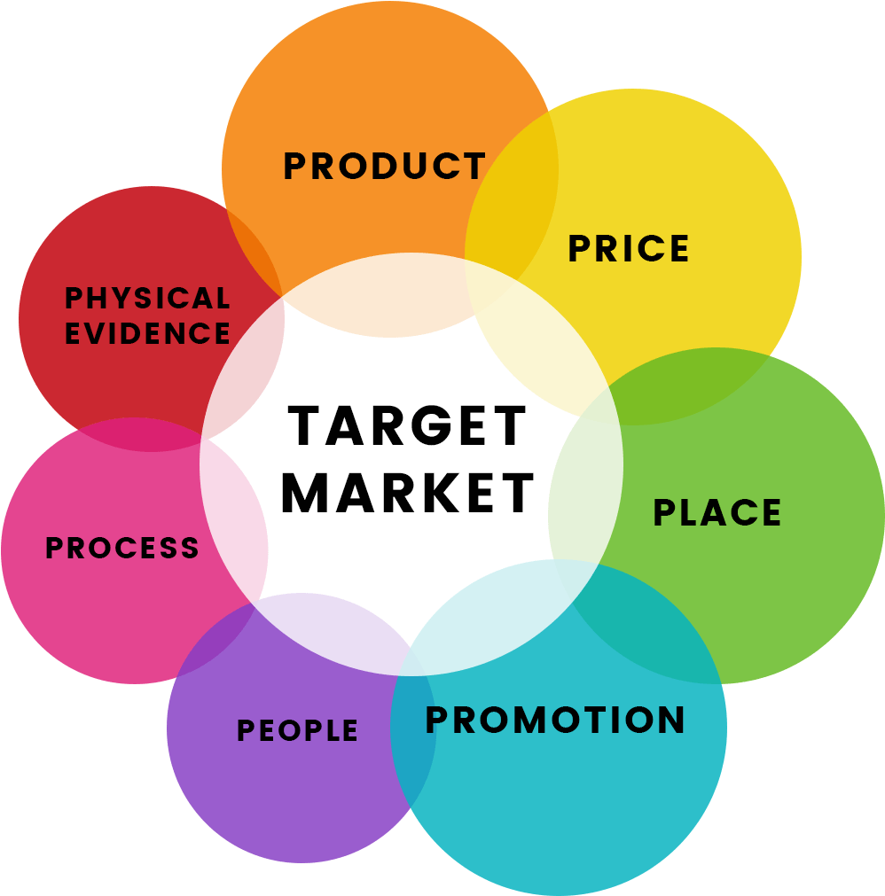

Source: (The marketing mix - Bing images)

ANALYSIS OF MARKETING MIX
By “Sadnan Bin Sattar's (2023) "7 Ps of Marketing Mix with Example"
The term "marketing mix" is well-known and used frequently in the marketing industry. The goal of the marketing mix is to draw in the target audience by placing the ideal mixture of products in the ideal environment at the ideal time and at the ideal cost. 4 Ps & 7 Ps is the name of the marketing mix. Since E. Jerome McCarthy first introduced the 4 Ps in 1960, they have been linked to the marketing mix idea. But Booms & Bitner later expanded on the 4 Ps Principle by adding three new Ps in 1981. The service provider sector was immediately impacted by these 3Ps. The 7 Ps of the marketing mix became popular after that.

Product
A product may be physical or abstract. If the product quality is good in either situation, it can gain market share. On the other side, a subpar product will not last or provide service in the fiercely competitive market. Before creating or distributing products, market research is essential. Producers need to confirm that there is a sizable target market. In order to improve their products, successful businesses continually seek for the needs and desires of their customers. The first "P" now covers services as well, however when the Marketing Mix was initially introduced. - By W. Kenton (2019).
Place
Place "Being in the right place at the right time" is a phrase we are all familiar with. It implies that location is crucial to marketing. A business ought to be where its clients want it to be. Place plays a crucial role in the marketing mix for both biological and service items. Businesses should examine the areas where customers may conveniently meet their demands. Sometimes a shift in location might cause a sharp rise in sales. Entrepreneurs must make the finest decision regarding the location so that customers can easily get their crucial service or product. By M. Acutt (2019)

The entry method of the company is franchise, the advantages and disadvantages, definition of franchise.

The company's entrance strategy in the United Kingdom is Franchising and licensing have several characteristics in that a franchisee is granted ownership of intellectual property rights. Nevertheless, the requirements for how the franchisee conducts business are frequently quite stringent; for instance, specific procedures must be followed or specific components must be used in manufacturing.
The franchisee is the person who pays the franchisor (the owner of the brand) for permission to use the name. In addition to ongoing franchise fees for marketing, royalties, and other costs, the franchisee pays an upfront franchise fee to the franchisor in exchange for permission to use the latter's trademark.
One tempting option for a business structure may be a franchise. It has a number of advantages, making it a well-liked substitute for those looking to start a new business without taking on the risks of going it alone.
Operating under the name of an established company is a benefit of a franchise. Each franchisee takes up the mantle with the ideas, the brand, the operating methods, and much more already proven and tested and ready to be applied repeatedly at a new location.

By operating under a franchise, a franchisee can benefit from the company's already well-known brand. As a result, there will (in principle) be far less effort (and expense) put into attempting to construct and strengthen the company's brand. Since the market will already be aware of and trust it, a steady flow of brand-loyal customers should result. Adopting a franchise entail enjoying the advantages of a registered trademark as well as the franchise's trademark.
There are drawbacks to opening a franchise, just like with other company strategy. People frequently hold the false assumption that the benefits outweigh the drawbacks, but this is because they are frequently deceived by the possible dangers of launching a brand-new company from scratch. The procedures for forming a limited company under which the franchise operates are the same as those you would follow to launch your own company.
The franchisee has very little (if any) control over the operation of the firm, which is the franchise's first and biggest drawback. The franchise agreement contains the already defined corporate regulations. It is quite uncommon for a new franchisee to be able to operate outside of these restrictions, which are outlined by the franchise brand.
If you were running a business, you probably wanted to minimize expenses. Choosing the cheapest suppliers will help you cut costs and increase profits. However, using the franchise supply network is a requirement of belonging to a franchise. You will be forced to work with the suppliers that the franchise agreement mandates. The obvious drawback for a franchisee in this situation is not only a loss of control but also a decrease in prospective income.
Another significant drawback of a franchise is the possibility that someone else could harm your company's reputation. As a franchisee, you would rely on the company's reputation to attract clients. Your business would be negatively impacted if other franchisees did something to harm the brand's reputation. This can adversely affect your sales and total revenues.
The prices are a significant drawback for most franchises. Frequently, a franchisee will be required to make an initial investment to enter into the franchise agreement. They will subsequently be paying ongoing fees for the assistance and instruction given by the franchisor as part of the ongoing franchise agreement. This ultimately limits how much money you can earn as a franchisee in terms of profits (and money in your pocket). There will typically be fewer limits on how you can run your firm and larger potential profit margins without the overheads if you complete a company formation to start your own limited company.
A business sale might be difficult. Selling a franchise firm may include extra risks because any prospective buyer is subject to the conditions that were agreed upon by the franchisor at the time

the franchise was given. Even if the firm has been successful, the terms of the franchise will have to be renegotiated when it is renewed, and any potential buyer may be discouraged by the uncertainty of the terms the franchisor may want to add on renewal. The initial franchise agreement was usually signed for a specific duration.
Before launching your new business, it is important to weigh the benefits and drawbacks of a franchise, just like with other legal business structures. Security is undoubtedly the biggest benefit, but the costs and diminished profit and control may turn some individuals off. Many people would undoubtedly opt to launch their own company over signing a franchise agreement. This is not to argue that considering opening a franchise is not worthwhile. By: Richard Jobling (2023)

Promotion
Promotion Another important P is promotion, which requires care. It's an art form. Promotion includes a variety of activities like advertising, public relations, special deals, and discounts. The goal of effective promotion is to convey the advantages of the goods and services. Websites can occasionally serve as promotional tools as well. Customers who are using a company for the first time typically evaluate it by visiting its website. Websites need to be more user-friendly and well-organized. Sales, advertising, sales promotion, PR, direct marketing, web communications, and personal selling are a few examples. By M. Acutt (2019)

People
The most crucial component of a service marketing mix is people. From the Managing Director to the front-line sales employees, every business depends on its management team. Customers, staff, operations, and knowledgeable employees all bring benefits and values to the service or product. For

instance, in an IT company, software developers are referred to as people; in a restaurant, chefs and waitstaff are referred to as people. By M. Acutt (2019)
Process
A service or product is provided to the final client through a process, which is like a system and strategies. Once more, the consumer is paying in part because the service is provided. It is more about the consumer-business interface and how the two interact with one another at various phases, or throughout the process. Speed is one of the elements of a successful purchase process. When it comes to the delivery of online-ordered goods, this speed idea is relevant. The consumer should come first when designing business processes, not your convenience. For instance, conversion is now being handled more by sales employees. By M. Acutt (2019)

Physical Proof
Physical proof is the tangible component of a product or service. The experience of the customer is equally important. When customers first interact with a company, they are unfamiliar. In this situation, the business must offer the clients tangible proof that will boost their confidence. Physical evidence can take various forms, including objects like structures, machinery, signs, and logos as well as documents like business reports, brochures, websites, and even business card. By M. Acutt (2019)

It is evident from the discussion of the marketing mix examples above that correct adherence to the 7 Ps of marketing mix is necessary for corporate success. Many business plans failed because they were not properly implemented according to the 7Ps. Each of these components must be correct for businesses or service providers. It is obvious that by adhering to these 7Ps, businesses would achieve their highest levels of success in terms of their products or services, maximize their earnings, increase customer satisfaction, sustain their products for a long time, and enhance their corporate image. By M. Acutt (2019).

Directional development strategy:

A directed strategy aids the organization in defining its core values and goals at their most fundamental level. Operationally, directed strategies concentrate corporate efforts and resources toward implementing growth, stabilization, or cuts depending on the organization's current needs and long-term objectives. By Shari Parsons Miller (2023)
The most basic kind of directional strategy are a company's mission and vision. Your company's mission statement outlines its goals and establishes the general tone for your strategic course. For instance, a community hospital in a low-income neighbourhood may operate as a non-profit to give widespread access to medical care, while a private medical practice may exist to provide speciality health services for profit. These two types of organizations have different purposes, which influence their strategic approaches. A vision statement defines the outcomes you expect to attain as you carry out your mission and aids in directing your strategy toward achieving corporate objectives. By Shari Parsons Miller (2023)
Growth When you want to go beyond present successes related to your product, performance, profit, or other company measure, you utilize a directional strategy focused on growth. For company expansion, healthcare firms using a growth strategy may simply step-up current operations through increased investment or efficiency. Other strategies include expanding your services into new markets, such as consumer health publishing or nutritional supplements, and taking on extra tasks that were previously handled by an outside source, such pharmacy services or maintaining medical equipment. By Shari Parsons Miller (2023)

Stability Stability-oriented direction seeks to preserve the status quo in your company's operations and results. The low-risk, moderate-reward technique doesn't call for any changes to your current procedures. It is particularly suitable for businesses that operate in dependable markets and generate steady returns on investment, like a reputable pathology lab or medical imaging center. The technique may also be helpful for companies looking for a temporary way to slow expansion or ride out a market shift. By Shari Parsons Miller (2023)

What is the BCG Matrix, and how does it work?
The Boston Consulting Group Matrix, often known as the product portfolio matrix, is a business planning tool used to evaluate the strategic position of a company's brand portfolio. The BCG Matrix is one of the methods for portfolio analysis that is most often utilized. It classifies the products and/or services of a corporation using a two-by-two matrix. Each quadrant is classified as poor or good performance depending on the proportional market share and market growth rate. 2023 by CFI Team
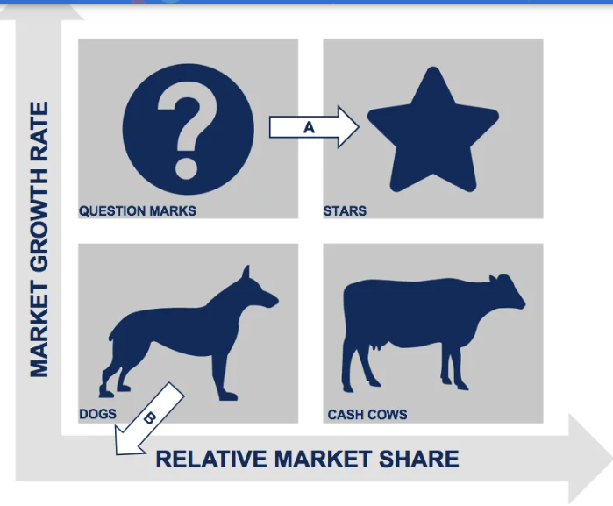

Source: BCG Matrix - Overview, Four Quadrants and Diagram (corporatefinanceinstitute.com)

The size of a product's market share and its dominance in a specific market are shown on the BCG Matrix's horizontal axis. It gauges a company's competitiveness using relative market share. The BCG Matrix's vertical axis shows a product's growth rate and its potential for expansion in a specific market.
In addition, there are four quadrants in the BCG Matrix:
Question marks: Products with high market growth but a low market share.
Stars: Products with high market growth and a high market share.
Dogs: Products with low market growth and a low market share.
Cash cows: Products with low market growth but a high market share.
The assumption in the matrix is that an increase in relative market share will result in increased cash flow. A firm benefits from utilizing economies of scale and gains a cost advantage relative to competitors. The market growth rate varies from industry to industry but usually shows a cut-off point of 10% – growth rates higher than 10% are considered high, while growth rates lower than 10% are considered low.

Ansoff Matrix:
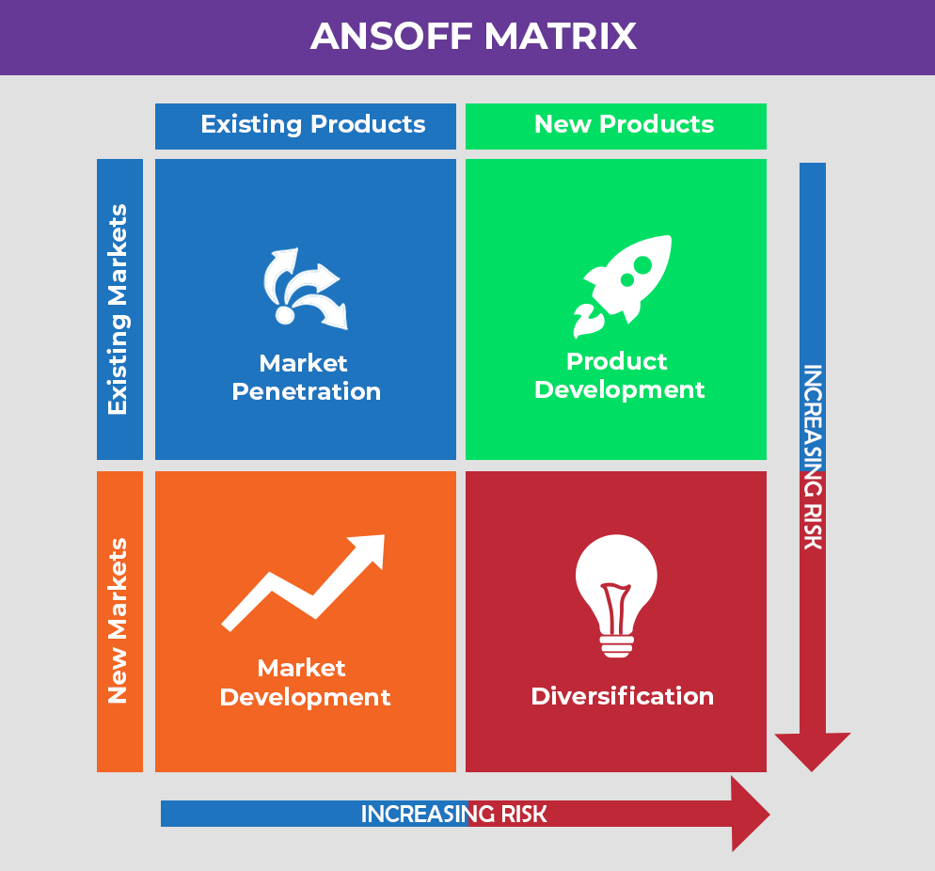

Source: (ansoff matrix in marketing - Bing images)
Both matrices can be used by organizations to decide how to increase the scope of their product offering. The BCG Matrix is focused on creating a success sequence where new products may develop into stars (high growth and high market shares items) and cash cows over the long term (high market shares, bad margin industries). The Ansoff matrix assesses how to create a product portfolio based on whether to concentrate on existing/new products or existing/new markets. 2023 - Gennaro Cuofan
You may use the Ansoff Matrix as a strategic framework to choose the optimum development plan based on the state of the market. Igor Ansoff, a mathematician and business leader, developed it. It assumes that a growth plan may be based on whether the market and the product are new or not.-By Gennaro Cuofano (2023)



According to the Ansoff Matrix, there are four marketing strategies that may be used: market penetration, product development, market development, and diversification. The Ansoff Product Market Growth Matrix: A Guide (2023)

Market Penetration marketing tactics often involve the least risk because consumers are already aware with the items and the existing market. Market penetration may also be increased by creating a variety of initiatives that will encourage rising product use. The application of toothpaste makes for a good example. The toothbrush head has an impact on how much toothpaste a person uses, according to study. Therefore, a larger toothbrush head will encourage the use of more toothpaste, which will ultimately result in more toothpaste purchases. Ansoff Product Market Growth: A Guide
The third marketing tactic is market expansion. Another name for it is "market extension". Using this strategy, the business sells its current products to new markets. This will be made possible by further market segmentation, which can find a new consumer base. According to this strategy, entering new markets is necessary because the current markets have already been fully utilised. Numerous methods, such as new geographic markets, distribution channels, product packaging, and price tactics, can be used to carry out this strategy. By exporting its items to new countries, the business can grow in new geographical markets. It would also mean opening more business locations in areas where the corporation has not previously expanded. Ansoff Product Market Growth: A Guide-By A Guide to the Ansoff Product Market Growth Matrix (2023)
The fourth strategy is diversification. In order to implement this growth strategy, a business must concurrently advertise or sell new products to new markets. It is the most risky tactic among the others due to the development of new products and the company's ignorance of potential development concerns. Additionally, the fact that a new market is being targeted raises the problem of unknown qualities. To proceed with diversification, a corporation must be certain of its expectations for the strategy's benefits and have a thorough awareness of the risks. Two types of diversification are available. Diversification can be connected or unconnected. The Ansoff Product Market Growth Matrix: A Guide (2023)

Conclusion:

Businesses who are considering expanding internationally or already have should consider investing in international marketing. In the new market, the organization's methods for reaching its target market domestically might not be as effective.
The NYS Collection in UK should think also to open a store, not only a kiosk like this they will have space for more products, as the space at the kiosk is limited they need to be very specific in analyse the sales of each month and ordering the new stock.
Selecting which overseas markets to enter is a crucial aspect of international activity. In this chapter, a number of methodological approaches have been discussed. These have been offered with the warning that a more pragmatist and instinctive approach to market selection may be used, though. This will be especially true for microbusinesses and smaller companies, where the owner manager's personal networks and cultural heritage are crucial. As we've seen, micro-segmentation can be extremely useful in assisting a firm in determining which clientele to target in order to increase efficiency.
The following stage of the marketing process is influenced by interactions between the activities related to knowing the customer's values. the following phase of the marketing cycle, specifically in respect to brand creation. Market research helps managers understand the current and future needs of customers while identifying how to best utilise brand equity in various cultural situations.
Summary and Conclusion Marketing is the most exciting business sport. It is essential to any successful business. It is continually changing as a result of the influx of knowledge, the development of technology, and the fierce rivalry that exists everywhere. Every business plan is supported by a marketing strategy.

Recommendations:

Nations where your business is already successful: Look at which nations are making the most conversions or visits to your website. Starting with those is a smart idea because you can immediately tell that people there are interested in what you have to offer. You may reach an even wider audience by localising you’re messaging.
Pick nations that are close to your home base geographically: Starting with nations that are geographically close to you may make the most sense if you're exporting tangible goods. When you first start out, this might make logistics for shipment lot simpler.
The following nations have fewer linguistic barriers: You must begin localising your business operations if you are starting to expand overseas.
Make sure your website, sales pages, blog posts, and other marketing material are accessible to your target audience in those markets when you expand into new markets. Starting with nations where there is less of a language barrier can be a quicker method to get started with international marketing because this is a huge step.
Translating your website's content and building new web pages specifically for that location and language are both examples of localising your website. You would need to translate your website material into Mexican Spanish, for instance, if you own a US-based business and want to start expanding into Mexico.
Consider setting up accounts for several brands.
Following the localization of your website, you might decide that it makes sense to localise your digital marketing initiatives as well. In this manner, you might use social media to target a distinct market group.
Even if Justin Trudeau shares every post in two languages, that approach might not be the ideal one for your company.
Including diverse team members from each foreign market you enter is a terrific method to master a worldwide marketing strategy.
You now have someone who can appropriately localise your website and marketing material, develop an ad campaign that targets that particular audience, and have first-hand knowledge of popular trends, holidays, and the general culture. This provides you a competitive edge.
You might even find that you wish to hire a complete marketing staff for each separate segment when you enter new markets abroad and develop in each new nation.
Including diverse team members from each foreign market you enter is a terrific method to master a worldwide marketing strategy.
Situational analysis and the strategic marketing plan both include internal analysis. It analyses the organisational, marketing, and financial situations. The analysis's findings are used as input for SWOT. The competitive, industry, distribution, and customer analyses that make up the external portion of the Situation Analysis deal with opportunities and dangers, whereas the internal analysis focuses on the situation's strong and weak areas.

References:

Advantages and Disadvantages of a Franchise - TheCompanyWarehouse.Co.Uk, (access on 28.04.23)
Ansoff Matrix – A Guide to the Ansoff Product Market Growth Matrix , (access on 28.04.23)
ansoff matrix in marketing - Bing images , (access on 28.04.23)
BCG Matrix - Overview, Four Quadrants and Diagram (corporatefinanceinstitute.com) , (access on 28.04.23)
BCG Matrix Vs. Ansoff Matrix - FourWeekMBA, (access on 28.04.23)
Conclusion of international marketing strategy - International Marketing (zabanga.us) , (access on 28.04.23)
Introduction to the marketing mix - The marketing mix - Edexcel - GCSE Business Revision - Edexcel - BBC Bitesize, (access on 28.04.23)
Kenton, W. (2019) Production Costs. Investopedia, New York. (access on 28.04.23)
Marketing Mix Definition - 4Ps & 7Ps of the Marketing Mix, (access on 28.04.23)
NYS Collection | Premium Eyewear Since 1996, (access on 28.04.23)
Place - Marketing Mix Distribution Strategy, , (access on 28.04.23)
The Ultimate Guide to International Marketing (influencermarketinghub.com) , (access on 28.04.23)
The Ultimate Guide to International Marketing (influencermarketinghub.com) , (access on 28.04.23)
The 7Ps of The Marketing Mix | Oxford College Of Marketing, (access on 28.04.23)
https://www.shutterstock.com/search/marketing-international?cr=bc&gclid=d1a23c755f8216f054a058256261434b&gclsrc=3p.ds&image_type=illustration&kw=%2Fsearch%2F&msclkid=d1a23c755f8216f054a058256261434b&pl=PPC_BNG_UK_DSA-&utm_campaign=CO%3DUK_LG%3DEN_BU%3DIMG_AD%3DDSA_TS%3Dlggeneric_RG%3DEUAF_AB%3DACQ_CH%3DSEM_OG%3DCONV_PB%3DMicrosoft-Ads&utm_content=FF%3DDSA+-+Search_AU%3DVisitors&utm_medium=cpc&utm_source=bing&utm_term=%2Fsearch%2F, (access on 28.04.23)

Marketing International: Over 135,312 Royalty-Free Licensable Stock Illustrations & Drawings | Shutterstock(access on 28.04.23)

5 Types of Content Marketing Formats (and How To Use Them to Get Results) (semrush.com) (access on 28.04.23)

