

Marketing & Business Development Lead

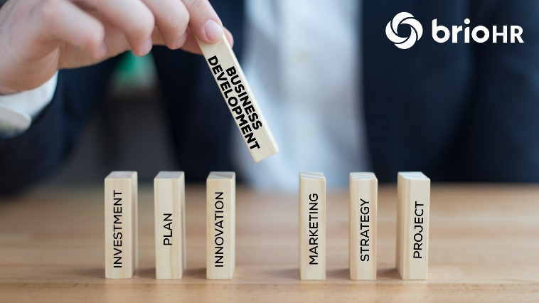   | Job Summary:  A Business Development Lead conducts market research to identify potential clients or markets, develops sales strategies to achieve business goals, negotiates contracts and partnerships and collaborates with internal teams such as sales marketing, and product development.  Key Responsibilities include:  • Management of company social media  • Full ownership of bids and tender process  • Engage with key internal stakeholders to produce detailed marketing research and literature  • Be a champion within the business for brand awareness  Skills required & Qualifications:  • Sales, Negotiation and research  • Communication skills  • Project Management and organisation skills  Salary & Compensation:  £40,000 - £50,000 p/a depending on experience

ZIA-UR-REHMAN TEHZEEB
14 Minstead Road, Erdington
Birmingham B24 8PT
Email: Ztehzeeb4@gmail.com
Mobile: 07392725172
Personal profile:
I am a passionate, hardworking, enthusiastic, and reliable individual who aspires to work to the best of my abilities to achieve my goals in life. I have excellent communication skills, and I am an organised and adaptable individual who enjoys working towards my goals.
Skills profile:
• I have excellent communication skills
• Excellent attendance
• I am passionate in all areas of my work
• Good team working skills
• Able to use my own initiative
• I am caring, trustworthy and a confident individual
• I love working as part of a team and helping out
Employment history:
In my recent employment history, I have undertaken a variety of work roles as detailed below:
2019: Monster Mayhem, Star City - Birmingham
• I was working at Monster Mayhem soft play area for younger children last year and some of the main duties included cleaning up and tidying the soft play area; working at the reception, taking bookings and payments, taking phone calls for bookings and general enquiries, giving food and drink out to customers, assisting customers when requiring help, helping prepare food in the kitchen such as light snacks, setting up and helping with the décor for pre booked parties and working till close on shift. One of my work experiences was Monster Mayhem, too.
Education and Training:
4 GCSE’s: English, Science, Textiles and Maths.
Vocational Studies in Business studied at college year 2019.
Functional skills in English and Maths studied at college 2019.
Btec Science Level 1 September 2020.
References:
References available upon request.

ZIA-UR-REHMAN TEHZEEB
14 Minstead Road, Birmingham
B24 8PT
Name: Bell Cornwall
Company Name: Bell Cornwall Recruitment (BCR)
Address: Runaway East
ARCA, Temple Row, Birmingham
B3 1NQ

17/02/2026
Dear Bell Cornwell, I wish to apply for the role of Marketing & Business Development Lead, currently being advertised on your website. Please find and enclose my CV for your consideration.
In my previous role, I have done my work experience and have also worked at Monster Mayhem, and I have been responsible for taking bookings over the phone and have taken payments for party bookings and also assisting customers when needing help.
During my work experience I have gained communication skills and organisation skills with my enthusiasm and dedication, project management and sales and negotiation research.
I am confident that I can bring this level of success with me to your organisation and help to build and succeed their reputation by giving my best and hardworking work to the company
Thank you for looking through my CV. I look forward to hearing from you soon

Yours Sincerely,
ZIA-UR-REHMAN TEHZEEB


