
Continental Hotel
Budget Planner

Module Name: Financial Management
Module Code: BMIH5007
Lecturers Name: Dale Clarke
Student Name: Natalia Sanches
Student N.: 2013495
March 23, 2022
University of Wales Trinity Saint David

Executive Summary

This work analysed the proposal to apply the zero-based budget in the financial department of the Continental Hotel located in London. The study aimed to provide details of the zero-based budgeting technique with the objective of implementing this type of budgeting approach in the future, presenting its usefulness and the advantages in its application. Considering that we tried to present an instrument that would better contribute to the management of resources to be spent by the financial department of this company, being proposed steps to be followed for possible application of this type of budget in the department, in order to strengthen the budget process, generating greater analysis, feedback and criticism of the resources to be used. The final result was the conclusion that the application of the Zero-Based Budget can be done in any organization regardless of size, and that the key factor for its functioning is the full support of the company's administration and the awareness of its employees, as it is a critical, onerous process that demands a lot of time from the people involved. On the other hand, this avoids the perpetuation of inefficiency in the processes and also increases people's involvement and interest, significantly improving their motivation. Bearing in mind that ZBB's main objective is to involve all employees, seeking commitment and commitment to the company's results.

Table of Contents
Executive Summary 1
1. Introduction 3
2. Zero Based Budgeting 4
2.1 Zero-based budgeting 4
2.2 Advantages of Zero-based budgeting over Traditional Based 5
2.3 Disadvantages of Zero-based budgeting over Traditional Based 7
2.4 How the Organisation Might introduce Zero-based Budgeting 8
3. Conclusion 10
4. Reference List 11

Introduction

The traditional corporate budget, also called organizational budget, being a management tool to control and measure the financial health of a company, making it possible to better understand the company's panorama as a whole, contains information that involves expenses and income over a year. or a period of time, with the mission to reduce expenses regardless of the size of the business, it becomes indispensable nowadays for any financial manager. The budget helps to optimize resources and control expenses, making tasks less complex, reducing the risk of failures and enhancing the efficiency of financial management, guiding and helping to define new paths and make more assertive decisions, based on real data, about what do with company money, (Graybeal et al., 2018).
The first step is to make a general analysis of the company's financial condition, for this it is necessary to gather information and report referring to the past, whether from the last year, quarter or semester, the more information the better the basis to start making the budget for the next period, (Stobierski, 2020).The business routine and the requirement for consistent transformation of assignments, to ensure the effectiveness and development of a business, request from experts who work in the administration and coordination of areas, a super durable exertion looking for the best presentation. One of the systems that have been broadly utilized by business visionaries looking for effectiveness and further developing business results is the alleged Zero-Base Budget, (Why is it important to have a zero-based budget?,2021).

Zero Based Budgeting

The Zero-Based Budget is a different methodology from the traditional one, as it projects income, expenses, and costs without considering previous years, (Underwood, 2022).

Zero-based budgeting

This device allows managers to have the option to coordinate and control the costs that the organization has eliminated in case of slack in the spending plan and create conditions for the leader to have more substantial components to evaluate their requests for the following deadline. This device allows finance chiefs to have the option to coordinate and control the costs that the organization has eliminated in case of slack in the spending plan and create conditions for the leader to have more substantial components to evaluate their requests for the following deadline. During the spending plan readiness period, every division is isolated into an expense place and subtleties the normal costs, in this manner diminishing the event of waste or venture and focal point of exercises that don't stick to the organization's present methodology, (Anaplan, 2022).
This guarantees that managers check and assess the event of abundances and the genuine need to carry out specific costs. Truth be told, this is the fundamental target of the Zero-Based Budget: to diminish(reduce) costs, dispense assets in light of current business goals and objectives, and carefully assess consumptions, (Comparing budgeting techniques, 2021).
The Zero-Based Budget depends on two essential statements: the first is that a spending plan must guarantee the organization's permanence, even in a dire situation; the second is that all fixed costs must be close to the organization's commitment threshold for the most terrible outcome imaginable, (S, 2017).
Recognizing pointless costs and wiping out superfluous exercises guarantees better focusing on and utilization of assets, the organization's emphasis on what will truly add esteem, along these lines carrying a few benefits to the business, (Webster, 2020).

Advantages of Zero-based budgeting over Traditional Based

Decreasing expenses and costs is progressively a requirement for organizations, whether because of expanded contest, the need to further develop productivity, or on the grounds that the organization is working confused and can't increment costs, among numerous different reasons, (Cheng, et all, 2021).
Normally, the attribution of "cutting" costs is traumatic, given that it is centred on misfortunes, but it can very well be worked with an emphasis on gains, this happens when the reduction of costs occurs through the increase of functional productivity and the financial plan zero-based is a fantastic administration system to achieve this goal, (Fritzen et all, 2020).
There are many advantages to using zero-based budgeting over other types of business budgets.

- Allows efficient allocation of resources.
The distribution of assets depends on needs and advantages and no longer on previous results as is usually the case with other budget management methodologies, with each expense being analysed for its cost X benefit, consequently coordinating assets with more emphasis, (Murphy, 2021).

- Implementation of improvements.
Administrators should always look to make improvements to their exercises, further developing the money-saving benefit ratio of each planned cost. Currently, the centre is not just planning the qualities, but further developing the way each cost is completed, (Serven, 2021).

- Detect inflated budgets
As all costs are dissected exhaustively, legitimizing the explanations behind being done, it normally wipes out the "fat" that chiefs as a rule put in the business financial plan, which is generally hurtful to the organization, since it increments expenses superfluously

- Increased managers motivation
It expands the inspiration of managers associated with the corporate spending plan by giving more prominent drive and obligation regarding direction, making a culture of ownership in those involved, (Funck et al., 2021).
- Improves communication
Costs and incomes are dissected and examined exhaustively, this interaction builds correspondence and coordination inside the association, (Aguilar and Shaikh, 2021).

- Eliminates outdated and unnecessary expenses
By breaking down exhaustively each organization cost, administrators distinguish and take out of date cycles or cycles that don't add esteem (squander), (Richard, 2021).

- Critical analysis of expenses
Financial administrators are urged to fundamentally take a gander at the manner in which administrations are given, assess new administrations, new suppliers and new advancements, to give a decrease in costs by expanding the organization's functional proficiency, (Underwood, 2022).

- Alignment with strategic planning
Assets should be distributed by the association's essential goals, so there is an arrangement of vital preparation with financial plan and monetary preparation, (Zero-based budgeting: Definition, features and advantages 2022).

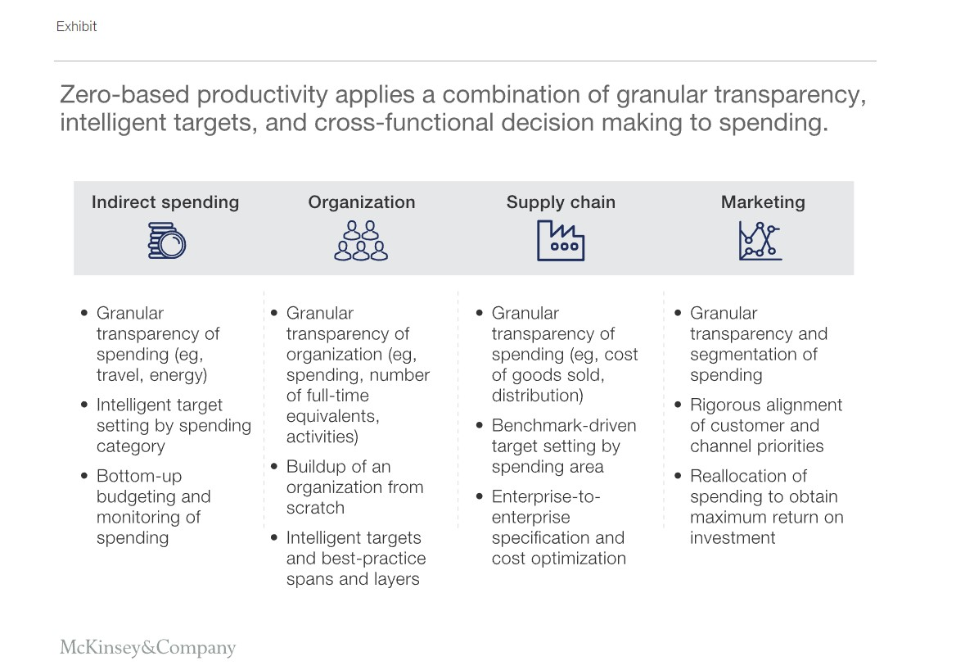

Disadvantages of Zero-based budgeting over Traditional Based

- Takes more time to perform
As revenues and expenses are analysed in detail, justifying their cost / benefit, this is more time consuming than traditional incremental budgeting, (Webster , 2020).
- Greater difficulty to control
As the controls increase, it demands a good control system for its administration, if the control is manual or without spreadsheets it can represent a loss of productivity, (Pros and cons of zero-based budgeting 2021).
• Requires specific training
As this methodology is more complex than other types of budgets, it requires specific training for managers so that managers are able to carry out budget planning, (Zero based budgeting (ZBB) training course 2021)

2.4 How the Organisation Might introduce Zero-based Budgeting

The application of the zero-base budget requires dedication, commitment, and training of the teams, since its implementation is not simple, and it is necessary to be prepared for a change of culture. Thus, the process of adopting this method requires a series of behavioural changes, considering that it is important to keep in mind that when adopting this type of budget, this hotel unit needs to have a complete history of all its costs, as a detailed strategy and well defined and targets divided by budget sectors.
After this initial mapping, it is possible to proceed to the next steps:
Realization through technical and behavioural training of teams, allowing professionals to prepare and help them understand the importance of cutting costs.
Division of the company into budget units, since each group follows a different logic of costs, after this division, a survey of the cost history of each of these units must be carried out
Identification of the strategy to follow after the two previous steps and when it is time to deploy strategies and identify the relationship between them, goals and the budget.
Analysis of unit metrics, individually evaluating the results of each unit and the short-medium and long-term goals of each one of them.
Definition of the minimum cost that the company needs to maintain its activities. It is important to have this information, as it helps in the preparation of the ZBB, which is the step that eliminates all superfluous costs.
Division of fixed expenses of each unit and classification of each one of them, this is the moment when managers and coordinators identify expenses, generating important data for the ZBB budget, ( Leshinski, 2022).
The zero-based budget is a mechanism that forces each sector of the institution to discriminate all possible expenses, being responsible for making a business budget individually for each cost centre from scratch. This method disregards past average expenses but avoids wastage.
This budget model has numerous advantages over other types of business budgets, especially over the traditional budget. One of the advantages of this model is that managers and employees are in their area of ​​expertise and will do a more thorough analysis of the real needs (of the moment).
So, if the company manages to make a good administration of this methodology to eliminating the disadvantages, it can achieve great results, extinguishing unnecessary or superfluous expenses in addition to improving operational efficiency.

Conclusion

Faced with the need to provide information that can improve managers decision-making and make the company increasingly dynamic, it was proposed to apply the Zero-Base Budget in the Continental Hotel’s financial department in order to contribute to the management of the expenses generated by this, reaching the conclusion that this type of budget can be applied in any organization regardless of size.
In this sense, the proposed application of the ZBB in the financial department of this and all units of the Continental Hotel group must be applied with full support from the financial department and management of the company. As it is a more costly process and requires more time to be understood that an improvement in the department’s processes may be possible, and if the return occurs, it can be applied in the other departments of the Hotel.
Considering further that every amount spent needs to be justified and that Continental Hotel undertakes to undertake revisions in the basic estimates for all packages each year, thus avoiding the perpetuation of inefficiencies. Some benefits of the method studied in relation to the traditional one can also be highlighted: it generates a questioning attitude when taking on practices arising from the past, focuses attention on productivity and not only on the cost relation, increases people’s involvement, significantly improving motivation and interest in work.
In times when the strain on organizations is incredible, ZBB enjoys an extraordinary upper hand over different techniques, the chance of ceaseless improvement. Understanding this rationale, it is expressed again that the principle thought of ​​ZBB is to include all workers, looking for responsibility and obligation to the organization's outcomes.

Reference List

- Aguilar, O. and Shaikh, F. eds., (2021). Zero-based budgeting: Deloitte Us. Deloitte United States. Available at: https://www2.deloitte.com/us/en/pages/operations/articles/zero-based-budgeting.html [Accessed March 23, 2022].
- Anaplan, (2022). What is zero-based budgeting? Anaplan. Available at: https://www.anaplan.com/blog/zbb-zero-based-budgeting-guide/ [Accessed March 20, 2022].
- Cheng, M. and Team, T.I., (2021). Zero-based budgeting: Benefits and drawbacks. Investopedia. Available at: https://www.investopedia.com/ask/answers/051515/what-are-advantages-and-disadvantages-zerobased-budgeting-accounting.asp [Accessed March 18, 2022].
- Comparing budgeting techniques (incremental v zbb)20, 2021. Comparing budgeting techniques (incremental v zbb). ACCA. Available at: https://www.accaglobal.com/ie/en/student/exam-support-resources/fundamentals-exams-study-resources/f5/technical-articles/comparing-budgeting-techniques.html [Accessed March 23, 2022].
- Fritzen, S. et al., (2020). Zero-based productivity: The power of informed choices. McKinsey & Company. Available at: https://www.mckinsey.com/business-functions/operations/our-insights/zero-based-productivity-the-power-of-informed-choices [Accessed March 18, 2022].
- Funck, K.von et al., (2021). To make zero-based budgeting work, change behavior. BCG Global. Available at: https://www.bcg.com/publications/2021/changing-how-companies-manage-cost-with-zero-based-budgeting [Accessed March 19, 2022].
- Graybeal, P., Franklin, M. and Cooper, D., (2018). Describe how and why managers use budgets. Principles of Accounting Volume 2 Managerial Accounting. Available at: https://opentextbc.ca/principlesofaccountingv2openstax/chapter/describe-how-and-why-managers-use-budgets/ [Accessed March 22, 2022].
- Leshinski, S., (2022). Using zero-based budgeting as a tool for growth and Innovation - Huron. Huron Consulting Group. Available at: https://www.huronconsultinggroup.com/insights/zero-based-budgeting [Accessed March 23, 2022].
- Murphy, K., (2021). The advantages and disadvantages of zero based budgeting (ZBB). PLANERGY Software. Available at: https://planergy.com/blog/advantages-and-disadvantages-of-zero-based-budgeting/ [Accessed March 19, 2022].
- Pros and cons of zero-based budgeting, 2021. Pros and cons of zero-based budgeting. insightsoftware. Available at: https://insightsoftware.com/blog/zero-based-budgeting/ [Accessed March 23, 2022].
- Richard, J., (2021). The ups and downs of zero based-budgeting. Solving finance. Available at: https://www.solving-finance.com/post/the-ups-and-downs-of-zero-based-budgeting [Accessed March 19, 2022].
- S, S., (2017). Difference between traditional budgeting and zero-based budgeting (with comparison chart). Key Differences. Available at: https://keydifferences.com/difference-between-traditional-and-zero-based-budgeting.html [Accessed March 18, 2022].
- Serven, L.,( 2021). https://blog.board.com/budgeting-planning-forecasting/top-tips-implementing-zero-based-budgeting/644/#gref. Implementing a successful Zero-Based Budgeting approach. Available at: https://blog.board.com/budgeting-planning-forecasting/top-tips-implementing-zero-based-budgeting/644/#gref [Accessed March 20, 2022].
- Stobierski, T., (2020). How to determine the financial health of your company: HBS Online. Business Insights Blog. Available at: https://online.hbs.edu/blog/post/how-to-determine-the-financial-health-of-a-company [Accessed March 18, 2022].
- Underwood, C., (2022). Advantages and disadvantages of zero based budgeting. eFinanceManagement. Available at: https://efinancemanagement.com/budgeting/zero-based/advantages-and-disadvantages-of-zero-based-budgeting [Accessed March 19, 2022].
- Webster , E., (2020). Benefits and drawbacks of zero-based budgeting. Vena. Available at: https://www.venasolutions.co.uk/blog/budgeting-forecasting/zero-based-budgeting [Accessed March 18, 2022].
- Why is it important to have a zero-based budget?, (2021). Why is it important to have a zero-based budget? Suits Me. Available at: https://suitsmecard.com/blog/why-is-it-important-to-have-a-zero-based-budget [Accessed March 23, 2022].
- Zero based budgeting (ZBB) training course, 2021. Zero based budgeting (ZBB) training course. Zoe Talent Solutions. Available at: http://zoetalentsolutions.com/course/zero-based-budgeting-zbb-training-course/ [Accessed March 23, 2022].
- Zero-based budgeting: Definition, features and advantages, 2022. Zero-based budgeting: Definition, features and advantages. Jedox. Available at: https://www.jedox.com/en/blog/zero-based-budgeting/ [Accessed March 23, 2022].

