Software Applications for Business
e-portfolio

Module: Software Applications for Business
Module number: ACCA4031
Student: Manuel Iacob
Student number: 2212910
Lecturer: James Williams

Task 1: e-Portfolio.
- https://lacatusalina1998.wixsite.com/manueliacob
- 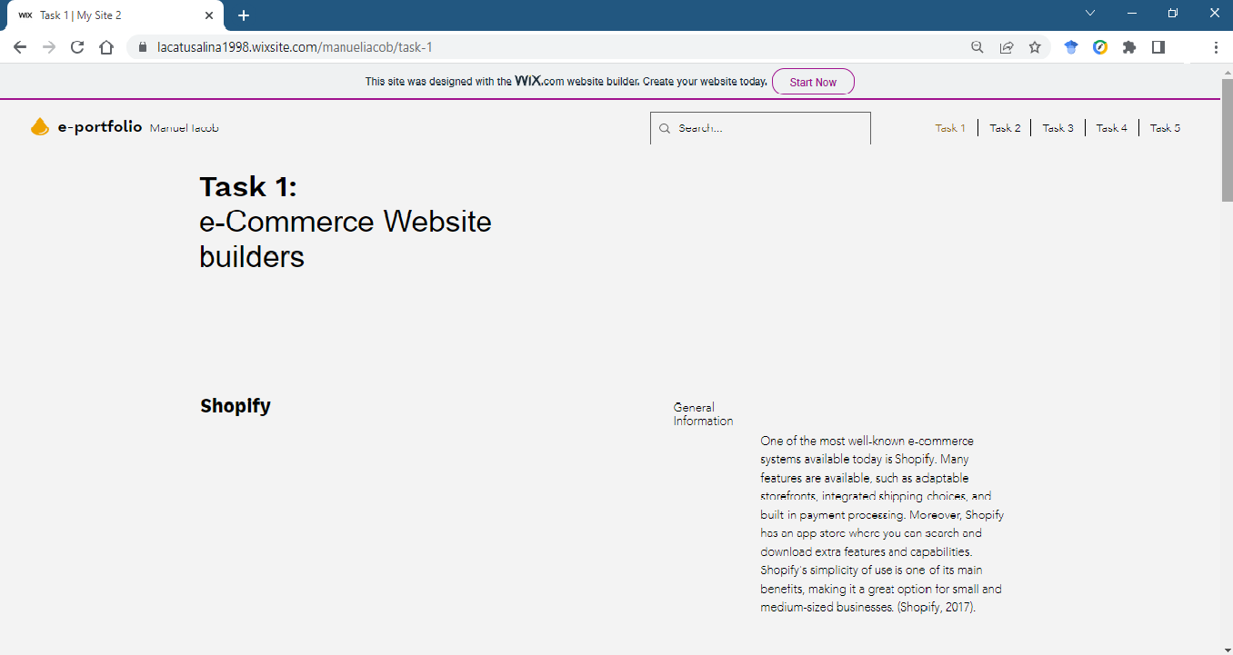
Task 2 – Mind-map.
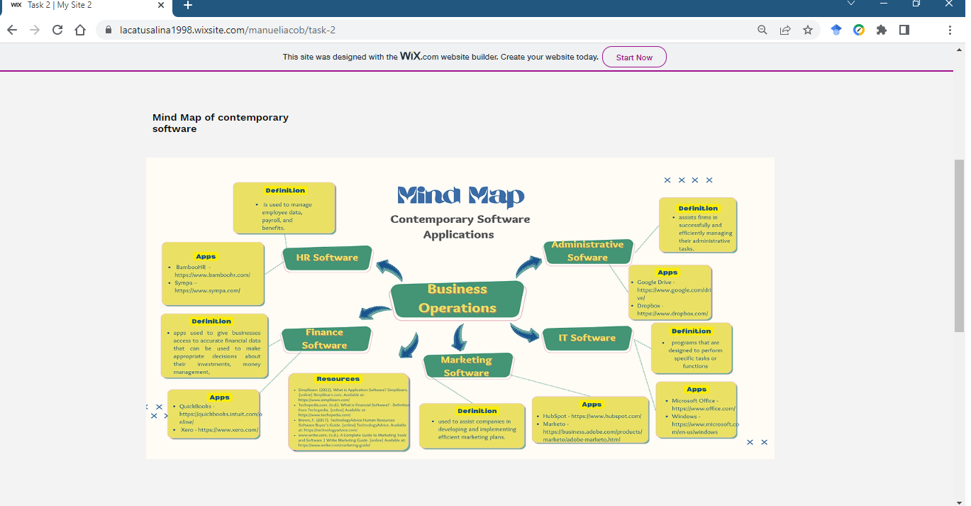Task 3 – Office Applications.
- 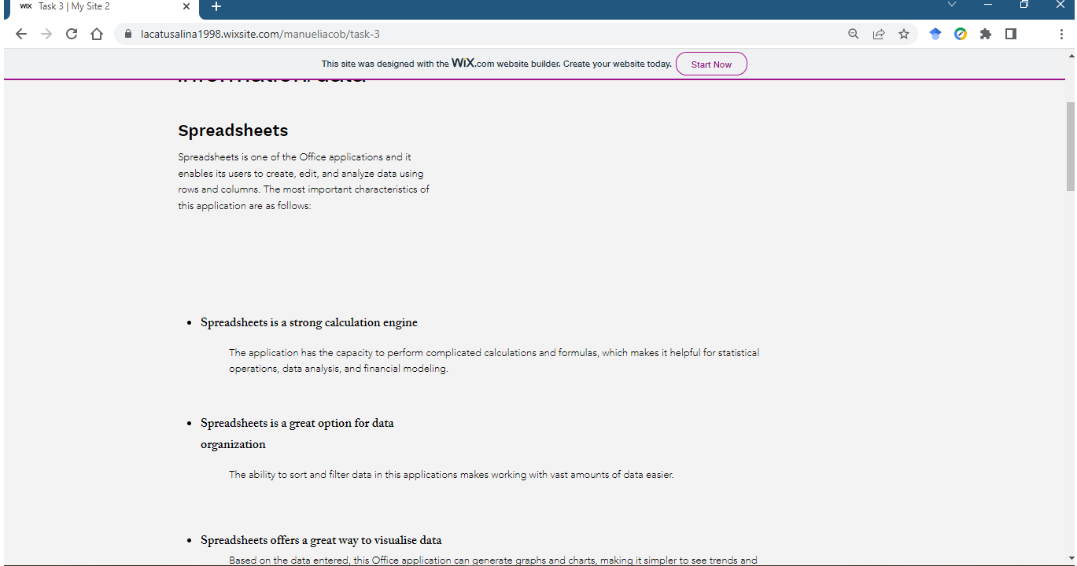
- 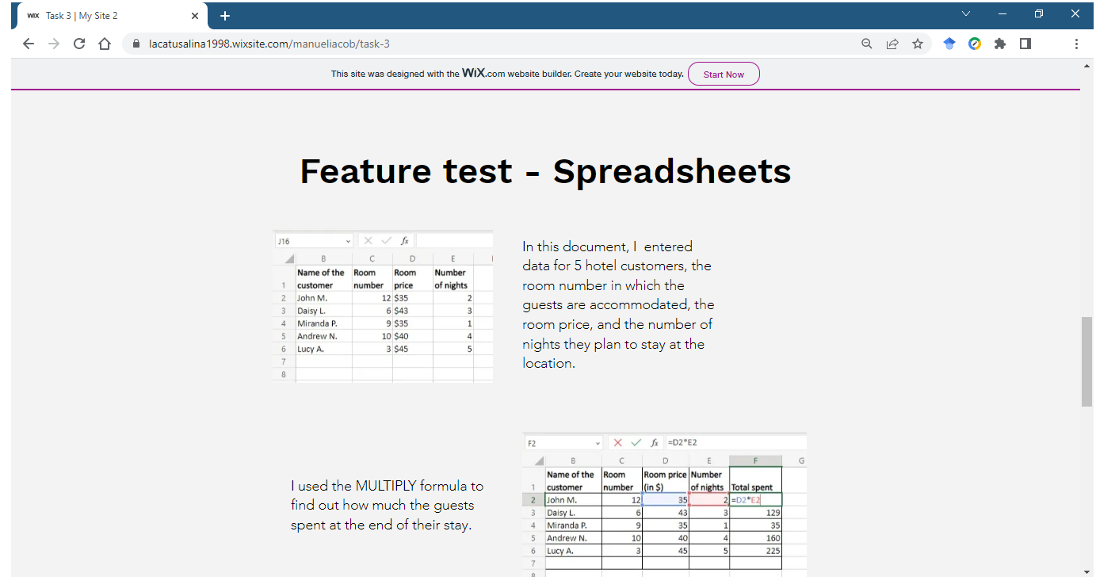
Task 4 – Digital Dashboard and Data Analytics software.
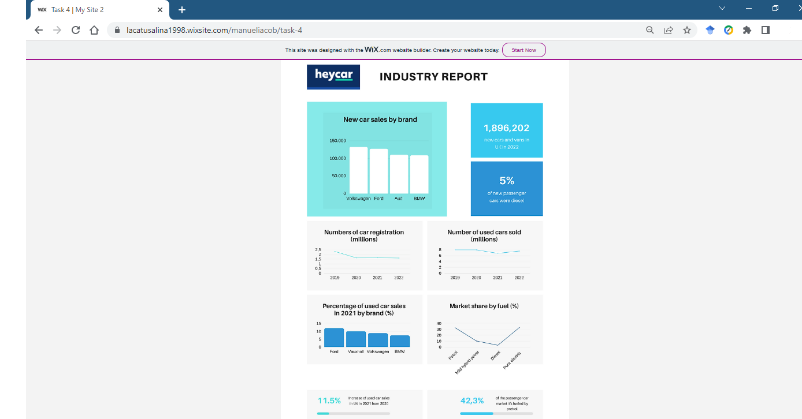
Task 5 - Communication, Collaboration & Project Management


