Digital Skills and Research Methods
LCHS4002
Student ID:2216277
Student Name:Eleana Daniela Virlan

Abstract
The discussion has focused on the impact of technologies on healthcare and lifeline personal alarm services. This discussion has provided the research background focusing on the different types of technologies. A brief description of the review of the existing literature has been mentioned. After that, the research methodology used in the research has been described. The type of research method, research philosophy, and data collection process has been discussed briefly. Further, an analysis has also been provided with the help of different graphs. Lastly, the discussion of the analysed data has also been provided in the following assessment.

Table of Contents
Introduction 4
Literature Review 5
Research Methodology 7
Findings and analysis 9
Conclusion 13
References 14

Introduction
Research Background
Nowadays the healthcare sector has become a vital part of the society because it provides services to the community for their well-being. The services provided by the above-mentioned sector become complex day by day and the advancement of technology helps to reduce cost, make easy interpretation, and accessibility of the sector. The health care services rely on the researchers who guided the sectors by their studies. The researchers who carry their research in this field, examine the cost of health care, the outcomes and the access to health care and they support further improvement of the sector by the help of technologies.
Problem Statement
Different technologies become a vital part of the health care sector to store and manage a large amount of data and to provide support for the well-being of society. The study will help to understand the ways for the betterment of the sector through technologies. Apart from that research on the technologies and its implication on the health care sector lower the cost of services. Application of artificial intelligence on health care services have increased excessively to manage large amounts of complex data in a suitable way as well as to provide the best care service for the seekers. Thus, the researcher will focus on to show the ways through which the application of digital technology has helped health care professionals to provide lifeline personal alarm services to patients in the UK.

Literature Review
Impact of digital technology on the lifeline personal care services
A personal alarm system refers to a system where one person can communicate with others to get service or need help at the time of requirement (nhs, 2022). Lifeline services are provided to the community with the help of various types of technologies. The development of digital tools has allowed in the last past decades which resolves different types of obstacles in the healthcare sector. This is reviewed by data that digital technology including telecommunication developed that has been applied to tackle various types of clinical complications. As opined by Ting et al., (2020), the proliferation of artificial intelligence helps to make interconnection among hospitals and facilitators of clinics. AI is used to understand the models which are associated with the risk of healthcare services (Tian et al.,2019). The study will make someone able to understand the trends and the outcomes of the risk assessment.
Types of technologies used in the lifeline personal care system
Various types of contemporary technologies are used to diagnose different critical health issues. X-rays and tomography are used in the diagnosis of various diseases to assist experts in identifying the problems. Including electronic health records, and collecting information about patients who need the help of modern technologies, The Uses of technology support the healthcare system to find various aspects of the diagnostic process and different tools are used to perform the task. Development in technologies like the invention of dialysis machines and infusion pumps drive the healthcare sector to another level. Electronic health care records system has been made in modern days that helps in the acquisition of patient records. Technologies used in this sector help to reduce human error which is made in the time of different processes (Qadri et al.,2020). The use of wearable technology helps to provide personalised health care to patients.
Lifeline personal alarm services
Lifeline services are the services which have been provided to low-income people and that enable the people to survive. In the healthcare sector lifeline services have been provided to promote the and growth well-being of patients. The services minimise the cost and provide a high quality of service (Dias and Paulo, 2018). Apart from that technologies are used in the fulfilment of psychological needs which indirectly helps in the well-being of physical health. The telecommunication services provided by the healthcare sector helps in emergency condition and are available 24 hours to serve the patients (which, 2022).
Technologies used in the healthcare sector assist the community with the advancement of technologies. Patients can easily access the best treatment that shows better recovery rate and has the lower pain sensation. Technologies help patients and experts both in the time of consultation during the pandemic situation in the time of Covid-19. During the treatment process families of patients need to maintain the communication process that is easily made by the digital communication system.

Research Methodology
Qualitative Research Method
There are two types of research methods depending on the type of data collected, Qualitative and Quantitative method. The qualitative method of research refers to collecting non-numerical data through conversation or observation. This research method focuses on analysing the gathered information avoiding numerical values to them. The major concern in this method is to discuss the reason behind the particular attitude of people (proprofssurvey, 2022).
Quantitative Research Method
The quantitative method refers to the systematic collection of data and interpretation of them with statistical and mathematical analysis. Information in the quantitative method can be depicted in numerical form.
Research Philosophy
The research philosophy refers to the framework that should be followed to conduct research. This process guides the researchers to focus on the knowledge gathered from the information and reality principles. There are four different types of research philosophy, they are positivism, pragmatism, realism, and interpretivism. The researcher in this research will apply interpretivism research philosophy to conduct the research. Interpretivism is concerned with subjective opinions and states that the basic principles are not enough to understand the social world. This specific method of research philosophy will help the researcher to gather the subjective attitude of employees and patients who had faced lifeline alarm services (Ramsberg, 2018).
Research Method
Depending on the type of research method used to conduct the study, that is using qualitative or quantitative methods singly or in a combination, the method can be of two types. The mono method refers to using one approach qualitative or quantitative. A mixed approach refers to using both qualitative and quantitative methods. The research during conducting research will apply the mono method of data collection and analysis to focus on the impact of technology on personal lifeline alarm services (Busetto et al., 2020).
Data Collection
The collection of information that will be analysed and interpreted with the help of research conducted is an important step in conducting research. There are two different types of data collection methods based on the source of information. The primary data collection method refers to the first-hand data collected by the researcher with the help of conducting surveys, interviews, or other types of data collection tools. Secondary data collection refers to using data gathered by someone else. Secondary data are collected from books, journals, newspapers, and magazines available in libraries and other internet sources. The researcher will gather the information that is already available in libraries and social networking sites. Thus the secondary data will be used for collecting information relevant to the research. This will help him to save the time and expenses needed in primary data collection (simplilearn, 2022).
Ethics in Research
Research ethics refers to the ethical principles that should be focused on while conducting research. The researcher will be honest in implementing the results conducted by the research. The client’s permissions will be regarded before collecting the data. Objectivity in research is another important ethics that should be concerned. The researcher will focus on objectivity while conducting the research and will avoid subjective bias in the research (Nichol et al., 2021).

Findings and analysis

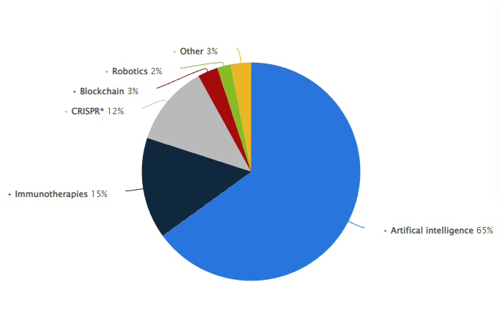
Source: (Stewart, 2022)
Fig: Usage of AI on the UK health care sector
Graph 1 Analysis: The above graph shows the percentage of advanced technologies impacting healthcare services in the UK. There is 15% of the usage of immunotherapy for cancer patients, and CRISPR technology is used in 12% of cases in health care. Block chain and robotics are used by 3% and 2% respectively for treatment in the UK. The most used technology is artificial intelligence which amounted to 65% of the UK health care system. Thus, there is a huge amount of application of AI and other technologies in the UK that are helpful in providing care to patients (Stewart, 2022).

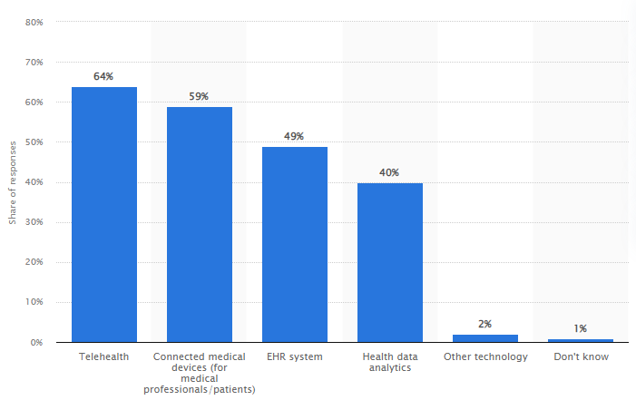
Source: (Stewart, 2021)
Fig: Usage of telehealth in the UK health care process
Graph 2 Analysis: The graph shows that the application of telehealth referring to providing delivery of services to patients through telephonic communication is 64% in the UK. Technically connected medical devices are used by 59% and EHR systems or Electronic Health Record systems for 49% in the UK. Health Data analytics are used by 40% to analyse the data of patients. Thus the graph indicates the number of technologies used in different areas of health care in the UK (Stewart, 2021).

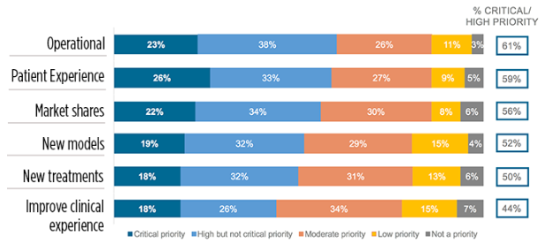
Source: (Sullivan, 2018)
Fig: Different aspects of technologies on UK healthcare
Graph 3 Analysis: The graph shows the impact of technologies on different aspects of health care services provided in the UK. Operational aspects are conducted using 61% of technologies. Patient experiences are handled by 59% with the help of technologies. Market shares and new models contributed 56% and 52% respectively applying technologies. New treatments are introduced by using 50% of advanced technologies. Healthcare providers also improve the clinical experiences of patients by using 44% of technology. Thus. The application of technology in UK health care services is widely used to improve the treatments given to patients (Sullivan, 2018).

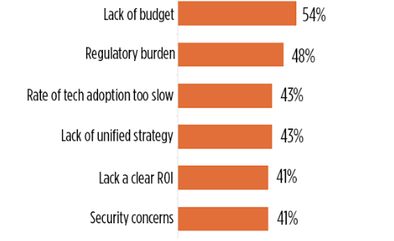
Source: (Sullivan, 2018)
Fig: Issues of related to usage of technologies in the UK healthcare sector

Graph 4 Analysis: There are also several issues regarding the usage of technology in healthcare services in the UK. The maximum amount of challenge that is faced by the UK healthcare services is due to lack of budget. The amount of regulatory burden faced is 48% in the UK. Issues regarding the rate of slow tech adoption and lack of unified strategy are both 43%. Both the challenges due to lack of return on investment and security control amounted to 41% (Sullivan, 2018).
Summary and Discussion
With the help of analysing the above graph, it can be found that the usage of technology has increased in recent years in the field of healthcare in the UK. During the pandemic, the use of advanced technology has proved to be useful in prodigy services to patients. The use of telecommunication services was helpful in the UK for the patients to connect with hospitals and care providers. Several machines are helpful in monitoring the health of patients. There are different types of technology used in hospitals and other kinds of caregiving institutions. These technologies are useful in improving the care provided to patients and increasing the rate of recovery. On the contrary, hospitals also face several issues when incorporating technologies into healthcare services in the UK. These issues also concerned hospitals which needed to work on resolving them.

Conclusion
The above research report has been developed based on understanding the role of technologies in the health care sector for providing the lifeline alarming services. The life line support provided by the health care sector helps in the well-being of the ageing community present in the UK. The study provides the opportunity to the researchers to conduct different researches on the health care sector. Along with this, the research has discussed such ways through which digitalisation has helped the caregivers to answer to the patients who have doubts on different clinical procedures related to their treatment. It has been concluded from this report that by using online platforms patients can share their problem with the experts easily during the time of need. Apart from that the collaboration processes between experts with the help of technology help to get new ideas to solve critical and severe clinical problems. Experts can share their ideas through the study. The research report has also provided certain understandings about the methods and techniques which have applied in the health care sector and lifeline service for creating new ways for better caregiving. Further, certain graph charts have also been provided for discussing such research areas. Lastly, the context has also defined the research methodologies that the researcher has undertaken for conducting this research.

References
Busetto, L., Wick, W. and Gumbinger, C., (2020). How to use and assess qualitative research methods. Neurological Research and practice, 2(1), pp.1-10.
Dias, D. and Paulo Silva Cunha, J., (2018). Wearable health devices—vital sign monitoring, systems and technologies. Sensors, 18(8), p.2414.
nhs, (2022). Personal alarms, monitoring systems (telecare) and key safes. [Online] Available at: https://www.nhs.uk/conditions/social-care-and-support-guide/care-services-equipment-and-care-homes/personal-alarms-security-systems-and-keysafes/ [Accessed 14 December 2022].
Nichol, A.A., Mwaka, E.S. and Luyckx, V.A., (2021), May. Ethics in Research: Relevance for Nephrology. In Seminars in Nephrology (Vol. 41, No. 3, pp. 272-281). WB Saunders.
proprofssurvey, (2022). Qualitative Research Methods: Types, Examples and Analysis. [Online] Available at: https://www.proprofssurvey.com/blog/qualitative-research/[Accessed 11 12 2022].
Qadri, Y.A., Nauman, A., Zikria, Y.B., Vasilakos, A.V. and Kim, S.W., (2020). The future of healthcare internet of things: a survey of emerging technologies. IEEE Communications Surveys & Tutorials, 22(2), pp.1121-1167.
Ramsberg, N., (2018). 3.0 Research methodology. [Online] Available at: https://medium.com/ma-leading-design/research-methodology-45871a6e4cc7[Accessed 08 December 2022].
simplilearn, (2022). What Is Data Collection: Methods, Types, Tools, and Techniques. [Online]Available at: https://www.simplilearn.com/what-is-data-collection-article[Accessed 05 December 2022].
Stewart, C., (2021). Technologies with the biggest impact in healthcare over the last year according to healthcare workers in the U.S. and the UK as of 2021. [Online] Available at: https://www.statista.com/statistics/1265763/impact-of-healthcare-technologies-in-the-us-and-the-uk/[Accessed 09 December 2022].
Stewart, C., (2022). Technologies predicted to have the most impact on health care as of January 2020. [Online] Available at: https://www.statista.com/statistics/1091107/technologies-impact-on-health-care-prediction/[Accessed 06 December 2022].
Sullivan, T., (2018). Focus on innovation: 3 charts explain where healthcare is headed. [Online] Available at: https://www.healthcareitnews.com/news/focus-innovation-3-charts-explain-where-healthcare-headed[Accessed 02 December 2022].
Sullivan, T., (2018). Focus on innovation: 3 charts explain where healthcare is headed. [Online] Available at: https://www.healthcareitnews.com/news/focus-innovation-3-charts-explain-where-healthcare-headed[Accessed 03 December 2022].
Tian, S., Yang, W., Le Grange, J.M., Wang, P., Huang, W. and Ye, Z.,(2019). Smart healthcare: making medical care more intelligent. Global Health Journal, 3(3), pp.62-65.
Ting, D.S.W., Carin, L., Dzau, V. and Wong, T.Y., (2020). Digital technology and COVID-19. Nature medicine, 26(4), pp.459-461.
which, (2022). How to buy the best personal alarm. [Online] Available at: https://www.which.co.uk/reviews/assistive-technology/article/how-to-buy-the-best-personal-alarm-aiDEp0U1Tdr2 [Accessed 12 December 2022].

