BMIH6005
Organisational Consultancy
Module Tutor: Julia Ault
Student name: Marius Neagu
Student ID:2026287

Table of Contents
1. Introduction 6
1.1 Purpose of the Report 6
1.2 Problems that would be discussed 6
1.3 Methods used to analyse the problem 6
2. Scope and Analysis 7
3. Improvements that can be done in the operations of the Hotel 13
7. Recommendations 15
8. Conclusion 17
Reference List 18

Executive Summary
This research offers a detailed analysis of the renowned Banke Hotel in Paris with the intention of identifying trouble spots and providing workable ideas for improvement. It has been possible to fully understand the Banke Hotel's strengths, weaknesses, opportunities, and threats thanks to a detailed examination of the hotel's operations using tools like PESTLE, SWOT, and TOWS evaluations. The Banke Hotel in Paris is in a terrific location and offers a substantial number of rooms that may meet a variety of tourist needs. The hotel has established a great reputation for organising events, particularly as a popular wedding venue. But the study has brought to light a number of problems that need to be resolved. The necessity for room renovations to suit changing guest expectations, gaps in staff training programmes, and restrictions in the feedback management system are just a few of the difficulties that must be overcome.
To address these issues and encourage changes, a number of ideas have been created. The first recommendation is to enhance training and development programmes for employees to ensure consistent service quality and promote a sustainable culture. By providing staff members with in-depth training in sustainable practises, customer service, and operational efficiency, The Banke Hotel can increase its service standards and ensure a wonderful guest experience. The second recommendation focuses on responding to criticism. Banke Hotel should put in place a reliable mechanism to gather, examine, and promptly address guest comments. The hotel may improve its reputation and client happiness by actively engaging with visitors and swiftly resolving any issues or recommendations.
Additionally, Banke Hotel needs to prioritise environmental sustainability. By installing rigorous waste management systems, employing energy-efficient practises, and utilising local suppliers, the hotel may reduce its carbon footprint and have a positive influence on the environment. By investing in renewable energy sources, such as solar panels, and exploring partnerships with local sustainability initiatives, Banke Hotel may position itself as a pioneer in environmentally responsible hospitality. To meet evolving visitor needs, room renovations are also necessary. Banke Hotel should invest in modernising its rooms, using sustainable design principles, and upgrading utilities to provide visitors a warm and contemporary atmosphere. The hotel may improve visitor happiness and set itself apart from rivals by providing cutting-edge technology like smart TVs, fast internet, and room automation systems.
The development of technology is essential for improving operations. The Banke Hotel should provide a user-friendly mobile application that makes it simple for visitors to manage reservations, use hotel amenities, and offer feedback. The hotel may improve operational efficiency by using data analytics to personalise guest experiences, learn important information about guest preferences, and make data-driven choices. The success of Banke Hotel may also be attributed to community involvement programmes and collaboration with nearby companies. To offer bundled packages and create a distinctive guest experience, the hotel should establish alliances with nearby restaurants, activities, and companies. Participating in neighbourhood projects, giving to regional causes, and encouraging responsible tourism may enhance the hotel's reputation and establish a good connection with the neighbourhood.
Employee recognition programmes, opportunities for professional advancement, and competitive pay and benefits all play a significant role in staff retention and motivation. Plans should be put in place by Banke Hotel to reward and acknowledge great performance, provide chances for career progression, and ensure competitive remuneration. By encouraging a positive work environment and prioritising staff well-being, the hotel can attract and retain top talent, which ultimately enhances guest satisfaction.
The Banke Hotel's long-term prosperity hinges on ongoing innovation and being up to date with industry trends. By frequently evaluating market dynamics, benchmarking against competitors, and embracing innovation, the hotel will be able to adjust to shifting guest preferences and maintain its competitive edge. According to the PESTLE study's findings, Banke Hotel enjoys a good macroenvironment that includes a growing economy, stable political conditions, and supportive legal and regulatory frameworks. However, the hotel is having problems that need to be fixed, such as environmental problems and changing customer preferences. Additionally, technology advancements offer opportunities to enhance tourist experiences and operational effectiveness. The SWOT analysis reveals that Banke Hotel offers a lot of benefits, such as a prominent location, a big selection of lodging alternatives, and a solid reputation as an event site. However, there are issues that need to be fixed, such as the necessity for room modifications and inadequate waste management practises.
To build strategies for Banke Hotel, the TOWS analysis integrates the results of the SWOT analysis. The analysis emphasises the need of building on strengths to rectify weaknesses, take advantage of opportunities, and reduce dangers. Enhancing staff training programmes, putting in place efficient feedback management systems, emphasising environmental sustainability, embracing technological advancements, fostering partnerships with nearby businesses, and placing an emphasis on employee recognition and community involvement are just a few of the recommendations.
This study examined the operations of the Banke Hotel, identified significant issues, and provided in-depth recommendations for enhancement. By implementing these recommendations, Banke Hotel may increase its operational efficiency, environmental sustainability, guest satisfaction, and overall competitiveness in the quick-paced hospitality industry. For these strategies to be successfully applied, a commitment to ongoing improvement is necessary.

1. Introduction

1.1 Purpose of the Report
The goal of this paper is to analyse several organisational factors while looking at Banke Hotel, a well-known hotel chain in Paris. The main goal is to pinpoint and address significant issues with Banke Hotel's operations, performance, and strategic placement in the cutthroat hospitality industry.

1.2 Problems that would be discussed
A few tools that will be utilised to examine the difficulties and issues include PESTEL analysis, SWOT analysis, and TOWS matrix. These methods were employed because they are effective for evaluating both internal and external factors that affect an organisation. PESTEL analysis will be used to assess the macro-environmental factors that have an impact on the business operations of Banke Hotel. In conducting this investigation, political, economic, social, technological, environmental, and legal concerns will all be considered. By examining these external sources, the research will identify the opportunities and potential risks that Banke Hotel may encounter.

1.3 Methods used to analyse the problem
A SWOT analysis will be performed to evaluate the internal strengths and weaknesses of Banke Hotel as well as the external opportunities and threats mentioned in the PESTEL research. This research offers insights on Banke Hotel's competitive advantage, areas that require improvement, and any dangers or issues the company could run into. In order to provide strategic recommendations, the TOWS matrix and the SWOT analysis findings will be merged. This matrix helps identify viable options by contrasting internal strengths and weaknesses with external opportunities and threats. It enables the provision of workable solutions to the issues and issues discovered.
To complement the research, the report may also incorporate other audit methods, such as workplace practises observation. By providing firsthand perspectives of the company operations, guest experiences, and employee practises at Banke Hotel, these methodologies can support the overall conclusions and recommendations. By integrating PESTEL, SWOT, and TOWS analysis with other audit approaches, this study aims to provide a comprehensive analysis of Banke Hotel's current situation, difficulties, and opportunities. The findings and recommendations will assist Banke Hotel in strengthening its operations, increasing its level of competition, and retaining its position as the leading hotel chain in Paris' hospitality industry.

2. Scope and Analysis
Several Paris towns are home to the renowned hotel chain Banke Hotel, which offers its guests opulent accomodation and first-rate services. A wide range of passengers are catered to by Banke Hotel, which has locations in both urban and suburban regions. Given the hotel's huge room inventory, guests have a variety of options to choose from, based on their preferences and needs (Giousmpasoglou and Hua, 2020). Each room was specifically designed and equipped with modern amenities to provide a comfortable stay. The network of hotels operated by Banke Hotel varies in age from older established establishments to more recent additions. The chain has been around for a while; some of its locations date back a long time, while others are newer enterprises. Because of this blend of established and cutting-edge assets, Banke Hotel can accommodate a variety of clients (Source: Gupta and Sharma, 2021).
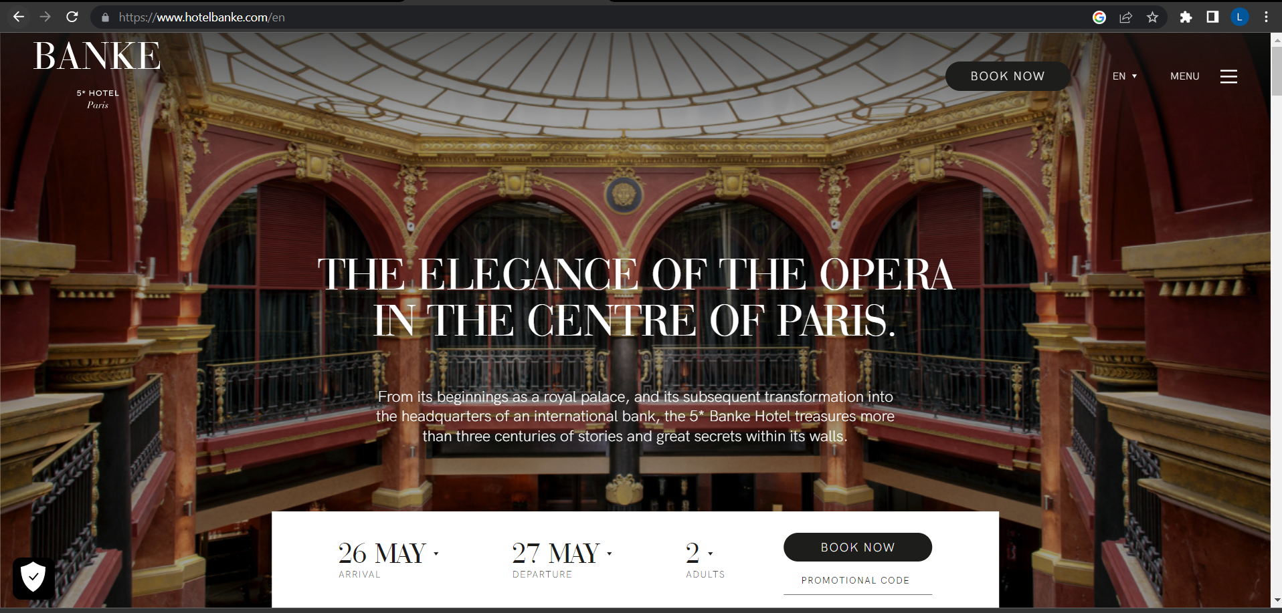
Figure 1: Hotel Website View
(Source: Banke Hotel, 2022)
Visitor feedback confirming Banke Hotel's commitment to provide exceptional service, cleanliness, and value for money. The helpful staff of the hotel has received praise from several guests for going above and beyond to make their stay special. The chain is well-known and has a loyal following in part because of its reputation for providing consistent quality across all of its locations (Bas and Sivaprasad, 2021). But it is important to keep in mind that Banke Hotel could occasionally have issues. Even though negative media attention tends to be infrequent, it is crucial to be aware of any such incidents that could have impacted the hotel's reputation. However, the most current data show that Banke Hotel has maintained a strong reputation as a reliable and trustworthy hotel choice.
Additionally, Banke Hotel has established a reputation as a well-liked venue for a range of events, including weddings. Its well-equipped event facilities and skilled staff have earned it a reputation as a top choice for hosting immaculate and unforgettable weddings. This positive reputation further elevates Banke Hotel's standing in the hotel industry (Atasoy et al.2022). The history of Banke Hotel, which includes its location, range of rooms, age of the hotels, present opinions, and reputation for staging special events, provides readers with crucial information about the hotel's activities. This extensive introduction sets the stage for the subsequent analysis and recommendations, enabling readers to understand the potential impacts of the ideas on the organisation.
PESTLE Analysis
PESTLE analysis is an effective method for evaluating the macroenvironmental elements that may have an impact on an organisation. A PESTLE study of Banke Hotel, a well-known hotel in Paris, is provided below:
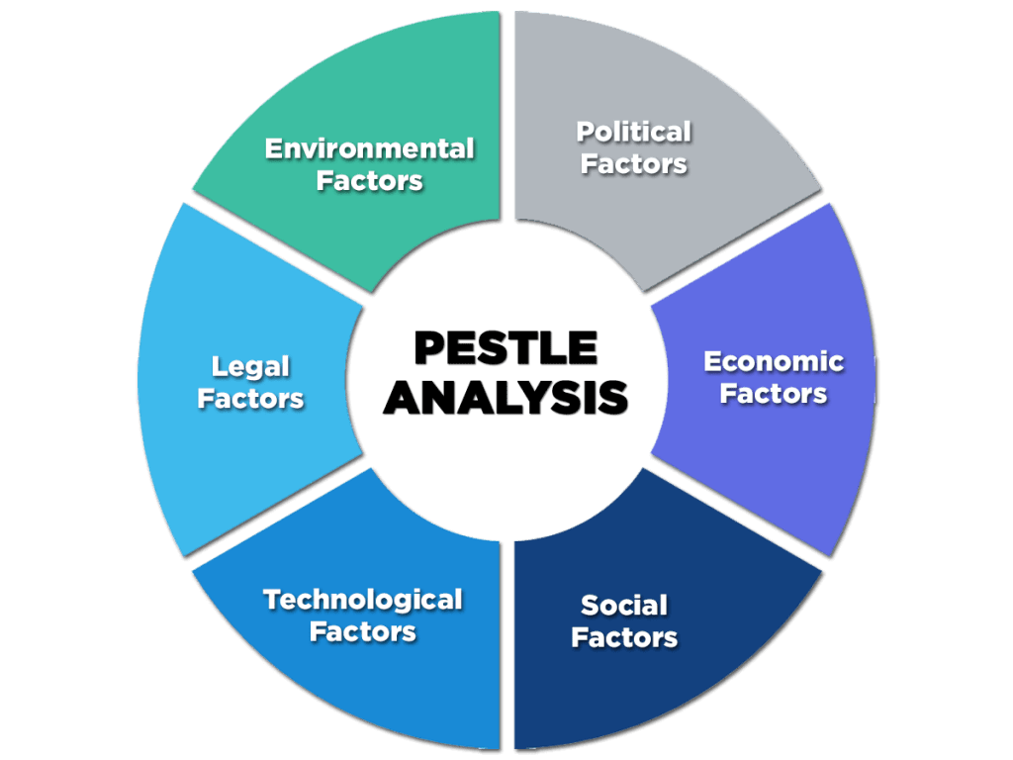
Figure 2: PESTLE Analysis
(Source: Filimonau and Magklaropoulou, 2020)
Political Factor | Banke Hotel operates in a politically stable environment in Paris. Initiatives of the government in the fields of hospitality, travel, and tourism might have a significant effect on the hotel industry. Tax regulations, employment rules, and laws controlling health and safety are just a few examples of the factors that may have an influence on Banke Hotel's operations (Volodymyrivna and Andriyich, 2019). International relations and political stability might also affect traveller arrivals, which could affect hotel occupancy rates.
Economic Factor | The performance of Banke Hotel is greatly influenced by the status of the economy. GDP growth, inflation rates, currency exchange rates, and consumer spending trends are important considerations. The earnings of Banke Hotel may be impacted by economic ups and downs as they relate to travel and tourism (Anilkumar et al., 2023). Economic conditions may also have an influence on corporate alliances and business travel, which may have an impact on the demand for hotel rooms.
Social Factor | Sociocultural factors, which also have an impact on consumer behaviour and preferences, have an impact on the demand for hotel services. Changing demographics, popular cultural trends, and lifestyle choices may have an influence on the target market for Banke Hotel (Bekbulatova et al. 2022). A variety of factors, such as evolving travel preferences, a focus on sustainability, and a desire for unique experiences, might affect customers' expectations, which can subsequently have an impact on Banke Hotel's promotions and marketing initiatives.
Technological Factor | Technological advancements have a big influence on the hospitality industry. Banke Hotel must stay current with new technology advancements in order to remain competitive. Technology has an influence on a variety of sectors, including online reservation systems, customer experience management, data analytics, and operational efficiency. Banke Hotel must stay current with technology advancements in order to enhance client experiences and streamline operations. (2002) (Daskalaki and Hyams-Ssekasi).
Environmental Factor | Environmental factors have increased in significance for the hotel sector. Banke Hotel must employ eco-friendly practices to address sustainability and environmental issues. Maintaining a favourable image and exceeding client expectations depends on factors like energy efficiency, waste management, and carbon footprint reduction (Zeng, 2021).
Legal Factor | The legal environment has an impact on how Banke Hotel operates and what constitutes compliance. It is necessary to follow all applicable labour, health and safety, data protection, and accessibility laws and regulations. To keep the hotel's image intact and stay out of legal trouble, compliance with these rules is imperative (Freeman, 2020).
Table 1: PESTLE Analysis
(Source: Written by Researcher)
Overall, the political, economic, social, technical, environmental, and legal aspects that influence Banke Hotel's operational environment must be continually monitored and adjusted. The hotel chain may find opportunities, reduce risks, and align its goals with the larger macroenvironmental landscape by being aware of these elements.
SWOT Analysis
An organisation's internal strengths and weaknesses, as well as the external opportunities and dangers it confronts, may all be assessed using the SWOT analysis. This is Banke Hotel's SWOT analysis:
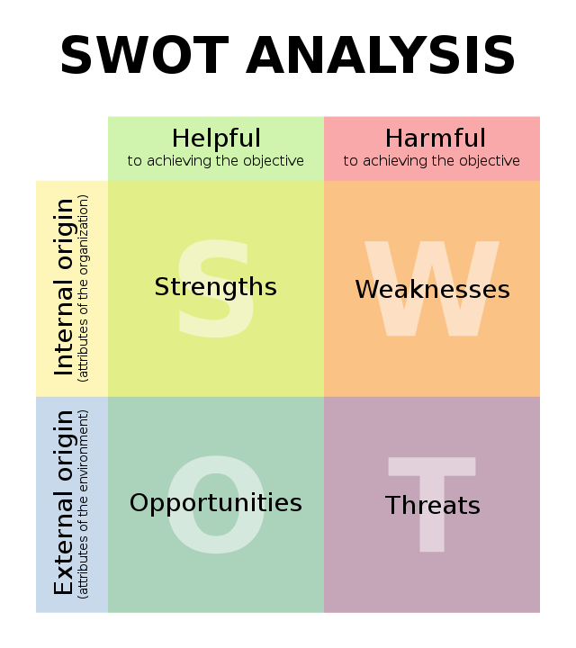
Figure 3: SWOT Analysis
(Source: Marwani et al. 2023)
Strengths  - The hotel maintains a high degree of cleanliness, comfort, and customer service.  - The hotel has a very strong recognition in Paris.  - The hotel has a very wide variety of networks that serve to make it accessible to the guests.. | Weaknesses  - The activities of the hotel are heavily dependent on the Paris market, making it subject to changes in the market.  - Although the Banke Hotel is present across Paris, its foreign footprint is quite restricted in comparison to other competitors in the market.  - The hotel provides rooms at a very affordable range which may result in limited presence of amenities (Floričić, 2023).
Opportunity  - Banke Hotel has potential to develop its footprint in foreign markets by utilising expanding tourist industries throughout the world (Gordon et al. 2019).  - By putting in place sustainable measures, the hotel chain may profit from the rising demand for eco-friendly practices. | Threats  - The hotel sector is heavily contested by other well-known hotel chains, independent hotels, and various types of lodging including vacation rentals.  - The travel and hospitality sectors may be impacted by economic downturns or modifications in consumer purchasing habits, which might have an influence on Banke Hotel's occupancy rates.
Table 2: SWOT Analysis
(Source: Written by Researcher)
TOWS Analysis
To design strategies that balance internal strengths and weaknesses with external opportunities and threats, a TOWS analysis incorporates the results of the SWOT analysis. The TOWS study for Banke Hotel is as follows:
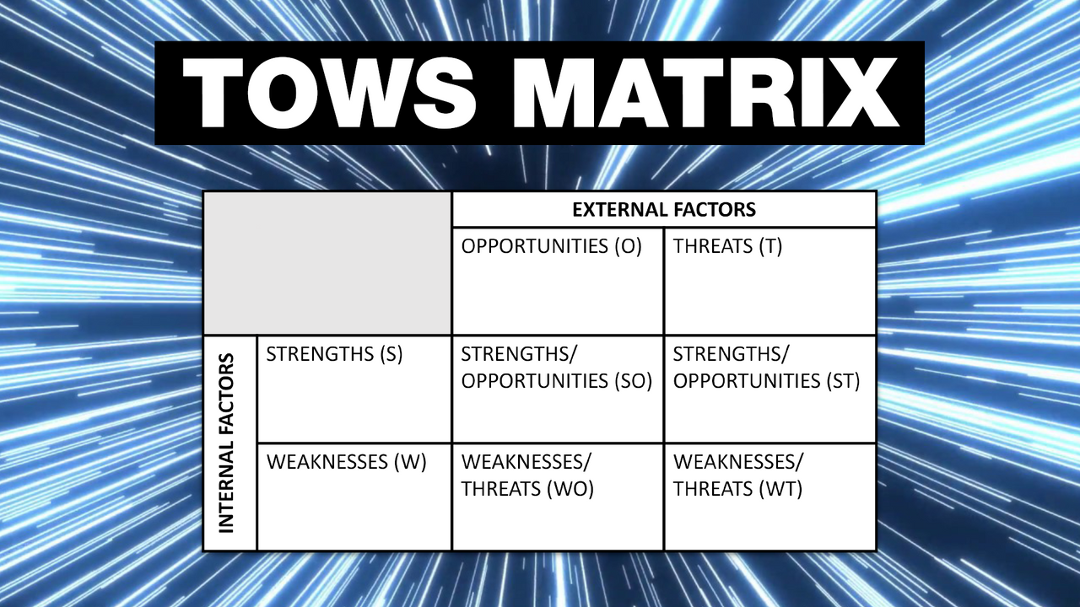
Figure 4: TOWS Matrix
(Source: Giglio et al. 2020)
Strengths-Opportunities (SO) Strategies | Profit from the increasing travel and tourism industries by entering new international markets and utilising Banke Hotel's strong image and extensive network. To enhance visitor experiences and pull in a broader audience, form partnerships with adjacent businesses and tourist destinations (Abdelmoaty and Soliman, 2020).
Strengths-Threats (ST) Strategies | Banke Hotel should emphasise its trustworthy quality and excellent customer service in order to combat the risk of strong competition. To distinguish out as a and draw in environmentally conscious travellers, emphasise sustainability initiatives and eco-friendly practises. This strategy could help the hotel chain stand out in a crowded market and attract customers who appreciate green products (Octafilia and Amin, 2022).
Weaknesses-Opportunities (WO) Strategies | By carefully entering growing tourism areas and forming alliances with large hotel chains, you may address your lack of worldwide presence. Increase the selection of amenities available to meet a wide variety of client tastes and draw visitors looking for a more upmarket experience (Huang et al. 2022). Utilising new consumer segments and diversifying its products are both possible with this tactic for Banke Hotel.
Weaknesses-Threats (WT) Strategies | Utilise cost-cutting techniques without compromising quality, such as supply chain management and optimising energy utilisation, to lessen the consequences of economic volatility. To maintain current customers and encourage repeat business, improve your customer loyalty programmes (Sinha and FParisey, 2020). This will help you reduce your dependency on the Paris market and lessen your risk of changing travel patterns.
Table 3: TOWS Analysis
(Source: Written by Researcher)

3. Improvements that can be done in the operations of the Hotel
The operations of Banke Hotel may be improved in a number of ways to improve the overall visitor experience and handle any problems. The recommendations listed below may be taken into consideration based on the study completed:
Providing Training to Staff for skill development
To ensure a continual level of service quality, The Banke Hotel can enhance its employee training programmes. This requires providing in-depth instruction in communication, problem-solving, and customer service (Pallathadka & Pallathadka, 2022). The addition of specific training modules on environmentally conscious behaviour and sustainable practises can also help to build a sustainability culture inside the firm.
Collecting feedback from the customer
Customers' comments on review websites should be continuously monitored and addressed by Banke Hotel. The hotel may show its dedication to patron happiness and highlight its readiness to handle any issues by swiftly and aggressively resolving complaints. This strategy will help the hotel gain a better reputation and draw in more visitors.
Promoting Sustainability
Any environmental issues may be resolved by Banke Hotel throughout all of its activities by using energy-efficient practises (Zhang et al. 2022). This means supporting water- and energy-saving behaviours as well as investing in energy-saving technologies like smart thermostats and LED lighting. By implementing waste management systems and assisting recycling initiatives, the hotel may further enhance its environmental performance.
Refurbishment of Rooms
It is crucial to regularly evaluate the state of hotel rooms and start renovation operations when necessary. Renovations should be given first priority at Banke Hotel to keep the rooms up-to-date, cosy, and aesthetically pleasing. To adapt to shifting visitor expectations, this involves updating the furnishings, fittings, and services.
Integration of Technology into operations
The Banke Hotel may consider employing technology to increase operating efficiency and enhance visitor experiences. Utilising a user-friendly mobile app might streamline operations and make it easier for customers to make reservations and complete check-ins and check-outs. By understanding client preferences and personalising services, data analytics may further increase customer satisfaction. (Filimonau and Koiwanit, 2021).
Getting connected with local businesses
Creating alliances with nearby companies may provide Banke Hotel visitors a distinctive and genuine experience (Sadhale, 2023). A great stay may be provided to visitors by collaborating with neighbourhood tour companies, eateries, and attractions to give personalised suggestions and packaged deals. This may set Banke Hotel apart from other hotels and draw in a larger spectrum of visitors.
Motivating Employees
Banke Hotel may set up employee recognition programmes and incentives to inspire and keep skilled workers. Employee morale may be raised and a good work atmosphere can be fostered by recognising excellent performance and offering chances for career advancement and development (Abdurrahman, 2023). Employee engagement increases the likelihood that guests will receive excellent service.
Engagement with Community
Banke Hotel may actively participate in the neighbourhood through programmes like volunteerism, philanthropic alliances, or event sponsorship. This participation shows the hotel's dedication to social responsibility and improves its ties to the neighbourhood.
Building a Continuous improvement environment
Fostering a culture of continuous improvement is crucial for Banke Hotel to be successful in the long run. Encourage customer feedback, value staff suggestions for process changes, and conduct frequent performance evaluations to foster a culture of learning and innovation (Yuliantari and Martini, 2019).
These changes should be prioritised based on their potential influence, cost-effectiveness, and feasibility within the organisational environment. Banke Hotel should regularly evaluate the application and usefulness of these recommendations and make adjustments as needed to sustain success in the always evolving hospitality industry.

7. Recommendations
The following are the recommendations that can be used to make enhancements in the performance of the hotel.
- First, improving personnel development and training programmes will guarantee constant service quality and encourage a sustainable culture inside the organisation. To handle customer issues swiftly and proactively, strengthening feedback and review management is essential (Dutta et al. 2022). Using the input to guide operational improvements and deliver individualised experiences.
- Through the implementation of energy-efficient practises, water conservation measures, and comprehensive waste management systems, the hotel's commitment to sustainability is in line with the improvement of environmental sustainability. Making an investment in room refurbishment, using sustainable design principles, and enhancing utilities can help meet visitor expectations and provide a modern, pleasant environment (Aroul et al. 2023).
- Utilising technology through a user-friendly mobile app, data analytics for tailored services, and cutting-edge guest management systems will streamline operations and boost efficiency (Lu and Tabari, 2019). Working with nearby businesses, offering package deals, and participating in neighbourhood projects will strengthen the hotel's ties to the area.
- Talented employees will be motivated and retained by putting in place employee recognition programmes, providing professional development opportunities, and offering competitive pay and benefits (Waliaula and Mbogo, 2022).
- If a culture of continual development is encouraged, market trends are tracked, and competitors are benchmarked, the hotel will remain competitive and adaptable. These recommendations can aid Banke Hotel in enhancing operations, differentiating itself from rivals, and offering unique client experiences (Blinova et al. 2021).
- Use self-service kiosks or mobile check-in to reduce wait times and enhance customer convenience. Provide clear directions and signage to help people check in and exit.
- By doing market research to learn about client preferences, you may develop a menu that is varied and can satisfy a range of dietary requirements and palates (Eyres et al., 2020). Use sustainable and local ingredients to develop environmentally sound practises and the local economy.
- Utilise dynamic pricing strategies to raise revenue and occupancy rates based on market demand and competition information. To increase supplemental revenue, employ cross-selling and upselling techniques that are effective (Handoko et al. 2022).
- Enhance cleaning practises to keep public areas and guest rooms consistently spotless and organised. Quality control techniques and routine inspections are necessary to maintain high standards of cleanliness (Bharwani and Mathews, 2021).
- Install voice-activated devices, fast internet, and smart TVs in guest rooms to provide them a seamless and modern stay (Horng et al. 2022). Offer useful services like a digital concierge and automated room systems to personalise guest stays.
- Especially in light of the COVID-19 epidemic, implement thorough health and safety policies to safeguard the wellbeing of visitors and employees (Papadopoulos et al. 2021). Regularly sanitise high-touch areas and instruct personnel on good sanitation practices.
- Take part in philanthropic partnerships and initiatives that advance charitable causes and the hotel's principles. Make guests aware of CSR activities to enhance the hotel's reputation and attract socially conscious travellers (Ratnasari et al. 2020).
- Develop specialised marketing plans that speak to certain clientele and emphasise the hotel's selling points. To engage clients and increase recognition, use social media platforms and digital marketing technologies (Sinha and Ekka, 2021).
- Promote interdepartmental collaboration and information sharing to improve communication and operational performance (Kumicki and Ku, 2019). To foster a collaborative workplace, organise training sessions and team meetings on a regular basis.

8. Conclusion
The investigation of Banke Hotel, one of Paris' well-known hotels, has, in the end, illuminated a number of its operating characteristics. The hotel's strengths, weaknesses, opportunities, and threats have been thoroughly analysed using techniques including PESTLE, SWOT, and TOWS evaluations. The Banke Hotel's great reputation as an event space, superb location, and ample room selection all contribute significantly to its success. However, a number of challenges and potential growth areas have also been recognised. Among these are improved waste management practises, room upgrades, enhanced personnel training, and an improved feedback management system.
A number of suggestions have been made to remedy these problems. These suggestions cover topics like employee appreciation, community involvement, environmental sustainability, technical improvements, feedback management, employee training and development, and continual improvement. Banke Hotel may enhance its operations, client experience, and general competitiveness in the hospitality sector by putting these suggestions into practice. It is crucial to emphasise that ongoing monitoring, adaptation, and assessment are necessary for these guidelines to be successful. In order to remain competitive, Banke Hotel must constantly monitor market developments, consumer preferences, and technology advances. Banke Hotel can further establish its position as the top hotel in Paris market by keeping a proactive attitude and developing a culture of continual development.
The study underlines the necessity of addressing the identified challenges and putting the suggested solutions into practise in order to achieve operational excellence, sustainability, and greater guest satisfaction. Banke Hotel has the chance to expand on its present strengths while minimising its shortcomings, grabbing opportunities, and fending off threats in order to become a top choice for both leisure and business guests.

Reference List
Abdelmoaty, G.A. and Soliman, S.A.E.M., 2020. Smart Technology Applications in Tourism and Hospitality Industry of The New Administrative Capital, Egypt. Journal of Association of Arab Universities for Tourism and Hospitality, 19(2), pp.102-129.
Abdurrahman, S.R., 2023. Pemanfaatan Desain Parametrik Dalam Perancangan ProdParis Keramik Dengan Visual Motif Tradisional (Studi Kasus: Hotel Best Western Premier La Grande).
Anilkumar, S., Koppar, R. and Baruah, P.,2023. Sustainability in Waste Management a Study of International Hotels-A Review of Literatures. Emerging Aspects of Redefining Tourism & Hospitality, p.164.
Aroul, R.R., Hodari, D., Bianchi, G. and Martignoni, G., 2023. The impact of affiliation on asset values: the case of PARIS hotels. Journal of Property Research, 40(2), pp.157-187.
Atasoy, B., Türkay, O. and Şengül, S., 2022. Strategic responses of chain hotels to COVID-19 from a situational crisis communication theory perspective. Journal of Hospitality and Tourism Insights.
Bas, T. and Sivaprasad, S., 2021. COVID-19 and Implications for Future Trends in Paris Travel and Tourism Sector. Available at SSRN 3623404.
Bekbulatova, A., Syzdykbayeva, B., Agybetova, R., Dulatbekova, Z. and Akimov, Z., 2022. Evaluation of the Main Performance Indicators of 4 and 5-Star Hotels using the Example of the Nur-Sultan City, Kazakhstan. Journal of Environmental Management & Tourism, 13(2), pp.497-506.
Bharwani, S. and Mathews, D., 2021. Techno-business strategies for enhancing guest experience in luxury hotels: a managerial perspective. Worldwide Hospitality and Tourism Themes, 13(2), pp.168-185.
Blinova, E., Gregorić, M., Rončević, A. and Skryl, T., 2021. CSR FOCUS OF HIGHLY RATED INTERNATIONAL HOTELS OPERATING IN RUSSIA AND CROATIA AS REPRESENTED ON THEIR WEB-SITES IN THE PERIOD OF COVID-19 PANDEMIA. In 10th International Scientific Symposium on Region, Entrepreneurship, Development (RED) (pp. 17-28).
Daskalaki, E. and Hyams-Ssekasi, D., 2022. Unravelling Entrepreneurship and Innovation Within the Hospitality Industry: A Case Study of Selected Hotels in Cyprus. In Entrepreneurship and Change: Understanding Entrepreneurialism as a Driver of Transformation (pp. 239-267). Cham: Springer International Publishing.
Dutta, V., Haldar, S., Kaur, P. and Gajpal, Y., 2022. Comparative Analysis of TOPSIS and TODIM for the Performance Evaluation of Foreign Players in Indian Premier League. Complexity, 2022.
Eyres, L., Deakin, V. and Mackie, P., 2020. Local Economic Change and Regeneration in Felixstowe Following the 2012 Coastal Resilience Project–A Case Study. Coastal Management 2019: Joining forces to shape our future coasts, pp.487-499.
Filimonau, V. and Magklaropoulou, A., 2020. Exploring the viability of a new ‘pay-as-you-use’energy management model in budget hotels. International Journal of Hospitality Management, 89, p.102538.
Floričić, L.P.I.S.T.,2023. Preffered E-Promotion Strategies of International Hotel Chains–Insights and Evaluation. Innovation Management, Entrepreneurship and Sustainability, p.716.
Freeman, J., 2020. On Determining the Value of Online Customer Satisfaction Ratings–A Case‐based Appraisal. Data Analysis and Applications 3: Computational, Classification, Financial, Statistical and Stochastic Methods, 5, pp.195-214.
Giglio, S., Pantano, E., Bilotta, E. and Melewar, T.C., 2020. ing luxury hotels: Evidence from the analysis of consumers’“big” visual data on TripAdvisor. Journal of business research, 119, pp.495-501.
Giousmpasoglou, C. and Hua, T.T., 2020. The use of self-service technologies in budget hotels: the case of bournemouth. European Journal of Tourism, Hospitality and Recreation, 10(3), pp.251-261.
Gordon, S., Adler, H., Day, J. and Sydnor, S., 2019. Perceived supervisor support: A study of select-service hotel employees. Journal of hospitality and Tourism Management, 38, pp.82-90.
Gupta, K. and Sharma, S., 2021. Kiosks as self-service technology in hotels: opportunities and challenges. Worldwide Hospitality and Tourism Themes, 13(2), pp.236-251.
Handoko, J.P.S., Kusumawanto, A. and Dharoko, A., 2022. Spatial Configuration Changes as a Form of Residential Adaptation in Urban Settlements in Indonesia: A Case Study of an Urban Settlement in Yogyakarta City Center in 1980 to 2020. The International Journal of Architectonic, Spatial, and Environmental Design, 17(2), p.131.
Horng, J.S., Liu, C.H., Chou, S.F., Yu, T.Y. and Hu, D.C., 2022. Role of big data capabilities in enhancing competitive advantage and performance in the hospitality sector: Knowledge-based dynamic capabilities view. Journal of Hospitality and Tourism Management, 51, pp.22-38.
Huang, A., Chao, Y., de la Mora Velasco, E., Bilgihan, A. and Wei, W., 2022. When artificial intelligence meets the hospitality and tourism industry: an assessment framework to inform theory and management. Journal of Hospitality and Tourism Insights, 5(5), pp.1080-1100.
Koiwanit, J. and Filimonau, V., 2021. Carbon footprint assessment of home-stays in Thailand. Resources, Conservation and Recycling, 164, p.105123.
Kuźmicki, M. and Kuś, A., 2019. Technological environment as a factor of development for enterprises providing accommodation services. Economic and Regional Studies/Studia Ekonomiczne i Regionalne, 12(3), pp.275-286.
Lu, L. and Tabari, S., 2019. Impact of Airbnb on customers' behavior in Paris hotel industry. Tourism Analysis, 24(1), pp.13-26.
Marwani, I.S., Darmawan, H. and Kalsum, E.U., 2023. Influence Implementation of CHSE, Prices and Facilities for Decisions to Stay During the COVID-19 Pandemic at Non-Star Resort Hotels. NHI HOSPITALITY INTERNATIONAL JOURNAL, 1(1), pp.39-54.
Negi, D.S. and Lohani, S., Growing Popularity of Budget Hotels in India. Bharti Publications, p.254.
Octafilia, Y. and Amin, A.M., 2022, March. MARKETING STRATEGIES TOWARD DIRECT AND INDIRECT PURCHASING AT THE PREMIERE HOTEL PEKANBARU. In International Conference of Business and Social Sciences (pp. 461-473).
Pallathadka, H. and Pallathadka, L.K., 2022. Role of FDI in Encouraging Hospitality Sector in the Changing Economic Environment: An Empirical Study. Journal of Contemporary Issues in Business and Government Vol, 28(3).
Papadopoulos, O., Lopez‐Andreu, M. and Jamalian, M., 2021. Violation and lack of awareness of employment rights in Paris's hotel industry: Isolation, fragmentation and barriers to labour enforcement. Industrial Relations Journal, 52(4), pp.315-330.
Banke Hotel. (2022). Financial Report: https://www.hotelbanke.com/en
Ratnasari, C., Setiawan, D.W. and Harsritanto, B.I., 2020. The Application of Artificial Lighting in Hotel Room: Grand Anugerah Hotel and Sae inn, Kendal. MAJ-Malaysia Architectural Journal, 2(1), pp.25-33.
Sadhale, M.V., 2023. A study of customer engagement as a business strategy with reference to five star hotels in pune city (Doctoral dissertation, Tilak Maharashtra Vidyapeeth).
Sinha, A.K. and Ekka, P., 2021. Hospitality Industry of India-Its present status and future prospects. The Researchers' International Research Journal, 7(1), pp.85-95.
Sinha, M. and FParisey, L.N., 2020. Circular Economy: Assessing a Progress of Resources Efficient Practices in Hotel Industry. In Circular Economy for the Management of Operations (pp. 89-117). CRC Press.
Volodymyrivna, F.S. and Andriyich, T.S., 2019. DEVELOPMENT TRENDS OF HOTEL CHAINS IN PARISRAINE. ENTERPRISES IN THE MODERN BUSINESS ENVIRONMENT 9, p.22.
Waliaula, S. and Mbogo, F., 2022. Leisure, English Premier League soccer spectatorship and social identities in Nairobi and Eldoret, Kenya. Soccer & Society, 23(8), pp.909-919.
Yuliantari, P.D. and Martini, I.A.O., 2019. Implementation Of Human Resource Development To Improve Employee Performance. International Research Journal Of Management, IT And Social Sciences, 6(6), pp.194-200.
Zeng, L., 2021. Analysis of Hilton Worldwide Hotel Group’s Transnational Operation Strategy. Academic Journal of Business & Management, 3(11), pp.20-27.
Zhang, X., Tavitiyaman, P. and Tsang, W.Y., 2022. Preferences of Technology Amenities, Satisfaction and Behavioral Intention: The Perspective of Hotel Guests in Hong Kong. Journal of Quality Assurance in Hospitality & Tourism, pp.1-31.

