Foreign Languages & Cultural Awareness
BMIH5003
Lecture'r name: Antoinette Milne
Student Name:Catalina Coman
Student ID:2238715
[Word Count: 2000]

Table of Contents
1 Component 1 - Professional Reflection 3
2 Component 2 – Training Plan 5
3 Component 3 – Student Self-Reflection 8
1.1 Discroll Reflective Model 8
3.1.1 What? 8
3.1.2 So What? 8
3.1.3 Now What? 8
4 Component 4 – Training Presentation 10
5 References 15

Component 1 - Professional Reflection
Cultural misunderstanding is quite common as it occurs because of lack of cultural sensitivity and awareness (Daskalaki, 2020). One of these things happened to me while I was working as a waiter at Premier Inn hotel. One of the French couples staying at the hotel, got furious and disappointed because of my lack of care. The menu was in front of the couple as the wife spoke quickly in French. Because I was in a hurry to serve them, I thought they wanted to place an order right away, so I started listing the dinner offers in English. Upon hearing it, they wrinkled their face in fury and answered in French. As the wife waved at me as she was as puzzled as I was, I knew I had done something very wrong. It is true that I did not get to know each other well because of the guests' preferred language, and I should have known better than to ignore it. Quite likely the beginning of serving the customer is to ask him if he or she uses a French language or not. I turned them down because i thought they spoke English fluently and immediately shift to English. Due to this mistake, the guests were confused, the conversation ended, and they might have been offended (Manoharan et al., 2021).
Because of this incident, I must try more to learn about other cultures and especially when I want to understand other people's ways that they choose to show themselves. If I want to provide great service, I should be aware that the guests can have different language needs and tastes. I need to do this by observing the guest's tone of voice, body language, and his/her favorite way of communication. I should not make assumptions about the people based on my own cultural norms. On the other hand, I should listen to them and work out a solution that will please them. Through the facial and body gestures, it is easy to know how confident they are by the way they speak the words and sentences need to use (Yang et al., 2022). I need to work on my language skills, especially with languages that hotel guests speak. It is not always possible to speak more than one language but learning a few key languages can be of great help in the process of guest happiness and avoiding mistakes. I will try to take a language course or discover another way to master a new language for this purpose. I also need to put active listening and understanding at the top of my list of priorities. If I pay attention to what they say, I can change how I do things to meet their needs and make sure they have a wonderful time. I should push myself to learn and get better. Because becoming culturally competent is an ongoing process, I need to keep an open mind and be eager to learn. Improving my knowledge, language skills, and understanding attitude will help me avoid future mistakes and give great service to people while working in Premier Inn.

Component 2 – Training Plan
Skill Gap Analysis | Training Goals | Success Metrics | Timeframe | Training and Format Materials | Support System
- Language Awareness | - To let staff know how important it is to recognize and allow people to use the language they prefer. | - A bigger number of workers who are sure they can figure out and meet guests' language needs based on tests they took before and after training. | - This will take almost 8 months. | - The training will talk about cues like body language and face reactions in class.  - As part of the training, staff will practice speaking the guest's language by playing different roles.  - Staff can use language choice cards while talking to customers with this method (Sull et al., 2020).  - Video lessons or online classes can help to learn how to talk to people well in two languages. | - During normal business activities, managers will give advice and go over training ideas again.
- Cultural Sensitivity | - To make staff more aware of culture norms and differences can make the place more welcome and flexible for people from. | - Cutting down on the number of complaints from tourists about culture misunderstandings, as shown by surveys and guest reviews. | - It will take around 6 to 7 months to reduce this skills gap. | - There will be classes on proper behaviour and how to deal with culture differences.  - Case studies or events that show cultural mistakes and how to avoid them. | - Encouraging people to work together and share knowledge to make the group better.  - The creation of a partner system so that more experienced workers can help train and guide new workers.
- Effective Communication | - To teach workers better ways about what they want to have to say so they can help customers and give them information even if they do not speak the same language. | - Surveys and reviews done after training show that better communication and participation among staff members lead to higher levels of guest happiness. | - It will take approximately 9 to 10 months. | - Conversation skills workshops that teach people how to listen carefully, say what they mean clearly, and show understanding (Costa-jussà et al., 2022).  - Language and conversation classes for guests that are based on the languages they use most.  - Learn how to deal with difficult speaking situations, like when people from different countries or languages are talking to each other (Yang et al., 2020).  - Individualized coaching and constructive criticism can help staff members improve their speaking skills. | - An idea box where workers can tell management how the training went and what they think could do better without giving their names.  - Holding regular meetings with managers to talk about success and find ways to make things better.

Component 3 – Student Self-Reflection

Disc roll Reflective Model

What?
When I first started looking into the hotel business, I did not fully understand how important it was to understand other cultures. I knew it was important to respect other cultures when they came to visit, but I did not fully understand how small differences in how people talk can cause problems. I understand that cultural awareness is significant when it comes to offering exceptional services to guests and promoting teamwork (Yeşiltaş et al., 2022).

So What?
Being culturally aware means more than just being nice which means understanding and meeting the specific needs and standards of each guest (Jhaiyanuntana and Nomnian, 2020). Because of the incident that happened I have learnt that the guests were disappointed, because of a lack of cultural awareness and understanding. I thought they can talk well in English. When I realized this, I changed how I do things and now I make cultural issues a focus in everything I do. For example, I met a Chinese family again after the meeting with the French couple, and they did not like how honest I was with them. I did not try to be too bossy, I let them look over the food at their own pace and then offered to help when they were ready.

Now What?
As I work in the Premier Inn and wish to pursue my career more in the hotel business in the future, I want to make it a priority to learn more about other cultures. I can reach this goal if I keep learning new things. I can also do this by taking real steps to improve my skills and ability to change. To learn more about different cultures, I want to do things like actively seek out reading that is culturally diverse, go to cultural events, and have relaxed talks with guests and coworkers (Oriade et al., 2021). For example, I learned about different ways to communicate and cultural values when I took a recent class on ethnic variety in the hotel business.
I found out more and got advice on how to better connect with guests. I will also like to keep improving my language skills, especially when it comes to the languages that people at the hotel speak. Using apps to learn languages and practicing basic words in important languages like Spanish and Mandarin has already helped me connect with my friends more deeply. I know that being culturally competent also means constantly thinking about myself and giving myself helpful feedback. By repeatedly reviewing my activities, I will improve how I do things and better meet the needs of all guests.

Component 4 – Training Presentation
Slide 1: Title
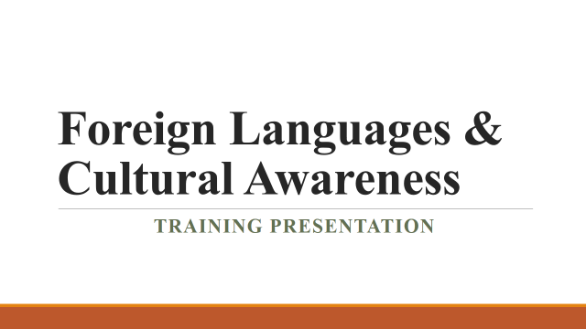
Slide 2: Introduction
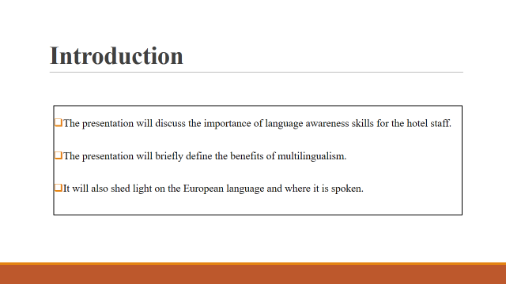
The presentation will discuss the importance of language awareness skills for the hotel staff. The presentation will briefly define the benefits of multilingualism. It will also shed light on the European language and where it is spoken. ￼
Slide 3: Benefits of Multilingualism
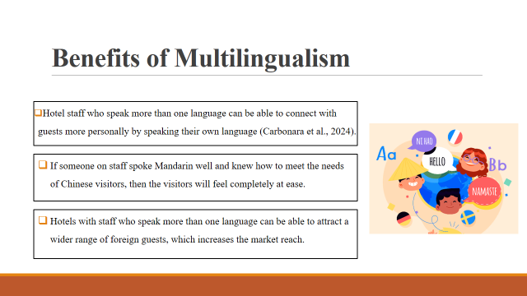
Hotels should think about providing services in the languages customers choose to stand out in the competitive global hospitality business and bring in a wider range of customers. Customers who are having trouble speaking or who need help usually find it helpful when workers speak more than one language. If the front desk person speaks more than one language, visitors will have a better time because they will be able to get help with their problems and get useful information in the language that works best for them.
Slide 4: Importance of Language Awareness Skills for Hotel Staff
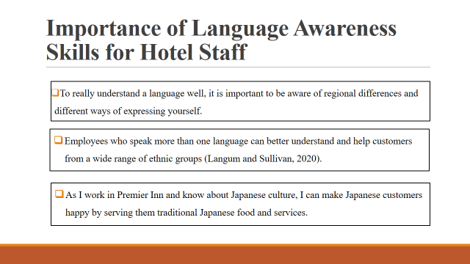
Language awareness is good for all customers and makes it less likely that rules will be broken by mistake. In addition, hotels that stress about language skills show they care about their guests and want everyone to feel welcome, no matter what culture they come from (Jayanath, 2021). This brings more attention to the hotel, which leads to more bookings and positive word-of-mouth from happy guests.
Slide 5: European Language – French
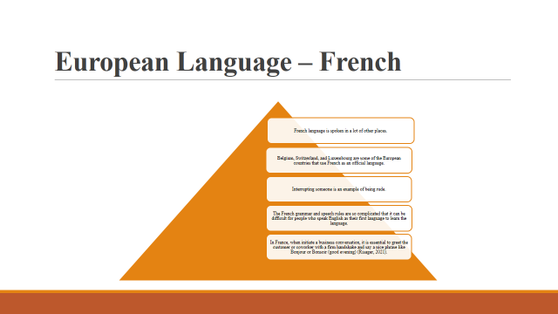
French is also spoken in some areas of Canada and other parts of Africa (Uzum et al., 2021). Yet, a great number of people say that they can speak French if they persevere and work hard enough. In order to be polite in business, should call someone by their last name and the title Monsieur (Mr.) or Madame (Mrs./Ms.). “S'il vous plait” (which means please) and “Merci” (which means thank you) are important French phrases to know for business conversations. In French business culture, cutting someone off in the middle of a sentence is often seen as rude.
Slide 6: Conclusion
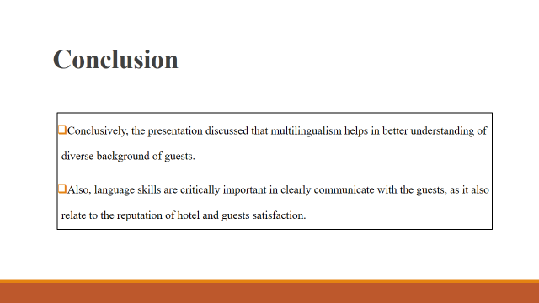
Conclusively, the presentation discussed that multilingualism helps in better understanding of diverse background of guests. Language skills are critically important in communicating with the guests, as they also relate to the reputation of the hotel and guests' satisfaction.
Slide 7: References
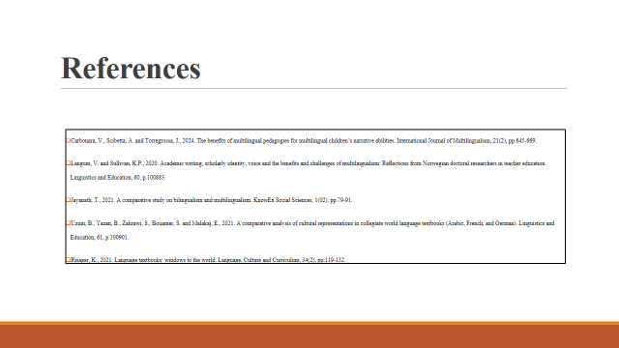

References
Carbonara, V., Scibetta, A. and Torregrossa, J., 2024. The benefits of multilingual pedagogies for multilingual children’s narrative abilities. International Journal of Multilingualism, 21(2), pp.645-669.
Costa-jussà, M.R., Cross, J., Çelebi, O., Elbayad, M., Heafield, K., Heffernan, K., Kalbassi, E., Lam, J., Licht, D., Maillard, J. and Sun, A., 2022. No language left behind: Scaling human-centered machine translation. arXiv preprint arXiv:2207.04672.
Daskalaki, E., 2020. Cultural Diversity and Indicated Intercultural Implications in the Hotel Working Environment in the United Kingdom: Underpinning the Employee’s Perspective. The Market: International Journal of Business, 1, pp.91-107.
Jayanath, T., 2021. A comparative study on bilingualism and multilingualism. KnowEx Social Sciences, 1(02), pp.79-91.
Jhaiyanuntana, A. and Nomnian, S., 2020. Intercultural communication challenges and strategies for the Thai undergraduate hotel interns. PASAA: Journal of Language Teaching and Learning in Thailand, 59, pp.204-235.
Langum, V. and Sullivan, K.P., 2020. Academic writing, scholarly identity, voice and the benefits and challenges of multilingualism: Reflections from Norwegian doctoral researchers in teacher education. Linguistics and Education, 60, p.100883.
Manoharan, A., Gross, M.J. and Sardeshmukh, S.R., 2021. Antecedents and outcomes of a culturally diverse workforce in hotels. Journal of Hospitality & Tourism Research, 45(8), pp.1383-1416.
Oriade, A., Osinaike, A., Aduhene, K. and Wang, Y., 2021. Sustainability awareness, management practices and organisational culture in hotels: Evidence from developing countries. International Journal of Hospitality Management, 92, p.102699.
Risager, K., 2021. Language textbooks: windows to the world. Language, Culture and Curriculum, 34(2), pp.119-132.
Sull, D., Sull, C. and Bersin, J., 2020. Five ways leaders can support remote work. MIT Sloan Management Review.
Uzum, B., Yazan, B., Zahrawi, S., Bouamer, S. and Malakaj, E., 2021. A comparative analysis of cultural representations in collegiate world language textbooks (Arabic, French, and German). Linguistics and Education, 61, p.100901.
Yang, C.E., Wang, Y.C. and Yang, J., 2020. Hotel restaurant service employees’ sources of positive and negative emotions. Journal of Quality Assurance in Hospitality & Tourism, 21(5), pp.542-563.
Yang, H., Cheung, C. and Li, W., 2022. Intercultural communication competency practices in the hotel industry. Journal of China Tourism Research, 18(1), pp.162-184.
Yeşiltaş, M., Gürlek, M. and Kenar, G., 2022. Organizational green culture and green employee behavior: Differences between green and non-green hotels. Journal of Cleaner Production, 343, p.131051.

