

Assignment 2

Name: Gianina-Maricica Chirila
Student ID: 2131738
Module code: LCBB4004
Module name: Marketing Fundamentals
Lecturer: Piyumika Gamage
Date: 30.04.2023

Table of content

1. Introduction ………………………………………………...……………………3
2. Nestlé’s description ………………………………………………………........4
3. PESTLE……........................................……………………………..................5
4. Porter’s Five Forces…………………………………………………………...12
5. Ansoff Matrix ………………………………............................................…..16
6. Conclusion ………………………………………...………....................…….18
7. Appendix ……………………………………………..………………………...19
8. Reference list ………………………………………..………………………...24



Source: Nestlé (2023)

1. Introduction

Every business and organisation operates within a dynamic environment and faces forces that are beyond their control and more powerful than them.
A successful business strategy should consider all these external forces to identify potential opportunities and threats and enable organisation to navigate towards success.
The marketing executive has to analyse the environments of marketing and create a plan describing the marketing process such as: situational analysis, objectives, strategy, implementation, and control (Kotler, P.T. et. al, 2020, p. 6).
The report will further assess and evaluate the Nestlé’s business environment through PESTLE, Porter’s Five Forces, and Ansoff Matrix models.

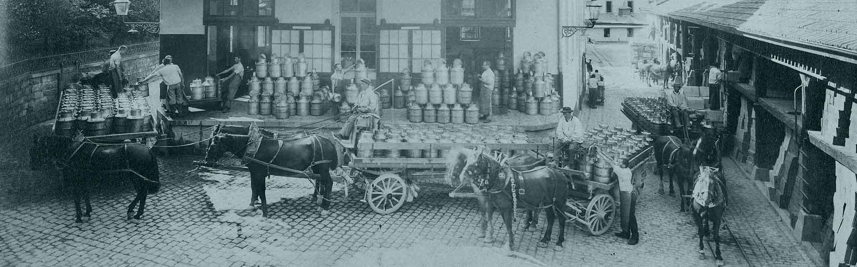
Source: Nestlé (2023)

2. Nestlé’s description

Nestlé is a globally operating business that focuses on food production and was founded in 1866. Its headquarters are located in Vervey, Switzerland, and it has operations spread across 80 countries worldwide. (Nestlé, 2023). Among the top 10 largest food production companies in the worls, Nestlé is ranked as the biggest in terms of revenue. (Britannica, 2023).
Nestlé aims to improve the quality of food, beverages, and nutritional supplements while considering environmental concerns. Nestlé focus on promising segments and aim to develop their research departament to positively impact people’s lives and well-being (Nestlé Annual Review, 2020).

3. PESTLE

The micro and macro environmental forces impact the company’s capacity to serve its clients. The six macroenvironmental forces are demographic, economic, natural, technological, political/social, and cultural forces (Kotler, P.T. et. al, 2020, p. 97).
Occasionally, these forces may be favourable to the organisation, but sometimes can be unfavourable to company.

Political factors
An examination of political factors involves considering a range of governmental influences, including the stability of the government , the impact of policies on areas such as education, health, and infrastructure, foreign trade policies, tax regulations, labour laws and so on (Bishop, T., 2013, p. 46).
Reports suggest that the stricter enforcement of labour laws that ban or discourage the use of child labour on cocoa farms will have an indirect impact on the operations of the company (mbaSKOOL, 2019).
Brexit is a significant factor that could impact Nestlé’s production and operations, as the UK now has the freedom to create its trade policy. Nestlé has nine factories in UK, which could potentially be affected (Edgington, T., 2020).
Due to the circumstances Nestlé could reconsider its decision to stay in the country or to plan to move their business to a different location, like Poland (mbaSKOOL, 2019).
Changes in loading and unloading procedures in ports may disrupt product transportation, while Nestlé sees the EU’s emphasis on environmental policies, such as the Green Deal, as benefecial for sustainable production. The Nestlé Group is also impacted by the Common Agricultural Policy and it is crucial to assess the impact of the policy reform to reduce support for large procedures and address income disparities (Huljić, B., Jagar, F. and Klanjčić, M. 2021, p.225).
US Nestlé operations can be impacted by its connections with Canada, Brazil, and Mexico, and the recent changes in the US government’s immigration policies are expected to decrease border tensions with Mexico (The White House, 2023).
Nestlé has numerous factories in China (Nestlé, 2021). The ongoing political tensions between China and US, or between China and Taiwan are critical factors that could potentially spark trade wars and multiple sanctions. Therefore, the China’s relations with the others can greatly affect Nestlé’s production.
Nestlé is required to engage in thorough brainstorming and extensive testing to revamp their products and satisfy customer needs when specific food regulations are altered, as was the case wit Maggi. However, Nestlé received a beneficial development when India recently lowered its corporate tax. This gives the company an edge to generate higher-quality goods, produce more efficiently, and improve the well-being of society at a reduced cost (mbaSKOOL, 2019).

Economic factors

Economic factors are a range of economic indicators such as unemployment, interest rate, and exchnage rates that can influence the operations of a business either directly or indirectly (Bishop, T., 2013, p. 46).
The economic environment is characterised by more economical consumers who seek greater value, that is, the correct combination of high-quality and service at a reasonable price (Kotler, P.T. et. al, 2020, p. 97).
Nestlé needs to adjust the marketing strategies to match the current economic conditions. In our time, marketers are placing more emphasis on the worth of their value propositions. They are prioritising the value for the cost, usefulness, and long-lastingness of their products and marketing messages (Kotler, P.T. et. al, 2020, p. 25).
Fluctuations in significant economic indicators like income, living expenses, interest rates, as well as saving and borrowing habits can significantly affect the market. Therefore, Nestlé must keep on eye on these variables by engaging in economic forecasting. By doing so, the company can capitalise on opportunities presented by changes in the economic environment (Kotler, P.T. et. al, 2020, p. 87).
The COVID pandemic has caused a halt in the increase of the interest rates, resulting in record low levels of practically zero interest rates in EU (European Central Bank, 2021).
Nestlé, which primarily conducts business in the US and China, has faced rising costs as a result of the ongoing trade disputes between these nations (mbaSKOOL, 2019).
Nestlé conducts its business using the Swiss franc as its currency, but also pays attention to the value of the US dollar. The prices of many of the materials used in Nestlé’s products are quoted in US dollars. It was a decline in the value of the US dollar relative to the Swiss franc during the first few months of 2021 (March to May). This trend could have some positive effects, such as potential profits from currency fluctuations and lower prices for raw materials. However, it could also result in higher prices for Nestlé products, making them less competitive(Puškar J. et al, 2021).

Social factors

The social, cultural and demographic factors refer to aspects such as health, safety awareness, and attitudes towards socially responsible behaviour (Bishop, T., 2013, p. 46).
Demography pertains to the study of the attributes of human populations. Presently, the demographic environment displays transformations in the age distribution, evolving family compositions, shifts in population locations, an increasingly well-educated and predominantly white-collar population, and escalating diversity (Kotler, P.T. et. al, 2020, p. 97).
An aging population can lead to a workforce that is both smaller in size and less inclined to work, which can result in higher labour costs. Additionally, companies may need to modify their management tactics to accommodate these demographic shifts, such as hiring more elderly employees (Bishop, T., 2013, p. 46).
An instance of this would be that the median age of individuals in India will be 28 years by 2020, whereas it will be 37 years in China, 38 years in U.S. 45 years in Western Europe, and 49 years in Japan (Kotler, P.T. et. al, 2020, p. 76).
For a successful step, Nestlé has to consider all these demographic factors, to do a thorough research on the market before to move to a new market.
Currently, the shifts in social media present significant strategic obstacles for Nestlé. The company needs to come up with strategies to effectively use social media in the business landscape and overcome any drawbacks it may have. The era of technology has introduced numerous innovative tools for building customer relationships. These include websites, online ads, videos, mobile apps, blogs, online communities, and social media platforms like Facebook, YouTube, and Twitter. For instance, Nestlé can use this trend and share their latest ads and videos on social media platforms, with the expectation the company will become more popular (Kotler, P.T. et. al, 2020, p. 18).
Via all these social platforms Nestlé can ask consumers for new product, service ideas or to actively participate in the creation of advertisements.
According to the research conducted by Archer Daniels Midland (2020) almost 31% of consumers purchase products that are adapted to their health needs, and 50% of them preffering natural ingredients in their food and drinks.This trend presents an opportunity for Nestlé business to develop innovative products, modifying and improving their recipes to lower the levels of sugar, salt and saturated fat. However, if Nestlé fail to respond to the new demand in a timely manner, the company will be affected by this risk.
Nestlé has to enhance its range of products, simplifying ingredients lists, and disclosing the origins of raw materials used in food production.
All these social factors will determine Nestlé to respond to all new trends.

Technological factors
Technological factors refer to various technological elements such as research and development activity, automation, technology incentives, and the speed of technological advancement. These factors can affect entry barriers, the minimum production level, and the outsourcing choices. Moreover, changes in technology can impact expenses, quality, and stimulate innovation (Bishop, T., 2013, p. 46).
The advancement of technology offers numerous advantages. In order to remain competitive in the market, it is essential for companies to keep up with current trends and incorporate new technologies. The digitalisation process has become a crucial factor in achieving success in business.
Each year, Nestlé allocates approximately CHF 1.7 billion towards research and development (Nestlé,2023).
Innovative technologies are very important for business success, but can also present a threat. As the number of cyber attacks grows, Nestlé can invest in innovative technologies like software to detect identity theft and harmful email, or to inevst in remote desktops, smart glasses, 360 degree cameras, and so on. The use of augmented reality has increased efficiency and enabled managing multiple projects at the same time.
Nestlé has invested in a start-up to transform the idea of using real-time data to monitor water quality and consumption into a tangible reality (Nestlé, 2023).
When a company resist to the new trends, their business suffers a decline. Therefore Nestlé must carefully monitor the technology environment, if not its products will become outdated, and Nestlé will miss new opportunities.

Legal factors
Legal factors are the external environmental components that are related to the laws and regulations of various countries (Bishop, T., 2013, p. 46).
Marketers need to put effort in staying up-to-date with regulatory modifications and their interpretations since regulations are frequently changing (Kotler, P.T. et. al, 2020, p. 91).
Nestlé is a globally company, so that means the company needs to be mindful of the legal factors that differ from one nation to another. The Food and Drug Administration (FDA, 2023) is responsible for regulating the food industry in the US, while the European Food Safety Authority (EFSA,2023 ) oversees it in the EU. The State Food and Drug Administration (C.i. Process, 2023) is responsible for food regulation in China.
Nestlé has been under pressure in India for endorsing research on a breast milk alternative that is said to be in a violation of both domestic and global laws. This situation has become a crucial issue that Nestlé must closely monitor. The entire company will suffer from its negative consequences if a legal violation occurs (mbaSKOOL, 2019).
Nestlé relies on discretionary income, but their profit may be impacted as the consumption of their products, including chocolate and sweets is expected do decrease. Furthermore, the introduction of sugar tax will likely cause the cost of Nestlé’s products to increase, resulting in a decline in sales volume as customers may opt to avoid buying Nestlé’s products due to the higher prices (Hussain, Z. 2014).
To avoid getting into more unethical scandals, Nestlé has to protect its trademark ensuring that it has a strong legal team specifically focused on the food industry.

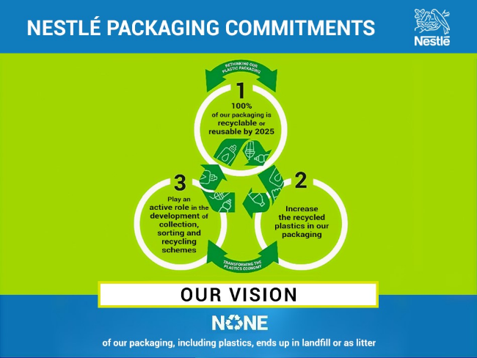
Environmental factors
Source: Nestlé (2023)

Government worldwide are mandating that firms adopt enviromentally conscious practices. Such a directive necessitates the modification of business operations and the investment in renewable energy sources (Studycorgi, 2022).
The natural environment is experiencing three significant trends, such as, lack of specific raw materials, elevated levels of pollution, and an increase in government involvement in managing natural resources (Kotler, P.T. et. al, 2020, p. 97).
The companies can either passively acknowledge the marketing environment as an uncontrollable factor, that they must conform to by identifying opportunities and avoiding threats as they come up. The companies can choose to be proactive and attempt to alter the environment instead of only responding to it (Kotler, P.T. et. al, 2020, p. 97). It is recommended to Nestlé to adopt a proactive approach instead of a reactive one.
As a socially responsible multinational corporation, in terms of promoting environmental sustainability it is recommended that Nestlé to reduce the use of disposable plastic packaging using recyclable or reusable materials, to contribute to the reduction of carbon dioxide, to plant trees, and to improve soil health.
Nestlé is investing over CHF 100 miilion by 2030 to reduce the greenhouse gas emissions of its three water brands. This move aims to shift towards more sustainable transportation, helping the company to reach its 2050 net zero goal(Nestlé,2022).
Nestlé, in February 2021, publicated ‘Nestlé’s Net Zero Roadmap’ report and outline the process how Nestlé moves towards a net zero company by 2050.

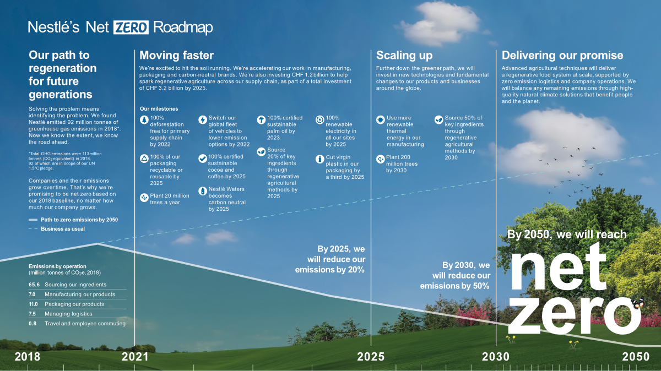

Source: Nestlé (2023)

4. Porter’s Five Forces

Due to the external environment is so vast, the Porter’s Five Forces model requires a continuos effort to scan and monitor the information about current and potential competitors (Huljić, B., Jagar, F. and Klanjčić, M. 2021, p.235).
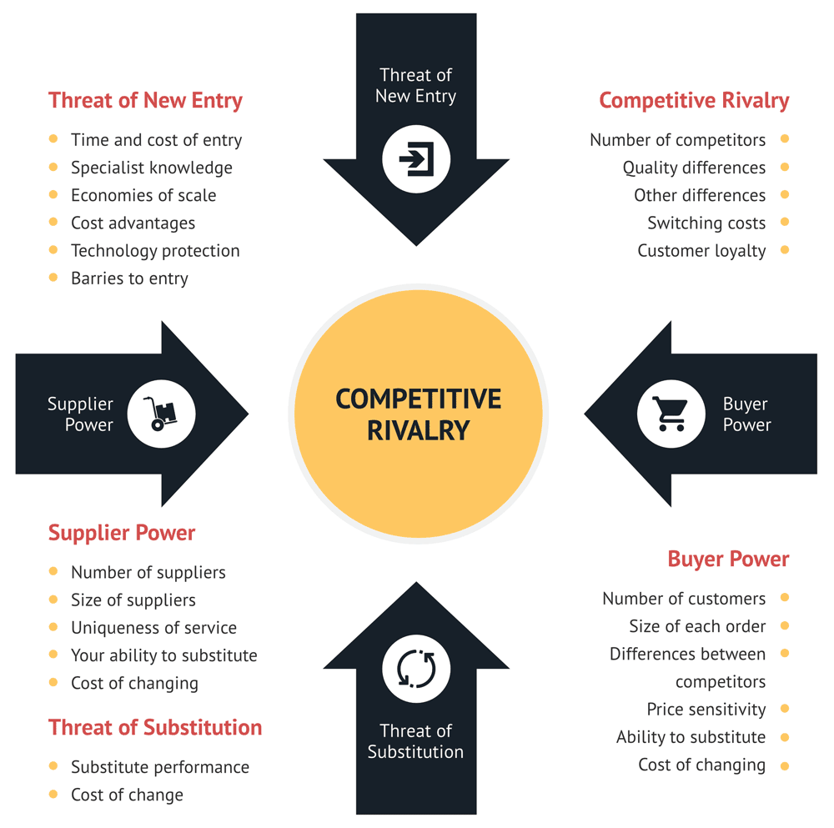

Source: Consulterce (2023)

Industry rivarly is high

Regradless of its location, Nestlé faces intense competition within its industry. In the United Kingdom, it must contend with brands like Kellogg, while in India, it faces competition from both local brands and newcomers to the food industry such as Knorr (Gower, K. 2012).

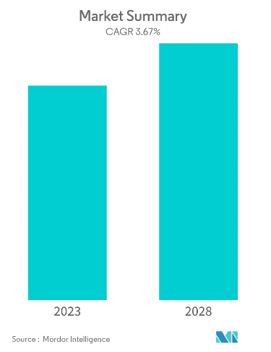
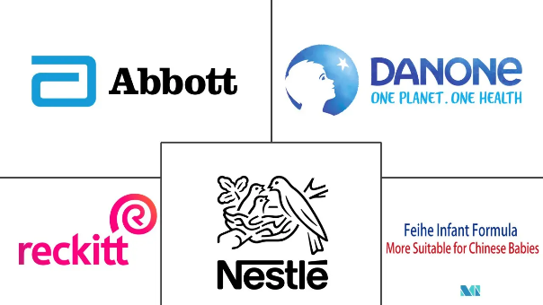

Baby food competitors
Source: Mordor Intelligence (2023)

Nestlé holds a leading position in the baby food and dairy products industries but are several factors that could potentially harm its profitability. The growth rate in the children’s food segment is predicted to be low and the strict regulations and exit barriers make it challenging to compete with other companies. (Mordor Intelligence, 2023).
Nestlé is a major player in multiple market segments, including pet food and nutritional supplements. The last two markets have many multinational competitors’ companies. The pet food segment is particularly attractive due to high growth rates and pet humanisation trends (Mordor Intelligence, 2023).

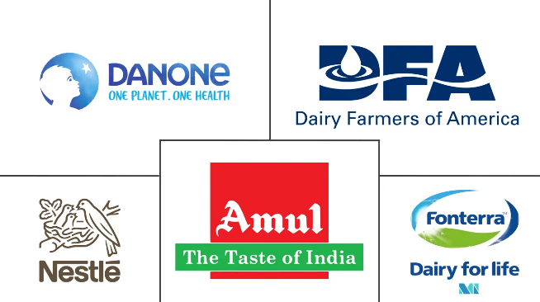
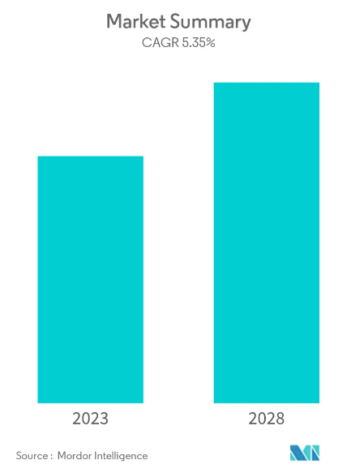
Dairy Product Competitors
Source: Mordor Intelligence (2023)

Threat of new entry
The possibility of new businesses entering the market is present when there are chances to generate substantial profits.
Despite being a player in the food and nutrition industry, Nestlé is at risk of facing new competition in the market, whether it comes from domestic or international firms. This is because the industry has low barriers to entry, as seen in Nestlé’s operations in India, where numerous small domestic players can easily enter the market and potentially disrupt Nestlé’s market share through pricing or product offerings that cater to local culture and taste preferences (Gower, K. 2012).

Threat of substitution is high
In the food industry, the customer preferences and the new trends play a vital role, therefore Nestlé has to be adaptable to the latest market needs to avoid the risk of substitute products. Nestlé should invest in a continuously research to stay ahead of the competitors.
The likelihood of alternatives posing a threat to Nestlé is high. Many other companies such as Kraft Heinz, Unilever, Danone provide comparable or alternative products in all areas of Nestle’s operations. Therefore, Nestlé must guarantee that it delivers a unique product experience that cannot be replicated and is desired by its customers (Gower, K. 2012).

Bargaining power of suppliers is low
Nestlé has low dependence on suppliers in economically weaker regions such as Pakistan or Bangladesh. This is due to its strong market presence, which allows it to attract numerous suppliers, thereby providing them with more business opportunities. Consequently, suppliers must adhere to Nestlé’s production guidelines, or they risk being replaced by other suppliers (Gower, K. 2012).
Nestlé’s cocoa procurement process is intricate and diverse, with sourcing from numerous countries and suppliers. Nevertheless, dominant suppliers such as Cargill have considerable bargaining power, and if there is any disruption in the relationship with the company, it can affect Nestle’s value chain and operations. To ensure stability and continuity in the supply chain, Nestlé needs to manage relationships with key suppliers by evaluating their performance, identifying risks, and maintaining open communication. This will ensure the quality, sustainability, and reliability of the cocoa supply chain while diminishing possible risks and challenges. In general, Nestlé’s suppliers have a low to moderate level of bargaining power (Huljić, B., Jagar, F. and Klanjčić, M. 2021, p.240).

Bargaining power of customers is high
Nestle’s customers have a high bargain power due to their strong influence on the brand’s success. The company’s products heavily depend on consumer satisfaction. and if a product fails to meet their taste preferences, they are likely to reject it. In addition, consumers in developing countries are highly price-conscious, which further increases their bargain power. Therefore, if Nestlé intends to expand its presence in these markets, it will need to lower its prices to match their affordability level (Gower, K. 2012).
Nestlé’s annual review (2022) highlights its commitment to maintain open lines of communication with a diverse a range of stakeholders. The objective is to gain deeper insights into their preferences and attitudes and integrate this information into the company’s products to enhance quality and efficiency. This strategy leads to satisfy and loyal customers, which increases Nestlé’s bargaining power. Given the information presented, it can be concluded that Nestlé’s buyers hold a high bargaining power (Huljić, B., Jagar, F. and Klanjčić, M. 2021, p.241)

5. Ansoff Matrix

The focus within the matrix is on weighing the advantages and difficulties of each strategic choice and determining on how well it aligns with the company’s internal resources and abilities when assessing the possibilities in both new and established markets (Varma, G. R. and Ravi, J., 2017, p.17).

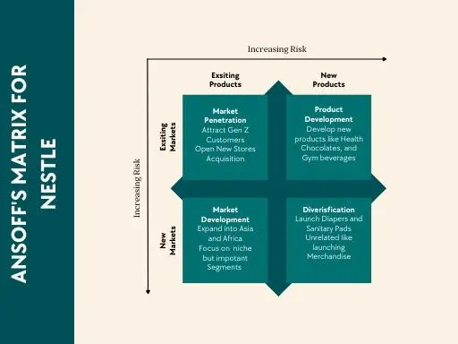
Source: SimpliMBA (2023)

Product development strategy involves selling new products in the markets where the company already operates.
The need for healthier and more natural products is rising each day, and Nestlé may
be addressing this by introducing a new line of vegan products to their existing market.
Developing new products is an expensive strategy and comes with a moderate level of risk. However, Nestlé is a proficient company in research and development, who possesses sufficient funds to introduce the new line of vegan products. Nestlé can introduce a new product line as long as the company has a deep understanding of their current market (Panchal, B., 2021).
To introduce and gather feedback on its new product line, Nestlé will use promotions and marketing techniques with reduced prices. Following this initial launch, Nestlé will make modifications to the product, introducing new variants, and will adjust the pricing strategy to enhance its profit margins (Khan Kasi, A. 2020).
A diversification strategy involves a company introducing a new product in a new market, which can be highly risky but can also result in substantial profits if executed properly with thorough research. Due to the significant investment required, it is advisable for Nestlé first to identify the new market, to conduct market research, analyse data, and plan a budget and projection for the original product’s release addressed to the market’s requirements. (Panchal, B., 2021).
Nestlé often use horizontal diversification as a strategy, which involves expanding into new markets by introducing related products to the ones it already sells. An illustration of this could be Nestlé’s expansion into the baby care industry by introducing diaper and other grooming products in addition to their existing line of infant formula and baby food (Khan Kasi, A. 2020).
There are several effective techniques that Nestlé can utilise to advertise their new product in a new market. These include offering a unique introductory promotion, taking advantage of Google My Business to increase visibility, promoting their entire portfolio, running social media advertisements, distributing coupons, or organising an event and so on.

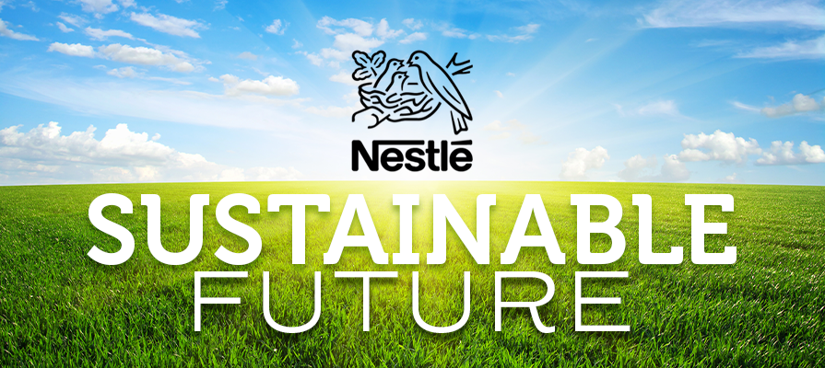
Source: Nestlé (2023)

6. Conclusion
Nestlé current market position is the result of the various forces that it has developed over time, which can be divided into three spheres: product and market portfolio, investment in research, development and production, and financial performance. This is evident from the PESTLE analysis, the Porter’s 5 Forces model, and the Ansoff Matrix tool (Huljić, B., Jagar, F. and Klanjčić, M. 2021, p.248).
Based on the marketing models discussed earlier, the marketing executive’s responsibility is to increase understanding of the favourable and unfavourable aspects of the company’s current situation. To create specific proposals and strategic objectives for the company’s further development, the SWOT analysis is supplemented by the TOWS matrix, which serves as a strategic roadmap (Huljić, B., Jagar, F. and Klanjčić, M. 2021, p.247).

7. Appendix
Nestlé’s positive/negative fators according to Garg, K. P. (2021, pp.429-430)
Positive factors | Negative factors
- The company’s commitment to its stakeholders and a holistic approach to business has led to the development of robust cultural principles.  - Nestlé strategic position is based on leading in terms of quality, ensuring customer satisfaction, and focusing on sustainability.  - Nestlé has a wide selection of brands to pick from.  - Due to Nestlés extensive history, it has established a unique and significant position in the affection and loyalty of its customers.  - The company’s emphasis on effective teamwork creates a sense of contentment and commitment among both its employees and customers.  - Nestlé’s operations in developing nations demonstrate their capability to enter untapped markets.  - Nestlé can focus on the expansion of markets such as Brazil, Russia, India, China, and Soiuth Africa which show potential for growth. | - Nestlé’s products have been criticised for their nutritional value, and that the company should re-examine their goods in order to fulfill their objective of providing ‘Good food, good life’.  - Nestlé has received negative publicity in recent years due to the scandals sorrounding the company’s marketing of infant milk products.  - The growth in competition and a decrease in customer loyalty has led to an increase in the purchasing power of buyers in the business.  - Rapid changes in the external macro-economic environment lead to quicker decision-making and intensified competition.  - The advancement in technology are driving both innovation and the challenges that accompany it.  - The ageing population is causing a shift in the composition of the workforce.

Nestlé market and the growth rate level according to Huljić, B., Jagar, F. and Klanjčić, M. (2021) and Mordor Intelligence (2023)
Market | Lower growth rates | Higher growth rates | Why lower or high rates? | Threats
Baby food | √ |  | - High entry  - Exit barriers | - The risk is low
Bottled water |  | √ | - Pollution  - Contamination of drinking water  - A rise in demand for functional beverages | - Capitalise on the rising demand to make a profit
Cereals |  | √ | - A rise demand in India and China | - Change in the consumers attitude for healthy and quality products  - Alternative to conventional meals
Chocolate and sweets | √ |  | - Consumers are more informed about the effects of sugar | - Growth in demand for natural sweeteners  - New trends
Pet Food |  | √ | - Pet humanisation trends | - Capitalise on the rising demand to make a profit

Substitute products table according to Huljić, B., Jagar, F. and Klanjčić, M. (2021) and Mordor Intelligence (2023)
Market | Substitute products | Substitution reason
Cereals  (Fitness, Cheerios) | - Protein drinks  - Smoothies  - Milkshakes | -The trend of healthy diet
Chocolate and sweets  (KitKat, Aero) | - Dark chocolate (>70% cocoa)  - Dried fruits  - Organic peanut/almond butter  - Nuts  - Frozen berries  - Organic honey | -The trend of healthy diet
Coffee  (Nespresso, Nescafe Original) | - Water ()  - Lemon and water  - Teas  - Nestea | - The trend of healthy diet
Water  (Perrier, S. Pelegrino) | - Competitive substitutes of water and beverage products (Jeema, Quality Beverages, Tipco, Naubahar, Red Bull, Coke etc.) | - Convenient cost  - Visible and accessible  - New trends or flavours
Ice cream  (Haagen-Dazs, Nestlé Ice Cream) | - Handmade ice cream  - Frozen yogurt  - Gelato  - Sorbet  - Organic coconut milk ice cream  - Frozen kefir with berries  - Pudding  - Granita  - Vegan chocolate shake | -The trend of healthy diet  - New trends of flavours

SWOT analysis by Nestle S.A.
Strengths +Opportunities = positive factors
Weaknesses +Threats= negative factors

SWOT analysis by Nestle S.A.
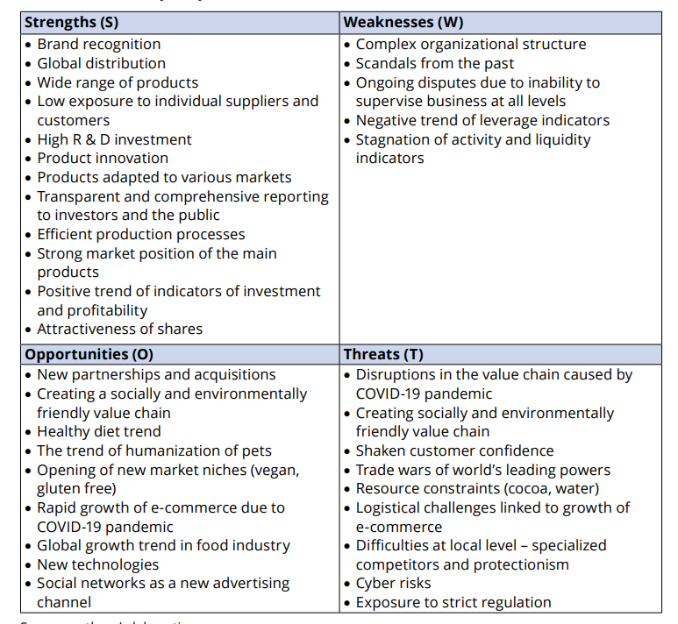
Source: (Huljić, B., Jagar, F. and Klanjčić, M. 2021, p.247).

TOWS analysis by Nestle S.A.

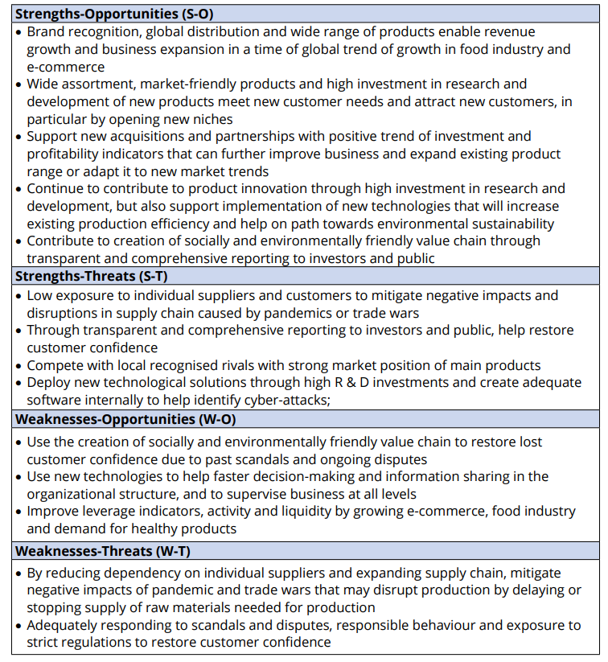

Source: (Huljić, B., Jagar, F. and Klanjčić, M. 2021, p.250).

8. Reference list:

Archer Daniels Midland (2020) Top Five Global Trends that Will Shape the Food Industry in 2021. Available at: https://investors.adm.com/news/news-details/2020/Top-Five-Global-Trends-that-Will-Shape-the-Food-Industry-in-2021/default.aspx (Accessed: 12.04.2023)
Bishop, T. (2013) Principles of Marketing Management, Delhi: Orange Apple.
Britannica (2023) Nestlé SA. Available at: https://www.britannica.com/topic/Nestle-SA (Accessed 8 April 2023).
C.i. Process (2023) CFDAand NMPA: food, health and medical authorities in China Available at: http://www.ciprocess.com/CFDA-NMPA-the-health-and-medical-authorities-in-China.htm (Available: 15.04.2023).
Edgington, T. (2020) ‘Brexit: What are the key points of the deal?’, BBC NEWS, 30th December. Available at: https://www.bbc.co.uk/news/explainers-55180293 (Accessed 12.04.2023).
European Central Bank (2023), Press releases. Monetary policy decisions. Available at:https://www.ecb.europa.eu/press/pr/date/2021/html/ecb.mp210121~eb9154682e.en.html (Accessed: 09.04.2023).
European Food Safety Authority (2023) Available at: https://www.efsa.europa.eu/en (Accessed: 12.04.2023).
Garg, K. P. (2021) ‘An Analysis Of The Environmental Factors Of Nestlé’, Journal Of Critical Reviews, 8(3), pp.427-433, Available at: https://www.jcreview.com/admin/Uploads/Files/625afe0f6324c7.71928592.pdf, (Accessed: 11.04.2023).
Gower, K. (2012) Nestle international business strategy. Available at: https://www.academia.edu/5598621/Nestle_international_business_strategy (Accessed: 25.04.2023).
Heubel, M. (2023) ‘Porter’s Five Forces Analysis: Definition, Model and Examples Explained’, Consulterce [blog]. 1st January. Available at: https://consulterce.com/five-forces-analysis/ (Accessed: 15.04.2023).
Huljić, B., Jagar, F. and Klanjčić, M. (2021) ‘Company analysis and risk management strategies in the global business environment – a case study collection’, in Sprčić, D. M.(ed.) The case study of Nestlé SA. company analysis. Zagreb: Faculty of Economics and Business, University of Zagreb, Available at: file:///C:/Users/boogi/Downloads/1258648.Company_Analysis_and_Risk_Management_Strategies_-_A_Case_Study_Collection_eBook.pdf (Accessed: 10.04.2023).
Hussain, Z. (2014) ‘Can political stability hurt economic growth?’, World Bank [blog]. 1st June. Available at: https://blogs.worldbank.org/endpovertyinsouthasia/can-political-stability-hurt-economic-growth (Accessed: 24.04.2023).
Khan Kasi, A. (2020) ‘Ansoff Matrix of Nestlé’, Ansoff.com [blog]. 5th January. Available at: https://ansoffs.com/ansoff-matrix-of-nestle/ (Accessed: 15. 04.2023).
Kotler, P. T. et al. (2020) Principles of marketing. Eighth European edition. Harlow, England: Pearson.
mbaSKOOL (2019) Nestle PESTLE Analysis. Available at: https://www.mbaskool.com/pestle-analysis/companies/17962-nestle.html (Accessed:26.04.2023).
Mordor Intelligence (2023) Baby food market-growth, trends, and forecasts (2023-2028). Available at: https://www.mordorintelligence.com/industry-reports/baby-food-market (Accessed: 15.04.2023).
Mordor Intelligence (2023) Bottled water market - growth, trends, and forecasts (2023-2028). Available at: https://www.mordorintelligence.com/industry-reports/bottled-water-market (Accessed: 15.04.2023).
Mordor Intelligence (2023) Breakfast cereals market - growth, trends, and forecasts (2023-2028). Available at: https://www.mordorintelligence.com/industry-reports/breakfast-cereals-market (Accessed: 15.04.2023).
Mordor Intelligence (2023) Confectionary market industry - growth, trends, and forecasts (2023-2028). Available at: https://www.mordorintelligence.com/industry-reports/confectionery-market-industry (Accessed: 15.04.2023).
Mordor Intelligence (2023) Dairy market - growth, trends, and forecasts (2023-2028). Available at: https://www.mordorintelligence.com/industry-reports/dairy-products-market (Accessed: 15.04.2023).
Mordor Intelligence (2023) Pet care market - growth, trends, and forecasts (2023-2028). Available at: https://www.mordorintelligence.com/industry-reports/pet-care-market (Accessed: 15.04.2023).
Nestlé (2021) Creating Shared Value and Sustainability report 2020. Available at: https://www.nestle.com/sites/default/files/2021-03/creating-shared-value-report-2020-en.pdf (Accessed: 10.04.2023).
Nestlé (2021) When was the last time you ate meat? Last night, last week-even last month? Available at: https://www.nestle.com/stories/healthy-food-meatless-meals-flexitarian-nutrition-needs (Accessed: 12.04.2023).
Nestlé (2022) Nestlé invests in logistics innovations to reduce greenhouse gas emissions for its international water brands. Available at: https://www.nestle.com/media/news/water-brands-logistics-investment-emissions-reduction (Accessed: 15.04.2023).
Nestlé (2023) Annual Review 2020. Available at: https://www.nestle.com/sites/default/files/2021-03/2020-annual-review-en.pdf (Accessed: 11.04.2023).
Nestlé (2023) Annual Review 2022. Available at: https://www.nestle.com/sites/default/files/2023-03/2022-annual-review-en.pdf (Accessed: 15.04.2023).
Nestlé (2023) Creating Share Value and Sustainability Report 2022. Available at: https://www.nestle.com/sites/default/files/2023-03/creating-shared-value-sustainability-report-2022-en.pdf (Accessed: 15.04.2023).
Nestlé (2023) Innovation, Science and Technology Available at: https://www.nestle.com/about/research-development (Accessed: 12.04.2023).
Nestlé (2023) Nestlé history timeline. Available at: https://www.nestle.com/sites/default/files/2022-12/nestle-company-history-timeline.pdf (Accessed: 10.04.2023).
Nestlé (2023) Nestlé’s net zero roadmap. Available at: https://www.nestle.com/sites/default/files/2020-12/nestle-net-zero-roadmap-en.pdf (Accessed: 15.04.2023).
Nestlé (2023) Our packaging sustainability strategy. Available at: https://www.nestle.com/sustainability/waste-reduction/packaging-strategy (Accessed: 12.04.2023).
Nestlé (2023) Our Sustainability Commitments. Available at: https://www.nestle-esar.com/re-sustainability/our-commitments (Accessed:14.04.2023).
Nestlé (2023) Suppliers. Available at: https://www.nestle.com/info/suppliers (Accessed: 15.04.2023).
Nestlé (2023) Supply chain disclosure. Available at: https://www.nestle.com/sustainability/sustainable-sourcing/supply-chain-disclosure (Accessed: 15.04.2023).
Nestlé (2023) Travel through our history timeline. Available at: https://www.nestle.com/about/history/nestle-company-history (Accessed: 10.04.2023).
Nestlé (2023) Welcome to Nestlé supplier portal. Available at: https://supplier.nestle.com/ (Accessed: 15.04.2023).
Nestle, M. (2020) ‘Nestlé makes its supply chain transparent’, Food Politics [blog]. 14 January. Available at: https://www.foodpolitics.com/?s=nestle+makes+its+supply+chain+transparent (Accessed: 10/04.2023).
Panchal, B. (2021) ‘Understanding an Ansoff Matrix with examples in detail’, Marketing10 [blog]. 28th January. Available at: https://www.marketing10.in/understanding-an-ansoff-matrix-with-examples-in-detail/ (Accessed: 25.04.2023).
Study Corgi (2022) 'Nestle Company: Strategy Enterprise and Innovation', Study Corgi [blog]. 10th August. Available at: https://studycorgi.com/nestle-company-strategy-enterprise-and-innovation/ (Accessed: 24.04.2023).
The White House (2023) Fact Sheet: President Biden Sends Immigration Bill to Congress as Part of His Commitment to Modernize our Immigration System. Available at: https://www.whitehouse.gov/briefing-room/statements-releases/2021/01/20/fact-sheet-president-biden-sends-immigration-bill-to-congress-as-part-of-his-commitment-to-modernize-our-immigration-system/ (Accessed: 10.04.2023).
U.S. Food & Drug Administration (2023) Food. Available at: https://www.fda.gov/food (Accessed: 12.04.2023).
Varma, G. R. and Ravi, J. (2017) ‘Strategic Analysis on FMCG Goods: A Case Study on Nestlé’, International Journal of Research in Management Studies, 2(4), pp. 12-22, Available at: http://www.ijrms.com/olvolume2issue4/GedelaRakeshVarma-JaladiRavi-3.pdf, (Accessed: 10.04.2023).

