University of Wales Trinity St David
Manufacturing with materials – The processing of Ceramics
BEng Materials Engineering

Table of Contents
Table of Figures 2
Material Limitations 3
Introduction of ceramics 3
Structure of ceramics 3
Properties 4
Furnace refractory bricks 6
Existing processes 6
Magnesia refractory brick production 6
Development of new processes 7
Manufacturing process 7
Conclusion 8
Reference 9
References 9

Table of Figures

Figure 1 Comparing young's modulus [7] 4
Figure 2 Comparing melting points [9] 5
Figure 3 Compressive strength [11] 5
Figure 4 Magnesia vs silicon carbide thermal shock [15] 7
Figure 5 Refractory brick manufacturing process [16] 8

Material Limitations

Introduction of ceramics

There is an ever-growing demand in various industries to produce materials that are stronger, lighter and cheaper. Due to this demand, material scientists are exploring the relationships of atomic structures against their mechanical properties. Ceramics are a type of material that are inorganic, non-metallic and solid. This type of material is usually comprised of a metal, non-metal or a metalloid which are bonded by covalent or ionic bonding.

There are five types of ceramics;
- Clay – Ceramics such as tiles and bricks are based primarily on clay. These ceramics are pressed/ extruded into shape. Clay ceramics which are manufactured with a high-density clay show good mechanical properties but lack in insulating properties. [1]
- Refractories – Ceramics such as furnace refractory bricks are insulating materials which are created to be placed under high temperatures and stresses. These types of ceramics are usually made of pure oxides but this can come at a cost. [1]
- Electrical – Silicon carbides are used in heating elements due to the materials high conductivity and resistivity properties. The conductivity of ceramics increased as temperature increases due to movement of anions and cations. [2]
- Magnetic – There are two types of magnetic ceramics called low conductivity and superconducting. Low conducting ceramics such as transformers are required due to their electrical insulation properties. Superconducting ceramics can conduct electricity with no resistance so they are super-efficient. [3]
- Abrasive – this type of ceramic can either be synthetic or natural. Examples of abrasive ceramics are diamond, tungsten carbide and silicon carbide. The properties that are critical to abrasive ceramics are hardness, wear resistance and toughness. [4]

Structure of ceramics

There are two types of bonds which are present in ceramics;

- Ionic
- Covalent

Ionic bonding sees the metal atom transfers electrons to the other non-metal atom. From doing this, the metal atom becomes positively charged and the non-metal atom becomes negatively charged. A strong electrostatic force is created by the two oppositely charged atoms and this attracts them together. Ionic bonds are entirely non-directional and this explains the packing arrangements of the ions into many different crystal structures. A limitation of this includes the size of the anions and cations. Anions are usually big and closely packed which can be seen in face centred cubic and hexagonally close packed structures in metals. Cations are usually small and can be found in interstices or spaces in between the anions. The next limitation is the law of electroneutrality. The crystal structure must always maintain electrically neutral. Positive and negatively charged anions and cations must keep to specific ratios in order to maintain a net balance. [5]

Covalent bonding occurs normally between non-metals. For this type of bonding to occur both parties must have a similar electronegativity. If so, these two atoms will share electrons. Covalent bonds are also very directional which enforces the shapes of the crystalline structures in these types of bonds. [5]

Properties

The young’s modulus of ceramics tends to be higher than metals. This is due to ceramics being ionically and covalently bonded which is stronger than the metallic bonds in metals.
Glass has an amorphous atomic structure which isn’t uniform and breaks its atomic structure very easily, this is seen in its young’s modulus results. [6]

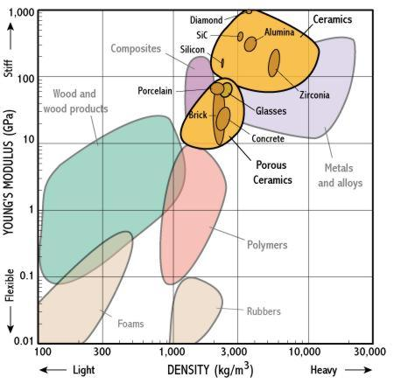
Figure 1 Comparing young's modulus [7]

Again, due to ceramics high bond strengths they usually have a very high melting points when compared to metals and polymers. Most ceramics are used in high temperature applications as a result of this property. Looking at the graph below it is clear that the material column showing the ceramics all tend to have higher melting points than any other type of material. [8]
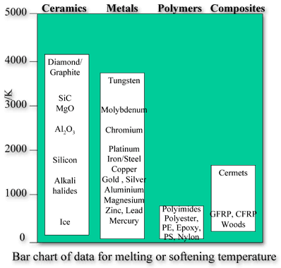
Figure 2 Comparing melting points [9]
Ceramics tensile strength is very poor as they tend to fracture before any plastic deformation can occur. This is due to a load being placed on them and they begin to crack which acts as stress concentrators. However, the compressive strength of ceramics are very high. Cracks do not propagate under compression and this is why a large quantity of ceramics are used in materials that undertake compressive loads. [10]
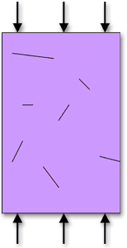
Figure 3 Compressive strength [11]

Furnace refractory bricks

Refractories are materials that provide linings for processing units that have high temperatures. This type of ceramic must be able to withstand a minimum temperature of 538°C and also be applicable in corrosive environments. There are generally two types of refractories, non-clay and clay. Non-clay is manufactured from a composition of around 88% alumina. Other types are made with chromite, magnesite, silica and silicon carbines. Clay refractories are manufactured with between 57 – 88 percent alumina with is lower than non-clay. Other clay refractors are made from hydrous silicates of alumina which are called fireclay [12]. Further on in this report will discuss the manufacturing process route for furnace refractories.

Existing processes

Currently the process of making hot dip galvanised steel requires that the steel substrate to be heated to temperatures up to 850°C to give the correct grain size for the given mechanical properties. Inside of the furnace are refractory bricks which help keep the furnace at these required temperatures. The current refractory bricks are made of magnesia or magnesium of oxide. We are experiencing defects where the refractory is breaking up due to furnace temperatures being quenched as a result of an operation failure. This is in place to protect the strip from overheating and creating a strip break.

Magnesia refractory brick production

The first processing stage of magnesia bricks is;
- Raw materials – Sintered magnesia sand is the main component of the brick. The sand is produced by sintering coke and magnesite in a vertical kiln. Other raw materials used in these bricks are CaO and SiO2. The main factors in the selection of raw materials are the chemical composition and sintering degree. The magnesia should be greater that 87%, Calcium oxide should be less than 0.5% and then silica needs to be less that 5%.
- Additions and particle composition – Particle size of the given magnesia brick will depend on the dimensions and the degree of sinter. It is essential that the bricks particles should be as closely packed as possible.
- Kneading – the section is the prepping for moulding. Kneading occurs in the wheel rolling machine or sand mixer. Mixing and ageing time is critical to this part of the process. Mixing should not be less that ten minutes to ensure all particles are thoroughly infused. Ageing time should be kept to a minimum so that the CaO content is kept low which improves the degree of sintering.
- Moulding – The moisture content in sintered magnesia is very low. High pressure moulding is used to increase the density up to around 3g/cm3 which increases the performance of the brick.
- Drying – Initially the mould is heated to a high temperature, this needs to be controlled to prevent cracking. Then in the tunnel dryer, the temperature is low at 100-120°C. This is to ensure the brick is a certain strength by controlling the moisture in the brick to 0.6% after drying. It is essential that the transfer between drying and firing is quick otherwise powdering and moisture absorption will occur.
- Firing – Firing of magnesia bricks is conducted in a tunnel or draft kiln. These temperatures will reach around 1550°C or for high purity products around 1750°C [13].

Development of new processes

Silicon carbide bricks can be used as an alternative to magnesia bricks. Silicon carbides have great characteristics such as high thermal shock resistance, high corrosion resistance and low thermal expansion coefficient. I believe that if the furnace was relined with silicon carbide bricks they would see less defects from them breaking up due to the increased thermal shock capabilities [14]. See the graph below which shows the thermal expansion of fused silica vs magnesia.

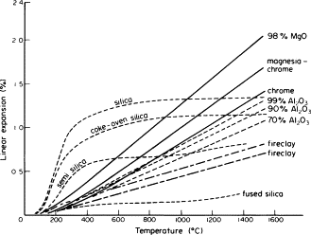
Figure 4 Magnesia vs silicon carbide thermal shock [15]

Manufacturing process

- Raw materials – A fine powder of silicon carbide is mixed with colloidal graphite. Particle size and ratios are calculated prior to mixing and is dependent on quality of the brick needed. This is achieved by a mixture of grinding and crushing.
- Mixing – The combination of materials is dry mixed in a porcelain ball mill for approximately one day with the addition of an alcoholic solution. It is critical that the bulk materials are homogeneously mixed.
- Shaping – To get the mix into the desired shape, a hydraulic press is used to forge the silicon carbide to formation. This is usually processed in moist conditions. The press used to form these types of refractory bricks are static pressed. Static presses are now seeing an increase in industrial applications due to its ability to produce flat, uniform and compact bricks when compared to impact press units.
- Firing – After the shape is made, the refractory is heated up to very high temperatures in a tunnel kiln to enforce the ceramic bond. This process is important so that the refractory characteristics such as high thermal shock adherence is achieved. In the tunnel kiln there are three zones. A preheat zone where combustion gas is used to increase temperature quickly. Firing zone where the material is heated at a high temperature for the required time. Finally, the cooling zone which cools the refractory at a required cooling rate.
- Final processing – This stage can vary depending on the customer specification. The refractory can be milled, grinded or sandblasted to achieve its final surface finish/dimensions.
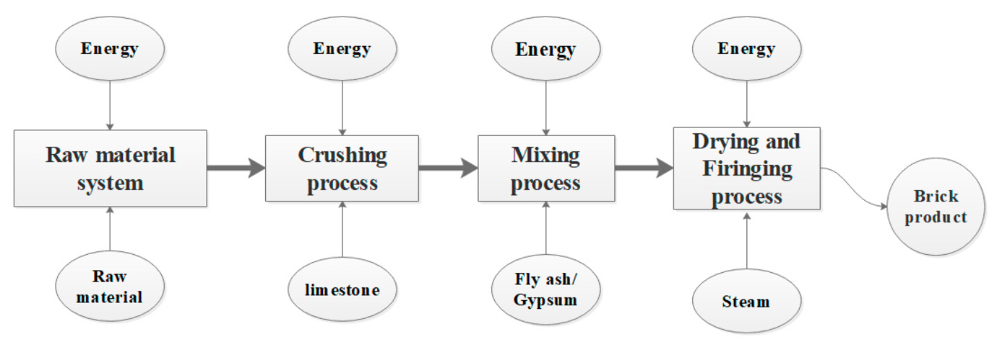
Figure 5 Refractory brick manufacturing process [16]

Conclusion

- Ceramics can be based into five categories called clay, refractory, electrical, magnetic and abrasive. Each of these types of ceramics display different properties and characteristic which can be applied to various industries and applications.
- When comparing ceramics against other types of materials, they have a higher young’s modulus and hardness than any other. However, Ceramics ultimate tensile strength is very poor due to them cracking before any plastic deformation occurs. Ceramics are also very brittle and not very ductile.
- After assessing the atomic structure of ceramics, it is clear to see why industries have difficulties in manufacturing them. Ceramics are very hard and brittle. To achieve the very high temperatures needed to manufacture ceramics a high energy and production cost is induced.
- When producing a magnesia refractory brick, it is critical that moisture is kept to a minimum so that mechanical properties are not affected.
- The manufacturing roots of the two types of bricks are very similar. Silicon carbides choice to use a static press gives the product enhanced performance in shape control and compactness of the brick.
- Tata steel’s hot dip galvanising line is currently experiencing issues where the refractory brick is breaking up due to thermal expansions when operational issues occur.
- From the research in the document, its implied that if a silicon carbide refractory brick is used the company would see less defects. This decision is based on the low coefficient of expansion and resistance to thermal shock. The root cause would be to stop operational errors and the magnesia bricks would suffice. Unfortunately, with aging assets and human error the chance of quenching the furnace is still at a high probability. These reasons enhance my opinion in the need to change the type of refractory brick.

Reference

References

[1] | Y. Fuchs, “CLAYS, ECONOMIC USES,” Encyclopedia of Geology, pp. 366-370, 2005.
[2] | S. Bharadwaj, S. Varma and B. Wani, “16 - Electroceramics for Fuel Cells, Batteries and Sensors,” Functional Materials, pp. 639-674, 2012.
[3] | F. Kools, “Hard Magnetic Ferrites,” Concise Encyclopedia of Advanced Ceramic Materials, pp. 200-206, 1991.
[4] | S. Malkin and T. Hwang, “Grinding Mechanisms for Ceramics,” CIRP Annals , vol. 45, no. 2, pp. 569-580, 1996.
[5] | T. Mason, “Britannica,” 1991. [Online]. Available: https://www.britannica.com/topic/ceramic-composition-and-properties-103137. [Accessed 2 Febuary 2021].
[6] | UKEssays, “Comparing Polymers: Metal and Ceramics,” November 2018. [Online]. Available: https://www.ukessays.com/essays/architecture/compare-polymers-metal-and-ceramics-architecture-essay.php#citethis. [Accessed 2 Febuary 2021].
[7] | “Young's Modulus - Density,” [Online]. Available: http://www-materials.eng.cam.ac.uk/mpsite/interactive_charts/stiffness-density/NS6Chart.html. [Accessed 2 Febuary 2021].
[8] | N. Nieva, C. Arreguez, R. Carrizo, C. Saborido and G. Lagarrigue, “Bonding Strength Evaluation on Metal/Ceramic Interfaces in Dental Materials,” Procedia Materials Science, vol. 1, pp. 475-482, 2012.
[9] | U. o. Sydney, “Properties 2,” [Online]. Available: https://www.materials.unsw.edu.au/study-us/high-school-students-and-teachers/online-tutorials/ceramics/properties/properties-2. [Accessed 2 Febuary 2021].
[10] | H. Awaji, T. Watanabe and Y. Nagano, “Compressive testing of ceramics,” Ceramics International, vol. 20, no. 3, pp. 159-167, 1994.
[11] | Ceramics, Properties 2, 2021.
[12] | J. Gilcheist, “Introduction,” Fuels, Furnaces and Refractories, pp. 9-13, 1977.
[13] | N. Brett, “Magnesium and Alkaline-Earth Oxides,” Concise Encyclopedia of Advanced Ceramic Materials, pp. 283-286, 1991.
[14] | J. Hojo, F. Hongo, K. Kishi and S. Umebayashi, “Concise Encyclopedia of Advanced Ceramic Materials,” Functionally Graded Materials 1996, pp. 419-424, 1997.
[15] | E. Ruh, “Refractory Materials, Metallurgical,” Concise Encyclopedia of Advanced Ceramic Materials, pp. 394-402, 1991.
[16] | J. Zhang, R. Srinivasan and C. Peng, “Ecological Assessment of Clay Brick Manufacturing in China Using Emergy Analysis,” 22 October 2020. [Online]. Available: https://www.mdpi.com/2075-5309/10/11/190/htm. [Accessed 3 Febuary 2021].

