Kristen Buller
2005063
BSc/HND Computing (All Streams)
HTML & CSS Web Development
L4 - Introduction to Web and Database Concepts

Contents
1. Introduction
2. Requirements
3. Implementation
4. Validation
5. Evaluation Part A
6. Evaluation Part B
7. Reference Links
8. Text listings

- Introduction

This report will discuss the website that I have create why and how. How I validated my web pages. How I researched website usability, accessibility and SEO techniques and everything I learned about improving and creating a website. I also talked about how I implemented SEO techniques to improve traffic, accessibility so anyone with a disability can access the website.
- Requirements

I have created a website with the sole purpose of promoting, and selling tickets for a football club called Swansea City. The target audience I have targeted adults, simple colours, easy navigation and the sole purpose of selling tickets, this website is targeted at adults buying tickets.

- Implementation

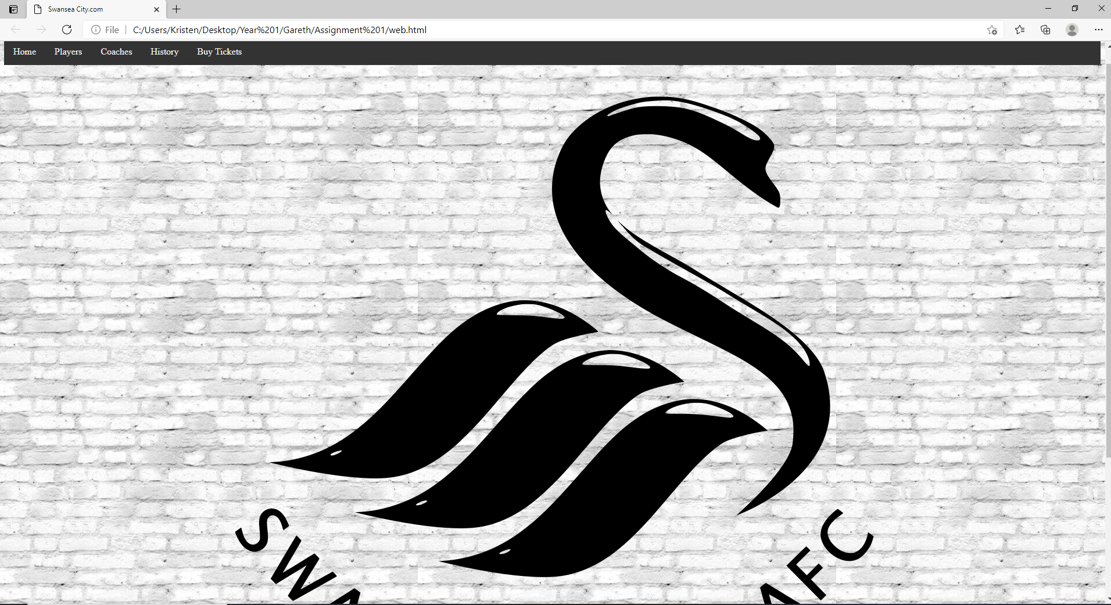
The homepage.
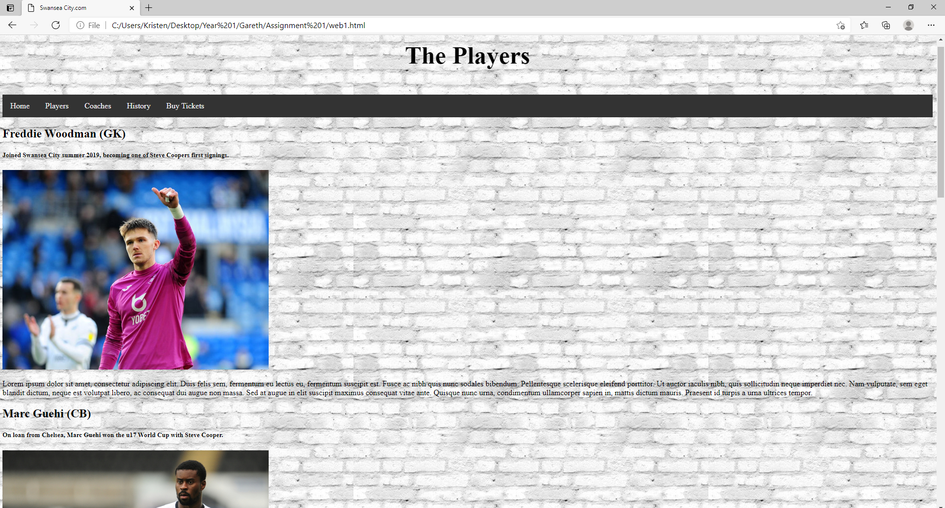
Images and information of the players.

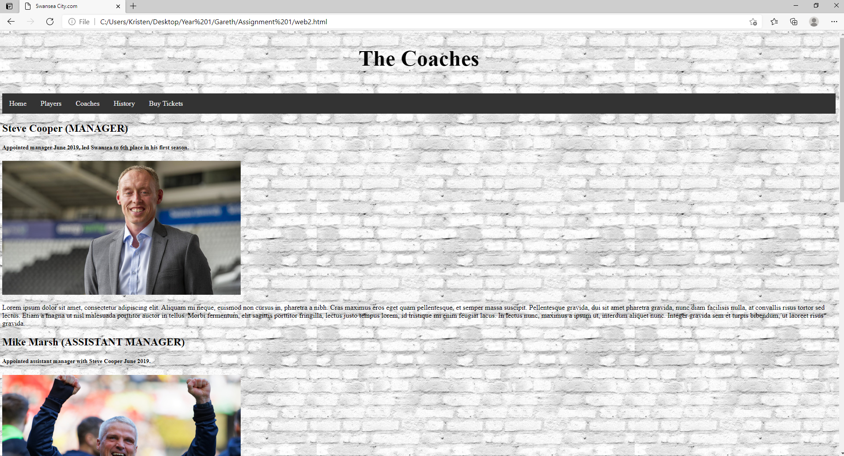
Images and information of the coaches.
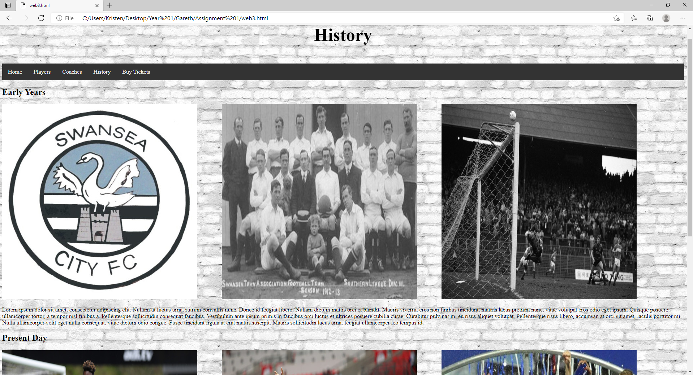
Images and information about the history.
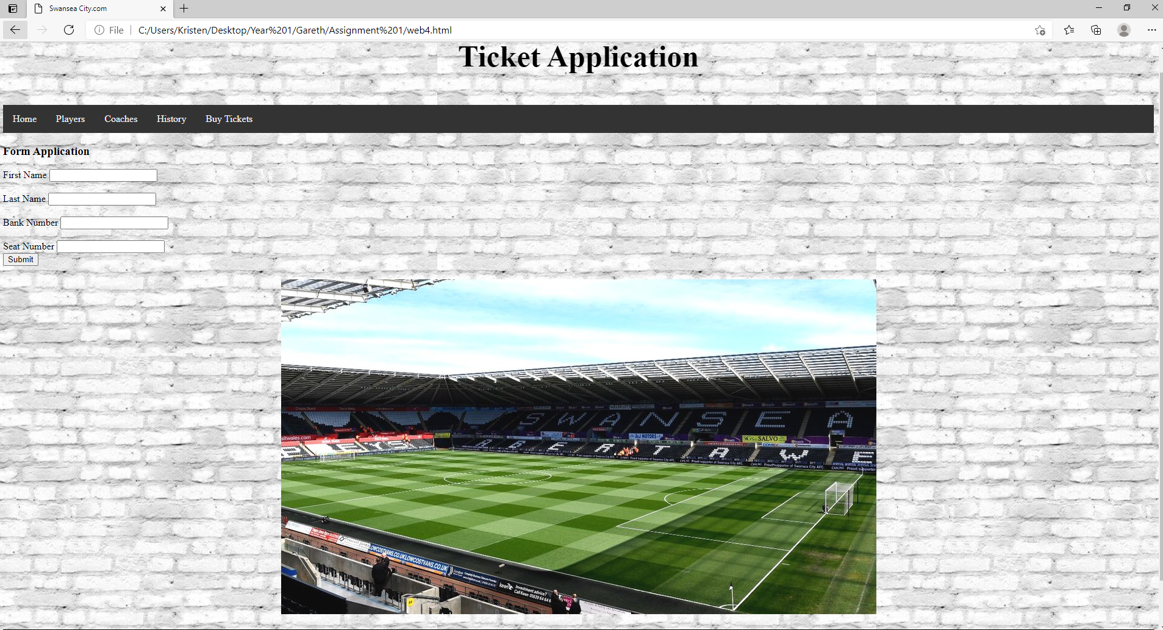
The application form for the ticket.s
- Validation

By validating my html code 5 different errors arose. Firstly, I used a language tag however the ISO did not recognise this language. I decided to remove this as it made no difference to my web page and was only considered a warning not an error.
The second error the validator detect was my background image was in the wrong place. So, I deleted the <body> background image in the HTML, and moved my body with the background image to my CSS.
I was told I had to use CSS instead of HTML for my logo, I decided against this. My reasoning as my homepage did not include a lot of text, and its primary focus was to show the logo, I did not need any space for boxes or words so I used my tags to insert the image instead of HTML.
I was told for my CSS that my headers padding needed a unit after my number. So, I went to my CSS file found the padding and after 15 I put 15px and it worked.

- Part A

Evaluation
[1] Website usability is all about how easy is it for someone to navigate throughout a website. Is it user friendly, or will the user find it to difficult to use? Ensuring that a website is optimized is one of the first things a website should concentrate on. Is the website optimized for mobile and pc? More and more people are using the internet on there’s phones, so ensuring that your website has flexibility and is properly optimized for all different devices it key to ensuring the website is usability. One key aspect that should always be given when someone is using a mobile phone is the ability to move down the web page by just dragging their finger. While compared to a PC you would want a slider on the right-hand side as its much more user friendly to do that while using a mouse. Lastly ensure you stick to common design elements. Things like ensuring that the logo of the organization is in the top left of the screen. Contact information is on the top right of the screen, typically personal things about a website will be at the top of the web page. Always make sure that the navigation bar which allows the user to navigate throughout the pages is also in the header, users will always look at the header for navigation. Also, the search bar should be in the header, only information like general text should be in the body. Also, things like the company’s social media or copyright symbols would be in the website’s footer.
[2] Website accessibility ensuring that your website is useable for everyone including people with disabilities. For example, those with learning difficulties could find it difficult to navigate through the website make sure all the content is easily accessible, and an option to speak to the computer to enter a certain section. Making sure your website is accessible to everyone whenever or not they are blind so having an option for the website to use audio to read out the contents, or if they are deaf allowing the ability to add subtitles if there are videos or audio. Another group are those with seizures, if your website has flashing lights always remove them as you want everyone to have access to the web page. Those with physical disabilities that can’t use a mouse or keyboard, allow the ability to speak to the computer to tell them where to go. Lastly you must ensure your website is laid out correctly, ensure the website is consistent throughout this will significantly not just help those with learning disabilities but everyone else.
[3] SEO search engine optimization is a search engine practice which gives you the ability to improve the quality and quality of traffic that can reach your website. This is through something called organic search engine results, for example typically if someone is researching a certain topic a very strong majority of people will not look at the second page. The name of a web page is vital, by choosing a SEO-friendly domain name this can help attract traffic to your web page. You want the right people going to your website, so by creating a good functional and informative website that will attract the correct people more people equal more traffic.

- Part B

Evaluation
Overall, I’m happy with my website in terms of its usefulness, different SEO techniques I have applied to my website, and accessibility for everyone. I will discuss the areas I am happy with but areas which I can improve on in the future. Firstly, I’m very happy with the navigation bar, its clean and easy to find. By place it in the header of my page, its easy for a user to navigate throughout my website and find relevant information that they need. I would however add a search bar in the future, search bars are essential for quick and easy navigation. I went with a black and white colour house style throughout my website, while I am happy with this as I think it looks clean and fresh, and it suits the colour style of the company that I am representing, in future I would like to add more. More brighter colours areas which include text and images that can have a coloured background behind them, by doing this it offers an even better colour style, and could even attract more younger audiences to my website. Overall, I think the usability of the website is very good. It’s easy to navigate, it’s easy to use, the overall structure is simple so its easy for people to browse the web page. The main aim of the website is to promote is to sell tickets, to do this you have to sell it to the audience so I needed to include good content for people to browse. For example, two of my web pages includes information about the football players and coaches. Another page explains the history of the club. Overall, I am happy with the information being recommended. I would however in the footer add more in the future, for example including the websites social medias to promote the business more.
First SEO technique I used was improving the experience of users throughout my site. Having a high-quality website that looks good is great, but making sure you have good factual information will keep people browsing meaning more time being spent and more traffic coming. Always updating the website information and physical appearance shows you care, meaning more trust and higher SEO ranking. According to a study, there is evidence to suggest Google rewards websites with low bounce rates so by keeping users interested will equal to attracting more users in the future. Throughout when describing the players and coaches, I have included sub headings of their names and a little paragraph about the player. By doing this it breaks down the website and allows the user to learn quickly about specific people at the club without having to go through a huge essay.
Knowing my target audience is vital to improving my websites reachability, using keywords like Swansea City Ticket Sales these words or very unique especially considering the football club are the only ones with the ability to sell them. While if someone was to just type the word Swansea then they would get a lot more options that are not connected to the club, like Swansea the city.
Branching out to YouTube to improve my websites SEO, YouTube had 2billion viewers last month. By creating high quality videos, I can link my website in the description to gain traction and improve my traffic this is something I would do in the future!
Ensuring my website is accessible for everyone is a priority. For example, for those with visual problems like colour blindness and other eye problems. So, I made sure that my text and background did not clash together, so by having a white background and black text I was able to ensure that the text was clearly readable and that no one with visual difficulties would struggle. I also added the ability that if a user was short sighted and could not read the text, they could use their mouse to zoom in to see the text better. This adds on will help significantly those with visual difficulties. Also making sure my website had the ability to use screen readers this is operated by the keyboard then the website will begin to read and communicate via the audio the contents of the web page.
Audio difficulties is another problem I have looked to address. For example, on my coaches’ web page there is a video with the manager speaking. However, those who are deaf or have difficulty hearing things would not be able to access this. So, there is an option to turn on subtitles, this is a great tool which allows those with hearing difficulties to get access to all the relevant information.
Motor difficulties those who cannot use a mouse, or find it difficult to use a mouse, giving them the ability to use a keyboard, to just use the arrows key to go up or down, or navigate to a different website. It was very important that I implemented this.
Those with learning difficulties can struggle especially by reading long text, so this is why I have tried to divide everything up in my web page. I have tried not to include too much information in one block, and include sub headings and pictures so the user can easily understand what information they are looking at.

- Reference Links

[3], ?, What is SEO?, What is SEO? Search Engine Optimization 2021 - Moz, 2020
[1] , Lars Lofgren, Website Usability Guide, A Simple Guide to Website Usability – 2021 Best Practices (quicksprout.com) , 12/12/20
[2], Ellice, 10 Ways to Make your Website Accessible, 10 Ways to Make Your Website Accessible - DreamHost, 24/07/20

- Text listings

<!DOCTYPE html>
<head>
<meta charset="utf-8"/>
<title> Swansea City.com </title>
<link rel="stylesheet" type="text/css"
href="web.css">

</head>
<body>
<br />

<div class="nav">

<a href="web.html">Home</a>
&nbsp; &nbsp;
<a href="web1.html">Players</a>
&nbsp; &nbsp;
<a href="web2.html">Coaches</a>
&nbsp; &nbsp;
<a href="web3.html">History</a>
&nbsp; &nbsp;
<a href="web4.html">Buy Tickets</a>
</div>
<h3 align="center">
<img src="logo.jpg">

</h3>
<div class="footer">
<h2>&copy;SwanseaCity.com</h2>
</div>

</body>
</html>

<!DOCTYPE html>
<html lang="eng">
<head>
<meta charset="utf-8" />
<title>Swansea City.com</title>
<link rel="stylesheet" type="text/css"
href="web.css">

</head>
<body background="back.jpg">

<body>

<div class="header">
<h1>The Players</h1>

</div>

<br />

<div class="nav">

<a href="web.html">Home</a>
&nbsp; &nbsp;
<a href="web1.html">Players</a>
&nbsp; &nbsp;
<a href="web2.html">Coaches</a>
&nbsp; &nbsp;
<a href="web3.html">History</a>
&nbsp; &nbsp;
<a href="web4.html">Buy Tickets</a>
</div>

<h2>Freddie Woodman (GK)</h2>
<h5>Joined Swansea City summer 2019, becoming one of Steve Coopers first signings.</h5>
<img src="player.jpg">
<p>Lorem ipsum dolor sit amet, consectetur adipiscing elit. Duis felis sem, fermentum eu lectus eu, fermentum suscipit est. Fusce ac nibh quis nunc sodales bibendum. Pellentesque scelerisque eleifend porttitor. Ut auctor iaculis nibh, quis sollicitudin neque imperdiet nec. Nam vulputate, sem eget blandit dictum, neque est volutpat libero, ac consequat dui augue non massa. Sed at augue in elit suscipit maximus consequat vitae ante. Quisque nunc urna, condimentum ullamcorper sapien in, mattis dictum mauris. Praesent id turpis a urna ultrices tempor.</p>

<h2>Marc Guehi (CB)</h2>
<h5>On loan from Chelsea, Marc Guehi won the u17 World Cup with Steve Cooper.</h5>
<img src="player1.jpg">

<p>Nunc vulputate semper tellus, sit amet viverra quam eleifend quis. Aliquam a eros leo. Pellentesque sed libero hendrerit, molestie augue eu, tincidunt arcu. Curabitur a felis ipsum. Cras mi nunc, convallis in suscipit sed, sollicitudin quis arcu. Mauris pretium mattis ultricies. Nunc tincidunt, nisl at finibus suscipit, nibh neque dapibus urna, a mollis dolor tellus vitae nibh. Proin malesuada odio a lectus tempus mattis. Pellentesque habitant morbi tristique senectus et netus et malesuada fames ac turpis egestas. Vivamus vitae tincidunt erat. Curabitur eu viverra enim, a auctor dui. Aenean nunc libero, porttitor nec consequat sed, efficitur nec neque.</p>

<h2>Matt Grimes (CM)</h2>
<h5>Joined Swansea City from Exeter City in 2015,four years later went on to become captain under Steve Cooper.</h5>

<img src="player2.jpg">
<p>In vestibulum accumsan nunc, ac maximus nunc dapibus sed. Pellentesque sollicitudin quam et tellus hendrerit, et iaculis arcu tristique. Maecenas non nulla a leo aliquam gravida ut a velit. Fusce scelerisque ornare lectus vitae tristique. Suspendisse erat felis, ultricies a leo sed, volutpat molestie diam. Nullam egestas luctus mi sit amet varius. Duis lobortis, felis a consequat consectetur, leo sapien suscipit orci, nec faucibus neque leo in ipsum. In feugiat ipsum sit amet semper ullamcorper. Nulla lorem quam, molestie semper ullamcorper non, congue sed urna. Etiam nec lorem odio. Donec sed tellus augue.</p>

<h2>Andre Ayew (LM)</h2>
<h5>Signed for a club record £20million, Andre would go on to become one of Swansea City's highest scoring players in the last 5 years.</h5>

<img src="player3.jpg">
<p>Donec facilisis, quam sit amet lacinia malesuada, orci massa pulvinar metus, eget ultricies odio metus eu ante. In vestibulum egestas metus, quis mattis magna pellentesque in. Donec fringilla ornare ante, sit amet venenatis eros auctor sed. Nullam et dictum eros, quis auctor mi. In hac habitasse platea dictumst. Praesent risus leo, facilisis non blandit at, tempus sit amet augue. Donec vestibulum finibus eros at suscipit. In id sem eu purus consectetur interdum. Fusce vel arcu quam. Donec rutrum massa vitae mauris feugiat lacinia sit amet tempor ligula. Aenean maximus lectus consectetur, pulvinar nibh id, tincidunt tellus. Aenean placerat interdum mi at eleifend.</p>

<h2>Wayne Routledge (CF)</h2>
<h5>Swansea Citys longest serving player, Routledge has been with the swans since 2011.</h5>

<img src="player4.jpg">
<p>Morbi mollis arcu at commodo tempus. Vestibulum at egestas arcu. Fusce finibus consectetur nulla. Integer lobortis erat et orci placerat, quis volutpat odio sodales. Curabitur libero sem, facilisis sed eleifend eget, ullamcorper sed purus. Curabitur lacinia sodales neque, vulputate mattis ex. Nulla facilisi. Ut ullamcorper metus ac ipsum vestibulum, vel efficitur tellus volutpat. Duis nec turpis ut nisl eleifend elementum in hendrerit leo. Mauris consequat ex a blandit varius. Donec vitae volutpat diam. Duis ultricies faucibus mi sed pretium. Phasellus vehicula mauris odio. Nam eleifend nisi dolor, sed aliquam lectus maximus ut. Quisque posuere malesuada justo.</p>

<div class="footer">
<h2>&copy;SwanseaCity.com</h2>
</div>

</body>
</html>

<!DOCTYPE html>
<html lang="eng">
<head>
<meta charset="utf-8" />
<title>Swansea City.com</title>
<link rel="stylesheet" type="text/css"
href="web.css">

</head>
<body background="back.jpg">

<body>

<div class="header">
<h1>The Coaches</h1>

</div>

<br />

<div class="nav">

<a href="web.html">Home</a>
&nbsp; &nbsp;
<a href="web1.html">Players</a>
&nbsp; &nbsp;
<a href="web2.html">Coaches</a>
&nbsp; &nbsp;
<a href="web3.html">History</a>
&nbsp; &nbsp;
<a href="web4.html">Buy Tickets</a>
</div>

<h2>Steve Cooper (MANAGER) </h2>
<h5>Appointed manager June 2019, led Swansea to 6th place in his first season.</h5>

<img src="coach.jpg">
<iframe width="640" height="310" src="https://www.youtube.com/embed/Ppm3AN_3UiY" title="YouTube video player" frameborder="0" allow="accelerometer; autoplay; clipboard-write; encrypted-media; gyroscope; picture-in-picture" allowfullscreen></iframe>

<p>Lorem ipsum dolor sit amet, consectetur adipiscing elit. Aliquam mi neque, euismod non cursus in, pharetra a nibh. Cras maximus eros eget quam pellentesque, et semper massa suscipit. Pellentesque gravida, dui sit amet pharetra gravida, nunc diam facilisis nulla, at convallis risus tortor sed lectus. Etiam a magna ut nisl malesuada porttitor auctor in tellus. Morbi fermentum, elit sagittis porttitor fringilla, lectus justo tempus lorem, id tristique mi enim feugiat lacus. In lectus nunc, maximus a ipsum ut, interdum aliquet nunc. Integer gravida sem et turpis bibendum, ut laoreet risus gravida.</p>

<h2>Mike Marsh (ASSISTANT MANAGER) </h2>
<h5>Appointed assistant manager with Steve Cooper June 2019.</h5>

<img src="coach1.jpg"
<p>Aenean pretium congue urna, aliquet ultricies velit dignissim hendrerit. Integer fermentum sapien sit amet tempor tincidunt. Duis sem enim, blandit eget augue quis, tempor tincidunt ipsum. Aenean blandit neque sit amet quam maximus, ac tempor ante finibus. Cras pretium urna a euismod pellentesque. Etiam ac lobortis ante. In dictum euismod finibus. Nunc et velit eu purus fringilla laoreet ac et purus. Fusce ultricies gravida mauris. Donec non convallis purus. Duis et turpis dictum, ornare diam vitae, bibendum libero. Suspendisse sed tellus eget ligula gravida fringilla.</p>

<h2>Alan Tate (ASSISTANT MANAGER) </h2>
<h5>Former Swansea defender led club to three promotions. Current assistant manager to Steve Cooper.</h5>

<img src="coach2.jpg">
<p>Phasellus ac eros vehicula, imperdiet lorem non, scelerisque tellus. Donec turpis nisl, aliquet et auctor vel, commodo vitae quam. Nulla accumsan tempor enim nec ullamcorper. Nam nisl est, scelerisque sed ultricies nec, pharetra quis ante. Pellentesque arcu enim, aliquet quis massa eu, vestibulum scelerisque nisl. Donec libero dolor, fringilla a pretium non, dapibus viverra libero. Duis elementum ut augue nec dignissim. Nulla pretium vitae libero sit amet cursus. Aenean ut felis nec dui scelerisque faucibus nec vel sem. Donec turpis arcu, tristique sit amet arcu sit amet, convallis cursus tortor. Nulla dictum bibendum nulla et facilisis. Pellentesque vitae volutpat metus, sit amet convallis risus. Proin ornare consequat eleifend. Etiam varius mauris purus, ut fringilla nisl iaculis malesuada. Nullam turpis turpis, gravida porta maximus nec, feugiat id augue.</p>

<h2>Martyn Margetson (GOALKEEPER COACH)</h2>
<h5>Appointed goalkeeper coach June 2019 under Steve Cooper</h5>

<img src="coach3.jpg">
<p>Nulla facilisi. Nulla nunc ipsum, egestas at mi id, tempus sollicitudin enim. Etiam lectus massa, vulputate in dolor eget, blandit aliquam purus. Mauris efficitur magna a consectetur mattis. In tellus ipsum, viverra a egestas ac, cursus id eros. Etiam euismod dolor dui, eget ornare sem dapibus at. Donec ac vestibulum nisl. Nunc finibus nibh vitae sapien pretium, a accumsan massa pulvinar. Phasellus sodales est a ipsum tempus tincidunt. Nam in facilisis tellus, ac mattis nisl. Quisque nec commodo tortor. Duis tortor mauris, fermentum ut pellentesque eget, malesuada lobortis erat.</p>

<div class="footer">
<h2>&copy;SwanseaCity.com</h2>
</div>

</body>
</html>

<!DOCTYPE html>
<html>
<head>
<meta charset="utf-8" />
<title></title>
<link rel="stylesheet" type="text/css"
href="web.css">

</head>
<body background="back.jpg">

<body>

<div class="header">
<h1>History</h1>

</div>

<br />

<div class="nav">

<a href="web.html">Home</a>
&nbsp; &nbsp;
<a href="web1.html">Players</a>
&nbsp; &nbsp;
<a href="web2.html">Coaches</a>
&nbsp; &nbsp;
<a href="web3.html">History</a>
&nbsp; &nbsp;
<a href="web4.html">Buy Tickets</a>
</div>

<h2>Early Years</h2>

<img src="history.jpg">
&nbsp; &nbsp; &nbsp; &nbsp; &nbsp; &nbsp; &nbsp; &nbsp;
<img src="history1.jpg">
&nbsp; &nbsp; &nbsp; &nbsp; &nbsp; &nbsp; &nbsp; &nbsp;
<img src="history2.jpg">
<p>Lorem ipsum dolor sit amet, consectetur adipiscing elit. Nullam at luctus urna, rutrum convallis nunc. Donec id feugiat libero. Nullam dictum mattis orci et blandit. Mauris viverra, eros non finibus tincidunt, mauris lacus pretium nunc, vitae volutpat eros odio eget ipsum. Quisque posuere ullamcorper tortor, a tempor nisl finibus a. Pellentesque sollicitudin consequat faucibus. Vestibulum ante ipsum primis in faucibus orci luctus et ultrices posuere cubilia curae; Curabitur pulvinar mi eu risus aliquet volutpat. Pellentesque risus libero, accumsan at orci sit amet, iaculis porttitor mi. Nulla ullamcorper velit eget nulla consequat, vitae dictum odio congue. Fusce tincidunt ligula at erat mattis suscipit. Mauris sollicitudin lacus urna, feugiat ullamcorper leo tempus id.</p>

<h2>Present Day</h2>

<img src="history3.jpg">
&nbsp; &nbsp; &nbsp; &nbsp; &nbsp; &nbsp; &nbsp; &nbsp;
<img src="history4.jpg">
&nbsp; &nbsp; &nbsp; &nbsp; &nbsp; &nbsp; &nbsp; &nbsp;
<img src="history5.jpg">

<p>Morbi ornare convallis quam sit amet gravida. Maecenas luctus vel eros quis volutpat. Etiam sed rhoncus lorem. Mauris pulvinar, mi ac mollis rhoncus, lectus lorem congue lectus, non pharetra libero ex ac nisl. Morbi mauris magna, ullamcorper eu condimentum eu, luctus a orci. Phasellus suscipit purus pellentesque, blandit metus quis, sollicitudin lacus. Ut auctor libero diam, ornare maximus purus pretium a. Sed non massa id ligula convallis interdum ac vitae lorem. Sed quis enim vitae neque bibendum tincidunt. Ut vel odio in quam faucibus gravida vel quis sapien. Donec vehicula, tortor eu iaculis lacinia, lectus lacus scelerisque erat, eu mollis arcu erat eu eros. Fusce quis est tempus, gravida tortor in, consectetur mi. In justo odio, tristique ut ultricies id, hendrerit ac mi.</p>

<div class="footer">
<h2>&copy;SwanseaCity.com</h2>
</div>

</body>
</html>

<!DOCTYPE html>
<html>
<head>
<meta charset="utf-8"/>
<title> Swansea City.com </title>
<link rel="stylesheet" type="text/css"
href="web.css">
</head>

<body background="back.jpg">

<body>

<div class="header">
<h1>Ticket Application</h1>

</div>

<br />
<div class="nav">

<a href="web.html">Home</a>
&nbsp; &nbsp;
<a href="web1.html">Players</a>
&nbsp; &nbsp;
<a href="web2.html">Coaches</a>
&nbsp; &nbsp;
<a href="web3.html">History</a>
&nbsp; &nbsp;
<a href="web4.html">Buy Tickets</a>
</div>

<h3>Form Application</h3>
<form action="ticket.html" method="GET">
<div>
<label>First Name</label>
<input Name="First Name">
</div>
&nbsp; &nbsp;
<div>
<label>Last Name</label>
<input Name="Last Name">
</div>
&nbsp; &nbsp;
<div>
<label>Bank Number</label>
<input Name="Bank Number">
</div>
&nbsp; &nbsp;
<div>
<label>Seat Number</label>
<input Name="Seat Number">
</div>
<button>Submit</button>
</form>

<h4 align="center">
<img src="stadium.jpg">
</h4>

<div class="footer">
<h2>&copy;SwanseaCity.com</h2>
</div>

</body>
</html>

*
{
box-sizing: border-box;
}

body
{
background-image: url("images/back.jpg")
}

.header {
padding: 15px;
text-align: center;
background-image: url("images/back.jpg")
}

.header h1 {
font-size: 50px;
text-align: center;
}

.nav {
overflow: hidden;
background-color: #333;
}

.nav a {
float: left;
display: block;
color: #f2f2f2;
text-align: center;
padding: 14px 16px;
text-decoration: none;
}

.nav a:hover {
background-color: #ddd;
color: black;
}

.footer {
padding: 5px;
color: white;
background: black;
margin-top: 20px;
}

