Component 2 - Research Report
Student Name: Labli Begum
Student Number: 2121373
Lecturer Name: Syed Navid Nasirpour
BMSW4003_BIRM
Digital Skills and Research Methods.

How do students use Technology to collaborate at UWTSD?



Contents
1. Introduction 3
2. Research design 3
2.1. Research Question 3, 4
2.2. Method 4
2.3. Ethical Considerations 5
3. Results 5,6,7
4. Discussion 8
5. Conclusion 9, 10
6. Reference List 11
7. Appendix A – A blank copy questionnaire. 12, 13, 14, 15

Introduction

As a group we had conducted research in student using technology to collaborate at UWTSD? The focus will be on the chosen question- Digital tools most used for collaborating. The three types of investigation method used for the survey will show, what questions asked? Who will it aim at? And how the data collected? This will follow by a brief mention on how important ethical consideration and how it matters when collecting data. Using MS Excel there will be diagrams of pie charts and bar charts which will display the survey questions and highlight the results. The results will show which digital tool or platform is use most often used and how effective it is for the students of UWTSD to collaborate with others? After a careful analysis, my discussion will look at how clear the results where, was it as expected and was there a surprise element to the results. Then using literature make comparison and look at hypothesis to what we as group believed is what the result show. As mentioned by Carvalho, Santos (2022) social media e.g., WhatsApp, Facebook, Instagram and Snapchat and Multimedia helped students to collaborate with their mentors in peer learning program. Also mentioned by Hart et al. (2019) virtual classroom like the blackboard collaboration online learning helped support to students connect and communicate as there were too many students, it became difficult to provide placement support and learning resources face to face. Hart et al. (2019) mentioned the blackboard collaborates, introduced to students to connect, and interact with peers and lectures and technical consideration which may affect the students learning program. A short video presented by Fajerman and Curtain (2020) on digital literacy serious: 0365 on collaboration tools will discuss this to see whether it relates to any of the results. Gan, et al (2015) mentioned in his research how students in higher education collaborate through iPad or web technology-enabled for teaching and learning. I will analyse this argument in my discussion from my results.​ My conclusion will challenge my critical thinking and whether the outcome of the results will be positive or negative for collaboration and the importance of digital skills. A reference list provided. Also, in appendix there is a blank copy of the survey question created through MS forms.

Research design

Research Question
Which digital tool commonly used for collaboration? Range of ways students connect and collaborate. I have chosen this question to know how often the range of digital tools used and how effective it is in collaborating with other? Based on the research question my target is to understand how digital skills used to help peers collaborate through technology. But also, to understand how much of is it used, if other digital skills used more/less than others to collaborate. To find out there will be research method carried. Survey questions in different forms. e.g., closed question, ranked question and Likert scale. This is to help me collect data and understand the results.

Method
The research method is what questions we asking? Who is it aimed at? And how the data collected. We are using qualitive methods to find quantitative data. the survey questions are based around the chosen question- which digital tools is mist used at UWTSD to collaborate with others? Here are few questions created as group in in week seven through MS Forms. There are three types of questions used to conduct the survey.
In my closed questions it is just answer yes or no. What age group? What is your gender? WhatsApp more or other digital tools to collaborate others? OneDrive more or other digital tools to collaborate with others? MS Teams or other digital tools to collaborate with others?
My ranked questions- Rank these digital tools (most at the top) used as often to work with others (MS Word, MS PowerPoint, WhatsApp, MS Teams, OneDrive, Outlook) Rank these digital tools (most at the top) as often to work with others on OneDrive (MS PowerPoint, MS Excel, MS Streams, MS Form)
Krupat, E (2002) mentioned the term Likert was a new method invented by a social scientist Rensis Likert back in 1932 to use to understand behaviour in his dissertation.
My Likert questions- MS Teams most often in collaborating with others. WhatsApp more or MS Teams to collaborate with others. OneDrive more or MS teams to collaborate with others. Not use any digital tools to collaborate with others. Use range of different digitals tools to collaborate. No digital tool I use more often than others. MS Teams and the OneDrive equally often when working with others. These questions are to understand students’ behaviour and feelings (Strongly Agree, Agree, Disagree, Strongly Disagree)
These questions where aimed at the students of UWTSD. As a group work, we had created these questions through MS Forms. We had got a consent from the students taking part voluntarily for the questionnaire. To make sure ethical consideration was in place we had made sure all participants were anonymous. These questionnaire forms collected, add participants student email address and when they receive an email notification on their outlook to take part in survey quiz, they can take part. Minimum five response or more to find out the results

Ethical Considerations
As Sanders et al (2019) highlighted key principles of ethical matters such as- respect for others, participant have rights to withdrew taking part in the survey, privacy, or confidentiality of the data, being fair and open minded and getting consent of the participants. To follow these principles, students of UWTSD given the choice to take part voluntarily with their consent to say yes. To make it clear on top of the form it states- ‘I consent to take part voluntarily’ only and no request for their identity. Equality and Human Rights Commission (2018) states under 1998 human rights act, every individual has the rights protected by government authority by law. So, for data protection we have kept all individual participants anonymous and not show their identity.

- Results (Created using MS Excel)

Closed questions (Pie Charts)
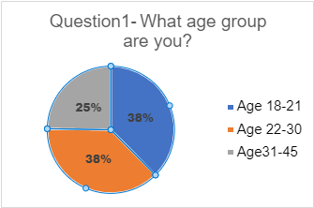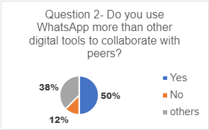

Q1. Age 18-21- 38% (3) 22-30- 38% (3) 32-45- 25% (2) = 8 participated
Q2. Yes- 50% (4) No-12% (1) other- 38% (3) = 8 participated
Q3. Yes- 60% (3) No- 40% (2) = 5 participated
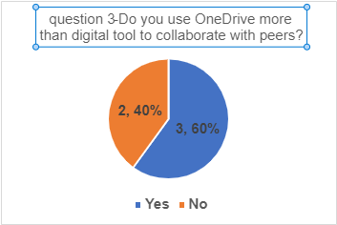
Q4. Yes 60% (3) No 40% (2) = 5 participated

Ranked Questions (Bar Charts)
3. Results (Created using MS Excel)
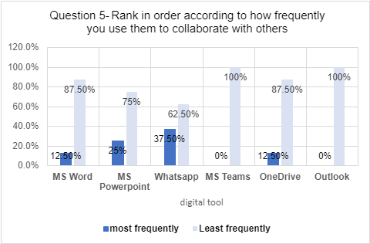

Q5. Response from eight precipitants. Rank in order: WhatsApp= 37.5% MS PowerPoint= 25% MS Word and OneDrive =12.50% MS Teams and Outlook 0%
Q6. Response from eight participants. Rank in order: MS Excel= 50% MS PowerPoint= 12.5% MS Word= 12.5% MS Forms= 12.5% MS Streams= 12.5%

3. Results (creating using Excel)

Likert Scale questions (Bar Chart A)
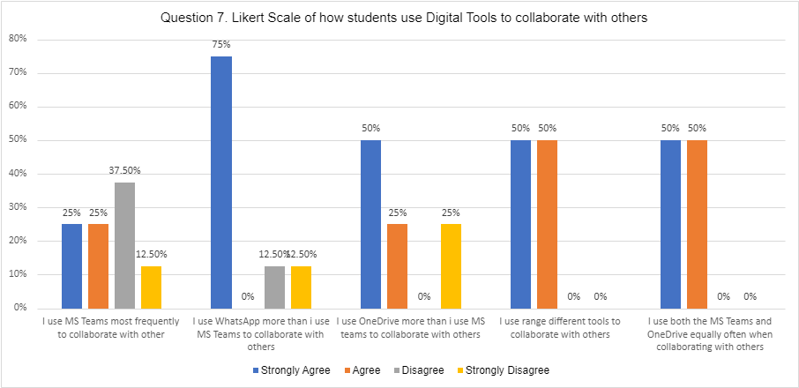

S/A-Strongly Agree A-Agree D-Disagree S/D- Strongly Disagree

MS Teams most frequently with others S/A= 25% A= 25% D=37.5% S/D= 12.50%
WhatsApp more than MS Teams S/A= 75% A= 0% D= 12.50 S/D= 12.5%
OneDrive more than MS Teams S/A= 50% A= 25% D= 0% S/D= 25%
Range of different tools to collaborate S/A= 50% A= 50% D= 0% S/D= 0%
MS Teams and OneDrive both equally S/A= 50% A= 50% D=0% S/D= 0%

Likert scale question (recommended Bar chart B from excel)

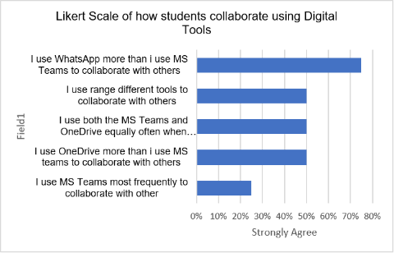

Discussion

In my results I have had full 100% consent saying yes to taking part in my survey. In total I had eight participants responded but also few questions 5 participants responded to the survey. Here are the data analysis. I have few questions out as they were not so relevant to my results. I have shown number of participants in brackets but also converted them in percentage figures too. I have created a pie chart displaying my closed question result Q1. What age group are you? 18-21 38% (3) 22-30 38% (3) and 31-45 25% (2) = 8 response. Which means we have more response from the younger range. Another closed question results Q2. Do you use WhatsApp more than other digital tools to collaborate with your peers? Yes 50% (4) Others 25% (1) and No 38% (3) = 8 response to collaborate with peers. Which means WhatsApp was popular. Q3. Do you use the OneDrive more than other digital tools to collaborate with peers? Yes 60% (3) No- 40% (2) = 5 response. Q4. Do you use MS Teams more than other digital tools to collaborate with peer? Yes 60% (3) No 40% (2) = five response. Which means both MS Teams and OneDrive are equally important but as its five response it is still not accurate result. In my ranked question I created a bar chart that shows Q5. Rank in order according to how frequently you use them to collaborate with others. results show 37.5% WhatsApp 25% PowerPoint 12.50% MS Word 12.50% OneDrive 0% MS Teams 0% Outlook = 8 response. Again, WhatsApp being most popular with the students. It is a surprise to know that MS Team and Outlook being least frequently used to collaborate with others as mentioned by Hart et al. (2019) MS Teams online learning helped support to students connect and communicate effectively. Q6. Response from eight participants. Rank in order how frequently you use to collaborate with others in on OneDrive? MS Excel 50% MS PowerPoint 12.5% MS Word 12.5% MS Forms 12.5% MS Streams 12.5% = 8 response. Moving to the Likert scale question the results show same questions, but I created two different bar charts. Q7. Likert scale how students use digital tools to collaborate with others? Bar chart (A) shows of how Strongly Agree, Agree, Disagree and the Strongly Disagree but the bar chart (B) is a recommend bar chart which shows a clear mode of results. Here are following results from bar chart B: - I use WhatsApp more than I use MS Teams to collaborate with others= 75%. I use the range of different tools to collaborate with others= 50%. I use both MS Teams and the OneDrive equally often when working with others= 50%. I use the OneDrive more than I use MS teams to collaborate with others= 50%, I use MS Teams most frequently to collaborate with others= 25%. This result shows again WhatsApp is at the top for connecting which proves one of my hypotheses which I will be explaining later.
Another reliable source Gan, et al (2015) had said although WhatsApp being popular with young learners, it was not the most effective way to communicate but My results fit with one of my literatures and mentioned by Carvalho, Santos (2022) social media e.g., WhatsApp, Facebook, Instagram and Snapchat and Multimedia helped students to collaborate with their mentors in peer learning program. being the way students are comfortable in communication, but the least frequent use of digital tool was MS Teams as I believed in hypothesis, Hart et al. (2019) mentioned online learning- Black board collaborative virtual classroom and web conference (just like MS Team) is the most effective way to support student in placement learning. Although the Blackboard collaboration helped students but in my hypothesis Carvalho, Santos (2022) did also mention because of technical glitches, students prefer a face-to-face meeting which could prove why MS Team being less popular with the students of UWTSD. Students are happy using range of digital tools. A short video presented by Fejerman and Curtain (2020) - Digital Literacy Series: O365 collaboration tools - how web conference and online communication created by a mind map of all other digital tools for project related activity and it covers parts of the results in how technology is necessary to engage with others. I do feel I my results could have been better as the ranked question shows the least frequent use of digital tool being a higher percentage of number than most frequent use with lower percentage. Having analysed that I do feel my Likert scale bar chart A is showing students feelings, but bar chart B (recommended chart from excel) shows clear and just stronger feeling from highest percentage to the lowest percentage.
With my hypothesis mentioned by Hart et al. (2019) online Blackboard collaboration virtual classroom helps improve digital skills and is the most effective way to support students in workplace, I was able to guess MS Teams is the way that helps student as it’s a virtual classroom too, but then with technical issues it shows the downside of virtual collaboration and how students should still need to be supported through face to face when it’s possible and probably it’s the least favourite in frequent use but having said that MS Teams and blackboard collaboration are two different online classroom intervention and analysis could be wrong. The results that were a complete surprise such Outlook not getting enough credit and I feel I could have used more literature to support how Outlook used as often. May be change the questions to how efficient these tools are in Likert scale question format.

- Conclusion
In my conclusion I have understood how students collaborate using technology at UWTSD. My discussion proved a digital media such as WhatsApp helps student to collaborate and is the most effective. Also, MS Teams and OneDrive were popular with the students. The result was my recommended bar chart B which gave me a better understanding how students feel from highest to lowest. They rely on WhatsApp more than MS teams or other tools as it is easy and reliable way to communicate, and this helps to mind map the digital tools which are important working to together. That is why they are comfortable using range of different digital tools. The issue I had was why outlook was not amongst the top in collaboration and I feel how I could have added questions regarding the technical issues student face online whether its MS Teams, internet issues or submitting assignments. These problems effect how efficient and reliable technology is, but it is minor to the greater outlook of using technology. However, students communicate to collaborate should be easy and if it is through social media then in my opinion it is better as it builds a community of students sharing innovative ideas, helping, learning, and through this kind of interaction students should and will find ways to support each other and help improve their digital skills and knowledge. That would be my recommendation.

6. Reference List

Carvalho A.R., Santos. C. (2022)’​, Developing peer mentor's collaborative and metacognitive skills with a technology- enhanced peer learning program’, Computers and Education open (3) 100070, Elsevier, Portugal
Curtain, D. and Fajerman, (2020) A. Digital literacy Serious: 0365-collaboration tools [video] Available at: https://www.bing.com/videos/search?q=https%3a%2f%2fyoutu.be%2fmxdacx3lubu&docid=607992822009041709&mid=C048D7273D33B6AE5759C048D7273D33B6AE5759&view=detail&FORM=VIRE (accessed: 27 June 2022)
Equality and Human Rights Commission (2018), The Human rights Act 1998, Available at: https://www.equalityhumanrights.com/en/human-rights/human-rights-act (accessed: 27 July 2022)
Gan, B., Menkhoff, T. and Smith, R. (2015) ‘Enhancing students’ learning process through interactive digital media: New opportunities for collaborative learning’, Computers in human behaviour, 51, pp. 652–663. Doi: 10.1016/j.chb.2014.12.048.
Hart. T., Bird. D., Farmer., (2019)​ ‘Using blackboard collaborate, a digital web conference tool, to support nursing student's placement learning: A pilot study exploring its impact’, Nurse Education in Practice, Vol. 38, Northampton
Krupat, E. (2022) ‘When I say … Likert item’, Medical education, 56(2), pp. 149–150. doi:10.1111/medu.14660.
Saunders, M.N.K., Lewis, P. and Thornhill, A. (2019) Research methods for business students. (8) ed. Harlow: Pearson.

- Appendix A – A blank copy questionnaire.

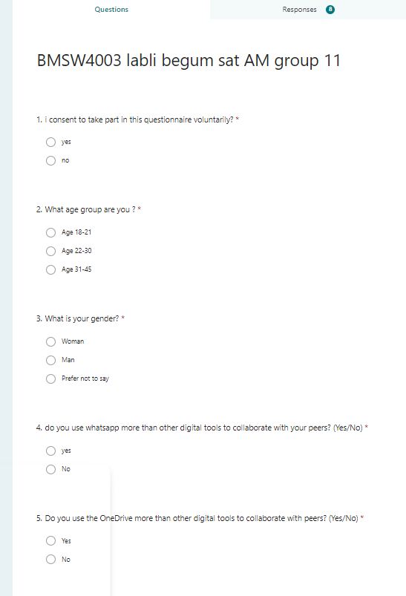

Appendix A – a blank copy of questionnaire
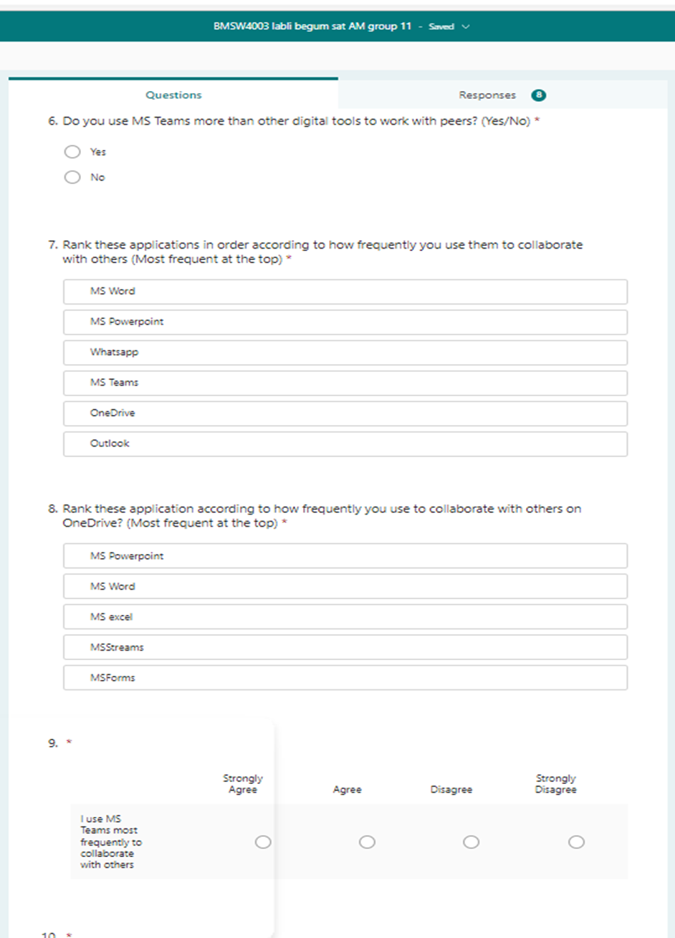

Appendix A – a blank copy of questionnaire.

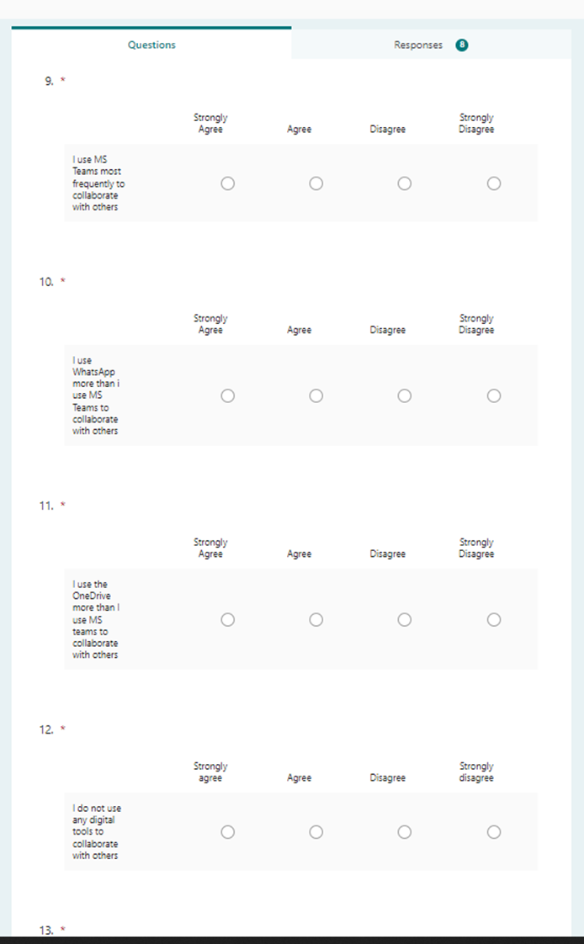

Appendix A- copy of questionnaire



