

UWTSD
OME DEGREE COURSE

Victoria C. Scally

Physics Assignment

© UWTSD 2025. All rights reserved. No part of this publication may be reproduced without the written permission of the copyright owner.

Academic integrity declaration
I declare that:
- the thesis submitted has been written by me alone.
- the thesis submitted has not been previously submitted to this university or any other.
- that all content, including primary and/or secondary data, is true to the best of my knowledge.
- that all quotations and references have been duly acknowledged according to the requirements of academic research.
I understand that to knowingly submit work in violation of the above statement will be considered by examiners as academic misconduct.
Table of Contents
Tables

- INTRODUCTION
It is common knowledge that there are many different materials used for armour plating, through time and experimentation different materials have become more commonly used and created for the purpose of armour plating, be it for a tank, for human wear or for other vehicles.
This paper will discuss the effects of a high speed ballistic projectile on two very different armour plate materials. In this case Inconel-718 and Copper.
The bullets in both of these simulations are identical and therefore a real comparison can be made using ABAQUS.
Comparing Copper and Inconel-718 as armour plate materials involves analysing their mechanical properties and how they behave under Johnson-Cook Damage parameters. The Johnson-Cook damage model describes failure under high strain rates and stress conditions typically see in ballistic impacts

- Copper Plating
The first simulation uses Copper.
The Johnsons Cook parameters for this material show it to be low in hardness and shear strength.
Copper is a relatively soft material. It has a low yield strength which means it will deform easily under impact. It lacks shear and tensile strength which is needed to resist projectiles hitting it at a high velocity.
As seen in figures 1-4 the forces taking effect on this plate and the main cause for the failure at the sheer stresses, the copper plate is seen to bend slightly as the bullet travels through the material, tearing out of the underside as it passes completely through causing complete failure of the plate. [2]
As copper deforms, it does absorb a small amount of the energy from the bullet, but not enough to protect it against failure.
Copper Johnson cook parameters:
Copper A 90 B 292 n 0.31 c 0.025 m 1.09
Young’sModulus 119GPa
Poisson’sRatio 0.33 [1]
The velocity of the bullet through this plate can be seen in figure 10.
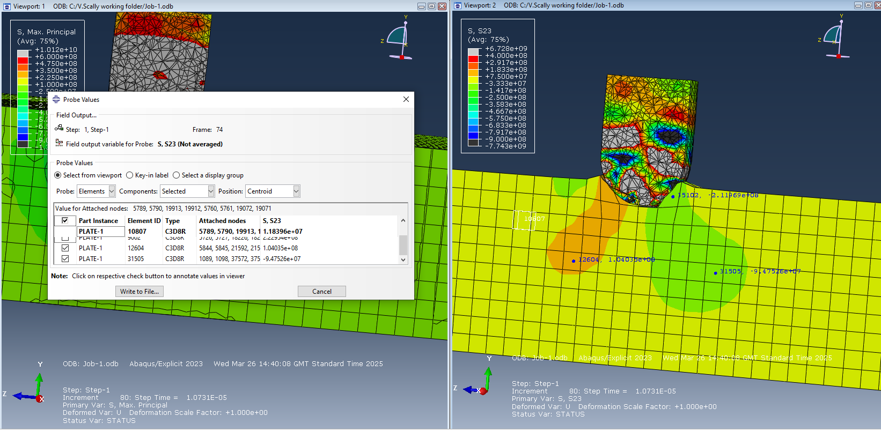
Shear forces are seen here with the bullet making initial contact with the copper plate. This is the initial impact and shows the material layers sliding down past one another
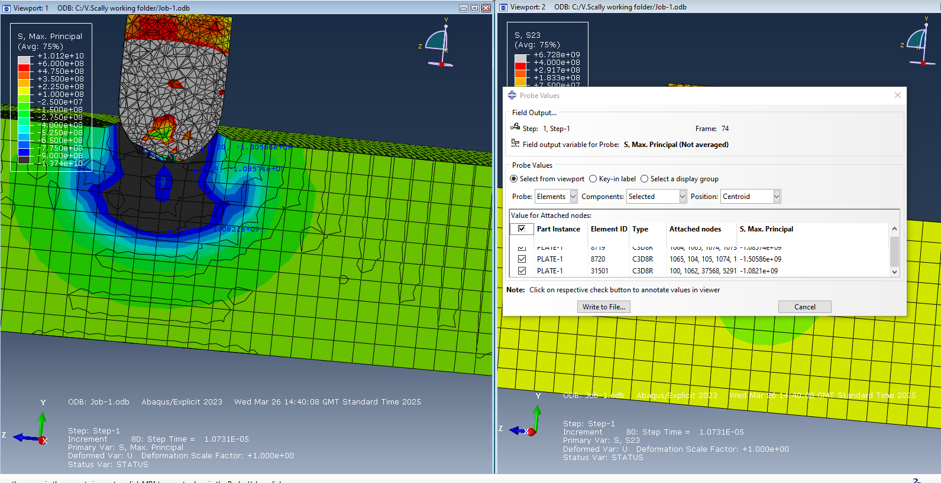
The above shows the compressive force being exerted on the copper plate at the beginning of the simulation.

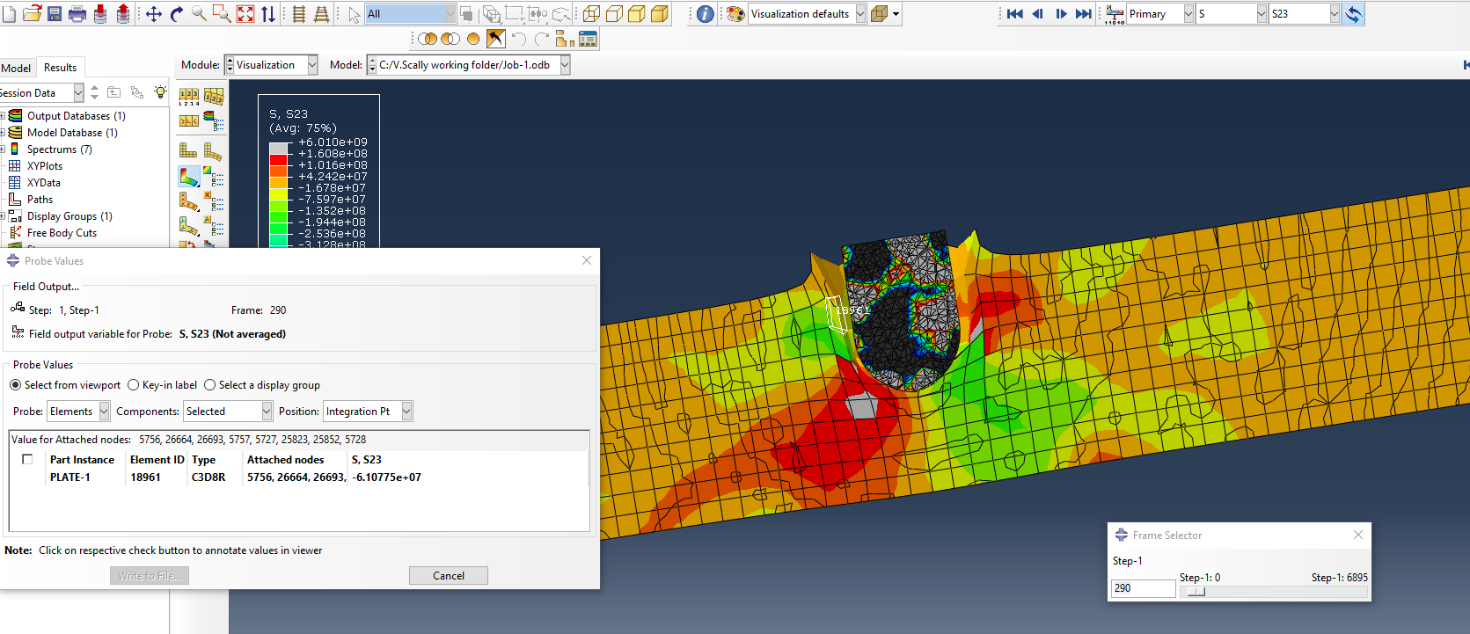

This screenshot shows more of the sheer stresses taking effect at the bullet travels further into the copper armour plate.
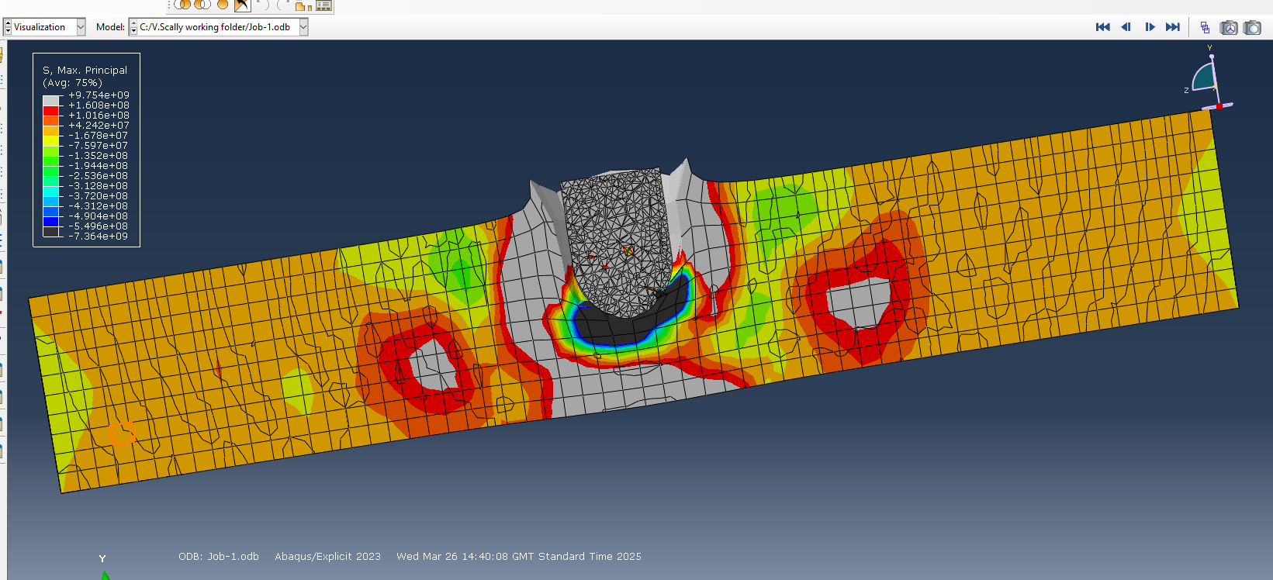
Further compressive force is exerted on the plate. This screenshot also captures the deformation of the plate and the beginning of the failure of the underside of the plate.
The plate eventually fails completely and the bullet travels through causing tearing of the metal and the deformation seen above of the upper level of the plate.

- Inconel-718
Simulation 2 uses Inconel-718.
The Johnson-Cook damage parameters of this material differ hugely from copper. Inconel-718 is a high-strength superalloy.
From figures 5-9 a spread of data is shown, though sheer stresses are seen to affect the plate as the bullet travels through, figure 9 shows a high tensile stress rate before the bullet bounces back out of the plate material.
This suggests that the tensile stress would be the cause for complete failure of the plate should the bullet have been powerful enough to penetrate entirely.
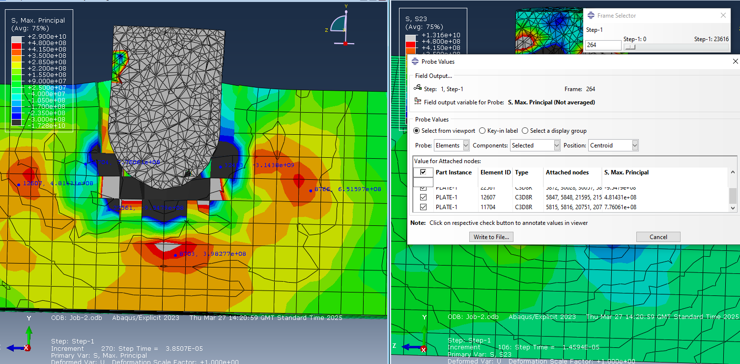
The max principal image shown here show a clear spread of the forces through the plate, especially strong near the tip of the bullet as it penetrates the upper surface.

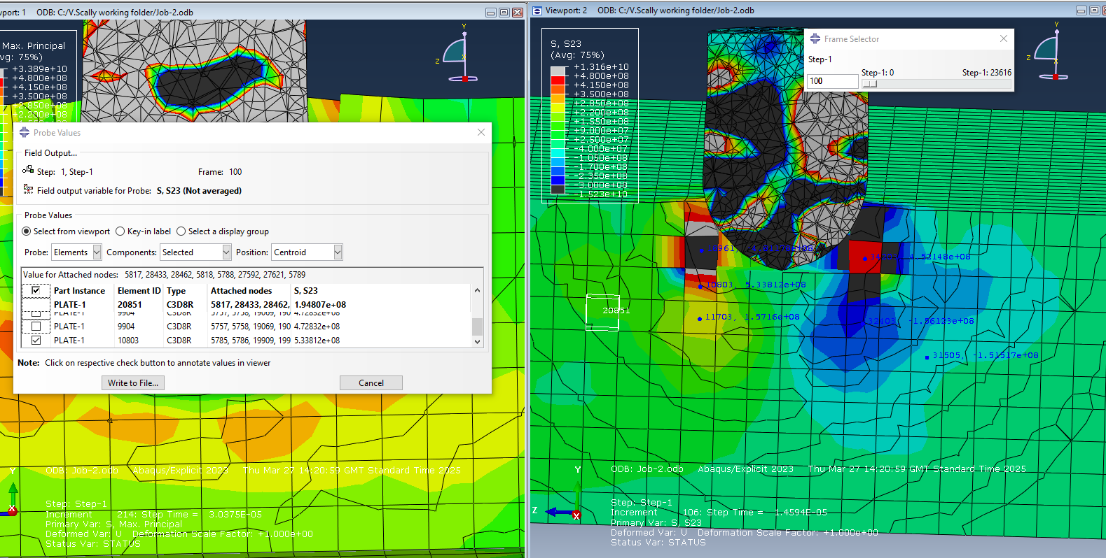
Sheer forces shown as the bullet pierces and enters through the surface of the plate.
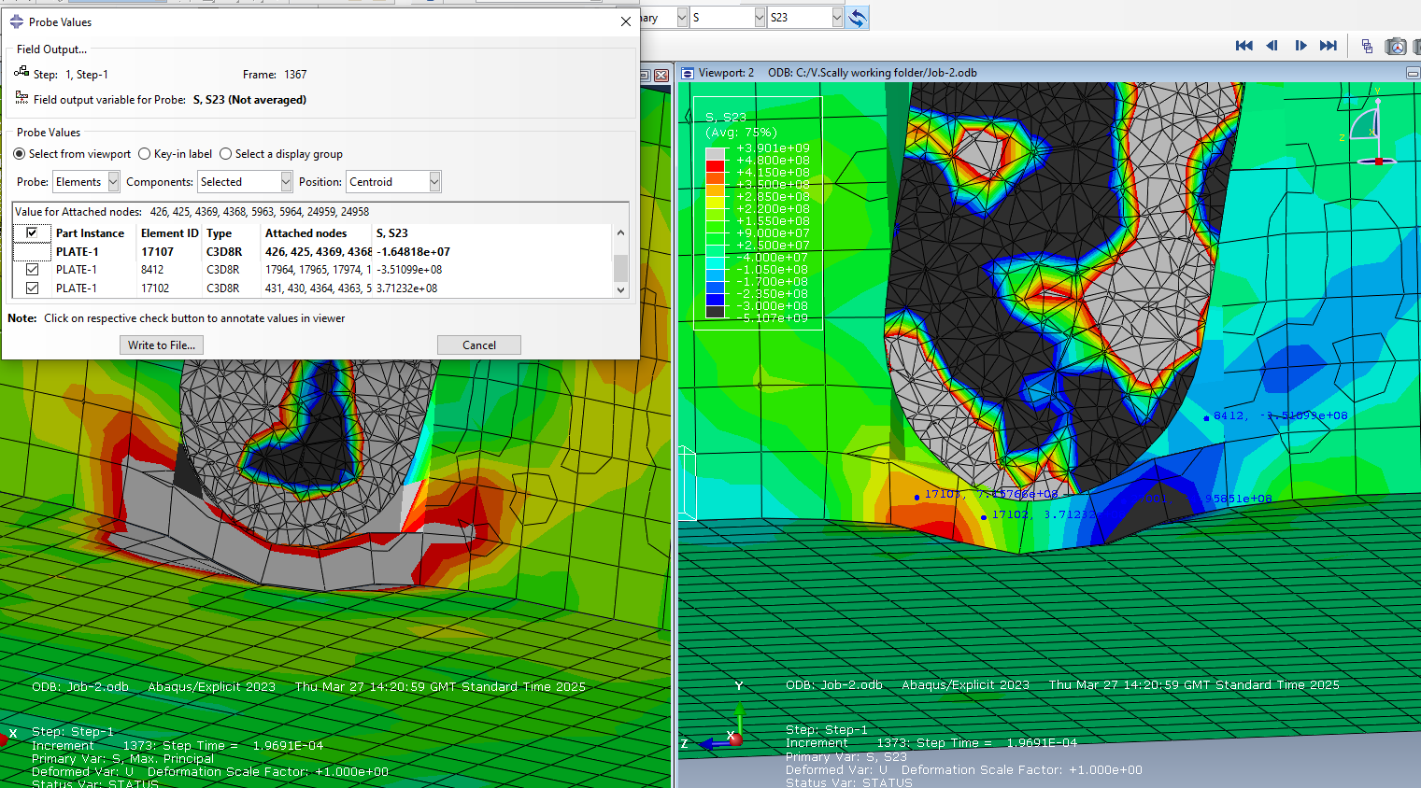
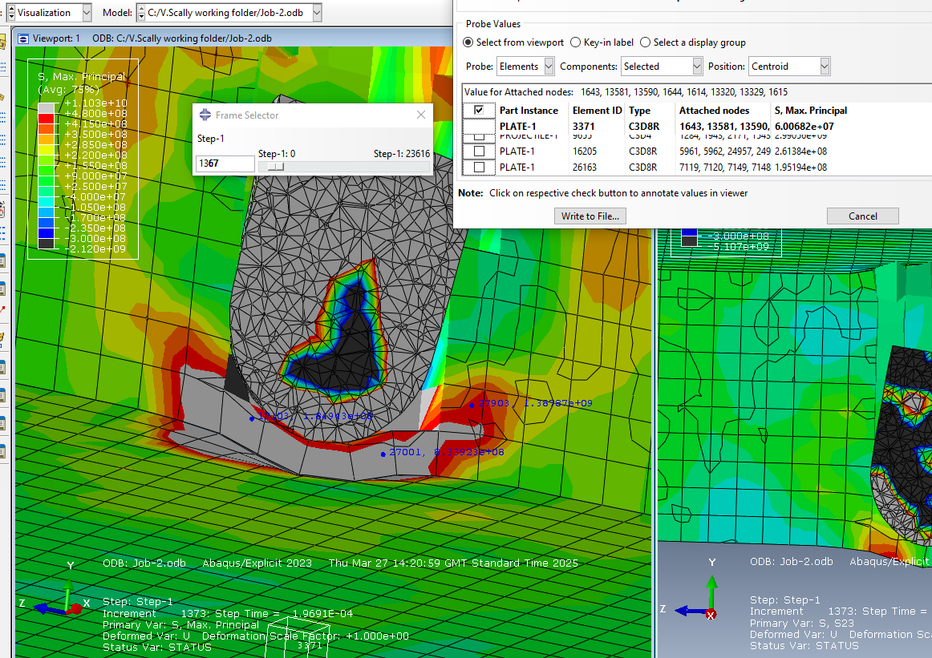
Figures 8 and 9 show sheer and tensile stress just before the bullet ricochets out of the armour plate.
Figure 8 shows the tensile force pushing the outside of the armour plate and deforming it, however this projectile is not powerful enough to pierce through the plate.
The velocity of this bullet can be see in figure 11.

Bullet Velocities.

Discussion
Although both metals used in these simulations have very similar and high density, their other material properties are vastly different.
Inconel-718 has approximately ten times more yield strength and hardness. This makes it a far more appropriate armour plating that copper.
Copper although reactive to both tensile and sheer strains, will ultimately fail due to the sheer forces as seen by the way the copper tears as the bullet penetrates entirely through the material.
Inconel-718 is far more resistant to sheer and tensile failure due to its properties addressed above. Under ballistic conditions the initial entry of the bullet is show to be due to both sheer and tensile forces on the armour plate though it can be summaries that due to figure 9 showing high levels of tensile strain on the outer edge of the armour plate before the bullet bounces back that should the bullet have been more powerful, the plate would fail due to tensile forces.

Conclusion
In conclusion the materials used in these simulations both behaved in entirely different ways.
Inconel-718 being a super alloy was deformed and pierced but however was able to withstand the bullet and did not fail. Should the bullet have been made from an alternative metal or travelling at a higher speed, from the results seen it is highly likely that the main cause for failure would be tensile strain on the metal. Though it is important to note that the sheer stresses also have some impact on this and cannot be discounted.
Copper, although being a dense material lacks the sheer and tensile strength to be used as an effective armour plate against any high speed projectile. It failed due to sheer stress as the bullet tore out of the other side of the armour plate. This shows it to be unsuitable for armour plating due to its mechanical properties.

