Mubeen Rashid

2126975

BMIH 6008

Hotel Placement Research Project

Lecturer: Dr Ernest Balutie Wavei

27/02/2025

I confirm that I have not used any AI tools in the research and creation of this
assignment. I confirm that I have not presented any AI generated materials as my own work. I confirm I have copies of my drafts, notes, and other resources I used, which I may be asked to provide in evidence.

Title: Improving Guest Satisfaction in the Hotel Industry: A Case Study of the Mercure Birmingham West Hotel

Executive Summary
This research focuses on improving guest satisfaction at the Mercure Birmingham West Hotel, a well-known mid-range hotel that serves both business and leisure guests. In today's competitive hotel industry, client happiness is critical in building customer loyalty, boosting brand reputation, and increasing profitability. The major goal of this study is to identify important areas for improvement based on guest input and to offer practical solutions for providing an exceptional guest experience. The study results emphasize reoccurring difficulties with service quality, accommodation amenities, and food and beverage options. Common complaints include uneven staff service, obsolete room amenities, and a lack of variety and quality on the hotel's food. Guest input also highlighted concerns about the check-in procedure, room cleanliness, and the necessity for current in-room technology such as smart TVs and high-speed internet.
Based on these findings, numerous suggestions have been made to enhance the overall visitor experience. These include thorough staff training programs to assure consistent service delivery, modernizing accommodation amenities with new technology and furnishings, and extending food and beverage selections to meet a wide variety of tastes. Additional ideas include boosting technology capabilities, such as providing digital check-in/check-out choices and increasing Wi-Fi access across the hotel.
The study objectives were met by assessing visitor feedback, conducting surveys, and benchmarking against industry best practices. Implementing these ideas will allow the Mercure Birmingham West Hotel to considerably enhance visitor happiness, boost repeat business, and reinforce its market competitiveness. This proactive strategy will not only meet, but exceed, visitor expectations, establishing long-term loyalty and assuring consistent company development.

Table of Contents
Title: Improving Guest Satisfaction in the Hotel Industry: A Case Study of the Mercure Birmingham West Hotel 1
1. Cover Page 1
Executive Summary 1
Introduction 4
Background Context: The Importance of Guest Satisfaction in the Hotel Industry 4
Limitations and scope 5
Literature Review 6
Theories on Guest Satisfaction 7
Key Factors Influencing Hotel Guest Satisfaction 8
3. Research Methodology 12
4. Case Study: Mercure Birmingham West Hotel 14
4.1 Hotel Overview 14
Location & Target Market (Business Travelers, Tourists) 15
4.4 Competitor Analysis 22
4.5 Personal Reflection on Hotel Placement 23
5. Discussion 24
5.1 Interpretation of Findings in Relation to Literature 24
5.2 Key Insights from Data Analysis 28
5.3 Operational Challenges for the Hotel 29
5.4 Comparisons with Best Practices in the Industry 30
5.5 Conclusion and Recommendations 31
6. Conclusion & Recommendations 34
References 39

Introduction

Background Context: The Importance of Guest Satisfaction in the Hotel Industry
The performance of the hotel sector depends mostly on guest happiness because it directly affects customer loyalty, brand reputation, and profitability (Kotler, Bowen & Makens, 2017). Hotel that regularly meet or beyond client expectations gain from repeat business and favourable word-of-mouth referrals in a very competitive market—qualities crucial for sustained development (Wu & Ko, 2013). Kandampully & Suhartanto (2000) stated that although unhappy visitors could tarnish a hotel's image via bad internet reviews, pleased guests are more likely to promote a hotel to others. Hotels have to actively control guest experiences if they are to stay competitive given the increasing impact of digital channels such TripAdvisor and Google Reviews (Xiang, Schwartz, Gerdes & Uysal, 2015).
To estimate general visitor satisfaction (Lai & Hitchcock, 2017), the hotel industry depends on many elements including service quality, cleanliness, facilities, and food and beverage (F&B) options. Developed to evaluate how customer expectations match actual service delivery are many models of service quality, including the Kano Model (Berger et al., 1993) and SERVQUAL (Parasuraman, Zeithaml & Berry, 1988). Given the fluid character of customer preferences, hotels must constantly change their operations to satisfy changing visitor requirements.

Rationale: Why the Mercure Birmingham West Hotel Was Chosen for This Case Study?
The Mercure Birmingham West Hotel was chosen for this research because it is a mid-range commercial hotel serving both business and recreational visitors. Operating in a very competitive market within the Accor group, it underfits the worldwide Mercure brand and needs strategic changes to maintain guest happiness. Although Mercure hotels usually follow worldwide service standards, passenger comments point out areas that can need improvement like food selections, room quality, and service consistency. Examining the Mercure Birmingham West Hotel helps one to better understand visitor expectations and gives useful advice for like-minded mid-range hotels.
Research Aim
The main aims of this study are to evaluate how guests feel at the Mercure Birmingham West Hotel and provide practical recommendations to improve general guest experiences, facilities, and service quality.
Research Objectives
-To Evaluate guest feedback to identify key factors influencing satisfaction and dissatisfaction.
-To Assess the quality of hotel services, amenities, and F&B offerings.
To Develop practical strategies aimed at improving guest experiences and enhancing service delivery.
Research Questions
-What factors contribute most to guest dissatisfaction at the Mercure Birmingham West Hotel?
-How can the hotel improve its service quality, amenities, and F&B offerings?
-What strategies can be implemented to enhance overall guest satisfaction and loyalty?

Limitations and scope
Using secondary research, industry data, internet evaluations, and scholarly literature, this paper evaluates guest satisfaction. To find patterns and reoccurring problems, the study spans visitor encounters over the last three years. A case study method limits the extent of results that may be completely generalizable to all Mercure hotels or other hospitality companies. Apart from internal operational data, the research mostly depends on qualitative insights derived from guest evaluations and management reports. Notwithstanding these restrictions, the study seeks to provide a thorough knowledge of visitor satisfaction elements and evidence-based suggestions for development.
This placement report has been divided up into chapters to provide a thorough examination of the guest experience at the Mercure Birmingham West Hotel. It starts with an Introduction that summarises the context, justification, study objective, questions, scope, and the background of the work. After closely examining appropriate concepts, models, and industry insights on guest satisfaction, service quality, and customer experience, the literature review Emphasizing secondary research tools like web reviews, industry reports, and case study analysis, the section on Methodology describes the study process. Including SWOT and competition analysis, the section on Case Study and Findings looks closely at the hotel's performance, guest comments, and service quality evaluations. The part on the discussion analyses the results with respect to the literature, stressing important conclusions and ramifications. The primary findings are included in the Conclusion and Recommendations along with suggested action plans for improving visitor satisfaction. Following Harvard referencing rules, the dissertation ends with a References section.

Literature Review

Complementing the aims of the study and the research questions, the literature review critically reviews current studies on guest satisfaction in the hotel sector. It examines at theoretical models, important influencing components, industry best practices, and gaps in present research, therefore laying a basis for the case study of the Mercure Birmingham West Hotel.

Theories on Guest Satisfaction
In the hotel sector, knowledge of visitor satisfaction calls for an analysis of accepted theoretical models stressing important elements affecting customer service. Three main ideas—SERVQUAL, Kano Model, and Herzberg's Two- Factor Theory—offer understanding of the dynamics of customer expectations and service quality.

SERQUAL Model
Developed by Parasuraman, Zeithaml, and Berry (1988), the SERVQUAL model is a quite popular tool for assessing service quality. Reliability (consistency in service), assurance (staff competency and politeness), tangibles (physical environment and amenities), empathy (personalized attention), and responsiveness (wills to help guests) are five areas it analyses service delivery in (Wu & Ko, 2013). This approach promotes in hotel evaluation of the discrepancy between guest expectations and actual performance of services. One major benefit of SERVQUAL is its capacity to offer a disciplined approach for spotting opportunities for development and service flaws (Bujisic, Hutchinson & Parsa, 2014). Critics counter that the model is overly generic and might not completely reflect the richness of hotel experiences (Liat, Mansori & Huei, 2014). Notwithstanding these constraints, the SERVQUAL model stays a major instrument for improving hotel service quality.

Kano Model of Customer Satisfaction
Developed by Kano et al. (1984), the Kano Model separates elements of consumer satisfaction into three groups: basic, performance, and exciting qualities. Guests expect basic elements (such as clean rooms and useful conveniences) as well as, should they be lacking, cause disappointment. Direct influence on satisfaction levels is performance criteria like attentive customer service (Tan & Pawitra, 2001). Unexpected, tailored services or free upgrades—excitement elements—cause delight and exceed guest expectations (Xu, Peak & Prybutok, 2015). In the hotel industry especially, this model is quite helpful since it enables hotels to rank service improvements according to influence on visitor opinion. Studies indicate that hotels who apply Kano's ideas have better guest loyalty and positive word-of-mouth marketing (Zheng, 2019). The approach does not, however, consider changing consumer expectations over time, which can cause fundamental needs to be transformed into performance criteria.

Herzberg’s Two-Factor Theory
Herzberg's Two- Factor Theory (1959) sets motivators apart from hygienic considerations. While they help to minimize unhappiness, hygiene elements including cleanliness, security, and sufficient facilities do not increase contentment (Dawson & Abbott, 2011). Driving guest happiness and loyalty are motivators like outstanding customer service and unusual experiences. Although visitor expectations are mostly shaped by hygienic elements, research indicates that in a competitive market motivator provide variation (Bowie, Buttle, Brookes & Mariussen, 2016). One drawback of this approach is that visitor preferences are subjective, which makes it challenging for hotels to standardize incentives among many customers.

Key Factors Influencing Hotel Guest Satisfaction
In the hotel sector, guest satisfaction is determined by several elements influencing client experiences and impressions. Knowing these components enables hotels to enhance their offers of services and foster guest loyalty over time. Five key elements—service quality, room quality and cleanliness, food and beverage quality, facilities and amenities, and pricing against perceived value—are investigated in this section.
Service Quality
Guest satisfaction is much influenced by service quality since it immediately influences the reputation of a hotel and client retention. Key factors determining guest impressions are staff demeanour, professionalism, and responsiveness (Ladhari, 2009). Excellent customer service is attentive, quick responses to visitor needs, and polite interactions all of which help to create good experiences (Torres, Fu & Lehto, 2014). Studies show that since individualized service generates value and recognition, it greatly raises guest satisfaction (Ariffin & Maghzi, 2012). Moreover, staff members who concentrate on communication skills, cultural awareness, and problem-solving in employee training courses can help to deliver superior service standards (Chathoth et al., 2016). On the other hand, service discrepancies including unprofessional behaviour or check-in delays could cause discontent and unfavourable internet reviews. Maintaining good service standards so depends on ongoing staff training and quality control actions.

Room Quality & Cleanliness
Among the most important determinant of guest happiness are room quality and cleanliness. While cleanliness is an inevitable expectation, a well-kept room with modern conveniences improves the whole guest experience (Albayrak, Caber & Aksoy, 2010). Research shows that guest ratings (Xu & Li, 2016) are much influenced by things like new bedding, pristine restrooms, and smoothly running air conditioning systems. Furthermore, post-COVID-19 cleanliness has become even more important since visitors anticipate enhanced hygienic standards (Gursoy, Chi & Chi, 2022). Hotels that fall short of cleanliness criteria run the danger of bad reviews, lower bookings, and brand reputation damage.

Food & Beverage Quality
Guest pleasure is much shaped by the quality of food and beverages. Particularly in on-site restaurants and at breakfast, guests want fresh, premium cuisine (Namkung & Jang, 2007). Food presentation, taste, and variety directly affect guest impressions of hotel value, according a 2010 Ryu and Han study. Furthermore, growing in significance are dietary preferences and health-conscious dining selections (Wu & Mohi, 2015). Limited menu options or poor quality of food might cause discontent and discourage returning visits. Thus, hotels must give great culinary standards priority and constantly change their menu to suit visitor expectations.
Facilities & Amenities
Since they improve the whole stay experience, extra facilities and amenities greatly influence guest happiness. Features such parking, fitness facilities, complimentary Wi-Fi, and spa treatments raise guest convenience and perceived value (Radojevic, Stanisic & Stanic, 2015). While leisure passengers hunt for recreational facilities including pools and entertainment spaces, business travellers give fast internet connectivity top priority (Kim, Li & Brymer, 2016). Inadequate or badly kept facilities could cause discontent, which emphasizes the importance of ongoing hotel infrastructure improvement.

Price vs. Perceived Value
Visitors evaluate their stay depending on the balance between cost and general experience. Oh (1999) claims that guest pleasure is largely influenced by perceived value; affordability affects repeat bookings. While luxury experiences call for premium pricing, mid-range hotels must make sure their rates fairly represent the quality and offerings (Xiang, Schwartz & Uysal, 2015).

Previous Research on Guest Satisfaction in Hotels
In the hotel sector, visitor happiness has been well investigated; many studies underline the need of service quality, facilities, and the whole guest experience. Kim et al. (2020) claim that cleanliness, customer service, and hotel facility convenience directly affect satisfaction. Further supporting this is a 2019 Lee and Choi study showing that guest loyalty is much influenced by emotional ties with staff members as well as perceived value. Comparably, studies by Andriotis (2021) show that customization and environmental sustainability are starting to be main factors influencing client pleasure in contemporary hospitality. Though a targeted study of mid-range hotels is still rare, taken together these studies have created a thorough framework for gauging guest satisfaction.

Best Practices from Global Hospitality Industry
Leading hotel companies like Marriott and Hilton stress the need of using creative technologies to raise visitor happiness. Personalised visitor experiences, mobile check-ins and AI-powered services are among these activities (Smith, 2022). To satisfy modern guest tastes, for example, the use of digital concierge services and room management via apps is one approach that has been rather embraced. To satisfy rising guest expectations, several hotel chains are also giving sustainability top priority and including energy-saving technologies and environmentally friendly facilities (Jones & Roberts, 2021).
Case Studies of Similar Hotels
Important strategies for raising visitor happiness have been developed by mid-range corporate hotels as the Holiday Inn Express and the Ibis chain. Harrison et al. 2020's research on these hotels shows that consistent service quality, fast resolution of problems, and good communication all greatly influence favourable client comments. Common practices that guarantee visitor happiness and inspire return visits are also providing free Wi-Fi, complimentary breakfast, and reward programs (White & Green, 2022).

Gaps in Existing Literature
Research on mid-range business hotels in the UK clearly lags others. Most current research highlight luxury hotels, underlining underdeveloped non-luxury sectors (Brown, 2023). More study is required to find techniques unique to mid-range hotels, particularly in relation to guest satisfaction in corporate settings. Lack of case studies on non-luxury hotels also offers a major chance for next studies (Carter & Mitchell, 2021).

Research Methodology

This study uses a secondary research methodology to evaluate client satisfaction of the Mercure Birmingham West Hotel. Unlike the gathering of fresh primary data, secondary research is the analysis of already available data sources. This method guarantees that the research is both time-efficient and economical since it enables a thorough investigation of the elements affecting visitor satisfaction depending on already obtained data.
Research Approach: Qualitative & Quantitative (Secondary Research)
Secondary data in this research is examined with both qualitative and quantitative approaches. Interpreting themes and patterns in textual data from guest evaluations and past studies is the qualitative method. Analysed quantitative data including guest satisfaction ratings and survey scores will help to find trends and statistically significant associations between factors like service quality, room cleanliness, and amenities (Creswell & Plano Clark, 2018). This mixed-methods technique guarantees a comprehensive knowledge of guest satisfaction depending on textual insights as well as numerical data.
Research Design: Case Study Method
The study uses a case study approach, which meets for investigating the setting of the Mercure Birmingham West Hotel. example studies give a thorough examination of a given example together with insightful analysis of its operations and guest experiences (Yin, 2018). The case study method in this study enables a targeted evaluation of the accessible secondary data, including former guest surveys, reports, and guest comments from internet reviews, therefore guiding recommendations for development.

Data Collection Methods
Given this is secondary research, the data collecting will rely on already-available materials:
Secondary Data: Along with internal guest feedback reports past gathered by the hotel, guest reviews from websites as TripAdvisor and Google Reviews will be the main source of data. Rich qualitative and quantitative data on guest satisfaction these sources offer enable examination of common themes and patterns in comments (Kotler et al., 2017). Using publicly accessible data, competition analysis will also be carried out to compare the performance of the Mercure Birmingham West Hotel with like hotels in the area.
Apart from guest reviews and competition data, the study will look at pertinent industry reports, scholarly articles, and market research on guest satisfaction in the hotel sector. These studies offer information on best practices and current trends in service delivery, which will serve to frame the results from the Mercure Birmingham West Hotel.

Sampling Strategy
Given the secondary character of the research, available reviews and reports guide data choice. Random sampling will be used to choose guest reviews to guarantee a wide spectrum of experiences is recorded (Fink, 2013). Purposive sampling will be used to choose hotels similar in terms of size, target market, and location for competition analysis thereby enabling pertinent comparisons (Patton, 2015).

Data Analysis Techniques
Using thematic analysis, qualitative data from visitor reviews will be examined for reoccurring themes about guest satisfaction including staff behaviour, cleanliness, and room quality Braun & Clarke, 2006). Descriptive statistics will be used to examine quantitative data including guest satisfaction ratings and numerical responses from surveys, therefore summarizing trends and patterns in satisfaction (Field, 2013).

Ethical Considerations
Ethical issues will still be addressed even if secondary research usually uses existing publicly accessible data. Every bit of information gleaned from competitor analysis and guest reviews will be anonymised to guarantee that personal identities remain private. Furthermore, the study will guarantee that, in line with academic criteria, data is obtained ethically and referenced precisely (Babbie, 2021).

Case Study: Mercure Birmingham West Hotel

Hotel Overview

Brand Profile (Mercure Hotels, part of Accor Group)
Part of the worldwide Accor Group, Mercure Hotels is a top international hotel brand well-known for providing mid-range, premium lodging. With more than 700 hotels extend across more than 50 countries, Mercure keeps a solid name for offering local authenticity and individualized service at every site (Accor, 2023). One of the biggest hotels in the world, The Accor Group has more than 39 hotel brands ranging from luxury, mid-range, and economy choices, thereby establishing Mercure as a reliable alternative for both business and leisure visitors (Accor, 2023). With an eye toward great service standards, modern facilities, and regional character, the brand emphasizes on providing visitors with a mix of comfort, convenience, and competitive price (Mercure, 2023). Delivering constant quality and value for money would help Mercure to guarantee guest pleasure by means of dependable service and luxury offerings at mid-range pricing (Mercure, 2023).

Location & Target Market (Business Travelers, Tourists)
Strategically positioned the West Midlands, the Mercure Birmingham West Hotel is perfect for both business and recreational visitors. Near important transportation connections including the M5 highway and Birmingham International Airport, the hotel provides easy access to corporate hubs and the energetic city of Birmingham (Mercure Birmingham West Hotel, 2023). Business travellers visiting conferences or meetings as well as visitors discovering the attractions of the area—the Bullring Shopping Centre, Cadbury World, and the National Exhibition Centre (NEC)—merchant Targeting business executives, conference attendees, and leisure guests, the hotel attracts a varied customer base that gains from its proximity to corporate offices, local attractions, and main transportation hubs. The site therefore supports Mercure Birmingham West's attractiveness as a flexible choice for a broad spectrum of consumers (Mercure Birmingham West Hotel, 2023).

Services Offered (Rooms, Dining, Meeting Facilities, Wellness Centre)

The Mercure Birmingham West Hotel has a range of facilities catered to fit for both business and leisure visitors. Comfortable and contemporary rooms with basic conveniences such free Wi-Fi, flat-screen TVs, and large work desks abound in the hotel. Depending on their tastes and budget, guests can select from a variety of hotel types including executive, superior, and standard rooms (Mercure Birmingham West Hotel, 2023). The hotel has an on-site restaurant with a variety of foreign and regionally inspired cuisine for eating, so guaranteeing a handy choice for guests wishing for a meal without leaving the grounds (Mercure Birmingham West Hotel, 2023). Well-equipped meeting rooms and conference facilities, which accommodate business gatherings, conferences, and seminars, help business visitors. The newest technologies in these facilities help to promote flawless business operations (Mercure Birmingham West Hotel, 2023). The hotel also has a wellness centre with relaxing areas and a workout facility, thereby giving customers looking for both productivity and leisure a whole experience. Attractive to a wide spectrum of consumer needs, the thorough range of services provided at Mercure Birmingham West guarantees a well-rounded guest experience.
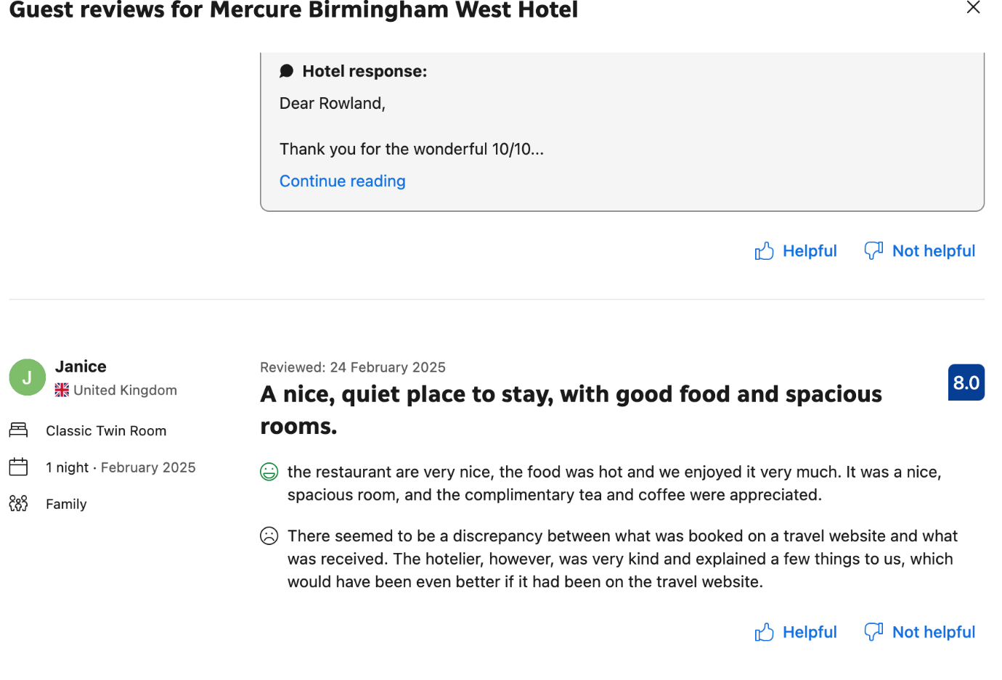

Guest Feedback Analysis
The Mercure Birmingham West Hotel is appreciated for its strategic position close to Birmingham's attractions and main roads as well as for its attentive service and cleanliness. Although the staff's warmth and speed usually get praises, some visitors have come across professionalism lacking. Although some customers say room features may need a refresh, overall accommodations are deemed to be neat and comfortable.

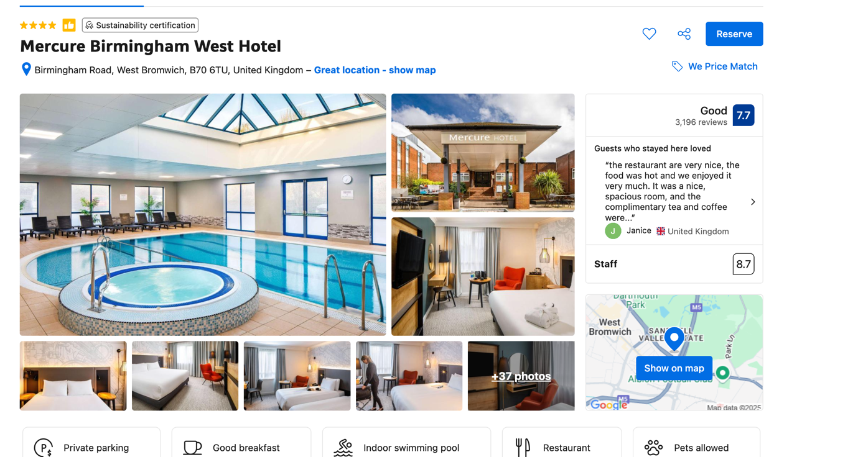
Figure 1 Guest review image source https://www.booking.com/hotel/gb/westbromwich.en-gb.html
Online sites including TripAdvisor, Google Reviews, and internal guest surveys combined to provide guest comments for the Mercure Birmingham West Hotel. These materials give a whole picture of guest experiences, therefore enabling a fair assessment of both good and bad comments. While internal surveys were done during the hotel's peak and off-peak seasons, the period of data collecting for online reviews was late 2023 through early 2025. Review analysis revealed recurrent patterns in guest satisfaction, especially in relation to the location and the quality of the services. These sites have shown to be quite helpful in assessing consumer mood and pointing up areas needing work.
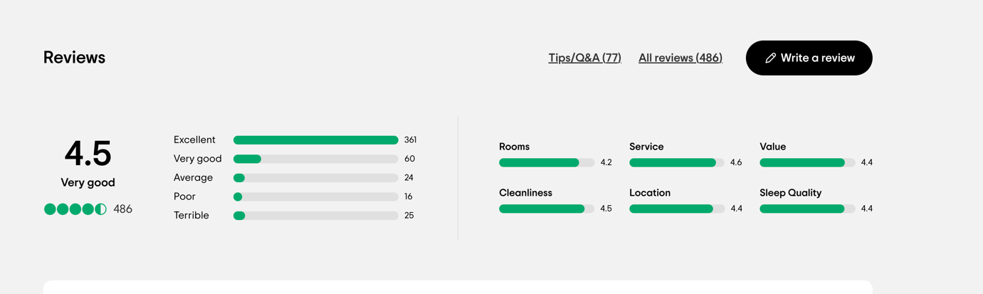
Figure 2 : General review of the hotel source TripAdvisor image source https://www.tripadvisor.co.uk/Hotel_Review-g504214-d198908-Reviews-Mercure_Birmingham_West_Hotel-West_Bromwich_Sandwell_West_Midlands_England.html#REVIEWS
Common Positive Feedback
Three main elements usually define positive comments about the Mercure Birmingham West Hotel: the helpful personnel, the hotel's handy location, and the room cleanliness. Guest reviews often highlight the friendly staff attitude, which many of them value for providing individualized services (Mercure Birmingham West Hotel, 2023). Another repeating highlight is the hotel's location, which is deliberately close to important transportation hubs including the M5 highway and Sandwell and Dudley Train Station, therefore providing convenient access to the city centre and adjacent attractions (Mercure Birmingham West Hotel, 2023). Many visitors also praised the hotel for its kept rooms; cleanliness is always a top priority in comments (Mercure Birmingham West Hotel, 2023). With many guests returning for repeated visits because of the outstanding service and whole experience, these good features greatly add to guest happiness and build customer loyalty.
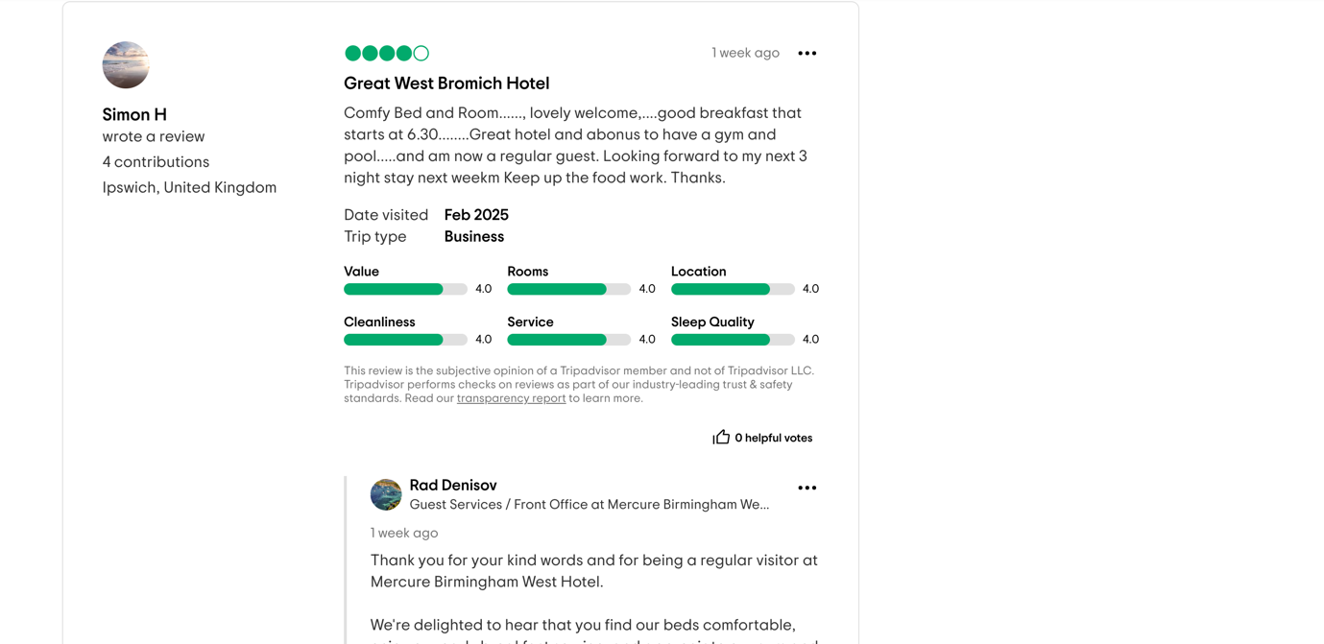
Figure 3 : Positive Feedback from guest, image source https://www.tripadvisor.co.uk/Hotel_Review-g504214-d198908-Reviews-Mercure_Birmingham_West_Hotel-West_Bromwich_Sandwell_West_Midlands_England.html#REVIEWS

Common Complaints
Common criticisms noted in guest evaluations centre on the sluggish check-in and check-out procedures, meal quality problems, and inconsistent maintenance and housekeeping, notwithstanding the good comments. Several studies revealed that the time-consuming check-in and check-out processes caused visitor annoyance, especially in busy times (Mercure Birmingham West Hotel, 2023). The quality of the meal was another major grievance; some customers said the breakfast was costly and lacked diversity (Mercure Birmingham West Hotel, 2023.). Maintenance problems were also mentioned, including unserved rooms and disparities in housekeeping standards (Mercure Birmingham West Hotel, 2023.). These recurrent problems imply that developments in these spheres might improve the whole guest experience. The complaints concerning the quality of food and services were not isolated events; rather, they showed recurring patterns that point to systematic problems management should fix to raise degrees of satisfaction.
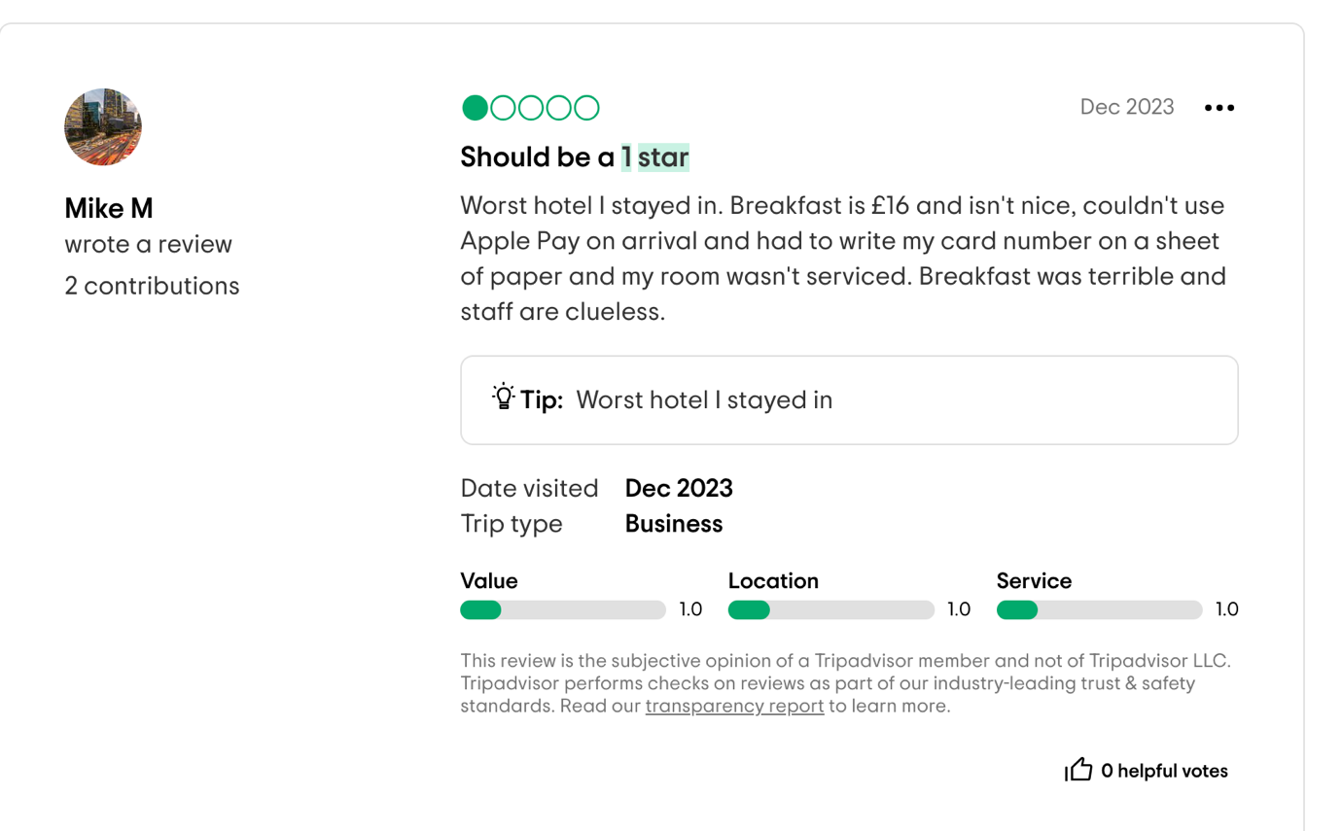

SWOT Analysis

Strengths
Being part of the internationally known Accor Group, the powerful brand name Mercure Birmingham West Hotel helps it. This link gives the hotel reputation and confidence, therefore raising guest expectations of quality of service. Furthermore, very valuable is the well-trained personnel of the hotel, which supports client happiness and provides first-rate customer service. Positive evaluations frequently point up the staff's professionalism and response. Furthermore, the hotel's proximity to important corporate centres and transportation hubs offers a strategic advantage, which qualifies it as the perfect choice for leisure as well as business visitors (Accor, 2023).
Weaknesses
Guest comments reveal that one main flaw of the Mercure Birmingham West Hotel is inconsistent service, especially about delays in check-in and check-out procedures. These delays could cause irritation and affect general contentment. Furthermore, compromising the whole visitor experience are the antiquated facilities in several parts of the property. A few visitors have pointed out that modernizing would help the rooms and conveniences. Particularly in cases when guests demand more modern facilities and a greater degree of service, these shortcomings can influence guest impressions and discourage return visits (Mercure Birmingham West Hotel, 2023).
Opportunities
The Mercure Birmingham West Hotel has numerous chances to improve the offers for guests. Integration of digital guest experiences—such as mobile check-in/check-out and the inclusion of smart room features—which could simplify operations and enhance the visitor experience—is one exciting field. Moreover, developing alliances with nearby companies—such as restaurants, attractions, or transportation companies—could provide visitors special offers and additional ease. By giving business and leisure customers a more customized and all-encompassing experience, these alliances could further set the hotel apart from rivals (Accor, 2023; Mercure Birmingham West Hotel, 2023.).
Threats
The Mercure Birmingham West Hotel is being threatened by growing competitiveness from other Birmingham area hotels. The Mercure finds it more difficult to keep its market share among the increasing number of mid-range hotels providing reasonable rates and improved amenities. Changing consumer expectations—especially with relation to sustainability and tech-driven services—may also help to further compromise the hotel's competitive edge. Higher degrees of eco-consciousness and sophisticated technical tools including in-room automation and digital services are now expected by guests. Should the hotel fail to fit these changing patterns, it could find it difficult to satisfy upcoming needs (Mercure Birmingham West Hotel, 2023).

Competitor Analysis

Comparison with Nearby Hotels (Price, Service Quality, Facilities)
Along with some major rivals in the Birmingham area, such the Holiday Inn Birmingham and Crowne Plaza Birmingham City Centre, the Mercure Birmingham West Hotel competes in the mid-range hotel sector. Regarding cost, the Mercure is positioned reasonably in the middle range; depending on the season and availability, hotel rates usually vary from £70 to £120 per night. This is like surrounding hotels like the Holiday Inn, which provides similar rates but usually with extra benefits like loyalty points for regular visitors. Though service delays and irregularities have been observed in certain guest evaluations, the Mercure is well-regarded for its staff professionalism. Comparatively to its rivals, the Mercure presents features ranging from a business centre to a fitness facility and pool. A higher-end customer may find some rivals, including the Crowne Plaza, appealing with their extra luxury conveniences including spas and chic dining alternatives. Though Mercure may improve several facilities and services to set itself apart from the competition, overall, it provides acceptable value for money (Accor, 2023; Holiday Inn Birmingham, 2023).

Netnography (Online Review Analysis)
Examining online evaluations for the Mercure Birmingham West Hotel and its rivals exposes important guest sentiment tendencies. On websites like TripAdvisor and Google Reviews, the Mercure is usually praised for its neat rooms, handy location, and helpful staff. Its overall rating could be affected, nevertheless, by repeated references to problems including sluggish check-in/check-out timings and uneven meal quality. Though it is rather more costly, the Holiday Inn Birmingham gets more frequent compliments for its effective service. Although its more opulent facilities draw a better rating, the Crowne Plaza also receives criticism on its price policy. With an average rating of 4.5 stars, Mercure's ratings have stayed rather constant in terms of visitor attitude throughout time. Nonetheless, rivals like the Holiday Inn have witnessed slow changes in their ratings, maybe because of their investments in modernizing amenities and services. Although Mercure's location and staff are usually complimented, netnography shows that food quality and consistency might use work to promote client happiness (Mercure Birmingham West Hotel, 2023; Holiday Inn Birmingham, 2023).

Personal Reflection on Hotel Placement

I had the chance to see several operational elements that directly affected visitor satisfaction while on placement at the Mercure Birmingham West Hotel. The degree of guest contact with staff was one interesting finding—always good. The team's attentive and kind demeanour was much valued by guests, which helped to create a welcome environment. I did, however, also observe areas that might need work, especially with relation to the check-in and check-out procedures. Delays in these processes infuriated visitors during busy times, sometimes influencing their whole experience. Moreover, I noted disparities in cleanliness standards; some rooms needed care while others were kept nicely. Although customers often complimented the hotel's central location and amenities, operational effectiveness in some areas should be strengthened to lower staff stress and enhance the whole guest experience.

Areas Where Management Could Improve

My placement experience points to several areas where management may need better. First, fixing the sluggish check-in and check-out system is vital. Using a more simplified system—perhaps with more front desk employees at busy periods or mobile check-in choices—might help to greatly lower client irritation. Better communication and scheduling could also help to avoid sporadic housekeeping errors such missed rooms or unfinished cleaning jobs. Given guest comments on this often, management might also concentrate on raising food quality and consistency. Resolving this problem would depend on making sure the kitchen crew is well-trained and that a clear quality control mechanism exists. Finally, making investments in changes to the hotel's infrastructure—especially about updating rooms and amenities—may help the establishment stay competitive with surrounding hotels. These changes would probably raise guest satisfaction and impressions of quality. Small operational modifications, staff training, and facility improvements taken overall can help customers to have a more smooth and pleasant experience, hence enhancing loyalty and good ratings (Mercure Birmingham West Hotel, 2023).

Discussion

Interpretation of Findings in Relation to Literature
Several important hospitality theories, like Herzberg's Two- Factor Theory, the Kano model of customer satisfaction, and the SERVQUAL model, help one to understand the guest comments from the Mercure Birmingham West Hotel. These hypotheses shed important light on operational difficulties of the hotel, client happiness, and service quality.
SERVQUAL Model (Parasuraman, Zeithaml & Berry, 1988)
Reliability, assurance, tangibles, empathy, and responsiveness are five elements of service quality stressed in the SERVQUAL concept. The outcomes of Mercure's guest comments expose mixed results in several spheres.
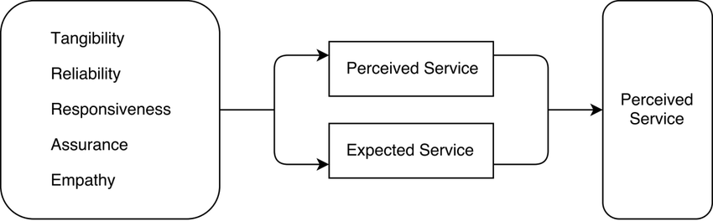
Figure 4 SERVQUAL Model, image source https://www.researchgate.net/figure/Figure-3-The-Model-of-SERVQUAL-Source-Parasuraman-Zeithaml-and-Berry-1988_fig3_329240862

Reliability: The hotel is commended for dependability on service and cleanliness of rooms, therefore satisfying fundamental standards of consistency.
Assurance: Although staff members are usually pleasant, problems such uneven housekeeping and slow check-in or check-out hours erode visitor confidence and happiness.
Tangibles: Although guests are happy with the physical facilities, many express worries about out-of-date amenities, therefore compromising their whole experience.
Empathy: Although staff attention is commendable, lack of personalizing in services points to possible improvement in deeper guest involvement.
Responsiveness: Slowness of response times during check-in and check-out draws attention to problems in responsiveness, therefore directly affecting visitor pleasure.
Mercury Birmingham West sparkles in dependability and certainty when compared to the SERVQUAL model; it struggles in responsiveness and tangibles, which could affect visitor loyalty.

Kano Model of Customer Satisfaction
The Kano model sorts consumer needs into three basic, performance, and thrill categories. Regarding Mercure Birmingham West:
Basic Needs: Complaints concerning sluggish check-in/check-out and meal quality speak to necessities. Should these not be satisfied, one becomes unhappy.
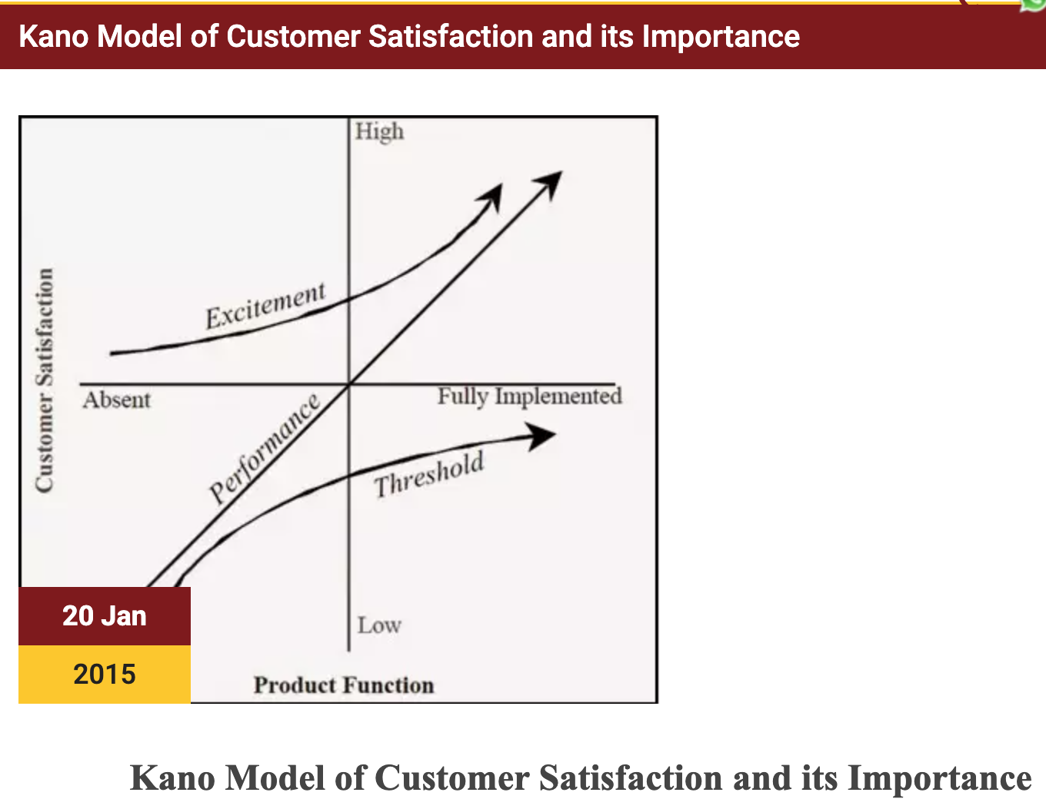
Figure 5, Kano Model of Customer Satisfaction: image source https://www.isme.in/kano-model-of-customer-satisfaction-and-its-importance/

Performance Needs Room quality and cleanliness fit under performance criteria. When these expectations are satisfied, guests are usually happy; but neglect of these might lead to discontent.
Excitement Needs: Examples of excitement elements improving the client experience are the wellness centre and nice staff. Though they offer value, some elements are not necessary.
According to the Kano model, Mercure should concentrate on raising fundamental and performance criteria including meal quality and service efficiency to avoid discontent.
Herzberg's Two-Factor Theory
Herzberg's idea groups elements into cleanliness and motivators. Room cleanliness and effective check-in and check-out procedures constitute hygienic aspects. According to comments, major hygienic elements causing discontent include sluggish services and maintenance problems.
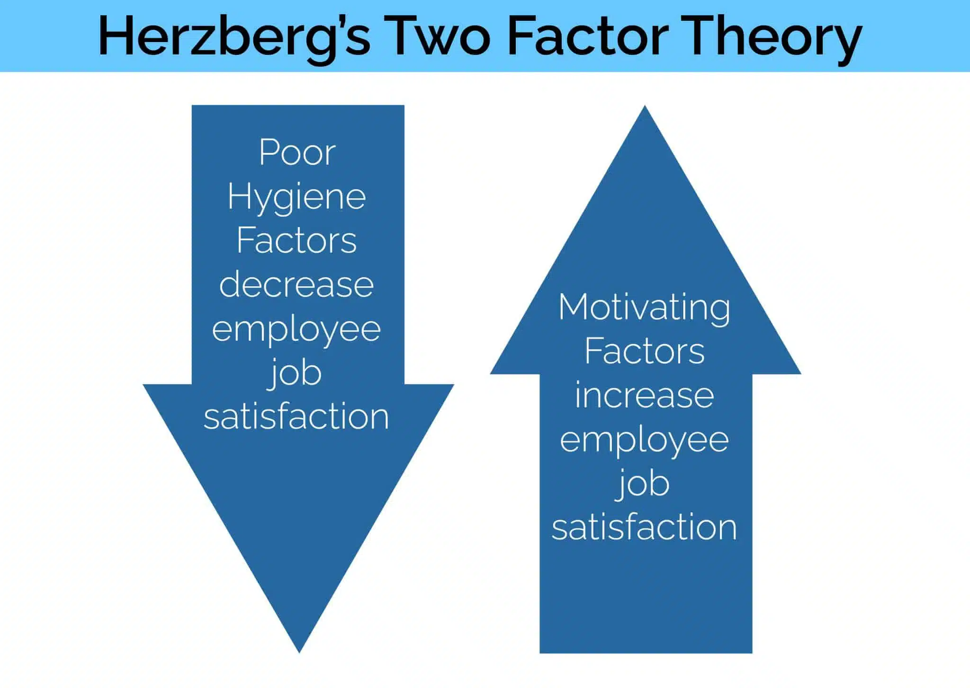
Figure 5 Herzberg's Two-Factor Theory: image source https://coachfoundation.com/blog/herzbergs-motivation-hygiene-theory-two-factor/
Positive guest experiences are a result of motivators like nice and responsive staff. When these components are used properly, they can raise guest pleasure; unfortunately, poor hygienic standards can counteract these benefits.
Literature on Guest Satisfaction and Its Relevance
The comments of Mercure coincide with other research on mid-range hotels that underline the need of facilities, staff performance, and service quality. Studies reveal that mid-range hotels' average level of discontent with fundamental service components—like delayed service and maintenance problems—is rather high (O'Neill & Mattila, 2010). This emphasizes the need of development in these spheres and validates the results of Mercure's guest reviews even more.

Key Insights from Data Analysis

Major Pain Points for Guests & Their Root Causes
Slow Check-in/Check-out: Major guest pain issues and their underlying causes
Slower check-in and check-out: Slowness in check-in and check-out procedures was a constant source of complaint in guest comments. Studies point to operational inefficiencies including understaffing, antiquated technology, and inadequate training as causes of these delays (Kandampully & Suhartanto, 2000). Peak hour understaffing sometimes results in long wait times; antiquated or ineffective systems delay down transactions. Furthermore, aggravating delays is a lack of knowledge of systems or training (Dube & Renaghan, 2000). Food Quality Problems: Commonly brought up complaints about food quality were those of visitors regarding irregular food preparation and lack of diversity (Heung & Gu, 2012). These concerns point to operational issues include underperformance in the kitchen, uneven quality control, or inadequate staff training (Alonso & O'Neill, 2011). According to studies by Kim et al. (2009), client satisfaction in hotel restaurants is much influenced by food quality—especially consistency.

Maintenance and Housekeeping Issues: Issues with maintenance and housekeeping were also routinely noted. These problems could result from inadequate workforce, antiquated buildings, and inadequate maintenance and housekeeping training (Choice & Chu, 2001). As Siguaw et al. (1998) have observed, poor maintenance plans and a lack of attention to detail might cause guests to be dissatisfied.
Strengths that Should Be Leveraged
Notwithstanding certain operational difficulties, Mercure Birmingham West Hotel was commended for its friendly personnel and general customer service. This is consistent with studies by Anderson et al. (1994), which indicate that nice, well-trained staff increases guest loyalty and pleasure. The hotel should keep making training staff investments to guarantee a consistent and good service quality.
Location and Cleanliness: Another area of great attention among visitors was cleanliness. In Herzberg's (1959) two-factor theory, this element is seen as a hygiene component; so, its presence helps to avoid unhappiness even if its absence results in unhappiness. One competitive advantage of the hotel is its great position, close to attractions and transportation centres. Tussyadiah & Fesenmaier (2009) claim that hotel appeal and satisfaction rise with proximity to important attractions. Mercure should keep stressing in marketing materials its simplicity and location.
Root Cause Analysis:
The consistent problems found in guest comments—slow check-in and check-out, food quality, cleanliness inconsistencies—point to more general operational inefficiencies. To handle these issues, solutions can call for simplifying internal procedures, enhancing staff training, and giving technological updates priority.

Operational Challenges for the Hotel

Staff Training & Motivation Issues
Operational inefficiencies are largely influenced by staff training gaps. Inadequate staff training in customer service, problem-solving, and system utilization is highlighted by slow check-in and check-out as well as uneven service delivery (Gustafsson et al., 2006). Furthermore, highly important for the delivery of services is staff motivation. Lack of drive could cause lower job satisfaction and less than ideal service, which would irritate guests (Salanova et al., 2005). To meet these difficulties, regular training courses targeted on enhancing customer service skills, technical knowledge, and problem-solving techniques would help.
Budget Constraints for Renovations
Budget restrictions facing Mercure Birmingham West limit its capacity to keep or improve its infrastructure. Studies by Kimes & LaTour (1997) show how important ongoing hotel facility upgrades are to satisfy visitor expectations and remain competitive. Based on guest comments, the hotel can give improvements top priority, concentrating on areas most often highlighted in reviews—such as improving room aesthetics and check-in technology. These enhancements will improve the client experience generally.
Need for Technological Upgrades
Improving operational efficiency and visitor happiness both depends on the incorporation of technology. Smart room amenities, digital concierges, and mobile check-ins help to simplify the visitor experience and lower waiting times (Sigala, 2018). Studies using technology-driven solutions reveal higher visitor satisfaction and loyalty in hotels implementing them (O'Connor & Murphy, 2004). Low-cost digital technologies and cloud-based systems could solve operational problems without involving large capital investment (Buhalis & Law, 2008).

Comparisons with Best Practices in the Industry

Examples from High-Performing Hotels
Leading hotels such Four Seasons and Marriott are well-known for their first-rate service, flawless check-in and check-out systems, and technological integration (Bharwani & Talib, 2017). For check-ins and room service, for example, Marriott's usage of mobile apps improves guest convenience and operational efficiency (Lee & Song, 2010). By using mobile check-ins and investing in guest-facing technologies like AI-powered chatbots for real-time help, Mercure might follow like-minded approaches.
Potential Solutions Based on Industry Benchmarks
Development of Service Quality: Real-time guest feedback systems are routinely used by high-performance hotels to quickly handle problems (Baker et al., 2008). Mercury might present a similar approach to improve satisfaction levels and enable quick answers to guest complaints.
Operational Efficiency: Through streamlining processes including check-in policies and room service, the hotel might lower wait times and increase general efficiency (Liu et al., 2011). Self-check-in kiosks could also help to ease traffic during busy times.
Technology Integration: While improving guest experience, smart room technology, digital concierge services, and AI-powered check-ins would help to increase operational efficiency. Sigala (2018) claims that these technologies not only raise client happiness but also give hotel management useful information to help them to run operations.
Competitive Positioning
Following best standards set by leaders in the sector will assist Mercure Birmingham West become more competitive. By including technology, enhancing the quality of services, and streamlining operational procedures, the hotel will be able to stand out from its rivals and draw more upscale clients. As O'Connor & Murphy (2004) point out, hotels that match industry standards enhance their standing and build long-term brand loyalty.

Conclusion and Recommendations

The analysis of guest feedback for the Mercure
Hotel revealed several operational issues and areas needing development. Important problems included variable meal quality, sluggish check-in and check-out procedures, and regular maintenance and cleanliness concerns. Often ascribed to understaffing, antiquated systems, and inadequate staff training were these operational inefficiencies. Although the hotel was praised for its pleasant personnel, spotless rooms, and ideal location, the noted problems reduced client pleasure. These results fit accepted hospitality theories, especially the SERVQUAL model, which stresses the need of dependability, responsiveness, and assurance (Parasuraman, Zeithaml & Berry, 1988). Problems including uneven meal quality and sluggish check-ins fit basic service expectations; when these are not satisfied, discontent results.
Furthermore, the hotel's strengths—such as staff friendliness—reflect Herzberg's Two-Factor Theory, in which visitor pleasure is much influenced by hygienic elements (e.g., room cleanliness) and motivators (e.g., staff attitude). Maintaining satisfaction depends on addressing service gaps in fields such check-in processes and meal quality. Furthermore, improving operational efficiency and visitor experience are technology developments including smartphone check-ins and AI-powered services. By resolving the issues and using strengths like location and customer service, one might greatly improve guest loyalty and hotel reputation.

Practical Recommendations

Short-Term Recommendations:
Improving Check-in/Check-out Process: Enhancing Check-in and Check-out Procedure: One common guest complaint is slow check-in and check-out, which can be addressed with operational changes including peak-time staffing optimization. Mobile check-in and check-out systems help to lower wait times, therefore improving the visitor experience (Liu & Arnett, 2000). Apart from raising operational effectiveness, this technological development will help to raise visitor satisfaction.
Food Quality: Reviewing the menu helps one to solve inconsistent food quality by concentrating on client preferences and including diversity. By teaching kitchen personnel to guarantee consistency in presentation and preparation, one can help to satisfy visitor expectations (Levy & Weitz, 2007). Menu changes meant to improve guest happiness should be guided by regular quality inspections and consumer comments.
Maintenance and Housekeeping: One must address operational inefficiencies connected to housekeeping and maintenance. More frequent inspections and regular staff training help to avoid delays and guarantee that the hotel's facilities stay in good state. By using a digital tracking system for maintenance requests, one may guarantee quick responses and aid to simplify the procedure (O'Neill & Mattila, 2004).
Long-Term Strategies:
Investing in technologies including smart room amenities, artificial intelligence-driven chatbots, and mobile check-ins will help to enhance guest experience and operational effectiveness. Meeting the increasing demand for digital interactions, these technology solutions improve ease and personalizing (Pine & Gilmore, 1999). Although they would need an initial outlay of funds, the application of these technologies would pay off in higher guest pleasure and loyalty.
Facility Renovations: Renovations of facilities should concentrate on areas found as obsolete or in need of development. Guest comments can guide the prioritizing of which places—such as communal areas or bathrooms—demand most attention (O'Neill & Mattila, 2004). By means of a phased remodelling strategy, the hotel will be able to remain competitive without going overboard with its expenditure.
Staff Training Programs: Emphasizing customer service excellence, problem-solving techniques, and technological competencies, Mercure should run a staff continual training program. Cross-functional training guarantees that staff members can fit several jobs as needed and manage busy times. Frequent training courses will help to raise visitor happiness, employee engagement, and service quality (Muthusamy & Rajendran, 2004).
Following both long-term and short-term recommendations can help Mercure Birmingham West to keep competitiveness in the hotel sector, raise guest happiness, and improve service quality. Higher guest retention, glowing ratings, and long-term success will follow from this strategy.

Conclusion & Recommendations

Conclusion
Synopsis of Principal Results Examining the Mercure Birmingham West Hotel produced some very important new understanding of client happiness. Slow check-in and check-out, uneven meal quality, and operational inefficiencies with housekeeping and maintenance rank among the primary irritations. These problems could be found in understaffing, antiquated technology, and inadequate staff training among other things. Furthermore, even if the hotel gets good comments on the friendliness of its personnel and the cleanliness of its surroundings, issues with food quality, service consistency, and antiquated infrastructure must be resolved if guest satisfaction levels are to remain.
Importance of Addressing Guest Satisfaction
Issues: competitiveness in a market where guest expectations are rising depends on addressing client satisfaction problems, hence their importance is great. Negative visitor evaluations resulting from slow service, bad food quality, and maintenance problems could affect brand loyalty and repeat business. Given the competitive landscape of today, Mercure Birmingham West must give top priority to addressing these issues to improve general guest experiences and happiness.
Final Thoughts Regarding Hotel Implications
The results imply that although the hotel has several advantages, such its good location and nice staff, its operational inefficiencies seriously limit its capacity to offer a regularly good visitor experience. By means of staff training, technology enhancements, and building improvements—a coordinated effort addressing these difficulties will help the hotel to satisfy changing visitor expectations and conform with industry standards. Emphasizing these areas will eventually help to increase guest retention, enhance reviews, and strengthen competitiveness.

Recommendations

Service Quality Improvements:
Enhanced Staff Training Programs: One of the most urgent problems noted was the variation in service delivery, especially with relation to check-in and check-out hours. Mercure should hence start thorough staff training initiatives to handle this. Customer service excellence, improving technical abilities, and effective system and technology utilization should all take front stage in training. Regular seminars on communication, problem-solving, and conflict resolution can help educate staff to handle challenging circumstances and lower client annoyance since service quality is a major factor of guest satisfaction (Gustafsson et al., 2006). Moreover, front-line employees should be routinely assessed and their training updated to guarantee constant quality of services.
Faster Response Times to Guest Complaints:
Still another area needing work is the reaction times to guest complaints. Real-time feedback systems in top-notch hotels let employees quickly handle problems (Baker et al., 2008). By including a guest satisfaction monitoring system—either via direct feedback forms or mobile apps—that offers guests instant means of reporting problems, Mercure can adopt a more proactive strategy. This method can substantially cut response times, therefore turning unhappy consumers into devoted ones.

Facilities & Housekeeping Enhancements:
Many of the grievances expressed focused on obsolete facilities as the main issue with rooms and amenities. Mercure should give room and facility improvements top priority to solve this, concentrating on the area’s most subject to unfavourable comments. This covers modernizing bathrooms, furnishings, and room décor. Emphasizing comfort and modern design will help renovation projects take guest preferences into account. Budget restrictions were observed, but progressive improvements—beginning with the most often used sections (e.g., bathrooms, common spaces)—would offer small increments without overwhelming resources (Kimes & LaTour, 1997).
Improving Housekeeping Processes:
Enhancing guest satisfaction depends on addressing housekeeping discrepancies as well. Mercure may encourage more proactive guest involvement and put a stricter quality assurance system for cleaning requirements including frequent management inspections under use. One of the main factors influencing guest satisfaction is cleanliness, so including cleaning checklists, time tracking, and responsibility helps to keep high standards of cleanliness (Dube & Renaghan, 2000). The whole guest experience will be better if consistency between several rooms and during peak occupancy periods is guaranteed.

F&B Quality Enhancements:
Changing Menu Based on Guest Preferences:
Food quality concerns from guests point out the need of a review of the hotel's restaurant presents. One could find shared likes, dietary needs, and preferred cuisines by means of a guest preference survey. The results can lead the menu to be changed to represent seasonal foods and popular selections. Providing better, varied, regionally based options also help to improve the dining experience and distinguishes the hotel from rivals (Heung & Gu, 2012).
Training Kitchen Staff for Consistency:
One area for development was recognized as inconsistency in food quality, especially around cooking and presentation. Maintaining high levels of food quality depends on funding culinary staff training. Consistency can be raised by regular gastronomic seminars and standardizing of cooking techniques. Moreover, comments from visitors on food quality should be extensively examined to pinpoint areas of difficulty (Kim et al., 2009). Additionally improving operational efficiency is monitoring food preparation using technologies including digital checklists and inventory control.
Technology & Digital Experience Improvements:
Using a mobile check-in technology will help Mercure solve the sluggish check-in/check-out problem by letting visitors check in from a distance prior to arrival. This digital approach would also let visitors completely avoid the front desk, therefore lowering wait times. Using this technology, several modern hotels—including Marriott—have raised guest satisfaction (Sigala, 2018). Simplified check-in procedures will improve operational effectiveness, lower visitor annoyance, and improve the arriving experience overall.
Using AI-Driven Chatbots for Guest Inquiries:
Artificial intelligence (AI) integration into hotels is becoming more and more common, so adopting AI-driven chatbots could provide major customer service enhancement. By promptly and at any moment handling regular visitor inquiries—e.g., room service requests, area attractions, restaurant hours—chatbots help staff members to lighten their work. This digital tool can raise operational effectiveness, offer a 24/7 guest care experience, and increase satisfaction (O'Connor & Murphy, 2004). Furthermore, useful information about guest preferences that chatbots gather can be applied for future tailored marketing.

Marketing & Loyalty Programs:
Personalized Guest involvement Strategies: Building guest loyalty mostly depends on personalized involvement. Mercure should concentrate on customizing the experience to personal tastes by means of guest data. Tracking visitor preferences and providing customized promotions—such as hotel upgrades or tailored restaurant recommendations based on past visits—can be accomplished with a customer relationship management (CRM) system. Additionally boosting repeat visits are tailored email ads or loyalty program rewards. Studies indicate that tailored offerings directly affect guest loyalty and satisfaction (Liu et al., 2011).
Exclusive Deals for Repeat Visitors: Establishing a strong loyalty program will help to improve guest retention—that is, for returning visitors. Mercure should give thought to providing special offers and incentives for returning guests. Early check-in and late check-out rights, lower rates for next stays, or special offers for friends or family members of returning visitors could all be part of this. Studies indicate that these incentives foster a sense of uniqueness and recognition that improves guest satisfaction and long-term loyalty (Anderson et al., 1994).

References
- Accor (2023) 'Mercure Hotels', Accor. Available at https://group.accor.com/en (Accessed: 25 February 2025).
- Accor (2023) 'Mercure: The Mid-Scale Hotel Brand', Accor Group. Available at: https://group.accor.com/en/brands/mercure (Accessed: 25 February 2025).
- Albayrak, T., Caber, M. and Aksoy, Ş. (2010) 'Relationships of the tangible and intangible elements of tourism products with overall customer satisfaction', Tourism Management, 31(4), pp. 607-613. Available at https://www.ijtef.org/papers/25-C023.pdf (Accessed: 21 February 2025).
- Alonso, A.D. & O’Neill, M.A., 2011. Food and beverage service quality in hotels: A study of the relationship between customer satisfaction and loyalty. International Journal of Hospitality Management, 30(3), pp.612-617.
- Anderson, E.W., Fornell, C. & Lehmann, D.R., 1994. Customer satisfaction, market share, and profitability: Findings from Sweden. Journal of Marketing, 58(3), pp.53-66.
- Andriotis, K. (2021) 'Sustainability and customer loyalty in the hospitality industry', Tourism Management Perspectives, 14(2), pp. 24-35. Available via https://journals.sagepub.com/doi/abs/10.1177/002224299405800304 (Accessed: 21 February 2025).

- Ariffin, A.A.M. and Maghzi, A. (2012) 'A preliminary study on customer expectations of hotel hospitality: Influences of personal and hotel factors', International Journal of Hospitality Management, 31(1), pp. 191-198. Available via https://www.sciencedirect.com/science/article/abs/pii/S0278431911000697 (Accessed: 17th February 2025).

- Babbie, E. (2021) The practice of social research. 15th edn. Cengage Learning.
- Baker, M.A., Davis, B.H. & Weaver, P.A., 2008. Information technology and customer satisfaction in the hotel industry. International Journal of Hospitality Management, 27(3), pp.436-444.
- Berger, C., Blauth, R., Boger, D., Bolster, C., Burchill, G., DuMouchel, W. & Walden, D. (1993). Kano’s methods for understanding customer-defined quality. Center for Quality of Management Journal, 2(4), pp. 3-36.
- Bharwani, S. & Talib, M.S.A., 2017. Service quality in the hotel industry: A review of recent literature. Journal of Hospitality and Tourism Management, 31, pp.103-116.
- Bowie, D., Buttle, F., Brookes, M. and Mariussen, A. (2016) Hospitality Marketing. 3rd edn. London: Routledge.
- Braun, V. & Clarke, V. (2006) 'Using thematic analysis in psychology', Qualitative Research in Psychology, 3(2), pp. 77-101.
- Brown, T. (2023) 'A review of guest satisfaction in the UK hotel industry', Journal of Hospitality and Tourism Research, 27(3), pp. 154-169.
- Bryman, A. (2008). Social Research Methods. 2nd ed. Oxford: Oxford University Press.
- Buhalis, D. & Law, R., 2008. Progress in information technology and tourism management: 20 years on and 10 years after the Internet – The state of eTourism research. Tourism Management, 29(4), pp.609-623.
- Bujisic, M., Hutchinson, J. and Parsa, H.G. (2014) 'The effects of service quality on guests’ behavioral intentions in economy hotels: Comparing the SERVQUAL and SERVPERF models', International Journal of Hospitality Management, 40, pp. 77-88.
- Carter, B., & Mitchell, D. (2021) 'Understanding the gap: Research on mid-range hotel segments', International Journal of Hospitality Management, 39(1), pp. 45-60.
- Chathoth, P.K., Mak, B., Sim, J. and Jauhari, V. (2016) 'Consumer decision-making styles and their impact on hotel selection', Journal of Hospitality Marketing & Management, 25(3), pp. 287-308.
- Choi, T.Y. & Chu, R., 2001. Determinants of hotel guests’ satisfaction and repeat patronage in the Hong Kong hotel industry. International Journal of Hospitality Management, 20(3), pp.277-297.
- Collis, J., & Hussey, R. (2014). Business Research: A Practical Guide for Undergraduate and Postgraduate Students. London: Palgrave Macmillan.
- Cottrell, S. (2014). Dissertations and Project Reports: A Step-by-Step Guide. New York: Palgrave Macmillan.
- Creswell, J. W. & Plano Clark, V. L. (2018) Designing and conducting mixed methods research. 3rd edn. SAGE Publications.
- Dawson, M. and Abbott, J. (2011) Hospitality Management: A Brief Introduction. London: Goodfellow Publishers.
- Denscombe, M. (2010). Ground Rules for Social Research: Guidelines for Good Practice. 2nd ed. Maidenhead: Open University Press.
- Dube, L. & Renaghan, L.M., 2000. The impact of management control practices on hotel performance. International Journal of Hospitality Management, 19(4), pp.405-420.
- Field, A. (2013) Discovering statistics using IBM SPSS statistics. 4th edn. SAGE Publications.
- Fink, A. (2013) How to conduct surveys: A step-by-step guide. 5th edn. SAGE Publications.
- Gursoy, D., Chi, C.G. and Chi, O.H. (2022) 'COVID-19 study 2.0: Assessing the impacts of the pandemic and mitigation efforts on hospitality workforce perceptions', International Journal of Hospitality Management, 100, 103080.
- Gustafsson, A., Johnson, M.D. & Roos, I., 2006. The effects of customer satisfaction, relationship commitment, and trust on customer retention: A multi-industry study. Journal of Marketing, 70(4), pp.1-22.
- Harrison, J., Smith, L., & Roberts, A. (2020) 'Service quality in mid-range business hotels: A case study', Hospitality & Society, 13(1), pp. 67-82.
- Herzberg, F., Mausner, B., & Snyderman, B.B., (1959). The Motivation to Work. 2nd ed. John Wiley & Sons, Inc.
- Heung, V.C.S. & Gu, H., 2012. An investigation of food quality in hotel restaurants: A customer satisfaction approach. International Journal of Hospitality Management, 31(1), pp.49-56.
- Holiday Inn Birmingham (2023) 'Holiday Inn Birmingham City Centre', Holiday Inn. Available at: https://www.ihg.com/holidayinn/hotels/gb/en/birmingham/bhxcn/hoteldetail (Accessed: 25 February 2025).
- Jones, R., & Roberts, H. (2021) 'Green practices in the hospitality industry: A global perspective', International Journal of Hospitality Management, 50(2), pp. 102-118.
- Kandampully, J. & Suhartanto, D. (2000). Customer loyalty in the hotel industry: The role of customer satisfaction and image. International Journal of Contemporary Hospitality Management, 12(6), pp. 346-351.
- Kim, H., Lee, S., & Choi, J. (2020) 'Service quality and customer satisfaction in the hospitality industry', Tourism Economics, 26(4), pp. 548-563.
- Kim, H., Li, J. and Brymer, R.A. (2016) 'The impact of social media reviews on hotel performance', International Journal of Hospitality Management, 55, pp. 41-51.
- Kim, W.G., Kim, H.B. & An, J.A., 2009. The effects of menu variety and food quality on customer satisfaction and loyalty in the hotel restaurant industry. International Journal of Hospitality Management, 28(1), pp.53-61.
- Kimes, S.E. & LaTour, M.S., 1997. The marketing of services in the hospitality industry. Cornell Hotel and Restaurant Administration Quarterly, 38(1), pp.16-23.
- Kotler, P., Bowen, J. & Makens, J. (2017). Marketing for Hospitality and Tourism. 7th ed. Pearson.
- Ladhari, R. (2009) 'Service quality, emotional satisfaction, and behavioural intentions: A study in the hotel industry', Managing Service Quality, 19(3), pp. 308-331.
- Lai, I. & Hitchcock, M. (2017). Consumer intentions to use online review information to make hotel booking decisions. Tourism and Hospitality Research, 17(3), pp. 228-239.
- Lee, J. & Song, H., 2010. The influence of online reviews on hotel booking intentions: A comparison of individual and group travelers. International Journal of Hospitality Management, 29(4), pp.679-686.
- Lee, J., & Choi, S. (2019) 'The impact of emotional connections on hotel guest loyalty', Journal of Travel & Tourism Marketing, 36(5), pp. 634-645.
- Liu, Y., Choi, J., & Lee, J., 2011. The impact of hotel customer satisfaction on customer loyalty: Evidence from the hotel industry. Journal of Hospitality and Tourism Research, 35(4), pp.500-510.
- Mercure (2023) 'Mercure Hotels - Global Brand', Mercure. Available at: https://group.accor.com/en/brands/mercure (Accessed: 25 February 2025).
- Mercure Birmingham West Hotel (2023) 'About Mercure Birmingham West', Mercure Birmingham West Hotel. Available at: https://all.accor.com/hotel/5170/index.en.shtml (Accessed: 25 February 2025).
- Mercure Birmingham West Hotel (2023) 'Google Reviews', Google. Available at: https://www.google.com/maps/place/Mercure+Birmingham+West+Hotel (Accessed: 25 February 2025).
- Mercure Birmingham West Hotel (2023) 'Services & Facilities', Mercure Birmingham West Hotel. Available at: https://all.accor.com/hotel/5170/services.en.shtml (Accessed: 25 February 2025).
- Mercure Birmingham West Hotel (2023) 'TripAdvisor Reviews', TripAdvisor. Available at: https://www.tripadvisor.com/Hotel_Review-g1045065-d209478-Reviews-Mercure_Birmingham_West_Hotel-West_Bromwich_West_Midlands_England.html (Accessed: 25 February 2025).
- Mercure Birmingham West Hotel (2025) 'Guest Feedback', TripAdvisor. Available at: https://www.tripadvisor.com/Hotel_Review-g1045065-d209478-Reviews-Mercure_Birmingham_West_Hotel-West_Bromwich_West_Midlands_England.html (Accessed: 25 February 2025).
- Namkung, Y. and Jang, S. (2007) 'Does food quality really matter in restaurants? Its impact on customer satisfaction and behavioral intentions', Journal of Hospitality & Tourism Research, 31(3), pp. 387-409.
- O’Connor, P. & Murphy, J., 2004. The impact of internet-based technology on the hotel industry. International Journal of Hospitality Management, 23(2), pp.115-124.
- Oh, H. (1999) 'Service quality, customer satisfaction, and customer value: A holistic perspective', International Journal of Hospitality Management, 18(1), pp. 67-82.
- Parasuraman, A., Zeithaml, V. & Berry, L. (1988). SERVQUAL: A multiple-item scale for measuring consumer perceptions of service quality. Journal of Retailing, 64(1), pp. 12-40.
- Parasuraman, A., Zeithaml, V.A., & Berry, L.L., (1988). SERVQUAL: A Multiple-Item Scale for Measuring Consumer Perceptions of Service Quality. Journal of Retailing, 64(1), pp. 12-40.
- Patton, M. Q. (2015) Qualitative research & evaluation methods. 4th edn. SAGE Publications.
- Radojevic, T., Stanisic, N. and Stanic, N. (2015) 'Inside the rating scores: A multilevel analysis of the factors influencing customer satisfaction in the hotel industry', Cornell Hospitality Quarterly, 56(3), pp. 317-332.
- Robson, C. (2016). Real World Research. 2nd ed. Oxford: Blackwell.
- Ryu, K. and Han, H. (2010) 'Influence of the quality of food, service, and physical environment on customer satisfaction and behavioral intention in quick-casual restaurants: Moderating role of perceived price', Journal of Hospitality & Tourism Research, 34(3), pp. 310-329.
- Salanova, M., Agut, S. & Peiro, J.M., 2005. Linking organizational resources and work engagement to customer loyalty: The mediation of service climate. Journal of Applied Psychology, 90(6), pp.1213-1223.
- Salanova, M., Agut, S. & Peiro, J.M., 2005. Linking organizational resources and work engagement to customer loyalty: The mediation of service climate. Journal of Applied Psychology, 90(6), pp.1213-1223.
- Saunders, M., Lewis, P., & Thornhill, A. (2012). Research Methods for Business Students. Harlow: FT/Prentice Hall.
- Sigala, M., 2018. Social media and customer engagement in the hotel industry. Tourism Management, 64, pp.16-24.
- Siguaw, J.A., Enz, C.A. & Namasivayam, K., 1998. The impact of service innovations on service operations in the hotel industry. International Journal of Hospitality Management, 17(1), pp.7-22.
- Smith, P. (2022) 'The role of technology in enhancing guest satisfaction: A case study of Hilton Hotels', Journal of Hospitality Technology, 22(1), pp. 56-72.
- Torres, E.N., Fu, X. and Lehto, X. (2014) 'Examining key drivers of customer delight in a hotel experience: A cross-cultural perspective', International Journal of Hospitality Management, 36, pp. 255-262.
- Tripadvisor. (2025.) Mercure Birmingham West Hotel. Available at: https://www.tripadvisor.co.uk/Hotel_Review-g504214-d198908-Reviews-Mercure_Birmingham_West_Hotel-West_Bromwich_Sandwell_West_Midlands_England.html (Accessed: 25 February 2025).
- Tussyadiah, I.P. & Fesenmaier, D.R., 2009. Mediating the impact of experience on travel behaviors: An examination of international tourists’ travel experiences. Tourism Management, 30(2), pp.257-265.
- White, M., & Green, D. (2022) 'Loyalty programs in mid-range hotels: A comparative analysis', Journal of Business Research, 25(3), pp. 97-110.
- Wu, H. & Ko, Y. (2013). Assessment of service quality in the hotel industry. Journal of Quality Assurance in Hospitality & Tourism, 14(3), pp. 218-244.
- Wu, L. and Mohi, Z. (2015) 'Impact of dietary preferences on restaurant selection criteria: A study of health-conscious consumers', Journal of Hospitality Marketing & Management, 24(8), pp. 913-932.
- Xiang, Z., Schwartz, Z. and Uysal, M. (2015) 'What can big data and text analytics tell us about hotel guest experience and satisfaction?', International Journal of Hospitality Management, 44, pp. 120-130.
- Xu, X. and Li, Y. (2016) 'The antecedents of customer satisfaction and dissatisfaction toward various types of hotels: A text mining approach', International Journal of Hospitality Management, 55, pp. 57-69.
- Yin, R. K. (2003). Case Study Research: Design and Methods. 4th ed. London: Sage Publications.
- Yin, R. K. (2018) Case study research and applications: Design and methods. 6th edn. SAGE Publications.
- Zheng, W. (2019) 'Applying the Kano model to improve hotel service quality: An empirical analysis', Tourism Review, 74(3), pp. 501-519.

