Your name: Andreea Mangarea
Your student ID number: 2208277
The module title: Marketing Essentials BMIH4005
Your lecturer’s name. Luciana Suardi

Raffles Hotel Singapore
Introduction
My marketing strategy will help determine the target demographic, the most effective means to reach clients, the right price base for the merchandise or service, and the performance indicators the company will use for example (80$ for tea will be 50$). The marketing plan is prepared for the top managers at the company. In framing my plan for SOSTAC, I will use the company’s SWOT analysis, customer profiles, partners, PESTLE analysis, Bowman's strategy clock, the 4 marketing Ps, and the Gannt chart. I will conclude by touching on the key areas, such as measuring success, and summarise the marketing plan challenges as I outline recommendations for the challenges.
Situation Analysis
SWOT Analysis
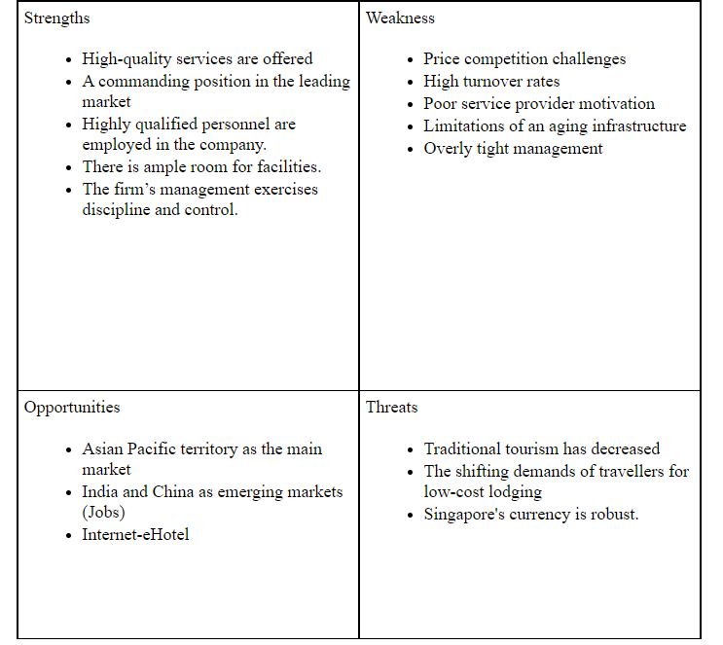

Customers
The Raffles Hotel uses a differentiation-based, laser-focused approach to market to upmarket clients (Powell). The market's target sector has a sizable amount of wealth and room for expansion, which makes this strategy effective. Since the consumers are wealthy, they will not look at other luxury hotels as options and are willing to pay a significant price premium for the best products and services offered.

- Competitors
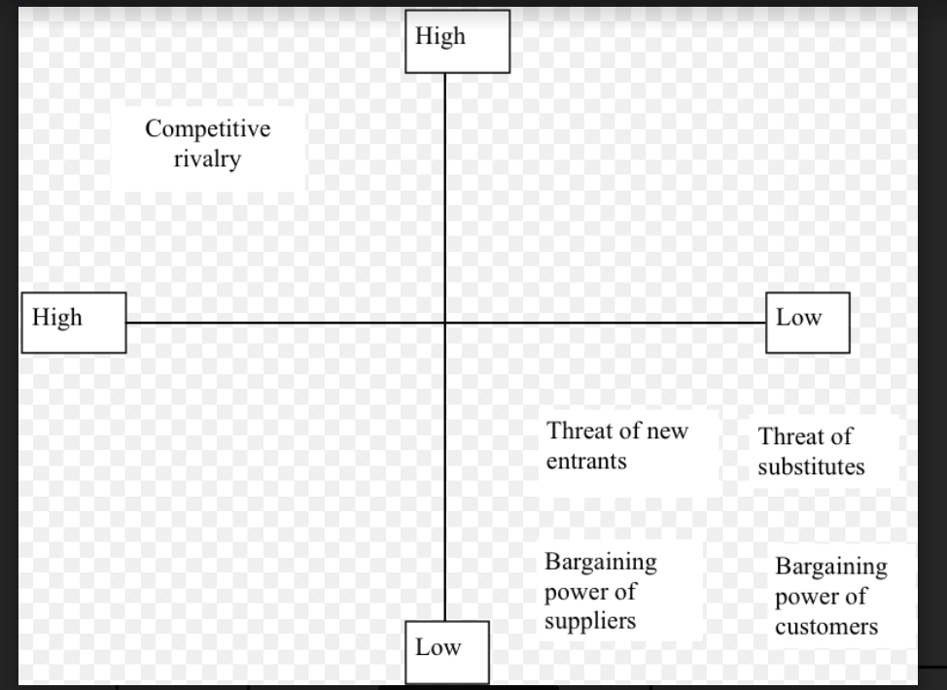

Collaborators
As part of their collaboration, Raffles has partnered with Rizzoli aiming to provide customers with insight into the glitz, romanticism, and background of a renowned luxury brand (Accor Group).

Pestle Analysis

Political  - The hospitality sector is subject to Goods and Services Tax (GST). | Economical  - Foreign exchange rate fluctuates constantly | Social  - Annually, particularly during the holidays, more people come.  - The things that individuals consume, like entertainment, can effortlessly influence them.
Technological  - In Singapore, the majority of hotels offer self-service computers in place of receptionists for check-in and check-out procedures.  - In Singapore, where the population is estimated to be 5.96 million (Worldometer), over 92% of people utilise the internet (Kemp). Customers benefit from being able to research hotels online. | Legal  - The Singaporean government covers the Safety and Health at Work Act.  - There is a limit of 8 hours per day or 44 hours per week that a worker cannot work past. Working overtime will not be charged to the hotel. | Environmental  - Hotels must generally give the three different kinds of recycle bins in their entrance and in each

Strategy
- Low Price and Low Value Added: Even when the price is low, the client still sees very little value, which reduces brand recognition (Cuofano).
- Low Price: Since commodities have become so common, businesses engage in price wars to gain market dominance.
- Hybrid: Customers are persuaded by this tactic that the company offers a superior commodity at a competitive price.
- Differentiation: Due to their sensitivity to a well-known brand's high-quality products on the market, clients are inclined to pay more for these commodities.
- Focused Differentiation: The organisation might achieve the highest profit margins if this plan is implemented correctly.
- Risky High Margins: This approach draws rivals or substitute goods into the market.
- Monopoly Pricing: Customers' value is considered when setting prices in monopolies, and they have few options (Sridharan).
- Loss of Market Share: It is often the worst scenario and suggests that the company is quitting the industry or collapsing.
Tactics
Product
The 5-star Raffles Hotel prides itself on being a fine example of ostentation. It is a classy hotel chain with extra perks, including parking spots, 24/7 assistance, online reservation alternatives, and complaint handling in addition to the basic, top-notch offerings like big spaces, contemporary decoration, high-speed Wi-Fi, and walk-in wardrobes (Serandipians). Furthermore, it offers improved services as part of its marketing mix products portfolio, which facilitates the search for service providers and saves money and time.
Place
The distribution plan for the Raffles Hotel's marketing mix is as follows. The headquarters of Raffles Hotel is in Singapore, and they have locations all around the globe. The business is present in regions such as Europe, Asia Pacific, the Indian Ocean, Africa, the Middle East and North America (Raffles Hotel).
Price
Given the client it serves and the type and calibre of services it offers, Raffles Hotel majorly employs a premium pricing strategy. Although, there is some cost variation for different kinds of rooms. Any other services that you use will also be billed separately. To boost sales during the slower seasons, discounts and allowances are also offered. The Raffles Hotel Singapore uses competitive pricing practices to maintain its competitiveness.
Promotion
The marketing plan for the Raffles Hotel includes the following promotional and advertising tactics. Raffles has used a variety of marketing strategies to improve the visibility of its brand. There has always been a focus on the desire to provide hospitality willingly and wholeheartedly and is well embedded in the purpose and culture of the company. Using mass media, such as television, magazines, journals, and billboard advertisements, Raffle can reach a bigger audience. It can also use an internet marketing strategy utilising its webpage and numerous social media channels (Lisboa). For Raffles, positive consumer feedback can also be a guiding force, which will help bring more clients.

Gannt Chart
Work | January | February | March | April | May | June
Get in touch with the marketing freelancer
Start the first campaign on February 28.
Stop the first campaign on March 30.
Start the second campaign on April 1st.
Complete the second campaign on May 31.
Start getting feedback

My marketing channels schedule was informed by the decision of resource allocation. Having enough time to allocate resources will ensure that the project does not stop until its final point.
Control
Website Visits
The number of visits is a marketing metric that shows how many people have visited a website (Marketing Evolution). To evaluate the success of the campaign, we will examine website traffic throughout the campaign time and contrast it with traffic from a previous one. This parameter will enable us to understand the level of popularity of the selected online product.
Return on Investment
This measure shows us the earnings concerning the campaign investments or expenditures (Gross). To evaluate if the campaign is successive, we will investigate whether the return on investment has gone up. We will be satisfied with our bottom line if the ROI is higher.
Conclusion
Insufficient Marketing Staff Knowledge
Core marketing principles are typically unknown to marketers in junior positions (CIM). What was successful in the world of marketing ten years ago might not be successful for marketing now. To address this issue, I recommend that the marketing manager first determine whether any of the marketing tasks may be outsourced by knowing what talents each employee possesses.
Maintaining Awareness of Recent Global Trends
Individuals are being affected by information from around the world as the world is becoming more connected (Cowart). Focusing on knowing business audiences, selecting the appropriate target markets, and ensuring that your material at least somewhat adheres to current trends are the best strategies to address this problem.


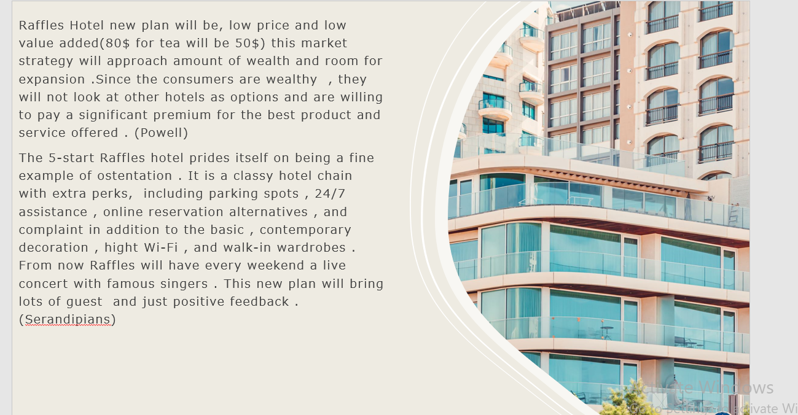

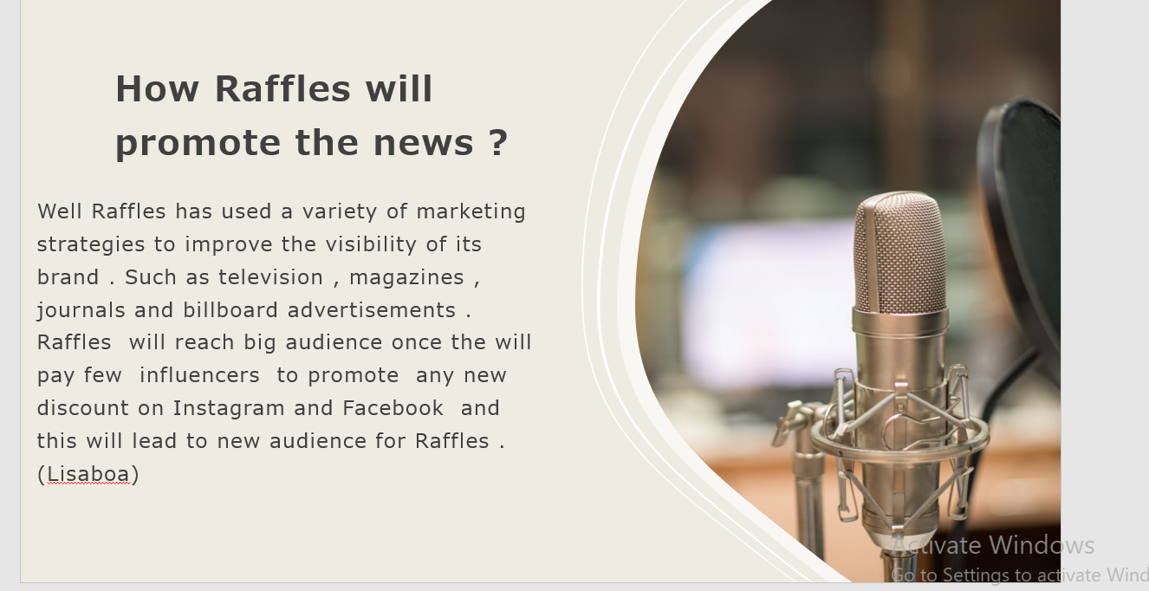
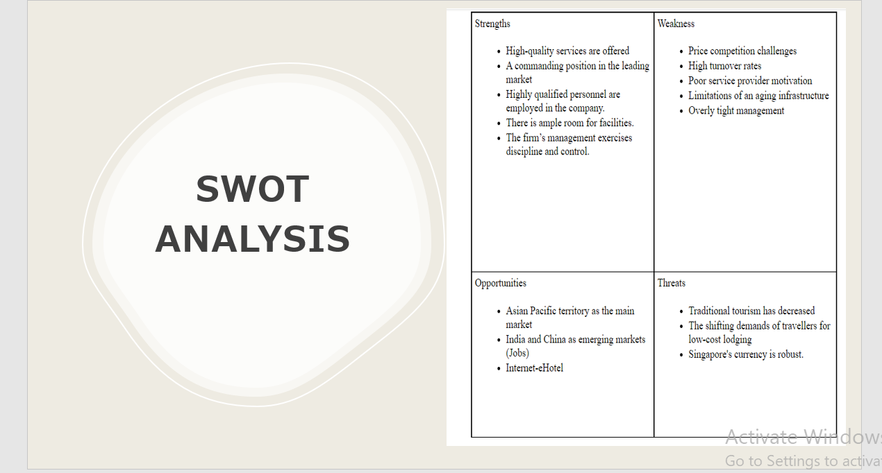

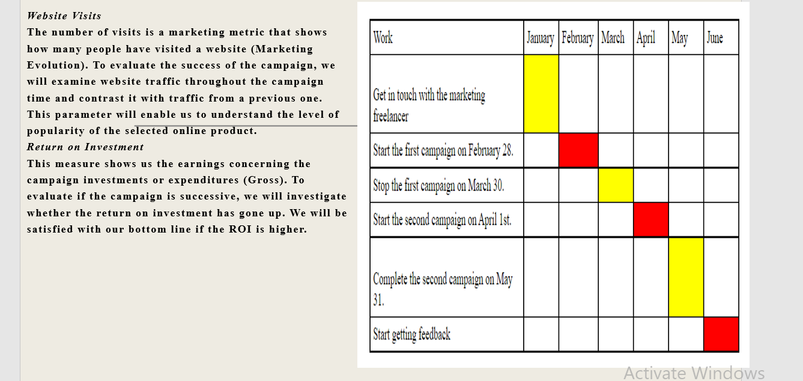

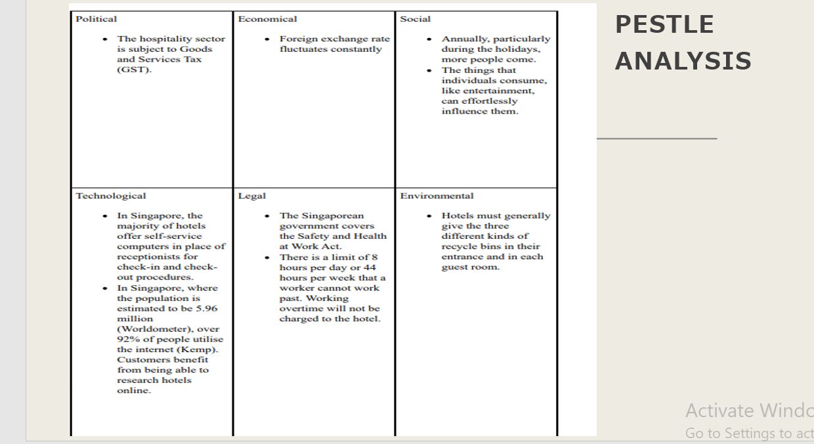

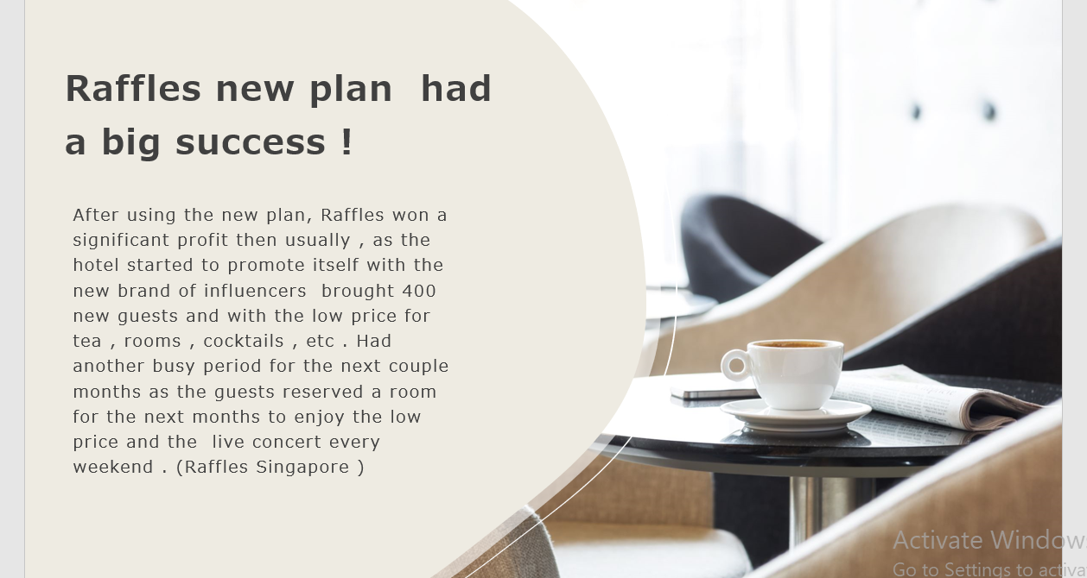

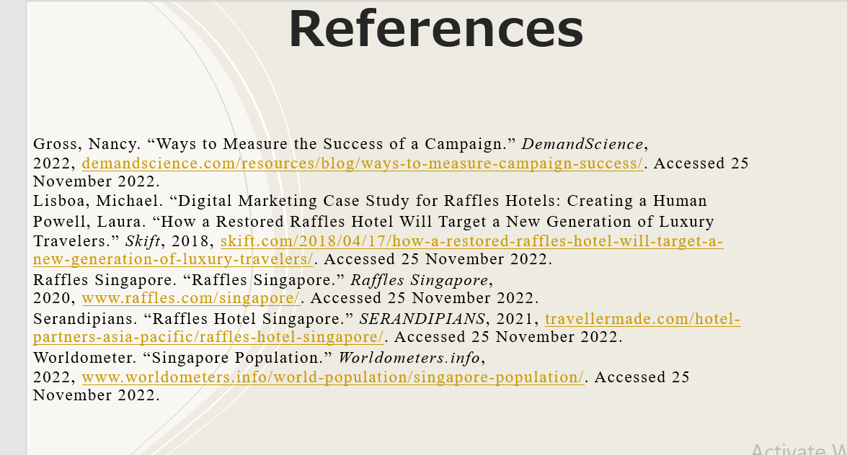

Works Cited
Accor Group. “Raffles and Rizzoli Partner to Provide a Glimpse into the Glamour, Romance and History of a Legendary Luxury Brand.” Accor, 2018, press.accor.com/raffles-and-rizzoli-partner-to-provide-a-glimpse-into-the-glamour-romance-and-history-of-a-legendary-luxury-brand-sharing-more-on-the-fascinating-guests-captivating-stories-and-unique-legacy-of/?lang=en. Accessed 25 November 2022.
CIM. “Today’s Top Five Marketing Challenges.” CIM, 2019, www.cim.co.uk/content-hub/editorial/todays-top-five-marketing-challenges/. Accessed 25 November 2022.
Cowart, Catrina. “Overcoming the Top 12 Marketing Challenges That Affect Your Business.” Rock Content, 2022, rockcontent.com/blog/marketing-challenges/. Accessed 25 November 2022.
Cuofano, Gennaro. “What Is Bowman’s Strategy Clock and Why It Matters in Business.” FourWeekMBA, 2020, fourweekmba.com/bowmans-strategy-clock/. Accessed 25 November 2022.
Gross, Nancy. “Ways to Measure the Success of a Campaign.” DemandScience, 2022, demandscience.com/resources/blog/ways-to-measure-campaign-success/. Accessed 25 November 2022.
Jobs, Soeg. “All about the Hospitality Industry in Singapore.” SOEG, 2019, www.soegjobs.com/hospitality-industry-singapore/. Accessed 25 November 2022.
Kemp, Simon. “Digital 2022: Singapore.” DataReportal, 2022, datareportal.com/reports/digital-2022-singapore. Accessed 25 November 2022.
Lisboa, Michael. “Digital Marketing Case Study for Raffles Hotels: Creating a Human

