
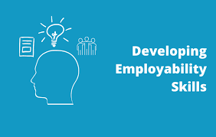
Individual presentation

- MODULE: Academic And
Employability Skills
- MODULE CODE: BMSW4001
- ASSIGNMENT TITLE: Ace Practical Portofolio
- TUTOR: Mr Toyin Adisa
- STUDENT ID: 2029869
- STUDENT NAME: Alexandra Florica

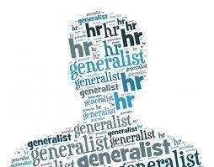
CAREER CHOICE

I really want to become an HR Generalist. This job requires a lot of skills, I consider that I have some of them, and I will learn the others with the help of higher education. I consider that I have the necessary skills and qualities for this position. All the time I enjoyed working and helping people.

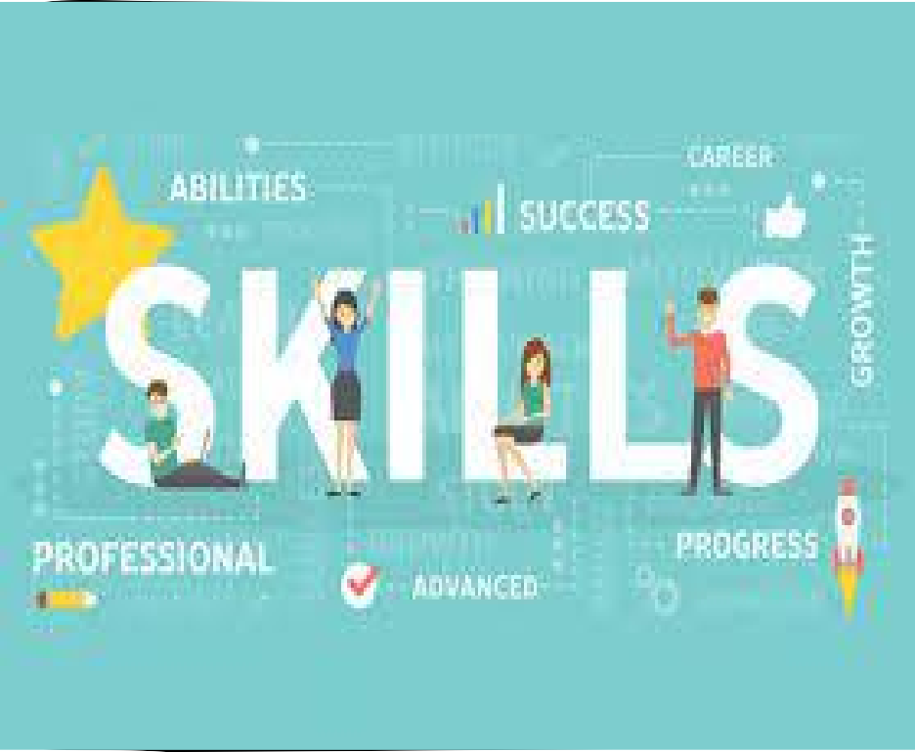
I have some of these skills because in the past I worked with the public for 8 years, this helped me to improve my communication skills. I had different jobs, which helped me develop the following skills: proactivity, advising, coaching, recruitment and selection, analytically driven and oriented and teamwork.
I currently work at Amazon as a Problem Solver, this feature helps me a lot to develop my career, because I work with people, I solve their problems, I guide them if they don't understand the process. Because I really want to learn as much as possible, I recently enrolled in an assistant HR course and started it this month.
And the best improvement I have made to improve my skills and career is that I enrolled at this university, and next year I can apply for the HR profile. After I finish, I will be 100% ready.


What is an HR Generalist?

As companies grow, HR departments divide HR Generalist duties into different jobs with subject matter experts taking over each of these areas. Some companies keep the title to describe a person that performs the core people- related functions in the organization. The HR generalist thus covers most of the HR functions, including hiring, compensation and benefits, HR administration, and other tasks.

HOW TO BECOME A HR GENERALIST?
Academic And Employability Skills:
- Communication skills
- Administrative expert
- HRM knowledge and expertise
- Proactivity
- Advising
- Coaching
- Recruitment and selection
- HRIS knowledge
- Intercultural sensitivity and language skills
- Analytically driven and oriented
- HR reporting skills
- Teamwork

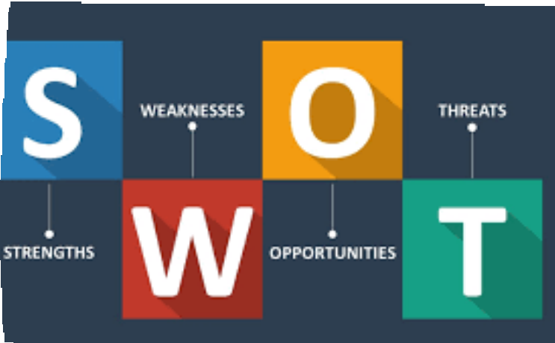STRENGTHS: staffing, development, compensation, safety and health, employee.
HUMAN RESOURCES
WEAKNSSES: financial, customer, employee.
OPPORTUNITIES: workforce growth, demand for products and services, translating to higher wages, growth for surrounding communities.
THREATS: offering better working conditions, higher wages, more desirable benefits by others, cause difficulty recruiting best- qualified people.

CONCLUSION
Human Resource Management is a vital department within any organization as it provides a company with its most valuable resource, its people. HR handles recruiting, training, compensating, developing policies, motivating, and developing strategies to keep the workforce within its corporation and much more.
There may be a single HR Generalist who performs all of the task’s or it may be broken down into departments.

REFERENCE LIST

  - https://www.digitalhrtech.com
    - https://www.prospects.ac.uk

