Programme: BA (Hons), Business Management
Module name: Data Handling and Business Intelligence
Module code: LCBB5014
Assignment tittle: Component 2 Coursework: Individual report
Student Name: Grace Alexandra, 2330971
Lecturer: Mr Ihsan Ul Ha

Table of Contents
Introduction 3
Data Cleaning & Preparation 4
Compute mean, median and mode. 5
Identify trends across time and visualize them. 6
Genre Performance by Rating 6
Language and Rating Trends 6
Statistical Analysis 8
Hypothesis Testing: Independent Samples T-Test 8
Correlation Analysis 8
Average rating can be predicted using the regression analysis 9
Insights and Recommendations 11
Conclusion 13
Reference 14

Letterbox Movie Classification Dataset: A Comprehensive Analysis of Viewer Behaviour, Genre Performance, and Rating Predictors
Introduction
One of the most data rich areas in today's economy is the film and entertainment sector, with exponentially large amounts of data generated by viewing engagement. One such sector that generates huge amounts of viewing engagement data with which to develop strategic business intelligence (BI) is the film and entertainment industry (Sai et al., 2025). Data analytics empowers organisations to make informed decisions, rather than relying on assumptions, and derive strategies that optimize their content curation, audience targeting, and operational efficiency (Hilal et al., 2025). In this report, a wide-ranging analysis of the Letterbox Movie Classification Dataset, which is composed of columns such as film titles, directors, genres, average ratings, run time, film language, counter for how many times the film has been viewed, likes and fan count, is presented.
There are four aims of this analysis. The data is cleaned and format standardised in the Microsoft Excel, making the missing value problem and making a standard format problem. Secondly, descriptive statistics are calculated which summarize important numerical and categorical variables (Motamedisedeh, 2025). Third, analyses and visualizations of trends are produced to analyze patterns of ratings and viewership data, as well as genre behavior. Fourth, statistical tests such as independent samples t-test, Pearson correlation and multiple linear regression are undertaken in order to test the significance of the observations (Akpan and Clark, 2023). This analysis is then broken down into first principles and applied to the entertainment and media sector to provide with actionable business recommendations.

Data Cleaning & Preparation
Data quality is one of the pillars needed for effective Business Intelligence. Data quality is expensive and can taint the credibility of its analyses. Many parameters in the Letterbox dataset needed to be systematically cleaned. Record of 9810 films. Missing values were identified in Watches (130 records, 1.3%), Likes (148, 1.5%), Fans (178, 1.8%), and Total Ratings (31, 0.3%). There was no missing data for key elements like Film Title, Average Ratings, Run Time or Original Language.
The highly skewed distributions of the variables Watches and Likes were handled by substituting missing numbers with the median value instead of the mean (median Watches = 17,950, mean = 170,296), or median Likes = 21,160, mean = 188,210). The median is more resistant to extreme values and better represents the center of values in a skewed data set. The remaining missing Fan values were corrected to ZERO to indicate that the fan data is missing, which is likely from movies that have little fan interaction. Imputations were identified and accounted for in an analytical transparency fashion by the use of a binary flag variable (“Missing Flag”).
The Genres field, which was also represented in a list of Python list strings, was split back into this string of primary genre (Di Grazia and Pradel, 2022). The original values in the field were standardized by assigning the terms to the same labels and a two-categorized variable was created, whereby 1 is ‘English' and 2 is ‘Non-English', for statistical comparison. The interquartile range (IQR) method was used to find the outliers from the runs. Using the interquartile range method the nosy values were found as follows: Q1 = 89 minutes, Q3 = 113 minutes, IQR = 24 minutes. Records stretching below 53 minutes and above 149 minutes were identified as potential outliers (726 records, 7.4%) but they were retained in the data set as they may have been short films or particularly long films.

Compute mean, median and mode.
Descriptive statistics is used to give a basic quantitative summary of the data and will be considered as a fundamental tool to take some decisions on the variables that need to be explored in more detail. Table 1 below presents the summary of the main numerical facts for the data.
Table 1 shows that most of the numerical variables appear very normal.
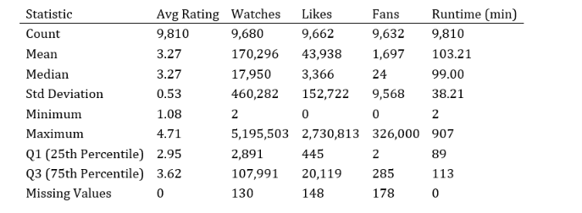
A few pertinent observations are made in Table 1. The mean and standard deviation of the ratings for all of the films together is of 3.27 with a narrow standard deviation of 0.53, which suggests that most of the films were towards the middle of the range of the ratings. The Watches mean (170,296) is significantly higher than the median (17,950), indicating that the distribution is strongly skewed to the right, which implies that a few extremely intriguing movies might have a substantial following. The difference in viewership which shows the highest number of watches with 5,195,503 was 289 times the median number of views per recorded video. Likewise, Fans has extreme right skewness (mean (1,697); median (24)), reinforcing the “blockbuster effect” which has been witnessed in all entertainment markets.
For categorical variables, English is the dominant original language (7,924 films, 80.8% of the dataset), followed by Italian (382, 3.9%), Japanese (303, 3.1%), and French (287, 2.9%). Drama is the most frequent primary genre (2,185 films, 22.3%), followed by Comedy (1,399, 14.3%) and Horror (846, 8.6%). The distribution of runtime indicates the mode is 90–110 minutes for 42.9% of the films, representing the range of time that are considered as the industry norm for theatrical feature films.

Identify trends across time and visualize them.
Most important tools of business intelligence are trend analysis and data visualization which help to detect patterns and assist with strategic decision making (Rahul et al., 2022). The Letterbox dataset shows a number of interesting trends when broken down by genre and language.

Genre Performance by Rating
The average rating and viewership calculations per primary genre of the top 10 rating most highly rated genres.
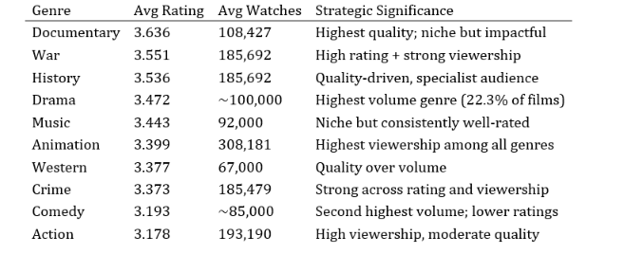
As Table 2 shows, there is an obvious difference between the genres with the highest number of ratings and the genres with the largest number of views. Viewership is shared by the genres of Animation (308,181 average watches) and Action (193,190), whereas Documentary and War films lead the pack in quality with an average 3.636 and 3.551 ratings respectively. This quality vs popularity dichotomy is part and parcel of the entertainment industry's normal trade cycle mix of blockbusters that deliver mass viewers and niche films that will get a critical warm reception. This divide implies that there are two content objectives: prestige and volume within the catalogue, and that content strategies need to be aware of the difference between them (Ahmed and Abdulkareem, 2023).

Language and Rating Trends
English-language movies have an average of 4.91, whereas the average of non-English language films is considerably higher at 5.62. Persian/Farsi films lead with an average rating of 3.861, followed by Czech (3.823), Swedish (3.774), Russian (3.673), and French (3.600). Films having English as their language have an average length of only 3.210 seconds, which is the smallest of all language groups with more than enough data. This also reflects the critical success that has faced international cinema from those who study foreign media consumption in the academic setting: self-selection biases – film lovers who are not interested in Hollywood films tend to give better ratings to less commercial films.
Only 36% of U.S. homes have a DSL filter that blocks spyware.
The running time histogram shows a skewed right distribution, with a central mode in the range 90 – 110 minutes that represents 42.9% of all films (n = 4210). Films between 60–90 minutes represent 24.8% of the dataset (n = 2,433), while very long films (>200 minutes) account for only 1.3% (n = 124). This distribution is based on the industry practice of theatrical release windows and broadcaster scheduling needs (Ma, 2025). A scatter plot of Watches on Watches vs. Likes (accompanied by an Excel spreadsheet shown in the appendix) reveals that the relationship between Watches and Likes is indeed strong and linear and positive, and that there is a strong clustering of films in the bottom half of the grid (low watches, low likes) and a long tail of viral films (high number of watches, high number of likes) whose engagement follows an exponential progression.

Statistical Analysis

Hypothesis Testing: Independent Samples T-Test
An independent samples t-test was used to formally test the difference in the ratings of English and non-English films (Wicaksono and Romero, 2026). The t-test can be used to compare the means between two independent groups (as the same t-test applies for two paired groups), and the dependent variable is continuous. The null hypothesis is that the mean ratings for English films are not different from the mean ratings for non-English films – there is no different in between their ratings on average – and the alternative hypothesis is that there is a statistically significant difference.
Independent samples t-test results comparing the means of the English films mean versus non-English films mean are shown in table 3 below.
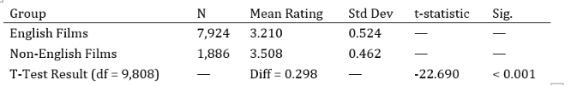
The t-test yields t(9,808) = -22.690, p < 0.001. The null hypothesis thus has to be rejected at the 0.001 significance level. For non-English films the mean of all ratings is 3.508 while for English films the mean rating is 3.210, a difference of 0.298 rating points. This is a statistically significant and clinically relevant difference of 9.3% higher than the English language mean. Important implications for media content acquisition and catalogue strategy.

Correlation Analysis
Pearson correlation coefficients were computed to examine linear relationships between the key numerical variables. Pearson correlation should be used for continuous variables and is used to give an indication of the strength of association as well as its direction.
Pearson correlation matrix (n ≈ 9,632)
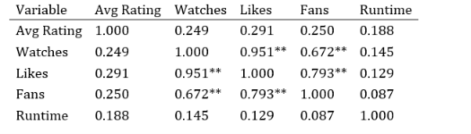
The correlation matrix highlights a number of important correlations. In the dataset, the most significant correlation is that of Watches and Likes (r = 0.951, p < 0.001), where there is a nearly linear relationship between the number of people that have seen a video and the number of people that are actually interacting with it. The same discovery was confirmed by social media studies proving that people prefer to "buy things" when they are exposed to them passively, meaning that they can see but not interact with the messaging.This has been backed up by the research on social media, which shows that passive exposure will induce active endorsement behaviour. There is a strong correlation between the number of fans and the number of likes received (r = 0.793) as well as the number of views watched and the number of fans (r = 0.672), which clearly indicates that the number of fans generated is directly proportional to views watched and the number of likes received. The Average Rating is not only positively correlated with Likes (r = 0.291), Fans (r = 0.250), and Watches (r = 0.249), but it also has moderate correlations, thereby indicating that quality can be shown to influence engagement, albeit in a non-primary way. While the assumption that longer films translate to larger audiences seems correct, programs such as RunTime reveal only weak correlations with all engagement metrics (r = 0.087-0.188).

Average rating can be predicted using the regression analysis
The multiple linear regression analysis was carried out to see how much the Average Rating is predicted by the number of Likes, Fans and Runtime. When wanting to gain understanding of the effect that two or more predictors have on a continuous outcome, regression analysis is appropriate.
Table 5: Multiple Regression Coefficients — Dependent Variable: Average Rating
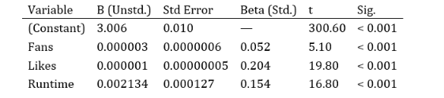
Model Summary: R = 0.331, R² = 0.110, Adjusted R² = 0.109, F(3, 9,626) = 390.4, p < 0.001
The overall correlation of the regression model is significant (F(3, 9,626) = 390.4, p < 0.001) and R2 = 0.110 means the joint regression model can explain 11.0% of the variance in Average Rating well. The model indicates that statistically all these three predictors contribute to the rating of films, but a relatively low R² values suggest that a lot of other variables are involved in predicting film ratings — such as director reputation, release timing, genre prestige and the amount of marketing investment is done in the film. With the highest value of the standardised effect (Beta = 0.204) are the likes, then the runtime (Beta = 0.154) and the fans (Beta = 0.052). A positive Runtime coefficient (B = 0.002134) means that every additional 10 minutes runtime the expected average rating goes up by +0.021 points - indicating that audiences like to reward more substantial films.

Insights and Recommendations
Several actionable points emerge from analysing this ‘Letterbox’ dataset for media and entertainment companies such as streamers, distributors and content producers.
Recommendation 1: Increase Non-English Language Content. On average, non-English films score a quality premium compared to English films (+0.298 points, p<0.001), one that is statistically significant. Experiences on platforms like Netflix have already proved the commercial power of investing in foreign content, for example, with such shows Money Heist, Squid Game. They should have clear acquisition goals for non-English products, spend money on localisation into subtitle infrastructure and rely on algorithmic recommendations to bring more visibility to titles that are not English.
Recommendation 2: Use Content Strategy by Genre Purpose. Documentary and War genres are optimized for the importance of critical quality (ratings) while Animation and Family genres are optimized for achieving commercial reach (viewership). A dual track content initiative of prestige production based and high viewership entertainment-driven initiatives will work better for platform KPIs, such as both critical acclaim and engagement hours (Amin, 2026).
Recommendation 3: Watch-Through Rate-the Most Important Engagement Lever. There has been an almost perfect correlation between Watches and Likes (r = 0.951) and it does not come as a surprise that viewership is the biggest driver of engagement. The key indicators that people should be focusing on on BI dashboards are the watch-throughs and click throughs of the recommendations. Like counts and fan acquisition should be seen as success factors down the road.
Recommendation 4: Optimize for 90–130 mini elapsed time. The only direct effects of runtime on engagement are that it positively predicts ratings with a Beta = 0.154. From 90 to 130 minutes covers 67.8% of all movies, as well as the range of viewers' expectations. For widespread or franchise release production should aim to shoot within this window, and runtimes extended for prestige and franchise release.
Restrictions and Further research. There are a few limitations with this analysis such as the relatively low R² value of the regression model (0.110), which makes it less than ideal for this analysis, and the single-source data not independently verified, nor any inclusion of temporal variables (release year and classification of streaming era). Future research should extend data pertaining to marketing expenditure, critical review score, franchise affiliation and release platform to build more powerful predictive models, which would aid in enterprise BI decision-making (Ridwan, 2025).

Conclusion
This report has worked with a structured, evidence-based analysis carried out in Excel, based on extracting and cleaning the data from the Letterbox Movie Classification Data, and visualising them using the raw data in MS Excel and then working with charts, graphs and frequency tables. This report has also used statistical testing in the data as well as regression modelling, all to the style of SPSS analytical method. Based on the results of analysis, the four main findings from the study are confirmed. First, there is a statistically significant difference between the average ratings of non-English and English language films (t = -22.69, p < 0.001), and there is clear evidence of the need to invest in non-English-language films. Second, the performance gap divides into two extremes: quality leaders, which includes Documentaries, War, History and viewership leaders including Animation, Family, Action and different strategies should be developed. The third finding was that Watches and Likes were almost perfectly correlated (r = 0.951), which reinforces that viewership is a key driver in downstream engagement. Fourth, the multiple regression model (R² = 0.110) shows that Likes, Runtime & Fans all have significant effect on rating, but the hypothesized variables are insuffices and the complexity of evaluating film quality needs more data input.
These insights are just a handful of examples showing how a data-driven entertainment business intelligence tool can help transform the industry. Organisation can become capable of using data analysis techniques, ranging from descriptive statistics to inferential testing to predictive modelling, and gain the power to make more informed decisions on content acquisition, catalogue management, audience building and resource allocation.

Reference
Ahmed, A. and Abdulkareem, A.M., 2023. Big data analytics in the entertainment industry: audience behavior analysis, content recommendation, and revenue maximization. Reviews of Contemporary Business Analytics, 6(1), pp.88-102.
Akpan, E.E. and Clark, L.J., 2023. Independent T-test statistics: It’s relevance in educational research. Int. J. Eminent Sch, 10(1), pp.79-88.
Amin, R.I., 2026. Examining How Generation Y's Workplace Preferences Influence Organizations' Approach to Implementing Gamification. The Academic Journal of Contemporary Commercial Research, 6(2), pp.1-24.
Di Grazia, L. and Pradel, M., 2022, November. The evolution of type annotations in python: an empirical study. In Proceedings of the 30th ACM Joint European Software Engineering Conference and Symposium on the Foundations of Software Engineering (pp. 209-220).
Hilal, M., Sumbal and Imad, M., 2025. Strategic Imperative of Data Analytics: Empowering Informed Business Decision-Making. In Emerging Disruptive Technologies for Society 5.0 in Developing Countries: Challenges and Applications (pp. 61-69). Cham: Springer Nature Switzerland.
Ma, D., 2025. Big Data-Driven Ecosystem Integration in the Film and Television Industry: A Framework for Information Resource. Information Resources Management Journal, 38(1).
Motamedisedeh, O., 2025. Handling Missing Values. In 96 Common Challenges in Power Query: Practical Solutions for Mastering Data Transformation in Excel and Power BI (pp. 451-488). Berkeley, CA: Apress.
Rahul, D.D., Mahmud, I., Aqif, H., Tariquzzaman, M., Akter, S., Osman, F.Y., Shafi, S.B. and Sozib, H.M., 2022. The Role of Data Visualization in Business Intelligence: Analyzing Tool Adoption and Decision-Making outcomes in US Companies. Cuestiones De Fisioterapia, 51(3), pp.310-329.
Ridwan, I.B., 2025. Optimizing enterprise decision-making through causal machine learning models and real-time business intelligence integration. Int J Adv Res Publ Rev, 2(5), pp.67-88.
Sai, V.S., Nair, G.P. and Krishnan, G., 2025, May. Beyond the Spotlight: AI-Driven Data Mining and Business Intelligence in Entertainment–A Review. In World Conference on Artificial Intelligence: Advances and Applications (pp. 99-109). Cham: Springer Nature Switzerland.
Wicaksono, H. and Romero, D.J., 2026. The impact of watching English movies on students’ listening comprehension. Journal of Research in English Language Teaching and Linguistics, 2(1), pp.1-19.

