

Development of a barcode scanning application for identifying recycling products

by
Dan Algie

Supervisor: Gaynor Thomas

Project submitted as part of the requirements for the award of
BSc (Hons) Computing (Software Engineering)
April 2021

Declaration

I, Daniel Algie declare that I am the sole author of this Project; that all references cited have been consulted; that I have conducted all work of which this is a record, and that the finished work lies within the prescribed word limits.
This work has not previously been accepted as part of any other degree submission.

Form of Consent

I, Daniel Algie hereby consent that my Project, submitted in candidature for the B.Sc. Software Engineering degree, if successful, may be made available for inter-library loan or photocopying (subject to the law of copyright), and that the title and abstract may be made available to outside organisations.

Abstract

The concept behind the project was to create an application where a user would scan a product on the side of a waste bin and it would return details of the product on an interface screen on the bin. This would tell the user which section of the bin to use (if it was metal recycling, plastic or paper recycling or normal waste) , this would be incorporated into the bins in the University Of Wales Trinity Saint David (UWTSD). Attending the university and being able to interact with the users and get feedback about the application would allow improvement when building, when building but due to COVID-19 this has changed and will be redirected to household items and what bins the Swansea council use and collect so instead of sections of the bin it will instead give information back to the user to tell them which collection bin the product goes into.
The project will be discussed in detail how it was achieved and how the application works from using data from a API using json to why it was decided to use a raspberry pi to run the application and the barcode scanner needed. It will discuss the problems which arise and how they were rectified and how the results of using a barcode scanner and raspberry pi and how this application was created, how the project was structured to display data to the user and the methodologies and structures needed to help improve the way we recycle and make this project a success.
Table of Contents
1 Declaration 2
2 Form of Consent 2
3 Abstract 3
4 Table of Figures 8
5 Chapter 1 - Introduction 9
6 Chapter 2 - Research & Review of Literature 10
6.1 Introduction 10
6.2 Similar concepts 10
6.2.1 Invisible barcodes Digimarc barcode 11
6.2.2 Barcodes 13
6.2.3 What is a barcode? 13
6.2.4 History of barcodes 13
6.2.5 What does a barcode do? 14
6.2.6 Types of barcodes 14
6.2.6.1 Code 39 14
6.2.6.2 Code 128 14
6.2.6.3 Interleaved 2 of 5 14
6.2.6.4 Universal Product Codes (UPC) 14
6.2.6.5 PDF417 14
6.2.6.6 Data matrix 15
6.2.6.7 Quick response (QR codes) 15
6.2.6.8 Universal product codes (UPC) barcode 15
6.2.7 How barcodes and barcode scanners work 15
6.2.8 Encoding a barcode 16
6.2.9 Barcode numbering 16
6.2.10 Check digit 17
6.3 Recycling 18
6.3.1 Recycling is confusing 18
6.4 Hardware 20
6.4.1 Raspberry pi 20
6.4.2 Scanners 21
6.4.3 Programming languages 23
6.4.4 HTML and CSS 23
6.4.5 JavaScript 23
6.4.6 PHP 23
6.4.7 API 24
6.4.8 SOAP (Object Access Protocol) 24
6.4.9 REST API 25
6.4.10 Database 26
6.5 Research conclusion 26
7 Chapter 3 - Research Methodology 27
8 Chapter 4 - Development Methodology 29
8.1 Waterfall 29
8.1.1 Advantages 29
8.1.2 Disadvantages 29
8.2 Agile 30
8.2.1 Advantages 30
8.2.2 Disadvantages 30
8.2.3 Advantages of the agile approach 30
8.2.4 Disadvantages 31
8.2.5 Feature driven development 32
8.3 Software 33
8.4 Hardware 33
8.5 Moscow 33
8.6 Database 34
8.6.1 Category 34
8.6.2 Web Details 34
8.6.3 User Details 35
8.6.4 Bin Location 35
8.6.5 Product 35
8.6.6 New database 35
8.7 Website 37
8.8 Use-case diagram 40
8.9 Sequence diagram 41
8.10 API 42
8.11 Implementation 43
8.11.1 Raspberry pi 43
8.11.2 Operating system 43
8.11.3 MYSQL 43
8.11.4 Apache 43
8.11.5 Php 43
8.11.6 Database 43
8.11.7 Website 44
8.11.8 Configuration 44
8.11.9 Security 45
8.11.10 The main webpage 47
8.11.11 API 48
8.11.12 Testing first stage 50
8.11.13 Testing application raspberry pi 58
8.11.14 Barcode testing 63
9 User feedback 64
10 Chapter 6 – Evaluation 66
11 Chapter 7 - Conclusions and Recommendations 68
11.1 Recommendations 68
12 Chapter 8 – Reflection 70
13 Chapter 9 – References 71
13.1 Bibliography 71
14 Appendices 78
14.1.1 Appendix A - User forms 78
14.1.2 Appendix B Gantt chart 83
14.1.3 Appendix C SQL 84
SQL statements to build recycling database 84
14.1.4 Appendix D main web page 86
14.1.5 Code for the main page of the website 86
14.1.6 Appendix E admin login and logout 89
14.1.7 login 89
14.1.8 Logout 89
14.1.9 Appendix F Admin form 90
14.1.10 Admin form 90
14.1.11 Input product into database 92
14.1.12 input category into database 93
14.1.13 Input bin location into database 94
14.1.14 Appendix G connecting database and website 96
14.1.15 Appendix H user form and input 97
14.1.16 User form 97
14.1.17 Appendix I display data 100
14.1.18 Displaying search by product name 100
14.1.19 Display data by barcode 103

Table of Figures
Figure 1-counterfeit table [6] 11
Figure 2-invisible barcode [10] 12
Figure 3-invisible barcodes food products [11] 12
Figure 4-shows first design barcode [13] 13
Figure 5 guard patterns of a barcode [27] 16
Figure 6 barcode break down [29] 16
Figure 7-shows type of plastic. 18
Figure 8-barcode scanner [44] 21
Figure 9-image barcode scanner [45] 22
Figure 10-soap envelope 24
Figure 11 Research methodology [66] 27
Figure 12 waterfall methodology [72] 29
Figure 13-life cycle 30
Figure 14 future driven development [76] 32
Figure 15 first database design 34
Figure 16 new database design 35
Figure 17-orginal design 37
Figure 18-new main page design 38
Figure 19-display information page 38
Figure 20-no data to display 39
Figure 21-admin form 39
Figure 22 use-case diagram 40
Figure 23 sequence diagram 41
Figure 24 main website page 46
Figure 25 data display for user 47
Figure 26 API code to retrieve data 48
Figure 27 API data displayed 48
Figure 28 original bin image code 51
Figure 29 working bin image code 52

Chapter 1 - Introduction

This piece of work will take the form of a software development project to check if everyday waste items are recyclable or not recyclable and display the information to the user to improve the way we recycle.
The overall aim is to create an easy-to-use application for everyone to be able to use and give an insight into what products are recyclable and which products are not. The user should have a good experience when using the application use of which should improve the amount recyclable waste not sent to landfill to improve and educate the user about recycling.
Objectives for the project
- Research Barcodes
- Research Recycling in the UK (United Kingdom)
- Research technology suitable for this project such as Raspberry pi and Arduino for suitability.
- Develop a Website that can communicate with the functional Database
- Develop a testing framework for the Website and Database

Chapter 2 - Research & Review of Literature

Introduction
Research is a key priority in how this project and application will work it will delve into looking at how barcodes work and what a barcode consists of and data regarding product barcodes while also looking at what could be for the future of barcodes. Furthermore, research will be conducted on the concepts which are already available using barcode and technology to improve the way people recycle and looking at key aspects and learning about how products are recycled and what solutions are out there tackling and improving recycling rates while focusing on how the application could work.

Similar concepts
Students at Bangkok University have created an application to help partial and visually-impaired individuals to be able to scan products and retrieve information regarding the product information such as product name what the product is how much the product cost [1].
Students from Curtin university Australia used a mobile phone camera and created a barcode scanner to help visually impaired people to use the application to scan products and will speech back to the user whether the product was in date to stop visual impaired people getting sick by not noticing that their food was out of date. [2]
In Italy, a company called Giunko [3] launched in 2014 created a mobile application where the user uses his mobile phone camera to scan a barcode and the barcode compares to a database storing over 1 million products then returns the data back to the mobile about the product and how to recycle the product.
Way to Eco [4]is a UK based company who have created an application called the WasteGuru app it works similar to Ginuko where the user scans a barcode using the mobile device and will receive information sent from the database regarding product information about recycling.
The packaging company Paccor [5] have been working at reducing the amount of plastic which gets sent to landfill so it can be recycled but instead of using universal product codes (UPC) barcodes they have created a way to tell using Digimarc barcode or invisible barcodes to determine what material the product is made out of when at the waste management centre and being removed from general waste to recycling.
Eugene [6] the recycling barcode scanner is a barcode scanner application created by a French Start-up company is different from previous concepts looked at above. Eugene has a mobile application to determine if a product is recyclable or not but it also has a wall device with built in monitor which can be used in a commercial setting. It also gives more features working with other companies to reward customers for using the product and to provide insight to improve recycling, the more you use the app it will reward you with gift vouchers and coupons for shopping it also has a shopping list feature where it added the product which has been scanned for the user so when they go shopping they can see items that the user have run out of or need to replace.

Invisible barcodes Digimarc barcode
Invisible barcodes are a concept where the product packaging looks exactly the same but underneath the packaging the whole product is covered in barcodes using ultraviolet vanish, this is undetectable to the user unless using a ultraviolet or infrared light, Currently, this concept is being used with many companies to stop counterfeiting items such as pharmaceutical drugs, tobacco and alcohol with the United Kingdom government showing that the annual loss to the economy through counterfeiting reaches 9 billion a year [7]. This is for all goods in the United Kingdom but studies show that the most forged product investigated by trading standards was counterfeit tobacco with 80 percent of all investigations finding counterfeit tobacco [8].
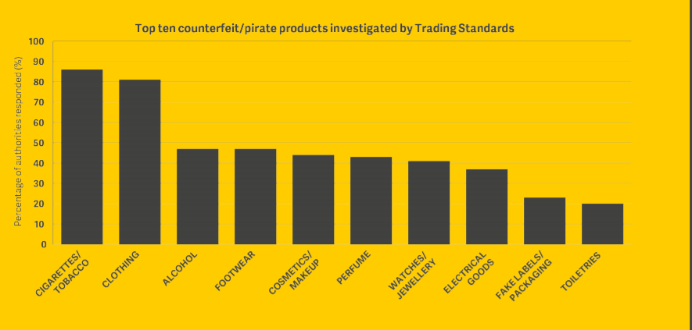
Figure 1-counterfeit table [6]

With companies using this technique to be used for the authentication of their product why is not then used for everyday products instead of just using a standard UPC barcode, this will make it easier to scan the product and can be used to improve the way we recycle. A recycling plant in western Germany has created a recycling conveyor belt with an ultraviolet light that can recognising invisible barcodes on everyday waste to determine the product and use an (AI) artificial intelligence to use a robotic arm to collect the products and move the waste into the correct piles. Due to the way the barcodes are all round the product it can determine without any issues of trying to read one barcode. This works with all packaging even with plastic bottles due to the customer not being able to see the barcode it would not affect the product brand and packaging for the customer [9] due to the nature of the barcodes these inks behave just like any other ink and can be applied the same way that barcodes and product information is applied to the product [10].

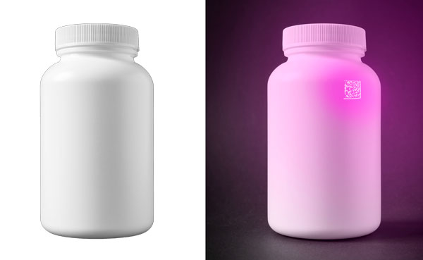
Figure 2-invisible barcode [10]

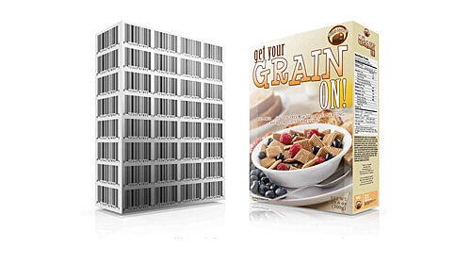
Figure 3-invisible barcodes food products [11]

Barcodes

What is a barcode?
A barcode is a machine-readable code which is created in the form of a sequence of numbers and parallel lines with variety of widths [12].

History of barcodes
The original idea of the barcode was first introduced in 1948 by Bernard Silver and Joseph Woodland after Silver overheard Joseph discussing the need for an automatic system for reading and entering data for products to speed up shopping queues. After several different attempts in October 7th 1952 the barcode was created and patented, this was far different from the barcodes which are seen today the original barcode was round like a dart-board and was broken up into different sections [13] [14]. In 1962, Philadelphia Storage Battery Co (Philco) purchased the patent and became the first barcode manufacturer a few years later it was sold to Radio Corporation of America (RCA) [15]
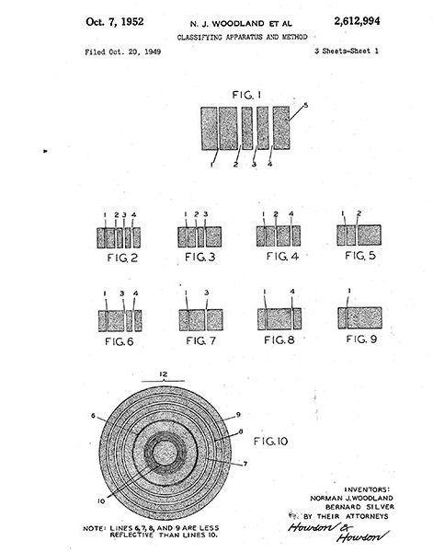
Figure 4-shows first design barcode [13]

The barcode was just a template and a concept of how it would work there is very limited articles and proof of the concept design created.

“A crude prototype in Woodland’s own home used a powerful 500-watt incandescent bulb. An oscilloscope was used to "read" the code; the whole thing was the size of a desk. Allegedly, it worked, up to a point. But an objective evaluation judged it to be 20 years ahead of its time.” [13]
This technology was advanced for the 1950s, therefore, it is limited to what could be achieved. It was not until the late 1960’s, early 1970’s where transistors and laser components were getting less expensive, and computer processors were getting smaller that it was possible to implement. In 1972, a Cincinnati Kroger [16] store had the equipment implemented to test scanning the dart board shaped barcode, but due to the shape of the barcode it was difficult and wouldn’t read the data of the barcode. In 1973 IBM (International Business Machines Corporation) [17] won the proposal to create the UPC (universal product code) [18] barcode and on July 26th 1974 the first product to be scanned was a pack of Wrigley’s [19] tutti fruit chewing gum [20] the technique of this barcode is still the same type of barcode used today in supermarket and retail shop across the world [13] [21].

What does a barcode do?
Barcodes work by using a scanner to read data about the product, retailers use these barcodes to detect the product and the price of the product the price of the product will be set by each retailer using their own database to use the serial code of the barcode to set the price once scanned.
That is just what the consumer sees but barcodes are used for so much more, such as for tracking deliveries, checking stock levels and making business run more effectively.
Every product made will have a barcode it might not be on show for clothes for example but that product when being delivered did have a barcode for shipping the item.

Types of barcodes
The following are the different types of barcodes that are currently produced [22] [23].

Code 39
This is a 1-dimension barcode with the ability to include the whole of the 128 ASCII character set and can be set to any length.

Code 128
This code is barcode is used for mainly shipping parcels around the world.

Interleaved 2 of 5
Mostly used in warehouse, factories, distribution centres and manufacturing code 2 of 5 is a numerical barcode where 2 numbers are paired together to make a symbol which allows you to customise yourself.

Universal Product Codes (UPC)
Used in nearly all products worldwide and are used in supermarkets, shops, retail and self-service checkouts. these barcodes will be discussed more due to these barcodes will be used for the project.

PDF417
Stacked linear 2D barcode mainly used for military and homeland security, these barcodes are also used with driver licences due to its advanced capabilities such as encoding to more than one data file they can also hold 4 times as much data as other barcodes.

Data matrix
2D barcode square shaped mainly used in the health sector and electronic manufactories because it can store a tremendous amount of data in a small space. This needs to be used with sophisticated scanners or smart phones to take the picture of the barcode and translate in one.

Quick response (QR codes)
Newsiest type of barcode used for marketing tools on advertisement boards and adverts where all data cannot be displayed or read, the QR code gets scanned by a smart phone to show the users website or videos of the company or product.

Universal product codes (UPC) barcode
UPC barcodes are the most common type of barcode and are used for all household products sold at supermarkets and retail stores around the world. They are used for the seller to easily stock-take and set prices for when products are checked out. But, the UPC barcode holds a lot more information which can utilised the barcode is a linear barcode for machine reading and has 12 numbers for humans to read. The first six numbers are the companies’ details and then 5 numbers are the product details, and the final number is a check id to make sure the barcode is correct.

How barcodes and barcode scanners work
Barcodes are created by a set amount of black lines with a white background the barcode is created with a set of black lines with different width and patterns this is nonsense if a human was to look at this part of the barcode, this is why there are numbers at the bottom of the barcode for humans to understand the barcode in case of errors or manual input needed. The width and spacing of the black lines in a barcode make it possible to convert each different set of lines to determine if a number is between 0-9 and using a infer red laser the scanner can take the numbers encoded using the black lines and white background and can determine the digits and feedback as a list of numbers to the computer. If a barcode is scanned upside down, then the computer and scanner can work out that the product has been scanned wrong by the way the barcode is set out it has a unique pattern which indicates the start and the end of the barcode so it can determine if the barcode was read the wrong way [24].

Encoding a barcode
The black bars of a barcode are set to a certain width the total width for a digit is always 7 modules and a UPC barcode has 12 digits so it is set out that the barcode must have 7 * 12 =84 modules.
A complete UPC barcode is 95 modules wide this is to include the start, middle and end guard patterns, it has the normal 84 modules and 11 modules for the guard patterns the start and end guard patterns have a pattern of bar space bar where the middle guard pattern has a pattern of space-bar-space bar-space before and after the start and end guard patterns, it is required to have a space of 9 modules wide the left side guard and middle guard have an odd number of modules where the right hand side has an even number of modules. This is how it determines which way the barcode is being read if the scanner reads the even numbers first it will determine the barcode is upside down and convert the barcode round [25] [26].

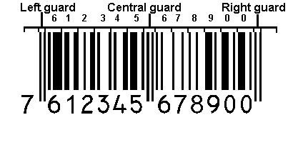
Figure 5 guard patterns of a barcode [27]

Barcode numbering
The barcode is broken down into different sections, the first section is the first digit represents the category of the product or the type of product, for example, if the first number is 5 or a 9 it is used for coupons or is a special promotion price if it has a number 2 at the beginning it is for weighed sale products such as meat or fruit and vegetables. While the second part of the barcode is broken down to a 5 sometimes 6 digits are for the company name or manufacturing company and the right section hold information about the product for example if the product has a 5 and is a promotional offer it will hold the value and information regarding the promotion [28].
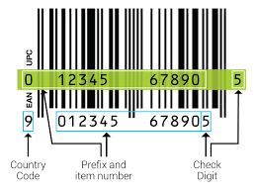
Figure 6 barcode break down [29]

Check digit
The check digit [30] (sometimes called a check sum) is the last number on the barcode and it is used to check for errors in the barcode this can be tested by a taking the numbers and doing a mathematical equation and if the end number is the same as the check digit number, then the barcode is correct.
To demonstrate this a UPC barcode number: 05111140759 2 the number 2 is the check digit the first step is to add all the odd numbers together and multiply the answer by 3.
0+1+1+4+7+9 = 22 * 3 = 66
then take the even numbers and do the same but don’t multiply by 3
5+1+1+0+5=12
Then add the numbers together.
66 + 12 = 88
Now use a single digit to round up to make a multiple of 10 and that is your check digit.
88 + 2 = 90 2 is the check digit and this is how you work out how the check digit is created.

Recycling
Recycling has now become an everyday occurrence and more products are recycled and companies are working on improving products for recycling department for environment, food and rural affairs (Defra) [31] British households generated 26 million tons of waste in 2020 that is equivalent to 260 cruise ships. This equivalates to the average person in the UK (United Kingdom) creates 400 kilo grams of waste a year this is 7 times the average person's body weight. With all these products going to waste, only 12 million of the 26 million tons is recycled, and 14 million tons is dumped at landfills. This is over half the produced waste which is not recycled [32]. Wales currently has the highest recycling rates; statics show that in 2018 wales had recycled 54.1 percent of household waste generated where England was 47.7 percent and Scotland at 45 percent and Northern Ireland 47 percent apart from wales. The UK is below the target set by the European Union [33] although Wales is over the guidelines set out by the EU as a whole the UK is still under half of all household waste is still not be recycled.

Recycling is confusing
With half of the waste produced not being recycled, what can be done to improve this? The first step would be understanding there are so many different types of plastics. Currently there are 7 different types of plastics which are used for our household products these include;
- Polyethylene Terephthalate (PETE or PET) recycling code 1
- High-density polyethylene (HDPE) recycling code 2
- Polyvinyl Chloride (PVC) recycling code 3
- Low-Density polyethylene (LDPE) recycling code 4
- Polypropylene (PP) recycling code 5
- Polystyrene or Styrofoam (PS) recycling code 6
- Miscellaneous plastics (includes polycarbonate, polylactide, acrylic, acrylonitrile butadiene styrene, fiberglass and nylon) recycling code 7

Some of these plastics are recyclable and some are not, and some must be taken to special destinations to be recycled because councils will not take them on bin day and because of all this it is difficult to tell what materials are recyclable and which are not. Companies are getting better at showing symbols for example recycling code 1 will have a triangle of arrows with the number 1 displayed in the middle of it to indicate what type of plastic it is.

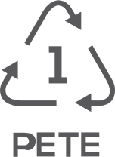 [34]
Figure 7-shows type of plastic.

But not all companies have these logos on their products, although a lot of companies are starting to get on board with improving recycling and are stating on the packaging of the product if the product is recyclable or not, there is still a lot that are not displaying this information and making it confusing about what products are and are not. To go back to England’s statistics, of 47.7 percent of products are recycled in 2018 but in January of 2020 that Sandwell in West Midlands Sandwell council had refused to collect 36,187 recycling bins due to the bins containing the wrong products for recycling (this is a staggering 676 bins a week refused for collection). This is just a small town with a population of just 327,378 [35], if this was on a larger scale of people such as London with a population of 8.982 million people it was not possible to find out how much waste got refused but London has a recycling rate of 33.4 percent so for the capital this is a lot lower than the average of 47.7 percent that England combined is achieving.
There are a lot of products which are out there which are not recyclable these items include.
- Plastic carrier bags
- Coffee cups
- Polystyrene
- Crisp packets
- Batteries
- Cling film and thin plastic on top of ready meals
- Takeaway coffee and teacups
- Sauce sachets

Even though some of the products are recyclable it is extremely difficult to separate and not cost effective to separate these but there are some companies doing remarkable changes with these products to help improve the amount waste going to landfill.
Tetra is one company which is changing the way we recycle, partnering with walkers crisp they recycle used crisp packets and other packaging which is difficult to recycle due to the foil used on the crisp packets and are separating the different materials and turning the recycling into viable products such a water storage container, garden furniture, plant pots. Terrae recycle are doing a lot more than just using crisp packets there taking a lot of different product cosmetic packaging, toothbrushes and cigarette waste and doing some remarkable stuff to improve the amount waste goes to landfill but also saving a lot of resources which is normally made from wood or metal such as coffee tables from cigarette waste to park benches made from coffee capsules to children’s play areas.
If this is possible then why isn’t more being done? The report has discussed about how confusing plastic is to recycle and the amount of different products which are recyclable and how people have a responsibility to improve the world in which they live, but does the city councils do enough to improve this? There is so much potential with the way people recycle if all these products were excepted for recycling, yes the cost will be higher to sort and collect these items or for setting up extra collection but the impact it could have on landfills in only a positive and incredible reduction in use of other materials, it could change a city for better and limit resources to other aspects if for example we stopped using metal for bus stops and traffic lights ,street lights could subset wood and not destroy forests in the process by using less wood for desks, benches, chairs.

Hardware
When creating the concept of the project the original idea was to create a smart bin, so it was originally planned to have a screen build into the bin to display the information and would have to have some sort of minicomputer to talk between the screen and the barcode scanner there are many different types of companies creating these products some include.
- Onion Omega2+ [36]
- Raspberry pi [37]
- Arduino [38]
- NVIDIA jetson nano [39]

When comparing the products, it came down two products the raspberry pi [37] 4and Arduino [38] it was decided to use the raspberry pi [40] (list why from power point)

Raspberry pi
A raspberry pi [37] is a computer slightly bigger than a credit card capable of extraordinary things for its size it works just like a normal computer and can run on any screen with a HDMI [41] port (high definition multimedia interface) the reasoning behind choosing the raspberry pi [37] over Arduino [38] was.
- Memory capacity was better and has easy option of changing SD card to extended memory if needed.
- a small computer which can run multiple programs and software at one time.
- Has the capability to create the whole application on
- Has built in WIFI no need to solder extra parts to raspberry pi [37]
- Has more USB ports to run scanner and keyboard and mouse same time while testing application.
- Easy plug and use setup with the mouse and keyboard
- Portable
- Can be run by power bank [42]
while researching the Arduino [38] and raspberry pi [40] to decide which option was better for the project the raspberry pi [37] had more relevant resources and information regarding the product and the nature of how the raspberry pi [37] works as a minicomputer with a functional operating system was a plus and the resources and the simplest of the raspberry pi [40]. The raspberry pi [37] was created so people can use simple and easy they were designed with the idea any one can use to have fun and create projects with these used in primary schools to help as an aid to teach children. Unlike the Arduino the raspberry pi [37] did not need to be built the Arduino [38] would need be soldered together to build the screen and scanner connections to the motherboard [40].
Raspberry pi [37] has a community of some amazing projects to help get used to working with the raspberry pi [37] and challenges to learn how to get use to the raspberry pi. When researching, it was found that there are similar concepts regarding the raspberry pi [37] where a teacher created a database of barcodes for taking out and returning where the student would enter their ID and scan a barcode added to the back of a tablet to register when a tablet has been checked out or checked back in [43].
the specifications of the raspberry pi were another beneficial reason behind deciding on the raspberry pi the specs include [37] [40]:
- 1.5Ghz 64-bit Quad-core CPU
- Comes with 2, 4 or 8 GB of RAM the 4GB option was purchased.
- Two USB (universal serial bus) 3.0 ports and two USB 2.0 ports these was an important part being able to use a keyboard mouse and scanner on the raspberry pi same time when creating the project and for testing.
- Two mini-HDMI ports (high definition multimedia interface) to connect to a tv or monitor or raspberry pi display screen.
- 4k display capable

Scanners
When deciding on a barcode scanner to use for the project it was discovered that a lot of scanners available for purchase were big or handheld scanners. This was not ideal for the project and smart bin concept because it would not be able to be built into the smart bin. Simple use such as a self-service check out at would be ideal as the public/users would be familiar with such a device or seen it in use and therefore would not need any training or instructions on the use of the smart bin.
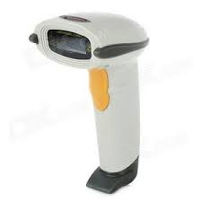
Figure 8-barcode scanner [44]

So, it was decided to use the raspberry pi barcode scanner it was small and sleek and could easily be implemented and created into the design of the bin.
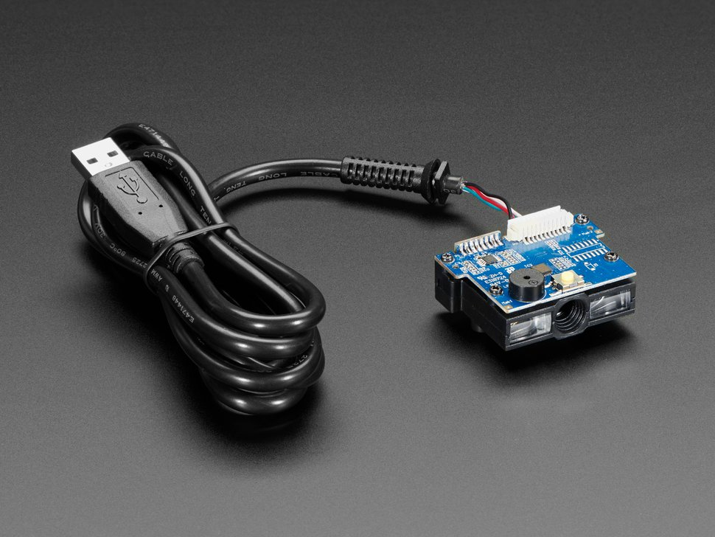[
Figure 9-image barcode scanner [45]

There were some deciding factors when choosing this barcode scanner unlike normal barcode scanners this barcode scanner works by taking images of the barcode, it takes a 100 photos every second instead of using a scanning mirror concept this is where the barcode uses a mirroring to move the laser into place for the scanner to read the barcode. Another good feature about this barcode scanner is its simplicity it works by plugging the barcode scanner into the raspberry pi by USB most scanners work like this, but this is where this barcode scanner differs it works same way as a keyboard, it takes a photo of the barcode and it will decode the image and just as if the user were typing the barcode out. It will display on the screen unlike other barcode scanners available for the raspberry pi needing additional software and setup to make the barcode scanner compatible and work correctly on the raspberry pi and this was the main reason although it might not be a issue there was worry when using the scanner and trying to integrate with the project it was unsure how this programme could be used with the application causing problems when transferring the barcode data to the website [45] [46].

Programming languages
Originally the programming language to be used to build the application was going to be created using C# [47] and asp.net [48] C# [47] is a programming language developed by Microsoft [49] in 2001 that runs on the .net [50] framework. It is a modern approach to how software is developed and being able to create your database, website, application, and backend development and using .net framework for the security all in one place and the software language being open source so has a become a desired language for many with a lot of added libraries which can be included to improve and help create your application. This is all a positive to how the project would work thus why it was a desired language to create to project on further investigation into the language it was not possible to use due to the nature of the raspberry pi [37] having issues performing the software to run application when testing the project.

HTML and CSS
HTML [51] (Hypertext Markup Language) is a programming language designed for creating websites it is used for structuring how the website displays its content from paragraphs to images and navigation bars.
CSS [51] stands for cascading style sheets this is where the cosmetics of the website are created this is used to style the website created from fonts colours, style the layout the is achieved by using the tags set out with in the structure of a html page.
HTML will be used to create and build a webpage and CSS will be used to style and create the layout of the webpage.

JavaScript
JavaScript [52] is a dynamic programming language designed for creating network-centric applications [53]. It is used both the client side and server side of your web sites and web pages interactive. Where HTML [51] and CSS [51] are languages which give style and structure to web pages.
JavaScript will be used for creating the admin login to have a drop-down menu to login so is not constantly on show for other users who will not have access to login.
Json (JavaScript object notation) is a text-based data format used for parsing data through server requests even though it uses JavaScript syntax it can be used without JavaScript this will be used to make and display data request from the barcode lookup API [54] [55].

PHP
PHP [56] Hypertext pre-processor is a server scripting language that is used with in websites and is embedded into the HTML. PHP can perform system function can open files and can delete and write into files. It can handle taking data from forms and correspond with a database to display information or send information to the database. It is also can be used to restrict or allow access to certain clients depending the information this makes it desirable to websites because you are not restricted on what can be displayed for example you could have an interface which data is accessed by several clients you can restrict what is displayed on the website and have each clients information display only to the client who it is intended for.
PHP [56] will be used to communicate with the database to transfer data from the database and website.

API
API (application programme interface) works is a similar way similar to when you go for a meal at a restaurant, and you have a menu and choosing your food and then the chefs cook the food it’s the waiter job to give your order to the chefs to cook your food and bring your food to you.
An API works the same way where it takes your search and delivers the information to a database or server and returns the correct information [57].

SOAP (Object Access Protocol)
SOAP [58] is a protocol web service and works by communicating between multiple computers and sending the data between these computers it sent using Hyper Transfer Protocol (HTTP) or Simple Mail Transfer (SMTP).
SOAP is created and runs on XML (Extensible Markup Language) and is a text-based format for structured data it is used for setting data into forms and retrieve and send request to a database or cloud storage to retrieve the data and send the data back to the user.
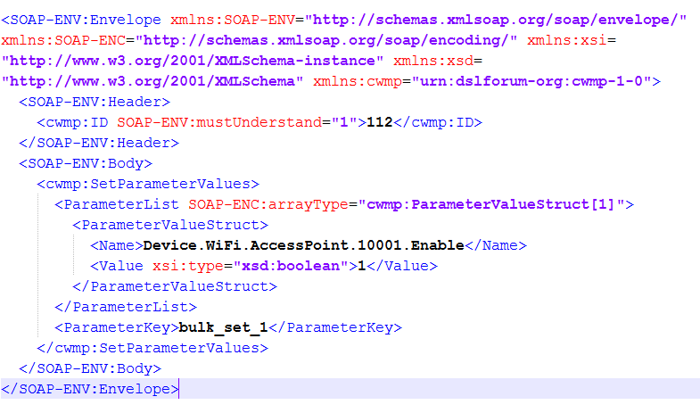
Figure 10-soap envelope

REST API
Representational state transfer(rest) [59] is a type of software architecture that was designed to request and receive data between HTTP request and applications. REST is also used to improve movement between application and webpages for example when cloth shopping online you set preferences to which clothing looking for it will send a request to the API and retrieve the information from the database or cloud storage and will retrieve information regarding the search preferences. If this wasn’t the case it would take a very long time if the website displayed all stock at one time customers would get tired of searching and look elsewhere.
REST can do a lot more than just gather information it can delete or add to a database making it desirable for business which can make front end forms instead of having to manual code into the database when new items are in stock or not stocked any more it also makes it easier to update current stock [60].
This has changed the way we use the internet and create websites long of the days adding and removing information from the website and hard-coding the information with REST API it is made simpler; the user won’t be aware but every search will navigate to another page it doesn’t long like that but every webpage has a URL (Uniform Resource Locator) and this URL will look for example something like www.tickets.com and you search for an artist then your URL will change to www.tickets.com/searchedartist once searched artist it will display all destinations the artist is playing and dates when click book ticket it will move to another page www.tickets.com/artist/booktickets these makes it easier to navigate and give the user the freedom to explore the information that user intends to see.
REST API runs on xml simple to SOAP but it also be created using json, json does not have as many restriction and rules to follow when making a request this gives the develop more freedom how to set out the data and can limit the amount of data received [61].
When creating the concept and idea of how the application will work, it was decided to use a REST API many companies create rest API for people to use the data stored in their database to display data and information not stored in their own database.
When researching what API were available it was discovered there are a lot of API which hold information about products and company information, but a lot didn’t keep barcode information due to the nature of the application the information retrieved comes from the UPC barcode there were two API found which use UPC barcode information.
First was Earth911 [62] API this is a fantastic API: The API uses json to make it request and has a lot of information regarding recycling can find recycling locations, product information, articles types of materials. This was not used due to speaking to the company and all information is currently for United States of America only so apart from product information for American products this API won’t be as helpful as hoped.
Barcode look-up [63] is a barcode API where it keeps records of products, company information, manufacture information and has a lot of UK products even though this also doesn’t display whether the product is recyclable it was decided to use barcode lookup this will be discussed further in the development section.

Database
Database [64] is a system created to store and hold information and data; it is a structure set into different tables and within those tables, holds fields regarding the type of data stored, for example, with a user form the table will be called user details and the fields will be name, address, email, postcode etc and each field will store the correct information regarding the user.
Supermarkets have their own database to store products and keep stock control it was researched into using the Tesco API to access their database to populate the database for all their products ,but currently the Tesco API has been taken down and currently not for use of the public anymore [65].

Research conclusion
In conclusion the research gives a great understanding on what was needed to make the project a success. There was a lot to learn and research before understanding if the project could be achieved the major parts were how barcodes work, the type of barcodes, the data stored and learning and getting a better understanding of recycling without this knowledge; problems and wrong information would have been used and could compromise the data. It was good looking at similar concepts too that companies are out there using technology for good to improve the way we recycle and improve the environment it also helped recognise that this project is an important topic and can become an application instead of a concept.

Chapter 3 - Research Methodology

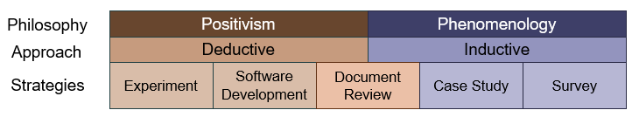
Figure 11 Research methodology [66]
The philosophy is a positivist that this development can be achieved, and the project can be a success with the technology available and programming languages and hardware this can be achieved. There will be a deductive approach this involves a structure approach to how this project can be become a reality instead of an idea.
Strategies will be a software development approach and document review. Software Development will be building and structure the idea and turning into an application for users to use this will need be discussed more in depth in the development methodology and document review is the section to review and learn about how it is able to work what concepts are similar and how it can be achieved.
For positivism and deductive artefacts, facts and figures and things which are quantifiable things which you can measure.
This project takes a positivism approach looking at facts and figures to quantitative data need to complete the project instead of an inductive approach due to relying more on the facts and data other than human feedback and ideas from surveys and case studies to research will be to find the correct data to help build the project and will be a choice which information is valid from solo research into the project [66] [67]
Deductive is a theory which generates a hypothesis that can be tested to prove the theory. the deductive approach is being used to take the research gathered and the idea and turning it into a project to create.
Strategies will be taking a software development approach to take the project and develop an application to determine if barcodes can be used to determine if a product can be recycled or not while using a document review strategy found earlier in the research and review section.
The strategies being used are software development strategy to determine whether the project can be constructed to determine if a product barcode can be scanned and used to give the user information regarding if the product is recyclable
The approach chosen was investigative methodology [68] approach this approach was chosen to determine how the project would work it was set out in stages.
- The first stage was to research similar and concepts of how the idea has been created is it feasible and achievable how it could work.
- To research into barcodes and methods of how products are recycled what products are recyclable what goes into what waste disposals
- What hardware would be needed for the user to use the application what scanners are available and what the scanner would run on.
- Research into programming languages is it cable of running on the hardware is the languages compatible and able to use to connect the database to the front end of the website to be cable to receive and send data.
- What API are available are they feasible how they can improve data collection

The advantages of using the investigating methodology it helps pave the way that the project will work and setting out the needs for completing the project and eliminating any issues which could arise. If the research wasn’t applied one issue that could of played a big problem into the project was the software when researching it was originally going to use c# and .net to create a web application and database using visual studios but when researching it is possible to run the c# and .net on the raspberry pi but it has run time issues and can stop the app from running and crash. Without researching the issues on raspberry pi, it would of come way later once the project was complete and uploaded on to the raspberry pi and had the possibility to ruin the whole project due to the nature of time scales and amount of hours spent creating the application it would not have been efficient time to complete

Chapter 4 - Development Methodology

Waterfall
Waterfall methodology is a linear concept of which one task cannot be started before another task Is finished all members of the team work together to get the task done. When using the waterfall approach is broken into 7 levels [69] [70] [71]
- Requirements time scales and requirements and guidelines for the project are discussed.
- Analysis the system specifications. This is also where technical resources and finances are audited for feasibility.
- Design what hardware, software and data structures will be used and how the application will look.
- Coding implementation using the requirements and models created to create the application.
- Testing this is where the application will be tested or in beta to check for bugs and issues.
- Deployment the application is deemed fully functional and is deployed or activated live.
- Maintenance correcting issues from customer responds and improving and fixing issues

Advantages
- Already established a plan and design of how it will look.
- Structured and disciplined organisation.
- Transfer’s information well of each step.
- Have an end goal before starting the project.

Disadvantages
- Makes changes difficult if problems arise can’t move forward till fixed.
- Excluded the client clients want to see where you are at with the project and will want to change making it difficult to implement.
- Testing will only begin when all code is complete this is risky because there could be bigger issues when putting the application together.
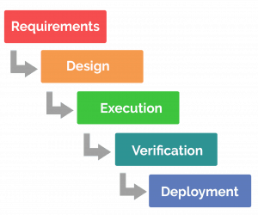
Figure 12 waterfall methodology [72]

Agile
Agile approach [73] is separating task and completing task at the same time to complete the task unlike waterfall you do not need to wait for one task to be finished to complete others. The project will be worked with the client and will show how the development is going to make sure on the right track of what the customer requires, and needs are meet [74] [75].

Advantages
- Testing as the project is build easier to find problems arising.
- Customer satisfaction
- Can change design and change aspects easier.

Disadvantages
- Harder for new team members.
- It is difficult to measure progress with multiple tasks being completed.
- Projects can run out of time because no clear end goal.
- No fixed design concept.
For the concept of this project both approaches were implemented for most of the project a waterfall approach was taken it was structured what was wanted to be achieved and how it would be implemented though due to the way the application was created some aspects would need to be created first and left and move forward to help finish the task.
For the development methodology an agile approach has been constructed to complete the project waterfall was the original approach setting out that one task would be completed before another task could be started this was the desired choice due to the nature of working alone on the project to ensure all aspects of one topic being completed before moving on to make sure no problems arise and no functionality was left out. Although this was tactically changed to agile due to research of how the project would work and changing of languages. Being able to use an agile approach to help build the application and connecting aspects of the application together with the database and website needing to be developed considering one another.

Figure 13-life cycle

Advantages of the agile approach
The way the project is agile has its advantages.
- Can deal with issues which can arise while developing the project.
- Can see problems sooner because working on multiple parts of the programme.
- Can change design easier.
- Have a better understanding how the project is coming together.

Disadvantages
- It can be difficult to keep to time scales due to the nature of moving between different sections of the development.
- Showing progress of project until all complete an outsider looking in can be difficult to understand.

Feature driven development

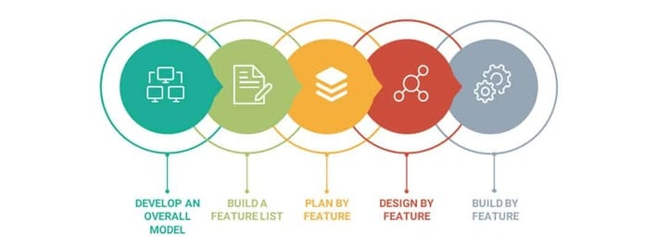
Figure 14 future driven development [76]
Feature driven development (FDD) is an agile framework it is developed around a software engineering approach to developing. It is broken down into 5 stages develop, build a feature list, plan by feature, design by feature and build by feature.
This methodology was designed to split task into different features to be completed faster and quicker.
Developing an overall model
This is the first stage of the process build a model of how the project will run and how the idea will be completed once planned it will help understand what the project will look like.
Building a feature list
Once the object model is built a list of key features which will need to be implemented into the project.
Planning by the feature
Using the knowledge from the first modelling process it time to break down the features that should be designing the feature should look and making a solution for the feature to be completed.
Building the features
This is where you put all the previous steps into action and develop the feature test and inspect the code for the feature.

The development methodology used is feature driven development (FDD). Feature driven development is an iterative and incremental software development progress originated from an agile methodology that focuses on the features for the application when it uses the features it does not mean product features but features to make the application work such as creating a login feature for the application. This approach was used to the nature of how the application was to be created due to moving features across to build the application once one feature was completed this includes coding testing and documentation of the feature it would be moved on to the next feature [77].

This was first used to develop a website from the wire diagrams of how the website should look and how the database will look and create a feature list to be completed. The main features to be implemented first, for example, would be the feature to search a barcode as this must be implemented before the feature data to display data to the user otherwise the database would not know what data to send. Planning by feature is why this methodology was chosen due to the nature of how the project was set out unlike waterfall where one task must be complete before another task can be started this gives the freedom to move between task once a feature has been completed due to the importance of the features and any problems which might occur. It can be eradicate quickly instead of staging out task with the waterfall methodology.
Designing the features was how they should be set out going back to the barcode search bar it was designed to be implemented into the centre of the webpage making it visible easier for the user to see and set out to be the main section for the user to see. Building the feature is taking everything processed in the preparation to building the feature this comes down to coding and testing the feature [78] [79].

Software
Software used to create the database and run a client server for the project in XAMPP. XAMPP is an apache web server which accepts sql and php which is perfect for creating a database and using php for the backend development to correspond the website to the database to receive and pass information between the database and the website. Apache is a web server software which is an open-source software which user can run webservers it accounts for 67% of all webservers in the world. Webservers work to take a http request and check few security and safety of the website and then take you to the website you required. Also, notepad++ will be used to construct the website and development of backend connections.
Languages which will be used when developing the project will consist of sql to construct the database, html to create the website with the backend php to correspond with the database and website also json will be used to get and receive request from the barcode lookup api.

Hardware
Hardware needed will be a raspberry pi 4 and a barcode scanner to be able to run the programme and to use the scanner to take the barcodes from the product.

Moscow

Must have | Should have | Could have | Won’t have
Database | Api access to data | Audio option about the information displayed | Mobile application
Website | Search product by name | recycling tips on websites | Shopping list of items for user
Admin authentication | Update database from website | Craft idea to use non recycling items | Rewards scheme to promote more use of application
Easy user interface |  | Photos of the product when scanned
 |  | User guide

The Moscow chart was used to determine and breakdown what will be needed when creating and designing the application it gets broken down into 4 sections the must have these are the main aspects of the application which will need to be implemented into the application. The application should haves these section are concepts and ideas which are a good idea and if can be implemented should be the could haves section is where ideas which could be used depending on timescales and feasibility and not essential to making the application and the wont haves this is the section where the ideas are not essential and can be added at a later date to update the application and add some new features to the application after the every other criteria has been meet.

Database
Originally the database was designed with the concept of the smart bin and would be using products from the University of Wales Trinity Saint David canteen so could gather information on all products sold and have access to the products to help fill the database.

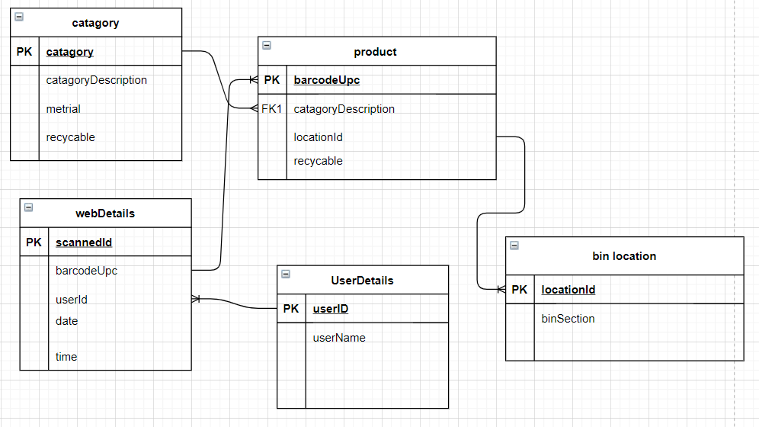
Figure 15 first database design
It was set out into 6 different tables which correspond with each table to store the data needed for the products the table consists of

Category
The category table is where the data about the product was stored it concluded of a description about the product this will set for example if the product was a 2-litre bottle of Coca-Cola or a 500 millilitres bottle of Coca-Cola. Material stores what material the product consists of if the product is plastic, metal, class, paper and cardboard, and then the recyclable field is where it sets the product is recyclable.

Web Details
The web details table was created with the idea of when a product is scanned it will auto increment an id and take the barcode scanned and the user who scanned that product to keep records of items which have been scanned most and the time and date of when the products have been scanned to look at what times and days the application gets used the most. This data eventually in a future development can be used for data mining research on the recycling habits of staff, student or visitors using the smart bins but also the products themselves such as the frequency of the products including the most popular products scanned during the academic year.

User Details
User details table is where it stores details about the user it sets a unique id for the user and stores there name this table corresponds with the web details table to determine who is scanning the product and using the application.

Bin Location
Bin location stores information regarding which bin is needed when scanning the item to dispose of the product.

Product
The product table is the most important of the database tables this is the table of information which displays and holds the data needed to display to the user the information regarding the product it includes displaying the barcode, description, if the product is recyclable and which bin the product gets disposed into.
This was the original concept of the design of the database although this was designed during covid 19 it was still believed that the University of Wales Trinity Saint David would be open academically for 2021 but due to changes and new restrictions this was not the case and University of Wales Trinity Saint David stayed closed and instead went to online learning with this in place it was decided to change the concept of how the database will work and change few different parts of the database.
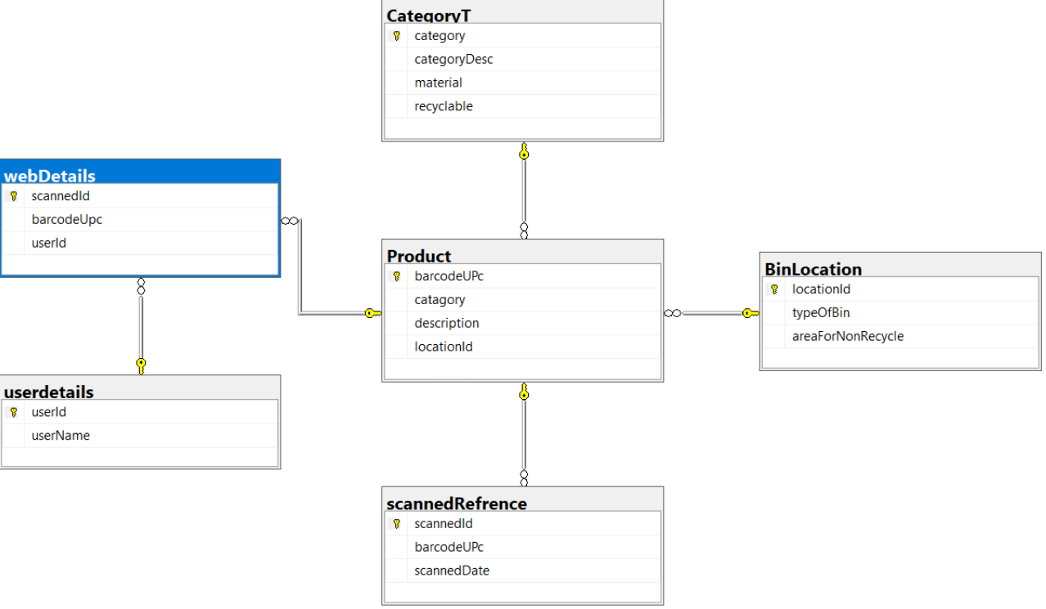
Figure 16 new database design

New database
The new database was created due to the nature of not being able to use products sold in the University of Wales Trinity Saint David cafeteria. This meant that the concept needed to change instead of having bin location set to section of the bin it was changed into different types of waste collection by Swansea council waste management collect from households. The changes to the database consists of the bin location table will now have type of bin field and this will store types of collections for waste black for general waste, pink for plastic, green for paper and cardboard it was also added that if some products are not recyclable by Swansea council but the products can be recycled by private recycling companies it will store a list of these places to take the waste. it was also changed that the only user which will be cable of login is if the user has admin rights to change and add to the database. It was also decided to change the scanned section no longer will it store items which have been scanned instead it will change to help with items which are not already stored in the database.

Website
Designing the website, its first approach was to make a nice, designed website with easy user functionality it was important that the website was usable by anyone from developers to someone who has never used a computer and to stick with the concept of this is a way to improve recycling and help and inform people about what products are recyclable and how to recycle there waste correctly.

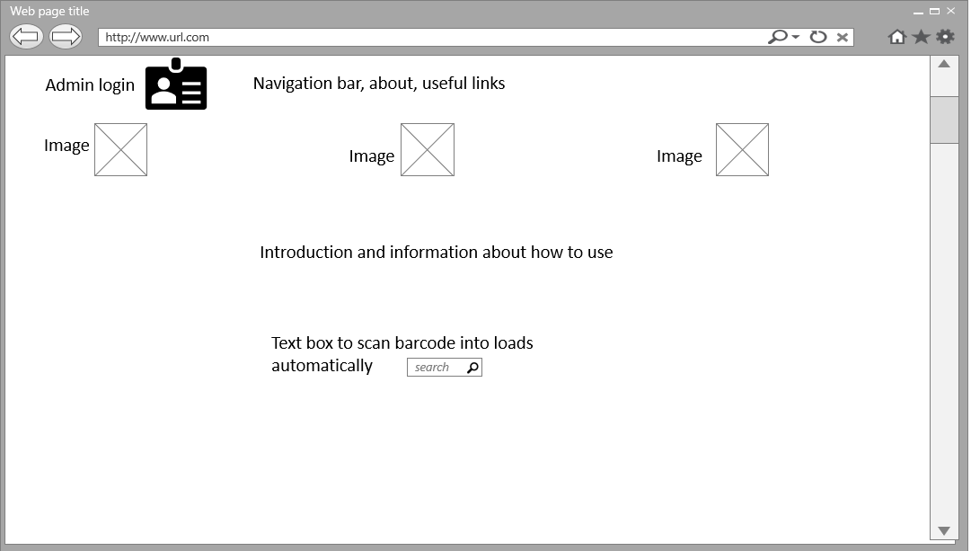
Figure 17-orginal design
The image above shows the concept of how the website was to be set out the concept it wanted to have a simple concept and a clear message about the website a how to guide to explain how to use the barcode scanner and how to use with the website to use the barcode to search the product this when looking at the design for the website it was quickly rectified and changed.

The concept for the website stayed the same but a search field for searching for a product by name instead was added so the website can still be used to find information for products without the barcode or if the barcode was damaged making the website still useable if the user does not have the barcode to the product and making the application more functional.
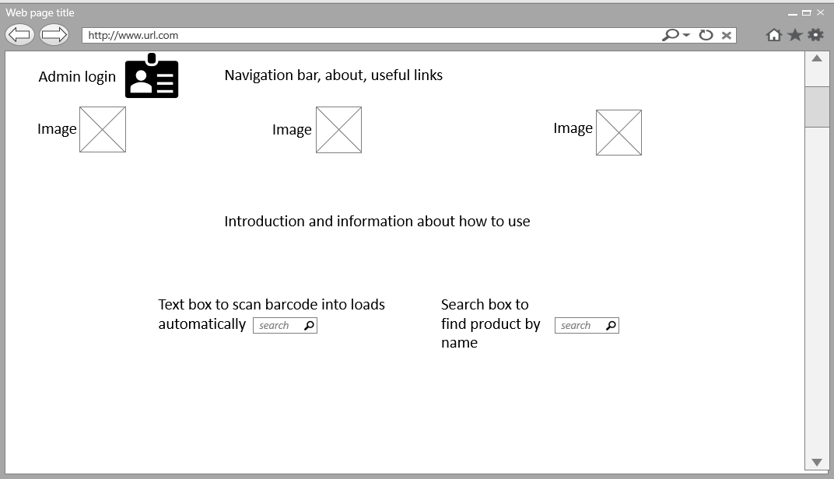
Figure 18-new main page design

Once a barcode has been scanned or a product name has been entered it will return information regarding the product from the database and display on to the website with a button to scan another barcode or search another product name.
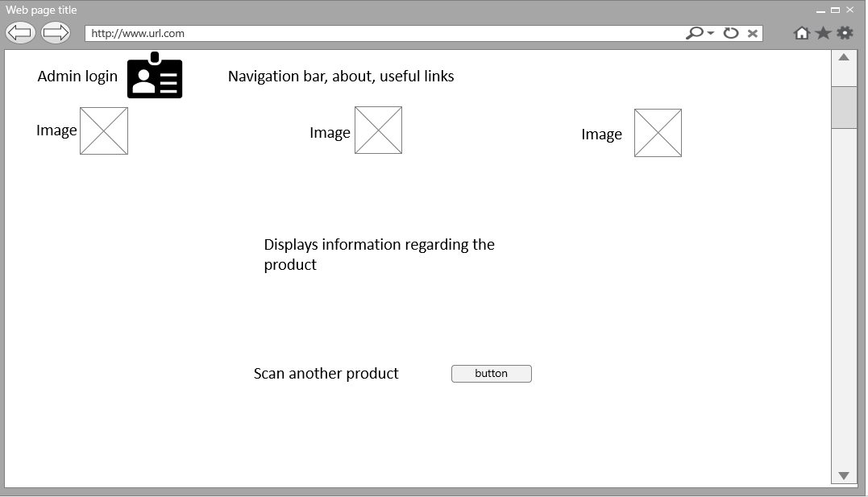
Figure 19-display information page

If there is no record in the database regarding the product instead of displaying information the website will display an error message and will ask to fill in the barcode and the product name and it will be added into the database to check and add required information.
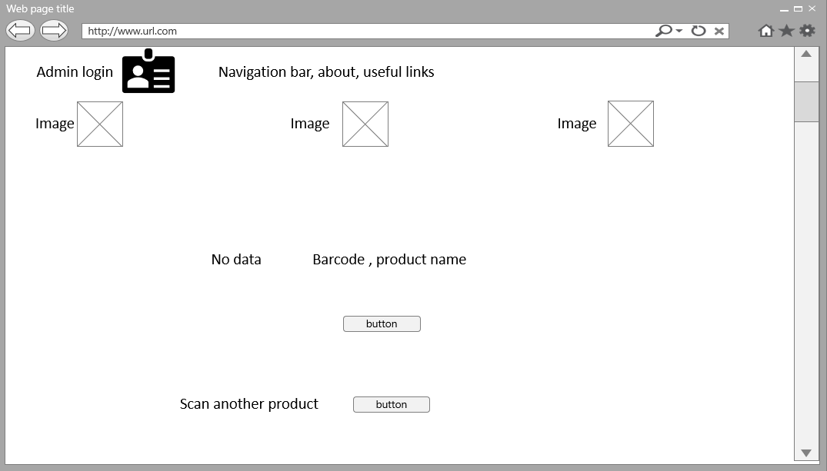
Figure 20-no data to display
The admin page design was very basic and had no elements of the original website design this website will only be seen by users with permitted access it’s a form which will correspond with the database to input data regarding products without needing to access the database.

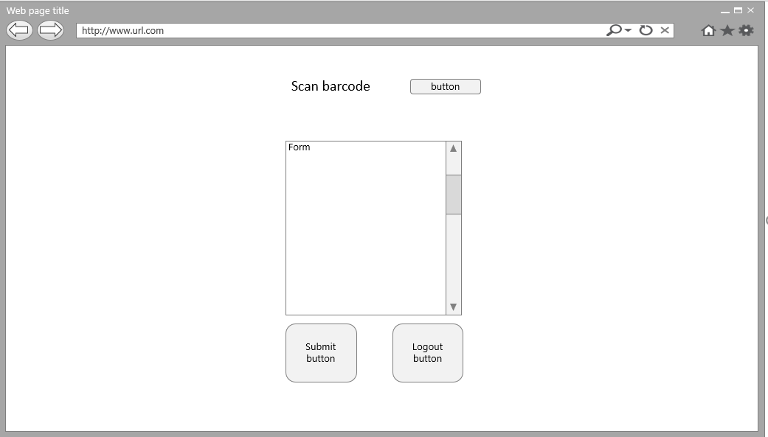
Figure 21-admin form

Use-case diagram
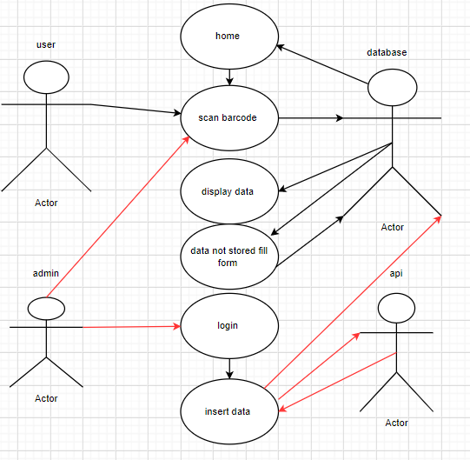

Figure 22 use-case diagram

Use-case diagram shows the steps which will be taken to connect to the various systems and explains the different roles the systems have in the diagram above the user case diagram shows how a user diagram shows an action where the users scan the barcode and corresponds with the system which is the database and returns the information to the user in this case the user actor if the data isn’t stored in the database it will return the user to a form to help populate the database and then will return the user back to the main home page.

Sequence diagram
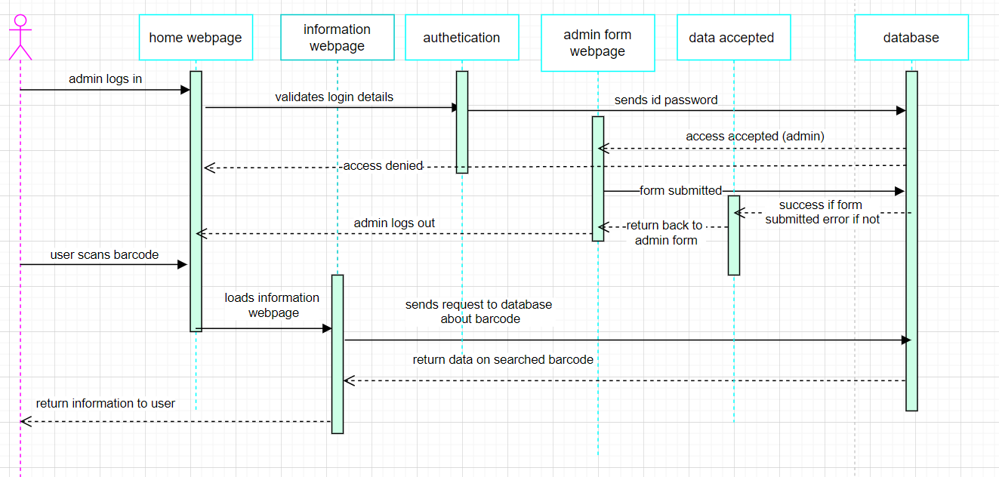
Figure 23 sequence diagram
The sequence diagram was designed to show how the concept of how the application will work and set out structure before developing the application it breaks down into two (parts a user using the application and a admin using the application) it shows the user scans the barcode on the home page then the application loads up the information page it send a request to the database searching for the data regarded to the database then the database returns the data back to the information page and displays the data to the user. The admin section of the sequence diagram the admin logins into the application then it sends the name and password to authentication where the authentication sends the name and password data to the database; the database checks the data if the data is not in the database it sends an error and returns the user back to the main home page if the user details are stored in the database it moves the admin to the admin form the admin sends a data form to the database the database checks the form with the correct fields and returns to data accepted either a success or an error and then returns back to admin form to send more data or log out and takes the admin back to home page.

API

Design for the API is difficult to do because of the concept of the API portraying data it was first looked at what the API can do using the barcode look up [63] API website it displays a list of possible data which can be retrieved when comparing what was available from the API there were only a few data options which were useful to import to the database. These include

- the barcode, but this was not needed due to the nature of the barcode being scanned
- the product name
- the description about the product details

this doesn’t have any information regarding recycling this has details about the production company and sizing and measurements of the product for example 2-litre or if the product is 1-litre it was looked into category of the product but this was not used it was believed that the category might hold information about material used but it was not it was set as if the product was a lamp it would come under house décor or if you scanned a plant pot it would come under garden décor it didn’t hold any information regarding the material used to create the product.

Implementation

Raspberry pi
This section is how the raspberry pi was built to run the application and the implementation of software needed to get the application running on the raspberry pi.

Operating system
Before any of implementation to the project could be constructed on to the raspberry pi it must first be setup the operating system was the first step in configuring the raspberry pi the operating system installed was raspberry pi OS [40] (operating system) this was installed onto the raspberry pi to make the application originally it was tried to install windows 10 [80] onto the raspberry pi [40] but this was not achievable this was the preferred choice so there would be no learning curve instead of having to learn how to use a Linux [81] based operating system although windows didn’t work once installing the raspberry pi [40] OS the learning curve was quickly rectified.
Running the application on the raspberry pi [40] the software needed to install was different to creating on a laptop using Microsoft windows [80] when creatin on windows instead of a Linux [81] operating system XAMPP [82] (cross-platform, Apache, MySQL, PHP and Perl)was used to create the application making it easier because XAMPP [82] has MySQL [83], phpMyAdmin [84], apache [82] and php [56] already installed so no need to install individually for the raspberry pi [40] it was needed to setup and install all separate this was achieved by installing and setting security from the console window of the raspberry pi [40].

MYSQL
MySQL [83] software was installed onto the raspberry pi to make it possible for the application database to be created.

Apache
Apache [82] was installed to create a server for the webpages to run on the server can search for the webpages on the server via http request.

Php
Php [56] was installed on to the raspberry pi so that mysql and appach can correspond using the php sending request and inputting data from and into the database.

Database
The implementation of the database was constructed using the design previously mentioned it was constructed using SQL [85] (structured query language) to create tables and the connections between the tables the database was made in MySQL [83] an open-source database management system the database was implemented using MySQL [83] for the need of a database system running on the raspberry pi [37] and with the raspberry pi [37] running Linux [81] operating system MySQL [83] would run instead of other database systems.

create table Product (
barcodeUpc varchar(13),
category int,
productDescription varchar(200),
locationId int,
PRIMARY KEY (barcodeUpc),
FOREIGN KEY(category) references CategoryT (category),
FOREIGN key(locationId) references BinLocation (locationId)
);
The code above is SQL [85] to create the table products it shows the fields need to be set in the table and what type of fields will be needed for data input it also shows how connections between the tables in the database connect the primary key the parent in the table is barcode UPC this is the main field where the foreign key are the children of the table and are primary keys from different tables for example the foreign key (category ) is the primary key from the table categoryT so it is referenced by the table and the field inside that table.

The code above is SQL [85] to create the table products it shows the fields need to be set in the table and what type of fields will be needed for data input it also shows how connections between the tables in the database connect the primary key the parent in the table is barcode UPC this is the main field where the foreign key are the children of the table and are primary keys from different tables for example the foreign key (category ) is the primary key from the table categoryT so it is referenced by the table and the field inside that table.

Website
The website was created using PHP and HTML [51] the website was set out with multiple pages, but the user will not need to navigate between pages the website redirects the user by the choices the user makes including the admin section there are a total of 12 PHP [56] files used to create although they are all webpages some are not for displaying instead for the backend to set up connections between database and websites and paths to other parts of the application.

Configuration
This is where the configuration between the database and the application is created setting up a link to parse data to and from the website. This is where you set the server the server username password and the database which to connect to.

<?
$strServer="localhost";//server name (doesn't change)
$strUser="root"; //server username (same)
$strPassword=""; //server password "" on xampp
$strDatabase="recyclingdatabase";
$link=mysqli_connect($strServer,$strUser,$strPassword,$strDatabase);?>

mysql_connect() [86] is a function set in php to setup up the connection it was stored in the variable link because it will be used again when making SQL [85] queries to the database instead of needing to write out the whole function.

Security
Having certain parts of the application needed to be hidden from users and only accessible by the admin a login was created to restrict the user seeing forms created for the admin to alter the database instead of needing to hardcode SQL statements into the database every time updating the database it was created that if the user doesn’t enter the correct username and password, it would keep the user on the main page.

<?
php session_start();//session access
include "confinfo.php";
$username = $_POST["un"]; // gets passed to form in index.php
$Password = $_POST["pw"];
$sqlString="SELECT * FROM userdetails WHERE ((userName = '$username') AND (PASSWORD = '$Password'))";
$result = mysqli_query($link,$sqlString);
$numrows=mysqli_num_rows($result);
if ($numrows==1) // if user is indentified, they have access to the search page {
$_SESSION["PASSWORD"]=$Password;
header("location:adminform.php");}
else{header("location:website2.php");
// echo "Login Failed";}
?>

The code above shows how this was achieved it takes the SQL [85] query to check with the database and checks with the configuration and SQL [85] query then using an if statement if the information is correct the user gains access or remains on home page.

The main webpage
This is the home page this is the first interaction where the user can scan barcodes or search for a product by name.
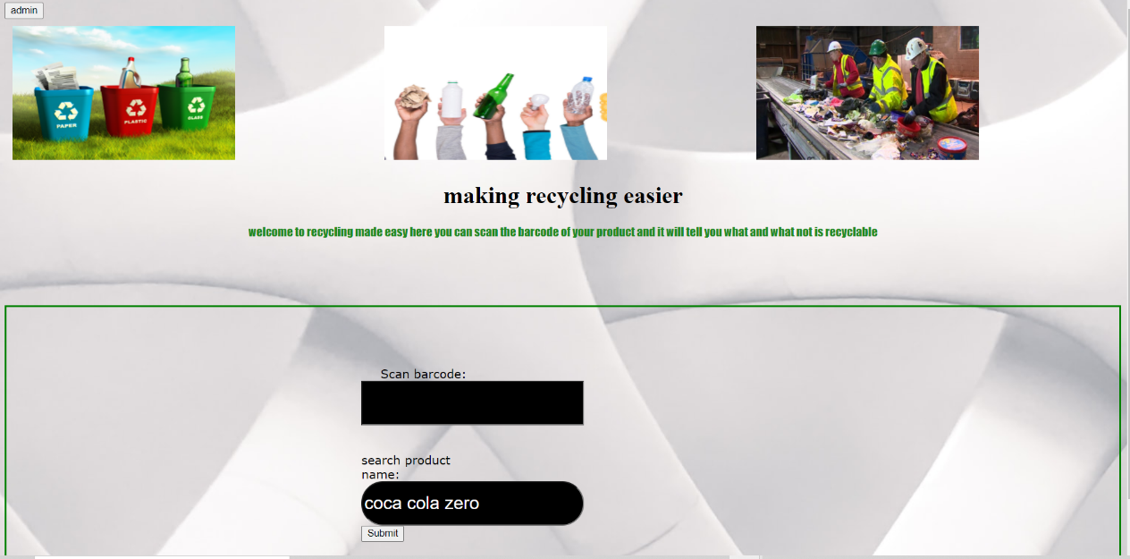
Figure 24 main website page

Image above shows the main webpage following the design of the website it was created to simplify how the user uses the application and give the user the option of searching by product name or barcode.

</form>
<br><br>
<form action="searchbyproduct.php" method="POST">
<label for="productsearch" style="font-family:verdana">search product name:</label>
<input type ="text" id="searchinput" name ="searchinput">
<input type="submit" value="Submit">
</div>

The code above shows a html form that takes the search by product name and sends the information to the searchbyproduct.php another web page.

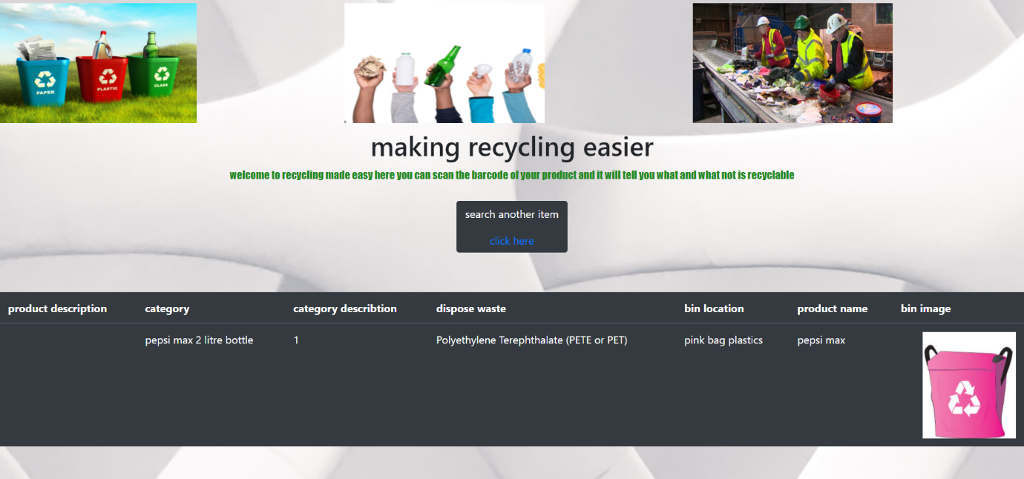
Figure 25 data display for user

The image above shows what the user sees when searching for the product if the product is saved in the database this is done in the backend of the website using php.

$searchinput =$_POST['searchinput'];
$sql1= "select * from product,categoryt,binlocation where ((productName = '$searchinput') and (product.category=categoryt.category) and (product.locationId=binlocation.locationId))";

Using SQL it sends a select statement to pull the information from the database regarding the product searched in the previous page set as the variable $searchinput and then input the data into a table for the user to see.

API
Implementation for the API the first steps were to first create a connection between the barcode lookup API this was done by using the API key to allow access to the barcode lookup database.
The code was written in json the code works by first setting that if the barcode is scanned into the html search box it calls the function which holds what is needed to make the call to the API it makes a request to the barcode lookup website and using the variable my input which was set to equal the input of the barcode to search for that barcode and all information regarding the barcode.

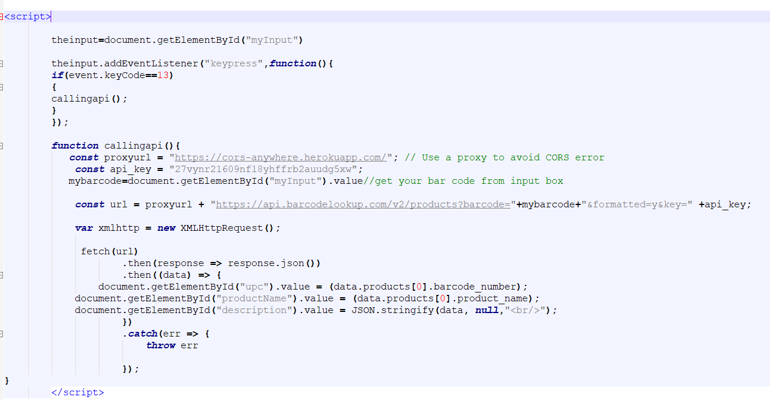
Figure 26 API code to retrieve data
With the data being received from the barcode lookup API it was then set out to take the parameter and data type for example string, integer or Boolean set out for the type of data created by barcode lookup and pass the data into the correct fields on the admin form and discard any data not needed, this also makes the data that visible on the screen and can be used to populate the admin database form.
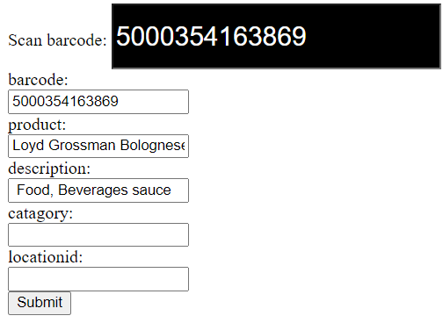
Figure 27 API data displayed
The image above shows how the data is displayed once the barcode is scanned at the top of the admin form and the code make the request to retrieve the data about that barcode.

Testing first stage
The first stages of testing the application were done to make sure no problems or errors arise when running the application before transferring the application and running on the raspberry pi.

Test case id | Test case | steps | Expected output | Actual output | status
1 | Load home page | 1.enter http request | Display home page | Displays home page | pass
2 | Scan barcode with product stored in database | 1.use barcode  scanner  2.scan product  3.display table with correct data  4.shows image regarding what bin the product goes in | Displays Table including all relative data about product and image for correct bin to dispose product | searched the barcode of a 2-litre bottle Pepsi max displays table and correct data but displayed all images | fail
3 | Scan another item | 1.press created button for scanning another item | Take the user back to home page to scan another item | Takes the user back to home to scan another item | pass
4 | Searched for a product by name | 1.search for product using search box.  2.display table with correct data  3.shows image regarding what bin the product goes in | Search for product  Display table with information regarding that product | Searched for Pepsi max displayed all data correct and correct image | pass
5 | Search for a company product with multiple products | 1.search for product using search box.  2.display table with correct data  3.shows image regarding what bin the product goes in | Search for coca cola zero having multiple coca cola zero products and different types of recycling in database | Searched for coca cola zero displayed all records and correct image for plastic and glass | pass
6 | Login for admin | 1.enter correct username and password.  2.allow access.  3.send user to admin form | Display the admin form page for admin | Accepted username and password and took the user to the admin form page | fail
7 | Login for admin wrong username | 1.enter incorrect username and correct password | Refuse access to admin form remain on home page | Refused access to admin page | Pass
8 | Login for admin wrong password | 1.enter incorrect password correct username | Refuse access to admin form remain home page | Refused access to admin page | Pass
9 | Login for both wrong username and password | 1.Enter incorrect username and password | Refuse access and remain on home page | Refused access and remained on homepage | pass
10 | Entering product name which has no data stored in database | 1.enter a product by name.  2.take the user to an input form to help update database | Display a form to input the barcode and product name | Displays input form to enter barcode and product name | pass
11 | Pass product not existing into database | 1.Takes product name and barcode of product not existing in database 2.stores in database | Input’s information into the database | Error regarding passing data | Fail
12 | Scanning barcode and has no data regarding product in database | 1.displays input form for barcode and product | Displays input form to enter barcode and product name | Displays input form | pass
13 | Api call for admin form | 1.scan barcode | Input’s data sent from api to barcode, product name and description to admin form | No data passed | fail
14 | Scan another item button on input form page | 1.click button.  2.takes user back to home page | Press button return to home page | Button works and sends user back to home page | pass
15 | Entering data into admin form to update database | 1.fill form  2.submit form  3.displays record added if success | Update the database from using admin form | Fill out admin and get error message | fail
16 | Logout | 1.logout button on admin form  2.logs the admin out  3.returns to homepage | Log’s admin out returns to home page | Click logout button successfully logs out and returns to home page | Pass

First steps of testing there were a few issues which failed the test which failed will be discussed and explaining how the errors were rectified.
Test case 2: Although the data was passing from the database correct initially the image displaying was incorrect it would display all the images for the types of bins green, pink and black bins this was down to the coding for how the images were to be displayed using an if statement that if the bin location equalled one it show a pink bag but it was showing all 3 this was due to syntax errors when introducing php and html that the way the php was coded that it would never read the other code would always set to pink
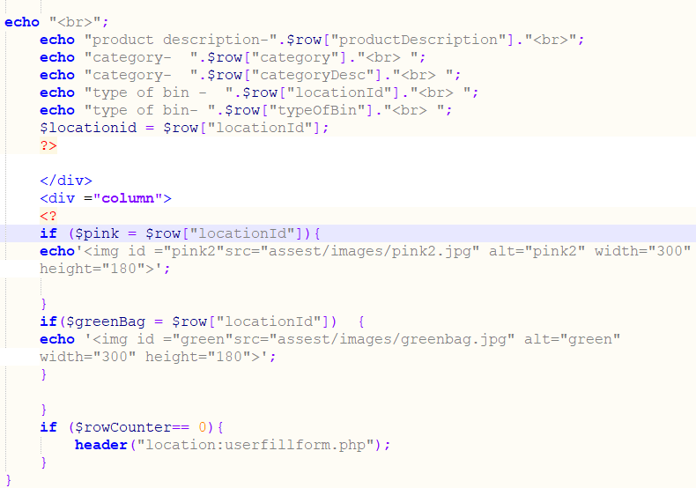
Figure 28 original bin image code
The image above shows how the old table was set out was using php to echo out the table and the image but was never correctly displaying the write image changing the way the tags are instead of using php to display the html table it was coded that the html page displays the code writing in php instead and this rectified this issue.
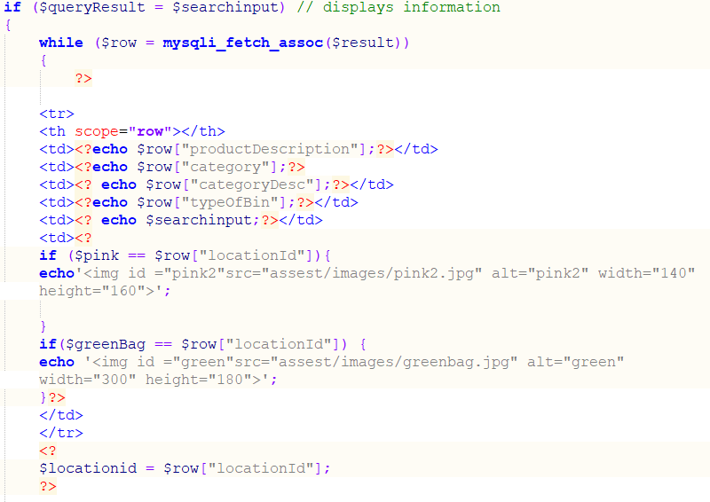
Figure 29 working bin image code
Image above shows the php [56] code inside the html form instead of the html inside the php.
Test case 6: Admin login this test failed due to a number of reason but all simple errors which wear rectified quickly the first error was not adding config to the database page so didn’t have any connection to the database and the SQL [85] statement requesting the information regarding the password and username was incorrect once the config page was added and spelling correct the login worked correctly.
Test case 11: Sending barcode and product name for items not in database. This did not work due to a problem when constructing the database adding the wrong foreign keys to the table. Meaning that the data could not be passed in due to the barcode entered must also be added into the product table or already exists, where the barcode was the primary key due to this issue to be fixed correctly the whole database would need to be redesigned. to fix this problem but due to the time scale for the application a quick fix was to make a new table separate to the original database just to hold this data this solved the issue but will need to be rectified at a later date to solve the issue correctly.
Test case 13 input data from API in to the admin form to retrieve data this failed due to the nature of the API when first using the API it is needed for the purpose of the free trial to only have the API for 7 days so it was needed to create a new account every 7 days once creating a new account a problem with the connection with the API. when opening up the CORS-anywhere [87] error it displays a notification saying wish to start your trial this was a new feature the API barcode lookup introduced and once agreed the API worked fine and displayed the information.
Test case 15 admin form inputting data to database this failed in testing because originally the form was created with all fields as one form the errors occurred when SQL [85] statement insert into database was that all fields needed to be inserted before the database could update and if only updating one section of the database meant that this would cause issues it was later designed so all parts of the admin form are broken into different parts and sent SQL [85] request regarding that section of the database needed to update.
After fixing the issues a new test was run on the application to make sure that any parts changed did not conflict with original features which worked before.

Test case id | Test case | steps | Expected output | Actual output | status
1 | Load home page | 1.enter http request | Display home page | Displays home page | pass
2 | Scan barcode with product stored in database | 1.use barcode  scanner  2.scan product  3.display table with correct data  4.shows image regarding what bin the product goes in | Displays Table including all relative data about product and image for correct bin to dispose product | searched the barcode of a 2-litre bottle Pepsi max displays table and correct data and image | pass
3 | Scan another item | 1.press created button for scanning another item | Take the user back to home page to scan another item | Takes the user back to home to scan another item | pass
4 | Searched for a product by name | 1.search for product using search box.  2.display table with correct data  3.shows image regarding what bin the product goes in | Search for product  Display table with information regarding that product | Searched for Pepsi max displayed all data correct and correct image | pass
5 | Search for a company product with multiple products | 1.search for product using search box.  2.display table with correct data  3.shows image regarding what bin the product goes in | Search for coca cola zero having multiple coca cola zero products and different types of recycling in database | Searched for coca cola zero displayed all records and correct image for plastic and glass | pass
6 | Login for admin | 1.enter correct username and password.  2.allow access.  3.send user to admin form | Display the admin form page for admin | Accepted username and password and took the user to the admin form page | pass
7 | Login for admin wrong username | 1.enter incorrect username and correct password | Refuse access to admin form remain on home page | Refused access to admin page | Pass
8 | Login for admin wrong password | 1.enter incorrect password correct username | Refuse access to admin form remain home page | Refused access to admin page | Pass
9 | Login for both wrong username and password | 1.Enter incorrect username and password | Refuse access and remain on home page | Refused access and remained on homepage | pass
10 | Entering product name which has no data stored in database | 1.enter a product by name.  2.take the user to an input form to help update database | Display a form to input the barcode and product name | Displays input form to enter barcode and product name | pass
11 | Pass product not existing into database | 1.Takes product name and barcode of product not existing in database 2.stores in database | Input’s information into the database | Input’s name of product and barcode into database to help with updating database | pass
12 | Scanning barcode and has no data regarding product in database | 1.displays input form for barcode and product | Displays input form to enter barcode and product name | Displays input form | pass
13 | Api call for admin form | 1.scan barcode | Input’s data sent from api to barcode, product name and description to admin form | Inputs data to admin form from api | Pass
14 | Scan another item button on input form page | 1.click button.  2.takes user back to home page | Press button return to home page | Button works and sends user back to home page | pass
15 | Entering data into admin form to update database | 1.fill form  2.submit form  3.displays record added if success | Update the database from using admin form | Fill out admin and get message database updated check database and new record added | pass
16 | Logout | 1.logout button on admin form  2.logs the admin out  3.returns to homepage | Log’s admin out returns to home page | Click logout button successfully logs out and returns to home page | Pass

Testing application raspberry pi
Testing how the application runs once installed onto the raspberry pi [40]

Test case id | Test case | steps | Expected output | Actual output | status
1 | Load home page | 1.enter http request | Display home page | Displays home page | pass
2 | Scan barcode with product stored in database | 1.use barcode  scanner  2.scan product  3.display table with correct data  4.shows image regarding what bin the product goes in | Displays Table including all relative data about product and image for correct bin to dispose product | No data displayed | failed
3 | Scan another item | 1.press created button for scanning another item | Take the user back to home page to scan another item | Takes the user back to home to scan another item | pass
4 | Searched for a product by name | 1.search for product using search box.  2.display table with correct data  3.shows image regarding what bin the product goes in | Search for product  Display table with information regarding that product | No data displayed | failed
5 | Search for a company product with multiple products | 1.search for product using search box.  2.display table with correct data  3.shows image regarding what bin the product goes in | Search for coca cola zero having multiple coca cola zero products and different types of recycling in database | Searched for coca cola zero displayed all records and correct image for plastic and glass | pass
6 | Login for admin | 1.enter correct username and password.  2.allow access.  3.send user to admin form | Display the admin form page for admin | did not log admin in | fail
7 | Login for admin wrong username | 1.enter incorrect username and correct password | Refuse access to admin form remain on home page | Refused access to admin page | Pass
8 | Login for admin wrong password | 1.enter incorrect password correct username | Refuse access to admin form remain home page | Refused access to admin page | Pass
9 | Login for both wrong username and password | 1.Enter incorrect username and password | Refuse access and remain on home page | Refused access and remained on homepage | pass
10 | Entering product name which has no data stored in database | 1.enter a product by name.  2.take the user to an input form to help update database | Display a form to input the barcode and product name | Displays input form to enter barcode and product name | pass
11 | Pass product not existing into database | 1.Takes product name and barcode of product not existing in database.  2. stores in database | Input’s information into the database | Input’s name of product and barcode into database to help with updating database | pass
12 | Scanning barcode and has no data regarding product in database | 1.displays input form for barcode and product | Displays input form to enter barcode and product name | Didn’t input data to databse | fail
13 | Api call for admin form | 1.scan barcode | Input’s data sent from api to barcode, product name and description to admin form | No data from api | fail
14 | Scan another item button on input form page | 1.click button.  2.takes user back to home page | Press button return to home page | Button works and sends user back to home page | pass
15 | Entering data into admin form to update database | 1.fill form  2.submit form  3.displays record added if success | Update the database from using admin form | Displayed error message | fail
16 | Logout | 1.logout button on admin form  2.logs the admin out  3.returns to homepage | Log’s admin out returns to home page | Click logout button successfully logs out and returns to home page | Pass

Test case 2, test case 4, test case 12 and 15 this have been discussed together because the reason of failing was the same issue. the reason these tests failed was due to when creating the database on phpMyAdmin [84] on the raspberry pi the MySQL [83] on the raspberry pi [40] changes all the tables and field names to Pascal case automatically so when calling the data the fields in the SQL [85] statement were incorrect once changing the php code for the webpage these problems were eradicated and worked properly.
Test case 6 admin login this was another issue when setting up MySQL [83] and phpMyAdmin [84] on the raspberry pi [40] there is an issue with the software where root for the host and root for the password cannot be used for phpMyAdmin [84]. This was rectified by manually putting MySQL [83] in safe mode and then overwriting and setting the user to dan and the password to dan. This had same privileges as user root and password root once this was changed and the configuration file was changed to the new user and password to connect the database to the website this issue was solved.
Test case 13 API call similar to the problems when testing on computer there was an issue with the API key updating the API key and accepting the trail changed the errors but didn’t eradicate the issue a different error came up and when researching the issue it is something to do with the web browser because trying again on the desktop version this issue was not a problem and will be looked into further but currently couldn’t be fixed this is not a massive issue because the admin would not login using the raspberry pi [40] this is for the user.
Testing of the application on the raspberry pi [40] once problems fixed.

Test case id | Test case | steps | Expected output | Actual output | status
1 | Load home page | 1.enter http request | Display home page | Displays home page | pass
2 | Scan barcode with product stored in database | 1.use barcode  scanner  2.scan product  3.display table with correct data  4.shows image regarding what bin the product goes in | Displays Table including all relative data about product and image for correct bin to dispose product | searched the barcode of a 2-litre bottle Pepsi max displays table and correct data and image | pass
3 | Scan another item | 1.press created button for scanning another item | Take the user back to home page to scan another item | Takes the user back to home to scan another item | pass
4 | Searched for a product by name | 1.search for product using search box.  2.display table with correct data  3.shows image regarding what bin the product goes in | Search for product  Display table with information regarding that product | Searched for Pepsi max displayed all data correct and correct image | pass
5 | Search for a company product with multiple products | 1.search for product using search box.  2.display table with correct data  3.shows image regarding what bin the product goes in | Search for coca cola zero having multiple coca cola zero products and different types of recycling in database | Searched for coca cola zero displayed all records and correct image for plastic and glass | pass
6 | Login for admin | 1.enter correct username and password.  2.allow access.  3.send user to admin form | Display the admin form page for admin | Accepted username and password and took the user to the admin form page | pass
7 | Login for admin wrong username | 1.enter incorrect username and correct password | Refuse access to admin form remain on home page | Refused access to admin page | Pass
8 | Login for admin wrong password | 1.enter incorrect password correct username | Refuse access to admin form remain home page | Refused access to admin page | Pass
9 | Login for both wrong username and password | 1.Enter incorrect username and password | Refuse access and remain on home page | Refused access and remained on homepage | pass
10 | Entering product name which has no data stored in database | 1.enter a product by name.  2.take the user to an input form to help update database | Display a form to input the barcode and product name | Displays input form to enter barcode and product name | pass
11 | Pass product not existing into database | 1.Takes product name and barcode of product not existing in database.  2. stores in database | Input’s information into the database | Input’s name of product and barcode into database to help with updating database | pass
12 | Scanning barcode and has no data regarding product in database | 1.displays input form for barcode and product | Displays input form to enter barcode and product name | Displays input form | pass
13 | Api call for admin form | 1.scan barcode | Input’s data sent from api to barcode, product name and description to admin form | Didn’t not enter data into admin form | fail
14 | Scan another item button on input form page | 1.click button.  2.takes user back to home page | Press button return to home page | Button works and sends user back to home page | pass
15 | Entering data into admin form to update database | 1.fill form  2.submit form  3.displays record added if success | Update the database from using admin form | Fill out admin and get message database updated check database and new record added | pass
16 | Logout | 1.logout button on admin form  2.logs the admin out  3.returns to homepage | Log’s admin out returns to home page | Click logout button successfully logs out and returns to home page | Pass

Barcode testing
Testing the same barcode in different ways to test if the barcode can read damaged barcodes. The barcode which will be used is a 2-litre bottle of Pepsi max [88] barcode number 4060800103307 for the testing.
Test case id | Test case | Expected result | Actual result | Status
1 | Normal barcode | Accept barcode display data | Accepted barcode displayed data | pass
2 | Using black maker pen to cover barcode | Not to accept barcode | Accepted barcode | Fail
3 | Reading barcode upside down | Convert barcode to correct order | Converted barcode to correct order | Pass
4 | Cut barcode horizontally down the middle and leave a gap in barcode | Barcode wont scan | Didn’t accept barcode with a gap in middle of barcode | Pass
5 | Cut barcode vertically down middle leave a gap | Barcode will not scan | Barcode didn’t scan | Pass
6 | Scan barcode cut horizontally and put back to together | Barcode will scan | Reads barcode | Pass
7 | Cut the barcode horizontally to the size of 1 cm. | Barcode scanner reads barcode | Barcode scanner reads barcode | Pass

The testing of the barcode scanner trying the same barcode in different scenarios proved the theories of what the barcode scanner was cable of.
Test case 2 using a black marker to colour in the barcode this failed because it wasn’t supposed to be able to scan the barcode this was due to the material of the product the barcode is oriented onto it was tested again using a different product on a different material and the barcode scanner was not able to scan the barcode.

User feedback

The application is ready for public testing it will discuss issues raised when the application is available for the public and getting a user perspective of the application to get feedback and any issues about the application which need to be improved.
Recycling application feedback questionnaire
ID:
Age:
Date of Test:

How confident are about what products are recyclable and which products are not?
What was your initial impression of the application?
Was it easy to use and easy to understand the concept of the application?
What did you like most about the application?
What did you least like about the application?
What other features would you like to see added to the application?
If this were a mobile application using your phone camera to scan barcodes, would you use the application?
Out of 5 stars what would you rate this application?
If this application were to be built into a smart bin for homes, would you purchase?

The table above shows the user feedback form and the questions chosen to ask regarding how the user found their experience using the barcode scanner and application. The original intention for the questions was to be of a quantitative nature using Likert scales and to be distributed to many people. Owing to the current covid crisis testing on this scale was impossible as such the author made the decision to use more qualitative and open question to a smaller group of individuals.
The questions were chosen to help gain an understanding of what the user liked about the application and what the user did not like to help improve the way the application runs it was also asked if the user would use the application if it was on a smart phone to help improve how the application could run in the future and bring new and improving application while keeping the features users like about the application already.
User feedback shows that out of all 5 people participating after using the application they would use again there are mixed feelings on the application and how the application works the feedback suggest that 4 out of 5 people would rather have the application on their smart phone and use there smart phone camera to scan the barcode instead of having a barcode scanner one point which was made about having a mobile application was from ID number 002 when asked what he least liked about the product he said “mobile app would be better to take to supermarket to check if the product was recyclable” and this was an answer that was not considered before the user feedback and it gives good reasoning why a mobile app could benefit if the user can find out the product is not recyclable but the same product next to it is which item are they more likely to choose.
When asked if the user would purchase the item as a smart bin for their home 4 out of 5 said yes with one saying they would not but would buy as a gift shows that the idea for it is valid and has a good concept factors such as pricing and sizing would all be issues depending on whether they would purchase the smart bin.
When it came to using the application, all users had no issues using the application but did have feedback about the interface of the application 4 out of 5 users said that the writing was too small and was difficult to read.
The feedback was helpful and gave an understanding to the need for the product but also some interesting ideas to change in the future to make the application a success first change to be made will be to enlarge the writing for the application for the data the user sees regarding the product and the welcoming and how to use messages both were too small. The second change will be audio to tell the user which bin the product needs to get put into this was an interesting one as the oldest user testing and given feedback ID number 001 gave the feedback for the audio and it was a good idea because all partisans said the writing was too small, but he was the only tester with bad eye visibility and said the audio feature is a feature he would like to see added. The last thing to be changed will be looking into a mobile application for the recycling application this was a feature the 4 out of 5 users said would use the 5 users said they would not because they do not own a mobile phone so keeping the original application concept is also a priority to not leave any demographic out.
To see full user feedback forms, see appendices appendix A.

Chapter 6 – Evaluation

Objectives for the project
- Research Barcodes
- Research Recycling in the Uk
- Research technology suitable for this project such as Raspberry pi and Arduino for suitability.
- Develop a Website that can communicate with the functional Database
- Develop a testing framework for the Website and Database

Taking what the originally objects stated as regiments to make this application a success and the relative research into how the product could work and what was needed to know to make the project a success the objectives originally set out to make the application run. Without the time spent researching and gaining information regarding recycling and how barcodes work and what hardware would be needed this application could never have been designed. Its pleasing that all objectives set out for what was needed to make the project were met to create and build the recycling application.
The original aim for the project was to take a technological approach to improve the way people recycle while keeping the application simple and easy for everyone to be able to use the original aim was to implement into a bin but the aim of a smart bin was altered to instead use materials which Swansea council waste collection pick up and the sort into the different coloured waste collection.
Overall, the question was” can it be achieved to use barcodes to help the way we recycle?”, and the answer is yes. If the project were to be started again with more time would be spent gaining information from the public instead of journals and news articles regarding recycling, finding out what products they find confusing and what they would like to be able to do with an application and which features would be needed to add for the application and as a new challenge would create the application with different languages to improve coding techniques and learn new languages.
After completion of the application one thing that is high priority to change is the way the API works to import data into the admin form ideally the original idea for the API would only show data if the database didn’t hold the data to the user and update the database for the next time that product is searched. Due to the nature of the API used this was not achievable due to the main information needed being is the product recyclable and the API did not provide that information; this is a problem because it is taking the admin to manually add in data to the database instead of having the application enter data into the database itself, it is taking more time and resources to populate the database. The database will be needed to be reconstructed to solve issues with how the key structure for the database is set out it was talked about in testing that the database would not accept the user form to input into the database and this was rectified for creating a new table just to store this information. This was a quick fix to show the application feature working but will need to be rectified and fixed probably for further development of the application. The interface for the application was to have an easy-to-use interface design making it easier for the user to navigate around the application without needing a user manual to explain how the application works while making the data presented about the products appealing and informative about the products they are scanning to make to inform the user about how to dispose of their products. The most important object for the application was connecting the backend of the website to correspond with the website’s front end to make sure the correct data was being displayed and was the correct data when requested this was achieved but would needed to be extended on for the search by product name to improve the way the user can search for a product currently if a user searches for Coca-Cola zero and the user enters coca cola it will not find the data this will need to be rectified to help improve the way the data is retrieved from the database.
Time management and planning have been a big part of how the application was created and made a success without this planning and guidelines set out before the application was created, without theses time frames this project could not be completed a few section of completion of the application were overdue the time scale but this was taken into consideration due to the nature and sizing and the tasks need to complete the application this was taken into account before the application was started. Find Gantt chart in appendices.

Chapter 7 - Conclusions and Recommendations

In conclusion, the application has been a worthwhile project it was set out to make an application which can scan a barcode and deliver to the user the information needed to let the users know if that product was recyclable or not and how to dispose of the product.
This project has become achievable due to the facts taken from the steps taken and discussed previously throughout this documentation.
Without research and understanding about how recycling and the materials used to make products the information needed the project would fail due to lack of knowledge and misguiding of how the product is to be entered into the database. Without research into barcodes and barcode scanners the wrong scanner could have compromised the way this application works or even be achieved. Research was also important to languages used for the raspberry pi [40] without research the project would have been codded using c# [47] and asp.net [47] after further research the raspberry pi [40] could not handle those languages and would have had issues running saving a lot of time and effort before constructing the design and implementation of the application.
The design of the application before implementation helped mould how the application will work from how the database was set out and what tables ad fields are needed also breaking down how the website will look before construction. this saved time and helped set out exactly what was needed for how the application will be built without going at the implementation without a design concept.
When it came to implementation there were a few issues building the application, but these were always going to arise from connection to database issues and design elements of the webpage these were all quickly rectified. This comes down to learning curve first time creating the application using new languages and concepts but they all got rectified quickly and fixed but without how the design was to be set out this would have taken longer to come up with how to set out completing the implementation.
Each section of the write up helped build the project and played a part in completion of the steps needed to make the application it made the objects to create this application come together to achieve that and meet all the objectives set out for this project.

Recommendations
There are a few changes and improvements which could be made to the application in most aspects from hardware to software and the way the application works but due to time scales and the research needed to make these changes this would be added later these include.
A better API the barcode lookup [63], the API worked and was acceptable to use for the concept of the application but large scale and moving forward with the project the time need to alter and add extra data added from the API slows down how the database is populated after researching similar API. This was the chosen API but was later found that an open-source database called open food facts [89] has an API with a large database of household products and has details of materials used and some but not all products have information about the types of plastics and metals and also if the product is recyclable. Due to finding this open-source database later it was not in time scale to implement but will be investigated deeper to see if it can be used to eliminate the admin needing to change data and can be used instead to input straight into the database automatically.
A backup database just in case something went wrong to store data and if the data could not be retrieved would have a backup database to display the information to the user therefore a different API would benefit if there were problems with the database the data could be generated by calling the API as a backup to the user. Also, the way the user searches for data to key word for example if the user just types Heinz [90] they have a lot of different products and currently as is with the database would need the whole product this will be changed to find key words regarding the product to help improve how the data is reached and displayed.
Mobile applications: the concept originally was for a smart bin for University of Wales Trinity Saint David [91] but this changed to using in a household environment so a mobile application using the users smart phone camera to scan the barcode scanner instead of needing a barcode scanner.
Instead of using a barcode scanner to determine the product use image reconnection where the user will take a photo of the product and return the information about that product instead this is something that would be investigated adding currently there is a beta (working development but still in testing) made by Microsoft [80]. Lope [92] looking into the software the user takes a set of photos and adds them to a database then when the user takes a photo it will be able to tell you what that photo is by previous photos in the database for example you take 5 photos of person holding a phone and set holding phone and take 5 photos holding different items or no items and if you take a picture and you are holding a phone the software can determine from the image that there is a phone in the photo. This is very early stages, but the concept has great potential and something which will be investigated much deeper to make part of the recycling application.

Chapter 8 – Reflection
In reflection, to the project it has changed the way the author portrays them self-it’s made them gain confidence and drive they didn’t know they had to take a concept an idea of a project and make the project a reality it’s given them the reality of it can be achieved just need to put your mind to it and has improved the thought process, its improved and taught about structure and planning while keeping to strict guidelines and planning for details that might not pop up and has shown that the capability to completing and solving issues they didn’t know was possible it been a bit of an eye opener and difficult but it has shown that you can reach the light at the end of the tunnel if you put your mind to it. It has also made it possible to see problems which might not be a problem because the programme works but is it beneficial or is there better options to complete the task.
For the completion of this task, it has taught a lot about the recycling and the importance of recycling that was not understood as clear before and has taught that there is more to be done. Looking to the future it has helped understand what the next chapter and what direction of development to pursue. For the future of the project taking what was discussed in recommendations and feedback of users to improve the application and move the application forward image recognition and a better way to import data will be investigated deeper and will be investigated being implemented.
This project has also helped understand and improve time scheduling and need the importance of planning previous assignments and projects haven’t been to this degree or size and the need for planning and setting out structure and more has been learned by doing this project than reading project management books, journals and how to guides. It also shows that learning by getting involved and making the project every step of the way that the author is cable of achieving and setting time scales and goals and meeting the target goal within the time frames and dealing with problems correctly to make the project work. Before when previously doing assignments and projects diving straight into the project and just coding without 100 percent knowing the concept will work the steps used for planning this project will be remembered and have set preparation for the steps needed when in industry working on projects or to lead a team to achieve these goals.

Chapter 9 – References

Bibliography

[1] | N.jethjarurach and y. Limpiyakorn, “Mobile Product Barcode Reader for Thai Blinads,” Bangkok, 2014.
[2] | E. peng, P. Peursum and L. LI, “Product Brcode and Expiry Date Detection for the Visually Impaired Using a Smartphone,” Fremantle, Australia, 2012.
[3] | scandit, “scandit,” [Online]. Available: https://www.scandit.com/blog/junker-app-eases-pain-of-consumer-recycling-with-scandit-barcode-scanner-sdk/. [Accessed 14 january 2021].
[4] | w. t. eco, “way to eco,” [Online]. Available: https://www.waytoeco.com/project/click-recyclingoracle/. [Accessed 15 january 20201].
[5] | J. Cornall, “dairy reporter,” 3 november 2020. [Online]. Available: https://www.dairyreporter.com/Article/2020/11/03/Paccor-looks-to-boost-recycle-rates-with-digital-barcode-technology. [Accessed 14 january 2021].
[6] | s. times, “strain times,” , 7 september 2017. [Online]. Available: https://www.straitstimes.com/world/europe/barcode-scanner-helps-you-recycle. [Accessed 14 january 2021].
[7] | i. p. office, “IPO counterfeit goods research,” government , united kingdom , 2020.
[8] | i. c. group, “ip crime and enforcement report,” intellectual property office , united kingdom , 2020.
[9] | b. news, “bbc news,” 14 november 2019. [Online]. Available: https://www.bbc.co.uk/news/av/business-50335737. [Accessed 15 january 2021].
[10] | cognex, “cognex,” [Online]. Available: https://www.cognex.com/en-gb/blogs/industrial-barcode-reader/invisible-barcodes-help-prevent-counterfeit-products. [Accessed 14 january 2021].
[11] | interpack, “interpack,” 10 may 2020. [Online]. Available: https://www.interpack.com/en/TIGHTLY_PACKED/SECTORS/FOOD_INDUSTRY_PACKAGING/News/Invisible_barcode_could_revolutionise_packaging_market. [Accessed 15 january 2021].
[12] | britannica, “britannica,” [Online]. Available: https://www.britannica.com/technology/barcode. [Accessed 14 october 2020].
[13] | G. Weightman, “SMITHSONIANMAG.COM,” 23 se[tember 2015. [Online]. Available: https://www.smithsonianmag.com/innovation/history-bar-code-180956704/. [Accessed 14 december 2020].
[14] | administartor, “data mark uk,” 28 august 2015. [Online]. Available: http://www.datamarkuk.com/2015/08/when-did-barcodes-begin-part-1/. [Accessed 14 december 2020].
[15] | rca, “rca,” [Online]. Available: https://www.rca.com/us_en/our-legacy-266-us-en. [Accessed 18 December 2020].
[16] | kroger, “kroger,” [Online]. Available: https://www.thekrogerco.com/. [Accessed 17 december 2020].
[17] | N. Reiff, “investtopedia,” 25 june 2019. [Online]. Available: https://www.investopedia.com/news/top-companies-owned-ibm/#:~:text=International%20Business%20Machines%20Corporation%2C%20better,history%20dating%20back%20to%201911.. [Accessed 19 december 2020].
[18] | shopify, “shopify,” [Online]. Available: https://www.shopify.co.uk/encyclopedia/universal-product-code-upc#:~:text=A%20UPC%2C%20short%20for%20universal,12%2Ddigit%20number%20beneath%20it.. [Accessed 19 december 2020].
[19] | mars, “mars,” [Online]. Available: https://www.mars.com/made-by-mars/mars-wrigley. [Accessed 22 december 2020].
[20] | scandit, “scandit,” [Online]. Available: https://www.scandit.com/blog/barcode-history-5-things-you-didnt-know-about-barcodes/. [Accessed 22 december 2020].
[21] | barcodes, “barcodes,” [Online]. Available: https://www.barcodesinc.com/articles/history-of-barcode-scanners.htm. [Accessed 20 december 2020].
[22] | admin, “barcode-label,” [Online]. Available: https://barcode-labels.com/getting-started/barcodes/types/. [Accessed 18 december 2020].
[23] | t. g. l. o. bussiness, “GS1 barcode chart,” GS1, Ewing, 2020.
[24] | b. i. a. tips, “basics of barcodes,” [Online]. Available: https://www.keyence.com/ss/products/auto_id/barcode_lecture/basic/mechanism/. [Accessed 15 january 2021].
[25] | b. encoding, “cut the knot,” [Online]. Available: https://www.cut-the-knot.org/do_you_know/BarcodeEncoding.shtml. [Accessed 14 january 2021].
[26] | b. scout, “byte cout,” [Online]. Available: https://bytescout.com/blog/barcode-information.html. [Accessed 11 december 2020].
[27] | gomaro, “gomaro,” [Online]. Available: http://www.gomaro.ch/Specifications/EAN13e.htm. [Accessed 11 october 2020].
[28] | Bcg7700, “global trade item number,” 17 february 2015. [Online]. Available: https://www.gtin.info/barcode-101/#:~:text=Below%20is%20a%20list%20of,(determined%20by%20the%20manufacturer. [Accessed 14 february 2021].
[29] | matthew, “matthews,” [Online]. Available: https://www.matthews.com.au/ean-13-barcode. [Accessed 9 october 2020].
[30] | gs1, “gs1,” [Online]. Available: https://www.gs1.org/services/how-calculate-check-digit-manually. [Accessed 14 december 2020].
[31] | goverment, “department of environment for rural affairs,” 2019. [Online]. Available: https://www.gov.uk/government/organisations/department-for-environment-food-rural-affairs. [Accessed 11 february 2021].
[32] | r. facts, “recycling facts,” [Online]. Available: https://www.recyclingbins.co.uk/recycling-facts/. [Accessed 11 february 2021].
[33] | “European union,” [Online]. Available: https://europa.eu/european-union/index_en. [Accessed 14 december 2020].
[34] | A. Mertes, “guality logo products,” 18 september 2020. [Online]. Available: https://www.qualitylogoproducts.com/promo-university/different-types-of-plastic.htm. [Accessed 15 february 2021].
[35] | r. guttridge, “express and star,” 13 january 2020. [Online]. Available: https://www.expressandstar.com/news/local-hubs/sandwell/2020/01/13/125000-recycling-bins-uncollected-in-sandwell-over-wrong-rubbish/. [Accessed 11 february 2021].
[36] | onion, “onion,” [Online]. Available: https://onion.io/store/omega2p/. [Accessed 6 november 2020].
[37] | r. pi, “raspberry pi,” [Online]. Available: https://www.raspberrypi.org/products/raspberry-pi-4-model-b/. [Accessed 28 september 2020].
[38] | aurdino, “arduino,” [Online]. Available: https://www.arduino.cc/. [Accessed 7 september 2020].
[39] | A. Alderson, “note book check,” 10 september 2020. [Online]. Available: https://www.notebookcheck.net/NVIDIA-Jetson-Nano-Raspberry-Pi-alternative-gets-cheaper-US-54-variant-with-2-GB-of-RAM.497483.0.html#:~:text=449.89%20USD%20(Amazon)-,NVIDIA%20Jetson%20Nano%3A%20Raspberry%20Pi%20alternative%20gets%20cheaper%20US%2454,with%2. [Accessed 21 september 2020].
[40] | r. pi, “rasperry pi,” [Online]. Available: https://www.raspberrypi.org/. [Accessed 14 october 2020].
[41] | cie-group, “cie-group,” [Online]. Available: https://cie-group.com/how-to-av/videos-and-blogs/what-is-hdmi-high-definition-multimedia-interface#:~:text=HDMI%20stands%20for%20High%20Definition,video%20over%20a%20single%20cable.. [Accessed 14 october 2020].
[42] | raspi, “raspi,” 2013, [Online]. Available: https://raspi.tv/2013/pi-duration-tests-and-review-of-two-new-lithium-battery-packs. [Accessed 14 febuary 2021].
[43] | d. mt, “youtube,” 27 july 2019. [Online]. Available: https://www.youtube.com/watch?v=GITYVmEG7xs. [Accessed 27 november 2020].
[44] | rgrokett, “instrucables,” [Online]. Available: https://www.instructables.com/Raspberry-Pi-Talking-Barcode-Reader/. [Accessed 30 november 2020].
[45] | adafruit, “adafruit,” [Online]. Available: https://www.adafruit.com/product/1203. [Accessed 15 september 2020].
[46] | g. f. s. mirrors, “first surface mirrors,” [Online]. Available: https://firstsurfacemirror.com/glass-first-surface-mirror/. [Accessed 14 november 2020].
[47] | microsoft, “microsoft,” [Online]. Available: https://docs.microsoft.com/en-us/dotnet/csharp/. [Accessed 17 september 2020].
[48] | microsoft, “microsoft docs,” [Online]. Available: https://dotnet.microsoft.com/apps/aspnet. [Accessed 7 november 2020].
[49] | m. limited, “microsoft,” microsoft , [Online]. Available: https://www.microsoft.com/en-gb?&ef_id=Cj0KCQjwgtWDBhDZARIsADEKwgOx5bNjiv0ljW7lEIPtabC3XY846qnutBegK3I6lr_1_6ftB3D7AJcaAhdSEALw_wcB:G:s&s_kwcid=AL!4249!3!220102949469!e!!g!!microsoft&ef_id=Cj0KCQjwgtWDBhDZARIsADEKwgOx5bNjiv0ljW7lEIPtabC3XY846qnutBegK3I6lr. [Accessed 20 september 2020].
[50] | altexsoft, “altexsoft,” 31 may 2020. [Online]. Available: https://www.altexsoft.com/blog/engineering/the-good-and-the-bad-of-net-framework-programming/. [Accessed 15 september 2020].
[51] | w. schools, “w3 schools,” [Online]. Available: https://www.w3schools.com/html/. [Accessed 29 october 2020].
[52] | pluralsight, “javascript,” [Online]. Available: https://www.javascript.com/. [Accessed 16 january 2021].
[53] | guru99, “guru99,” [Online]. Available: https://www.guru99.com/interactive-javascript-tutorials.html. [Accessed 16 october 2020].
[54] | M. w. docs, “MDN web docs,” [Online]. Available: https://developer.mozilla.org/en-US/docs/Learn/JavaScript/Objects/JSON. [Accessed 22 january 2021].
[55] | w. schools, “w3 schools,” [Online]. Available: https://www.w3schools.com/whatis/whatis_json.asp#:~:text=JSON%20stands%20for%20JavaScript%20Object,describing%22%20and%20easy%20to%20understand. [Accessed 18 december 2020].
[56] | php, “php,” 11 february 2021. [Online]. Available: https://www.php.net/. [Accessed 14 march 2021].
[57] | mulesoft, “mulesoft,” [Online]. Available: https://www.mulesoft.com/resources/api/what-is-an-api. [Accessed 15 january 2021].
[58] | altexsoft, “altexsoft,” 20 august 2019. [Online]. Available: https://www.altexsoft.com/blog/engineering/what-is-soap-formats-protocols-message-structure-and-how-soap-is-different-from-rest/#:~:text=SOAP%20or%20Simple%20Objects%20Access,transmit%20data%20over%20HTTP%2FHTTPS.. [Accessed 17 january 2021].
[59] | zell, 17 January 2018. [Online]. Available: https://www.smashingmagazine.com/2018/01/understanding-using-rest-api/. [Accessed 17 february 2021].
[60] | r. hat, “red hat,” [Online]. Available: https://www.redhat.com/en/topics/api/what-is-a-rest-api. [Accessed 17 february 2021].
[61] | u. staff, “up,” work, 19 April 2017. [Online]. Available: https://www.upwork.com/resources/soap-vs-rest-a-look-at-two-different-api-styles#:~:text=REST%3A%20The%20key%20differences,this%20while%20REST%20uses%20URIs.. [Accessed 17 february 2021].
[62] | e. 911, “earth 911,” [Online]. Available: https://api.earth911.com/. [Accessed 17 march 2020].
[63] | b. l. up. [Online]. Available: https://www.barcodelookup.com/. [Accessed 16 september 2020].
[64] | A. Hughes, “serchSQLserver,” [Online]. Available: https://searchsqlserver.techtarget.com/definition/database#:~:text=A%20database%20is%20a%20collection,or%20interactions%20with%20specific%20customers.. [Accessed 14 october 2020].
[65] | t. laps, “tesco lap,” [Online]. Available: https://www.tescolabs.com/category/api/. [Accessed 17 january 2021].
[66] | N. whithead, research methods lecture notes, Swansea : UWTSD, 2020.
[67] | b. r. methodology. [Online]. Available: https://research-methodology.net/research-philosophy/positivism/#:~:text=In%20positivism%20studies%20the%20role,that%20lead%20to%20statistical%20analyses.. [Accessed 15 january 2020].
[68] | M. ines, “oxford university,” 2003. [Online]. Available: https://oxford.universitypressscholarship.com/view/10.1093/acprof:oso/9780199259427.001.0001/acprof-9780199259427-chapter-7#:~:text=The%20investigative%20methodology%20is%20a,police%20respond%20to%20a%20crime.. [Accessed 17 January 2021].
[69] | p. manager, “project manager,” [Online]. Available: https://www.projectmanager.com/waterfall-methodology. [Accessed 14 december 2020].
[70] | s. sheet, “smart sheet,” [Online]. Available: https://www.smartsheet.com/content-center/best-practices/project-management/project-management-guide/waterfall-methodology. [Accessed 16 december 2020].
[71] | livity, “livity,” [Online]. Available: https://lvivity.com/waterfall-model. [Accessed 17 december 2020].
[72] | d. team, “data science project management,” [Online]. Available: https://www.datascience-pm.com/waterfall/. [Accessed 17 january 2021].
[73] | WRIKE, “WRIKE,” [Online]. Available: https://www.wrike.com/project-management-guide/faq/what-is-agile-methodology-in-project-management/. [Accessed 17 december 2020].
[74] | A. Olic, “activecollab,” 21 june 2017. [Online]. Available: https://activecollab.com/blog/project-management/agile-project-management-advantages-disadvantages. [Accessed 17 december 2020].
[75] | javapoint, “javapoint,” [Online]. Available: https://www.javatpoint.com/advantage-and-disadvantage-of-agile-methodology. [Accessed 17 december 2020].
[76] | a. global, “erhnuy,” [Online]. Available: https://aist.global/en/use-a-feature-driven-development. [Accessed 17 febuary 2021].
[77] | S. Goyal, feture driven development, Munich: University Munich , 2008.
[78] | erhnuy, “aist global,” [Online]. Available: https://aist.global/en/use-a-feature-driven-development. [Accessed december 17 2020].
[79] | l. c. c. team, “lucidchat,” [Online]. Available: https://www.lucidchart.com/blog/why-use-feature-driven-development. [Accessed 18 december 2020].
[80] | J. Osborne, D. Grabaham and M. Branscombe, “tech radar,” 17 January 2021. [Online]. Available: https://www.techradar.com/uk/reviews/pc-mac/software/operating-systems/windows-10-1267364/review. [Accessed 1 february 2021].
[81] | “linux,” 17 january 2021. [Online]. Available: https://www.linux.org/. [Accessed 3 february 2021].
[82] | “apache friends,” [Online]. Available: https://www.apachefriends.org/index.html. [Accessed 6 october 2020].
[83] | mysql, “mysql,” [Online]. Available: https://www.mysql.com/. [Accessed 9 october 2020].
[84] | phpmyadmin, “phpmyadmin,” [Online]. Available: https://www.phpmyadmin.net/. [Accessed 9 october 2020].
[85] | M. heller, “info world,” 1 november 2019. [Online]. Available: https://www.infoworld.com/article/3219795/what-is-sql-the-lingua-franca-of-data-analysis.html. [Accessed 7 january 2021].
[86] | p. manual, “php,” [Online]. Available: https://www.php.net/manual/en/function.mysql-connect.php. [Accessed 21 january 2021].
[87] | npm, “npmjs,” 16 february 2021. [Online]. Available: https://www.npmjs.com/package/cors-anywhere. [Accessed 1 march 2021].
[88] | pepsi, “pepsi,” [Online]. Available: https://pepsi.co.uk/. [Accessed 11 march 2021].
[89] | o. f. facts, “open food facts,” [Online]. Available: https://uk.openfoodfacts.org/. [Accessed 19 february 2021].
[90] | heinz, “heinz,” [Online]. Available: https://www.heinz.co.uk/. [Accessed 16 january 2021].
[91] | u. o. w. t. s. david, “uwtsd,” [Online]. Available: https://www.uwtsd.ac.uk/. [Accessed 11 march 2021].
[92] | lobe, “lobe,” microsoft , [Online]. Available: https://lobe.ai/. [Accessed 17 march 2021].

Appendices

Appendix A - User forms

Recycling application feedback questionnaire
ID: | 001
Age category: | 11/5/40
Date of Test: | 15/3/2021

How confident are about what products are recyclable and which products are not?
Understanding of recyclable if glass, paper, metal confusing for plastic

What was your initial impression of the application?
It was very good there is a market it for it.

Was it easy to use and easy to understand the concept of the application?
Yes there was trouble initially using the scanner but once used became comfortable with the barcode scanner and easy to use

What did you like most about the application?
The images which display the bag to put the waste into

What did you least like about the application?
Due to impartial sight bigger writing for instructions and displaying information about product, was happy to receive image instead of information of product as well.

What other features would you like to see added to the application?
Voice instruction once product scanned explaining how to recycle the product

If this were a mobile application using your phone camera to scan barcodes, would you use the application?
No don’t own a smart phone.

Out of 5 stars what would you rate this application?
4 out of 5

If this application were to be built into a smart bin for homes, would you purchase?
yes

Recycling application feedback questionnaire
ID: | 002
Date of Birth: | 30/9/88
Date of Test: | 15/3/2021

How confident are about what products are recyclable and which products are not?
50 percent unsure about plastics most

What was your initial impression of the application?
It’s a good idea as it’s following the trends of ego friendly

Was it easy to use and easy to understand the concept of the application?
Yeah simple
text could of been bigger

What did you like most about the application?
The fact i feel im doing my small bit to improve the environment

What did you least like about the application?
Not portable
a mobile app would be better to take supermarket to check if the product was recyclable before purchasing.

What other features would you like to see added to the application?
Maybe have some facts about recycling

If this were a mobile application using your phone camera to scan barcodes, would you use the application?
yes

Out of 5 stars what would you rate this application?
3 stars

If this application were to be built into a smart bin for homes, would you purchase?
Yeah, most probably to improve the way we recycle

Recycling application feedback questionnaire
ID: | 003
Date of Birth: | 30/09/1960
Date of Test: | 18/3/2021

How confident are about what products are recyclable and which products are not?
Reasonably confident some plastic are confusing about which can and cannot be recycled

What was your initial impression of the application?
Great idea

Was it easy to use and easy to understand the concept of the application?
Straight forward

What did you like most about the application?
Seemed fairly straight forward exactly where the product gets recycled.

What did you least like about the application?
If has to many same products when searched would not want to have to scroll through multiple products

What other features would you like to see added to the application?
Option to change size of writing so wouldn’t need glasses a successful sound to say the item was scanned

If this were a mobile application using your phone camera to scan barcodes, would you use the application?
Yes would use

Out of 5 stars what would you rate this application?
4 stars

If this application were to be built into a smart bin for homes, would you purchase?
Yes it’s a good idea but depends on price. Depends on size and if needed to be stored outside.

Recycling application feedback questionnaire
ID: | 004
Date of Birth: | 29 03 91
Date of Test: | 18/3/2021

How confident are about what products are recyclable and which products are not?
Pretty good

What was your initial impression of the application?
Was impressed it’s a good idea

Was it easy to use and easy to understand the concept of the application?
Yeah straight forward

What did you like most about the application?
Easy and simple to use

What did you least like about the application?
Writing could be bigger

What other features would you like to see added to the application?
Making audio available and option to change size of writing.

If this were a mobile application using your phone camera to scan barcodes, would you use the application?
yes

Out of 5 stars what would you rate this application?
3 if changed made would be 5

If this application were to be built into a smart bin for homes, would you purchase?
Not for myself but as a home warming gift or for elderly family member

Recycling application feedback questionnaire
ID: | 005
Date of Birth: | 15 09 56
Date of Test: | 18/3/2021

How confident are about what products are recyclable and which products are not?
It is a total minefield, as there are so many plastics, some recyclable, some not.
What was your initial impression of the application?
Something which is practical and serves a purpose. Useful for the future.

Was it easy to use and easy to understand the concept of the application?
Yes. It does what it says on the tin.

What did you like most about the application?
That it is practical and useful. Takes the guesswork out of it.

What did you least like about the application?
Nothing really. It worked, and it is at the early stages.

What other features would you like to see added to the application?
Some sort of a reward scheme to encourage recycling

If this were a mobile application using your phone camera to scan barcodes, would you use the application?
yes

Out of 5 stars what would you rate this application?
4 for now. It has potential

If this application were to be built into a smart bin for homes, would you purchase?
yes

Appendix B Gantt chart
Please find attached a copy of the Gantt chart used to determine dates and time schedules for creating the recycling application

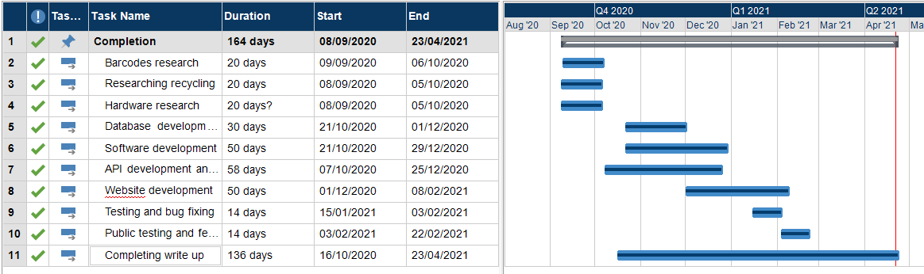

Appendix C SQL
SQL statements to build recycling database.

-- Switch to your database
USE `recycling databse`;

create table userdetails (
userId varchar(30),

userName varchar(30),
primary key(userId)
);

create table CategoryT(
category int AUTO_INCREMENT,
categoryDesc varchar(100),
material varchar(300),
recyclable BIT,
PRIMARY KEY(category)
);
create table BinLocation(
locationId int AUTO_INCREMENT,
typeOfBin varchar(30),
areaForNonRecycle varchar(250),
PRIMARY key (locationId);
create table Product (
barcodeUpc varchar(13),
category int,
productDescription varchar(200),
locationId int,
PRIMARY KEY (barcodeUpc),
FOREIGN KEY(category) references CategoryT (category),
FOREIGN key(locationId) references BinLocation (locationId)
);

create table webDetails(
scannedId int AUTO_INCREMENT,
barcodeUpc varchar(13),
userId varchar(30),
PRIMARY KEY(scannedId),
FOREIGN KEY(barcodeUpc) REFERENCES Product(barcodeUpc),
FOREIGN KEY(userId) REFERENCES userDetails(userId)
);

create table scannedRefrence(
scannedId int AUTO_INCREMENT,
barcodeUPc varchar(13),
scannedDate datetime,
PRIMARY KEY(scannedId),
FOREIGN KEY (barcodeUpc) references Product(barcodeUpc)
);

Appendix D main web page

Code for the main page of the website
<html>
<head>

<link rel="stylesheet" href="assest/bootstrap-4.3.1-dist/css/bootstrap.min.css"/>
<link rel="stylesheet" href="assest/StyleSheet.css"/>
<meta name="viewport" content="width=device-width, initial-scale=1"/>
</head>
<button class="open-button" onclick="openForm()">admin</button>

<div class="form-popup" id="myForm">
<form action="login.php" method="post" class="form-container">
<h1>Login</h1>

<label for="un"><b>username</b></label>
<input type="text" placeholder="username" name="un" required>

<label for="ps"><b>Password</b></label>
<input type="password" placeholder="Enter Password" name="pw" required>

<button type="submit" class="btn">Login</button>
<button type="button" class="btn cancel" onclick="closeForm()">Close</button>
</form>
</div>
<body id= "backimage">
<div class="row">
<div class="column">
<img id ="3bins"src="assest/images/recycling-2.jpg" alt="3bins" width="300" height="180">
</div>
<div class="column">
<img id ="hands"src="assest/images/recyclinghands.jpg" alt="3bins" width="300" height="180">
</div>
<div class="column">
<img id ="swan"src="assest/images/swanrecycle2.jpg" alt="3bins" width="300" height="180">
<br><br>

</div>
</div>
<br><br><br>
<div id="welcome">
<h1>making recycling easier</h1>
<p id="intro">welcome to recycling made easy here you can scan the barcode of your product and it will tell you what and what not is recyclable </p>
<p id="intro">to use the barcode scanner press the yellow button on the top of the scanner and hold 10cm away from the product.</p>
<p id="intro">if the product your looking for has a damaged barcode you can search the product by name in the second search bar</p>
</div>

<br><br><br><Br>
<div class="row" id="searchbars">

<div class ="container">
<div class= "center">
<form action="database.php" method="POST">
<div class="column">
<div id="barcodeSearch" style="font-family:verdana">
Scan barcode: <input name="myInput" id="myInput"></div>
</form>
<br><br>
<form action="searchbyproduct.php" method="POST">
<label for="productsearch" style="font-family:verdana">search product name:</label>
<input type ="text" id="searchinput" name ="searchinput">
<input type="submit" value="Submit">
</div>
</form>
</div>
</div>
</div>
<div>
</div>
</div>
</div>
</body>
<script>
function openForm() {
document.getElementById("myForm").style.display = "block";
}
function closeForm() {
document.getElementById("myForm").style.display = "none";
}
</script>
<!-- JS -->
<script src="https://code.jquery.com/jquery-3.3.1.slim.min.js" integrity="sha384-q8i/X+965DzO0rT7abK41JStQIAqVgRVzpbzo5smXKp4YfRvH+8abtTE1Pi6jizo" crossorigin="anonymous"></script>
<script src="https://cdnjs.cloudflare.com/ajax/libs/popper.js/1.14.7/umd/popper.min.js" integrity="sha384-UO2eT0CpHqdSJQ6hJty5KVphtPhzWj9WO1clHTMGa3JDZwrnQq4sF86dIHNDz0W1" crossorigin="anonymous"></script>

<script src="assest/bootstrap-4.3.1-dist/js/bootstrap.min.js"></script>
</html>

Appendix E admin login and logout

login
<?php
session_start();//session access
include "confinfo.php";
$username = $_POST["un"]; // gets passed to form in index.php
$Password = $_POST["pw"];
$sqlString="SELECT * FROM userdetails WHERE ((userName = '$username') AND (PASSWORD = '$Password'))";
$result = mysqli_query($link,$sqlString);
$numrows=mysqli_num_rows($result);
if ($numrows==1) // if user is indentified, they have access to the search page
{
$_SESSION["PASSWORD"]=$Password; header("location:adminform.php");
}
else
{header("location:website2.php");
// echo "Login Failed"}?>

Logout
<?session_start();//access session

$_SESSION["username"]="";

// ob_end_clean();
session_destroy();
header("location:website2.php");

?>

Appendix F Admin form
Below is the code for the admin form and each section to input data into the database.

Admin form
<?
session_start();
include "confinfo.php";
?>
<html>
<head>
<link rel="stylesheet" href="assest/StyleSheet.css">
<meta name="viewport" content="width=device-width, initial-scale=1">
</head>
Scan barcode:
<input id="myInput">
<div id="productForm">
<form action="inputproduct.php" method="POST">
<label for="upc">barcode:</label><br>
<input type="number" id="upc" name="upc"><br>
<label for= "productName">product:</label><br>
<input type="text" id="productName" name="productName"><br>
<label for= "description">description:</label><br>
<input type="text" id="description" name="description"><br>
<label for= "catagory">catagory:</label><br>
<input type="number" id="catagory" name="catagory"><br>
<label for= "locationid">locationid:</label><br>
<input type="number" id="locationid" name="locationid"><br>
<input type="submit" value="Submit">
</form>
</div>
<div id="categoryform">
<form action="inputcategory.php" method="post">
<label for= "catagoryDesc">category description:</label><br>
<input type="text" id="catagoryDesc" name="catagoryDesc"><br>
<label for= "material">material:</label><br>
<input type="text" id="material" name="material"><br>
<label for= "recycable">recycable:</label><br>
<input type="text" id="recycable" name="recycable"><br>
<input type="submit" value="Submit">
</form>
</div>
<div id="binlocationform">
<br>
<form action="inputbinlocation.php" method="post">
<label for= "typeofbin">typeofbin:</label><br>
<input type="text" id="typeofbin" name="typeofbin"><br>
<label for= "area">area for non recycling:</label><br>
<input type="text" id="area" name="area"><br>
<input type="submit" value="Submit">
</form>
</div>
</div>
<button>
<a href="logout.php"> LOGOUT</a> <!-- button to log out-->
</button>
</div>
</div>
</body>
<script>

theinput=document.getElementById("myInput")
theinput.addEventListener("keypress",function(){
if(event.keyCode==13)
{
callingapi();
}
});
function callingapi(){
const proxyurl = "https://cors-anywhere.herokuapp.com/"; // Use a proxy to avoid CORS error
const api_key = "27vynr21609nf18yhffrb2auudg5xw";
mybarcode=document.getElementById("myInput").value//get your bar code from input box

const url = proxyurl + "https://api.barcodelookup.com/v2/products?barcode="+mybarcode+"&formatted=y&key=" +api_key;
var xmlhttp = new XMLHttpRequest();

fetch(url)
.then(response => response.json())
.then((data) => {
document.getElementById("upc").value = (data.products[0].barcode_number);
document.getElementById("productName").value = (data.products[0].product_name);
document.getElementById("description").value = JSON.stringify(data, null,"<br/>");
})
.catch(err => {
throw err

});
}
</script>
</html>

Input product into database
<?
include "confinfo.php";
// product form variables
$upc = $_POST['upc'];
$productname= $_POST['productName'];
$description = $_POST['description'];
$catagory = $_POST['catagory'];
$locationid =$_POST['locationid'];
//binlocation form variable
//$typeofbin = $_POST['typeofbin'];
//$area = $_POST['area'];
$servername = "localhost";
$username = "root";
$password = "";
$dbname = "recyclingdatabase";
$conn = new mysqli($servername, $username, $password, $dbname);
if($conn -> connect_error)//check variable set
{ die("connection fail". conn_->connect_error);
}
$sql = "INSERT INTO product (barcodeUPc , category , productDescription, locationId, productName)
VALUES ('$upc', '$catagory','$description','$locationid','$productname')";
if ($conn->query($sql) ===TRUE)
{ echo "new record created successfully";
}
else{ echo "Error: " . $sql . "<br>" . $conn->error; }?>

input category into database
<
<!DOCTYPE html>
<html>
<head>
<body>
include "confinfo.php";
// catagory form variables
$catagoryDesc = $_POST['catagoryDesc'];
$material = $_POST['material'];
$recycable = $_POST['recycable'];
$servername = "localhost";
$username = "root";
$password = "";
$dbname = "recyclingdatabase";
$conn1 = new mysqli($servername, $username, $password, $dbname);
if($conn1 -> connect_error)//check variable set
{
die("connection fail". conn1_->connect_error);
}
$sql1 = "INSERT INTO categoryt (categoryDesc , material, recyclable)
VALUES ('$catagoryDesc','$material','$recycable')";
if ($conn1->query($sql1) ===TRUE)
{
echo "new record created successfully";
}
else{
echo "Error: " . $sql . "<br>" . $conn->error;
}
?>
<input type="button" value="back!" onclick="history.back(-1)" />
<?
$url = htmlspecialchars($_SERVER['HTTP_REFERER']);
echo "<a href='$url'>back</a>";
?>
</head>
</html>

Input bin location into database
</body>
<div>
<p>welcome to recyclable barcode test </p>
</div>
<div class=container>
<div id="searchwrapper">
<input type="text"
name="searchBar"
id="searchBar"
placeholder="search for a barcode"
autofocus/>
<?
include "confinfo.php";
// catagory form variables
$catagoryDesc = $_POST['catagoryDesc'];
$material = $_POST['material'];
$recycable = $_POST['recycable'];
$servername = "localhost";
$username = "root";
$password = "";
$dbname = "recyclingdatabase";
$conn1 = new mysqli($servername, $username, $password, $dbname);
if($conn1 -> connect_error)//check variable set
{ die("connection fail". conn1_->connect_error);
} $sql1 = "INSERT INTO categoryt (categoryDesc , material, recyclable)
VALUES ('$catagoryDesc','$material','$recycable')";
if ($conn1->query($sql1) ===TRUE)
{ echo "new record created successfully"; }

else{
echo "Error: " . $sql . "<br>" . $conn->error;
}
?>
<input type="button" value="back!" onclick="history.back(-1)" />
<?
$url = htmlspecialchars($_SERVER['HTTP_REFERER']);
echo "<a href='$url'>back</a>";
?>
</head>
</html>

Appendix G connecting database and website
<?
$strServer="localhost";//server name (doesn't change)
$strUser="root"; //server username (same)
$strPassword=""; //server password "" on xampp
$strDatabase="recyclingdatabase";

$link=mysqli_connect($strServer,$strUser,$strPassword,$strDatabase);
?>

Appendix H user form and input

User form
<?
session_start();
include "confinfo.php";
?>
<html>
<head>
<link rel="stylesheet" href="assest/bootstrap-4.3.1-dist/css/bootstrap.min.css"/>
<link rel="stylesheet" href="assest/StyleSheet.css"/>
<meta name="viewport" content="width=device-width, initial-scale=1"/>
</head>
<body id= "backimage">
<div class="row">
<div class="column">
<img id ="3bins"src="assest/images/recycling-2.jpg" alt="3bins" width="300" height="180">
</div>
<div class="column">
<img id ="hands"src="assest/images/recyclinghands.jpg" alt="3bins" width="300" height="180">
</div>
<div class="column">
<img id ="swan"src="assest/images/swanrecycle2.jpg" alt="3bins" width="300" height="180">
<br><br>

</div>
</div>
<br><br><br>
<div id="welcome">
<h1>making recycling easier</h1>
<p id="intro">sorry for the incovenence your product isn't in the database if you could please enter the barcode and product name and we will look into it and update the databse soon this will be a great help to improve the apllication </p>
</div>
<br><br><br><Br>
<div class="row" id="searchbars">
<div class ="container">
<div class= "center">
<form action="userinput.php" method="POST">
<label for= "barcode">barcode:</label><br>
<input type="text" id="barcode" name="barcode"><br>
<label for= "productName">product name:</label><br>
<input type="text" id="productName" name="productName"><br>
<input type="submit" value="Submit">
</form>
</div>
<div class ="row" id="backbutton">
<button class="btn btn-dark">
<p id= "backtowebsite2"> search another item </P>
<a href="website2.php"> click here</a> <!-- button to log out-->
</button>
</div>
</div>
</div>
<div>
</div>
</div>
</div>
</body>
<script src="https://code.jquery.com/jquery-3.3.1.slim.min.js" integrity="sha384-q8i/X+965DzO0rT7abK41JStQIAqVgRVzpbzo5smXKp4YfRvH+8abtTE1Pi6jizo" crossorigin="anonymous"></script>
<script src="https://cdnjs.cloudflare.com/ajax/libs/popper.js/1.14.7/umd/popper.min.js" integrity="sha384-UO2eT0CpHqdSJQ6hJty5KVphtPhzWj9WO1clHTMGa3JDZwrnQq4sF86dIHNDz0W1" crossorigin="anonymous"></script>
<script src="assest/bootstrap-4.3.1-dist/js/bootstrap.min.js"></script>
</html>
user input form to database
<?

include "confinfo.php";
// product form variables
$upc = $_POST['barcode'];
$productname= $_POST['productName'];
$servername = "localhost";
$username = "root";
$password = "";
$dbname = "recyclingdatabase";
$conn = new mysqli($servername, $username, $password, $dbname);
if($conn -> connect_error)//check variable set
{ die("connection fail". conn_->connect_error);
}
$sql = "INSERT INTO userinput (barcode , productInput)
VALUES ('$upc','$productname')";
if ($conn->query($sql) ===TRUE)
{
echo "new record created successfully";
header("location: website2.php");
}
else{
echo "Error: " . $sql . "<br>" . $conn->error;
}
?>

Appendix I display data

Displaying search by product name
<?
session_start();
include "confinfo.php";
?>

<html>

<head>

<link rel="stylesheet" href="assest/bootstrap-4.3.1-dist/css/bootstrap.min.css"/>
<link rel="stylesheet" href="assest/StyleSheet.css"/>
<meta name="viewport" content="width=device-width, initial-scale=1"/>
</head>

<body id= "backimage">
<div class="row">
<div class="column">
<img id ="3bins"src="assest/images/recycling-2.jpg" alt="3bins" width="300" height="180">
</div>
<div class="column">
<img id ="hands"src="assest/images/recyclinghands.jpg" alt="3bins" width="300" height="180">
</div>
<div class="column">
<img id ="swan"src="assest/images/swanrecycle2.jpg" alt="3bins" width="300" height="180">

</div>
</div>
<div id="welcome">
<h1>making recycling easier</h1>
<p id="intro">welcome to recycling made easy here you can scan the barcode of your product and it will tell you what and what not is recyclable </p>
</div>
<div class ="row" id="backbutton">
<button class="btn btn-dark">
<p id= "backtowebsite2"> search another item </P>
<a href="website2.php"> click here</a> <!-- button to log out-->
</button>
</div>
<?
$searchinput =$_POST['searchinput'];
$sql1= "select * from product,categoryt,binlocation where ((productName = '$searchinput') and (product.category=categoryt.category) and (product.locationId=binlocation.locationId))";

$result = mysqli_query($link,$sql1);
$queryResult = mysqli_num_rows($result);
$rowCounter = mysqli_num_rows($result);
echo "<br>";
echo "<br>";
$pink = 1;
$greenBag = 2;
$blackBag =3;
?>
<div class="center">
<table class="table table-dark ">
<thead>
<tr>
<th scope="col">product description</th>
<th scope="col">product name</th>
<th scope ="col">category describtion</th>
<th scope="col">bin location</th>
<th scope="col">bin image</th>
</tr>
</thead>
</div>
<?
if ($rowCounter== 0){
header("location:userform.php");
}
if ($queryResult = $searchinput) // displays information
{
while ($row = mysqli_fetch_assoc($result))
{
?>
<tr>
<td><?echo $row["productDescription"];?></td>
<td><?echo $row["productName"];?></td>
<td><? echo $row["categoryDesc"];?></td>
<td><?echo $row["typeOfBin"];?></td>
<td><?
if ($pink == $row["locationId"]){
echo '<img id ="pink2"src="assest/images/pink2.jpg" alt="pink2" width="300" height="180">';
}
if($greenBag == $row["locationId"]) {
echo '<img id ="green"src="assest/images/greenbag.jpg" alt="green" width="300" height="180">';
}
if($blackBag == $row["locationId"]) {
echo '<img id ="black"src="assest/images/download.jfif" alt="black" width="300" height="180">';
}
?>
</td>
</tr>
<?
}
}
?>
</table>
</div>
</div>
</body>
<script src="https://code.jquery.com/jquery-3.3.1.slim.min.js" integrity="sha384-q8i/X+965DzO0rT7abK41JStQIAqVgRVzpbzo5smXKp4YfRvH+8abtTE1Pi6jizo" crossorigin="anonymous"></script>
<script src="https://cdnjs.cloudflare.com/ajax/libs/popper.js/1.14.7/umd/popper.min.js" integrity="sha384-UO2eT0CpHqdSJQ6hJty5KVphtPhzWj9WO1clHTMGa3JDZwrnQq4sF86dIHNDz0W1" crossorigin="anonymous"></script>

<script src="assest/bootstrap-4.3.1-dist/js/bootstrap.min.js"></script>
</html>

Display data by barcode

<?
session_start();
include "confinfo.php";
?>

<html>
<head>
<link rel="stylesheet" href="assest/bootstrap-4.3.1-dist/css/bootstrap.min.css"/>
<link rel="stylesheet" href="assest/StyleSheet.css"/>
<meta name="viewport" content="width=device-width, initial-scale=1"/>
</head>
<body id= "backimage">
<div class="row">
<div class="column">
<img id ="3bins"src="assest/images/recycling-2.jpg" alt="3bins" width="300" height="180">
</div>
<div class="column">
<img id ="hands"src="assest/images/recyclinghands.jpg" alt="3bins" width="300" height="180">
</div>
<div class="column">
<img id ="swan"src="assest/images/swanrecycle2.jpg" alt="3bins" width="300" height="180">
</div>
</div>
<div id="welcome">
<h1>making recycling easier</h1>
<p id="intro">welcome to recycling made easy here you can scan the barcode of your product and it will tell you what and what not is recyclable </p>
</div>
<div class ="row" id="backbutton">
<button class="btn btn-dark">
<p id= "backtowebsite2"> search another item </P>
<a href="website2.php"> click here</a> <!-- button to log out-->
</button>
</div>
<?
$myInput =$_POST['myInput'];
$sql= "select * from product,categoryt,binlocation where ((barcodeUpc = '$myInput') and (product.category=categoryt.category) and (product.locationId=binlocation.locationId))";

$result = mysqli_query($link,$sql);
$queryResult = mysqli_num_rows($result);
$rowCounter = mysqli_num_rows($result);
$pink = 1;
$greenBag = 2;
$blackBag =3;
if ($rowCounter== 0){
header("location:userform.php");
}
if ($queryResult = $myInput) // displays information
{
while ($row = mysqli_fetch_assoc($result))
{
?>
<div class="center">
<table class="table table-dark ">
<thead>
<tr>
<th scope="col">product name</th>
<th scope="col">product description</th>
<th scope="col">bin location</th>
<th scope="col">bin image</th>
</tr>
</thead>
</div>
<tr>
<td><? echo $row ["productName"];?></td>
<td><?echo $row["productDescription"];?></td>
<td><?echo $row["typeOfBin"];?></td>
<td><?
if ($pink == $row["locationId"]){
echo'<img id ="pink2"src="assest/images/pink2.jpg" alt="pink2" width="300" height="180">';
}
if($greenBag == $row["locationId"]) {
echo '<img id ="green"src="assest/images/greenbag.jpg" alt="green" width="300" height="180">';
}
if($blackBag == $row["locationId"]) {
echo '<img id ="black"src="assest/images/download.jfif" alt="black" width="300" height="180">';
}
?>
</td>
</tr>
<?
$locationid = $row["locationId"];
?>
<?
}
}
?>
</div>
</div>

</body>
<script src="https://code.jquery.com/jquery-3.3.1.slim.min.js" integrity="sha384-q8i/X+965DzO0rT7abK41JStQIAqVgRVzpbzo5smXKp4YfRvH+8abtTE1Pi6jizo" crossorigin="anonymous"></script>
<script src="https://cdnjs.cloudflare.com/ajax/libs/popper.js/1.14.7/umd/popper.min.js" integrity="sha384-UO2eT0CpHqdSJQ6hJty5KVphtPhzWj9WO1clHTMGa3JDZwrnQq4sF86dIHNDz0W1" crossorigin="anonymous"></script>

<script src="assest/bootstrap-4.3.1-dist/js/bootstrap.min.js"></script>
</html>

