PRACTICAL ASSESSMENT 2019/2020 Answer Sheet

SCHOOL OF ENGINEERING

NAME OF COURSE/PROGRAMME: | BEng Motorcycle Engineering
YEAR OR LEVEL: | Year 1
NAME OF MODULE/UNIT/ASSESSMENT PAPER: | Motorcycle Technology
MODULE NO: | M4X00392
DATE OF ASSESSMENT: | 28th April 2020
START TIME: | 09.00
FINISH TIME: | 11.30
TIME ALLOWED: | 2.5 hours

INSTRUCTIONS TO CANDIDATES:

Answer all questions.

Use the data set provided to answer all questions.

You can use screen shots of the data to help with your answers.

QUESTION ONE
B
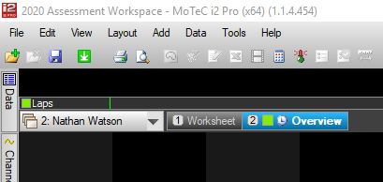
Right click new workbook – name, right click new workspace – name.

B
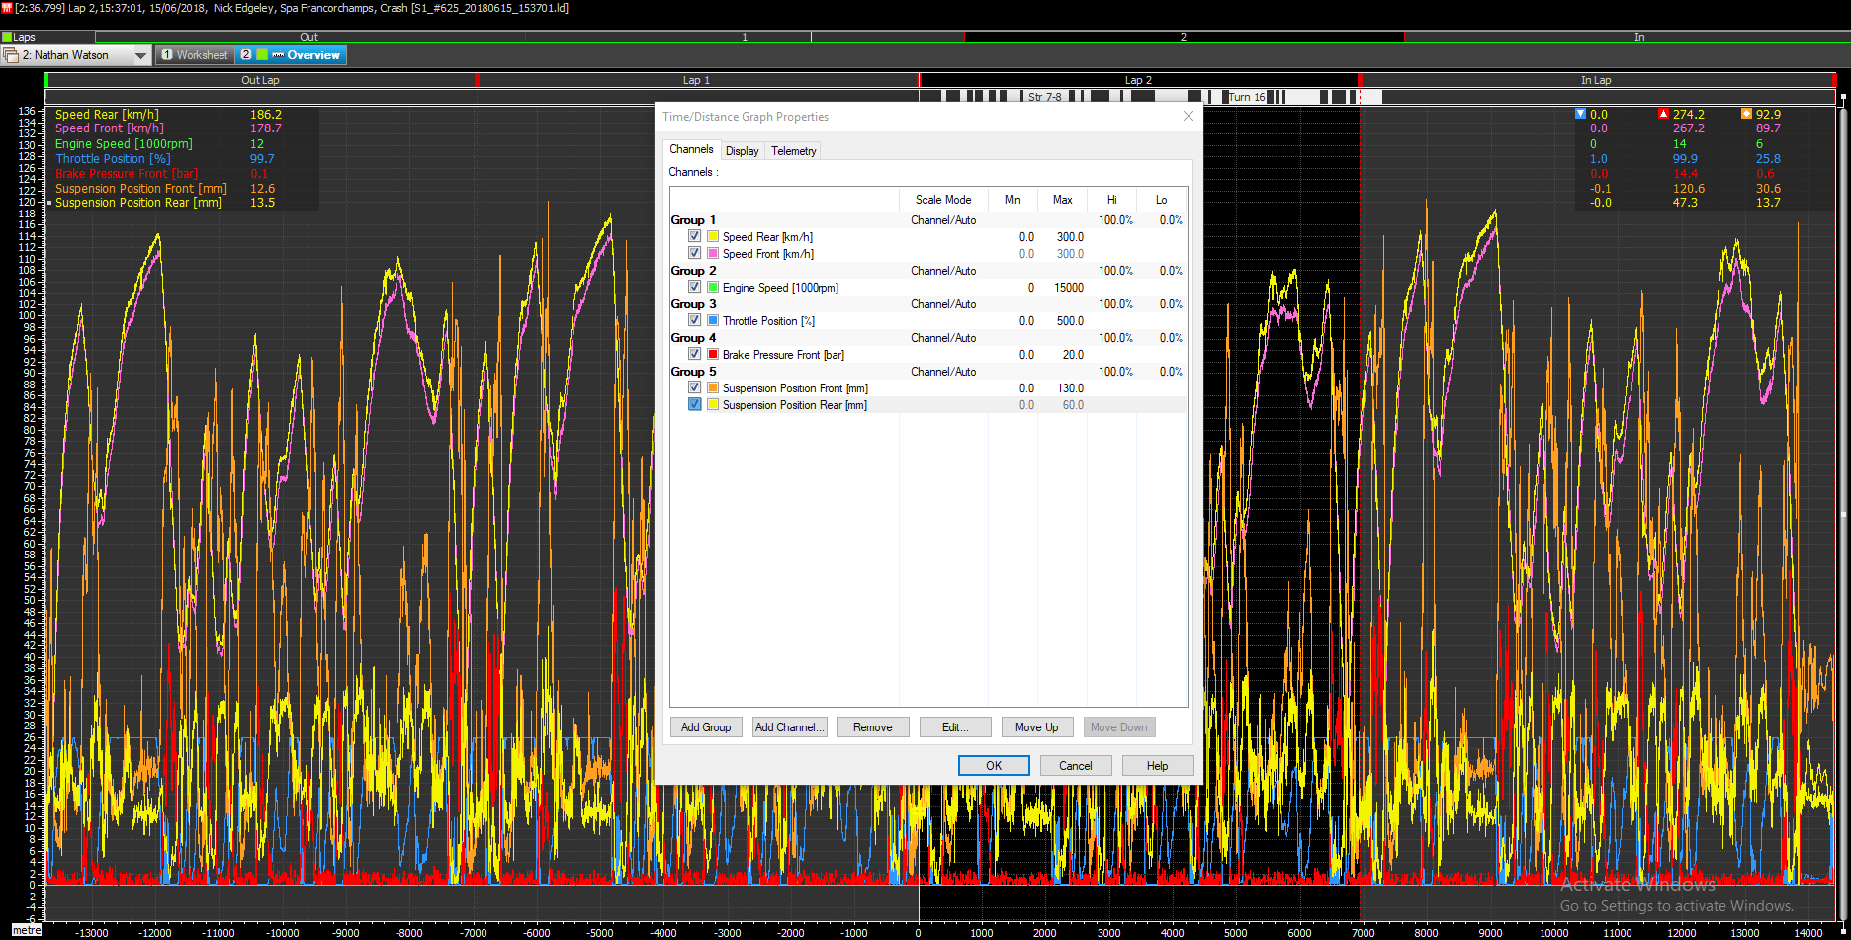
Used M function and zoom out to find maximum values over all data and set limits accordingly.

C
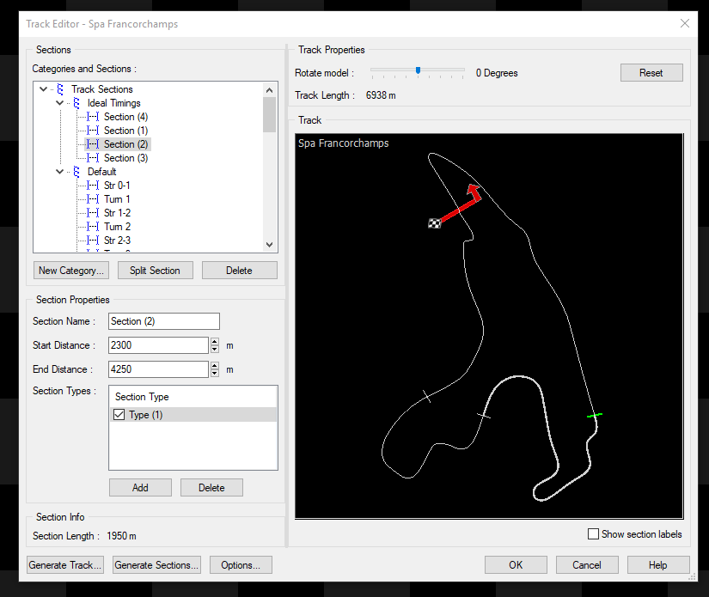
Track Editor > New category > split sections
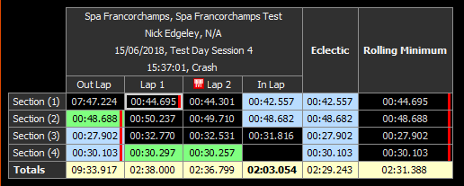
Time Graph > Ideal timings

QUESTION TWO
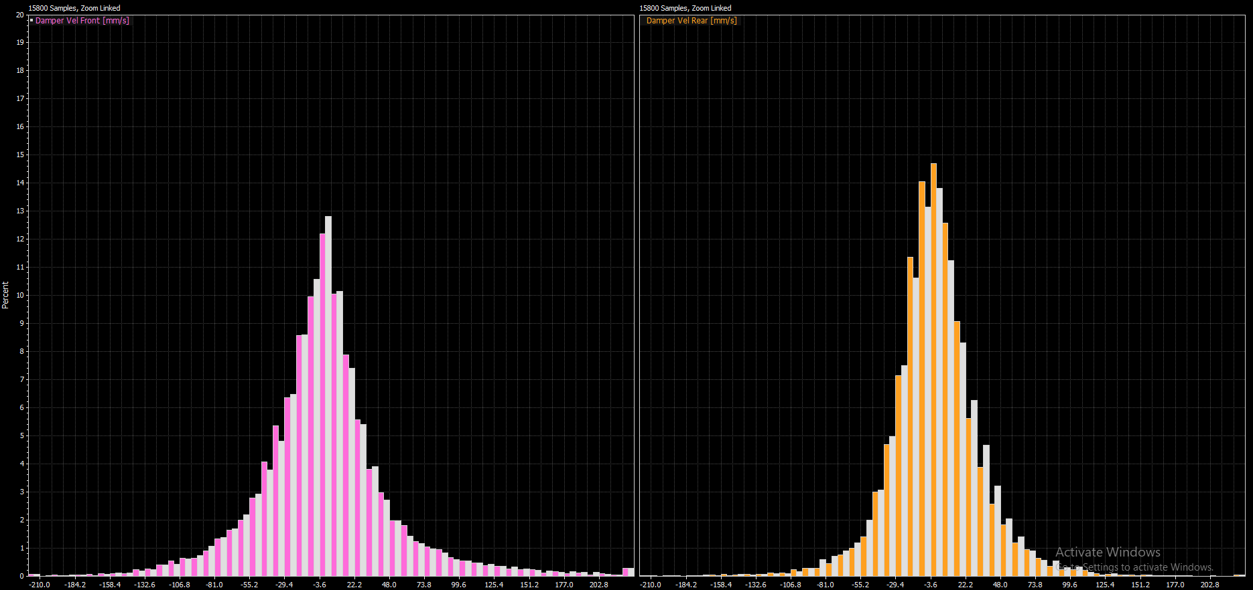
These histograms can be used to check bump and rebound of suspension across the laps by using the distance travelled +/-.
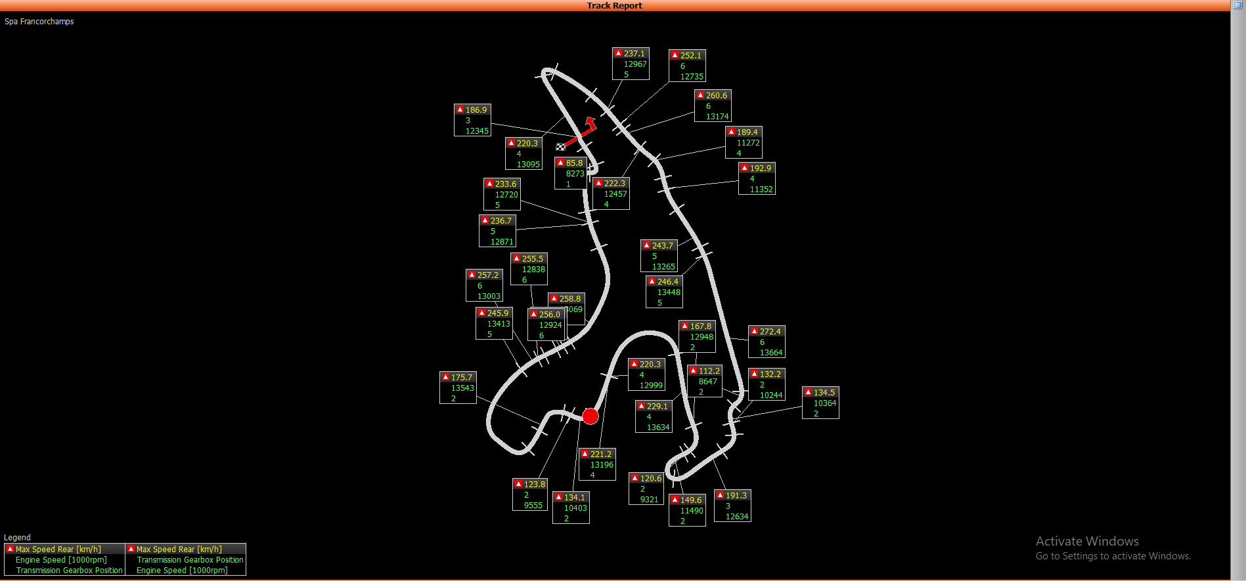
Track report shows gear pos, max speed on straights, min speed on corners as well as rpm. This can be used to check if the gearing of the bike is correct.
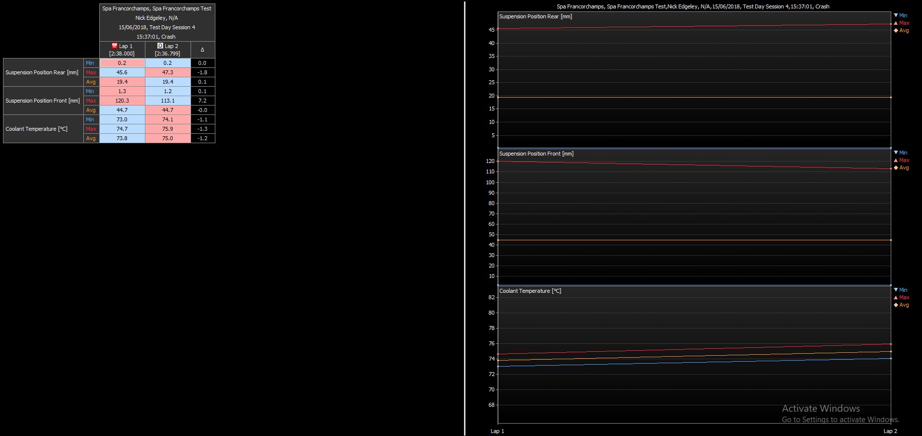
This report can show clear comparisons of data Min/Max/Avg over compared laps. This can be useful to check running conditions such as engine temp, or to check suspension settings e.g. is the suspension using the full range of travel it can be.

QUESTION THREE
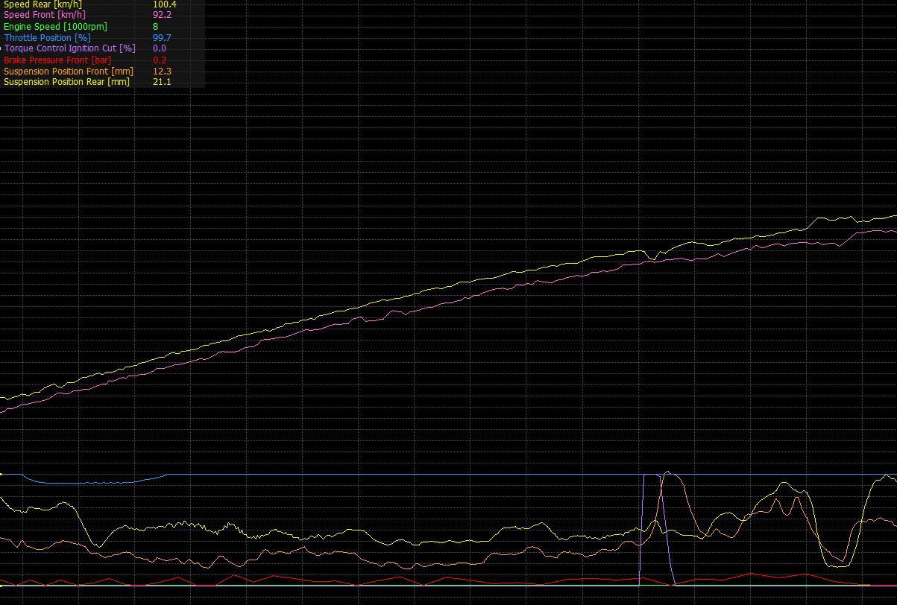
Throttle 100%, torque ignition cut, slight drop in rear wheel speed and drop in front suspension extension are signs of TC kicking in.
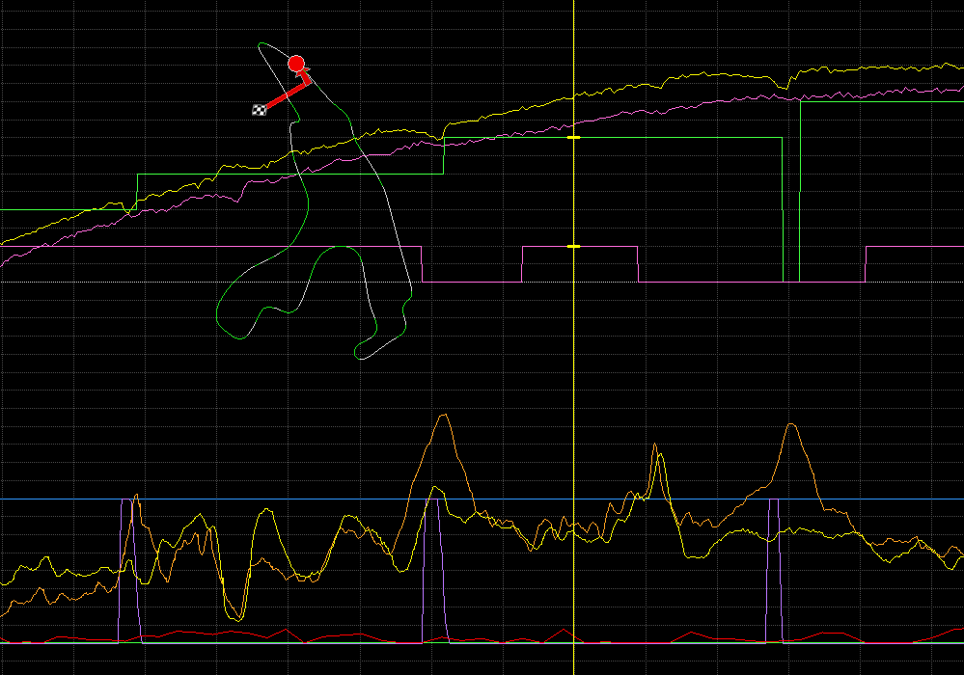
Exit of sharp corner onto straight, low gear, 100% throttle, suspension travel is regulated between ignition cuts and acceleration is positive. You can see where the anti wheelie turns off by the sharp increases in suspension travel. This was confirmed using anti wheel status channel.
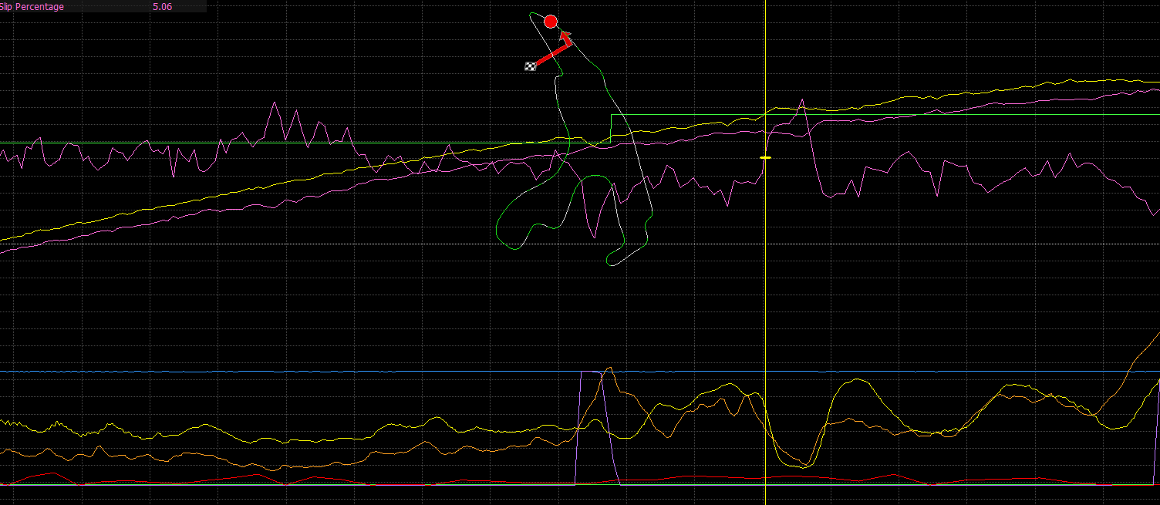
I think TC is activated at around 5% slip.

QUESTION FOUR
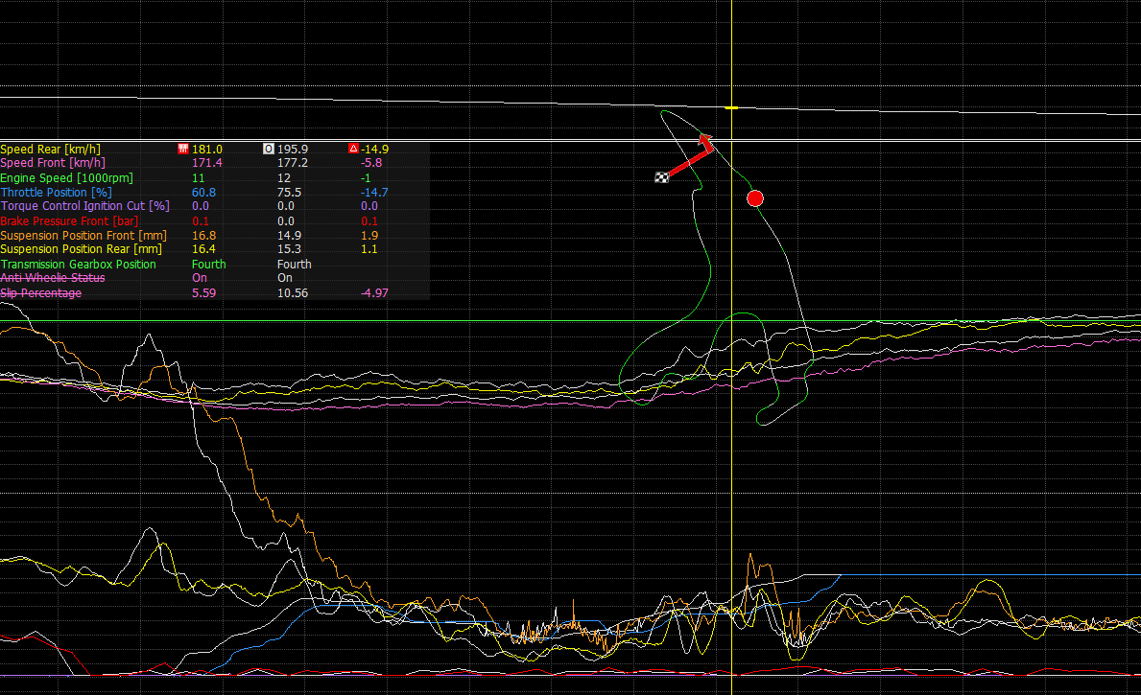
Lap 5 off brakes earlier at the corner and on throttle quicker. By end of straight he is 4 tenths faster.
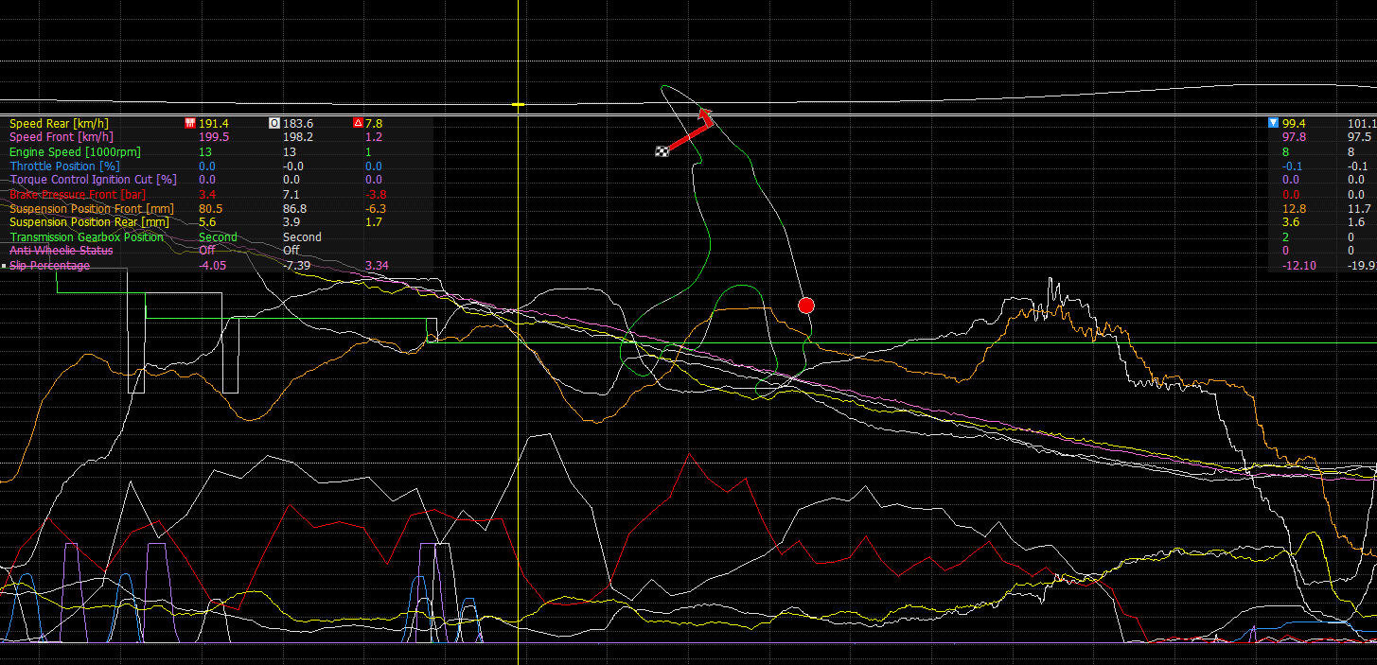
He then loses 2 tenths by braking early.

QUESTION FIVE
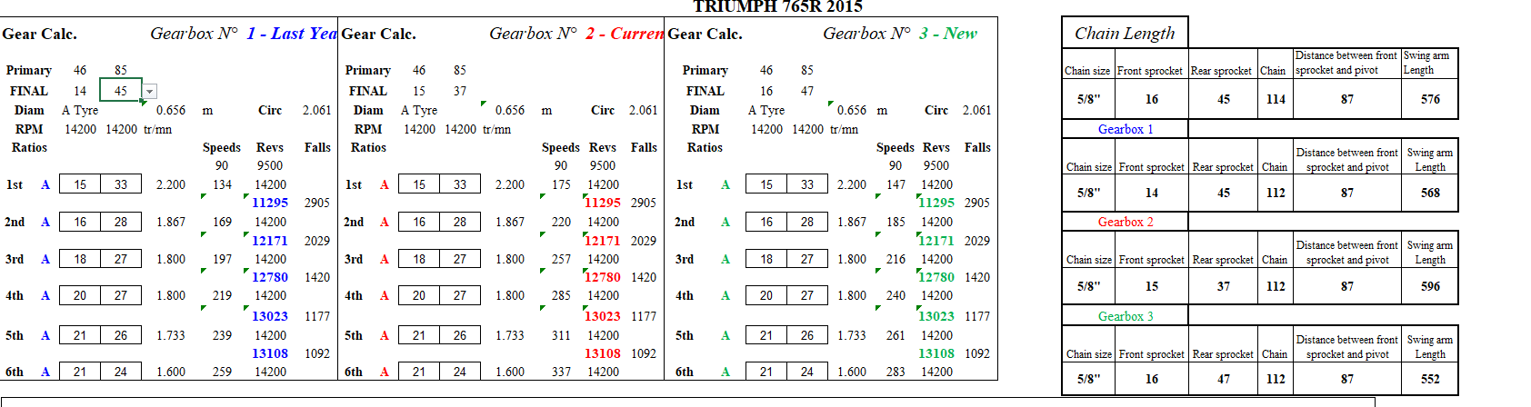
14 front 47 rear sprocket sizes with an A type tyre give a 112 link 5/8” chain 568mm swingarm length.
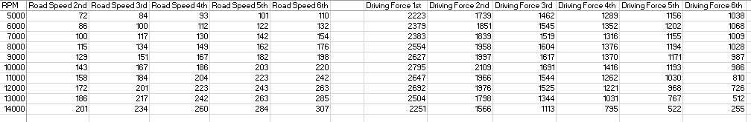
1st gear, 10k rpm has a driving force of 2795


