

POPULATION HEALTH AND DIGITAL HEALTH PROMOTION
Name :Krish Patel
Student id : 2426744
Module Name: Population health and digital health promotion
Module code:LCHS7009
Professor Name: Dr Besty Jose

Table of Contents
Blog 1 3
References 6
Blog 2 8
References 11

Blog 1
The impact of NHS Digital Weight Management Programme on accessing Global Obesity
Obesity: A Continuous Health Crisis in the World
One of the most significant concerns about the problem of the population health and in the United Kingdom is obesity. According to the estimates made by the World Health Organisation (2025), it is estimated that over a billion people in the world have obesity. In the UK, overweight and obese adults constitute 63% of the adult population based on the reports by the NHS England (NHS, 2020). Furthermore, according to government statistics, obesity is a contributor to over 30,000 deaths annually in England, as well as high risk of cardiovascular diseases, type 2 diabetes, stroke, and cancers (Public Health England, 2019; Pringle, 2021; NHS, 2023).
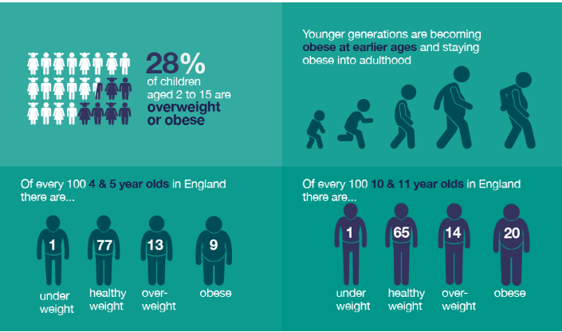
Figure 1: statistics on obesity
(Source: Public Health England, 2019)
Unless the rate of obesity decreases in the UK and by 2050, the amount of healthcare expenditure in the UK is estimated to be more than £9.7 billion per year (Holmes, 2021). An increase in cases also exerts stress on NHS services and extends waiting times and lowers the workforce productivity.
Obesity Prevention NHS Digital Technology
In response to this crisis, NHS England has introduced the NHS Digital Weight Management Programme that contains approved mHealth applications and programme such as NHS digital weight management to change behaviour (NHS England, 2021).
These apps utilise:
- Database of calories and macronutrients.
- Connection of wearable devices.
- Feedback systems, which are personalised.
NHS Programme: www.england.nhs.uk/digital-weight-management
The way NHS Digital Weight Management Programme contributes to Digital Health Promotion
The NHS Digital Weight Management Programme is a digital health intervention approved by the NHS and the one that is intended to help adults living with obesity or other health issues. The programme by NHS England offers remote support in behavioural weight management by using smartphone applications, online portals and virtual coaching services.
The programme allows users to:
- Monitor diet, calories consumed and exercise using digital devices.
- Provide remote assistance of trained health coaches.
Evidence of Effectiveness
It has been found out that weight-management programmes that are conducted digitally can be highly useful in influencing behavioural change and weight loss. Obesity Reviews published a systematic review that discovered that weight reduction was statistically significant using digital behavioural interventions delivered by mobile applications and online platforms (Pujia et al. 2025). Similarly, Antoun et al. (2022) have found out that continuous digital tracking of both diet and physical activity can enhance adherence to weight-loss programmes and provide a long-term lifestyle change.
Critical Impact Analysis
Benefits
Accessibility: The programme enables people to receive weight-management services remotely with the use of smartphones or computers, which boosts the participation in the UK.
Personalisation: The customers get customised dietary and lifestyle plans depending on their health information and personal objectives.
Disadvantages
Issues with data privacy: Digital health platforms store sensitive health data, which, in case of data breach, may severely impact the privacy of users.
Digital divide: A certain population can be limited by a lack of digital literacy, access to the internet, or even having a smartphone.
Addressing the Limitations
The use of digital interventions alongside primary healthcare services should be considered to improve the effectiveness of the programme and allow the healthcare professional to better monitor the progress and offer more instructions.
Conclusion
The NHS-approved digital technologies, including the NHS Digital Weight Management Programme, exhibit a quantifiable aspect to combat obesity by means of behaviour-change interventions and remote health.

References
Antoun, J., Itani, H., Alarab, N. and Elsehmawy, A., 2022. The effectiveness of combining nonmobile interventions with the use of smartphone apps with various features for weight loss: systematic review and meta-analysis. JMIR mHealth and uHealth, 10(4), p.e35479.https://doi.org/10.2196/35479
Holmes, J., 2021. Tackling Obesity: The Role Of The NHS In A Whole-system Approach. [online] The King’s Fund. Available at: https://www.kingsfund.org.uk/insight-and-analysis/reports/tackling-obesity-nhs.
NHS Digital., 2020. Adult Overweight and Obesity. [online] NHS Digital. Available at: https://digital.nhs.uk/data-and-information/publications/statistical/statistics-on-obesity-physical-activity-and-diet/england-2020/part-3-adult-obesity-copy.
NHS England., 2021. NHS England» Digital Weight Management Programme. [online] England.nhs.uk. Available at: https://www.england.nhs.uk/ourwork/prevention/obesity/digital-weight-management-programme/.
NHS., 2023. Obesity. [online] NHS. Available at: https://www.nhs.uk/conditions/obesity/.
Pringle, P., 2021. Around 31,000 heart and circulatory deaths attributed to excess weight and obesity every year. [online] British Heart Foundation. Available at: https://www.bhf.org.uk/what-we-do/news-from-the-bhf/news-archive/2021/april/31000-heart-and-circulatory-deaths-obesity-each-year.
Public Health England., 2019. Health matters: Obesity and the Food Environment. [online] GOV.UK. Available at: https://www.gov.uk/government/publications/health-matters-obesity-and-the-food-environment/health-matters-obesity-and-the-food-environment--2.
Pujia, C., Ferro, Y., Mazza, E., Maurotti, S., Montalcini, T. and Pujia, A., 2025. The role of mobile apps in obesity management: systematic review and meta-analysis. Journal of medical Internet research, 27, p.e66887.https://doi.org/10.2196/66887
World Health Organization., 2025. Obesity and Overweight. [online] World Health Organization. Available at: https://www.who.int/news-room/fact-sheets/detail/obesity-and-overweight.

Blog 2
Designing ‘DiWell AI’: A Smart Digital Solution for Diabetes Prevention and Management
Diabetes: An Emergent Worldwide Crisis.
Diabetes is considered to be one of the most rapidly spreading chronic diseases in the world (Hossain et al. 2024; Liu et al. 2022). The International Diabetes Federation (2023) estimates that currently 589 million adults have diabetes, and this number is expected to grow to 643 million by 2030 (International Diabetes Federation, 2025). In the UK, a population of about 4.3 million has been diagnosed with diabetes, out of which type 2 diabetes is found in about 90% of cases (Diabetes UK, 2023). This rising prevalence is imposing a high economic burden on the NHS since almost 10 billion of the budgets is spent on diabetes-related treatment (NHS England, 2024; Gregory, 2023).
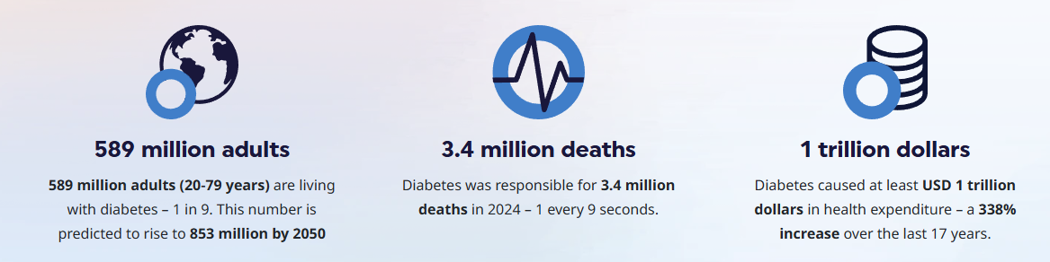
Figure 1: World Diabetes Prevalence.
(Source: International Diabetes Federation, 2025)
Prevalence of diabetes is increasing at a quicker rate in the low- and middle-income nations including India and China where urbanisation and lifestyle shift form a significant part of the disease burden (Mohan, 2025). The UK has a higher rate of diabetes associated with obesity than most European countries, which is why the implementation of preventive digital strategies is much needed (Thorlu-Bangura et al. 2023; Diamantis et al. 2022).

Introducing “DiWell AI”: An Innovative Digital Health Intervention
The difference between DiWell AI lies in having predictive artificial intelligence modelling, combined with real-time behavioural coaching and clinician supervision in a single platform. In contrast to traditional tracking applications, it shifts to a response-monitoring to a risk-prevention strategy (Menon et al. 2023). DiWell AI is combined with:
- One day, CGM device synchronisation.
- Hypo- and hyperglycaemia predictive analytics AI.
- Individualised dieting and exercise prescriptions (Eguia et al. 2024).
- Chatbot with NLP-enhanced support of instant guidance (Sah et al. 2025).
- Assure telehealth access to medical staff.
How DiWell AI Proposal helps to Promote Health.
The majority of currently existing diabetes applications pay more attention to glucose logging, but DiWell AI implements machine learning algorithms to predict glucose changes even before they happen (Pullano et al. 2022). Having a human-in-the-loop telehealth system will help to make the AI-generated recommendations clinically validated (Bakken, 2023).
Critical Impact Analysis
Advantages
- Personal and foreseeable care.
- Early detection of risks and preventing complications (Jansen et al. 2024).
- Reduction in hospitalisation and medical spending.
- Always in contact with smart notifications.
Disadvantages
- The issue of digital literacy is particularly widespread among the elderly (Vercruyssen et al. 2023).
- Problems of data security and privacy.
- Risk of over-reliance on robotic AI suggestions.
- Costs of integrating the wearable gadgets.
Addressing the Limitations
In order to enhance accessibility, DiWell AI would include simplified navigation, multilingual support and tutorial guidance. Security would be increased by strong encryption and adherence to international health data standards.
Conclusion
DiWell AI provides a progressive online health promotion platform for diabetes management. Although there are limitations, AI innovation and professional oversight can be a considerably strong measure to preventive healthcare implementation and enhance long-term outcomes on a population level.

References
Bakken, S., 2023. AI in health: keeping the human in the loop. Journal of the American Medical Informatics Association, 30(7), pp.1225-1226. https://doi.org/10.1093/jamia/ocad091
Diabetes UK., 2023. Number of people living with diabetes in the UK tops 5 million for the first time. [online] Diabetes UK. Available at: https://www.diabetes.org.uk/about-us/news-and-views/number-people-living-diabetes-uk-tops-5-million-first-time.
Diamantis, D.V., Karatzi, K., Kantaras, P., Liatis, S., Iotova, V., Bazdraska, Y., Tankova, T., Cardon, G., Wikström, K., Rurik, I. and Antal, E., 2022. Prevalence and socioeconomic correlates of adult obesity in Europe: the Feel4Diabetes study. International journal of environmental research and public health, 19(19), p.12572.https://doi.org/10.3390/ijerph191912572
Eguia, H., Sánchez-Bocanegra, C.L., Vinciarelli, F., Alvarez-Lopez, F. and Saigí-Rubió, F., 2024. Clinical decision support and natural language processing in medicine: systematic literature review. Journal of Medical Internet Research, 26, p.e55315.https://doi.org/10.2196/55315
Gregory, A. (2023). UK in ‘rapidly escalating’ diabetes crisis as cases top 5m, report says. The Guardian. [online] 12 Apr. Available at: https://www.theguardian.com/society/2023/apr/13/uk-in-rapidly-escalating-diabetes-crisis-as-cases-top-5m-report-says.
Hossain, M.J., Al‐Mamun, M. and Islam, M.R., 2024. Diabetes mellitus, the fastest growing global public health concern: Early detection should be focused. Health science reports, 7(3), p.e2004.https://doi.org/10.1002/hsr2.2004
International Diabetes Federation., 2025. Diabetes around the World in 2025. [online] IDF Diabetes Atlas. Available at: https://diabetesatlas.org/.
Jansen, S.N., Kamphorst, B.A., Mulder, B.C., van Kamp, I., Boekhold, S., van den Hazel, P. and Verweij, M.F., 2024. Ethics of early detection of disease risk factors: A scoping review. BMC medical ethics, 25(1), p.25.https://doi.org/10.1186/s12910-024-01012-4
Liu, R., Li, L., Shao, C., Cai, H. and Wang, Z., 2022. The impact of diabetes on vascular disease: progress from the perspective of epidemics and treatments. Journal of diabetes research, 2022(1), p.1531289.https://doi.org/10.1155/2022/1531289
Menon, S.P., Shukla, P.K., Sethi, P., Alasiry, A., Marzougui, M., Alouane, M.T.H. and Khan, A.A., 2023. An intelligent diabetic patient tracking system based on machine learning for E-health applications. Sensors, 23(6), p.3004. https://doi.org/10.3390/s23063004
‌Mohan, V., 2025. Lessons learned from epidemiology of type 2 diabetes in South Asians: Kelly West Award Lecture 2024. Diabetes Care, 48(2), pp.153-163. https://doi.org/10.2337/dci24-0046
NHS England., 2024. NHS Identifies over Half a Million More People at Risk of Type 2 Diabetes in a Year. [online] www.england.nhs.uk. Available at: https://www.england.nhs.uk/2024/06/nhs-identifies-over-half-a-million-more-people-at-risk-of-type-2-diabetes-in-a-year/.
Pullano, S.A., Greco, M., Bianco, M.G., Foti, D., Brunetti, A. and Fiorillo, A.S., 2022. Glucose biosensors in clinical practice: Principles, limits and perspectives of currently used devices. Theranostics, 12(2), p.493. doi: 10.7150/thno.64035
Sah, A.K., Elshaikh, R.H., Shalabi, M.G., Abbas, A.M., Prabhakar, P.K., Babker, A.M., Choudhary, R.K., Gaur, V., Choudhary, A.S. and Agarwal, S., 2025. Role of artificial intelligence and personalized medicine in enhancing HIV management and treatment outcomes. Life, 15(5), p.745.https://doi.org/10.3390/life15050745
Thorlu-Bangura, Z., Poole, L., Sood, H., Khan, N., Stevenson, F., Khunti, K., Gill, P., Sajid, M., Hanif, W., Bhala, N. and Modha, S., 2023. Digital health, cardiometabolic disease and ethnicity: an analysis of United Kingdom government policies from 2010 to 2022. Journal of public health policy, 44(2), p.179. https://doi.org/10.1057/s41271-023-00410-z
Vercruyssen, A., Schirmer, W., Geerts, N. and Mortelmans, D., 2023, September. How “basic” is basic digital literacy for older adults? Insights from digital skills instructors. In Frontiers in Education (Vol. 8, p. 1231701). Frontiers Media SA.https://doi.org/10.3389/feduc.2023.1231701

