

Task 3 – Reflective portfolio

STUDENT NAME: PETRU PARASCA
STUDENT ID: 2123010
MODULE: PROFESSIONAL AND CAREER DEVELOPMENT(BMSW4005_BIRM)
ASSIGNMENT: PORTFOLIO OF WORK; TASK 3
LECTURE NAME: Muhammad Islam

Table of Contents
INTRODUCTION 3
What is a reflection and what does it mean? 3
SWOT ANALYSIS 4
PERSONAL DEVELOPMENT PLAN (PDP) 5
Skills needed in the industry to join 5
JOHARI WINDOW MODEL 6
McClelland THEORY OF MOTIVATION – Learned Needs Theory 6

John Driscoll reflection model…………………………………………………………..8
List of references 8

INTRODUCTION

The creation and expansion of the data covered in the Job and Career Development module is the purpose of this task. To present more unequivocal nuances, this errand is positioned to show the nuts and bolts of reflexes. Having said that, it's important to note that it's a well-designed portfolio with a variety of important focal points that aid in the creation and expansion of information about reflections and their meanings.
To make the points easier to investigate, the portfolio now includes a few clever, explicit practises. His Self-Perception Plan, the Johari Window Model, and his SWOT analysis. Similarly, when McClelland's inspiration hypothesis is dissected, the needs of workers are considered. Furthermore, I will evaluate my learning using John Driscoll's method of reflection on book assessments, mock meetings, British business rules, and various perspectives presented throughout the modules.

What is a reflection and what does it mean?

Reflection is the cycle that occurs when a person essentially examines past activities and issues (Mumford, 1999). Reflection is the quality, connection, and foundation of everything that has occurred in the past.
When discussing reflection, it is essential to determine its implications for individuals and circumstances. The individual can examine all perspectives and angles that can be addressed and improved to achieve better results than before by reflecting on previous experiences (HCPC, 2020). It has the potential to assist individuals in developing previously acquired abilities and learning new ones. Positive reflection results can be summarized, and further research into more extensive areas of interest can follow. This is valuable information without further ado (Webb, 2018).

SWOT ANALYSIS

It is a framework for strategic planning that helps people understand the problems in their lives better. To put it another way, having personal knowledge of a situation, management, or an individual's strengths, weaknesses, opportunities, and threats are helpful (Kenton, 2021).

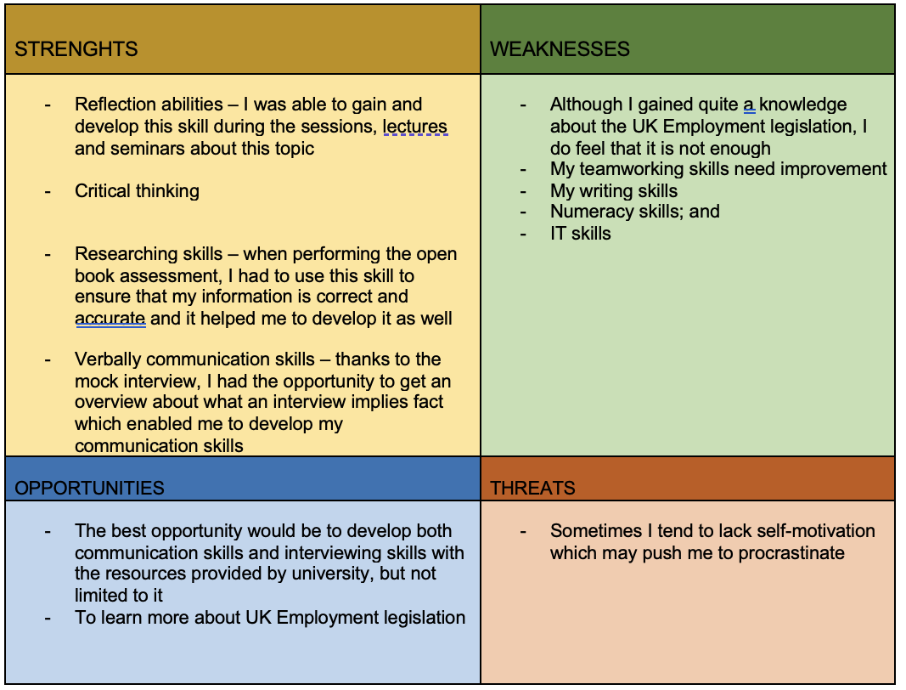
A q s e r t y h j n b c d s a w e r t y h g f d s x c v b n h g f d s A q s e r t y h j n b c d s a w e r t y h g f d s x c v b n h g f d s A q s e r t y h j n b c d s a w e r t y h g f d s x c v b n h g f d s A q s e r t y h j n b c d s a w e r t y h g f d s x c v b n h g f d s A q s e r t y h j n b c d s a w e r t y h g f d s x c v b n h g f d s A q s e r t y h j n b c d s a w e r t y h g f d s x c v b n h g f d s A q s e r t y h j n b c d s a w e r t y h g f d s x c v b n h g f d s A q s e r t y h j n b c d s a w e r t y h g f d s x c v b n h g f d A q s e r t y h j n b c d s a w e r t y h g f d s x c v b n h g f d A q s e r t y h j n b c d s a w e r t y h g f d s x c v b n h g f d s A q s e r t y h j n b c d s a w e r t y h g f d s x c v b n h g f d A q s e r t y h j n b c d s a w e r t y h g f d s x c v b n h g f d A q s e r t y h j n b c d s a w e r t y h g f d s x c v b n h g f d A q s e r t y h j n b c d s a w e r t y h g f d s x c v b n h g f d s
s
s
s

s
s

Source: Prepared by the author based on journal

PERSONAL DEVELOPMENT PLAN (PDP)

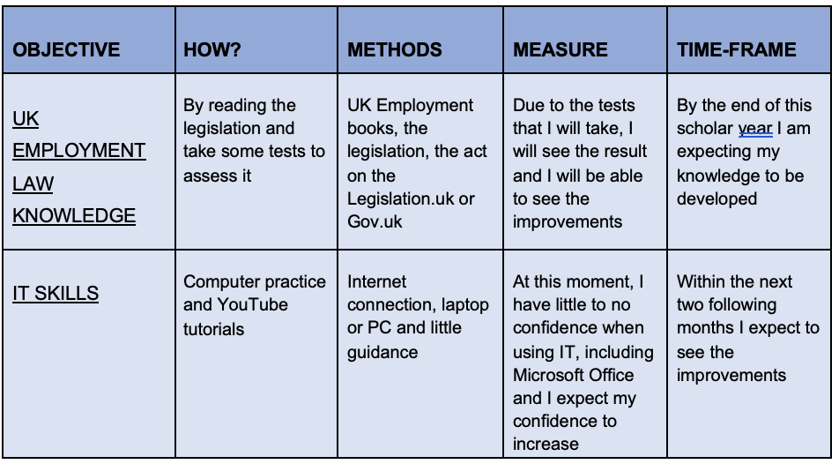
Source: Prepared by the author based on journal

Skills needed in the industry to join

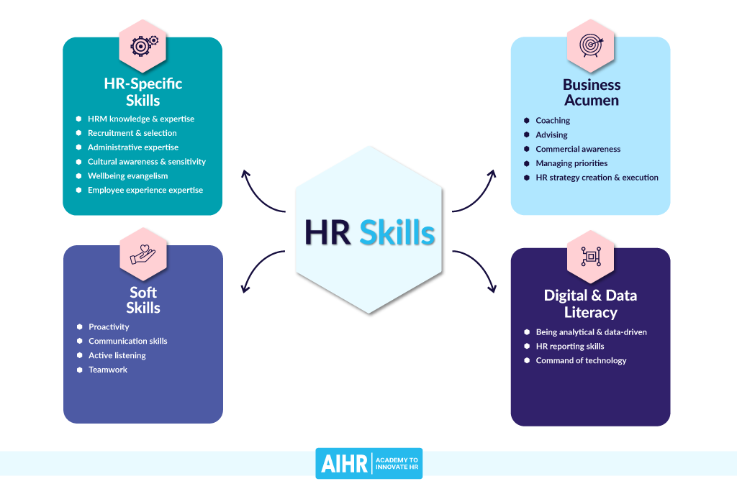
Source: Prepared by the author based on journal
- Communication skills: Communication is the skill most frequently mentioned in HR job postings. An HR person is a link between the company and its employees, so her skills in good communication in this area are very important.
- HR strategy implementation: HR professionals need to take an essential point of view. Even if you haven't reached the level where creating an HR strategy is part of your responsibility, you should be able to understand strategic intent and translate it into actionable execution plans.
- Positivity: This is often seen as a personality trait rather than ability. But you can nurture it over time. As an HR manager, you are the bridge between employers and employees.

JOHARI WINDOW MODEL

Communication Theory, 2020 presents this straightforward model as evidence that the "self" has four distinct facets. According to (Self-awareness,2013) the idea is that the individual knows two sides of herself and that others who interact with the individual know two sides of her.
These pages change as people react and receive feedback (Sinclair, 2021). My colleagues and teachers were unaware of my reflection and investigative skills before this module, so the panels were rearranged with a larger "unknown" and a smaller "unknown" Open. They saw it and changed it again after receiving feedback. The panel changed again to be more open to me and the feedback that was provided for feedback.

McClelland THEORY OF MOTIVATION – Learned Needs Theory

In your capacity as a director, motivating staff members is crucial to the regularity of benefits and errands. Based on Maslow's Necessity Hypothesis, the McClelland hypothesis proposes that people have three distinct and significant inspirations, each with its unique characteristics—religion, orientation, culture, etc (1988, McClelland).
1. Performance: The person is dedicated to the success of the company and overcomes all obstacles and procedures to accomplish goals.
2. Belonging implies that the individual places a high value on teamwork, necessitating a need to belong to a group. These individuals lack risk tolerance.
3. Singular power indicates that powers and decency of effect must be enforced.

The supervisor is obligated to look at every employee for my part and compare one of the 3 elements that inspire them; After that, the supervisor can decide which class works excellently for the personnel. From there, the supervisor can circulate directly to the subsequent step, which is selecting the sort of management that wishes for use for the group to be greater power and the project's shape. It's now no longer a great concept to present personnel association motivators with high-chance initiatives due to the fact they might not be engaged with them (WWP, 2021). The concept's shape makes it very useful for activity overall performance and worker engagement. It offers the supervisor a risk to research greater approximately their personnel more and offers them schooling for getting to know and improve. As a result, the personnel’s overall performance improves, even main to economic profits. Because it's miles each concise and green on the equal time, I in my view locate this concept useful. Therefore, through considering the 3 motivators and reading the personalities of the personnel, the ideal distribution of the motivators to the personnel, consisting of assigning duties and initiatives which might be extraordinarily aggressive and high chance to the "electricity group" will simply bring about advantageous outcomes, such as expanded worker engagement, self-improvement and motivation, activity overall performance, and economic compensation (Kurt, 2021).

This is a shorter cycle of reflection that allows those who use it to have an honest opinion of their previous experiences and, as a result, develop the skills and knowledge needed to improve next time. (Toolshero, 2020). This cycle of reflection consists of three direct and simple questions:

1 What? – A description of the experience and its nature, including all relevant details; the more details included, the more important and useful they are. What exactly happened, who was involved, whether it was a positive or negative experience, etc
2. What's wrong? – This section is for emotions, including emotions before and after an experience. Reactions to experiences and justifications for them are very important, as is the course of events between then and now.

What now? - In a nutshell, it's about how the experience ended, what we learned, what steps we could have taken to avoid conflict, and the differences between now and then. Would the approach have been different now that we have more knowledge and skills? (Gladd, 2021).

John Driscoll reflection model
Create your reflections using the John Driscoll reflection model, related to open book assessments, mock interviews, UK employment law, teamwork, communication, collaboration, problem-solving skills, IT literacy and other skills. Evaluate your findings.

When the assessment was presented, we were still getting to know it. It was divided into several sections, all of which I found interesting and challenging. However, when I saw the open book assessment section, I became concerned because I assumed it would involve a lot of pressure, and my skills for working under pressure aren't as strong as they should be. Even though I didn't overreact, I felt anxious and nervous, and I considered what I needed to do right away to boost my confidence.
As a result, I started practising improving my ability to work under pressure and my analytical abilities and earning a good grade. I can see why I became anxious in that situation, and I'm glad that now that my skills and knowledge have improved, I wouldn't feel the same if I had to do it again. I received the announcement for the mock interview positively because I was just glad to be able to practice it.
After all, doing so will increase my chances of passing an interview. I was thrilled, and I couldn't wait to perform; however, I was aware of the number of details and difficulties during the experience, but I worked hard to explore and complete it. I’m glad I did it because I learned that I am an ambitious person. Even though it was hard, I didn't give up. I discovered I had skills I didn't know I had, including creativity and design skills that helped me write my resume and cover letter. If I had to do the same thing over again now, I'm sure I would, but it would feel the same at first. I no longer feel that it is challenging because it has shown that there is something to be done.
When I first heard about UK employment legislation, I panicked because I assumed I would struggle with it simply because it is related to law, and that there would be a lot of words I would not understand, preventing me from achieving a good grade and improving myself.
I was working on it after I calmed down, and while reading some paragraphs, I realised that it is not as complicated as I thought it would be. I was calm, and I was regretting that I panicked at the start. Now I know that I shouldn't pass judgement so quickly, especially when I'm not sure about the subject's contents. I gained a lot of confidence as a result of this, and I am grateful for that.

List of references


