

MARKETING MANAGEMENT
LCMB7001

COURSE: MBA General Management
MODULE CODE: LCMB7001
ASSIGNMENT TITLE: 2
STUDENT NAME: Ashfaque Kakappara
STUDENT NO: 2131199
LECTURER: Tushara Balendran

TABLE OF CONTENTS

1. INTRODUCTION……………………………………….…….….4
2. PESTLE Analysis……………………………………….…………4
2.1. Political
2.2. Economic
2.3. Social
2.4. Technical
2.5. Environmental
2.6. Legal
3. PORTER’S FIVE FORCE ANALYSIS…………...…………….………………………………6
3.1. Threat of new entrants: Low
3.2. Threat of Substitution: High
3.3. Bargaining power of buyers: High
3.4. Bargaining power of suppliers: Low
3.5. Rivalry among existing competitors: High
4. SWOT Analysis……………………………….…………………9
4.1. Advantages
4.2. Disadvantages
5. SEGMENTATION, TARGETING AND POSITIONING.…………………………….………………………10
6. MARKETING MIX…………………………….……………….12
6.1 Product
6.2 Price
6.3 Place
6.4 Promotion
7. RECOMMENDATIONS………….………………………….13
7.1. Ansoff matrix
7.2. Product life cycle
8. CONCLUSION…………….……………………………………15
9. REFERENCES………………………………………….……….16

1. INTRODUCTION
The mobile phone market is one of the fastest growing markets in the world, In the UK the major mobile companies like Apple, Sony, and Xiaomi are operating in the country (Statista, 2022).
Samsung Company is a leading electronic company established in 1938 by Lee Byung-Chull in South Korea (Bondarenko, 2022), now the company is operating in different industries including electronics, insurance, and so on, driven by the vision of making lives easier (Samsung, 2022).
2. PESTLE Analysis
PESTLE analysis is used to conduct a macro analysis of the company (Rastogi and Trivedi, 2016).
Figure 1: PESTLE
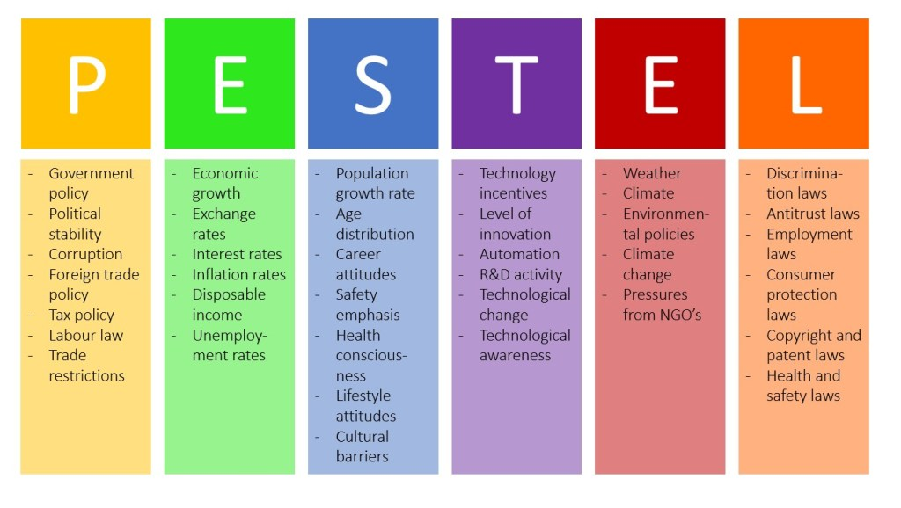
Source: business-to-you.com
2.1. Political: In a World Bank report the UK is recognized as a politically stable country (trading economics, 2022). The country is following progressive income tax policies therefore, the companies are only subjected to pay the tax based on revenue (GoCardless, 2022). In the UK there are no trade barriers (ITA, 2022), since the legal restrictions and political instability is low, the country has scored 70 above in the World Bank survey of 2020 (Trading economics, 2020), it provides an advantage for Samsung to make new investments and explore new markets within the country.
2.2. Economic: The UK economy is at a reviving phase, the GDP growth rate of the country has been showing a downward growth due to the widespread effect of the Covid-19 pandemic even though the country’s economy is in the retrieval phase (Clark, 2022). The current inflation rate is measured at 10.1%, which increases the disposable income of people (BBC, 2022). As income of people increases, they will prefer better quality mobile phones, since Samsung is recognized for its high-quality products at a reasonable price the demand for Samsung products will also increase.
2.3. Social: As per the World Bank data the population growth in the UK is indicating a steady growth rate since 2020 (World Bank, 2022), according to Neill (2022), the majority of the population falls between the 15-64 age group. This population is highly beneficial for the growth and development of Samsung since the company is targeting people of this age group (Samsung, 2022). Nowadays the number of people who are using mobile phones to satisfy a variety of needs more than phone calls has increased in the country (Setyo Kriswanto et al., 2019).
2.4. Technical: The country is a highly innovative country investing high level of R&D expenditures for instance in 2021 the R&D expenditure was at 2.4% (OGL, 2021). The people are also identified as highly technologically aware people which can be attributed with the sudden life style and preference changes in consumption (Setyo Kriswanto et al., 2019). Since the Samsung Company is highly focused on frequent innovation and introduction of advanced products the technological awareness among people will positively affect the company (Samsung, 2022).
2.5. Environmental: the country has well-established laws and policies for the protection and conservation of air, water, and other natural resources (DOMMETT, 2017), and the manufacturers of electronic products in the UK are advised to review all the production and procurement stages to reduce the electronic waste generation (Brown, 2021). Following these plans and policies will increase the public acceptance of the product thereby will foster the growth of the company since the people are highly concerned about environmental protection (ONS, 2021).
2.6. Legal: the country has well-defined labour laws which serve as a guideline for the employees and employers and reduce conflict among people (Coyle, 2017), since the company is dealing with an industry that requires a high level of innovation and development protection of new developments using copyright and patent claims are also the important UK have well-identified patent and copyright acts and claims (copyright, 2022). Since the laws are well-defined the company can operate more freely which will foster the innovation and development activities of Samsung in the UK (Coyle, 2017).
Considering the environmental analysis and environmental scanning of factors it can be identified that all factors are highly favourable for an electronic company to grow, the economic conditions, economic awareness of people, economic growth, and even the demographic dividend factors are highly flexing for the growth and development of the company.
3. PORTER’S FIVE FORCE ANALYSIS
Porter’s five forces is a tool to identify the micro factors (Rothaermel, 2016).

Figure 2: Porters Five force
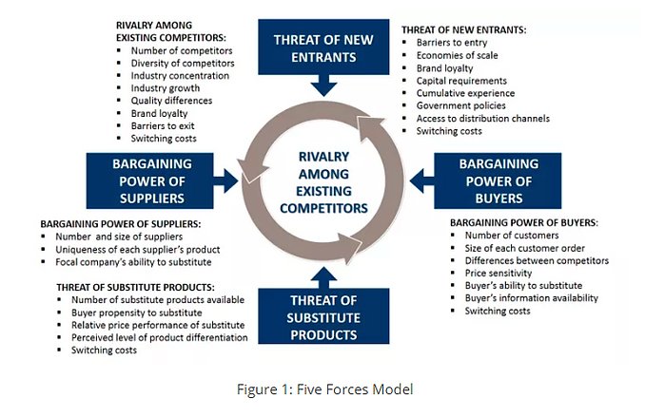
Source: business-to-you.com
3.1. Threat of new entrants: Low
The electronic industry is a highly competitive industry (Catalano and Smith, 2022). The capital requirement for entering the industry is high and the economies of scope and scale are high for the already established companies (Brock, 2022), consumers are highly concerned about the brands, therefore, brand loyalty is high phones (Mathew and Panicker, 2017), for instance, in 2020 about 64% of Samsung consumers was about to retain their preference for Samsung products (Kozhuch, 2019).

3.2. The threat of Substitution: High
Since a large number of competitors are in the market, For instance, Samsung phones was highly demanded among consumers due to its high battery power and 5G support along with AI technology which was not available in the Apple phones or any other phones in the market (supportapple, 2022). Therefore the propensity to substitute is high among people. Price is also another influencing factor since most of the phones are offering almost similar facilities people will prefer phones with a justifiable price (Kramer et al., 2021).
3.3. Bargaining power of buyers: High
For electronic products, the buyer’s ability to substitute is high since a large number of products with similar features are in the market (Counterpoint, 2022), therefore, it is essential to understand the demands of the customers, here, Samsung is considered as the innovator (Samsung, 2022). For instance, Samsung introduced 5G network phones and now apple have incorporated the same in iPhone 12 series (Techdesk, 2020).
3.4. Bargaining power of suppliers: Low
In the electronic industry, most of the manufacturing industries are supplying for their own production therefore the bargaining power of suppliers is low, For instance, the designing and raw material supply for the production of Samsung products are done by the company itself (Samsung, 2022), which reduces the dependency of the company on external sources and increases the quality of the products.
3.5. Rivalry among existing competitors: High
The smartphone or electronic industry is a rapidly changing industry where consistent updating are taking place therefore the level of competition is high (Counterpoint, 2022). The brand loyalty among consumers is high (Mathew and Panicker, 2017), the brand loyalty for Samsung among the consumers in the UK are above 64% (Kozhuch, 2019), even though the largest share of sales in the UK market are of Apples which increases the competition among these rival companies (Statista, 2022).

4. SWOT Analysis
Table 1: SWOT
Strength | Weakness | Opportunities | Threat
•Samsung is recognized as trendsetter (Samsung, 2022) | • Depended upon consumer electronic sales | • Change in lifestyle of people are asking for new innovations (Setyo Kriswanto et al., 2019). | • Increasing environmental protection laws (DOMMETT, 2017).
• High brand loyalty (Mathew and Panicker, 2017). | • Fast launching of similar products one after another (Rayome, 2021). | • Technological growth | • Large number of competitors (Counterpoint, 2022).
• High level of R&D investments (Samsung, 2022) |  |  | • Rapidly changing industry
• Experience stores phones (Mathew and Panicker, 2017).
Source: Self-developed
4.1. Advantages
• Samsung is recognized as the trend setter (Samsung, 2022)
• Increasing brand loyalty (Mathew and Panicker, 2017).
• Frequent adaptation and lifestyle change (Setyo Kriswanto et al., 2019)
4.2. Disadvantage
• Increasing competition (Counterpoint, 2022)
• Fast innovation and immediate launching of products one after another (Rayome, 2020).
• Rapidly changing industry.
5. SEGMENTATION, TARGETING AND POSITIONING
The market segmentation is important for any product, For Samsung, the market segmentation in the UK is as follows,
Table 2: Segmentation
Geographic | Demographic | Psychographic | Behavioural
• Population density  • City size | • Age  • Income  • Occupation | • Lifestyle | • Loyalty  • Attitude towards product
Source: self-developed
For the sales of the Samsung phones in general and S20 series in particular, the company was targeting business persons by offering features like live capturing and connectivity, 5G facility and AI-enabled camera, and related facilities that were not available with the other potential competitors.
Samsung is positioned to identify the relative position of the product in the market relative to its competitors offering similar features.
Figure 3: Positioning
High Price
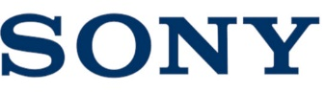  Low Status |     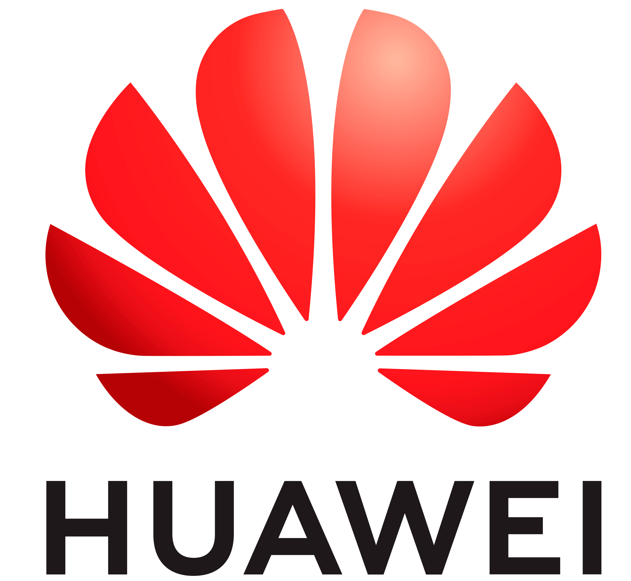    High Status
    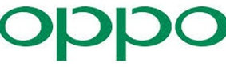 | 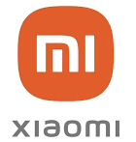  
Low Price
Source: self-developed

6. MARKETING MIX
Marketing mix refers to the strategies used by the firm to promote the product in the market (The economic times, 2022). The marketing mix elements are,
6.1 Product
Brand identity intends to create awareness among the consumers about the product, (mindtools, 2018). For Samsung the company has been introducing every single product under a single brand name using different model names, for instance, the Samsung S20 series, Samsung Watch, Samsung flip, Samsung life insurance, and therefore, it can be said that the company is following a corporate umbrella branding (Samsung, 2016).

6.2. Price
Pricing is another important factor influencing product demand (Chron, 2021). Psychological and skimming strategies are the important pricing strategies used by Samsung, through the launch of the S20 series in the UK the company is aiming to attract consumers by using a Psychological and skimming pricing strategy (Ajmera, 2017), these strategies are giving a competitive edge to the company since only a limited number of brands have introduced the same features (Wired, 2020).
6.3. Place
For the distribution of Samsung products in the UK, the company mainly is using Physical stores, the company has its own physical stores in different parts of the country which are also known as experience stores from where the consumers can also avail of customer services, in UK more than 10 experience stores are operating in different parts of the country (Samsung, 2022).

6.4. Promotion
For promoting different products in the UK the company has adopted different strategies such as Campaigns, brand ambassadors, direct and digital marketing facilities, and so on (Shastri, 2022). For instance, Samsung has brand ambassadors in different parts of the world such as BTS in South Korea, and Alia Bhatt in India through which the product is getting more recognition (Samsung, 2021).
7. RECOMMENDATIONS
7.1. Ansoff Matrix
For Samsung, in the UK market penetration strategy will be the best suited because the company has a well-established brand value and the brand loyalty towards Samsung products among people in the UK are also high phones (Mathew and Panicker, 2017), the only disadvantage of Samsung in the UK is that the company introduces new products without taking much gap which creates confusions among the buyers and results in a low purchase of the respective product (Rayome, 2021).
Figure 4: Ansoff matrix
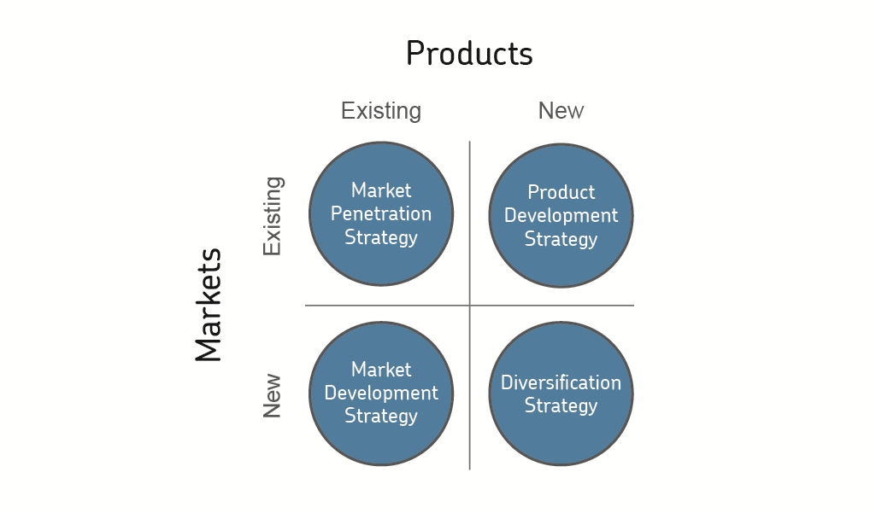
Source: aqa.org.uk
Therefore, the market penetration strategy will help to increase the sales of the existing product, the company will be able to increase customer awareness about a product through product promotion, and sales-based strategies. The company is also recognized as the trendsetter (Samsung, 2022), therefore the focus of the company should be on attracting the customers towards the Samsung products before any other company such as apple or Xiaomi would introduce a similar feature phone which will provide a competitive advantage for the company (Rothaermel, 2016).
7.2. Product life cycle strategy
From introducing a new product into the market the product life cycle deals with the amount of time a product is in the market (TWI, 2022).

Figure 5: Product life cycle
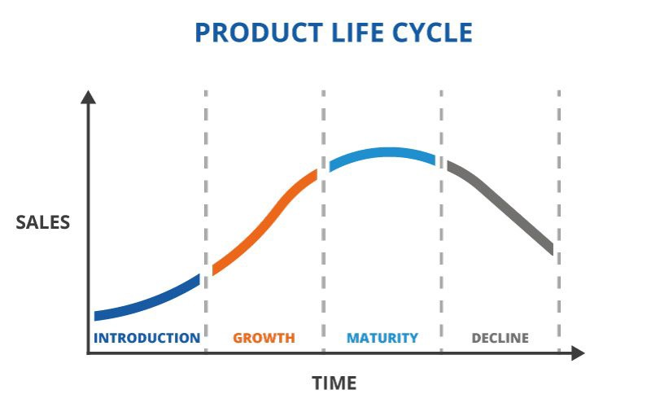
Source: TWI Global.com
It can be identified that the Samsung S20 series is in the growth stage of a product life cycle in the UK, the S20 was introduced in 2020 later on the company introduced the S20+, S20 Ultra, and so on therefore, the products are in the growth stage (Samsung, 2022).
Samsung is a company with a pioneer status in the mobile industry since it introduce new products with new features in the market (Samsung, 2022). Therefore, as per the nature of the company and the demand of the customer’s market expansion strategy will be best suited, the company should focus increasing consumers awareness, and should focus on encouraging the consumers to purchase that product (Rayome, 2021).

8. CONCLUSION
Samsung is the trendsetter in the phone industry, Furthermore, brand loyalty and consumer preference towards Samsung products are also very high (Mathew and Panicker, 2017), the company is also providing excellent customer services (Samsung, 2022), which serves as an attracting factor, by focusing more on market penetration the company can seize the market.

9. REFERENCE
Ajmera, S (2017) ‘Samsung's simple yet effective pricing strategy’ LinkedIn [Online]. Available from: https://www.linkedin.com/pulse/samsungs-simple-yet-effective-pricing-strategy-shreyansh-ajmera#:~:text=Samsung%20uses%20Skimming%20price%20strategy,beginning%20before%20competitors%20catch%20up.. Accessed on: 05 September 2022.
BBC (2022) ‘What is the UK inflation rate and why is the cost of living rising?’ bbc.com [Online]. Available form: https://www.bbc.com/news/business-12196322. Accessed on: 04 September 2022.
Bondarenko, P (2022) ‘Samsung South Korean company’ Britannica [Online]. Available from: https://www.britannica.com/topic/Samsung-Electronics. Accessed on: 05 September 2022.
Brock, T (2022) ‘What Are the Key Barriers to Entry in Electronics?’ Investopedia [Online]. Available from: https://www.investopedia.com/ask/answers/042115/what-are-key-barriers-entry-companies-electronics-sector.asp. Accessed on: 05 September 2022.
Brown, T (2021) ‘The environmental impact of electronics manufacturing’ the manufacturer [Online]. Available from: https://www.themanufacturer.com/articles/the-environmental-impact-of-electronics-manufacturing/. Accessed on: 04 September 2022.
Catalano, T and Schmitt (2022) ‘Who Are Apple's Main Competitors in Tech?’. Investopedia [Online]. Available from: https://www.investopedia.com/ask/answers/120314/who-are-apples-aapl-main-competitors.asp. Accessed on: 05 September 2022.
Chron (2021) ‘Relationship Between Level of Prices and Demand’ Chron [Online]. Available from: https://smallbusiness.chron.com/demand-curve-its-role-pricing-decisions-20752.html. Accessed on: 05 September 2022.
Clark, D (2022) ‘Monthly growth of gross domestic product in the United Kingdom from January 1997 to June 2022’. Statista [Online]. Available from: https://www.statista.com/statistics/941233/monthly-gdp-growth-uk/#:~:text=The%20gross%20domestic%20product%20of,in%20growth%20since%20January%202021. Accessed on: 04 September 2022.
Counterpoint (2022) ‘Global Smartphone Market Share: By Quarter’. Counterpoint [Online]. Available from: https://www.counterpointresearch.com/global-smartphone-share/#:~:text=Samsung%20led%20the%20global%20smartphone,shipments%20of%20272%20million%20units. Accessed on: 01 September 2022.
Coyle, C (2017) ‘An overview of Employment Law in England & Wales’ colmancoyle.com [Online]. Available from: https://www.colmancoyle.com/wp-content/uploads/2017/04/An-overview-of-UK-Employment-Law-document.pdf. Accessed on: 05 September 2022.
DOMMETT, K. (2017) ‘United Kingdom: UNITED KINGDOM’, European Journal of Political Research Political Data Yearbook, 56(1), pp. 275–282.
GoCardless (2022) ‘When does a small business have to pay tax in the UK?’. Gocardless.com. Available from: https://gocardless.com/guides/posts/when-smbs-have-to-pay-tax/#:~:text=If%20your%20business%20earns%20between,year%20and%20pay%20National%20Insurance. Accessed on: 04 September 2022.
ITA (2022) ‘Trade Barriers’. ITA [Online]. Available from: https://www.trade.gov/country-commercial-guides/united-kingdom-trade-barriers#:~:text=The%20UK%20has%20no%20significant,of%20EU%20Directives%20and%20regulations. Accessed on: 04 September 2022.
Kramer, L. Boyle, M. and Williams, P (2021) ‘How Does the Law of Supply and Demand Affect Prices?’ Investopedia [Online]. Available from: https://www.investopedia.com/ask/answers/033115/how-does-law-supply-and-demand-affect-prices.asp#:~:text=It's%20a%20fundamental%20economic%20principle,services%20when%20demand%20is%20unchanged.. Accessed on: 05 September 2022.
Kozhuch, K (2021) 'Samsung Leads the Way for Android Phone Brand Loyalty (Report)' tomsguide.com [Online]. Available from: https://www.tomsguide.com/news/samsung-leads-the-way-for-android-phone-brand-loyalty-report. Accessed on: 05 September 2022.
Mindtools (2022) ' Keller's Brand Equity Model' mindtools [Online]. Available from: https://www.mindtools.com/pages/article/keller-brand-equity-model.htm. Accessed on: 05 September 2022.
ONG (2021) ‘Corporate report Innovation and growth report 2020-21’. Gov.uk [Online]. Available from: https://www.gov.uk/government/publications/promoting-innovation-and-growth-the-ipo-at-work-2020-21/innovation-and-growth-report-2020-21#:~:text=The%20UK's%20Innovation%20Strategy%2C%20launched,IP%20is%20central%20to%20that. Accessed on: 04 September 2022.
ONS (2021) 'Public attitudes to the environment and the impact of climate change, Great Britain: November 2021' ONS [Online]. Available from: https://www.ons.gov.uk/releases/publicattitudestotheenvironmentandtheimpactofclimatechangegreatbritainnovember2021. Accessed from: 05 September 2022.
Rayome, A (2021) ‘Don't buy a Galaxy S20 phone right now. Here's why you should wait’ CNET [Online]. Available from: https://www.cnet.com/tech/mobile/dont-buy-samsung-galaxy-s20-phone-right-now-heres-why-you-should-wait-for-galaxy-s21-release/. Accessed on: 05 September 2022.
Rastogi, N. and Trivedi, M.K. (2016) ‘PESTLE Technique - A Tool to Identify External Risks in Construction Projects’, International Research Journal of Engineering and Technology, 03(01), pp. 384–388. Available at: www.irjet.net.
Rothaermel, F.T. (2016) ‘Competitive advantage in technology intensive industries’, Advances in the Study of Entrepreneurship, Innovation, and Economic Growth, 26, pp. 233–256. doi:10.1108/S1048-473620160000026008.
Setyo Kriswanto, E. et al. (2019) ‘Smartphone: Social Attitude and Healthy Lifestyle’, (January 2018). doi:10.2991/yishpess-cois-18.2018.6.
Samsung (2016) ‘Galaxy: reviving from edge’ Samsung [Online]. Available from: https://mpk732t22016clusterb.wordpress.com/tag/samsung/. Accessed on: 05 September 2022.
Samsung (2022) ‘Galaxy S20 FE | S20 | S20+ | S20 Ultra 5G’ Samsung [Online]. Available from: https://www.samsung.com/uk/smartphones/galaxy-s20/. Accessed on: 05 September 2022.
Samsung (2022) ‘Manufacture at the speed of light’ Samsung [Online]. Available from: https://www.samsung.com/us/business/solutions/industries/manufacturing/. Accessed on: 05 September 2022.
Samsung (2022) ‘Discover the power of innovation on your doorstep’ Samsung [Online]. Available from: https://www.samsung.com/uk/samsung-experience-store/about/. Accessed on: 05 September 2022.
Samsung (2022) ‘How Samsung Galaxy Has Rewritten Smartphone History in 10 Innovative Technologies’ Samsung newsroom [Online]. Available from: https://news.samsung.com/global/how-samsung-galaxy-has-rewritten-smartphone-history-in-10-innovative-technologies. Accessed on: 05 September 2022.
Samsung (2021) ‘Alia Bhatt Unfolds Her World with Samsung Newsroom India’ Samsung newsroom India [Online]. Available from: https://news.samsung.com/in/alia-bhatt-unfolds-her-world-with-samsung-newsroom-india#:~:text=Samsung's%20latest%20foldable%20smartphones%20have,chapter%20in%20its%20innovation%20journey. Accessed on: 05 September 2022.
Shastri, A (2022). 'Detailed Marketing Strategy of Samsung' IIDE [Online]. Available from: https://iide.co/case-studies/marketing-strategy-of-samsung/. Accessed on: 05 September 2022.
Statista (2022) ‘Market share of mobile device vendors in the United Kingdom (UK) 2010-2021’. Statista [Online]. Available from: https://www.statista.com/statistics/487780/market-share-of-mobile-device-vendors- uk/#:~:text=Apple%20claimed%20the%20leading%20position,not%20had%20over%2050%20percent. Accessed on: 04 September 2022.
The economic times (2022) ‘What is 'Marketing Mix'’ the economic times [Online]. Available from: https://economictimes.indiatimes.com/definition/marketing-mix. Accessed on: 05 September 2022.
Techdesk (2020) 'iPhone 12 vs iPhone 11: What has changed in a year?' The indian express [Online]. Available from: https://indianexpress.com/article/technology/techook/iphone-12-vs-iphone-11-price-specs-6724540/. Accessed on: 05 September 2022.
Trading economics (2022) ‘United Kingdom - Political Stability And Absence Of Violence/Terrorism: Percentile Rank, Upper Bound Of 90% Confidence Interval’. Tradingeconomics [Online]. Available from: https://tradingeconomics.com/united-kingdom/political-stability-and-absence-of-violence-terrorism-percentile-rank-upper-bound-of-90percent-confidence-interval-wb-data.html#:~:text=90%25%20Confidence%20Interval-,Political%20Stability%20and%20Absence%20of%20Violence%2FTerrorism%3A%20Percentile%20Rank%2C,compiled%20from%20officially%20recognized%20sources. Accessed on: 04 September 2022.
TWI (2022) ‘WHAT IS A PRODUCT LIFE CYCLE? (DEFINITION, STAGES AND EXAMPLES)’ TWI [Online]. Available from: https://www.twi-global.com/technical-knowledge/faqs/what-is-a-product-life-cycle#:~:text=A%20product%20life%20cycle%20is,growth%2C%20maturity%2C%20and%20decline. Accessed on: 05 September 2022.
World Bank (2022). ‘Population growth (Annual %) –United Kingdom’. Data.worldbank.com [Online]. Available from: https://data.worldbank.org/indicator/SP.POP.GROW?locations=GB. Accessed on: 04 September 2022.
Wired (2020) ‘Samsung Galaxy S20 is all 5G, no thrills, but a winner by default’. Wired [Online]. Available from: https://www.wired.co.uk/article/samsung-galaxy-s20-uk-release-date-price-specs. Accessed on: 05 September 2022

