Abstract
A python application that uses the Rick and Morty API
Network Progammability ACCA5029
Assignment Two
Donna Kennett
1908067@student.uwtsd.ac.uk
University of Wales Trinity Saint Davies
School of Applied Computing
Declaration

I declare that this report is the product of my own work and is not being submitted for any other degree etc.

D M R Kennett

Table of Contents
1 Purpose 4
2 Scope 4
3 Development 4
3.1 Exploration 4
3.2 Flowchart 6
3.3 Postman 6
3.4 Pseudo Code 8
3.4.1 Function 1 8
3.4.2 Function 2 8
3.4.3 Function 3 8
3.4.4 Sorting the data 9
3.5 Creating the graph 9
3.5.1 Pseudo code 10
3.5.2 Python code 10
3.6 Code 11
3.7 Git 11
3.7.1 Branches 12
3.7.2 Main repository 14
4 Lessons Learnt 14
5 Future Work 15
6 References 15
7 Appendices 16
7.1 Annex 1 - HTML Request 16
7.2 Annex 2 - Code 16

Purpose
Using GET requests to interrogate the Rick and Morty API.

Scope
Analyse the data obtain from the GET requests (see Annex 1) to find and display the ten most seen characters of the Rick and Morty show.

Development

Exploration
To find out the steps needed to solve the problem a dummy program was created using Postman and Python to make a simple GET request to the Randomfox API [1]
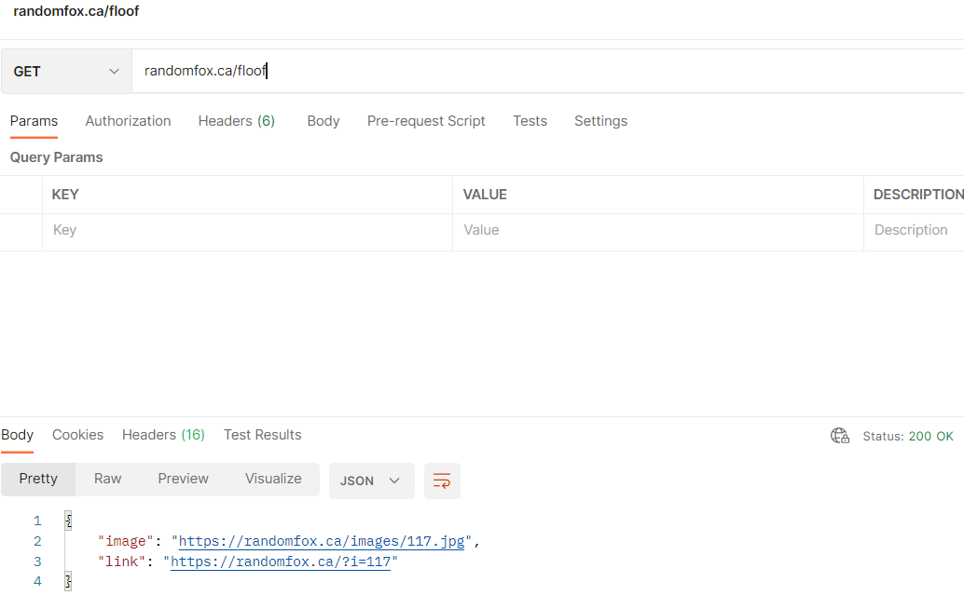
Fig 1: Postman output (see 4.3 for more information about Postman.

The Python Requests library can be used to make HTTP requests to a specified API using GET, PUT, POST etc. For this project just the HTTP GET method was needed.
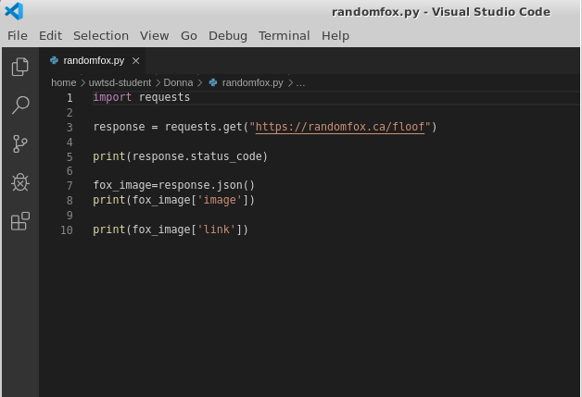
Fig 2: Python code to obtain fox picture.
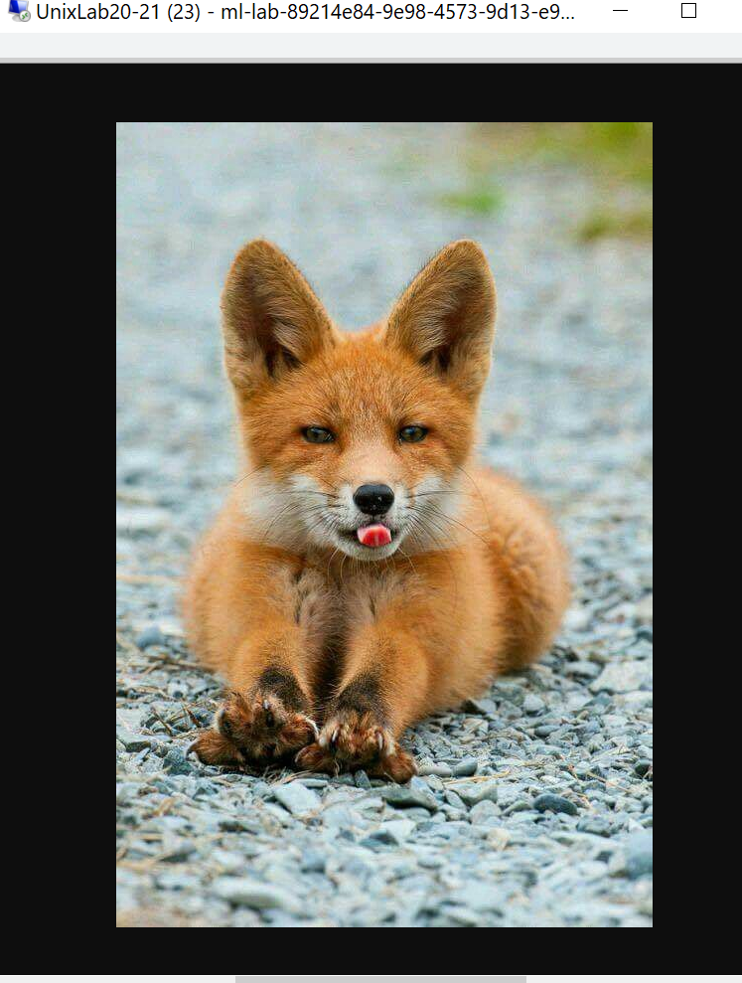
Fig 3: Random fox picture returned from the API.

Flowchart
Using the lessons learnt from the exploration stage above the following flowchart was created.
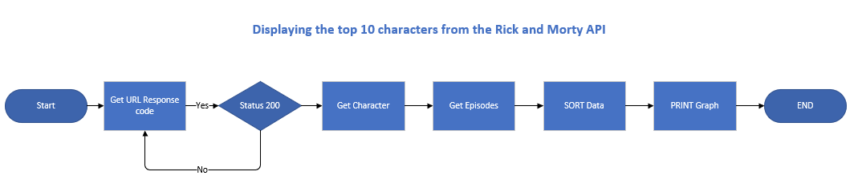
Fig 4: Initial Flowchart

Postman
The Postman tool was used to test HTTP requests and established endpoints for the API [2].
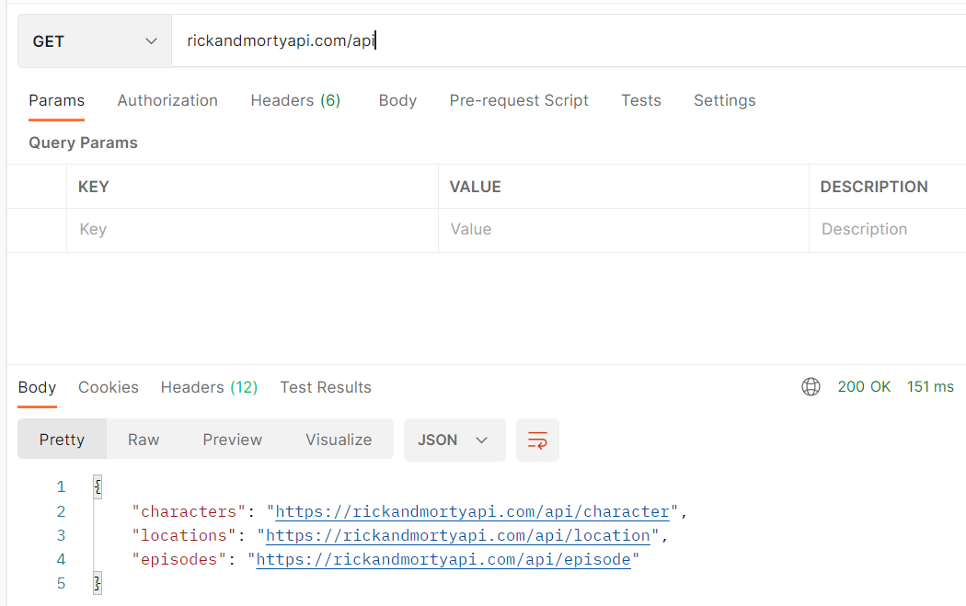
Fig 5: Postman

Status 200 OK which means the connection was successful and that the data has been separated into:
{"characters":"https://rickandmortyapi.com/api/character","locations":"https://rickandmortyapi.com/api/location","episodes":"https://rickandmortyapi.com/api/episode"}
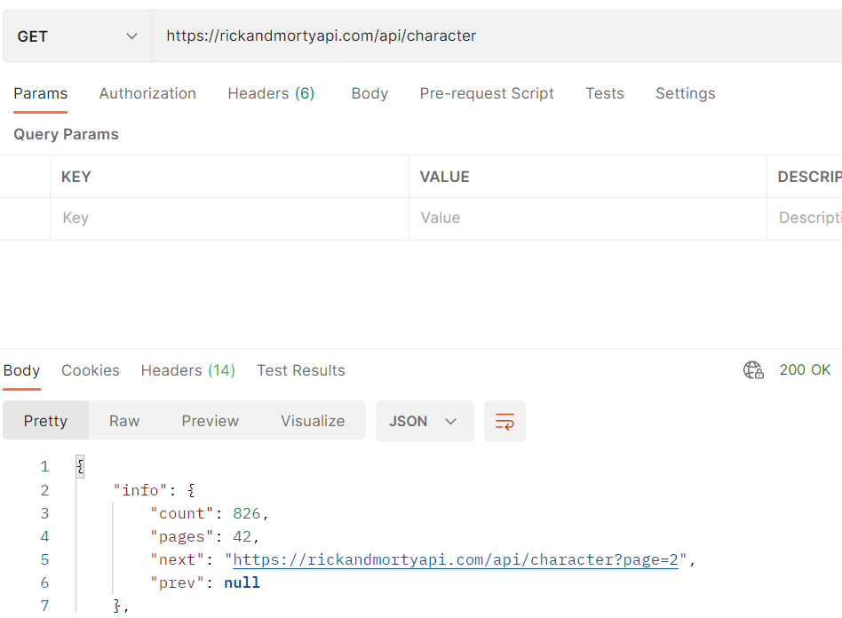
Fig 6: Postman returns the headers, key/value pairs which are needed to make the correct requests.

However, the data is split into pages which complicated the process.
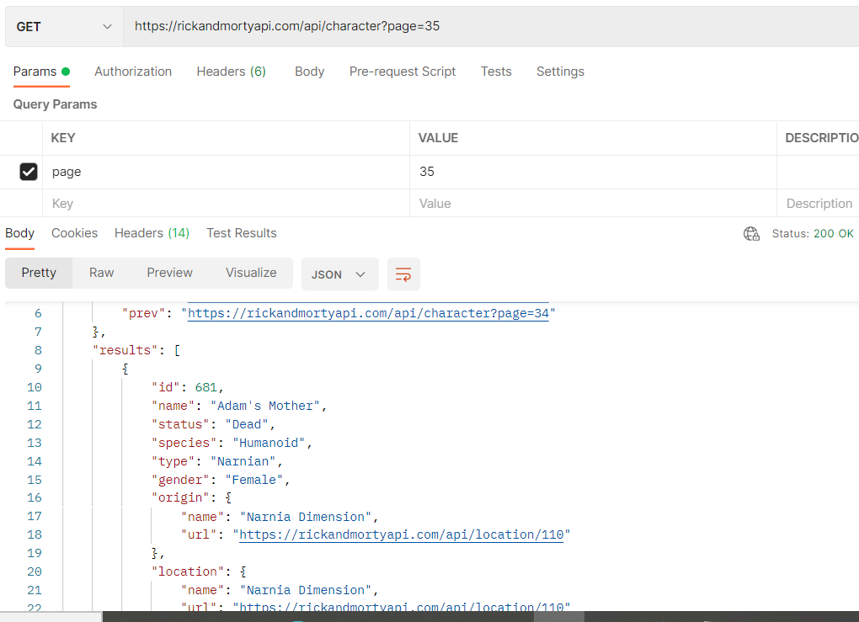
Fig 7: Separate character key/value pairs

Pseudo Code

Function 1
To get total number of pages:
FUNCTION GET (total_pages):
RETURN pages
ENDFUNCTION

Function 2
Pagination:
FUNCTION request (url, page number (x)):
response <- GET (url + y page of x)
RETURN response (in JSON)
ENDFUNCTION

Function 3
Obtaining the data:
FUNCTION getdata (pages):
List <- [ ]
for item in total_pages["results"]:
character <- {
"name": item = "name",
"no_episodes" = length(item["episode"])
}
Append list(character)
ENDFOR
RETURN list
ENDFUNCTION

Initial testing of the list using the head and tail function looked like the list was already ordered. However, this was not the case when the full list was checked. Extra code was needed to sort the list, fortunately this can be done with the Pandas library.

Sorting the data
The Pandas library [3] was chosen for its ability to work with dataframes. As a data frame is a 2-dimensional labelled data structure it works well with the key value pairs of an API. Pandas is a very well-known tool for use with data analysis.

csvData <- pandasForSortingCSV.read_csv("firstlist.csv")
dataframe <- csvData.sort_values(by <- ["no_episodes"], ascending=False)
dataframe.to_csv("sortedlist.csv", index=False)
dataframe <- pd.read_csv("sortedlist.csv")
results <- dataframe.head(10)

Creating the graph
Once the data is sorted the graph needed to be created. Research found the Matplotlib library [4], which not only creates graphs it works well with dataframes.
A simple python program was created to trial using Matplotlib to create a simple bar graph using dummy data.

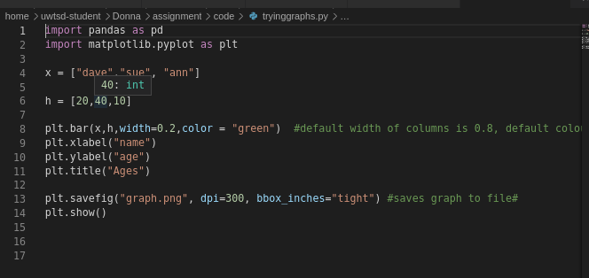
Fig 8: Dummy graph program using Pandas and Matplotlib Libraries.

The graph produced:
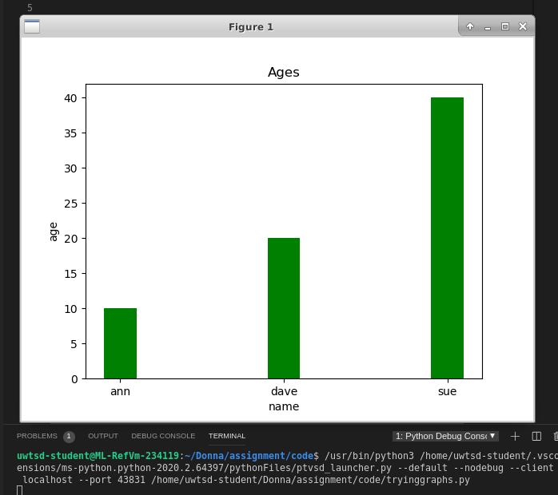
Fig 9: Graph

Pseudo code
Using the Matplotlib library the following pseudo code was created:
X <- list (row[])
Y <- list (row[])
plt.figure()
plt.bar(X, Y) #default width of columns is 0.8, default colour is blue #
plt.xlabel("Name”)
plt.ylabel("Number of episodes")

Python code

data = pd.read_csv("top10.csv") #initialsing the lists for X and Y
df = pd.DataFrame(data)

X = list (df.iloc[:, 2]) #selects rows in dataframe #
Y = list (df.iloc[:, 3])

plt.figure(figsize = (15, 8)) #width and hight of figure
plt.bar(X, Y, color = "green") #default width of columns is 0.8, default colour is blue #
plt.xlabel("Character", fontsize=16)
plt.ylabel("Number of episodes", fontsize=16)
plt.title("The Top 10 reoccurring Rick and Morty Characters", fontsize=24)

plt.savefig("Rick and Morty graph.png", dpi=200, bbox_inches="tight") #saves graph to file#
plt.show()

Code
Please see Annex 2 for full code.

Git
Git hub was used throughout the development process.
A remote repository was created :
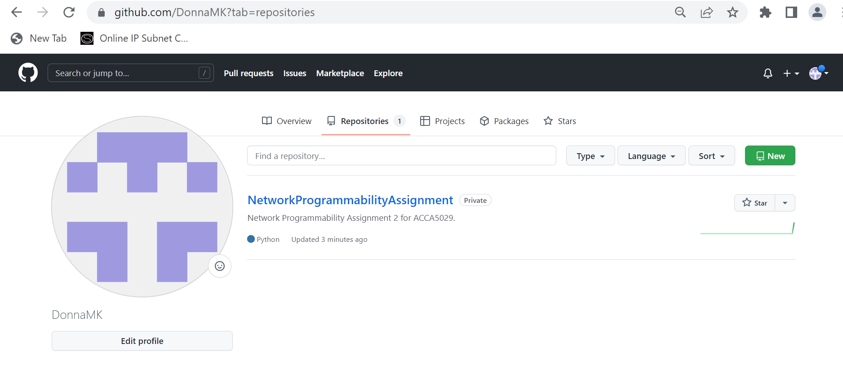
Fig 10: Remote repository
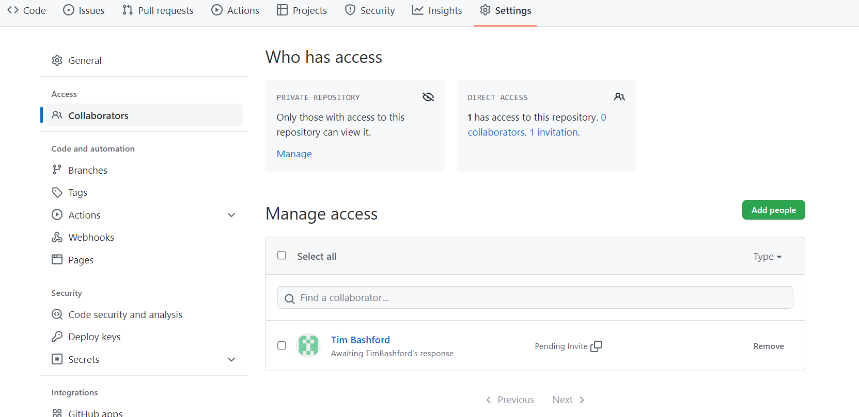
Fig 11: Private repository with access for one collaborator.

Local repository:
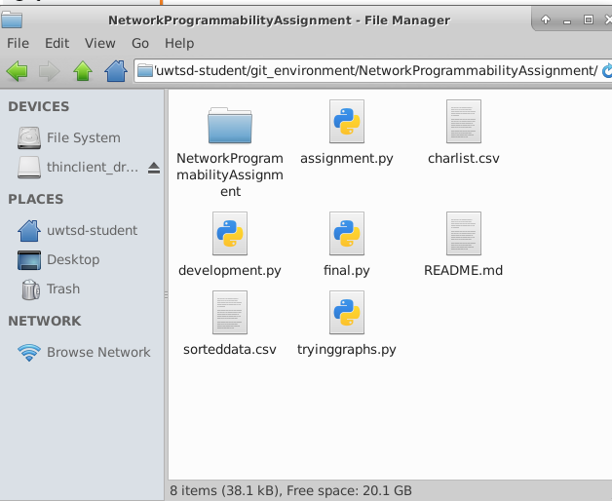
Fig 12: Local repository

Branches
Two branches were used in Gib hub, Main and Dev. The Dev branch was used for development:
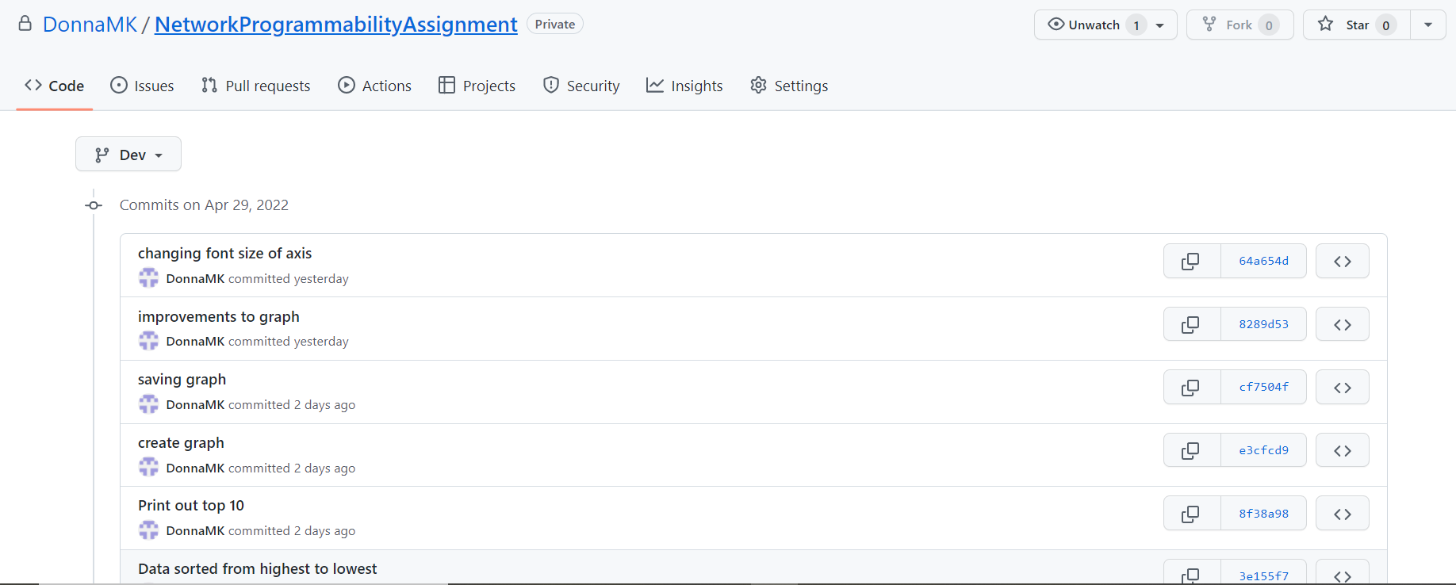
Fig 13: Development Branch

Once development was complete this was merged into the main branch.
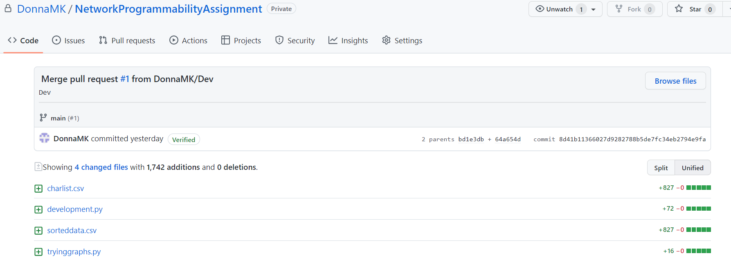
Fig 14: Merging branches

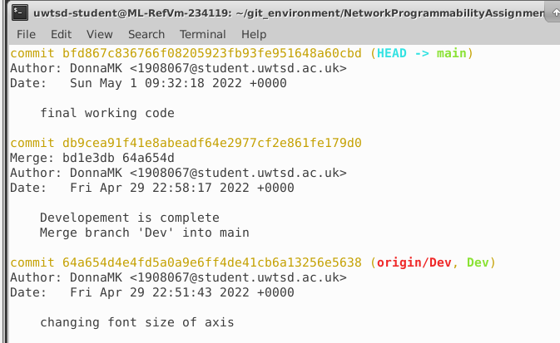
Fig 15:Commit log

Main repository
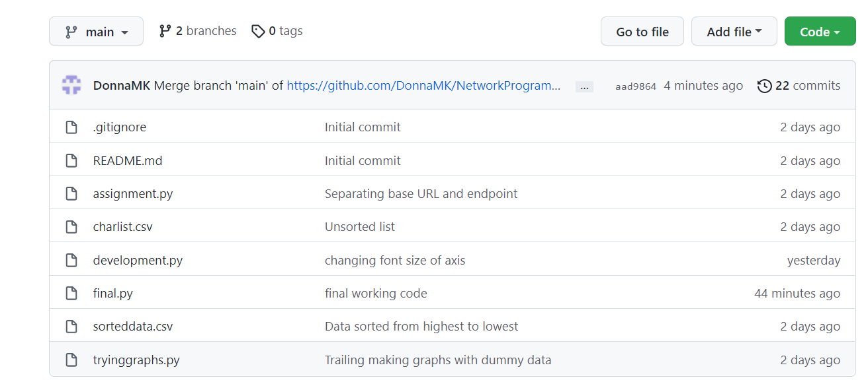
Fig 16: Main branch after merge.

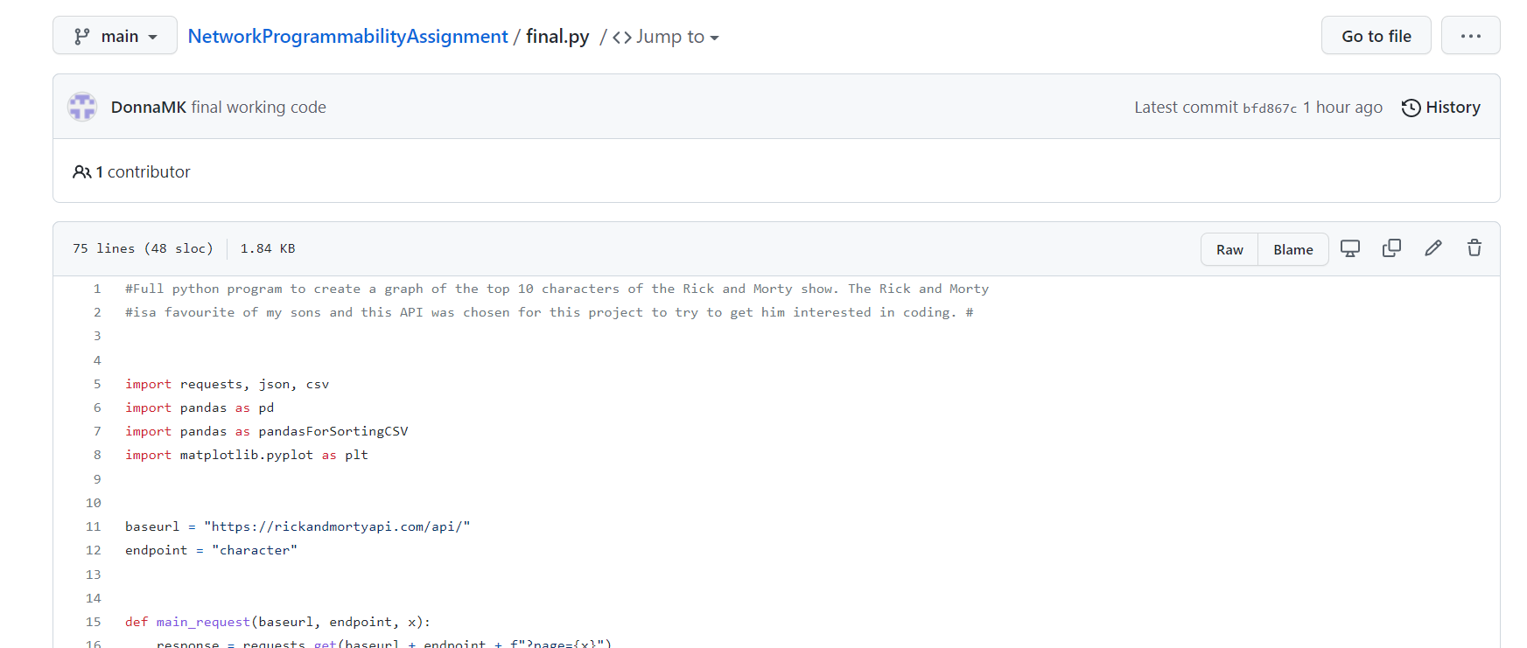
Fig 17: Extract of the final code.
After the branches were merged the Development branch was not deleted as it provides a history of the changes made.

Lessons Learnt
Start small, test that works and then move onto the next step.
Change one thing at a time and use Git to keep track of versions.
Planning helps to visualise the problem and break it down into manageable steps.
Be patient.
Use meaningful names and useful commit statements.
There is so much more to learn.
Programmes are more complicated and take longer than first thought.

Future Work
Additional features could include:
- User search facility to find additional information from the Character, Episode and Location endpoints. For example, function to find out how many characters are aliens and how many are still alive.
- Function to work out which episode a specific character first appears in and what was their last.
- Function to find the current location of a specific character.

References

[1] | “Random Fox,” Xinitrc, [Online]. Available: https://randomfox.ca/. [Accessed 1 April 2022].
[2] | “Learning Centre - Introduction,” Postman, [Online]. Available: https://learning.postman.com/docs/getting-started/introduction/. [Accessed 1 April 2022].
[3] | “DataFrame,” Pandas, [Online]. Available: https://pandas.pydata.org/docs/reference/frame.html. [Accessed 10 April 2022].
[4] | “Matplotlib: Visualization with Python,” Matplotlib, [Online]. Available: https://matplotlib.org/. [Accessed 20 April 2022].
[5] | B. S. R. A. P Casanova, “Architecture-Based Run-Time Fault Diagnosis,” in Software Architecture - 5th European Conference,, Essen, 2011.

Appendices

Annex 1 - HTML Request
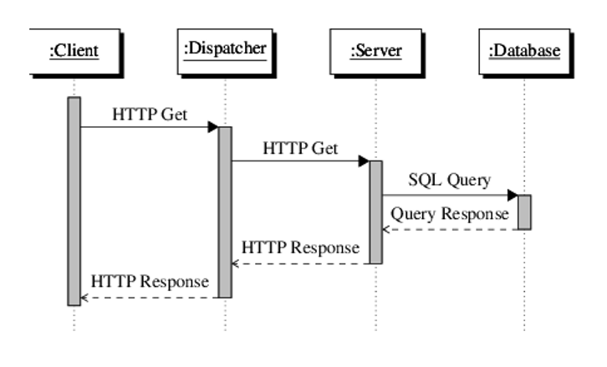
Fig 18: Example HTML GET request [5]

Annex 2 - Code

import requests, json, csv
import pandas as pd
import pandas as pandasForSortingCSV
import matplotlib.pyplot as plt

baseurl = "https://rickandmortyapi.com/api/"
endpoint = "character"

def main_request(baseurl, endpoint, x):
response = requests.get(baseurl + endpoint + f"?page={x}")
return response.json()

def get_pages(totalpages):
pages = totalpages["info"]["pages"]
return pages

def parse_json(totalpages):
charlist = []
for item in totalpages["results"]:
char = {
"id": item["id"],
"name": item["name"],
"no_episodes": len(item["episode"])
}

charlist.append(char)
return charlist

mainlist = []
data = main_request(baseurl, endpoint, 1)
for x in range(1,get_pages(data)+1):
mainlist.extend(parse_json(main_request(baseurl, endpoint, x)))

dataframe = pd.DataFrame(mainlist)

dataframe.to_csv("charlist.csv", index=False)

csvData = pandasForSortingCSV.read_csv("charlist.csv")

dataframe = csvData.sort_values(by = ["no_episodes"], ascending=False)

dataframe.to_csv("sortedlist.csv", index=False)

dataframe = pd.read_csv("sortedlist.csv")
results = dataframe.head(10)

dataframe = pd.DataFrame(results)
dataframe.to_csv("top10.csv")

data = pd.read_csv("top10.csv")

df = pd.DataFrame(data)

X = list (df.iloc[:, 2])
Y = list (df.iloc[:, 3])

plt.figure(figsize = (15, 8))
plt.bar(X, Y, color = "green")
plt.xlabel("Character", fontsize=16)
plt.ylabel("Number of episodes", fontsize=16)
plt.title("The Top 10 reoccurring Rick and Morty Characters", fontsize=24)

plt.savefig("Rick and Morty graph.png", dpi=200, bbox_inches="tight")
plt.show()

