

Contents:
Executive summary……………………………………………………………………………3
Introduction……………………………………………………………………………………4
Sustainability…………………………………………………………………………………..4
Three pillars of sustainability.....................................................................................................4
Sustainable tourism……………………………………………………………………………6
Aims for sustainable tourism…………………………………………………………………..7
Purpose of sustainable tourism in developed and developing countries………………………8
Economic point of view………………………………………………….…………………….8
Environmental point of view……………………………………………………….………….9
Socio-cultural point of view…………………………………………………….……………..11
Advantages of sustainable tourism…………………………………………………………….12
Limitations of sustainable tourism……………………………………………..………………13
Conclusion……………………………………………………………………….……………..13
Recommendations……………………………………………………………...………………14
References……………………………………………………………..……………………….15

Executive summary: Sustainability means meeting the needs of the present generation from the natural resources and preserving them so that future generations can use that too to fulfill their needs. It has three pillars, environmental sustainability, economic sustainability and social sustainability.
Tourism is successfully implementing sustainability in itself. Sustainable tourism is directed towards a tourism where conservation of natural resources and preservation of places, economical benefit of the local people is maintained.
Sustainable tourism has a lot of benefits including conservation of natural resources, preservation of places, carbon reduction, wastage reduction, uses of renewable energy, ensuring economical benefit for local communities etc.
Sustainable tourism is implemented more accurately in the developed countries than the developing ones. Developed countries tends to rank better in the sustainable tourism index by the Economist intelligence unit in 2013.
A comparison of how sustainable tourism has been effective in developed and developing countries has been shown in this report.
Governments have been left behind by the NGOs and private sectors is promoting the campaign which is not a good news. It’s time they should come forward to share their hand with the NGOs and other private sectors to initiate the plan to successfully establish sustainable tourism in their respective countries.

Introduction: The purpose of this report is to critically analyze the concept of sustainable tourism. Tourism managers and planners of almost all places are now enthusiastically embrace the sustainable tourism idea. To understand the sustainable tourism idea we need to know what is sustainability and what are it’s indicators and bases. The growing concern with the effects of industrialization on environment, deforestation, global warming etc. resulted in raising a new view that challenged the current western method. That idea gave birth to a focus upon a different business plan, that increase environmental preservation and conservation of natural resources with more emphasis upon the future.

Sustainability: Sustainability is a complex subject. Sustainability is a study of how nature functions, remain diverse, produce things which is needed by the ecology to keep the balance. Human civilization takes resources from nature to sustain the modern way of life. There are several examples in history where a civilization has destroyed it’s own environment that it affected the survival chances of human being. Sustainability defines how people might live in harmony with the environment around them, and protect it from any kind of damage and destruction. Sustainability means meeting the human needs without compromising the ability of the future generations so that they can meet their own need too. Sustainability does not only mean environmentalism, it has concerns over social equity and economic development.

The three pillars of Sustainability: In 2005, the World Summit on Social Development identified the three pillars of sustainable development. They can be presented as economic sustainability, social sustainability and environmental sustainability.
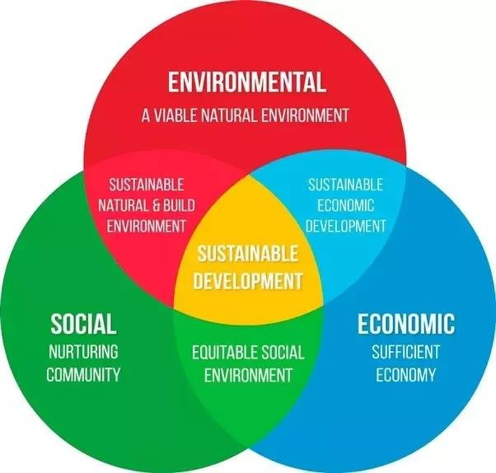
Source: Researchgate.net
- Economic sustainability: It has been seen in recent times that the industrialized countries have more people below the poverty zone. Here sustainability means to give everyone a proper chance to uphold their livelihood. People across the globe should be able to maintain their freedom and have access to the resources which they require, financially or other, to meet their needs. Economic system should be intact and create opportunities for everyone.

- Environmental sustainability: Human civilization has developed itself by taking resources from the environment. The integrity of preserving the environment should be maintained. Humans should consume the economical resources by keeping the ecological balance so that they don’t perish and can replenish itself for the future generations.

- Social sustainability: There are universal human rights and basic necessities for all the people living in this planet. People should have the resources to keep their families secure and healthy. Leaders should ensures the personal, and cultural rights and all the people should be protected from any kind of discrimination.

Sustainable tourism: Sustainable tourism establishes a balance between the economic, environmental and socio-cultural activities of tourism and offers an effective role in conserving biodiversity. Sustainable tourism methodology minimize the impacts on the environment and local culture so that future generations can have it. It also generate income, employment and Conservation of local ecosystems. It maximizes the positive contribution of tourism in conserving biodiversity and also Poverty reduction to move towards the sustainable development goals. Income which is generated through this process are spent on reserving the ecology and to protect the inhabitants. Thus, local communities and socio-cultural aspects would be protected and people can also move around freely. Actually, tourism can play a key role in raising awareness and to change behavior among the million of people travelling across the globe every year.

Aims for sustainable tourism: Twelve major aims for sustainable tourism has been identified by the UN (UNWTO 2013).
- Economic validity: Destinations should be able to maintain their attractiveness over the long term.
- Local prosperity: Minimize leakage of tourists spending from the local economy.
- Employment equality: Enhance quantity as well as quality of jobs including remuneration and working conditions.
- Social equity: Widespread and equitable distribution of social and economic benefits to the host community.
- Visitor fulfillment: Safe and enriching experience for visitors without any discrimination.
- Local management: Local communities empowered towards destination planning and decision making.
- Community wellbeing: Maintain integrity of community structures and practices and control any degrading effects.
- Cultural richness: Preserve traditions, heritage, architecture and cultural uniqueness.
- Physical integrity: Maintain quality of landscape.
- Biological diversity: Contribute towards conservation of habitats, flora and fauna.
- Resource efficiency: Minimize use of non-renewable resources in tourism infrastructure and operations.
- Environmental integrity: Minimize pollution and waste generation.
Source: UNWTO 2013.
Purpose of Sustainable tourism in developed and developing nations: Whether it’s a developed nation or not, it is important to have sustainable development goals. It has been found that the developed nations have done more than the emerging nations to regulate this policy. They also encouraged the travel and tourism businesses to reduce their environmental footprint, increased coordination with the NGOs to protect their cultural and environmental assets. From the developed nations, UK can be taken as an example. And from the developing one we can take India as an example.

Economic point of view: European countries have shown more interest in this process and have taken steps to implement it governmentally. They have come up with policy makings and implementation in the tourism sectors. Countries of the Europe have always had a reach history on tourism sectors. Developing ones like India, China are now coming forward to attract people in their countries. Sustainable economy ensures that the smaller businesses would also sustain in the same economy with the bigger ones. Sustainable tourism preaches engagement of local and traditional things to the visitors. That’s how it engages the local people into different types of work. Thus creating a lot of job opportunities for the local people. Tourism industry needs a lot of infrastructure and different other services like sanitation, public security and catering helping the poorer people to have jobs. Sustainable tourism can be enormously beneficial for the local economy and community. One of the main purpose of this sustainable tourism is that the economic benefits coming out of this activities are shared with the local people.
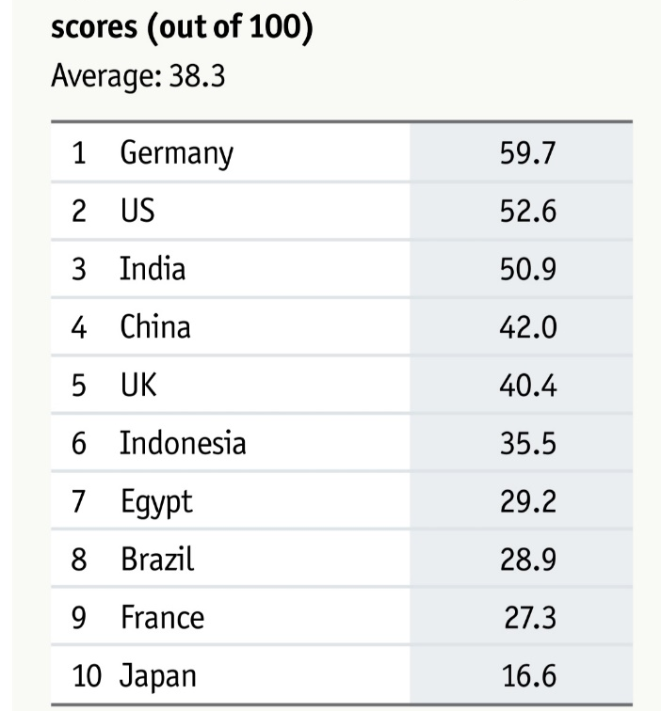
Figure: Economic sustainability index.
Source: The Sustainable Tourism Index published by The Economist intelligence unit, 2018.
From the report of ‘The sustainable tourism index' of The Economist’s intelligence unit in 2018, Germany ranks first with 59.7 points out of 100 where average is 38.3. India ranks 3rd in the ranking with 50.9 points and UK in 5th with 40.4 points.

Environmental point of view: When it comes to the point of environment, NGOs and private sectors have taken more initiative than the government. The focal point of environmental sustainability in tourism is to protect the environment from any danger and keep it in good shape for the future use. Germany tops the ranking in environmental sustainable tourism with more than 90 points out of 100. Government is encouraging tourism businesses to reduce usage of water and energy, and reduce the carbon emission.
The UK government passed several law mandating an EIA (Environmental Impact Assessment act,2001) requirement for activities related to tourism. The index shows comparison of countries
on their environmental performance. Nations should reduce the growth of greenhouse gas emission, improve air quality, improve water reserve etc. The problem is tourism-specific
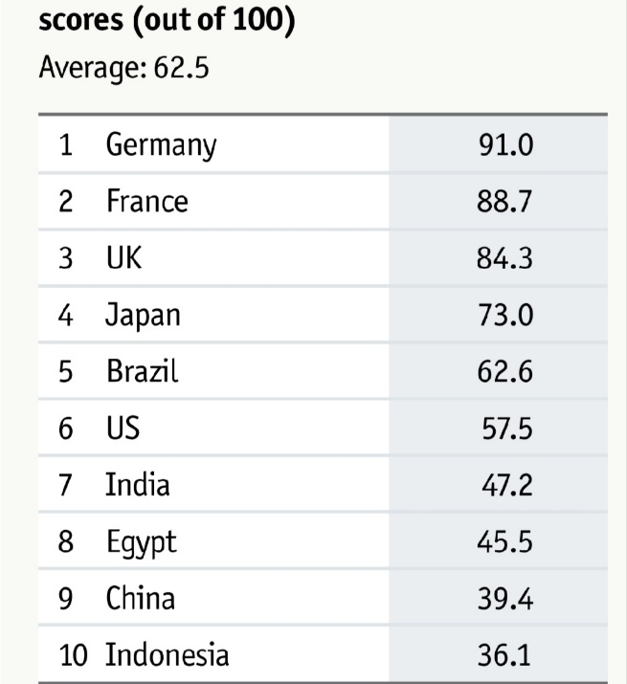
indicators on environmental performance are not always available across the globe.

Figure: Environmental sustainability index.
Source: The Sustainable Tourism Index published by the Economist Intelligence unit in 2018.
From sustainable tourism index report of the Economist, UK ranks 3rd on environmental sustainability and India 7th.

Socio-cultural point of view: Sustainability doesn’t only mean the conservation of environmental and natural resources, but also mean the preservation and protection of heritage and unique cultural significant destinations. UNESCO World Heritage Committee has played an important role in protecting many of the historical sites across the globe. UK has the 3rd highest density of heritage sites among all the countries.( UNESCO, United Nations Statistics Division). The protected areas of UK has benefited from the European Charter for Sustainable tourism. Established in 1995 by the European Federation of Protected areas (Europarc), the charter was taken as a planning tool to implement sustainable tourism practices in more than 400 places across the continent by the organizations managing those areas. Socio-cultural Sustainability means fulfil of the social value, security, religion, peace, Social justice, human right etc. of local people for now and for the future generations.
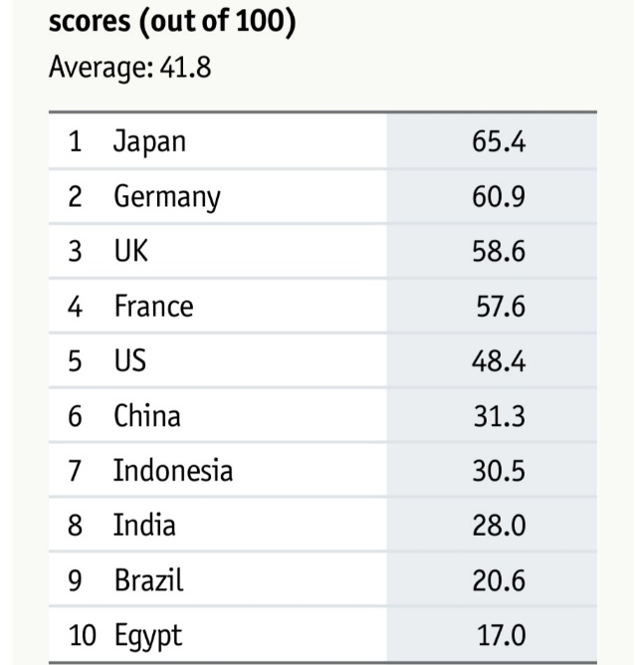
Figure: Socio-cultural sustainability index.
Source: The Sustainable Tourism Index published by The Economist intelligence unit in 2018.
In the sustainable tourism index of the Economist Uk ranks 3rd and India at 8th. In India the sustainable tourism in socio-cultural sector has been nurtured by the state governments. Here, the nature and wildlife tourism initiative of Karnataka state and ecotourism initiative of Sikkim are mention worthy.

Advantages of sustainable tourism: There are a lot of benefits of sustainable tourism. Some of them are mentioned below:
- Sustainable tourism helps the local communities economically. The profit earned by the tourism industry is spend for the local people and environment.
- It helps to conserve the natural resources given to us as a gift from the mother earth.
- Sustainable tourism helps the visitors to have a more real look of the place. The raw cultural exposure is the basic of sustainable tourism.
- It can have a massive impact on reduction of carbon uses, usage of renewable energy etc.
- It uplifts the local culture which helps to maintain and nurturing the local cultural elements for the future.
- This process helps the local communities to avoid the displacement and resettlement of the local tribes.
- It grows a sense of natural conservation in the minds of the tourists. Which will be a positive mentality for the future.

Limitations of sustainable tourism: There are some limitations of sustainable tourism too.
- There are no definite rule of following the process. Governments of different countries are having different issues to deal with to promote the campaign. So, the implementation of sustainable tourism as a legal policy hasn’t seen the light in many areas of the world.
- Sustainable tourism is against carbon emission but uses of vehicles and planes are unavoidable. So, there are matters to think before going fully into the system.
- There will be a concern of physical issues also. This tourism will demand high physical ability. There are some health issues also as different corner of the earth contains different types of diseases.
- Ecotourism has it’s limit within itself. It wont offer all the luxuries offered by other luxurious destinations.
- There’s another concern on cost management. Ecotourism will not always be cost effective.
- The desired standards cannot be maintained Every time.

Conclusion: Sustainable tourism has the ability to preserve natural and cultural resources and help the local people by ensuring economic benefits. Till now NGOs and tourism related private sectors are taking initiatives to promote sustainable tourism but they are not getting enough support from the governments. If the respective government takes an initiative to work together with the tourism management, planners and businesses then the goal can be achieved very easily. And the destinations, people living around the destinations, people came to visit the destinations will be the most beneficiaries from sustainable tourism.

Recommendations: The industrialization and advancement in technologies has lead us to a point where nature is being harmed and we are destroying our ecosystems. Sustainable tourism comes with a positive idea to do what we are doing but in way so that nature is not harmed. Rather natural and culture resources get the highest priority to be protected. Not only these but economic benefits are also there which helps the people to live better in this capitalistic world.
- This report explained sustainability and how it has formed. Three bases including environmental, economic and socio-cultural sustainability. It is a wide spread thing. So extensive study and research is needed before implementing it.
- Governments should take initiatives to promote the process. Policies and laws should be there to formulate it in the tourism industry.
- Tourism related organizations should come forward to create more opportunities to explore the natural resources but not by harming or destroying them.
- Initiatives should be taken to educate tourists so that they can have an idea of how sustainable tourism is benefiting the environment. Thus a positive mentality will grow among the people about it.

References:
- UN documents. (1987) ‘Our common future: Report of the World Commission on Environmental and Development’. Website. Available at: http://www.un-documents.net/ (accessed: 4 March 2020)
- Pearce, P.L., Morrison, A.M., Rutledge, J.L. (1998) ‘Tourism bridges across continents’. Sydney: The McGraw-Hill Companies, Inc.
- Pigram, J.J. (1990) ‘Sustainable tourism: policy consideration’. Journal of tourism studies, 1(2), pp- 2-9.
- Place, S. (1995) ‘Ecotourism for sustainable development: oxymoron or plausible strategy?’ Geojournal, 35(2). Pp- 161-173.
- Stabler, M.J. (1997) ‘Tourism and Sustainability: principles to practice’. Wallingford: CAB International.
- Hardy, A. Beeton, R.J. Pearson, L. (2002) ‘Sustainable tourism: An overview of the concept and its position in relation to the conceptualisations of tourism’. Journal of sustainable tourism. Vol. 10, No. 6.
- Liu, Z. (2003) ‘Sustainable tourism development: A critique’. Journal of sustainable tourism. Vol. 11, No. 6.
- Greenhotelier.org. (2002) ‘Sustainable tourism initiatives in UK’. Online. Available at: https://www.greenhotelier.org%sustainable-tourism-initiatives-in-the-uk (accessed: 4th March 2020)
- Davies, P. (2018) ‘France, Germany and UK lead world in sustainable tourism’. Online. Available at: https://www.travelweekly.co.uk/france-germany-and-uk-lead-world-in-sustainable-tourism (accessed: 5th March 2020)
- Gold, M. (2017) ‘The sustainable tourism index: Enhancing the global travel environment’. Website. Available at: https://eiuperspectives.economist.com/sustainability/sustainable-tourism-index/white-paper/ (accessed: 5th March 2020)
- UNWTO.org. ‘statistics’. Website. Available at: https://www.unwto.org/statistics/ (accessed: 5th March 2020)
- Greentourism. (2019) ‘Sustainable tourism’. Online. Available at: https://www.greentourism.eu/SustainableTourism/ (accessed: 5th March 2020)
- UNWTO. (2020) ‘Sustainable development’. Website. Available at: https://www.unwto.org/sustainable-development/ (accessed: 5th March 2020)
- Lacalinao, P.(2019) ‘What is sustainable tourism and why is it important?’. Online. Available at: https://visit.org/blog/what-is-sustainable-tourism/ (accessed: 5th March 2020)
- Gaval, I. (2016) ‘The economic benefit of sustainable tourism’. Website. Available at: https://ecobnb.com/economic-benefits-sustainable-tourism/ (accessed: 5th March 2020)
- Grant, M. (2020) ‘Sustainability’. Online. Available at: https://www.investopedia.com/sustainability.asp/ (accessed: 5th March 2020)
- UCLA. (2020) ‘What is sustainability’. Online. Available at: https://www.sustain.ucla.edu/about-us/what-is-sustainability/ (accessed: 6th March 2020)
- Environmental protection agency. (2020) ‘Sustainability’. Website. Available at: https://www.epa.gov/sustainability/ (accessed: 6th March 2020)
- UN. (2020) ‘Sustainable tourism’. Website. Available at: https://sustainabledevelopment.un.org/sustainabletourism/ (accessed: 6th March 2020)
- Ferreira, S. (2018) ‘ Why is sustainable tourism so important’. Online. Available at: https://www.thewisetravellers.com/inspiring-blog/why-is-sustainable-tourism-so-important/ (accessed: 6th March 2020)
- The travel foundation. (2020) ‘Sustainable tourism’. Online. Available at: https://www.thetravelfoundation.org.resources-categories/what-is-sustainable-tourism/ (accessed: 6th March 2020)

