

Task 2: reflective activity

Student Name: Missara Altom Hamed
Soudent ID : 2545475
Module Code : LCHS4001
Module : Academic and employability skills
Lecturer : Rajeev Nath

Submitted on: 05/08/2026

Using GIBBs reflective cycle module in my research
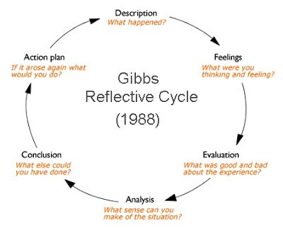
This Photo by Unknown Author is licensed under CC BY-NC

Section | Response
1. Research | When I started my task one, I first read the assignment instructions to understand what I needed to do. then I searched for information using NHS website and nursing journals. At first, I found too much information so I had to choose the parts that were most useful. The CRAAP test helped me think more carefully about whether a source was reliable and suitable to use. now I feel more confident about finding and selecting information for my assignments.
2. Presenting | Before my presentation, I organised my notes and practiced speaking a few times. I also looked through my slides to make sure I understood what I want to say instead of heading directly from them, during the presentation I was nervous at the beginning, but I become more comfortable as I continued, next time I would like to speak more naturally and make better eye contact with audience.
3. Challenges you faced | The biggest challenge for me was putting information into my own words without changing the meaning. I also found it difficult to speak confidently because English is not my first language. I know these are areas that I need to keep improving I think more practice and feedback from tutor will help me become more confident.
4. Actions to improve | Before the next term, I want to improve my time management so I do not leave my work until the last minute. I also want to develop my academic writing and referencing skills.  Reading more journal articles should help me understand how academic writing is structured.
5. Further steps needed to Prepare for Task 3 | For task three I will begin my research earlier and make a simple plan before I start writing. I will continue to use reliable sources and check that they are relevant to my topic. I also want to improve my note-taking, critical thinking, and presentation skills so I can produce better work in future assignments.

