
Module: Introduction to Web and Database Concepts (ACCA4023)
Programme: Computing
Assignment Title: HTML & CSS Web
Development
Lecturer: Divya Chidambaram

Biniyam Memberu
ID 2405357
Contents
Introduction 2
Requirements 3
Implementation 4
Validation 8
Evaluation 10
References 13
Appendices 14

Introduction
The document outlines the comprehensive development process of the Yeha Hiking Tour and Travel website, which serves as a responsive, multi-page platform for promoting guided hiking activities. The report clarifies all design decisions made to produce a website that ensures excellent usability and visual appeal, and that adapts automatically to different devices. The report begins with Requirements, which describe the website's primary function and content, and identify its intended user. It then presents screen captures of all completed pages and explains the development work. In addition, the report displays HTML and CSS validation results, which show all detected errors along with their solutions, as well as the development process. It also presents validation results for the homepage and main stylesheet. The Evaluation section examines web quality elements through detailed explanations of usability and accessibility, as well as a search engine optimisation analysis of the website and two comparable active websites. The report ends with an assessment of design choices and an evaluation of the finished product's ability to fulfil contemporary web requirements.

Requirements
Yeha, Hiking Tour and Travel operates as a legitimate organisation that runs guided hiking tours through its website. The website's primary functions are to display available tours, showcase beautiful landscapes through a gallery, and make contact information accessible to attract new clients. The website promotes hiking tours and provides contact details for potential clients. The website content explores outdoor activities, natural exploration, and sustainable travel practices. The website targets nature lovers, adventure enthusiasts, and all tourists seeking guided hiking tours that offer safe, exciting experiences while respecting the environment. The website features are briefly elaborated in the implementation section. The website should feature an attractive design that allows users to navigate easily between pages while ensuring full accessibility on desktop and mobile devices.
Additionally, the website meets current standards, and a usability evaluation should assess its layout, navigation, readability, and overall user experience. The evaluation process includes an accessibility assessment, followed by the development of guidelines to achieve both accessibility and inclusivity. The evaluation process provides a structured approach to development for search engine optimisation and mobile compatibility testing, utilising browser tools and physical devices to verify responsive design and display quality.

Implementation
The website consists of four main pages: Home, Tours, Gallery, and Contact. Each page was hand-coded using HTML and styled with a shared CSS file. Design principles were applied using Notepad++. Visual elements, such as hover effects, hero and feature sections, background images, and a lightbox gallery using a gallery grid, were included to enhance the user experience. Screen captures of each page were taken using the Snipping Tool.

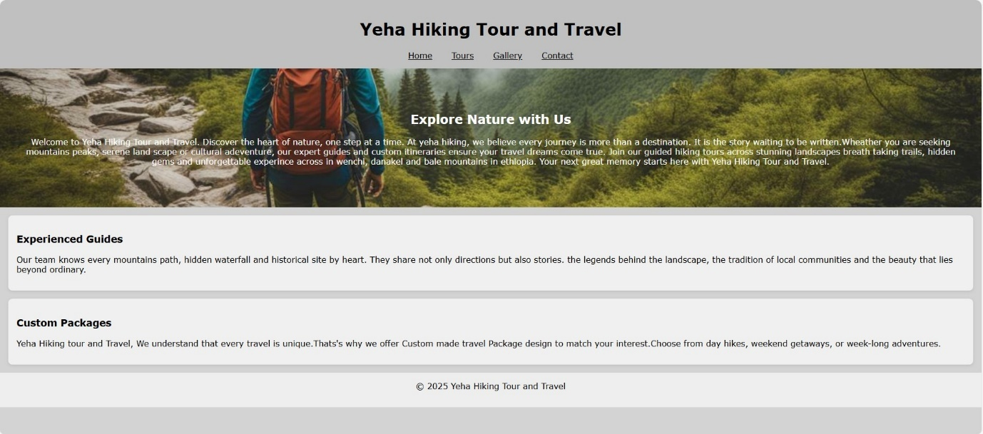
The above image shows the homepage.
Home page
It is used as the website's face. It serves as the central hub for navigation and a link to other sections of the page.
Purpose
The homepage serves as the entry point to your website. Introduce the brand, "Yeha Hiking Tour and Travel" is clearly presented with a firm header and navigation bar. Engaging visitors involves the scenic background and a welcoming message, which creates an emotional connection with nature lovers and adventure seekers. Communicate the core offerings, highlighting guided hiking tours, custom travel packages, and destinations across Ethiopia.
Key Features
Navigation Bar
- Positioned at the top for easy access.
- Includes links to essential pages: Home, Tours, Gallery, and Contact.
- Ensures smooth user experience and site-wide consistency.
Hero Banner
- Features a full-width background image of a forest trail with a hiker, reinforcing the theme of exploration.
- Contains a bold headline: "Explore Nature with Us", which sets the tone and purpose of the site.
- Includes a compelling welcome paragraph that outlines the company’s philosophy and tour destinations (Wenchi, Danakil, Bale Mountains).
Experienced Guides and Customer Package Section
- Emphasises the value of local knowledge and storytelling.
- Builds trust by showcasing the guides' familiarity with trails, waterfalls, and cultural landmarks.
- Offers options for day hikes, weekend trips, and extended adventures.
- Appeals to a wide range of travellers with different timeframes and interests
Footer
- Includes copyright information.
- Adds a professional touch and marks the end of the page.
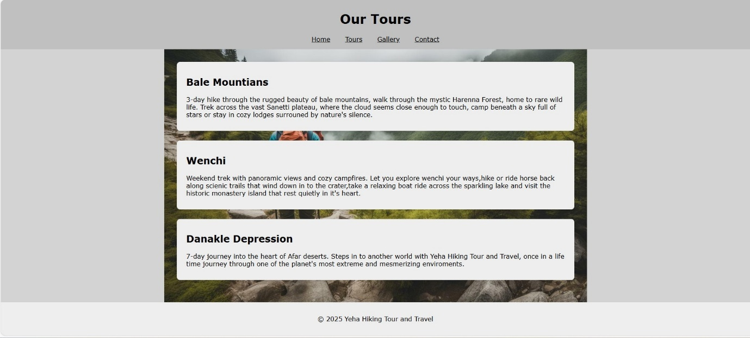
The above image shows the tour page.
Tour page
The Our Tours page showcases the core offerings of Yeha Hiking Tour and Travel, presenting three distinct hiking experiences tailored to different durations, landscapes, and traveller interests. This page is designed to inform, inspire, and guide users toward selecting their ideal adventure.
Purpose
This page serves as a catalogue of hiking packages, helping users compare destinations and choose experiences that align with their preferences—whether they seek forest serenity, volcanic extremes, or cultural immersion.
Key Features
Navigation Bar
- Consistent with the homepage, the top navigation includes links to Home, Tours, Gallery, and Contact.
- Enhances usability and site cohesion.
Tour Listings
- Each tour is featured in a container and is presented with a title, duration, and a descriptive paragraph that paints a vivid picture of the journey.
- The three featured tours include the Bale Mountains, Wenchi, and the Danakil Depression.
Footer
- Displays copyright information.
- Maintains brand identity and professionalism.

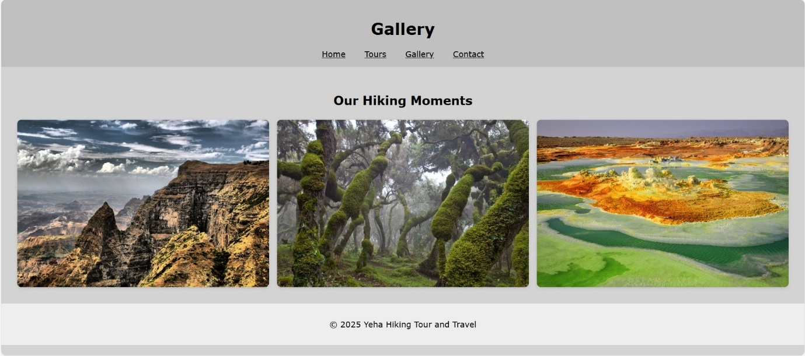
The above image shows the Gallery page.
Gallery page
The Gallery page of Yeha Hiking Tour and Travel is designed to visually immerse visitors in the breathtaking landscapes and unique environments featured in the company’s hiking tours. It serves as a powerful storytelling tool, using imagery to evoke emotion and inspire exploration.

Purpose
This page showcases the diversity and beauty of Ethiopia’s natural terrain, helping potential travellers visualise the experiences offered. It reinforces the brand’s identity and builds trust through authentic, high-quality visuals.
Key features
Image Gallery
- Displays three vivid photographs:
- Each image is carefully selected to represent a different ecosystem and tour destination.
Navigation Bar
- Consistent with other pages, includes links to Home, Tours, Gallery, and Contact.
- Ensures seamless movement across the site.
Footer
- Displays copyright information.
- Maintains brand consistency and professionalism.
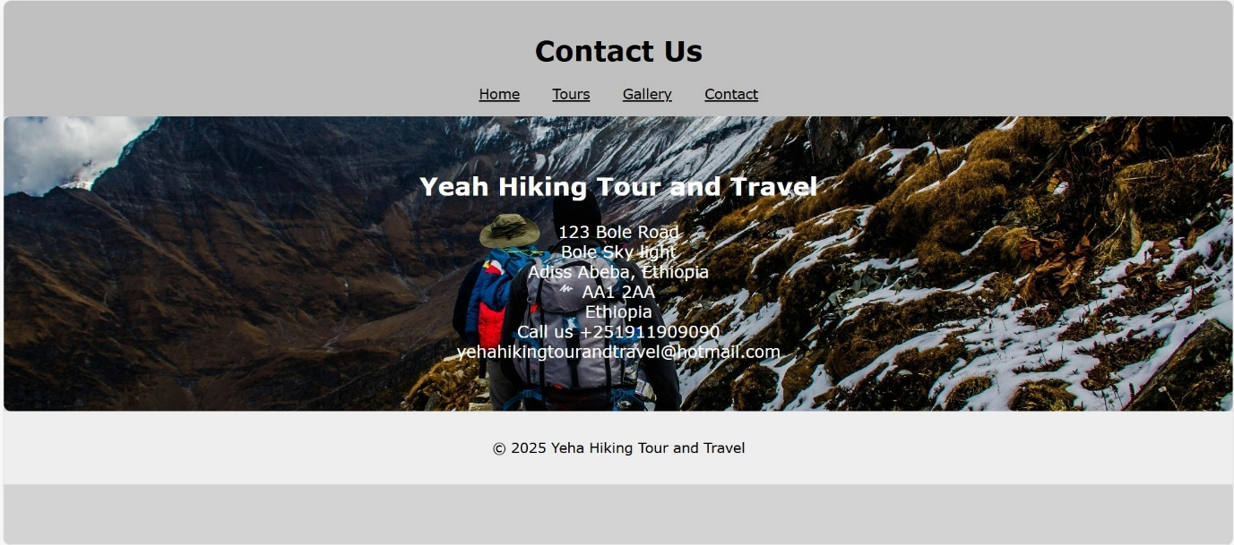
The above image shows the contact page.
Contact page
The Contact page provides essential information for users to reach Yeha Hiking Tour and Travel. It reinforces the company’s accessibility.
Purpose
This page is designed to facilitate direct communication with potential clients, offering precise contact details and a welcoming visual that reflects the brand's adventurous spirit.

Key Features
Navigation Bar
- Consistent with the rest of the site, includes links to Home, Tours, Gallery, and Contact.
- Enhances usability and site-wide cohesion.
Contact Information
- Includes the company name, physical address, phone number, and email:
- Presented in a clean, readable format.
Footer
- Displays copyright information.
- Maintains brand identity and professionalism.

Validation
Web developers who work professionally detect markup errors through document validation. The specification contains numerous rules that you do not need to remember, as validation serves as your error-detection tool. Validation serves as your tool for error detection. The validation process examines document tags for matching patterns, checks nesting structures, detects character encoding issues and rules, attributes, typing mistakes, and other minor errors [1].
The Yeha Hiking Tour and Travel website underwent validation against W3C standards to verify HTML and CSS code for structural accuracy, semantic correctness, and cross-browser compatibility. The website required this validation process to improve accessibility, maintain device-independent rendering, and enhance search engine optimisation.
The homepage (home.html) was validated using HTML(http://validator.w3.org/). Some problems were identified. The first warning consideration is to declare the language of the document. Additionally, there are minor errors, including missing alt attributes, unclosed tags, and some syntax errors. After validation, the adjusted HTML code was validated, and the document checking was completed; no errors or warnings were shown [2].
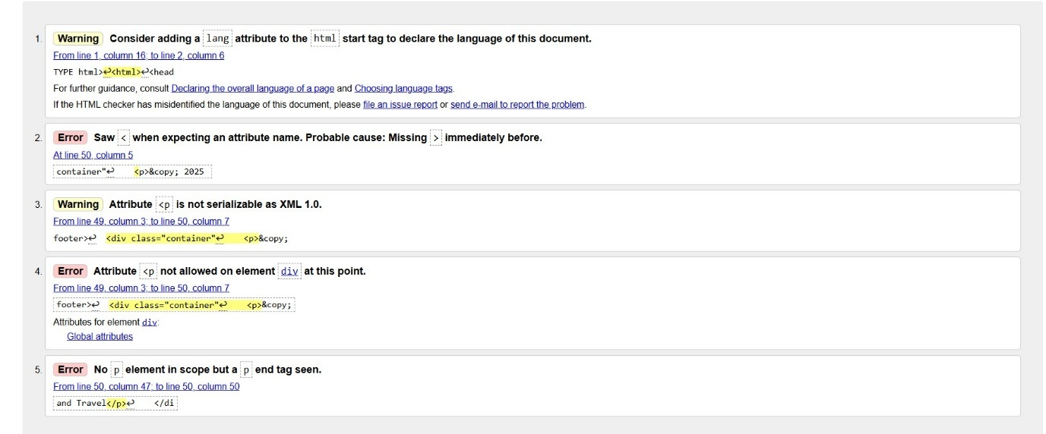
The image shown above is the validation result.
The main stylesheet (style.css) was validated using CSS(http://jigsaw.w3.org/css-validator/) . Some problems were identified. The first is a syntax error, misspelt properties (e.g, backgroud-color instead of background-color) as well as missing a colon and a semicolon. After validation, the adjusted CSS code was validated, and the document checking was completed; no errors or warnings were shown [3].
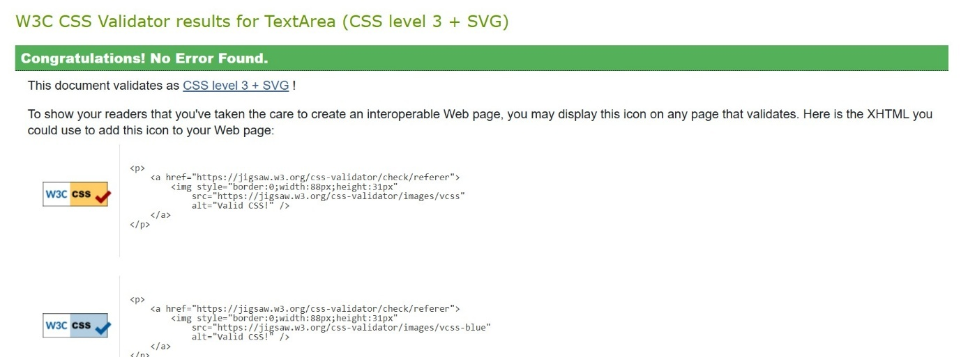
The image shown above is the final CSS validation result.
Furthermore, I had some difficulty, first when I was creating the four pages to link with the CSS, I used the code <link rel="stylesheet" href="style.css">, but when I save the document in CSS, I wrote it in styles, adding “s”, it took age, it was challenging to find the spelling error to link the pages.
On the gallery page, I use an image to make it more attractive, but the picture is blurry in both the preview and the output. I use some Invalid values in the gallery grid, e.g., px used where % is expected, and vice versa. I’ve used a percentage in a CSS property where the browser expects a pixel value.
Additionally, Redundant or conflicting rules occur when the same code is applied twice with the same value (e.g., width: 100% and auto) to make the gallery fit the screen. Still, I discovered it has the same implications.

Evaluation
Usability
The ability of users to interact with a website effectively and efficiently defines usability. The website's usability depends on how well its layout is organised, how easy it is to navigate, how readable the content is, and how well the site functions for users. A website with high usability minimises user frustration, boosts user engagement, and maintains user retention [4].
Usability evaluation occurs during the design and testing stages through user testing. The main problems with usability stem from inadequate navigation systems and inconsistent design elements. Enhancing usability results in user-friendly interfaces that become more efficient and lead to better user satisfaction [5].
The website provides users with the necessary tools and features through its utility functionality. The website contains four fundamental pages: the homepage, gallery section, tour list, and contact form. The website contains proper navigation links which follow a logical organisation structure.
The website usability evaluation determines how user-friendly the site is through its interface design and mobile compatibility. The website features a basic design structure which maintains uniform visual elements throughout its entire content. The website provides an excellent mobile experience. The website becomes more interactive through its hover effect functionality.
The information quality in Content depends on how well the material presents clear and valuable information that covers all necessary points. The tour descriptions provide brief yet helpful information. At the same time, gallery images display appropriate content that looks good, and the contact page includes all required contact information, including email and phone numbers.
The website needs additional features to become more functional. To enhance the website, it requires a booking or inquiry form with validation to create an interactive experience. Users can better understand tour locations through the addition of a map or location-based feature. The website needs improved contrast and font size adjustments.
Accessibility
Websites become accessible through accessibility standards, which enable users with disabilities to use them, including people who have visual, auditory, motor, or cognitive disabilities. The implementation of semantic HTML, keyboard navigation, screen reader compatibility, and WCAG 2.1 guidelines forms the basis of accessibility [6].
Accessibility improves digital inclusion and user satisfaction. Many developers lack awareness or training in accessibility standards [6].
Perceivable
All information and user interface elements need to display content that users can understand through their senses. The website includes text alternatives for all images through descriptive alt attributes, which state "e.g., alt="bale mountains". The website presents information through readable colour combinations and appropriate font sizes.
Operable
All keyboard users need to access website navigation elements and interface components. The website enables users to navigate menus and buttons using keyboard input.
Understandable
The user interface requires information that users can understand for operation. The website features a navigation system which maintains a consistent page structure. The website uses basic language that readers can understand for both tour descriptions and headings.
Robust
The content needs to be strong enough for different user agents, including assistive technologies, to correctly understand it. The website uses properly structured HTML, which gets validated through the W3C Markup Validation Service. The content uses standard HTML tags and attributes throughout the document.
Suggestions
The website accessibility can be improved through several enhancements. The website needs to achieve minimum test contrast ratios while providing keyboard-accessible hover-only interactions, maintaining a uniform site layout and terminology, and following best practices for future technology compatibility.
Search Engine Optimisation
Search Engine Optimisation (SEO) involves website optimisation to improve search engine rankings. The optimisation process for search engines requires websites to include relevant keywords, structured headings, meta tags, alt attributes, and a mobile-friendly design. A well-executed SEO strategy helps to become more visible, attract more visitors [7].
Search rankings improve when developers use meta tags correctly, together with optimised titles and structured content. Implementing SEO during development creates permanent visibility and performance benefits for websites [7].
The website contains distinct descriptive titles for all its pages. Page titles help search engines identify page content, which in turn leads to higher click-through rates in search results.
The following text includes summaries of each page section via meta tags, which use the following format: <"Join our guided hiking tours, discover breathtaking trails, hidden gems.">
The page structure becomes easier for users and search engines to understand through semantic headings, which include <h1>Our Hiking Tours</h1>.
The addition of descriptive alt attributes to all images occurred, for example: <img src="Mountain trail.jpg" alt=" Bale Mountain">.

Comparative Website Evaluation: McDonald’s vs Burger King
Usability: A website becomes usable when users find it easy to navigate and experience positive interactions with the interface.
- The McDonald's website presents an animated interface with promotional content and visually appealing design elements. The website design leaves first-time users feeling overwhelmed by its crowded layout [8].
- The Burger King website presents a simple design with prominent text and easy-to-use navigation that leads users through essential functions, including food ordering and location search [9].
The Burger King website provides users with an uncomplicated, easy-to-use experience.
Accessibility: The website accessibility feature enables users with disabilities to access all website content effectively.
- McDonald’s uses low-contrast text and lacks form labels [8].
- Burger King uses clear headings and form labels, making it more accessible [9].
Burger King provides better accessibility features, enabling all users to access its content.
Search engine optimisation: websites to gain visibility in search engine results pages.
- McDonald’s implements an advanced website structure. The website structure follows a clear hierarchy through its headings [8].
- Burger King implements fundamental SEO practices on its website, including keyword-optimised titles and optimised image alt tags. The website includes titles and alt text, but its keyword implementation remains underdeveloped [9].
McDonald’s improved SEO approach enables the company to attract more online users.
Mobile responsiveness: The website functions properly on all mobile devices.
- McDonald’s provides a fully responsive design, which includes touch-friendly and adaptive layouts [8].
- Burger King provides users with a fast mobile experience through its simple design, delivering quick load times and full functionality [9].
Both deliver mobile performance through their fast and easy-to-use interfaces.

References

[1] | J. N. Robbins, “Learning Web Design,” in Learning Web Design, A Begginer's Guide to HTML,CSS, Java and WebGraphics, O'Relly Media, 2018, pp. 66-67.
[2] | “W3C Markup validation Service,” W3c, [Online]. Available: https://validator.w3.org/. [Accessed 06 11 2025].
[3] | “W3C CSS Validation Service,” W3C, [Online]. Available: https://jigsaw.w3.org/css-validator/. [Accessed 06 11 2025].
[4] | “Usability,” Interaction Design Foundation, [Online]. Available: https://www.interaction-design.org/literature/topics/usability#what_is_usability?-0. [Accessed 07 11 2025].
[5] | S. C.-C. Catalina Astudillo-Rodriguez, “Systematic Literature Review in Usability Web: A Tertiary Study,” Usability and User Experience, , Vols. Vol. 110,, no. AHFE, p. 133–143, 2023.
[6] | “Accessibility engineering in web evaluation process: a systematic literature review,” Accessibility engineering in web evaluation process, vol. Vol 23, no. Springer Nature, pp. 653-686, 2023.
[7] | “International Journal of Research Publication and Reviews,” Exploring SEO Best Practices in Web Development: Enhancing Website , vol. Vol 5, no. 7, pp. 4294-4298, 2024.
[8] | “McDonald,” McDonald, 2015-2025. [Online]. Available: https://www.mcdonalds.com/gb/en-gb.html. [Accessed 08 11 2025].
[9] | “Burger King,” Burger King, 2015. [Online]. Available: https://www.bk.com/. [Accessed 08 11 2025].

Appendices
Home.html
<!DOCTYPE html>
<html lang="en">
<head>
<meta charset="UTF-8">
<meta name="viewport" content="width=device-width, initial-scale=1.0">
<title>Yeha Hiking Tour and Travel</title>
<link rel="stylesheet" href="style.css">
</head>
<body>
<header>
<h1>Yeha Hiking Tour and Travel</h1>
<nav>
<a href="home.html">Home</a>
<a href="tours.html">Tours</a>
<a href="gallery.html">Gallery</a>
<a href="contact.html">Contact</a>
</nav>
</header>
<section class="hero">
<h2>Explore Nature with Us</h2>
<p>
Welcome to Yeha Hiking Tour and Travel. Discover the heart of nature, one step at a time. At yeha hiking,
we believe every journey is more than a destination. It is the story waiting to be written.Wheather you are
seeking mountains peaks, serene land scape or cultural adeventure, our expert guides and custom itineraries
ensure your travel dreams come true.
Join our guided hiking tours across stunning landscapes breath taking trails, hidden gems and unforgettable
experince across in wenchi, danakel and bale mountains in ethiopia. Your next great memory starts here with
Yeha Hiking Tour and Travel.
</p>
</section>

<section class="features">
<div>
<h3>Experienced Guides</h3>
<p>Our team knows every mountains path, hidden waterfall and historical site by heart.
They share not only directions but also stories. the legends behind the landscape, the
tradition of local communities and the beauty that lies beyond ordinary. </p>
</div>
<div>
<h3>Custom Packages</h3>
<p>Yeha Hiking tour and Travel, We understand that every travel is unique.Thats's why
we offer Custom made travel Package design to match your interest.Choose from
day hikes, weekend getaways, or week-long adventures.</p>
</div>
</section>

<footer>
<div class="container">
<p>&copy; 2025 Yeha Hiking Tour and Travel</p>
</div>
</footer>
</body>
</html>
<! hero used for responsive different screen sizes and to write a word on the image to make it attractive>
<! feature used for responsive alignment across devices and semantic structure>
Tours.html
<!DOCTYPE html>
<html>
<head>
<meta charset="UTF-8">
<meta name="viewport" content="width=device-width, initial-scale=1.0">
<title>Tours-Yeah Hiking</title>
<link rel="stylesheet" href="style.css">
</head>
<body>
<header>
<h1>Our Tours</h1>
<nav>
<a href="home.html">Home</a>
<a href="tours.html">Tours</a>
<a href="gallery.html">Gallery</a>
<a href="contact.html">Contact</a>
</nav>
</header>
<section class="tourlist">
<article>
<h2>Bale Mountians</h2>
<p>3-day hike through the rugged beauty of bale mountains, walk through the mystic Harenna Forest,
home to rare wild life. Trek across the vast Sanetti plateau, where the cloud seems close enough
to touch, camp beneath a sky full of stars or stay in cozy lodges surrouned by nature's silence.</p>
</article>
<article>
<h2>Wenchi</h2>
<p>Weekend trek with panoramic views and cozy campfires. Let you explore wenchi your ways,hike or
ride horse back along scienic trails that wind down in to the crater,take a relaxing boat ride across
the sparkling lake and visit the historic monastery island that rest quietly in it's heart.</p>
</article>
<article>
<h2>Danakle Depression</h2>
<p>7-day journey into the heart of Afar deserts. Steps in to another world with Yeha Hiking Tour and
Travel, once in a life time journey through one of the planet's most extreme and mesmerizing enviroments.</p>
</article>
</section>

<footer>
<p>&copy; 2025 Yeha Hiking Tour and Travel</p>
</footer>
</body>
</html>
Gallery.html
<!DOCTYPE html>
<html>
<head>
<meta charset="UTF-8" />
<meta name="viewport" content="width=device-width, initial-scale=1.0"/>
<title>Gallery-Yeah Hiking</title>
<link rel="stylesheet" href="style.css" />
</head>
<body>
<header>
<h1>Gallery</h1>
<nav>
<a href="home.html">Home</a>
<a href="tours.html">Tours</a>
<a href="gallery.html">Gallery</a>
<a href="contact.html">Contact</a>
</nav>

</header>
<section class="gallery">
<h2>Our Hiking Moments</h2>
<div class="gallery-grid">
<img src="Mountain trail.jpg" alt="Bale Mountain">
<img src="Forest.jpg" alt="Forest">
<img src="Denakel.jpg" alt="Denakel">

</div>
</section>

<footer>
<p>&copy; 2025 Yeha Hiking Tour and Travel</p>
</footer>
</body>
</html>

Contact.html
<!DOCTYPE html>
<html>
<head>
<meta charset="UTF-8" />
<meta name="viewport" content="width=device-width, initial-scale=1.0"/>
<title>Contact-Yeah Hiking</title>
<link rel="stylesheet" href="style.css" />
</head>
<body>
<header>
<h1>Contact Us</h1>
<nav>
<a href="home.html">Home</a>
<a href="tours.html">Tours</a>
<a href="gallery.html">Gallery</a>
<a href="contact.html">Contact</a>
</nav>
</header>

<section class="contact-address">

<h2>Yeah Hiking Tour and Travel</h2>
<p>123 Bole Road<br>
Bole Sky light <br>
Adiss Abeba, Ethiopia<br>
AA1 2AA<br>
Ethiopia<br>

Call us +251911909090<br>
yehahikingtourandtravel@hotmail.com</p>

</section>

<footer>
<p>&copy; 2025 Yeha Hiking Tour and Travel</p>
</footer>
</body>
</html>
CSS
Styles.css
body {
font-family: Verdana,sans-serif;
background-color:#D3D3D3;
margin: 0;
padding: 0;
}

header {
background-color:#C0C0C0;
color: black;
padding: 1em;
text-align: center;
}
nav a {
margin: 0 1em;
color: black;

}
.hero {
background: url('hiking.jpg') no-repeat center center/cover;
color: white;
padding: 4em 2em;
text-align: center;
}

.features div {
flex: 1 1 50%;
margin: 1em;
background-color: #f0f0f0;
padding: 1em;
border-radius: 8px;

box-shadow: 0 2px 6px rgba(0,0,0,0.1);
transition: transform 0.3s ease, background-color 0.3s ease;
}
.features div:hover {
transform: translateY(-5px);
background-color: #e6f4ea;
}

.tourlist {
padding: 2em;
max-width: 1000px;
margin: auto;
background: url('hiking.jpg') no-repeat center center/cover;
}
.tourlist article {
background-color: #eee;
padding: 1em 1.5em;
margin-bottom: 1.5em;

border-radius: 8px;
box-shadow: 0 2px 6px rgba(0,0,0,0.1);
transition: transform 0.3s ease, background-color 0.3s ease;

}

.tourlist article:hover {
transform: translateY(-5px);
background-color: #e6f4ea;
}

.contact-address {
padding: 2em;
text-align:center;
font-size:1.2em;
background-color:#fdfdfd;
color:white;
transition: background-color 0.3s ease, transform 0.3s ease;
border-radius: 8px;
background: url('hiking1.jpg') no-repeat center center/cover;
}
.contact-address:hover{
background-color:#e0f7e9;
transform: scale(1.02);
}

.gallery {
padding: 2em;
text-align: center;

}

.gallery h2 {
color: black;
margin-bottom: 1em;
}

.gallery-grid {
display: grid;
grid-template-columns: repeat(auto-fit, minmax(180px, 1fr));
gap: 1em;
}

.gallery-grid img {
width: 100%;
height: auto;
border-radius: 8px;
box-shadow: 0 2px 6px rgba(0,0,0,0.1);
transition: transform 0.3s ease;
}

.gallery-grid img:hover {
transform: scale(1.05);
}

footer {
background-color: #eee;
text-align: center;
padding: 1em;
}

