Student Name: Rume Meah
Student ID: 1813924
Module code: BMSW 4002

Business Report for Sarah Davis

Lecturer : Dr Eric Osei

- EXECUTIVE SUMMARY

Sarah Davis - proprietor of a large discount store based in Birmingham, would like advice
In regards to maintaining effective teamwork and communication within the organization.

The scope of the business staff involves a total of 20. An analysis of the business dynamic will be done to help identify the best practice available from existing communicative business modules, to help staff reach common goals.

Recommendation will be given as to how develop communication.
TABLE OF CONTENTS

- Executive Summary………………………………………………….p2
- Table of Contents……………………………………………………..p3
- Introduction…………………………………………………………….p4
- Communication in Sarah’s Business………………………………..p5
4.1 Importance of Effective Communication……………………….p5
4.2 Importance of 2 way Communication………………………….p6
4.3 Effective methods of communication…………………………..p8
4.4 Significance of non-verbal communication……………………p12
4.5 Action Plan……………………………………………………….p13
- Conclusion/ Recommendations….…………………………………p14
- References……………………………………………………………p16
- Appendix……………………………………………………………….p17

- INTRODUCTION

Sarah Davis owns a large discount store based in Birmingham. Over the last few years the business has rapidly expanded and advice has requested consultation on how to maintain effective communication and teamwork within the organization.

This report will focus on how the business will needs to enhance and maintain their communications skills within the workforce environment for overall success. At present there is a total of 20 within the workforce or varying positions within a shiftwork –

4. Communication in Sarah’s Business

In any successful business communication is key. Effective communicators from both team leaders and workers will motivate each other to reach goals which in turn builds good teams. With open dialogue, everyone will be able to voice constructive ideas/ advice to help each other. Employees will be able to recognize their responsibilities and perform to the best of their abilities.
Customer service predominantly relies on good communication. You must be able to deliver what your customer requests, even if you are not able to, you must be prepared to answer with open and honest dialogue which makes sense. There will be times when disagreements occur but trying to find a positive outcome to all concerned would lessen problems.
According to Maund, Schriek and Tinkler, communication is when there are two parties – sender and receiver. The communication process is when the sender sends a message to the receiver via thoughts, information and ideas that is transmitted through a communication medium, which can vary in the forms of verbal, images, hand gestures etc. The receiver will then encode the message accordingly. (Maund, Schriek and Tinkler, pg. 47).
4.1 Importance of Effective Communication
Good communication skills will help you achieve. By being able to communication vocally and written, it can set you apart from your colleagues and help you excel at work. You can help yourself and your company by being a good communicator. Become an effective communicator and you’ll not only help your company; you’ll help yourself.
Preventive measures can be undertaken with good communication. Honest/ open dialogue, lets everyone work together to create a good outlet, and less likely to turn into arguments. Honest dialogue will give respect to one another, even if there are differences in opinions. ,
Customer service relies on good communication. Customers can vocalize requirement by communication, once you know what they require you are able to assist them. Listening skills are required so you can answer any queries within a timely fashion and in a way that it makes sense. Unhappy customers can take to social media to vent their frustration if not deal with correctly causing detrimental effect to your company reputation
4.2 Importance of two-way communication (models of Communication)
Two way communication is a process which a message is sent from the sender to the receiver. In turn the receiver sends the response back to the sender so they (sender) can interpret the message and reply accordingly. Any feedback aids the sender to measure the effectiveness of the message.
What can good proactive two way communication achieve in a business environment -
- Accuracy of Understanding: Staff misunderstanding can be removed immediately and solved.
- Job satisfaction: Employees are able to air their concerns, suggestions, grievances and complaints. It also helps create good rapports between management and subordinates, which in turn will improve the efficiency of both the parties.
- Independent Environment: Enables you to exchange information freely between management and staff without hesitation which in turn allows feedback which will enhance the working relationship between management and staff.
- Dynamic Process: Active progression of exchanging messages between staff. Interactive responses flowing between sender and receiver, enables both parties to make dynamic decisions.
- Increases the Efficiency of Management: Staff from all levels can establish a good working relationship as it will remove misunderstanding, which in turn will have a positive effect in efficacy.
- Providing Suggestions: Management can receive suggestion and opinions from staff, for better planning and decision making, helping put positive plans into action.
- Giving Acknowledgement: When the receiver receives the message from the sender, the feedback from the receiver provides clarification that the receiver has correctly/not correctly deciphered the message.
- Business Communication: As the receiver and sender have the ability to share information it is a complete communication as without feedback, communication will be unproductive and incomplete.
- Receivers Reactions: Once you are able to decipher the feedback from your receiver, you are able to proactively influence the changes needing to be implemented from the positive/ negative feedback this can lead to alterations in the decision making/ policies.
- Application of Direction: With organizations, management send orders, instructions, and advice, policies and programs to the staff. Enabling staff to share suggestions, opinions/ criticism with management for the betterment of the company and help clarify. This two way communication provides implementation of direction via the feedback system.
- Evaluating the Effectiveness of Communication: Both parties are able to evaluate and voice their opinions freely and by the feedback system they are able see how effective the communication is.
- Building Healthy Business Relationship: Feedback creates a better understanding within both parties. In a Two Way business communication, Management can understand the staffs concerns. If they are unable to understand the message/ contradicts it, management can effectively clarify or rectify it easily, ensuring better understanding. In turn this will remove any industrial dispute by establishing a good labor-management rapport.

According to Wells (2011), the earliest communication model was implemented by ‘Shannon and Weaver’ in 1948. A basic process which enables the sender to reach out to the receiver with a message. Fig 1
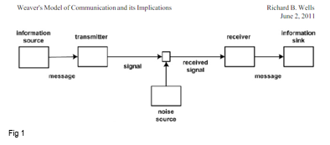
Sender – Manager: Initiator of message
Encoder : Message is transmitted to signals
Note: Is the signals/ binary data transmitted through satellites/ cables
Decoder : Reception where signal is converted into message.
Note : Receiver converts data into understandable message. If incorrectly decoded, it will influence the communication between the sender and receiver.
Receiver - Sales Staff: Is the destination to which the message sent
Note : After the receiver decodes the message – feedback will be given, if there is noise within this communication if will affect the flow of the message.
Noise: Noise within the communication channel, will affect the outcome of the message i.e. Thunder, background noise etc. – message will either not be received/ disruption will cause the receiver misinterpret the message, leading to misunderstanding
Note : This model is has external noises which affects messages/ signals via external sources. I.e. network problems will have adverse effect on the mobile phone message/ distracting messages

  - Effective methods of communication

As this company is a retail shop, generally face to face is imperative to communication alongside of nonverbal gestures for staff and customer communication. In addition to this there are various channels also available. Information Technology is key to moving forward, additional spectrums are required to move with the time i.e. emails/ internet, smartphones, tablets, conference calling etc.

Face to Face/ Body language (verbal/nonverbal)

According to Qadri (2019), face to face communication is the impact of physical presence with their body language. It is an important part of social communication and integration into the social system, it is a unique characteristics which is not found in any other communication methods. Used effectively it can achieve productive communication.

Verbal Communication is most important, according to Brink, Costigan (2015) that listening, conversing and presenting are most important in the workplace environment. Listening is the most important function followed by conversing and presenting.

According to Argyle (1972), there are 3 forms of nonverbal communication –

- Nonverbal is a means of communicating via facial/body expressions, attitudes and manipulation of the social surrounding
- Replacing a language with nonverbal communication
- Nonverbal supporting verbal conversation

Awareness of negative verbal/nonverbal should be taken into account as everyone has different temperaments/ understanding. Different vocal views will can inevitably cause clash, if used together with poor stance, no eye contact, arms crossed –as these are all are barriers.

Internet (emails, smartphones/ tablets)

According to Scott, S, electronic communication is a key factor in the running of a business. The internet streamlines electronic communications i.e. Emails/ video conferencing/ instant messaging, these factors remove time and space barriers, providing real-time communication. Managers and staff are able to work remotely and able to maintain real time communication.

Various software’s are available for businesses to ensure smooth running of businesses i.e. Scheduling Rota see fig 2 (Wheniwork.com). This can be used to provide Rota information, either emailed to staff or printed and placed on staff noticeboard. Fig 2 (Appendix 1)

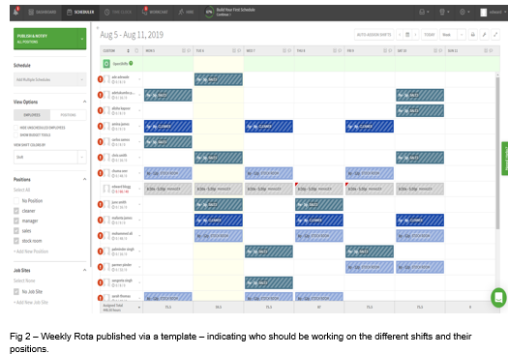

For staff that are on leave, video calling and speaking on the phone will make the individual feel that they are still in the ‘loop’ of work. The significance of still being involved whilst being absent will alleviate any concerns the individual could have whilst on leave.

Efficient IT communication relies on good broadband connection and regular updating of software, interrupted signals will cause the messages to not be delivered at the right time causing delays.

Informal/Formal Memos

This is a cost effective document which is displayed on a central point - staff room (appendix 1) everyone can refer to as and when required. General points made for all staff to adhere to – Appendix 2

Telephone

Telephone, streamlines good communication between staff/ customers, its quick/ easy and gives a more personal touch. Should emails not reach the individual in time, a telephone call would be quicker in reaching staff for messages in real-time involvement.

Reliable connectivity is paramount, for real time communication. Emphasis must be given to updated software and payments for contract must be made in a timely manner – direct debit.

Work Environment

Staff room environment plays a huge factor for employees, according to Taskspace (2016), it is a change of scenery, with the right communal setting it can help boost morale of staff and connect with each other. Communication within a comfortable environment, with good furnishing will help employees relax and have a positive outlook. Appendix 4

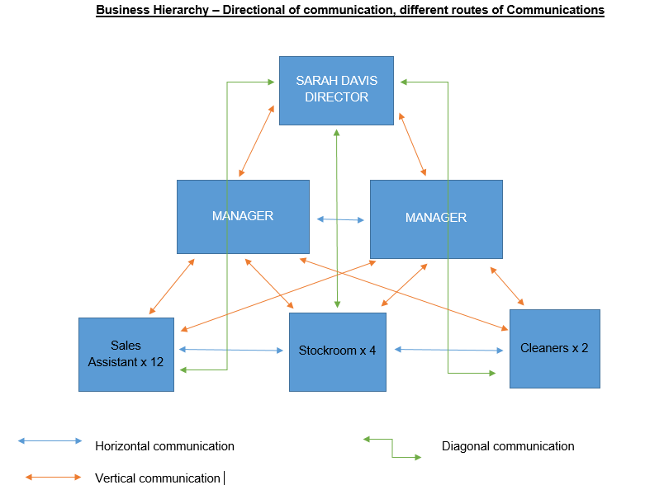

Fig 2

Being able to access management is key to a supportive work environment – fig 2

  - Significance of non-verbal communication

What is non-verbal communication?

According to Mindtools, non-verbal communication is body language and facial expressions. Staff can use these to demonstrate their feelings/ intentions by the posture, expressions and hand gestures.

You are able to decipher positive/ negative feelings, if interpreted correctly you can resolve issues. If used hand in hand with verbal messages, it will strengthen the message you are trying to convey positively. According to Ethos3, how an individual presents themselves is a key factor as this can create trust/ clarity and interest, by demonstrating sensitivity to body language and nonverbal cues can enhance your presenting skills by Repetition – reinforce message, Contradiction – make speaker untruthful, Substitution – place of talk, Complementing – verbal message and Accenting – underline a point . – Appendix 3

Practicing the art of gestures can be practiced in front of a mirror, so that you can see how you are perceived by your posture and facial expression, using these tools with the tone of your voice can either enhance your message or the opposite.

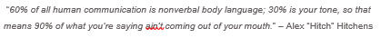

  - Action Plan

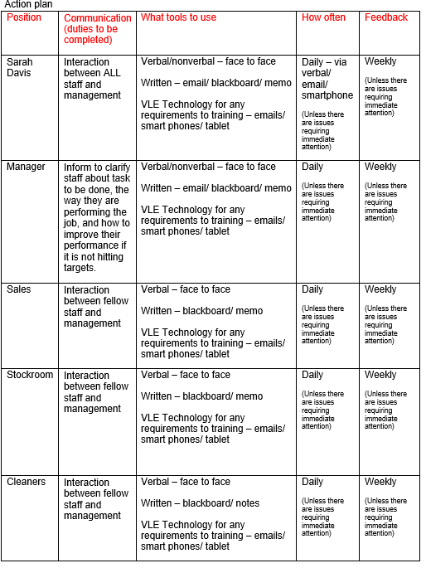

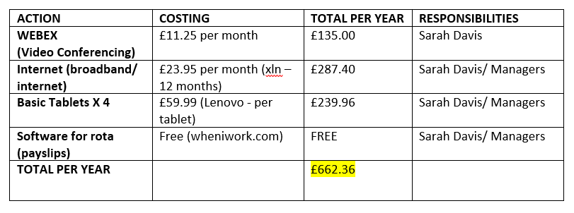

Timely interaction between management and staff should be adhered to, meetings should be appointed when all staff can get together i.e. 8.30am (before opening).

- Conclusion/ Recommendations

Conclusion

All staff should be respectful of individual culture/ views to get along. Any barriers can be overcome by using verbal content concisely and simplifying language, used alongside with good nonverbal cues (body language) – it will proactively work for a better understanding. Using language on its own is not enough to clearly put a message across, this must be incorporated with posture, hand gestures, facial expressions.

All communication between staff (email/ verbal etc ) should be reiterated to show that the message has been deciphered correctly. If not there should be feedback available readily with no fear of backlash.

Recommendations

Regular centralized meetings between staff and managements is imperative for smooth running of the business, to air any concerns positive/ negative. Management should provide clear and concise information in regards to duties are expected from staff, vice versa. Communication will rely on IT, importance MUST be placed on reliable connectivity of these sources i.e. Internet, regular updates of software is imperative, taking into account the costing? Does the cost outweigh the necessity?

Management should lead by example and be trained to be empathetic and also take into account that home and family responsibilities also affect job performance/ attendance, as home/ family responsibilities directly affect attendance and performance. Team building outings would be productive – meals out/ bowling etc. this will show support and togetherness.

Publish a quarterly employee newsletter devoted to the stores aims, where they are now and where does the company want to be? This will show staff inclusion. Promote an action plan to make sure everyone is on the same page. All staff should be placed on communicative training primarily so they are on the same page, which can be updated on a 6 monthly basis.

6. REFERENCES

Argyle, M., 1972. Non-verbal communication in human social interaction.

Brink, K.E. and Costigan, R.D., 2015. Oral communication skills: Are the priorities of the workplace and AACSB-accredited business programs aligned?. Academy of Management Learning & Education, 14(2), pp.205-221.

Ethos, the Importance of Non-Verbal Communication. Available at: https://www.ethos3.com/speaking-tips/the-importance-of-non-verbal-communication/ (Accessed: 9th August 2019)

Jack, R.E. and Schyns, P.G., 2017. Toward a social psychophysics of face communication. Annual review of psychology, 68, pp.269-297.

Maund, A and Schriek, M and Tinkler, P, K (2017) Certificate in Higher Education: Skills for the Workplace. London: Sage

Mindtools, Essential Skills for an excellent career. Available at: https://www.mindtools.com/pages/article/Body_Language.htm (Accessed: 8th August 2019).

Qadri, B. (2019) Power of Face to Face Communication in the Modern World.

Scott, Sherrie. "How Does Internet Shape the Workplace?" Small Business - Chron.com, http://smallbusiness.chron.com/internet-shape-workplace-11288.html. (Accessed 08 August 2019).

Taskspace, The importance of the Staff Room. Available at: https://www.taskspace.co.uk/importance-staff-room/ (Accessed: 9th August 2019)

- APPENDIXS
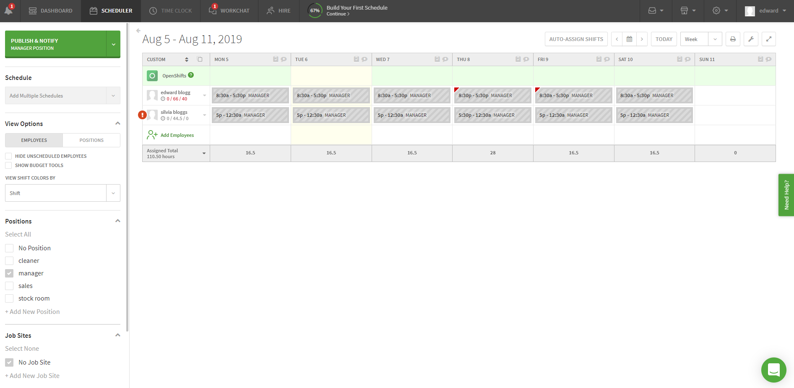

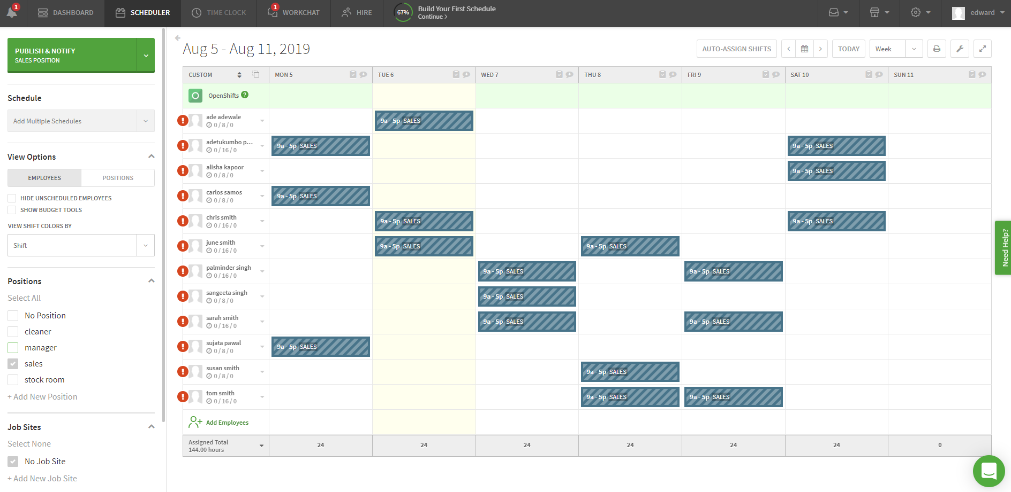

Appendix - 1 – Group Rotas

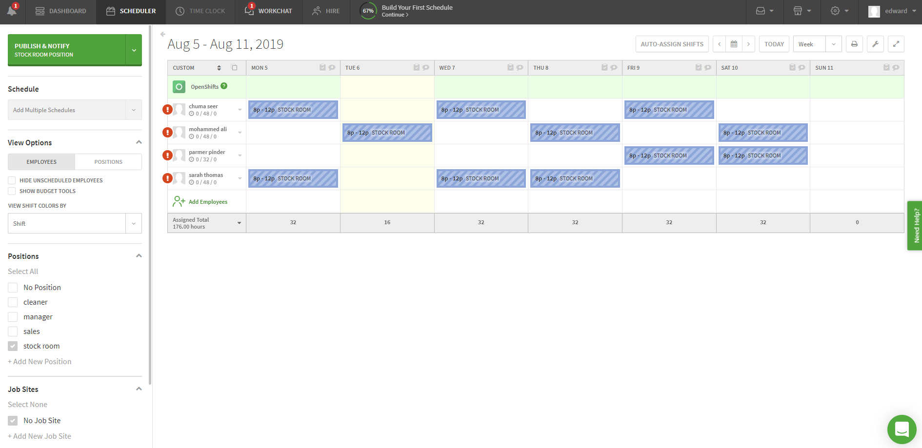

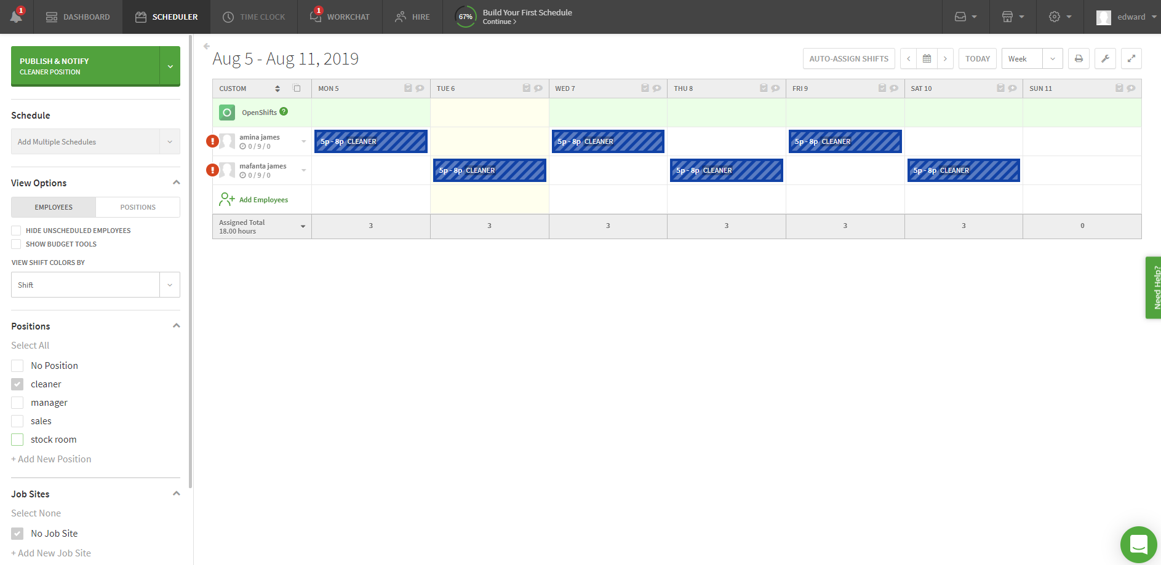

Appendix 1 - Group Rotas
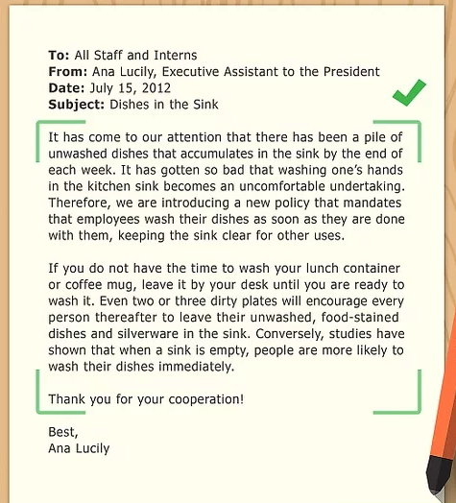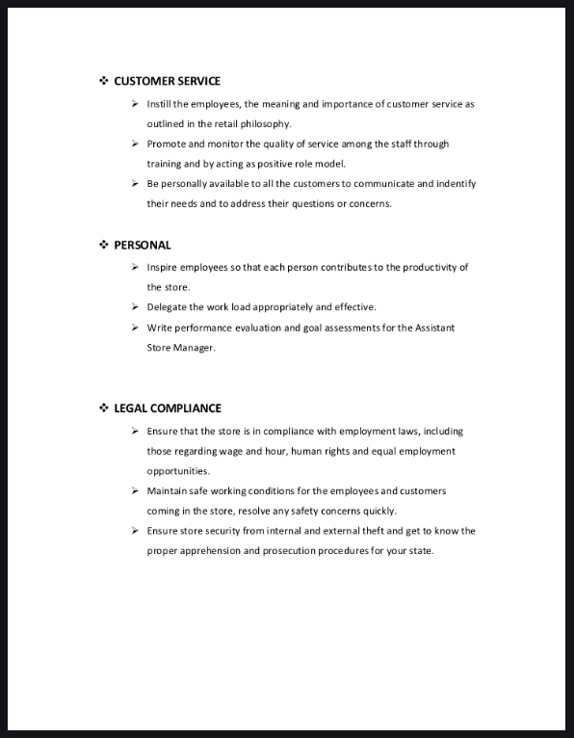

Appendix 2 – memos informal/formal

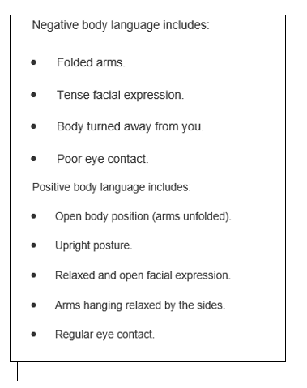
Appendix 3 – Nonverbal cues Body Language



Appendix 4 - Staff room

